LV6 Contemporary Themes
– Conference Learning Log

Student Name: | Abdul Khalique  1704981

Week 1 | Monday June 1st, 2020
Planning:

- In this meeting, we discussed picking a theme for each person
- We had to choose who would go into three groups – marketing, management, technology
- How we would work together as a group outside of lectures to work on the conference
- Making sure we all record our minutes in our learning log

Organising:

- The teams are Management: Abdul Khalique, Salah Uddin
- Marketing: Abdul Motin, Faruki
- Technical: Samsuddin,Sattar
Managing:

- Making sure we take minutes every meeting
- Making sure we update each other on new developments

Marketing:

- Main concerns: choosing a conference name, choosing who takes what task and who is our target audience going to be

Technical:
- As a group, we decided to build a website which will include viewable content and will be viewed by all
- Group members will upload their own videos and themes

Problems/Resolution Action Plan:

- We will be looking at how Global issues affected tourism

Focus for the Week:

Choosing who does which task for the conference

Student Signature:

__________________Abdul Khalique________________

Date:

__________________1st June 2020_______________

Week 2 | Monday June 8th, 2020
Planning:
- We had a discussion with our tutor at the conference today about making a plan. According to this plan, we had to organise who would be in the three groups - Management, Marketing, and Technology and give each person a specific role.
- Management team: Salauddin, Abdul Khalique,
- Marketing team: Abdul Mottin, Faruki
- Technology: Samsuddin, Sattar

Organising:
- With my team (management team), we have chosen our theme on terrorism and the impact it has on the global tourism industry
- I arranged a meeting with my team members Salauddin and Khalique through Whatsapp to discuss our plan
- Through WhatsApp, we discussed what we needed to research, analyse and areas to focus on for this project

Managing:

- The management team has created a Gantt Chart to keep track of the progresses and duration of the meetings that have been done so far
- We reminded the other team that we will be monitoring their progress and offer support to ensure everyone is at the same pace.

Marketing:

- In the conference, we had a discussion on what the name our brand needs to be
- Earlier today we did some tasks to help us learn how to strengthen our brand and what message we want to convey to our viewers

Technical:
- The technology team (SallaUddin and Sattar) has designed a website and a logo

Problems/Resolution Action Plan :
- There were some technical problem during this lesson, as some students were unable to access the conference calls, and some were struggling to choose their theme
- We then suggested themes for people who weren't sure on what to pick and eventually, everyone finally chose a theme they were happy with
- Themes
- Tsunami (Salauddin)
- Global Air Pollution (Abdul Mottin)
- COVID 19 (Samsuddin)
- Terrorism and its impact on the tourism industry (Abdul Khalique)

Focus for the Week:
- Monitor everyone’s progress
- Research on chosen theme, analyse and find areas to look into


I am Abdul Khalique and I am full time Taxi Driver. I completed my Higher Education Skilled For The Workplace Course in 2018 and now I am studying BA (Hons) International Hotel Management. My aim is to have this degree completed.

Student Signature:

___________________Abdul Khalique_______________

Date:

_____________8th June 2020____________________

Week 3 | Monday June 15th 2020
Planning:

Attendees: M.S Uddin, Shams Uddin, Abdul Khalique, A. Mattias, Sattar, Faruki

The Minute Taker was Saluddin

Agenda: We discussed the agenda from previous meeting and checked if there were further progress with this agenda

We discussed how we all have laptops now to aid us and we discussed what our plan will be as a result

Organising:

Organising how we will use the laptop to create and add to our website

Whatsapp group meeting was decided every Friday, 12pm – this meeting will be conducted to discuss our next actions

Decided on what our next deadlines will be

Decided on meeting and we will email John and Samantha to confirm on 22/6/2020

Managing:

We will be doing our own learning logs using the word document format. Having a learning log template has been useful as it allows a more seamless work

Decided on a website logo, this allowed me to see how important teamwork is and how compromising is important for successful team work

Managing team will be make sure everyone attends the meetings

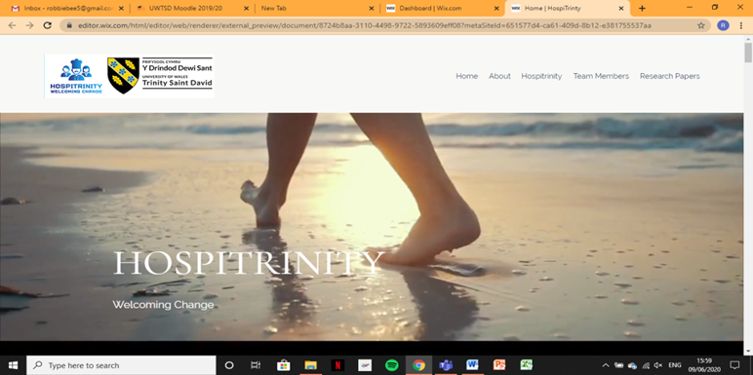

Marketing:

Everyone will have their own profile with a photo on the website
There will also be a marketing email sent out to different companies to showcase our service and conference that will take place

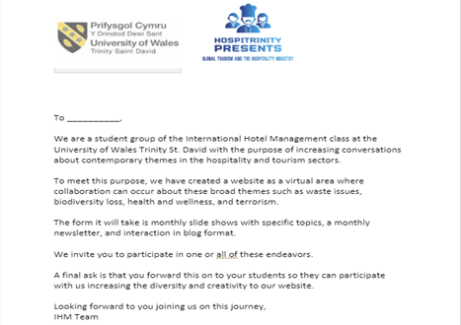

Technical:

We will have our meeting conference online via a Skype call

Problems/Resolution Action Plan :

Problems that we face are with attendance however, we are resolving this by choosing a specific time and day.

Focus for the Week:

To stick to our deadlines and work as a team by prioritising our attendance and keeping each other informed

Student Signature:

___________________Abdul Khalique_______________

Date:

________________15th June 2020_________________

Week 4 | Monday June 22nd 2020
Planning:

Attendees: M.S Uddin, Shams Uddin, Abdul Khalique, A. Mothin, Faruki

For this meeting, we discussed a gantt chart with Samantha and how we all have laptops that were given to us. We were discussing we could upgrade our conference, how were going to contact each other and how we will conduct our research

Organising:

We chose what our agenda for this meeting will be – organising the conference, researching on google, designing a logo, branding and promoting our website, how to make a business plan and choosing a theme

Managing:

The project manager will choose a conference venue, accommodation, activities and catering

Marketing:

The Marketing team will contact the media, create promotional material and manage the website, blog and social media

Technical

This technical team will design the logo and sort out the brochures

Problems/Resolution Action Plan :

Designing a website on the computer is hard and researching how to create a conference has been difficult

Focus for the Week:

Our focus will be to prepare for the conference and finish our logs and report paper

Student Signature:

__________________________________

Date:

_________________________________

Week 5 | Monday June 29th 2020
Planning:

Attendees: M.S Uddin, Faruqi, A. Khalique, Shams Uddin, S Mation

Today’s agenda was about updates on our progress and being ready for the conference

Organising:

We decided that we can speak on Microsoft teams
We decided to not go ahead with arranging catering, breakfast or lunch or transport cost and not paying a conference room

Managing:

Managing team making sure that we all felt ready for the conference and making sure we feel confident we’ll be successful

We have prepared our budget as a team

Marketing:

We have chosen our logo and theme
Invited school to attend conference – this will help to promote our hospitality company and conference

Technical:

We decided that we can speak on Microsoft teams to conduct our virtual conference

Problems/Resolution Action Plan :

Everyone now feels more confident about the conference and our deadlines have been completed

Focus for the Week:

To be ready for the conference

Student Signature:

__________________________________

Date:

_________________________________

Conference Review | Planning; Organisation; Management; Marketing of the Event and Conference Delivery

I have learnt many new things preparing for this conference. Initially, the conference was supposed to be a physical conference where we choose a venue, catering, guests and promote it physically however, it has been changed to an online conference.

Choosing to go online has been challenging and it required a lot of hard work and team dedication. We used Microsoft teams to create an online space for us to communicate and choose our deadlines and tasks. This has been difficult as many of my team members and myself have full time jobs and family commitments so at first, attendance at these meetings were not full attendance, however, our solution was to choose a specific day and have a video call on that day. This worked better for us and we were able to work around the commitment.

Another challenge we faced was the lack of computer use, however, we were sent laptops from our university and this aided us to complete our tasks such as picking our logo, creating our website profile and complete our learning logs. I have learnt how to create minutes and how to log into Microsoft teams. Creating a whatsapp group for our team and supervisor has been successful as it meant that most of us could have access to our minutes as we took photos or scans of our minutes.

Throughout this experience, I have learnt the importance of team work and how it is importance to communicate to get the work done effectively. I have improved my typing skills and listening skills.

