DIGITAL SKILLS AND RESEARCH METHODS

OTIS WILSON

STUDENT ID:1808060

Introduction
How can technology be used effectively in the workplace and what are the advantages and disadvantages?!! The two main advantages of technology in the workplace that everyone could name if the question was asked is it cuts cost and it saves time, which is both very important in today’s workplace. The time and man power that would have to go in to tasks without the use of technology at the workplace is unthinkable in 2019, and the time it will take to get task done without technology in the workplace is also unthinkable. The disadvantages of the technology in the workplace just the name one it can be a major distraction if used incorrectly which could affect work time. I will go more in to the effective use of technology at the workplace with evidence of research and references.
Technology
What is technology?!! I looked up meaning of technology in the dictionary and it says technology is things created by humans that make life easier or solve problems therefore technology is all around us and it evolving every year. Technology has changed the way we receive and give information, how we talk to friends, the way we eat and drink and live. When many people think of technology they think of smart phones, cameras, laptops etc. But an umbrella that protects you from the rain is also classed as technology.
According the YouTube video I watched (Wiselifer,2015) from 1770 communication was simple and interment.
1876 technology begin to change when the phone was invented.
1946 was the year the way people worked was different as a computer was invented.
1984 was a year the way people connected was different.
1991 was a year internet dating was introduced.
2002-2019Google has consumed and controlled us.

Modern Technology
What is the definition of modern technology? According to the dictionary the word modern means relating to the present or recent times as opposed to the remote passed. It also states characterized by or using the most up-to-date techniques, ideas or equipment. For example I just used Google on my phone type in dictionary, type in the word I was looking for and in seconds I had an answer, before smart phones and Google in 2002 I would of had to find the dictionary than find the word I was looking for which would of took much longer.

Effective use of modern technology at workplace
According to an article on the internet (Tech.co,2015) the use of modern technology in today’s workplace thanks to a wide range of tools, applications and services available today allows enterprises to quickly automate a wide range of tasks that were done manually in the past. This improves workflow, reduces workload on employers and allows companies to focus on more important aspects of the business. The article also states there are four main technologies that can boost a company’s efficiency. Although there are many more these four are a must have in the modern day business.
- CRM software(customer relationship management); this software is useful by all companies all over the world with a large client base, it is monetary to all companies unless they rather everything to be upside down. It is also massively helps reduce the number of employers as software automates tasks that employers had to do themselves in the past.
- Business phone systems (Virtual PBX); it helps cut costs ensures grater communication improves work performances most companies cannot afford regular telephone service providers. Also according to article (Tech.co, 2015) business phone systems as also known as virtual PBX systems are the future of business. Company of all sizes use this system, which is a service you can purchase from a number of different providers, you just have to check which one suite your business.
- Modern accounting software; MAS is much more effective than old accounting software as the MAS performs a number of tasks that employers would have to do themselves, the speed and accurateness of MAS cannot be equalled by the top accountant. Other benefits include high security, transactions are more easy and quick to do and works well alongside CRM system with tracking and collecting payments right on time.
- Credit card payment processing software; experts claim in a short time credit card and online payments systems will push cash payments out of style totally, so this is a mandatory system for all modern businesses, which gives customers more options for paying. Market research also shows this system gives you a boost in sales as customers prefer to pay by card, an can do so from their phone, laptop and other devices.

Using social media as a tools
Social media is very useful and a great tool as it is cost effective and can reach a worldwide audience in a matter of minutes. It is easily accessible, and gives instant results. The three main tools social media is used for is communication, into gathering and marketing which help business understand the analytics, learn from competitors and successful people in the same industry whose been doing it longer, I am going to break down all three tools and explain how they are all useful.
- Communication;before social media to communicate around the world you would have to send letters and wait on reply, which was a lengthy process or make overseas calls, which was very expensive. According to a YouTube video (Entrepreneur,2016) social media allows us to now communicate 24 hours around the clock, which enables businesses to be able tell their story and get customers to buy more in to whatever industry you in to. I took this course because I am starting my online fashion company, and wanted a better understanding on the business side of things. Through social media I am able to communicate with people in the same industry, share ideas, comment on pictures and videos, start advertising within a few minutes, communicate whatever you want to communicate and you can also change the communication.
- Information gathering; what is information gathering? Information gathering is a skill used to acquire as much information is possible about the target that you are targeting, and according to a YouTube video (Hackert,2018) you can target a website, IP address, person or anything, in order for to do so you can must have some useful info about whatever or whomever you want to target. For example in starting my online fashion line this year once my business plan is complete, so I am targeting all my competition who are successful online, watch how they grow, track their audience, see their marketing strategies then incorporate those techniques in to my business.

Marketing
How can social media are used for marketing, with websites, like Facebook, Twitter, Instegram etc. Company are now able to get across to their audience what their values are and what their company stands for, and what the company wants people to know about it. It also helps the company stay relevant and keeps its vitality, the way to do so according to YouTube video (Carmichael,2014)is not to talk about why your better than your competitors, or lead with lies like the dairy industry did for 20 years trying to convince people milk was good for them, which made sales start falling until they got with a company called GotMilk who didn’t even speak about the product and sales start rising. Well I am starting my online fashion brand which is called street life couture where we specialises in hats and matching accessories for each season. Taking a quote from a YouTube video (Carmichael, 2014) Stew Jobs said our customers want to know who is apple what we stand for and how do we fit in to the world. I just explain who SLC is now to explain what it is stand for, SLC represents for culture no matter where you are from SLC stand for unity in a community and we intend to honour those who came from humble beginnings and defied the odds. SLC is a brand that was build through public demand and will be bringing arrange of seasonal accessories that speak the direct lingo phrase and terms for all cultures eventually as we grow. We also have a customised option online to fit all sizes and ages, this tells you exactly where we fit in this world. The aim is to take this small brand and turn into a worldwide brand where we built selling power all around the world strategically.

Online Presence
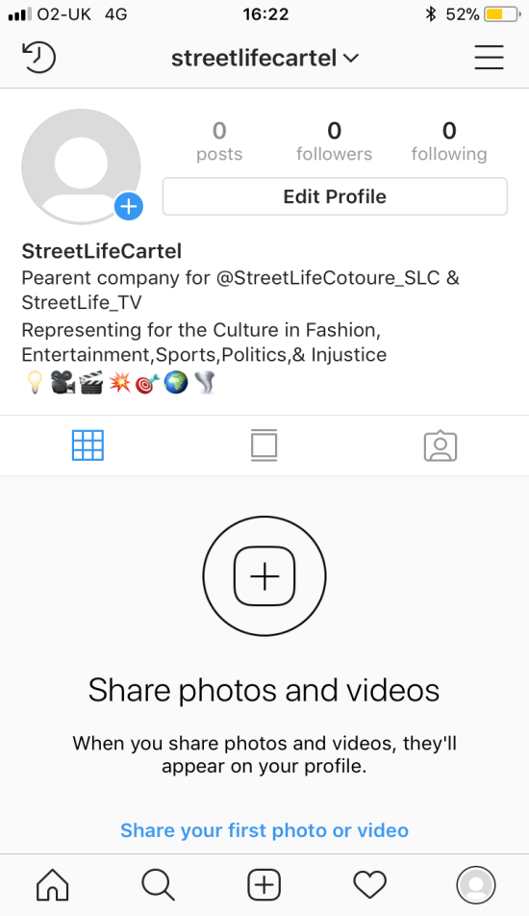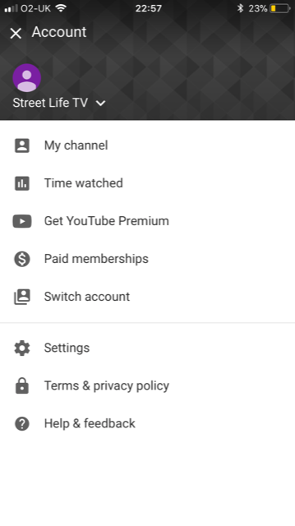
As you can see above in my pictures I have my Instegram account, which is the parent company to my clothing company, and I also have a YouTube channel, which are both going to be used as promotional tools to promote my clothing company, but not only that it’s a way to connect with near audiences and give them a chance to know what our brand is about, who we are and what we stand for, and where do we fit in this world. (Carmichael, E/2014) now as you can see from the picture if you need it, you will see it not just promotion for the clothing line, we will be celebrating successful people from all walks of the culture who came from humble beginnings and was able to turn their life’s around. We plan on celebrating those who have done it and we plan to motivate those who are trying to make it, we also plan to change the negative perception people have of the streets and focus on all the positive people and things that come from there.
Conclusion
In this assignment we looked at the effective use of technology at the workplace, highlighted some advantages and disadvantages of it. Also I looked at the difference between modern technology and technology, and broke down how you can use social media as a tool for businesses and I created an online presence and explained how it can be used.
I used research skills and references from articles and some YouTube videos to provide the information in more details for the assignments which gives better understand of the effects of technology and how to research and reference the information that I provided.
References
(Wise lifer/2015) https://youtu.belokq35r6ryo The Evolution of Modern Technology
(Tech.co/2015) https://tech.co/news/technology-every-business-needs-today 4 Technologies Every Business Needs Today
(Entrepreneur, 2016)
(Carmichael,E, 2014)https://www.youtube.com/watch?v=kshIWIc15yg Amazing Marketing Strategy
(Hackert,2018)

