“Recognising the main factors of Anti-Social Behaviour and identifying how local authorities can help reduce incidents in the Rhondda valley”

Connor Costello
1920589
BSc (Hons) Professional Policing Practice
Word Count: 3815

Declaration

This work has not previously been accepted in substance for any degree and is not being concurrently submitted in candidature for any degree.
Signed: Connor Costello
Date: 08/01/2023

Statement 1:
This dissertation is being submitted in partial fulfilment of the requirements for the degree of BSc. Signed: Connor Costello
Date: 08/01/2023

Statement 2:
This dissertation is the result of my own independent work/investigation, except where otherwise stated. Other sources are acknowledged by footnotes giving explicit references. A bibliography is appended.
Signed: Connor Costello
Date: 08/01/2023

Statement 3:
I hereby give consent for my dissertation, if accepted, to be available for photocopying and for interlibrary loan, and for the title and summary to be made available to outside organisations.
Signed: Connor Costello
Date: 08/01/2023

Statement 4:
I hereby give consent for my dissertation, if accepted, to be available on the university’s IT system to those who have consent to use the system.
Signed: Connor Costello
Date: 08/01/2023

Acknowledgments

I would like to thank the staff at the University of Wales Trinity St David for the time and support provided throughout the course of this final project, especially my supervisor Rhiannon Sandy for all her hard work and guidance she has provided throughout the process. I also wish to thank the university for being the gateway to the career that I am so fond of.

Finally, I would like to thank my family and colleagues, specifically my co-worker Rebecca for her continuous encouragement and support throughout my first three years in South Wales Police. I will always be thankful for the support you have all provided me to succeed in my career.

Abstract

This supporting paper will gather the views on the subject from serving members of South Wales Police. In this research project, the topic of Anti-social behaviour will be investigated and the already existing literature available to the public will be reviewed. The views of serving police officers that work in the Rhondda valley were gathered via a questionnaire to gain an improved understanding of how incidents of Anti-social behaviour are experienced on the front line of Policing. For example, the general ages of offenders and the most prominent times the behaviour occurs. These front-line officers belong to both the standard response shifts and the neighbourhood team which specialise in the topic. The results of this questionnaire were analysed with the researcher identifying their findings in one of the final chapters. From the investigation conducted, the researcher then provides recommendations to identify incidents as they are ongoing and to reduce the impact on victims of the behaviour by educating offenders. This is a supporting paper to be used in conjunction with a presentation given by the researcher.

Contents

Chapter 1 – Introduction …………………………………………………………………………………………………………………… 6
Chapter 2 – Aims and Objectives ………………………………………………………………………………………………………… 7
Chapter 3 – Literature Review …………………………………………………………………………………………………………… 8
Chapter 4 – Research Methods …………………………………………………………………………………………………………… 11
Chapter 5 – Analysis of Results …………………………………………………………………………………………………………… 12
Chapter 6 – Conclusion ……………………………………………………………………………………………………………………… 17
Chapter 7 - Recommendations …………………………………………………………………………………………………………… 18
Chapter 8 – Bibliography …………………………………………………………………………………………………………………… 19
Chapter 9 – Appendix ………………………………………………………………………………………………………………………… 21

Chapter 1: Introduction

Anti-social behaviour is an already established issue that has been a main focus area for policing organisations and politicians for the past few decades. As the issue further established itself in the United Kingdom, the was no specific definition of Anti-social behaviour. This led to the behaviour being outlined in the Crime and Disorder Act 1998. As the topic began to encompass more types of incidents, the Anti-social Behaviour Act 2003 was drafted. This legislation granted policing organisations dispersal powers to allow them to place restrictions on members of the public to avoid large public order issues that would have an impact on others. The matter was then further outlined in the Anti-social Behaviour, Crime and Policing Act 2014 that established a further definition of the problem and removed outdated processes such as Antisocial Behaviour Orders (ASBOs) in place of more appropriate court orders to impose on offenders such as Criminal Behaviour Notices and Orders (GOV.UK, n.d.)

Anti-social behaviour is classed as a crime and the effects of the offence on members of the public can vary. Although it is generally seen as a low-level offence, exposure to numerous isolated incidents can have a large impact on persons and seriously impact not only their quality of life but also the mental wellbeing of the person. There have been a number of documented cases where the issue has caused extreme community tension and even been an impact factor in members of the public taking their own lives. These cases negatively impact on policing organisations in the United Kingdom and inevitable encourage a level of distrust in the police who generally tackle this issue on the front line.

Chapter 2: Aim and Objectives

Aim:
The aim of this piece of work is to gather the experience of Anti-social behaviour by front line police officers and to identify actions that could prevent occurrences

Objectives:

- To examine the existing definitions of Anti-social behaviour and explain the behaviour

- To gather the experiences of officers in the Rhondda valley and analysis the results of the questionnaire

- Identify areas where action can be taken to reduce the impact of anti-social behaviour on members of the public

Chapter 3: Literature Review

To assess the main factors of anti-social behaviour and identify how it can be reduced, a review of the information currently available on Anti-Social Behaviour is required, as is an explanation of the general concept as the definition in law allows opportunity for individual interpretation. There is already a plethora of literature published on not only anti-social behaviour but the key underlying issues that are suspected to be root causes and factors. The purpose of a literature review is simple; it is to educate oneself in the topic area and to understand the established information before shaping an argument or justification (Arshed and Danson, 2015). A literature review can be summarised as presenting a wide-ranging background of the published works available on a subject, to not only highlight similarities in the literature but also to identify inconsistencies in theories that have potential to be filled by the writer.

Anti-social Behaviour is defined in legislation by the Antisocial Behaviour Act 2003 as 'behaviour by a person which causes, or is likely to cause, harassment, alarm or distress to persons not of the same household as the person’. Even though the definition is published in legislation, the existing literature appears to disregard this with each author providing their own loose conditions for anti-social behaviour. This might be because the definition being somewhat vague and encapsulates a large variety of actions and behaviours. Millie (2008) sets out ‘an elastic definition of ASB’ and justifies this approach by stating that anti-social behaviour covers a large range of actions from littering to serious harassment. This vague definition gives room for a considerable degree of local discretion. It also allows for a person responsible to provide a defence that they did not realise that their actions were considered to be anti-social behaviour, and that they did not understand how their actions were affecting others. This can create unclear boundaries between those accidently committing the act and those intentionally carrying out the acts in an effort to affect other members of the public.

There is also an argument that people’s behaviours are affected by the expectations of their location. For example, a person’s behaviour might be regarded as normal in an area with a generally lower income and working class, but the behaviour would be perceived as anti-social to those who reside in a more affluent area, such as those persons who reside in what are perceived as middle- and upper-class areas. This has also been discussed by Millie (2008) who states that the behaviour will be perceived depending on a number of variables, one of which is the behavioural and aesthetic expectations of the location at the time the behaviour occurs such as graffiti by famous artists. According to Millie (2008), if the murals were in more public places, then they would not be celebrated and would likely be perceived as anti-social behaviour by the general public, like most other cases of graffiti. This refers back to their elastic definition of anti-social behaviour.

The Metropolitan Police state that there are three main categories that anti-social behaviour can be classified in to. These classifications have been drafted by the volume of people affected by the actions of the person. The classifications outlined are Personal, Nuisance and Environmental (Metropolitan Police, n.d.). Personal is when the person is targeting either a specific individual or group; nuisance is when the person’s actions cause trouble, annoyance or suffering to the community; environmental is when the person’s actions affect the wider environment around them such as in open public spaces or buildings. The Metropolitan Police categorise thirteen different types of Anti-Social Behaviour under these three main headings. This categorisation allows the Metropolitan Police to more easily identify the leading issues in their occurrences of anti-social behaviour as the types are much more specific than the vague definition laid out in UK legislation. It also allows for statistics to be carried out on the identified types.

The Anti-Social Behaviour, Crime and Policing Act 2014 builds on the current laws that were established. This legislation introduced a more effective way to deal with the issue such as flexible powers and tools that could be quickly used to tackle anti-social behaviour. These tools range in severity from minor civil injunctions, which could be used by a number of local agencies, to dispersal powers that the police can introduce on a person who commits the offence to not return to a specified area for up to forty-eight hours (Home Office, 2022). This guidance set out by the Home Office places the victim first and considers the impact of the behaviour not only on the victim but also the surrounding community to prevent financial loss or a decline in reputation of the area.

Victim focus is now constantly at the heart of policing, but it is also key when dealing with incidents of anti-social behaviour as there can be dire consequences when failing to identify victims that are vulnerable and/or intimidated. The case of Fiona Pilkington is an example of a constabulary failing to identify that she was vulnerable and intimidated when she reported numerous incidents of anti-social behaviour. In 2007, Fiona killed herself and her disabled daughter Francesca Hardwick by setting fire to their car (Hampshire Safeguarding Adults Board, no date). Fiona had contacted the local police 33 times to report incidents of anti-social behaviour. The constabulary was investigated by the IPCC (Independent Police Complaints Commission) which found that there was not appropriate safeguarding put in place for the victim (IPPC, 2011). This investigation found that due to the incidents being investigated in isolation from one another, they were unable to identify any key repeating factors that contributed to the acts Fiona was victim to. Unfortunately, this is only one example whereby victims of anti-social behaviour have been failed. Following this investigation, all Constabularies in England and Wales were provided feedback and requirements with regards to keeping victims at the heart of all investigations. A key process implemented for this is the Community Trigger which allows victims of persistent behaviour a right to a multiagency review of every incident they have reported, allowing the opportunity to identify any risks that have been overlooked and better safeguard the victim (GOV.UK, 2020).

Bor, McGee and Fagan (2004) undertook a study into the early risk factors of anti-social behaviour, conducted on children at 5 years of age and again at 14. They found that those children who had behaviour problems such as attention and/or aggression issues and marital instability were two to three times more likely to be involved in anti-social behaviour at the later stage of the study. However, they also found that maternal substance abuse and poor parenting style did not necessarily increase the risk of being involved in the behaviour in the later stages (Bor, McGee and Fagan, 2004). Farrington (2005) also conducted a study into the childhood origins and found that ‘the comorbidity and versatility of antisocial behaviour poses a major challenge to understanding’ but there are many key factors that can contribute to the behaviour later in life such as impulsiveness, low school achievement, low IQ and so on. Farrington states that mechanisms linking to the risks are not well established. This appears to be a common theme in the literature. There appears to be a clear inconsistency in the knowledge of anti-social behaviour when discussing key factors and possible links that could be identified.

Chapter 4: Research Methods

In an effort to answer the objectives of this piece of project, research must be carried out on the topic of antisocial behaviour. This chapter will discuss not only the way in which the data to be evaluated was gathered but also how reasonable steps were taken to ensure that it was dependable and precise. It will also highlight the steps taken to ensure that there are no issues regarding consent.

Research is a systematic process of gathering, analysing and interpreting data in order to gain an understanding of a topic (Leedy and Ormrod, 2005). For this project to be conducted as impartially as possible, both primary and secondary research must be conducted. Hox and Boeije (2005) that ‘primary data is data that are collected for the specific research problem at hand, using procedures that fit the research problem best.’ Secondary data is the collection of data that has already been published. It focuses on answering questions with studies and the already existing information available (Smith, 2008). Both primary and secondary research will be used in this project to evaluate and provide recommendations on as much information as possible. Primary research will be more relevant as it is information collected from a specified target group with experience of antisocial behaviour and will be the most relevant data to evaluate in reference to the project question.

Universally there are two different classes of data considered when researching, Qualitative and Quantitative (Adams, 2007). This project will evaluate both types of data but with a larger focus on quantitative data as it is more friendly to the reader and there are less complications when analysing numerical information as graphics can be used to present the results. This project will collect data by distributing a questionnaire to front line police officers and neighbourhood policing team (NPT) within the Rhondda valley (College of Policing, 2018). Questionnaires are viewed as a more objective research tool that can produce generalisable results (Harris and Brown, 2010) because of large sample sizes, and the sample group being asked have a plethora of experience of anti-social behaviour due to attending such incidents regularly. The questionnaire will feature both open and closed questions; the closed questions will allow for numerical values to be gathered for quantitative analysis while the open questions will be used to gather opinions of the persons in the sample (Worley, 2015). This allows for simpler analysis of the results while also being able to gather an insight of the persons views on the research topic. The questionnaire will be planned, designed and piloted before a final copy is published for the data to be gathered.

Prior to commencing the questionnaire, the sample member is to be informed that their submission of the form means they are consenting to being involved in the research. There will be a front-page detailing that the results will be gathered anonymously.

Chapter 5: Analysis of Results Chapter

This chapter will outline the results of the questionnaire completed by serving police officers in the Rhondda Valley. These findings will be briefly discussed and linked to published literature. The smaller word count does not allow for a detailed review of all the questions put to the participants and some aspects of the results will be discussed in greater length in the presentation.

Figure 1
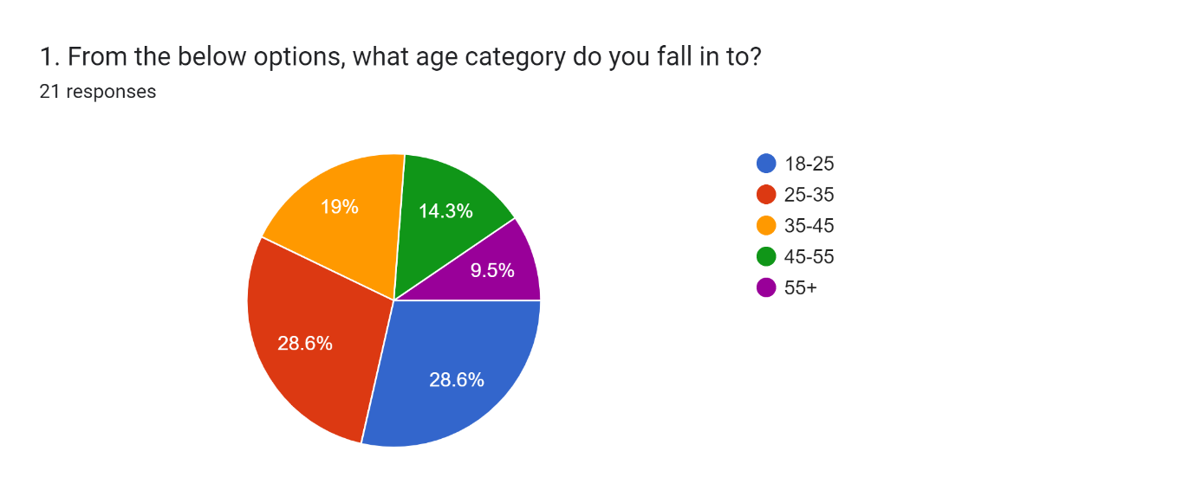
The first question from the questionnaire was set out to determine the participants age, this was to compare any age groupings’ views to another. As can be seen in Figure 1, the most underrepresented category is fifty-five and onwards with only two participants belonging to that category. Due to this questionnaire being distributed to serving police officers, this is to be expected as police officers generally retire at the ages of 55 to 60 depending on when they start their service.

Figure 2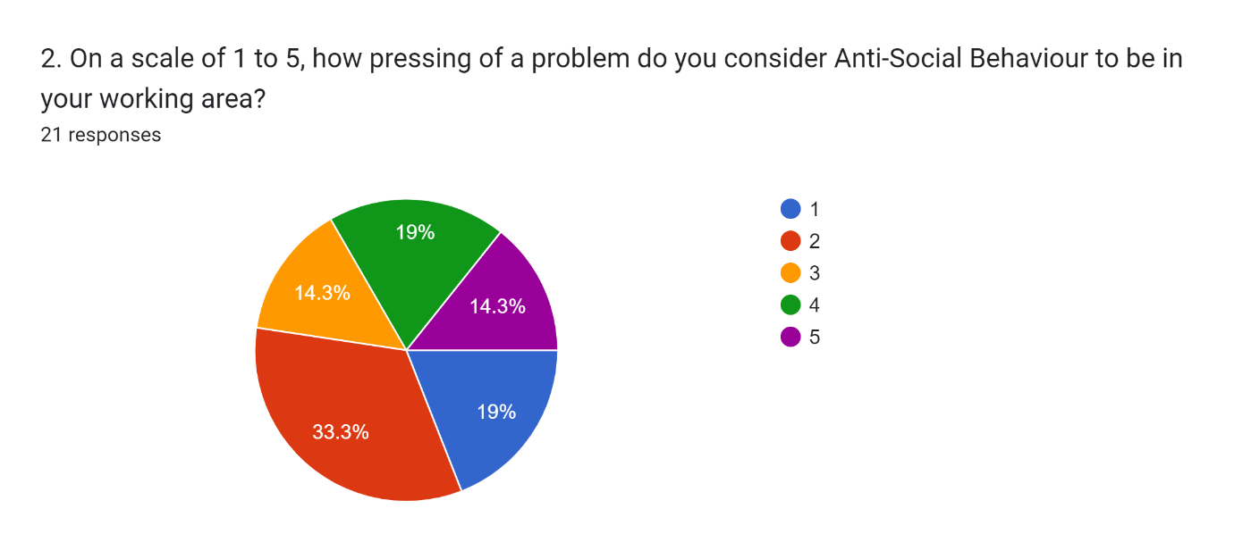
From Figure 2 it can be seen that there was a full range of the possible results returned. Seven participants rated the issue as a two which resulted in the above figure, the other options were returned a similar number of times. A possible explanation of this can be given when considering Millie’s (2008) statement that failing to limit the behaviour considered anti-social allows for a large amount of behaviour to fall under its umbrella, therefore the participant’s perception of the behaviours will heavily influence the answer they provide.

Figure 3
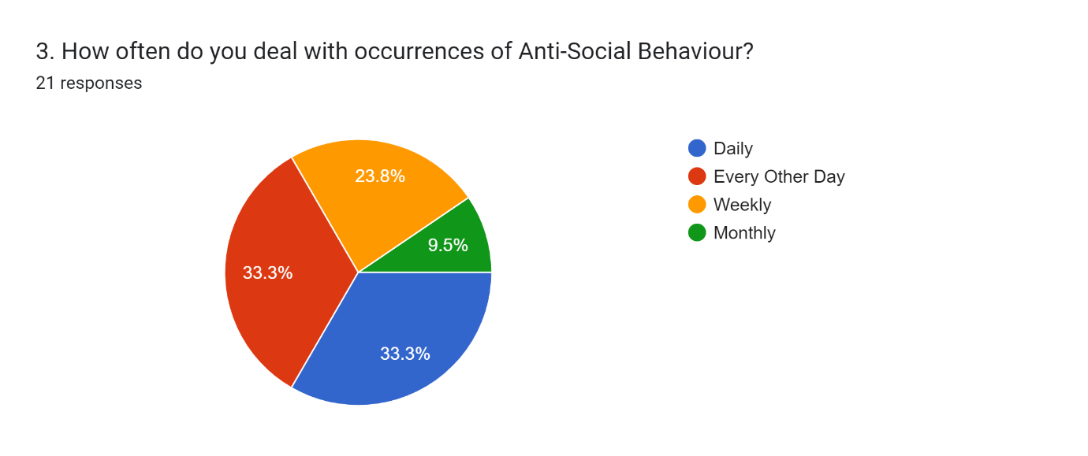
It is clear that police officers regularly encounter anti-social behaviour in their duties. Figure 3 indicates that within one week that there is a 90% chance that an officer will encounter the behaviour once and a 67% chance that it will be more than once.

Figure 4
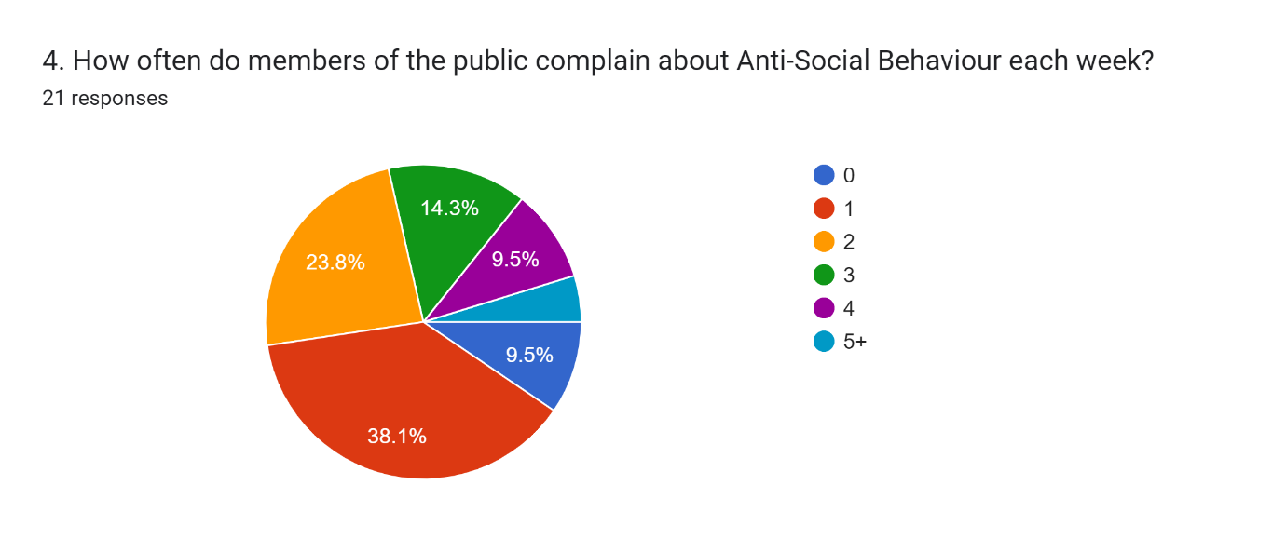

Question 4 was put to the participants to gather data on how often members of the public voice their concern about the discussed behaviour. Figure 4 shows that members of the public are still being affected by the issue due to officers receiving complaints about anti-social behaviour every week as is supported in the above figure.

Figure 5
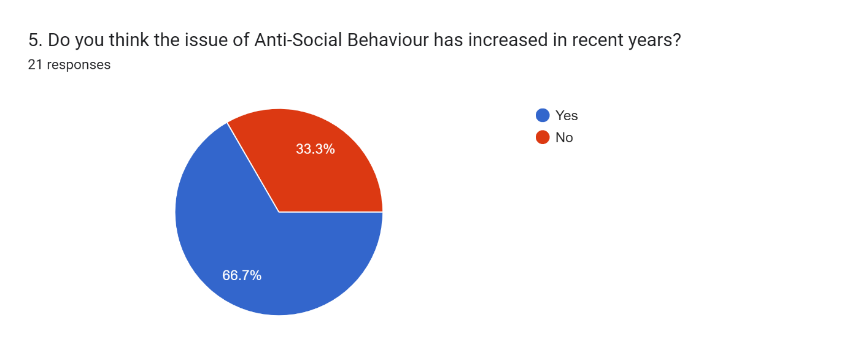
A larger number of participants believed that there has been an increase in anti-social behaviour in recent years. This finding supports the Local Government Association’s (n.d.) statement that the number of anti-social behaviour incidents reported has increased, with a large increase during the lockdown periods.

Figure 6
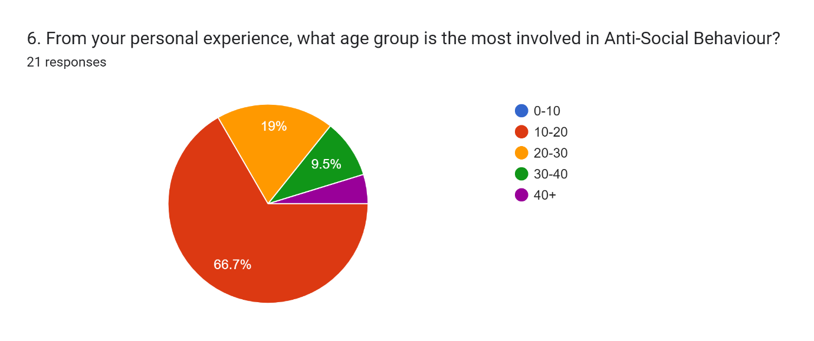
This question was put to the participant to gather a perceived age range for the persons they believed were most likely to display the behaviour. Figure 6 shows that persons in the 10–20 age group are the main persons stated to be responsible. Riley (2007) states that anti-social behaviour legislation was published to prevent children from offending which is supported by this chart highlighting the teenager age category as the main offenders. Further Anti-social behaviour legislation has been published since 2007 to prevent children offending so the figure also indicates that the legislation does not work as intended.
Figure 7
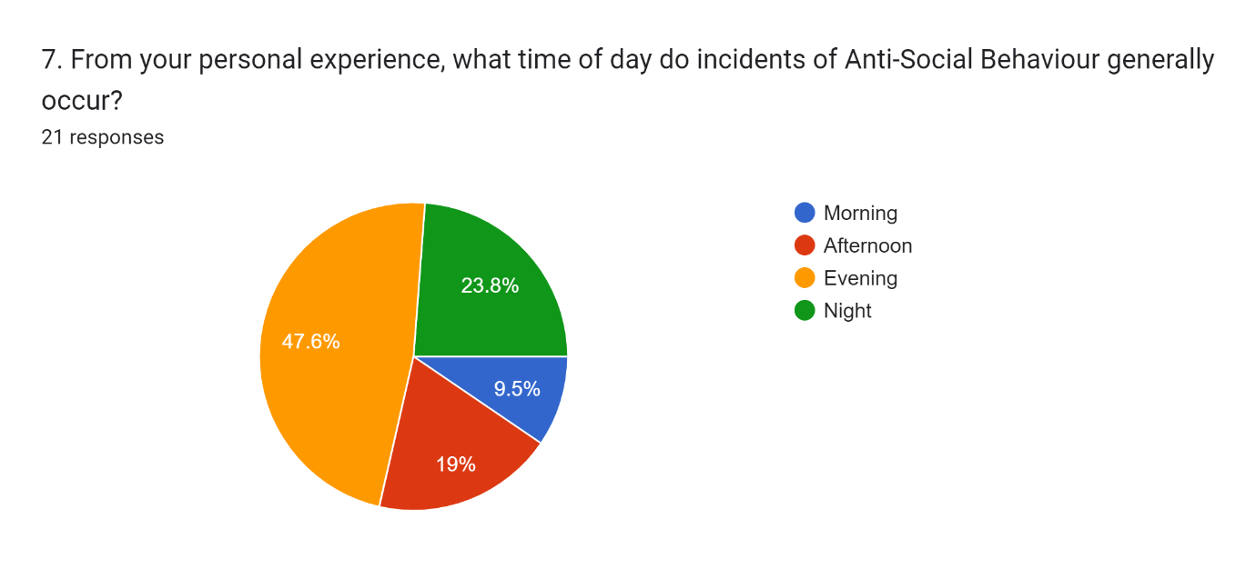
Figure 7 shows that the participants believe that the most likely time was evening followed by night. There is a possible link here between Figures 6 and 7, as the age group mainly responsible would be in school during the times of day when the behaviour is less present to the officers. Children only generally come into contact into the police in the mornings in cases of truancy.
Question 8 was a closed question to ascertain if the participant had an opinion of current police involvement in the issue and there was a blank box left to gather this opinion. These are qualitative answers and will be discussed in the presentation.
Question 9 was put to the participants to identify if they had ever been a victim of anti-social behaviour, with 67 percent of them stating that they had.
Finally question 10 sought to identify any similar result patterns between those officers on regular duties and those who work within the Neighbourhood Policing Team. These patterns will be discussed in the presentation.

Chapter 6: Conclusion Chapter

The first objective was to examine the existing and to better define anti-social behaviour in today’s society. As discussed, most low-level crime incident has an element of the behaviour present. It appears that the best definition is any act that is likely to cause harassment, alarm or distress to another person. The definition is vague compared to other criminal offences published in legislation, but it can be argued that this is necessary to ensure that victims of the behaviour are identified in order to provide a greater service to the public.

The second objective of this research and the first part of the aim of the project was to gather the experiences of police officers, both on the neighbourhood team and elsewhere, on what factors are most frequently present in anti-social behaviour in the Rhondda Valley. Although all age groups can be responsible for the behaviour, the findings of the research clearly indicate that police officers in the Rhondda valley associate persons aged 10-20 as mainly responsible for the behaviour. The survey also highlighted that police officers mainly experience incidents of Anti-Social Behaviour in the evening. This would also reinforce the officer’s views that the 10-20 year old group would be primarily responsible due the fact they would be unable to carry out the behaviour in the daytime due to education commitments such as school which does not carry on into the evening.

From the returned results, it can be seen that 66% of police officers surveyed believed the number of incidents involving anti-social behaviour had increased. This could be explained by the Covid-19 pandemic as members of the public were subject to lockdown restrictions which did not allow them to socialise with others, attend places of education or work. It is to be expected that incidents of the behaviour will rise due to those restrictions currently not being in place. Officers that belong to the neighbourhood team are the most likely to see this rise as they dealt with more incidents in their personal experience and this is supported in the primary survey conducted.

The final objective of this research and the main aim was to identify ways in which anti-social behaviour could be reduced in the Rhondda valley. From the research, short comments from participants with what they believe could be implemented by South Wales Police to achieve this were gathered. The main theme for most of the responses gathered was further engagement with young children by officers. Community engagement could be led by neighbourhood teams in South Wales Police and there should be consideration for them to attend schools more frequently to discuss the issue. The actions that could reduce the behaviour will be discussed in the recommendations chapter below.

Chapter 7: Recommendations

The recommendations chapter of the supporting paper will be outlining actions that can be carried out by those in a position of power to mitigate the impact of the behaviour on members of the public. It will also be outlining the confines of the research undertaken and identifying actions that would have provided a more accurate view of the topic from the participants involved. It would be unwise not to consider the impact that the coronavirus had on the entire world. The lockdown restrictions imposed on the entire United Kingdom from March 2020 will have naturally reduced the number of anti-social behaviour incidents occurring due to the simple fact that the vast majority of the general public were staying indoors. The questionnaire was carried out in October of 2022 but there is still potential for the impact of coronavirus to still effect the participants and skew the findings. Another restriction of the conducted questionnaire is that there were only 21 replies with only 8 being from members of the neighbourhood policing team. A larger response from this team would have allowed for a more varied spectrum of results returned as they specialise in the behaviour and have a higher exposure to incidents.

The questionnaire returned that officers are mainly faced with the behaviour in the evenings and 66% of participants believe the age group of 10 to 20 are the most frequent offenders. As stated in the analysis chapter, this is best explained by children being in school or in bed the other periods of the day. The main recommendation would be to have more police engagement with young children during their education time. This would allow members of South Wales Police the opportunity to not only explain the impact of their behaviour on other people but also the conditions that could be imposed upon the children should they commit the behaviour. Along with this recommendation, young persons who are found responsible should be spoken to with their guardians present so that they can also monitor behaviour in the house and raise any concerns to the relevant local authority.

One of the qualitative questions returned were for a higher CCTV presence. Some regular hotspots for repeat offending of the behaviour are monitored by council CCTV in the Rhondda valley. Although this is a positive step towards tackling the subject, there are still many areas that do not have a camera present. A higher volume of CCTV cameras along key areas would not only allow for a higher diligence of monitoring but also allow the opportunity to identify incidents as they occur.

If further research was conducted into this specific area, it should explore a more detailed analysis of the types of anti-social behaviour committed and the different impacts the types have on members of the public who report it to South Wales Police. There should also be consideration for the research to expand the sampled area, this could be to include the Cynon and Taff valley. Analysis of these results would create the opportunity to identify if any specific type is more present in different areas.

Chapter 8: Bibliography
Adams, J. (2007) Research methods for graduate business and social science students. New Delhi ;: Response. P.
Antisocial Behaviour Act 2003. Available at: https://www.legislation.gov.uk/ukpga/2003/38/contents/enacted?view=plain (Accessed 17th July 2022)
Antisocial Behaviour, Crime and Policing Act 2014. Available at: https://www.legislation.gov.uk/ukpga/2014/12/contents/enacted (Accessed 20th July 2022)
Arshed, N. and Danson, M. (2015) ‘The Literature Review’, in MacIntosh, R. and O'Gorman, K. (eds.) Research Methods for Business and Management. CITY: Goodfellow Publishers Limited. Pp 31-49.
Bor, W., McGee, T. R. and Fagan, A. A. (2004) ‘Early Risk Factors for Adolescent Antisocial Behaviour: An Australian Longitudinal Study’, Australian & New Zealand Journal of Psychiatry, 38(5), pp 365–372.
College of Policing (2018) Neighbourhood Policing. Available at: https://www.college.police.uk/guidance/neighbourhood-policing (Accessed 7th January 2023)
Crime and Disorder Act 1998. Available at: https://www.legislation.gov.uk/ukpga/1998/37/contents (Accessed 4th January 2023)
Farrington, D. P. (2005). Childhood origins of antisocial behaviour. Clinical Psychology & Psychotherapy: An International Journal of Theory & Practice, 12(3), 177-190.
GOV.UK (2020) Community Trigger (Anti-social behaviour case review). Available at: https://www.gov.uk/guidance/anti-social-behaviour-asb-case-review-also-known-as-the-community-trigger
GOV.UK (n.d.) Punishments for antisocial behaviour. Available at: https://www.gov.uk/civil-injunctions-criminal-behaviour-orders (Accessed 7th January 2023)
Hampshire Safeguarding Adults Board (n.d.) Learning from Experience Database – Serious Case Reviews: Fiona Pilkington (Leicestershire). Available at: https://www.hampshiresab.org.uk/learning-from-experience-database/serious-case-reviews/fiona-pilkington-leicestershire/ (Accessed 22 July 2022).
Harris, L.R. and Brown, G.T. (2010) ‘Mixing interview and questionnaire methods: Practical problems in aligning data’. Practical Assessment, Research, and Evaluation, 15(1), p.2 – you need to provide the full page range of the article e.g. pp. 2–23.
Home Office (2022) Anti-social Behaviour, Crime and Policing Act 2014: Anti-social behaviour powers Statutory guidance for frontline professionals. Available at: https://assets.publishing.service.gov.uk/government/uploads/system/uploads/attachment_data/file/1088750/2022_Updated_ASB_Statutory_Guidance-_FINAL.pdf (Accessed 21 July 2022)
Hox, J.J. and Boeije, H.R., (2005) Data collection, primary versus secondary. PDF
IPPC (2011) IPCC report into the contact between Fiona Pilkington and Leicestershire Constabulary 2004-2007. Available at: https://www.hampshiresab.org.uk/wp-content/uploads/2009-Fiona-Pilkington-Leicestershire.pdf (Accessed 20th July 2022)
Leedy, P.D. and Ormrod, J.E., 2005. Practical research (Vol. 108). Saddle River, NJ, USA: Pearson Custom.
Local Government Association (n.d.) Tackling anti-social behaviour: case studies. Available at: https://www.local.gov.uk/tackling-anti-social-behaviour-case-studies (Accessed: 24th October 2022)
Metropolitan Police (n.d.) What is antisocial behaviour? Available at: https://www.met.police.uk/advice/advice-and-information/asb/asb/antisocial-behaviour/what-is-antisocial-behaviour/ (Accessed 18th July 2022)
Millie, A. (2008) 'Anti-social behaviour, behavioural expectations and an urban aesthetic', British Journal of Criminology, 48(3), pp. 379-394.
Millie, A., (2008) Anti-social behaviour. McGraw-Hill Education (UK).
Riley, D., 2007. Anti-social behaviour: children, schools and parents. Education and the Law, 19(3-4), pp.221-236.
Smith, E. (2008) Using secondary data in educational and social research. Maidenhead, England: Open University Press. Pp. 3-4
Worley, P. (2015) Open thinking, closed questioning: Two kinds of open and closed question. Journal of Philosophy in Schools, 2(2), pp.17-29.

Chapter 9: Appendix
Blank Questionnaire
Anti-Social Behaviour
This is a voluntary questionnaire and the results are completely anonymous
Please note that by completing this questionnaire that you will be consenting for your answers to be used in a piece of work for submission to UWTSD
1. From the below options, what age category do you fall in to?
Mark only one oval.
18-25
25-35
35-45
45-55 55+
2. On a scale of 1 to 5, how pressing of a problem do you consider Anti-Social Behaviour to be in your working area?
Mark only one oval.
1
2
3
4
5
3. How often do you deal with occurrences of Anti-Social Behaviour?
Mark only one oval.
Daily
Every Other Day
Weekly
Monthly
4. How often do members of the public complain about Anti-Social Behaviour each week?
Mark only one oval.
0
1
2
3
4
5+

5. Do you think the issue of Anti-Social Behaviour has increased in recent years?
Mark only one oval.
Yes
No
6. From your personal experience, what age group is the most involved in Anti-Social Behaviour?
Mark only one oval.
0-10
10-20
20-30
30-40
40+
7. From your personal experience, what time of day do incidents of Anti-Social Behaviour generally occur?
Mark only one oval.
Morning
Afternoon
Evening
Night
8. Do you believe more could be done to reduce Anti-Social Behaviour by South Wales Police?
Mark only one oval.
Yes
No
If so, what more do you believe could be done?

9. Have you ever been a victim of Anti-social behaviour?
Mark only one oval.
Yes
No
10. Are you a part of the local neighbourhood policing team?
Mark only one oval.
Yes
No

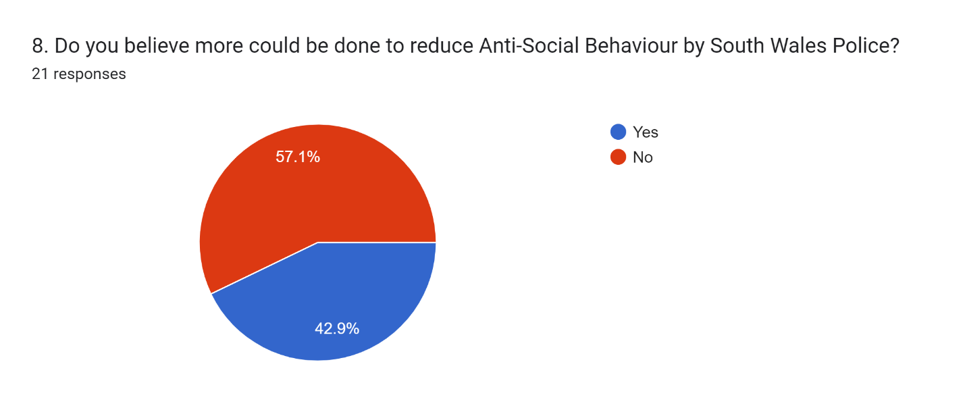
Figure 8

Figure 9
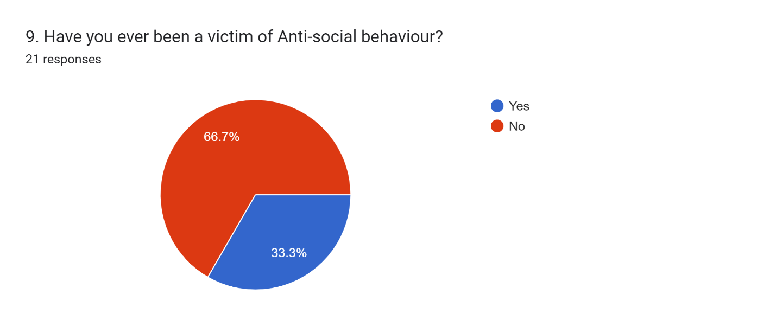
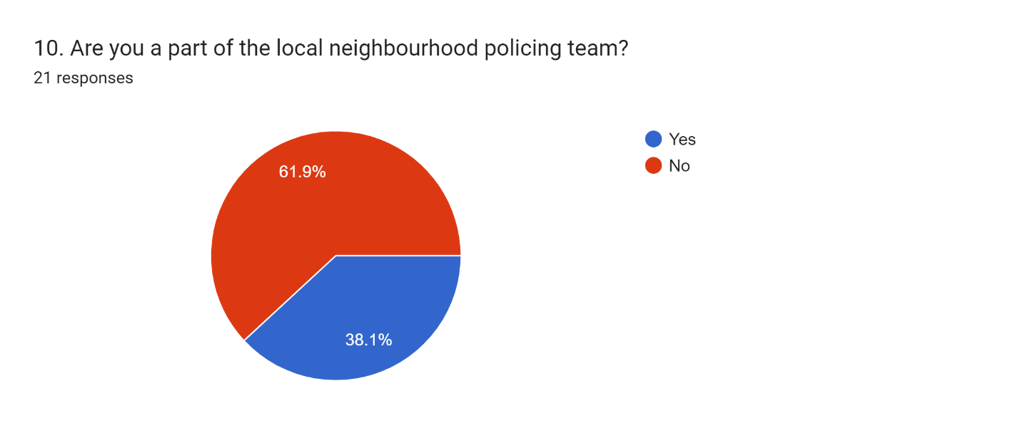
Figure 10

