Introducing the Modern Workplace
LCBB4003
Daniel Andrei Orosz
2010834
Lecturer :Dr. Gregory Cowan

Organisational structure and culture by introducing the Modern Workplace

Table of Contents
Introduction 3
Organisational Behaviour 4
Definition of Organisational behaviour 4
Characteristics of organisational behaviour 4
Key forces affecting organisational behaviour 5
Organisational structure 6
How organisational structure affects Organisational behaviour 9
Organisational culture and performance 10
Characteristics of a sound organisational culture 10
Organisational culture and performance 11
Conclusion 12
References 13

Introduction
Society is changing at its own pace. Organisational structure also gets a new shape in modern society for the changing of everything. The era of communication, multimedia to a virtual network, information to the algorithm, everything brings about the changes. Now, organisational gets new shapes in building the tech-based office building, paperless office and so many so. Furthermore, remote office even, when people were worried about the office and this office itself become vanished for the sake of technological revolution, is the coolest thing ever (Kengatharan and Puviraj, 2021). We are talking about the organisation and its culture in the eyes of the business. This report will discuss the culture and structure of an organisation and how these cultures and structure of an organisation influence performance.

Organisational Behaviour

Definition of Organisational behaviour
Organisational behaviour is the concept of the individual component of an organisation and its combined effort for the betterment of stakeholders related to the organisation. It is a concept of how organisational blood flows from upper to lower organisational body part. Moreover, it incorporates the measurement of the overall performance of the organisation (Akanni and Ndubueze, 2017). According to Keith Davis, ‘Organisational behaviour is the act of people, organisation and their combined effect. It is a human tool and how this human tool affects the whole organisation and makes a new shape of behaviour. Every institution and organisation uses this concept for better performance’. According to Stephen Robbins, ‘It is a study to investigate the impacts of individuals, groups and how these structure applied in the form of organisational effectiveness.

Characteristics of organisational behaviour
The behavioural approach to management: Every organisation is considered as the part of a management and which indicates the behavioural approach to the management. It emerges a separate field of study for weighting human behaviour in the organisation.
Cause effect relationship: Everything that happens within a human body is the cause-effect relationship (Sharm, 2020). And this relationship helps a human to predict his or her behaviour. Manager can use this to get a glimpse of behavioural activities on a particular human being.
Branch of social science: organisational behaviour is primarily shaped by the individual behaviour within an organisation but the culture and social bonding make different behaviour in a similar organisational structure. Thus, psychology, anthropology and other social science-related topics are involved in building good organisational behaviour.
Three levels of finding: Organisational behaviour analyse individual, organisation and the combination of individual and organisational behaviour. That indicates that group behaviour is very important when it comes to behaving in an organisation. But individual thinking or behaviour shapes group behaviour.
Rational thinking: When an individual comes into an organisation, he or she brings his or her characteristics to the organisation and these characteristics give rational thinking about the organisation.
Combination of theory: Organisational behaviour brings the combined behaviour with the help of widely-accepted theory and research. Every technique uses to solve an organisational problem, comes from the whale of research and practical experiment.

Key forces affecting organisational behaviour

Figure: Key forces affecting OB
Source: (Chinomona, 2016)
People: Human being is the most important element in the organisational structure. People in an organisation bring up the internal system of the organisation (Strongman, 2013). Different types of individual, groups such as large or big, formal or casual consist of that system. As we have already mentioned that organisation is a combination of people, the leader of that group must give proper direction to achieve group objectives. As a result, a manager must identify the techniques by which he can predict group behaviour.
Technology: It gives resources with which individual works and makes an impact on the performance they do. No one can accomplish any task with a bare hand at least in the current generation (Strongman, 2013). The use of technology brings up significant advantages to the organisation. It allows us to accomplish with more accuracy and we are protected from many misuses. For the wide range of uses, technology incorporate paperless office, home office and these systems also change the use of technology and organisational structure.
Structure: The structure of an organisation defines the formal relationship between the group and the individual. The managers assign different task to the people in the organisation and the people in the organisation follow some step by step processes which are predetermined by the organisation. These step by step processes are also connected structurally. Every organisation has some fundamental values and these values come from a proper structure of that organisation.
Environment: An organisation consists of an extensive internal and external environment. Every organisation is part of a smaller or larger part of a big industry and every industry has certain fundamental rules. These rules control organisational behaviour.

Organisational structure
The organisational structure in the form of a formal hierarchy from top to bottom of an Organisation. It defines certain activities, certain tools and responsibilities to achieve the objectives and goals of an organisation. Organisational structure also determines the flow of information from top management to small individual groups such as reporting bosses. A successful organisational structure defines the task of an individual properly and every individual work for the betterment of group performance. As organisational structure defines the chain of command, by which we can see who reports to whom. A proper chain of command can ensure it. Some of the organisational structure is discussed below.
- Work specialisation: F.W. Taylor addressed this structure many years ago. If a person is specialised in doing something, he will be assigned to do this for a long period. By doing this, time and costs decrease and efficiency increases He named it as ‘One best way’. In a big automobile company, a person doesn’t build the whole car. Here, a person who works in an engine assembling area, will not work in the design area for a long time. He continuously does the same job. As a result, accuracy and efficiency will increase by good numbers and defects and damages will decrease significantly. There might have some demerits too but these vary from organisation to organisation.

Figure: Work specialisation
Source: (Strongman, 2013)
- Departmentalisation: When tasks are distributed to the specialised workers and these tasks need structural orders to complete. Departmentalisation combines the tasks and creates the flow of orders so that the process continuously goes from input to finishing stand. There are many ways to make departmentalise the work (Chinomona, 2016). One is functional. It is the process of making a department based on function such as raw material procurement function, production function and so on. Based on the industry or the firm, these functions vary. Another departmentalisation is created based on the product or services. If a firm produces different types of product, this firm can make departmentalisation based on the product such as Apple corporation has different product and they can create a department based on the product (Chinomona, 2016). Another departmentalisation form is done based on the process. Suppose, a firm produces consumer electronics products, to produce these products requires different activities such as design, testing, software installation and so on. So, these activities are considered a process
- Chain of command: It fosters the military authoritative system in a company. Organisation creates a chain of command based on authority and responsibility. When a person gives a command to his subordinates, he disseminates the information to theirs’ subordinate and every person reports to his or her next reporting bosses. Henry Fayol is the pioneer of a chain of command. He first uses the chain of command structure in his theory. It has another name which is called unity of command.
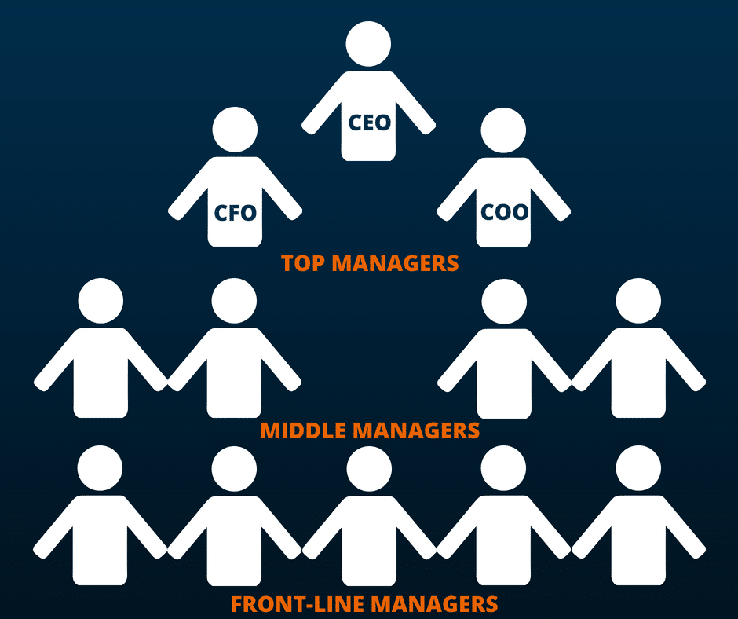
Figure: Chain of command
Source: (Roomer, 2018)
Centralization and Decentralization: If a manager holds the power of decision-making activities, he is defined as a centralised manager. In other words, If the flow of information comes from a single corner of the organisation and decisions are concentrated from a single person then, it is called a centralised decision. On the other hand, if a person cant’s hold control of deciding for the whole organisation, it is called the decentralised organisation. Organisation to organisation, this structure varies (Roomer, 2018). Some organisational decisions are open to all and some aren’t such as military organisational decision becomes very inclusive. But Educational institutional decisions are very exclusive and explicit.
Some other organisational structures have too. These structures vary from firm to firm. Even, some firms adopt more than one structure. In some cases, a firm uses a combined structure.

How organisational structure affects Organisational behaviour
Organisational structure makes a shape to a firm; how this firm conducts its operation and how it survives in the competition. On the other hand, organisational behaviour determines the individual and group behaviour and makes a culture to the firm. Organisational structure brings up specific guideline to the firms and organisation behaviour adapts these guidelines for the betterment of the firm. If we buy a product from a renowned brand, we buy brand values that the firm has created over time such as I-phone (Kengatharan and Puviraj, 2021). We spent a lot of money on buying an I-phone but the thing is it doesn’t give that much value. Yet, we paid for the brand value. And this brand value is created by a proper organisational culture that is also created over time. We indirectly buy that culture; the thinking of the people who work there.

Figure: Organisational culture
Source: (Akanni and Ndubueze, 2017)

Organisational culture and performance
Organizational culture consists of the organisational own philosophy, experiences, expectations, people work here and the values it carries for its stakeholders. Besides, it guides the member’s behaviour, inner working expectations and interaction with outside the firm. Culture is dependent upon the beliefs systems, shared values, attitudes, moves, custom rules, and inner manner of the organisation (Kengatharan and Puviraj, 2021). Sometimes, some unwritten activities might be considered as part of the organisational culture such as some cultural traits can be identified by seeing the dress-code of employees to an organisation, some can be categorised by seeing the shoes of the employees.

Characteristics of a sound organisational culture
Every organisational culture is different from each other. But some firm stays at the peak of the industry and some stays down the line. Now the question is what makes an organisation special and how it competes with the others (AJDAROVSKA and ATTAR, 2020). The answer will be its values and culture. A sound organisational culture must have some unique characteristics. These are given below
- Alignment with the company’s objectives, mission and vision statement.
- The practice of appreciation for the good works
- Culture of trust each other. Even, it can be in between two teams.
- Performance of what the firm can do for
- Team building among the workers and everyone should thrive for group performance
- Mutual respect to each other
- Innovation in technology
- Ensuring safety and security by the firm.

Organisational culture and performance
Organisational culture affects all aspects of the business. It incorporates the core benefits to the organisation. If the organisational goal is aligned with the culture, organisations become supportive, workers feel comfort in the workplace and overall values increase. 77% of the workers believe that organisational performance depends on the organisational culture (Isfahani and Rezaei, 2017). More than 65% of the workers believe that organisational culture plays an important role in safety and security. So, organisational behaviour plays a vital role in creating a better workplace by aligning with organisational culture. That’s why people in the organisation boost organisational performance.

Figure: Impact of culture on performance
Source: Self-created

Conclusion
Every organisation has some core values that make them unique. A good organisational culture can create these values to intensify organisational performance (Rezaei and Barzoki, 2017). People in the organisation uses papers to keep a record of everything and the communication channel got stuck for a load of information flows. Keeping records of everything in the manual manners become ruthless activities at once.

References
AJDAROVSKA, Z. and ATTAR, M., 2020. ANALYSING THE RELATIONSHIP BETWEEN ORGANISATIONAL CULTURE AND ORGANISATIONAL AMBIDEXTERITY. Business & Management Studies: An International Journal, 8(3), pp.3550-3581.
Akanni, A. and Ndubueze, K., 2017. Organisational Climate and Organisational Citizenship Behaviour of Employees in Selected Private Companies in South-East, Nigeria. Australasian Journal of Organisational Psychology, 10.
Chinomona, E., 2016. Organisational citizenship behaviour and employee perception of equity on organisational commitment. Corporate Ownership and Control, 14(1), pp.230-240.
Isfahani, A. and Rezaei, A., 2017. The impact of perceived organisational support on organisational citizenship behaviour: the mediating role of organisational trust. International Journal of Business Excellence, 13(4), p.441.
Kengatharan, N. and Puviraj, M., 2021. Employer branding on organisational citizenship behaviour: A moderated moderation model of organisational politics and organisational dissent behaviour. SMART Journal of Business Management Studies, 17(1), pp.91-102.
Kengatharan, N. and Puviraj, M., 2021. Employer branding on organisational citizenship behaviour: A moderated moderation model of organisational politics and organisational dissent behaviour. SMART Journal of Business Management Studies, 17(1), pp.91-102.
Rezaei, A. and Barzoki, A., 2017. Relationship between perceived organisational support, organisational citizenship behaviour, organisational trust and turnover intentions: an empirical case study. International Journal of Productivity and Quality Management, 21(3), p.273.
Roomer, E., 2018. Culture and organisational context: how it influences voice behaviour. MaRBLe, 1.
Strongman, L., 2013. The Psychology of Social Undermining in Organisational Behaviour. Australasian Journal of Organisational Psychology, 6.

