Group Project:
Viking E-Bike Technologies:
Smart Reflective Jacket
Ashleigh Elder P141924
16th of May 2018

Abstract and Acknowledgments
Acknowledgements
First, I would like to thank the course director Gareth Jones without whom I would not be writing this assignment.
Secondly, I would also like to thank Dr Gary Jones who co-led this module and john young for assistance provided to the class and for allowing the use of laboratory equipment outside of lecture hours.
Finally, I would like to thank my remaining group member, Thorbjørn Kristiansen, for their effort in the group aspect of the project.
Abstract
This report demonstrates the project development life cycle of an electronic device for the e-bike market, specifically as part of a “company” with a group of peers. The company “Viking E-bike Technologies” eventually only consisted of two members despite starting with four as the two other members had to remove themselves from the course for unforeseen reasons. The product proposed was a “smart” reflective jacket that reacts to external lighting in to maintain visibility for a moment after the reflective strips are no longer detecting a light source. The project was completed through several stages; Initial research, planning, initial design, initial development, initial prototype with testing happening throughout. The stage that took the longest was the initial development as many ideas needed work after feedback was given for the initial viva. Whilst failing to complete all the objectives that were decided during the planning phase the project was still successful during simulation and many lessons were learned over the duration of the module such as the importance of parts acquisition and making good use of available resources.

Contents
- Introduction
  - Keywords 3
  - Objectives 3
    - “Viking E-Bike Technologies” 4
    - “Smart Reflective Jacket” 5

- Research Methods and Materials
  - Initial Research and Project Proposal 6
    - Similar Products 6-7
    - Potential Circuits and Components 7-8
    - Parts Values and Costs 8
    - Programming Techniques 8-9
  - Product Development and Additional Research
    - Initial Critique 10
    - Circuits and Components 10
    - Parts Values and Costs 11

- Methodology 11

- Project Management
  - Project Management: Overview 12
  - Law and Ethics 12
  - Time Management 12
  - Project Management: Conclusions 13

- Initial Design
  - Development 13
  - Final circuit 14
  - Final Program 15-17

- Initial Prototype
  - Necessary Components 18
  - Final Design 18

- Conclusion 18

- Bibliography
  - References 19-20
  - Appendixes 21-37

1: Introduction
1.1: Keywords
VET = Viking E-bike Technology (name of the company), LED = Light Emitting Diode[], LDR = Light dependant Resistor, Simulink = Proteus’ simulation software[], Proteus = Electronics circuit design software[], IEEE = The Institute of Electrical and Electronic Engineers[], PIC = Peripheral Interface controller[], CCS = Code Composer Studio, IDE = Integrated Development Environment[]
1.2: Objectives
18,477 cyclists were injured or killed during 2016[1], as part of a small company that specialises in the development of electronics-based products for the electronic bicycle market several products must be designed to promote visibility and road safety. This report aims to address the issues and necessary development processes required to complete a project of this magnitude by producing and reviewing a recognisably individual product whilst working as part of a group. To accomplish this goal, several weekly group meetings were held with the results being recorded and attached[figx-x].
During the first meeting the company name and each member’s individual project was announced with ideas being pitched for improvements and potential methods that could be used for the completion of the task. “Viking E-bike Technologies” (hereafter referred to as VET) was the name agreed upon during this meeting, and the product discussed by this report is the “Smart Reflective Jacket”. This jacket should react to light illuminating several LED’s that should light up in a pattern flashing on for a couple of seconds after a light has stopped illuminating the jacket meaning drivers have more of a chance of seeing cyclists that were only lit up for a moment as they were coming around a corner or the driver just wasn’t paying attention for a moment.

1.2.1: “Viking E-Bike Technologies”
VET initially had 4 members but over the course of the project two had to leave the group due to unforeseen circumcision, although the name was decided by three members who were the only ones to show up to the first meeting and unanimously agreed on the name. The group’s aims and objectives were also discussed in detail with a set of clearly defined aims and objectives agreed upon and can be seen below:
Group aims
- Produce and market a clearly identified individual product for the electric bicycle market.
- Promote safety and visibility
- Demonstrate effective teamwork and communication skills
Group objectives
- Each decide on an individual product after assessing it’s feasibility and discussing it as a group
- Give a presentation describing the project and how it aims to meet assignment brief
- Discuss progress and ideas/solutions in group meetings and record the results of each meeting weekly
- Each produce a working and clearly identified individual product
Group meetings were maintained by the two remaining members after Andrew Hardwick and Zebastien Jones had to leave and they were very useful for working out layouts and ideas for the interim and final viva presentations and time was set aside to meet out of hours to work further on these presentations. This was also effective for developing time managing methods and group checkpoints to best ensure the groups objectives are fulfilled. Despite being a useful resource, the group meetings could have been more effective and in the future it would be wise to mention more issues and develop on ideas more effectively.
As two members left the group the final projects for this group were an “Illumismart” bike light that maintains road vision but reduces brightness when the bike slows down in to reduce power usage and the aforementioned “smart” reflective jacket.

1.2.2: “Smart Reflective Jacket”
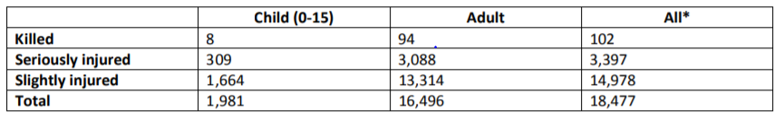Sharing the road with other vehicles can be dangerous for cyclists as they lack any protective chassis and vehicles driving to close to a cyclist can cause them to lose control, 18,477 cyclists were injured or killed during 2016[1]. Human error appears to be the biggest issue as The Royal Society for the Prevention of Accidents states that, “Driver/rider error was the most frequently reported reason for the incident involving 71% of all reported accidents in 2016”[1][2].
It is intended that the “smart” reflective jacket use an LDR on each side to set a reference voltage for attached to specific inputs of a microcontroller that determines which set of LED strips should flash and in which order. These LEDs should continually flash when exposed to an external light source and remain illuminated for the duration of their cycle as the light source is removed. This lengthens the duration the cyclist is visible for to increase visibility at times when the driver might not normally notice a quick flash from a reflective strip or aren’t paying attention when turning.
While it is necessary that other lights are used with a bike in the United Kingdom, accessories can be used to enhance visibility and safety of the cyclist. Across the duration of this project it aims to:
- Produce and market an “intelligent” reflective jacket for cyclists and general road use
- Ensure that the jacket takes road safety into account and that it provides adequate visibility.
For the project to successfully meet these aims a set of specified objectives have to be completed, the objectives decided on for this project were to:
- Research similar products and minimum requirements of the reflective jacket
- Develop a working simulation of the product using Simulink
- Ensure the reflective jacket addresses problematic situations to ensure the safety of potential users
- Give an assessed informative presentation describing and marketing the product
- Create a working prototype of the Jacket

2: Research Methods and Materials
2.1: Initial Research and Project Proposal
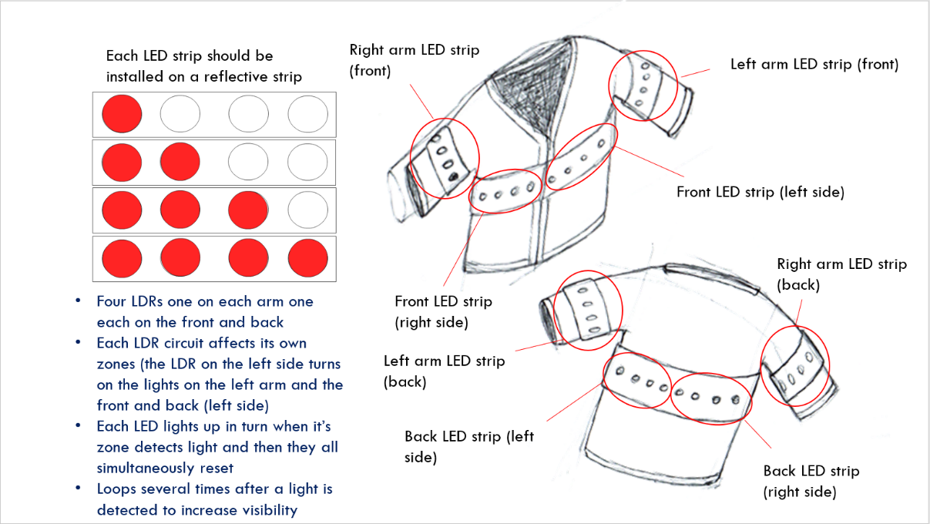

After comparing similar products on the market an initial sketch, shown in [fig 2], was developed, after a group meeting brainstorming ideas, it shows the intent of the project. For this project to succeed research needs to be initiated starting with potential circuits for fulfilling individual tasks then deciding which components are the best choice and commencing any additional research into development methods before beginning development of the initial Proteus Simulation.
2.1.1: Similar Products
Two different products were assessed that have similarities to the project proposed:
- The Lumenus Jacket
- The Lumenus Backpack
- Fuloon Safety Vest
Both the Lumenus Jacket and backpack offer directional indicating lighting and break lights as part of a mobile app[3] but an idea like this would be too difficult to attempt considering the time limit for the project. The jacket and backpack however still come with vibrant colours and reflective sections[3] for increased visibility, this means that even if the electronics fail the user still has a failsafe alternative available. Whilst an effective product the Lumenus Jacket costs £141.39[3] which is a reasonable price considering the product but the smart reflective jackets aims to be affordable to promote visibility and awareness of cyclists on the road thereby seeding interest in the product itself as more people feel safer on the road cycling.

The Fuloon Safety Vest however is much more affordable at £15.99[4] and still has flashing speed options available. The Fuloon Safety Vest is also similar to Lumenus products in that the LEDs are used alongside bright reflective strips to improve visibility and act as a failsafe in the event of electronic failure. This product is also effective but when using each light simultaneously and keeping the jacket turned on whilst cycling a lot of power is used which is why the reflective jacket aims to remain off until required to conserve power.
2.1.2: Potential Circuits and Components
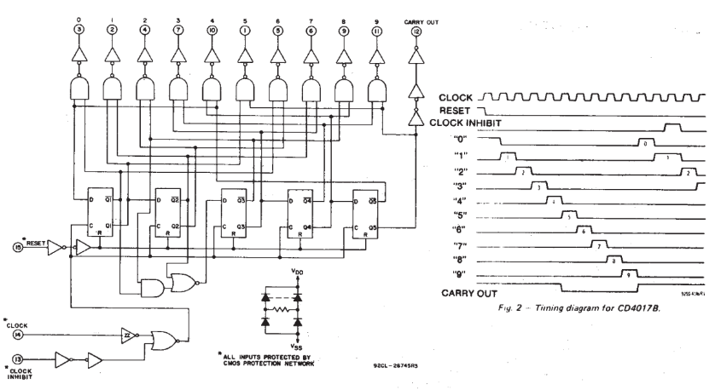
One potential method of setting each LED strip to light in a pattern could be a Decade counter. Using a supply voltage between 3V and 15V[5] he CD 4017B Decade counter[figure] outputs high voltage level on each output pin in turn but although it means no coding would be necessary for the project the jacket needs multiple LEDs illuminated simultaneously and a decade counter does not allow for this. This would also require one counter for each zone of the jacket whereas the same if not better effect could be achieved by a cheap PIC microcontroller.
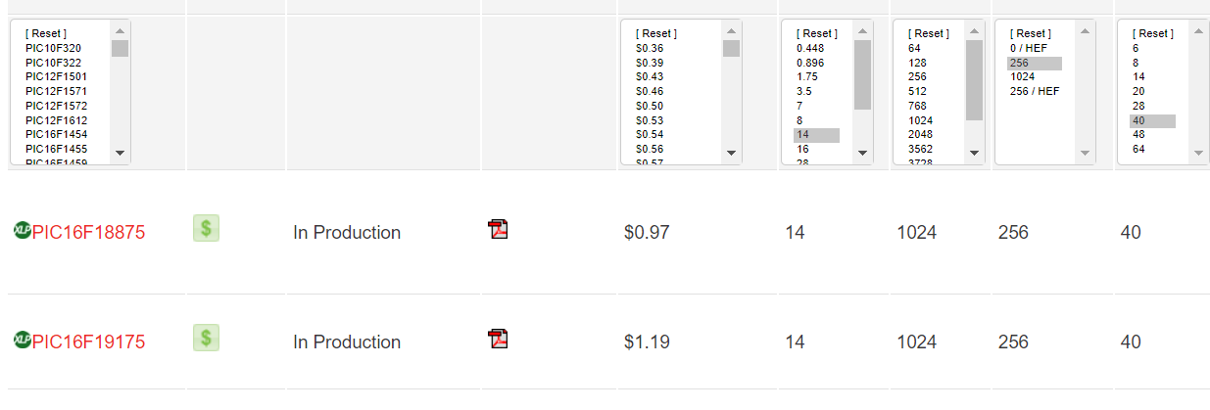

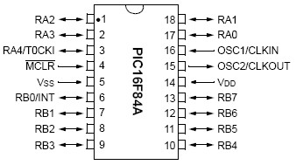
There were two main PIC microcontrollers that were considered with one alternative being a 16F84A Microcontroller on each zone, but this would require purchasing 4 different PICs also the 16F887 is readily available from university stores for this project. The ideal microcontroller for this situation would be the 16F18875 but the 16F887 works out cheaper and as aforementioned is readily available

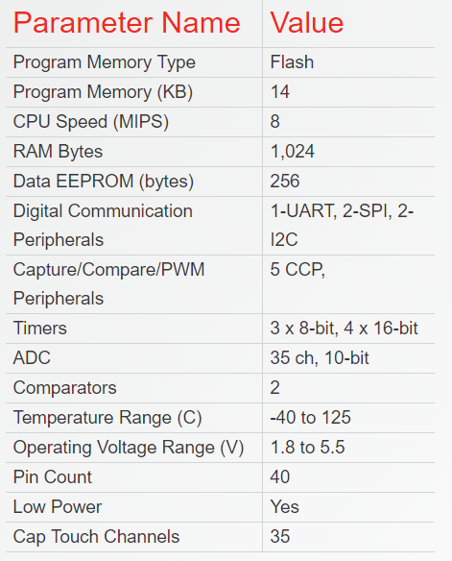
The 16F887 PIC microcontroller has 14KB program memory which is more than enough for the small amount of code required for this project.
Important values:
- Operating Voltage Range = 1.8V to 5.5V
- Pin Count 40
- Max current 25mA

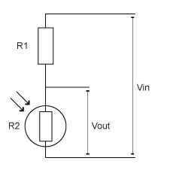
The LDR circuit[fig] works in this instance by flipping the R1 resistor and R2 LDR as the LDR detects darkness and raises its resistance accordingly from a minimum resistance of 2kOhms and a maximum of 200KOhms[6]. The necessary resistance can be calculated using the equation:
$Vout=Vin∙\frac{R2}{R1+R2}$[7] 9*(7.5k/12.5k) = 5.4v
2.1.3: Parts Values and Costs
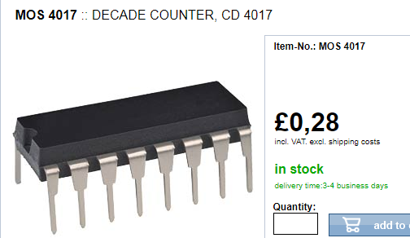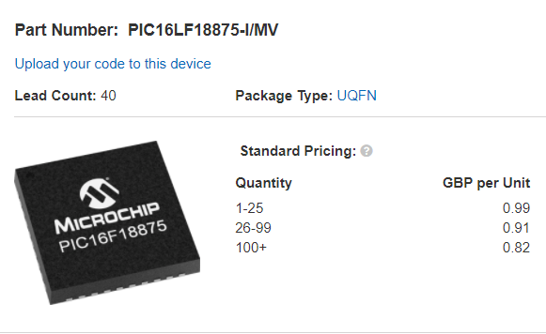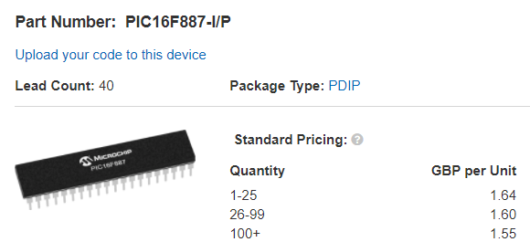
2.1.4: Programming Techniques
The CCS IDE was used for this project, as this was new terrain information on important pieces of code was gathered[8].
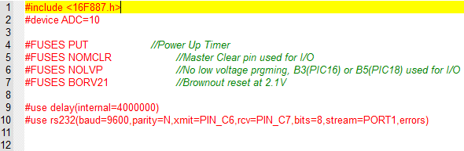
The code above was generated to the specification of the PIC microcontroller being used for this project.

#DEFINE OVERRIDE PIN_X9 // This means that the OVERRIDE word can be used to call the specified pin to make reading code easier for humans to understand.
void main()
{
} // The main function of the program where everything begins from.
while(condition(s))
{
} // While the condition(s) is true loop
!input(pin), true // If the specified pin is not receiving an input then output success.
if(condition(s))
{
} // If the condition(s) are true then loop
delay_ms(x); // Delay by xms before executing the next command
output_X(0); // Clear all bits from the output port specified
output_bit(pin,1); // Set the specified pin to high output

2.2: Product Development and Additional Research
2.2.1: Initial Critique
After the interim viva the following issues were acknowledged:
- How is the wiring going to reach the different sections of the jacket?
- A Zener Diode should be used to avoid overvolting the PIC
- More in depth research is required
- How is the project going the be powered?
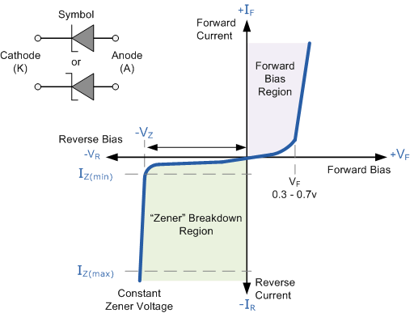
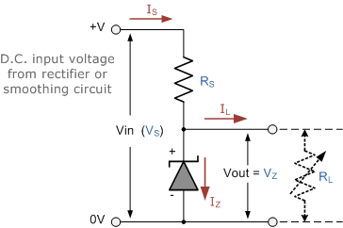
2.2.2: Circuits and Components

The Zener Diode acts as a clamp which means that when the reference voltage raises above 5.2v[9] the Zener diode reaches the breakdown region and allows any excess voltage through to ground.
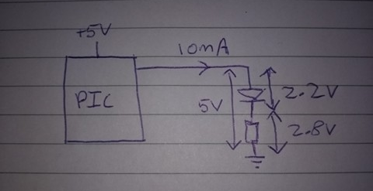
As shown[fig] the PIC outputs 5v and 10mA and a green LED requires 2.2V to run[]. Using this information and Ohm’s Law we can see that:
$R=\frac{Vs-VLED}{ILED}$ = (5-2.2)/(10*10-3) = 2.8/0.01 = 280Ohms [10]
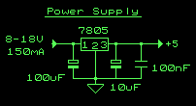
The 7805 Voltage Regulator[11] requires smoothing capacitors on the input and output. It takes a variable incoming voltage and outputs a set 5V[11] the smoothing capacitors also work re remove high voltage spikes from the input voltage. For this project 100uF and 100nF Capacitors are being used. Although 0.33uF and 0.1uF Capacitors can also be used. This will be used to reduce the 9V power supply that is required for the reference voltage for the LDR circuit.

2.2.3: Parts Values and Costs
- 16F887 =£1.60, Voltage regulator = £2.40, LDR and LEDs = 9.33
- Labour = 200*15 = £3000
- Final Price = £33.33
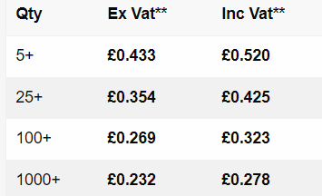
- Selling Price = 3033.33/ 75 =£60.66[12][13][14][15][16][17][18]
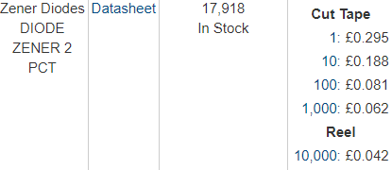

3: Methodology
An initial feasibility test needs to be completed before attempting to develop initial designs, this needs to address and compare similar products on the market and prove why the project is necessary. Then potential circuits can be assessed so that the developer can determine what is best for the project. After the initial circuits were determined any skills required were researched and various skills learned for the development of the project including pic programming methods and wiring techniques. After deciding on useful circuits, the individual parts were designed, tested, and combined on Proteus to demonstrate during the interim viva. The prototype was successful as it identified flaws in the design meaning that they could be improved upon for the final prototype.
As the interim viva provided a plethora of issues more research was required into new components and a more in depth and detailed review of each existing circuit was undertaken to improve the developer’s understanding of the principles behind each sub circuit. Using this information, the final Proteus design was developed and a program coded and tested in order to provide the LED’s power in the correct order corresponding to the inputs.
Additional time was used during the design stage as there were many issues apparent after the interim viva, this combined with a lack of realization that the issue would arise there was a lack of components required for the completion of a breadboard prototype. If the project were to continue then after a health and safety assessment and review of correct soldering and wiring procedure, the breadboard prototype would be developed with key points being tested along the way for example the voltage at the reference points of the LDR circuits and the output ports of the PIC microcontroller. Another form of testing is to look at the response of the LED’s as stimulus is moved around the jacket.

4: Project Management
4.1: Project Management: Overview
A project plan was developed alongside this assignment to take project risks and important laws and regulations into account to decide what is and is not feasible for the project to ensure no laws or regulations are broken throughout the development process and use of the product. A Gantt chart was developed using Microsoft project to manage time effectively so that the final deadline could be met in time with any potential issues allocated extra time to compensate.
4.2: Law and Ethics
The British Computer Society Code of Conduct[19] and IEEE[20] code of conduct were taken into consideration when designing this product[My Project Plan].
The Road Vehicles Lighting (Amendment) Regulations 2005 state that “it (is) now legal to have a flashing light on a pedal cycle, provided it flashes between 60 and 240 times per minute” [1][21]. As the product needs to avoid dazzling drivers it must stick to a maximum flashing frequency of 240 times per minute to stick within the bounds of the law[My Project Plan].
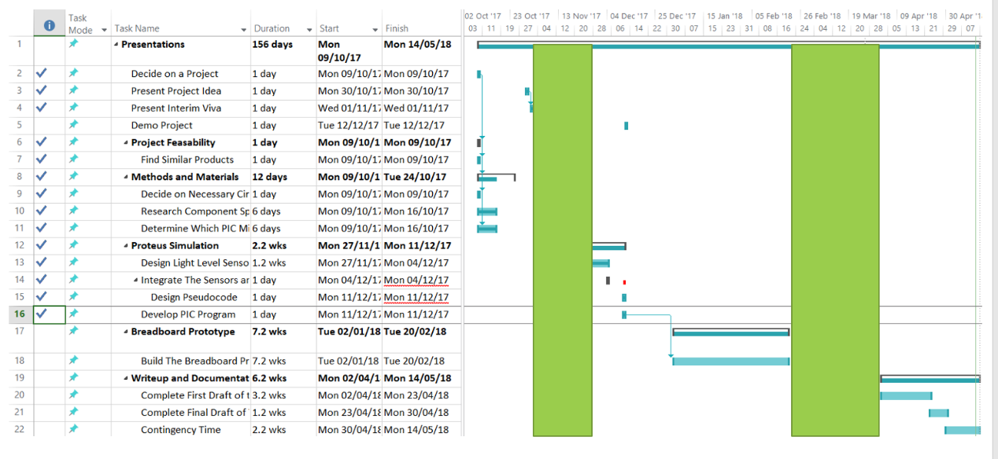
4.3: Time Management
To efficiently manage time each group member developed a Gantt chart and thought this project it’s generally been successful although the project did run over deadline this was due to unavailable parts therefore time should have been allocated earlier in the project to acquire components. Another reason the project ran over deadline is due to lack of knowledge as there were several issues noted in the interim viva the demanded drastic design changes later during in the project development cycle. Despite these problems the project managed to run successfully on Proteus.

4.4: Project Management: Conclusions
The project proposed adheres to IEEE and the British Computer Society Code of Conduct guidelines and follows the appropriate laws for lighting on bikes. It does it’s best to anticipate risks although there were several unanticipated issues that could have been covered in further detail with time being allotted appropriately as part of the Gantt chart. This should prevent issues with meeting the deadline for the initial prototype.
5: Initial Design
5.1: Development
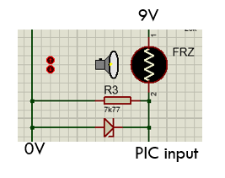
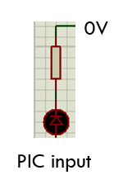
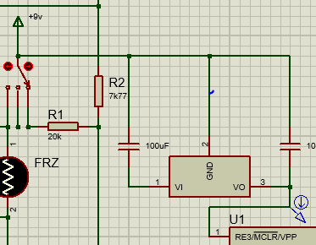

5.2: Final circuit
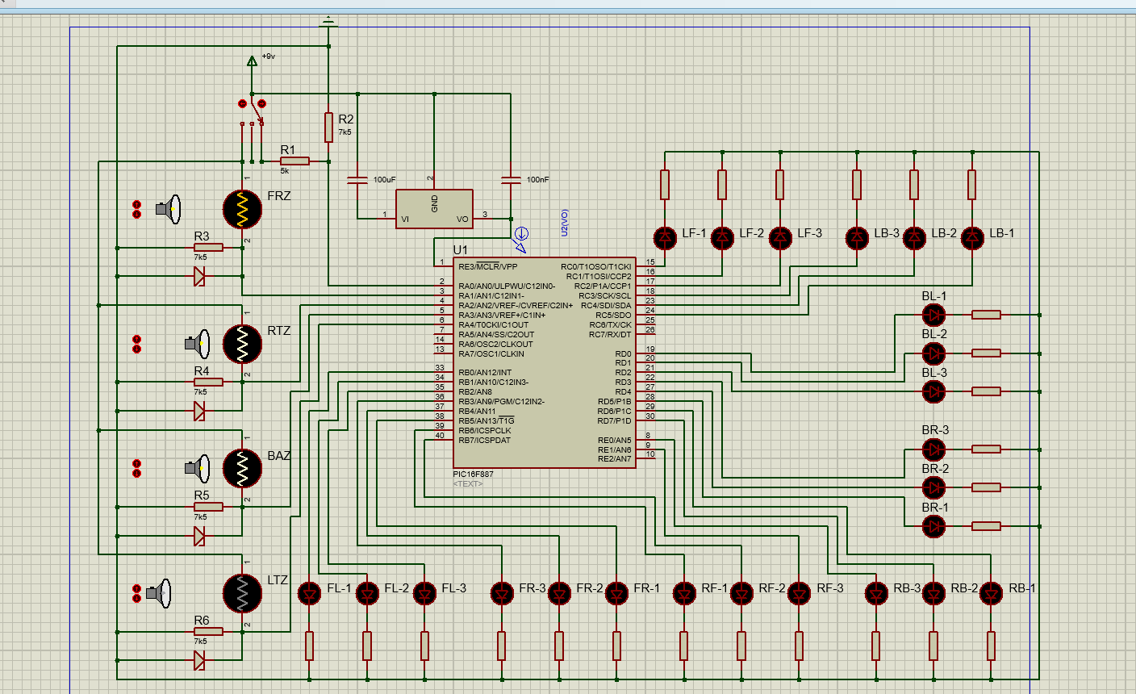

5.3: Final Program
Main.h

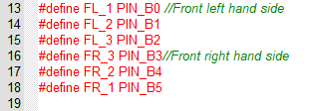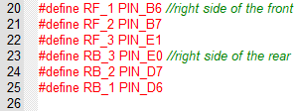
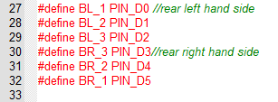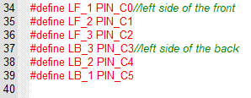
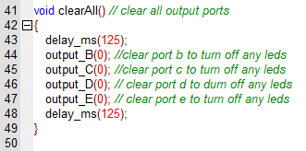

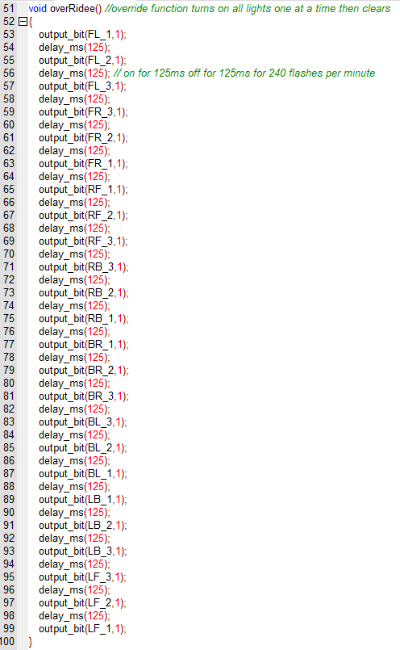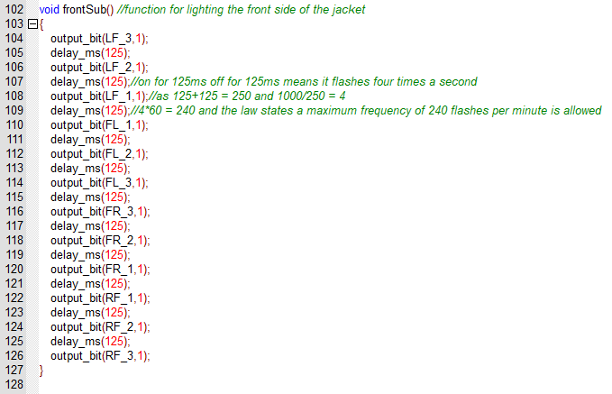
Main.c

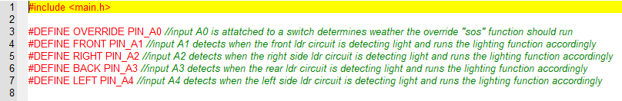

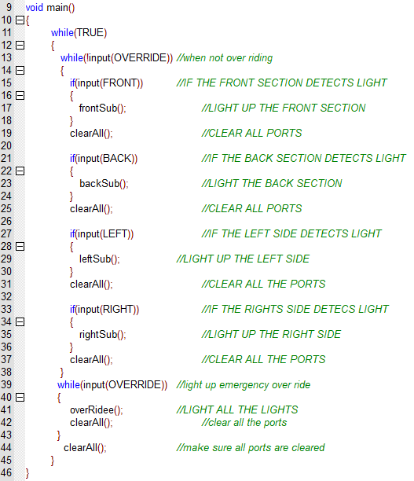

6: Initial Prototype
6.1: Necessary Components
The final components necessary for the completion of this project are as follows:
- 4x light dependant resistor
- 5 x 7k77 resistors
- 1 x 20k resistor
- 4 x 5.1v 1w Zener diodes
- 1 x 16f887 pic microcontroller
- 1 x 3 state switch
- 7805 voltage regulator
- 100uf capacitor
- 100nf capacitor
- 24 x LEDs
- 24 x protective resistors
6.2: Final Design
The final design remains incomplete as there was a shortage of components and new ones were not ordered in time, a prototype was created using the parts at hand although due to missing parts cannot be powered or tested, this was a last minute decision that was not anticipated during risk assessment and time should have been allotted after the final design before the final Proteus program was completed.
7: Conclusion
Overall the project has been a success, with almost all the goals being completed in time as seen below:
- Research similar products and minimum requirements of the reflective jacket (completed)
- Develop a working simulation of the product using Simulink (completed)
- Ensure the reflective jacket addresses problematic situations to ensure the safety of potential users (completed)
- Give an assessed informative presentation describing and marketing the product(completed)
- Create a working prototype of the Jacket (incomplete)
Despite not completing each goal successfully the project was a success because many lessons were learned for the future from project management and timekeeping to practical deployment of skills. For example, too much time was spent on the Proteus development as the difficulty of the task was underestimated and not enough time was allocated elsewhere. On a more practical degree the project was partially successful in that a working simulation was developed that could easily be transferred to the real world (with some fault finding).
8: Bibliography
8.1: References
[1] HMSO, “The Road Vehicles Lighting Regulations.” 1989. [Online]. Available: https://www.rospa.com/rospaweb/docs/advice-services/road-safety/cyclists/cycling-accidents-factsheet.pdf.
[2] Who, “Road Safety Factsheet: Brazil,” no. November, p. 2009, 2011.
[3] Lumenus ,“When Reflection Isn’t Enough.” 2017. [online]. Available: https://www.kickstarter.com/projects/lumenus/led-lit-wearable-tech-saving-walk-run-bike-and-mot
[4] Fuloon, 2018 [Online]. Available: https://www.amazon.co.uk/Fuloon-Safety-Visibility-Reflective-Stripes/dp/B00BMLAB7S
[5] V. Ryan, “the 7490 Decade Counter.” p. 7490. 2018 [Online]. Available: http://www.technologystudent.com/elec1/count1.htm
[6] amazon, 2018 [Online]. Available: https://www.amazon.in/Sellify-100pcs-0-5K-200K-Light-Dependent-Photoresistors/dp/B0173B5VLG
[7] P. Pmts, “Voltage dividers,” Notes. pp. 3–5. 2018 [Online]. Available: https://learn.sparkfun.com/tutorials/voltage-dividers
[8] M. Bates, “Programming 8-bit PIC Microcontrollers in C, 1st Edition”. Newnes, 2008
[9] mouser, 2018 [Online]. Available: https://www.mouser.co.uk/Semiconductors/Discrete-Semiconductors/Diodes-Rectifiers/Zener-Diodes/_/N-ax1mh?P=1yuq473
[10] Zero Point Labs, “LED Resistor Calculator”, 2018. [Online] Available. http://www.ohmslawcalculator.com/led-resistor-calculator
[11] electronicsforu ,“All About 7805 IC | Voltage Regulator Pin Diagram &amp; Schematics.” . 2017 [Online] Available: https://electronicsforu.com/resources/learn-electronics/7805-ic-voltage-regulator
[12] I. Glassdoor, “Computer Programmer Salary,” no. 65. p. 400264, 2016.
[13] Microchip, “PIC16F877A - Microcontrollers and Processors.” .2018
[14] Mouser, “L7805CV STMicroelectronics _ Mouser United Kingdom.” . 2018 [Online]. Available https://www.mouser.co.uk/ProductDetail/STMicroelectronics/L7805CV/?qs=9NrABl3fj%2FqplZAHiYUxWg%3D%3D&gclid=Cj0KCQjwre_XBRDVARIsAPf7zZhv72SikOnS8Pc5lbEygX0hNT5ywcdpGtSMg95JfLWQz9YctfmFao4aAoSVEALw_wcB
[15] Rapid, “L7805CV STMicroelectronics _ Mouser United Kingdom.” .2018 [Online] Available: https://www.rapidonline.com/Kingbright-L-7104GT-3mm-2-2V-Green-LED-Transparent-56-0555?IncVat=1&pdg=pla-339723229188:kwd-339723229188:cmp-757438067:adg-44804851896:crv-207912323492:pid-56-0555:dev-c&gclid=Cj0KCQjwre_XBRDVARIsAPf7zZgQAKQ2CuaAlhxEKUN7yOyfwHEM6F0s84bxAXCqVGZjpWrEEssgQRkaAsPfEALw_wcB
[16] Farnell,“5.1v Zener diode Zener Diode”,2018 [Online] Available: https://www.mouser.co.uk/Search/Refine.aspx?Keyword=5.1v+Zener+diode&Ns=Pricing|0&gclid=Cj0KCQjwre_XBRDVARIsAPf7zZhCL-WiKSrV_-qZ2DBHc1IX_n2zbyEtjuc967i8AHeJcn72Xn_zA0oaAgYOEALw_wcB
[17] VSafety, “Supertouch Standard Storm Hi Vis Bomber Jacket - Hi Vis Bomber Jackets - Hi Vis Workwear - PPE & Workwear.” .2018 [Online] Available: https://www.vsafety.co.uk/supertouch-standard-storm-hi-vis-bomber-jacket.html?utm_source=google&utm_medium=product_feed_or_listings&gclid=Cj0KCQjwre_XBRDVARIsAPf7zZjZi-_ZCv8MtHqLATSYi9QoYFD3-tE97i54XsSZaV5V07TR0bVeqKgaAvqwEALw_wcB
[18] SafetyShop, “Waterproof high-vis reflective jacket - Safetyshop.” . 2018 [Online] Available: https://www.safetyshop.com/high-visibility-reflective-jacket.html?LGWCODE=36761;144151;6391&gclid=Cj0KCQjwre_XBRDVARIsAPf7zZjQTF1U-lY05-pED-ruP9aVjaL4jA9zR-h5_mexhaBiYKgw5OxdSzwaAnfqEALw_wcB
[19] IEEE board, “IEEE Code of Conduct,” no. June, pp. 3–4, 2014.

[20] R. Alves, A. Souza et al, “Code of Conduct For Bcs”, Igarss, 2014

[21] IEEE, “IEEE - IEEE Code of Ethics,” Ieee, no. 0. p. 2015, 2017.
[22] S. Bever, “An updated guide to cycle lighting regulations | Cycling UK,” Cycling UK. 2017.

8.2: Appendixes
(fig1)[]

(fig 2)
(fig 5)
(fig 3)

(fig4)

(fig 7)

(fig 6)

(fig 8) (fig 9) (fig 10)
(fig 11)

(fig 13)
(fig 12)
(fig 14) (fig 15)

(fig 17)
(fig 15)

(fig 18)

(fig 19)
(fig 20)
(fig 21)
(fig 22)
(fig 23)
(fig 24)
(fig 25)
(fig 26)
(fig 27)
(fig 28)

(fig 29)(fig 30)

(fig 31)
(fig 32)



Minutes of Group Meeting
12 pm, Monday 16th October 2017

Present: | Thorbjørn Kristiansen (Chair) | Ashleigh Elder (secretary)

APOLOGIES
None given

PREVIOUS MINUTES
Chose Projects and discussed as a group before final projects were agreed upon

MATTERS ARISING ON THE PREVIOUS MINTUES
(Now re-read the last minuites and comment on any actions taken, in chronological order)
- Thorbjørn Kristiansen – SmartLight adaptive bike light
- Ashleigh Elder – Smart Reflective Jacket
- Andy Hardwick – Motor Control Unit

ISSUES DISCUSSED
- Name and Focus of the company
- Issues with current decisions

Any Other Business
Due to unforeseen circumstances Andy Hardwick has decided to leave the group.
Zebastien Jones not in attendance.

Date of next meeting
REPORTED: The next scheduled meeting of the Group is Monday 23rd October 2017 at 12pm, to be held on the 5th floor of the main building.

Minutes of Group Meeting
12 pm, Monday 13th November 2017

Present: | Thorbjørn Kristiansen (Chair) | Ashleigh Elder (secretary)

APOLOGIES

None given

PREVIOUS MINUTES
Discussed presentation results and future improvements
Initialised talks regarding design ideas
General technical counselling across individual projects

MATTERS ARISING ON THE PREVIOUS MINTUES
(Now re-read the last minuites and comment on any actions taken, in chronological order)
(a) Insufficient primary research material for the viva
(b) Group aims and objectives poorly defined
(c) Project development ideas ideas exchanged

ISSUES DISCUSSED
- Demonstrated individual project progress to the group. No issues apparent and
everything is on schedule
Any Other Business
Zebastien Jones not in attendance.

Date of next meeting
REPORTED: The next scheduled meeting of the Group is Monday 20th November 2017 at 12pm, to be held on the 5th floor of the main building.

Minutes of Group Meeting
12 pm, Monday 4th December 2017

Present: | Thorbjørn Kristiansen (Chair) | Ashleigh Elder (secretary)
APOLOGIES

None given

PREVIOUS MINUTES
Initialised planning stage of interrim viva
Compiled list of problems found in the last presentation and discussed improvements

MATTERS ARISING ON THE PREVIOUS MINTUES
(Now re-read the last minuites and comment on any actions taken, in chronological order)
(a) Poorly defined Aims and Objectives
(b) Insufficient primary research material for the viva
(c) Not enough detail

ISSUES DISCUSSED
(a) Discussed individual presentation progress
(b) Decided not to merge presentations
Any Other Business
Set aside Saturday the 9th of December to practice the individual presentations in front of the group
Zebestian Jones is not in attendance

Date of next meeting
REPORTED: The next scheduled meeting of the Group is Monday 5th February 5th 2018 at 12pm, to be held on the 5th floor of the main building.

Minutes of Group Meeting
12 pm, Monday 5th February 2017

Present: | Thorbjørn Kristiansen (Chair) | Ashleigh Elder (secretary)
APOLOGIES
None given

PREVIOUS MINUTES
Discussed presentation results and future improvements
Initialised talks regarding design ideas
General technical counselling across individual projects

MATTERS ARISING ON THE PREVIOUS MINTUES
(Now re-read the last minuites and comment on any actions taken, in chronological order)
(a)
(b)
(c)

ISSUES DISCUSSED
- Compared progress over the holidays
Any Other Business
Due to unforseen circumstnces Zebastian Jones has left the group.
Date of next meeting
REPORTED: The next scheduled meeting of the Group is Monday ^{th} October 24th 2016 at 10.30am, to be held on the 5th floor of the main building.

(fig)APPENDIX Smart Reflective Jacket: Group Project Plan
Ashleigh Elder P141924
27th of April 2018

Contents
- Introduction 2

- Risk Management 2-3

- Sustainability 3-4

- Law and Ethics 4

- Quality Assurance 4

- Conclusion 5

- Bibliography
  - References 5
  - Appendix 6

Introduction
For this assignment a clearly identified individual product for e-bikes was developed as part of a group. Through the group the company “Viking E-Bike Technologies” was created to market these products and make sure they fulfil the requirements of the company focus. The project proposed for this assignment is a “Smart Reflective Jacket” that promotes road safety and cyclist visibility using a non-integrated bicycle accessory. This “Smart Reflective Jacket” is a reflective jacket that detects and responds to traffic and street lights by lighting LED strips on the corresponding reflective sections of the jacket. This light strip remains on for a few seconds after the light source is removed from the product in to make sure the cyclist is visible even when there is no direct light to reflect (an improvement on a typical reflective jacket). In case of emergency for added security there is an SOS setting where each zone lights at the same time that can be enabled using a simple switch.
This assignment aims to demonstrate how this project plans to deal with issues that might arise during the project development life cycle and commercial use. This includes legal and ethical issues and adhering to good quality control practices.
Risk Management
The Project Management Body of Knowledge states that “Risk is an uncertain event or condition that, if it occurs, has an effect on at least one [project] objective”[1]. Risks have varying degrees of severity depending on how negatively they could affect the project goals. Luckily a risk can be identified and analysed to develop strategies to mitigate the effects (and in some instances prevent the risk from developing into an issue). There are four steps to successfully managing risk in a project[2] which include:
- Identification
- Analysis and Evaluation
- Planning
- Treatment and Monitoring
First, the risks to the project need to be identified so that they can be managed successfully and is usually achieved with the use of causal maps and brainstorming sessions.
- lack of knowledge
- requirement changes
- lack of parts
- personal events (i.e. illness, appointments… e.c.t.)
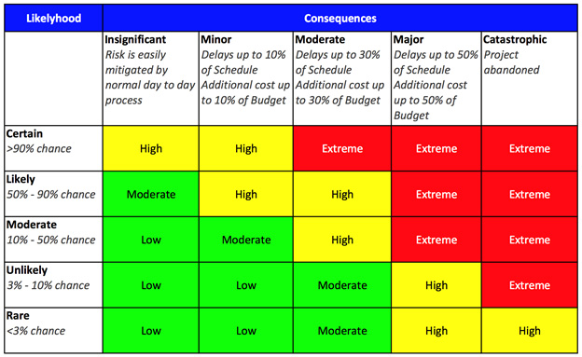
- Unrealistic time and cost estimates
After the risks have been identified the next step is to analyse and evaluate their potential severity and the chance of these risks occurring and developing into problems. Risks are measured by two quantifiers, likelihood and severity, severity being the quantifier that holds the most weight when determining risk (fig1) severity.
This means that each risk can be put onto a checklist ranked from extreme severity to low severity. Having applied this method to the project the potential risks and their severity can be seen below:
- lack of knowledge (Extreme)
- requirement changes (High)
- personal events (i.e. illness, appointments… e.c.t.) (High)
- Unrealistic time and cost estimates (Moderate – High)
- lack of parts (Moderate)
The above checklist shows that lack of knowledge is the greatest risk but this can be rectified by allocating time to research the correct software coding methods and circuits at the beginning of the project. Requirements changes and personal events are the only other issues being high severity are difficult to avoid thus extra time should be allocated in order to accommodate potential issues.
Sustainability
Philippe Vaesken states that, “Sustainability in project management is about balancing or harmonizing social, environmental and economic interests in a project”[3]. Sustainable design in project management should take the project life-cycle into account rather than focusing entirely on its production methods. There are three main categories (or ‘Orders’) that the projects sustainability can be assessed by, these being First, Second and Third Order. First Order is directly caused by the projects existence whilst Second Order is the willingness of the application to reduce other impacts and Third Order is caused by societal changes to the products environment.
First Order – This includes energy use and as the project uses electricity it should run from a renewable energy source like rechargeable batteries as this reduces e-waste as spent batteries don’t need to be discarded. Another way this project directly assists the environment is it’s for use with an electric bicycle and promotes e-bikes and road safety for cyclists and other pedestrians.

Second Order – This project could potentially help reduce levels of greenhouse gasses by promoting electronic bikes and cycling. This product in particular can have other applications to promote safety for pedestrians near the road.
Third Order - The independent states that, “Paris will ban all petrol- and diesel-fuelled cars by 2030, a decade ahead of France’s 2040 target.”[4]. Many countries are attempting to reduce the amount of petrol and diesel fuelled cars on the road as a way to tackle climate change meaning that many people may turn to alternative means of transport such as electric bikes. This project promotes road safety and can add an additional layer of security to cyclists thus promoting e-bikes.
Law and Ethics
Define Law and Ethics
It is vital that Law and Ethics are taken into consideration when planning any project as they can affect many things the project is and is not allowed to do. This project takes this into account by consulting the British Computer Society Code of Conduct[5], and the IEEE Code of Conduct[6][7] as they define the overall standards expected for an electronics and software based project along with the Road Vehicles Lighting Regulations as the project uses lighting and is intended for road use.
Both the British Computer Society and the IEEE Code of Conducts broadly cover several topics but in short, they aim to protect the environment and the rights and wellbeing of the public, maintain professional integrity for the profession.
With regards to safety the smart reflective jacket needs to be weather proof assessing sustainability earlier in the project helps this as the project intends to promote safety. The Road Vehicles Lighting (Amendment) Regulations 2005 state that “it (is) now legal to have a flashing light on a pedal cycle, provided it flashes between 60 and 240 times per minute” [8][9]. As the product needs to avoid dazzling drivers it must stick to a maximum flashing frequency of 240 times per minute to stick within the bounds of the law.
Quality Assurance
According to the module studied there are four main areas the project needs to maintain:
- Effectiveness – ability to achieve user goals with accuracy and completeness
- Productivity – avoids excessive use of resources in achieving user goal
- Safety – within reasonable levels of risk of harm to people, business, software, property, environment etc,
- Satisfaction – happy users!
As there is no working prototype as yet it is difficult to assess quality, the virtual prototype works successfully according to the requirements of the project plan but further testing is needed. This also applies to long term quality of the product and whether it’s susceptible to faults early in its use.

Conclusion
Throughout this report the many issues facing and new project were assessed, and preventative measures were put in place to best deal with them. Risks that were more severe were allocated additional time to overcome in case they became an issue although some big issues couldn’t be prepared for. Decisions for the project have been made by first consulting questions of law and ethics and this has changed a few decisions including the speed of the light flashing and time alight. The project also appropriately maintains a balance between quality and sustainability through many indirect means and a couple of direct ones.
In conclusion time should be set aside for the developer to gain an understanding of the software and hardware use to build the project and more time needs to be put in to testing to ensure a great quality assurance.
Bibliography
References
[1] Project Management Institute, Project Human Resource Management. 2008.
[2] Bright Hub Inc., “What are the 5 Risk Management Process Steps?” 2012.
[3] P. Vaesken, “Project Management and Global Sustainability What Is Sustainability ?,” PMI Global Congress Proceedings – Dallas, Texas. pp. 1–12, 2011.
[4] C. Beale, “European cities announce bans on petrol and diesel cars as green initiative spreads across continent,” The Independent. 2017.
[5] R. Alves, A. Souza et al, “Code of Conduct For Bcs”, Igarss, 2014
[6] IEEE board, “IEEE Code of Conduct,” no. June, pp. 3–4, 2014.
[7] IEEE, “IEEE - IEEE Code of Ethics,” Ieee, no. 0. p. 2015, 2017.
[8] S. Bever, “An updated guide to cycle lighting regulations | Cycling UK,” Cycling UK. 2017.
[9] HMSO, “The Road Vehicles Lighting Regulations.” 1989.

