Databases and Application Development ACCA5026
LECTURER: DR Malik Uzair Mehmood

Date :02 April 2026
DATABASE DESIGN & IMPLEMENTATION
ionut ionel
2026
Table of Contents
I. Introduction 2
II. Database Design 3
ERD for GreenLeaf _Organics 4
III. Implementation documentation 5
A) Database of Greanleaf_Organics 6
B) Create Tables 7
C) Constrains and Structure 11
D) Realistic simple Data insertion 14
E) Validation queries 16
VI. Stored procedure creation 17
Successful Transaction (COMMIT) 19
ROLLBACK 21
Triggers creation 22
Function execution 24
V. Indexes Creation 26
VI. Conclusion 27
VII. References 28

Introduction
This report presents the design and implementation of a relational database system for GreenLeaf Organics, a UK-based company specializing in organic food, eco-friendly products, and sustainable living solutions. As the company expands its operations through an online platform, there is a growing need for an efficient and scalable database system to manage products, suppliers, customers, and transactions effectively.
The proposed database solution is designed to support key business processes, including supplier registration, product listing, customer management, order processing, and customer feedback. By implementing a structured relational database, the system ensures accurate data storage, efficient retrieval, and consistency across all operations. The use of primary keys, foreign keys, and constraints helps maintain data integrity and enforce relationships between entities.
Furthermore, the system incorporates important database concepts such as normalization, stored procedures, triggers, and transaction management. Normalization to Third Normal Form (3NF) reduces redundancy and prevents data anomalies, ensuring that the database remains reliable and maintainable. Transaction handling using COMMIT and ROLLBACK ensures that critical operations, such as order processing, are executed safely and consistently.
Performance optimization is also considered using indexing, which improves query execution speed for frequently accessed data. Additionally, auditing mechanisms using triggers allows tracking changes within the database, enhancing transparency and accountability. This report demonstrates how a well-designed relational database system can support GreenLeaf Organics in delivering efficient, reliable, and scalable operations for its growing online business platform.

Database Design
The database design for GreenLeaf Organics was developed from the operational requirements described in the case study. Because the business is launching an online platform to manage suppliers, products, customers, orders, stock, and reviews, the database needed to support structured data relationships, strong integrity controls, and future scalability. A relational design was selected because the scenario depends on clearly defined entities and repeatable transactions rather than unstructured content [1], [2]. This design approach also supports the later implementation of foreign keys, stored procedures, transaction control, and indexing for performance.At the conceptual stage, the system was analysed by separating the business into its core data objects. The result was a set of eight principal entities: Supplier, Product, Category, ProductCategory, Customer, CustomerOrder, OrderItem, and Review. Each entity represents a real business object or event [1], [3]. Suppliers store the details of certified producers and manufacturers who provide goods to GreenLeaf Organics. Product stores the items sold on the platform, including organic certification details, stock quantity, and pricing. Category groups products into meaningful classifications such as organic food, natural skincare, and eco household items. ProductCategory is an associative entity used to resolve the many-to-many relationship between products and categories. Customer stores account information for individuals or organisations that place purchases. CustomerOrder records each purchase transaction, while OrderItem stores the individual products within each order. Review captures customer feedback and ratings linked to purchased items and, where required, the supplier that provided them.
The attributes of each entity were selected to balance business usefulness with normalization. Supplier includes supplier_id as the primary key together with supplier name, contact name, email, address details, certification number, certification expiry, and supplier status. Product includes product_id as the primary key and supplier_id as a foreign key, followed by product name, description, unit_price, stock_qty, organic_certification_code, expiry_date, sku, and is_active. Category uses category_id and category name, while ProductCategory uses a composite primary key consisting of product_id and category_id. Customer includes customer_id together with name, contact, address, type, and registration fields. CustomerOrder includes order_id, customer_id, order_date, order_status, payment_method, delivery_address, and total_amount. OrderItem contains order_item_id, order_id, product_id, quantity, unit_price, and line_total. Review uses review_id, customer_id, product_id, supplier_id, rating, review_text, and review_date. These attributes directly reflect the information needed to run the online store and avoid unnecessary duplication [1], [4].The relationships between the entities are central to the design. One supplier can supply many products, but each product is linked to one supplier only. This is a one-to-many relationship and reflects the case study statement that each product is supplied by one supplier. One product can belong to multiple categories and one category can contain multiple products, so a many-to-many relationship exists between Product and Category. This was resolved through the ProductCategory table, which stores combinations of product_id and category_id. One customer can place many orders, but each order belongs to a single customer. One order can contain many order items, and one product can appear in many order items across different orders. Reviews are linked to customers and products, allowing the business to store user-generated feedback [2], [3]. The design also links reviews to suppliers so that supplier service can be evaluated when required by the business process.

ERD for GreenLeaf _Organics
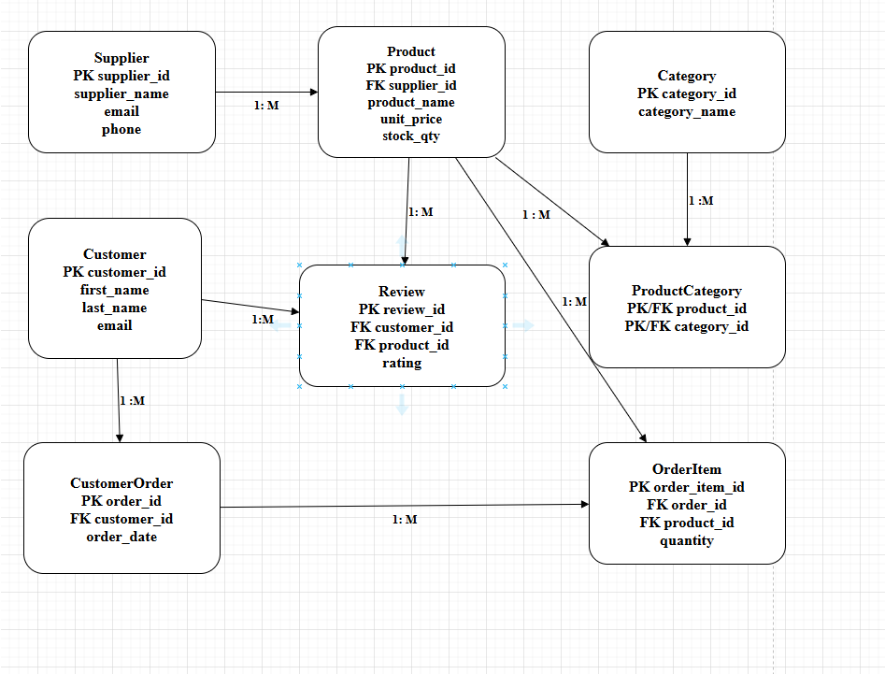
Figure 1. Illustrates the Entity Relationship Diagram (ERD) for the GreenLeaf Organics database. It shows the main entities, their attributes, and the relationships between them, including one-to-many and many-to-many associations resolved through associate

Figure 1 presents the Entity Relationship Diagram for the proposed schema. The ERD shows all entities, primary keys, foreign keys, and cardinalities. Including ProductCategory as a bridging table is particularly important because it demonstrates that the design handles the many-to-many classification requirement correctly. Likewise, separating CustomerOrder from OrderItem preserves the distinction between an order header and the products contained within it. This makes the design easier to query and more suitable for transaction-based processing [1], [2]. For example, when a customer places an order, the database can create one order record and then add multiple order items under that order without repeating customer information or storing product data redundantly on the order table.
The design was normalized to Third Normal Form (3NF). In First Normal Form, all attributes are atomic and there are no repeating groups. This principle is satisfied because no table stores multiple values in a single field; for example, categories are not stored as a comma-separated list inside Product. In Second Normal Form, all non-key attributes depend on the whole key. This is especially relevant to ProductCategory, where the table contains only the two key attributes that identify each relationship, and to OrderItem, where quantity and unit_price depend on the individual order item row rather than on part of a composite structure. In Third Normal Form, transitive dependencies are removed so that non-key attributes depend only on the primary key and not on other non-key attributes. Supplier details are stored only in Supplier, customer details only in Customer, and category descriptions only in Category. This reduces redundancy, supports data integrity, and prevents update anomalies [1], [4], [5].Several design decisions were made to support later implementation in MySQL through XAMPP. Surrogate primary keys using integer identifiers were chosen for most entities because they simplify joins and are practical for AUTO_INCREMENT behavior in phpMyAdmin. Foreign key constraints were included to preserve referential integrity between related tables. These choices show that the schema is not only theoretically correct but also implementation ready [2], [6].Database design provides GreenLeaf Organics with a robust relational structure that supports supplier and customer management, product and category classification, order handling, inventory control, and customer feedback. The ERD reflects the business scenario accurately, while normalization to 3NF ensures that the model is efficient, maintainable, and appropriate for a transactional online store [1], [2], [3].

III. Implementation documentation
The implementation phase translated the conceptual and logical database design of GreenLeaf Organics into a working relational database using MySQL within the XAMPP environment. The database was created in phpMyAdmin, while SQL scripts were prepared and organised in Sublime Text before execution. This approach improved readability, reduced syntax errors, and provided a structured method for testing each stage of development. The implementation supports supplier management, customer records, product listings, category assignment, order processing, product reviews, and performance optimisation through indexing.[7]

Database of Greanleaf_Organics
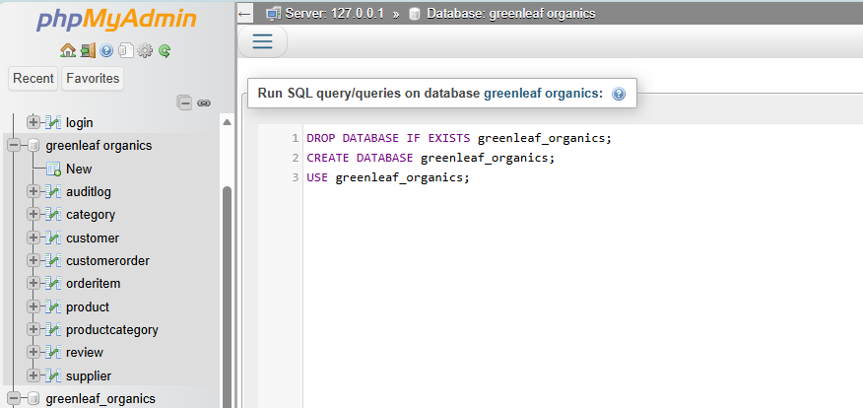
Figure 2 Database creation of Greenleaf_Organics
The first stage of implementation involved creating the greenleaf_organics database and defining the core tables according to the ERD. These tables included Supplier, Customer, Product, Category, ProductCategory, CustomerOrder, OrderItem, and Review. Each table was created with a primary key to uniquely identify each record, and foreign keys were added to enforce referential integrity between related tables. This ensured that, for example, a product could not exist without a valid supplier, and an order item could not exist without a corresponding order and product. The use of primary and foreign keys is consistent with relational design practice because it preserves consistency across connected entities and supports reliable transaction processing [1], [2].

Create Tables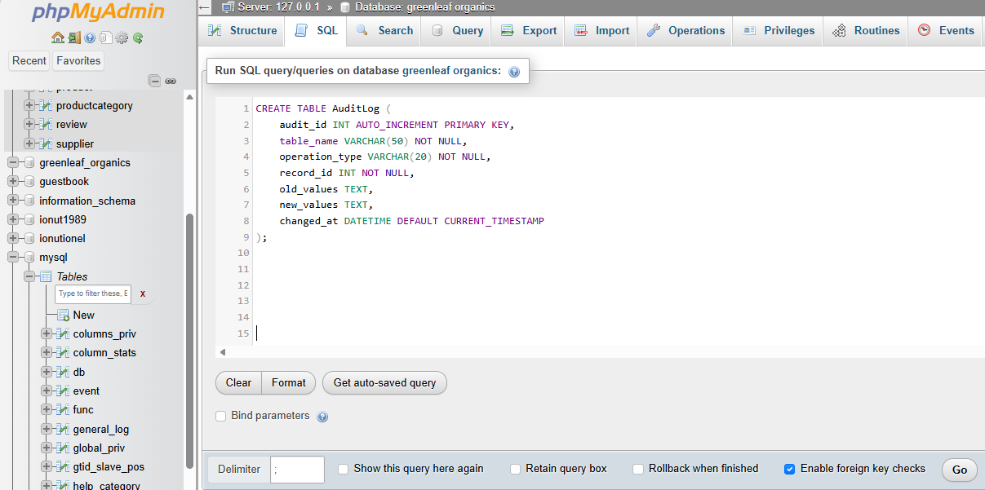
Figure 3 Create Table of Audit log
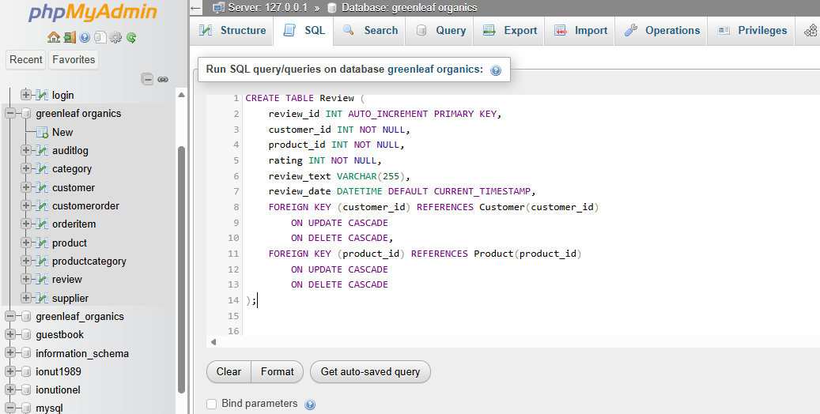
Figure 4 Create table Review

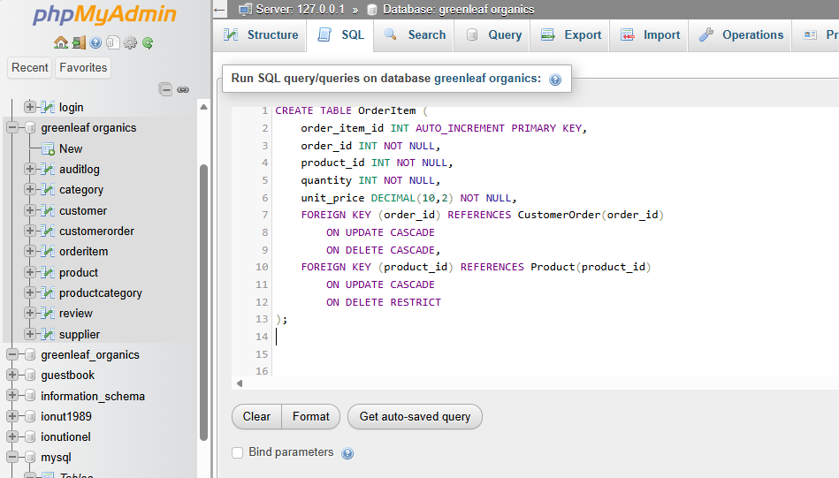
Figure 5 Create table of Order item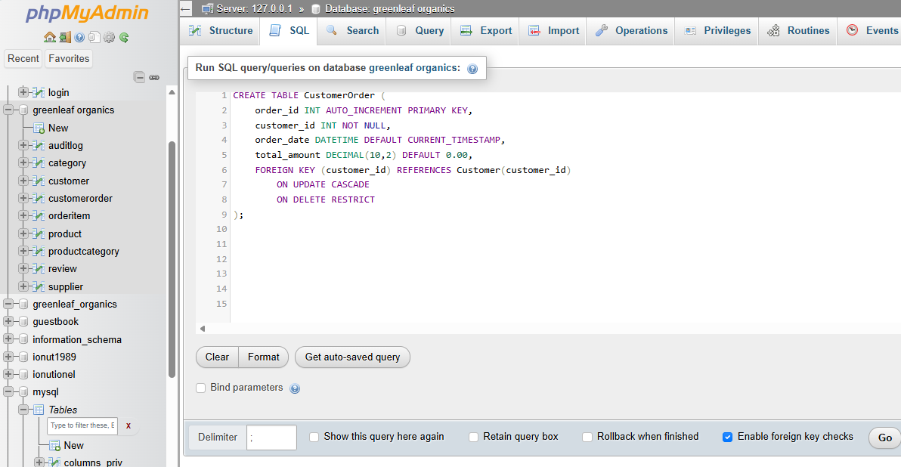Figure 6 Create table of Custom Order
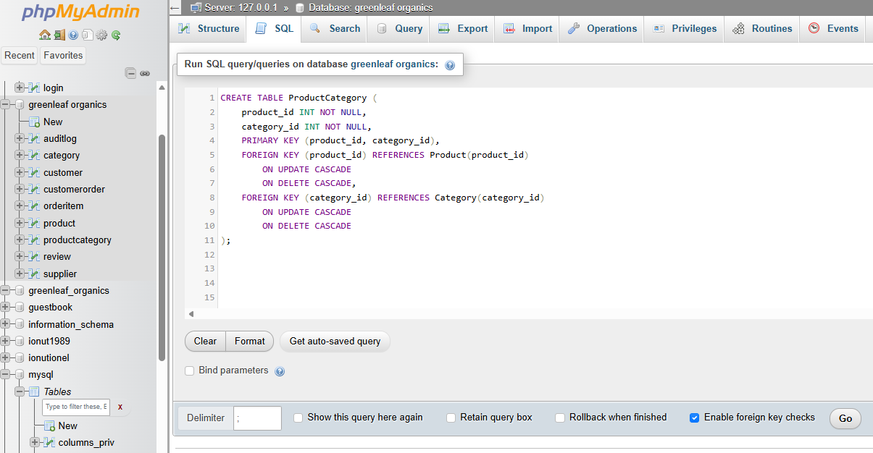Figure 7 Create table of Product of Category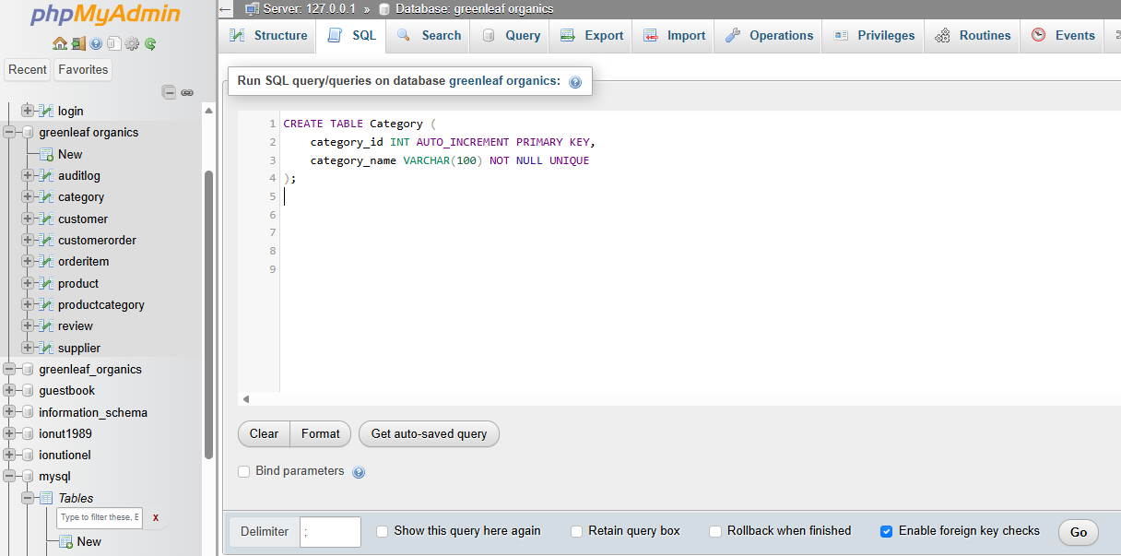
Figure 8 Create table of Category
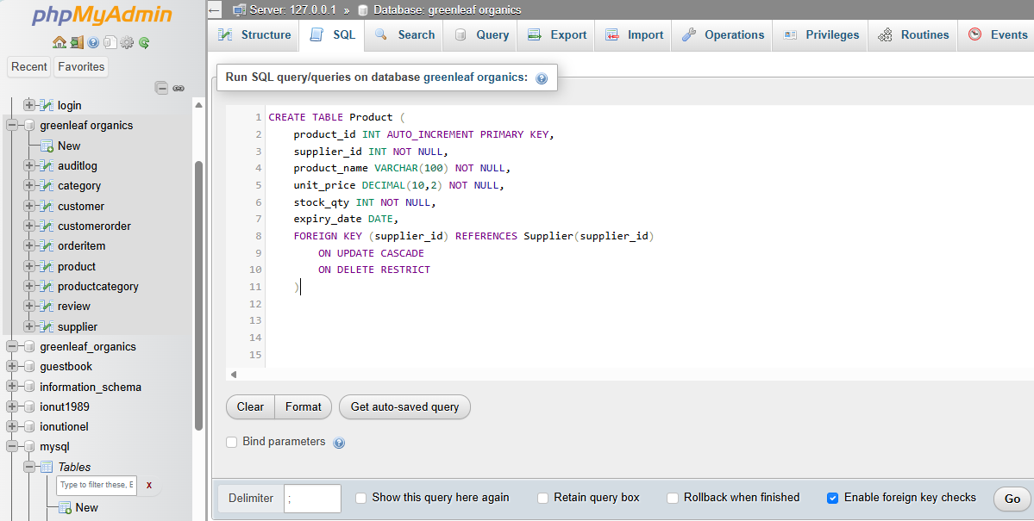Figure 9 Create table of Product
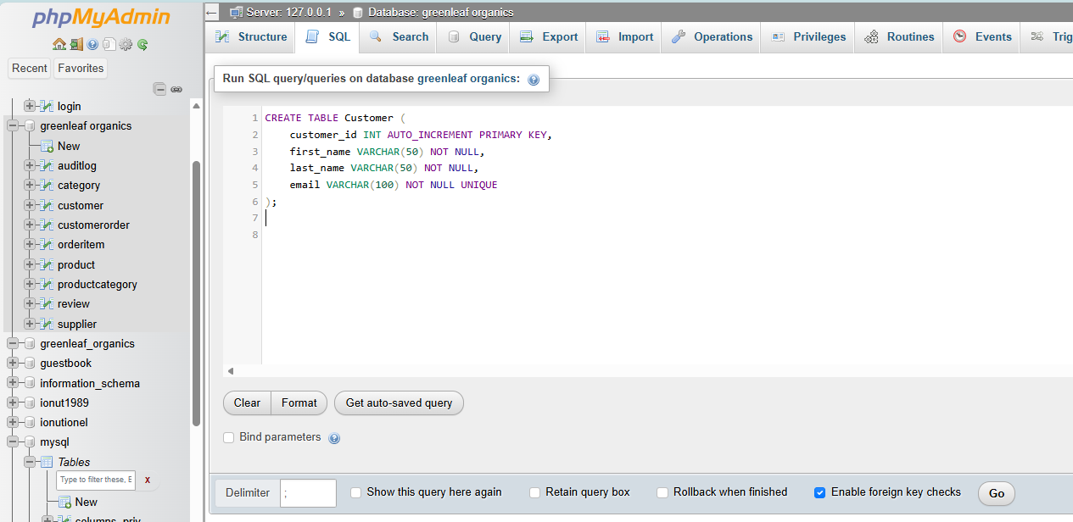Figure 10 Create table of Costumer
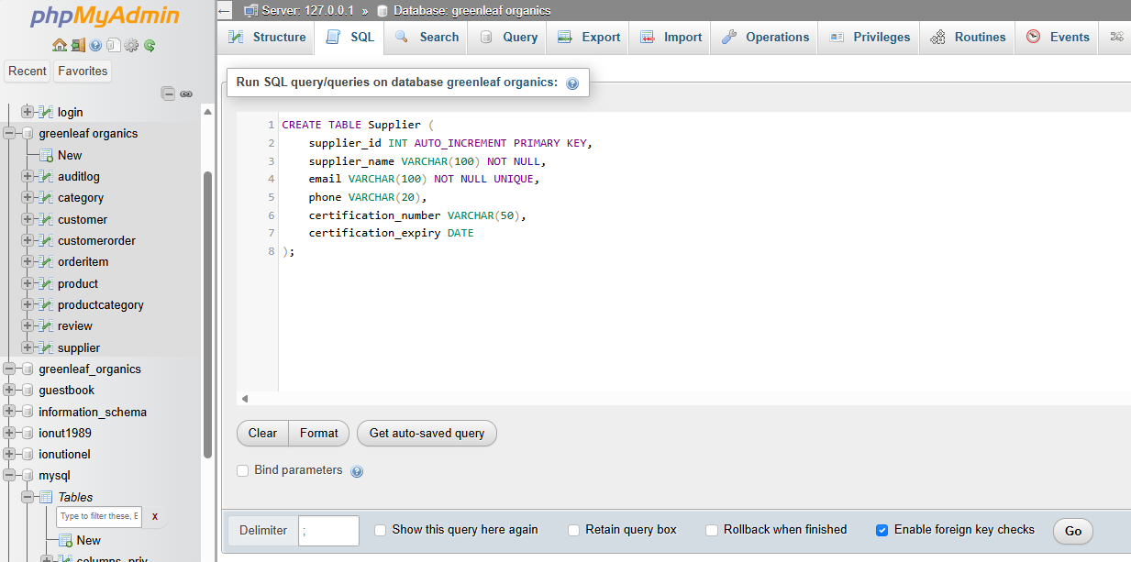Figure 11 Create table of Supplier

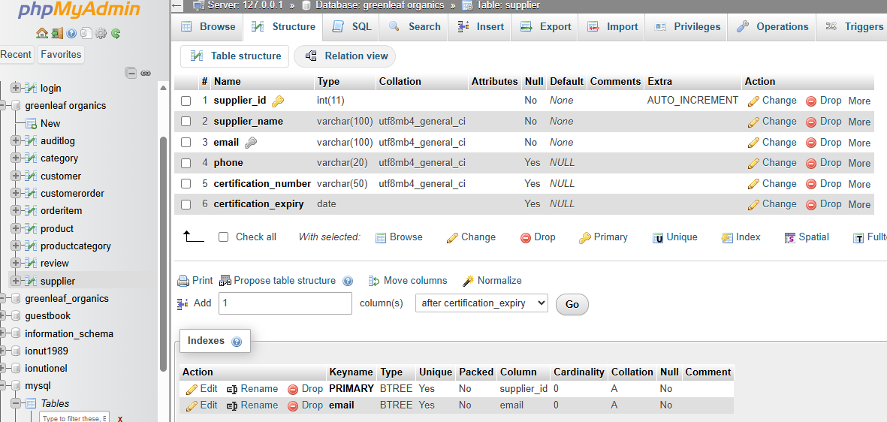
Figure 12. It contains the supplier identifier (name, email address, phone number
The Supplier table stores information about businesses that provide products to GreenLeaf Organics. It contains the supplier identifier, supplier name, email address, and phone number. In a fuller implementation, certification information can also be stored to reflect the company’s organic sourcing requirements. The Customer table stores customer details such as customer ID, first name, last name, and email. These two tables act as parent tables for other entities and are fundamental to the operation of the online store.[8]

Constrains and Structure
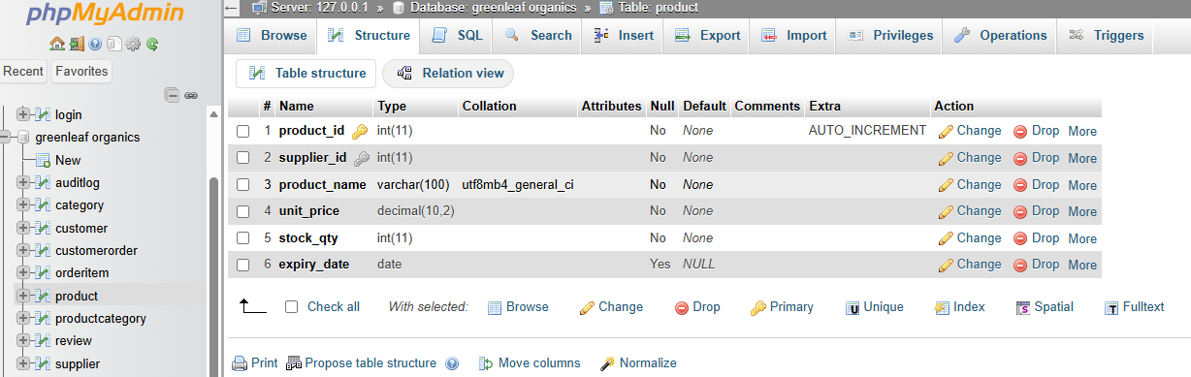
Figure 13. Illustrates the structure of the Product table as implemented in phpMyAdmin. The table includes a primary key (product_id) with auto-increment functionality and a foreign key (supplier_id) that enforces referential integrity with the Supplier

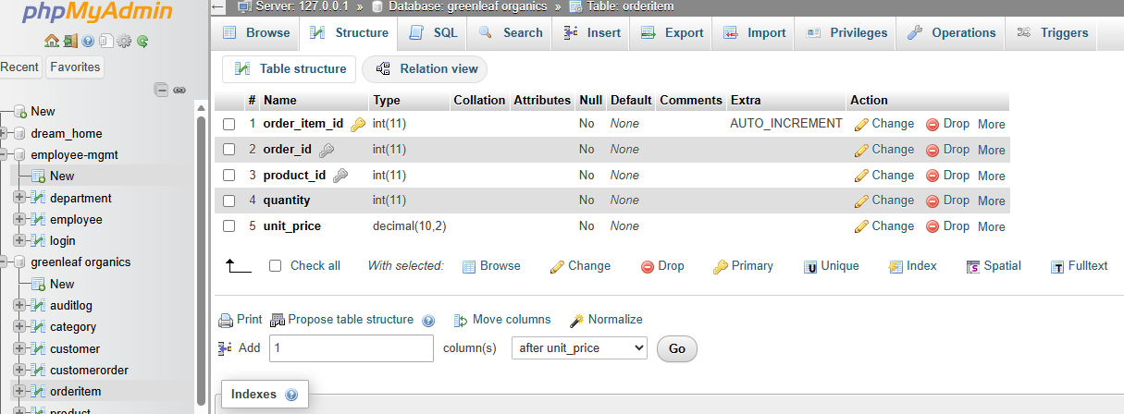
Figure 14 shows the structure of the OrderItem table in phpMyAdmin. The table includes primary and foreign key relationships linking orders and products, as well as attributes such as quantity and unit price
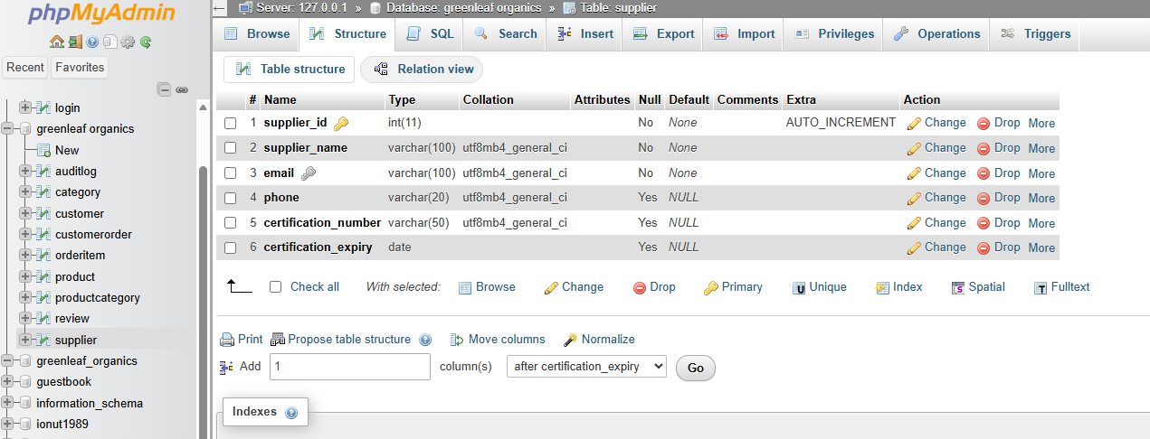
Figure 15 shows the structure of the Supplier table in phpMyAdmin. The table includes the primary key (supplier_id) and attributes such as supplier_name, email, phone, certification_number, and certification_expiry. This table stores information about suppliers providing products to the system.
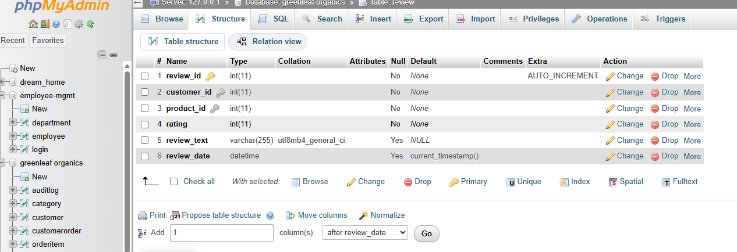
Figure 16 shows the structure of the Review table in phpMyAdmin. The table includes the primary key (review_id) and foreign keys (customer_id and product_id), along with attributes such as rating, review_text, and review_date. This table is used to store customer feedback and ratings for products.
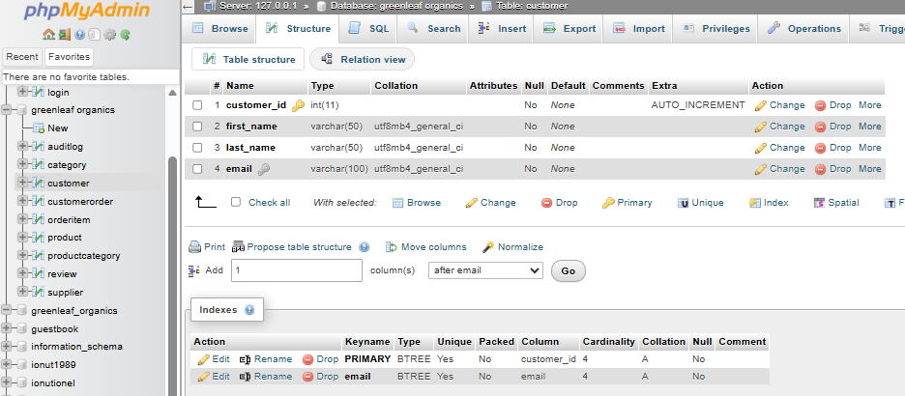
Figure 17 Figure X illustrates the structure of the Customer table within the GreenLeaf Organics database. The table defines customer_id as the primary key with AUTO_INCREMENT to ensure unique identification of each customer. Additional attributes such as first_name, last_name, and email are included to store essential customer details. This structure supports efficient customer management and ensures data integrity within the system.
The Product table was implemented to store individual items available for sale. It includes the product ID, supplier ID, product name, unit price, and stock quantity. The supplier_id field was implemented as a foreign key to link each product to its supplier. This relationship reflects the business rule that one supplier may provide many products, but each product is associated with one supplier. The Category table stores category names used to classify products. Because one product can belong to more than one category and one category can contain multiple products, a junction table named ProductCategory was created. This table contains product_id and category_id as a composite primary key and foreign keys to the Product and Category tables. This implementation resolves the many-to-many relationship in a normalized way and prevents duplication of category data [8]. Order processing was implemented using the CustomerOrder and OrderItem tables. The CustomerOrder table stores each transaction header, including the order ID, customer ID, and order date. The OrderItem table stores the products within each order and includes an order item ID, order ID, product ID, and quantity. This separation between order header and order line data is important because a single order may contain multiple products. It also supports accurate calculation of totals, stock updates, and future reporting. The Review table was implemented to support customer feedback. It contains the review ID, customer ID, product ID, and rating. This allows one customer to leave multiple reviews for different products and enables one product to receive multiple reviews from different customers.After creating the tables, integrity constraints were applied. Primary key constraints ensure uniqueness, while foreign key constraints ensure valid relationships between tables. Additional constraints such as NOT NULL, UNIQUE, and appropriate data types were used to improve data quality. For example, product names and supplier names should not be null, and email fields should remain unique where necessary. These constraints reduce insertion errors and help maintain reliable operational data. Figure references in the final report should show screenshots of table creation statements and the successful execution messages in phpMyAdmin. An index is also applied to the email attribute to improve search performance when retrieving customer records.[9]

Realistic simple Data insertion

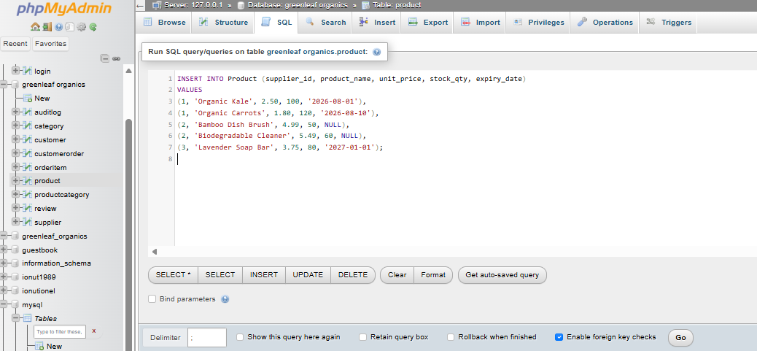
Figure 16 presents sample data inserted into the database tables to simulate real-world operations.
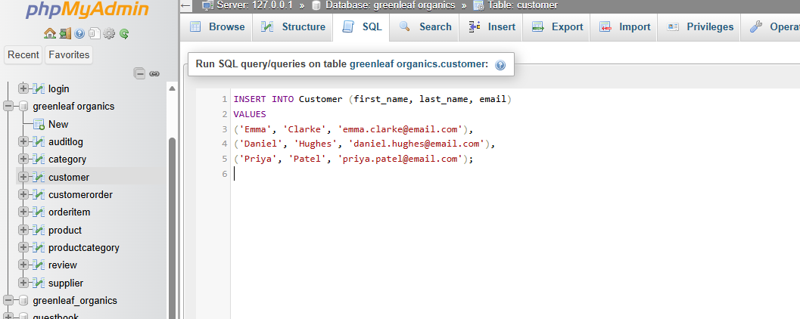
Figure 17 presents the insertion of sample data into the Customer table using SQL statements in phpMyAdmin. The data includes customer details such as first name, last name, and email address, representing realistic users of the GreenLeaf Organics.
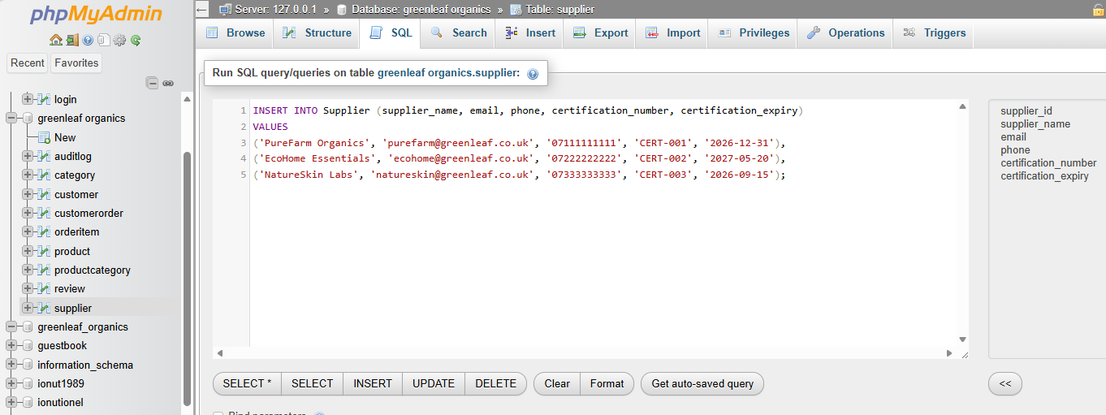
Figure 18 illustrates the insertion of sample data into the Supplier table using SQL statements in phpMyAdmin. The data includes supplier names, contact details, certification numbers, and certification expiry dates, representing certified organic supplier
Following tables creation, realistic sample data was inserted to simulate normal business operation. Sample suppliers represented organic producers, sample customers represented online shoppers, and sample products reflected the company’s organic and eco-friendly product range. Categories such as organic food and eco household goods were inserted to classify products. Orders and order items were then inserted to demonstrate how purchases are recorded. Reviews were also inserted to show how customer feedback is stored. Using sample data is important because it validates whether the structure can support real business activities and whether relationships between tables behave correctly. It also enables testing of joins, filters, and transactional processes.

Validation queries
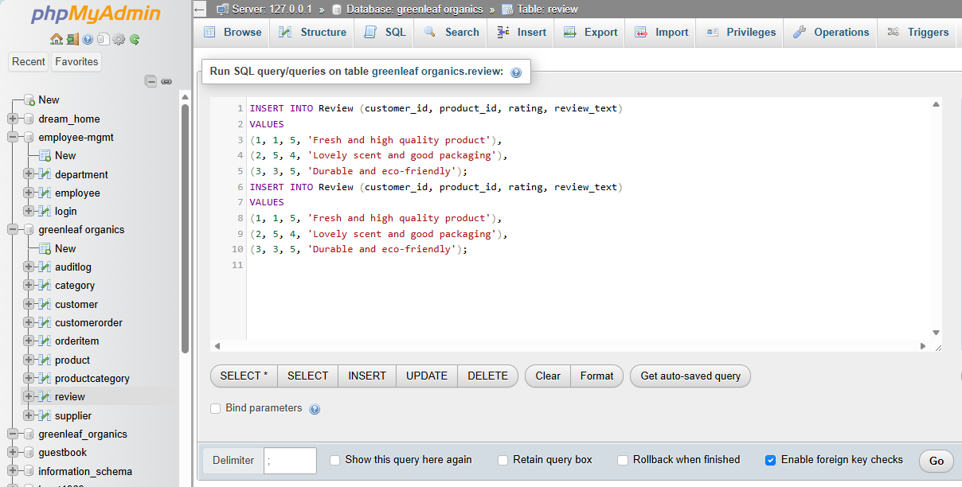
Figure 19 illustrates the insertion of sample data into the Review table using SQL statements in phpMyAdmin. The data includes customer_id, product_id, rating, and review_text, representing customer feedback on purchased products.
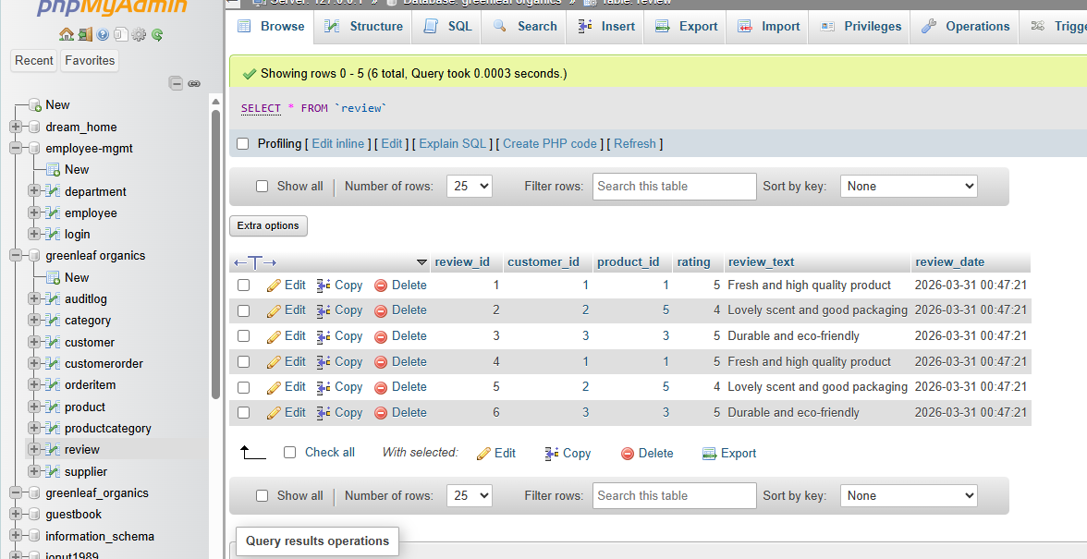
Figure 20 illustrates the insertion of sample data into the Review table using SQL statements in phpMyAdmin. The data includes customer_id, product_id, rating, and review_text, representing customer feedback on purchased products. This implementation all
The implemented sample data also made it possible to run validation queries. For example, joins between Supplier and Product were used to display which supplier provides each product. Queries joining CustomerOrder, OrderItem, and Product were used to display order contents. Queries on the Review table were used to identify which products had received customer ratings. These queries verified that the foreign key relationships were functioning correctly and that data could be retrieved efficiently across multiple related tables. Such testing is important in relational implementation because a database design is only successful if it performs correctly under realistic usage conditions [7], [9].

VI. Stored procedure creation
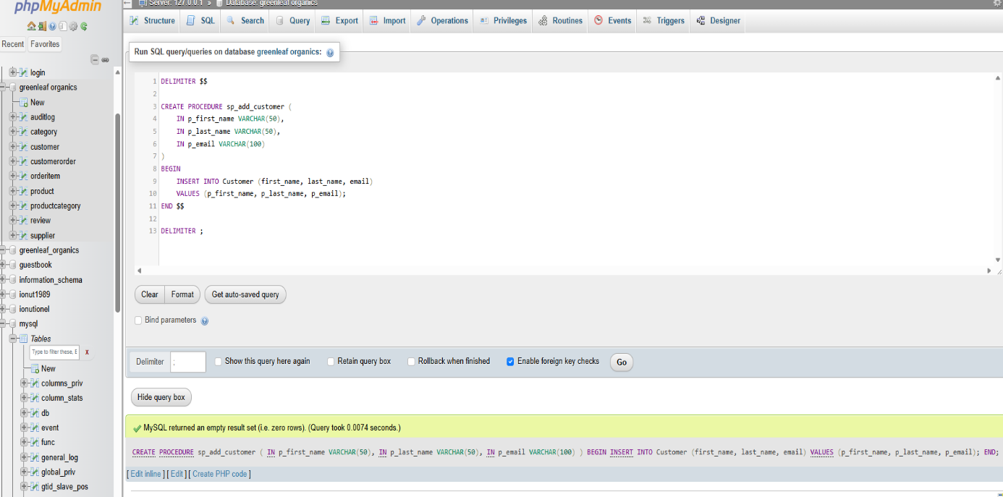
Figure 21 illustrates the creation of a stored procedure used to insert customer records into the database. The procedure encapsulates SQL logic, allowing controlled and reusable database operations.
Stored procedures were implemented to support controlled and efficient execution of CRUD (Create, Read, Update, Delete) operations within the GreenLeaf Organics database. A stored procedure is a precompiled collection of SQL statements stored within the database, which can be executed repeatedly with different input parameters. This approach improves performance, enhances security, and ensures consistency in database operations[9].
In this system, stored procedures were primarily used to perform INSERT, UPDATE, and DELETE operations. For example, an insert procedure was created to add new customer records, ensuring that all required fields are validated and correctly inserted into the Customer table. Similarly, update procedures can be used to modify product details such as stock levels or pricing, while delete procedures allow controlled removal of records such as customer reviews or inactive products. By encapsulating these operations within procedures, the system reduces redundancy and ensures that business rules are consistently applied.[10]
Furthermore, stored procedures provide an additional layer of abstraction between the application and the database. This helps to enhance data security by limiting direct access to underlying tables and allowing only predefined operations to be executed. In addition, stored procedures can be integrated with transaction control mechanisms such as COMMIT and ROLLBACK, enabling safe execution of multi-step processes. For instance, when processing an order, a stored procedure can ensure that all related operations (order creation, order item insertion, and stock update) are completed successfully before committing the transaction.
Another advantage of stored procedures is improved maintainability. Changes to business logic can be implemented within the procedure without requiring modifications to the application layer. This makes the system more flexible and easier to manage as requirements evolve. Overall, the use of stored procedures in this project demonstrates an effective approach to managing database operations, improving performance, and ensuring data integrity within a relational database environment.
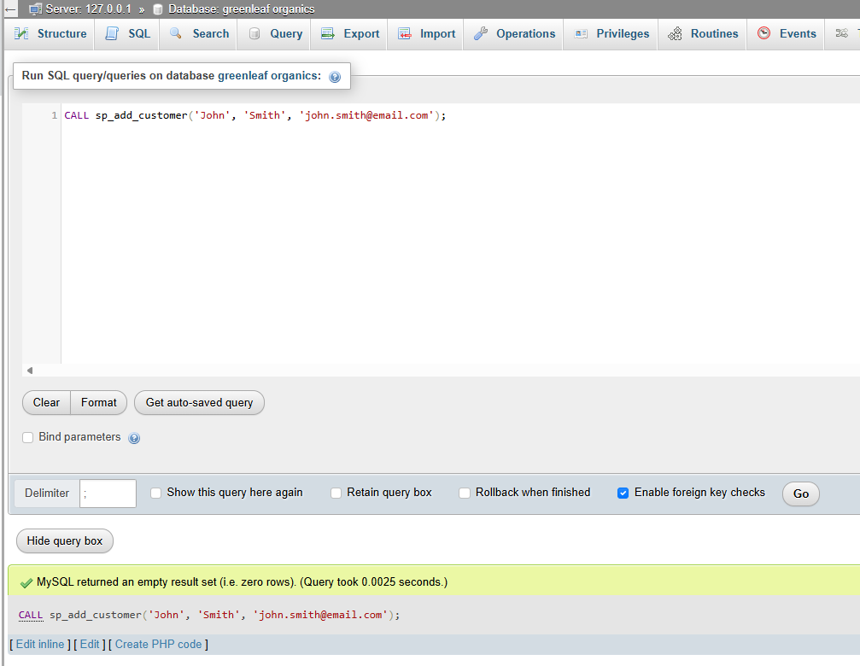
Figure 22 shows the execution of the stored procedure, where a new customer record is successfully inserted into the database. This demonstrates how stored procedures can simplify repeated operations and improve consistency.
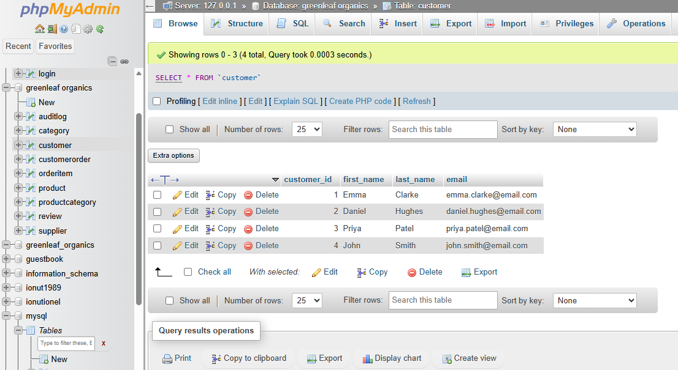
New costumer added
Figure 23 New record added
Stored procedures were introduced to demonstrate controlled CRUD functionality. Insert procedures can be used to add new customers, products, or orders. Update procedures can be used to change stock levels, update supplier details, or modify customer information. Delete procedures can be used to remove reviews or deactivate product records where appropriate. Stored procedures are useful because they centralise business logic inside the database layer, improve consistency, and can reduce repeated SQL code in the application layer. They also support better control over multi-step operations, especially when transaction logic is included [10], [11].

Successful Transaction (COMMIT)
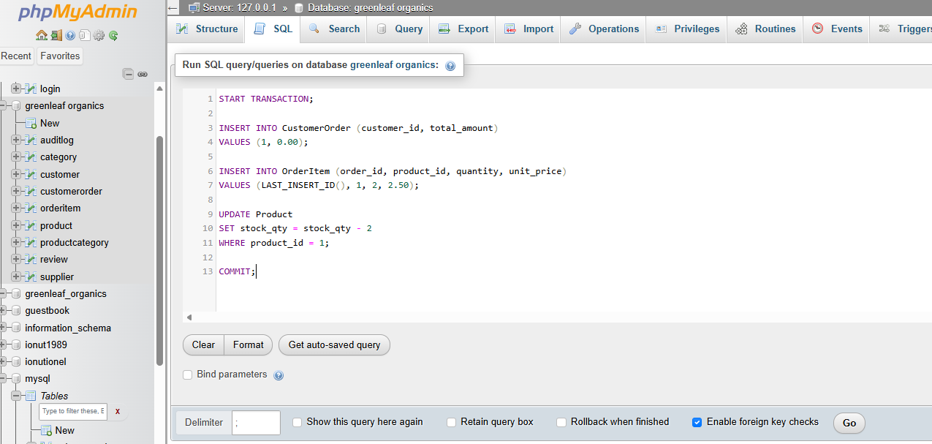
Figure 24 Successful Transaction (COMMIT)
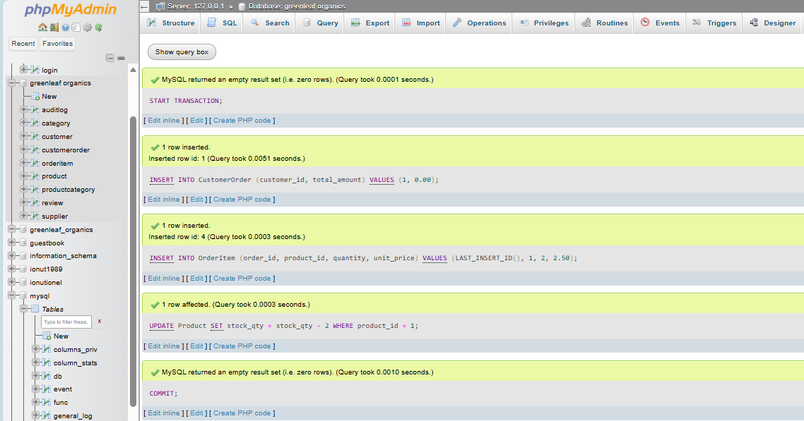
Figure 25 illustrates a successful transaction where multiple related operations, including order creation, order item insertion, and stock update, are executed as a single unit. The transaction is committed only after all steps are completed successfully
Figure 24 demonstrates a successful transaction in which all operations are executed correctly and committed to the database. The COMMIT operation finalizes the transaction, ensuring that all changes are permanently applied and the database remains in a consistent state. This highlights the importance of transaction control in guaranteeing atomicity and durability within relational database systems [12],
A key part of the implementation is transaction handling. GreenLeaf Organics requires order processing to be reliable, especially when stock levels must be updated immediately after a purchase. For this reason, transactions using START TRANSACTION, COMMIT, and ROLLBACK were implemented. In a typical transactional scenario, the database first inserts the order record, then inserts order items, checks available stock, updates stock quantities, and finally commits the transaction if all steps succeed. If any step fails, such as insufficient stock or an insertion error, the transaction is rolled back so that no partial order remains in the database. This is essential for maintaining atomicity and consistency in e-commerce systems, where incomplete transactions could lead to incorrect inventory levels or misleading order histories [13].
The COMMIT operation plays a critical role in transaction management by permanently saving all changes made during a transaction to the database. Once a transaction is committed, its effects become visible to other users and cannot be undone. In the context of GreenLeaf Organics, COMMIT is used after successfully completing all steps involved in order processing, including inserting the order record, adding order items, and updating stock quantities.The use of COMMIT ensures that the database maintains consistency and reliability by applying all changes as a single atomic unit. This is particularly important in e-commerce systems, where incomplete or partially executed transactions could result in incorrect inventory levels or inaccurate order records. By committing only after all operations have been successfully executed, the system guarantees that no invalid or incomplete data is stored.Furthermore, COMMIT contributes to the durability property of ACID transactions, ensuring that once a transaction is finalized, the changes will persist even in the event of system failures. This makes transaction management a fundamental component of robust database systems. In combination with ROLLBACK, COMMIT provides a mechanism to control data integrity and ensure that only valid and complete operations are permanently recorded in the database [13], [14].

ROLLBACK
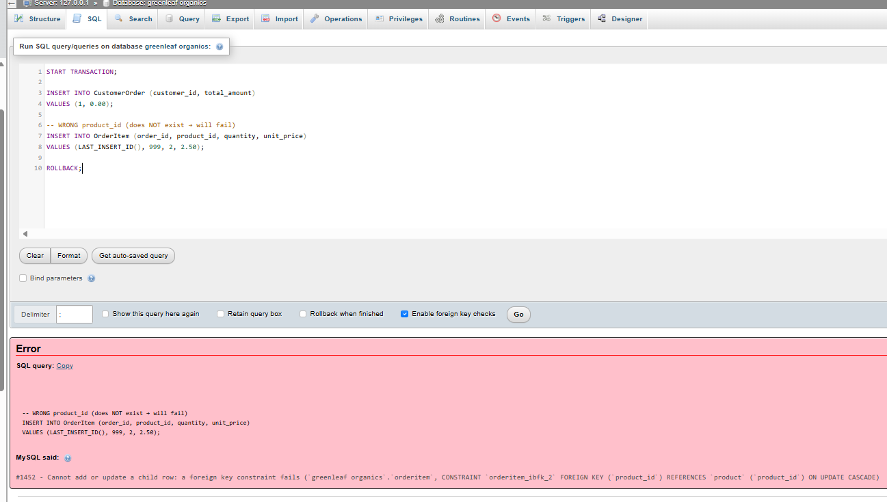
Figure 26 illustrates a failed transaction scenario where an invalid product reference causes an error during execution. As a result, the transaction is rolled back, ensuring that no partial or inconsistent data is stored in the database.
Figure 25 demonstrates a failed transaction where an invalid foreign key (product_id) causes an error during execution. As a result, the ROLLBACK operation is triggered, ensuring that all previous operations within the transaction are undone and no partial data is stored. This illustrates the importance of transaction control in maintaining database consistency and integrity [14], [15}

Triggers creation
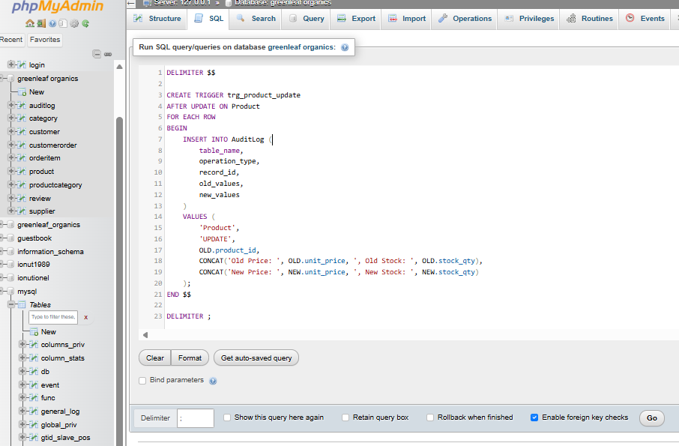
Figure 27 showing the creation of a database trigger that automatically records updates made to the Product table. The trigger captures both old and new values, ensuring that all changes are logged for auditing purposes.
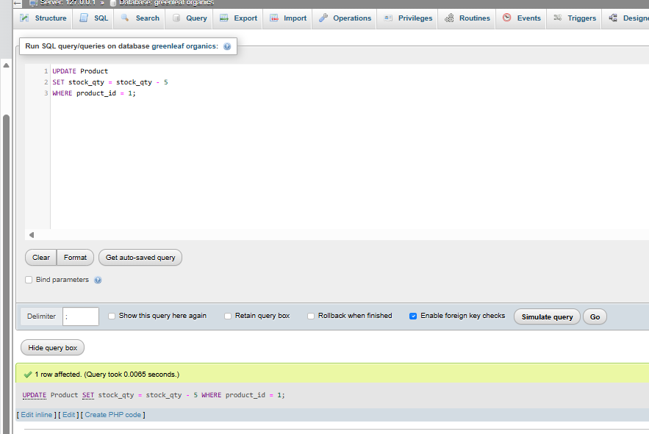
Figure 28 Figure X illustrates the creation of a database trigger that automatically records updates made to the Product table. The trigger captures both old and new values, ensuring that all changes are logged for auditing purposes.
Triggers and functions were also considered as part of the implementation. An audit trigger can be created to record updates or deletions on important tables such as Product or CustomerOrder. This provides a record of who changed data and when the change occurred. A function may also be created to calculate average product rating or count total items in an order. Triggers are particularly useful because they automate secondary actions without requiring manual intervention, while functions simplify repeated calculations. In the context of GreenLeaf Organics, these features improve maintainability, transparency, and reporting capability.

Trigger Execution / Audit Log Output
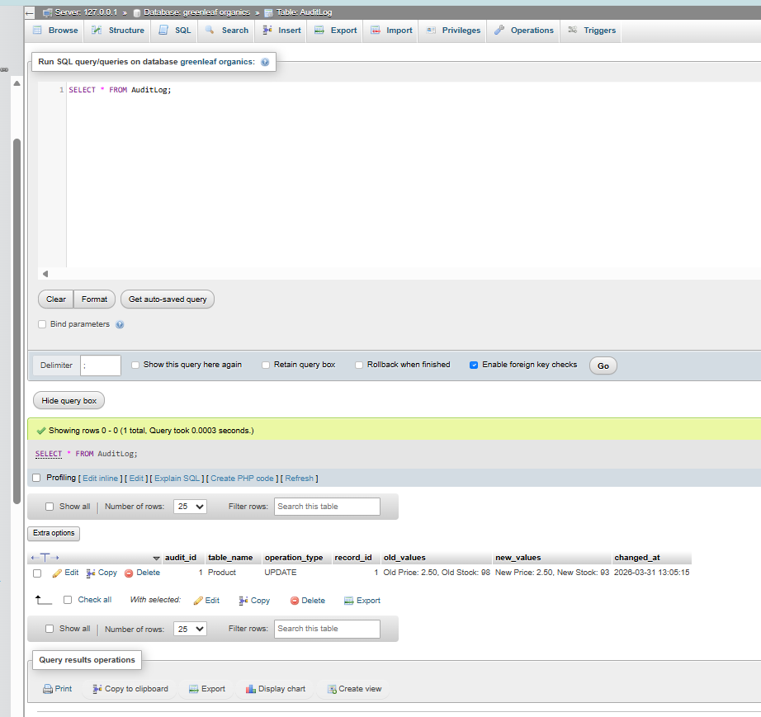
Figure 29 shows the AuditLog table after the trigger execution. The log records the update operation, including the affected product, previous values, new values, and timestamp. This demonstrates how triggers support transparency and data tracking within the database system.

The implementation of triggers enhances database accountability by automatically capturing data modifications without manual intervention. The audit log mechanism ensures traceability of changes, which is essential for maintaining data integrity, security, and compliance in database systems.
[3] R. Elmasri and S. B. Navathe, Fundamentals of Database Systems, 7th ed. Boston, MA, USA: Pearson, 2016.
[4] C. J. Date, An Introduction to Database Systems, 8th ed. Boston, MA, USA: Addison-Wesley, 2004.

Function execution
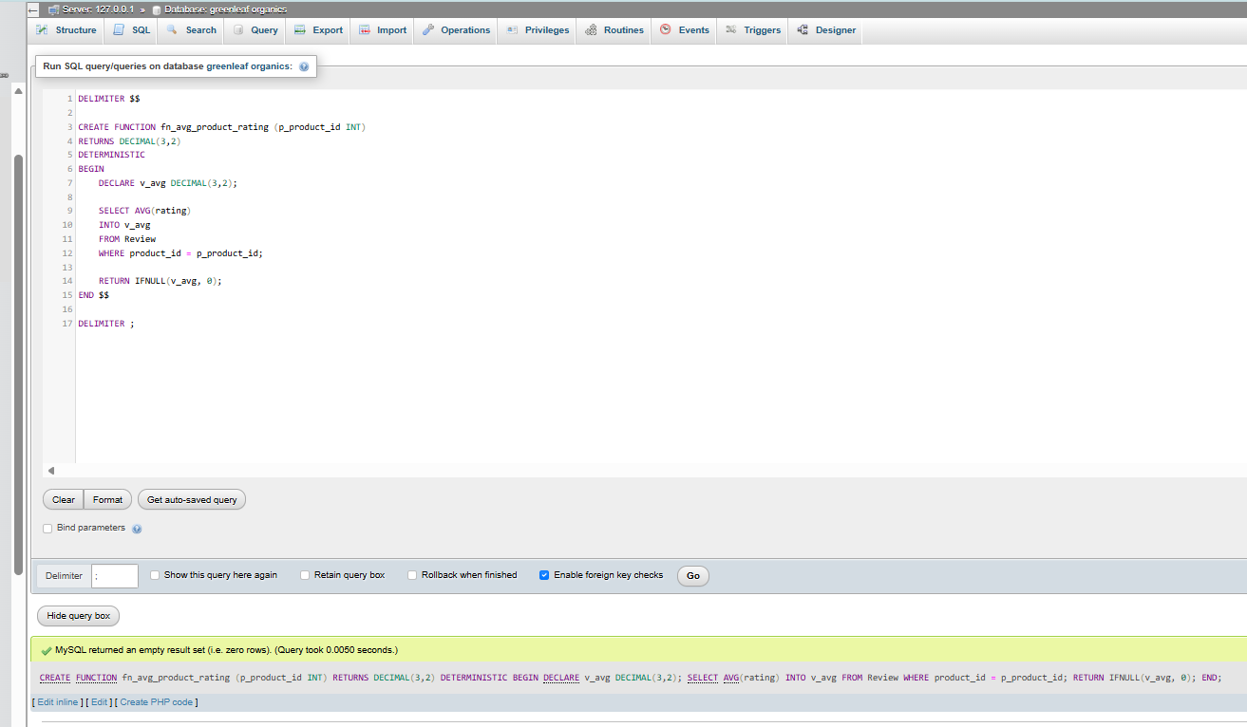
Figure 30 Figure 10 shows the successful creation of a user-defined function that computes the average rating for a given product. The function uses an aggregate operation (AVG) on the Review table and returns a calculated value. This highlights the use of functions to improve efficiency, reusability, and support advanced data analysis within relational database systems.
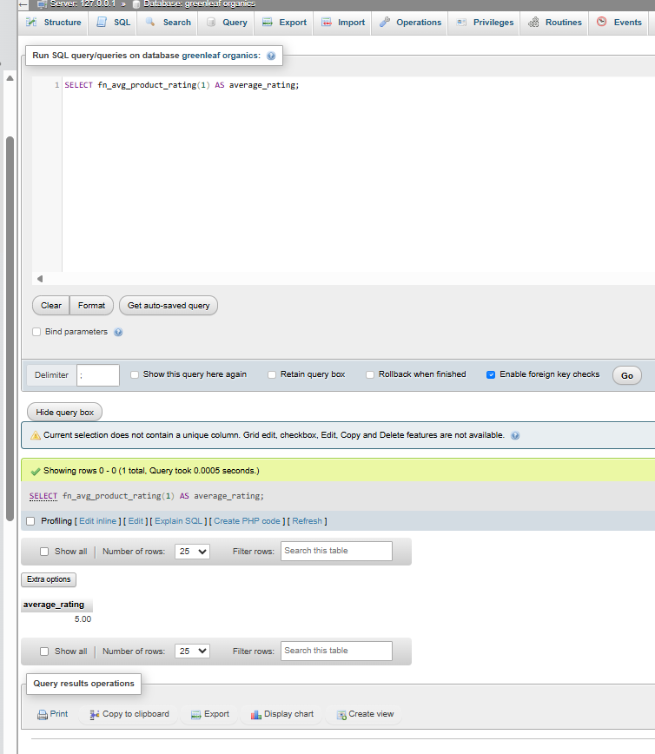
Figure 31 Figure 11 shows the execution of a user-defined function in phpMyAdmin used to calculate the average rating of a product. The SQL query calls the function with a specific product ID, and the result displays the computed average rating (5.00). This demonstrates how functions can be used to perform reusable calculations and support analytical queries within the database system.

V. Indexes Creation

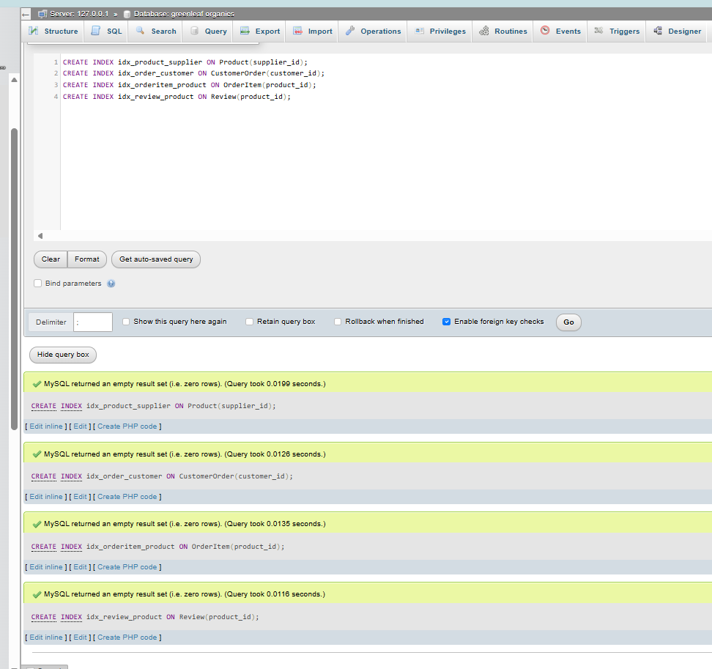
Figure 32 Figure X shows the creation of indexes on key columns within the database to improve query performance. Indexes were applied to frequently accessed attributes such as foreign keys, enabling faster data retrieval and more efficient execution of join operations.
To improve performance, indexing was added to frequently queried fields. Suitable indexes include supplier_id in Product, customer_id in CustomerOrder, product_id in OrderItem, and product_id in Review. These indexes were chosen because they support the most common joins and filters used in product browsing, order history retrieval, and review display. Indexes improve search speed by reducing the need for full table scans, which is especially important as transaction volumes increase. However, indexing must be applied carefully because excessive indexing can slow inserts and updates. For GreenLeaf Organics, the chosen indexes reflect a reasonable balance between transactional efficiency and query performance . To enhance database performance, indexing was implemented on frequently accessed attributes within the system. Specifically, secondary indexes were created on foreign key columns, including supplier_id in the Product table, customer_id in the CustomerOrder table, and product_id in both the OrderItem and Review tables.[16] These columns were selected based on their involvement in common query operations such as joins, filtering, and data retrieval for product listings, order histories, and customer reviews.The use of indexing significantly improves query execution efficiency by reducing the need for full table scans and enabling faster data access through indexed search paths. This is particularly important in transactional systems where large volumes of data are processed and retrieved regularly. However, it is also acknowledged that excessive indexing may negatively impact write operations, such as INSERT and UPDATE, due to additional overhead in maintaining index structures.Therefore, a balanced indexing strategy was adopted to optimise read performance while maintaining acceptable write efficiency. This approach ensures that the database system for GreenLeaf Organics can support scalable and efficient operations, aligning with best practices in relational database performance tuning [17].Furthermore, indexing contributes to improved scalability by ensuring that query performance remains efficient as the size of the dataset increases, making it suitable for growing e-commerce platforms.

VI. Conclusion
This report focused on the design and implementation of a relational database system for GreenLeaf Organics, developed to support its growing online operations. The database was designed based on the business requirements and translated into a structured and well-organised system. Key entities such as Supplier, Customer, Product, Category, CustomerOrder, OrderItem, and Review were created and linked using primary and foreign keys. In addition, normalization to Third Normal Form (3NF) was applied to reduce redundancy and ensure data consistency throughout the database.During the implementation phase, several important database concepts were applied in practice. Stored procedures were used to perform CRUD operations in a controlled and reusable way. Transaction management using COMMIT and ROLLBACK was implemented to ensure that multi-step processes, such as placing an order, are completed safely without causing data inconsistencies. Triggers were also introduced to automatically record changes in the database, while indexing was used to improve query performance and speed up data retrieval. Together, these features helped create a reliable and efficient database system.From a personal perspective, this project helped me better understand how relational databases work in real-world scenarios. One of the main challenges I faced was dealing with foreign key constraints and ensuring that data was inserted in the correct order. I also encountered errors when working with transactions and functions, which required debugging and problem-solving. These challenges helped me develop a deeper understanding of data integrity, error handling, and the importance of careful planning in database design; this assignment improved my practical skills in database design and implementation. In the future, the system could be improved by adding features such as user authentication, enhanced security, and further performance optimisation for handling larger datasets. This project has given me valuable experience in building a complete database system that meets real business requirements.Overall, the implementation successfully transformed the GreenLeaf Organics ERD into a functional relational database prototype. The database supports realistic business operations, maintains data integrity through keys and constraints, allows data testing with sample records, and demonstrates more advanced features such as stored procedures, transactions, triggers, and indexing.

VII. References
[1] T. Connolly and C. Begg, Database Systems: A Practical Approach to Design, Implementation, and Management, 6th ed. Harlow, UK: Pearson, 2015.
[2] A. Silberschatz, H. F. Korth, and S. Sudarshan, Database System Concepts, 7th ed. New York, NY, USA: McGraw-Hill, 2020.
[3] R. Elmasri and S. B. Navathe, Fundamentals of Database Systems, 7th ed. Boston, MA, USA: Pearson, 2016.
[4] C. J. Date, An Introduction to Database Systems, 8th ed. Boston, MA, USA: Pearson, 2004.
[5] P. Rob and C. Coronel, Database Systems: Design, Implementation, and Management, 12th ed. Boston, MA, USA: Cengage Learning, 2019.
[6] H. Garcia-Molina, J. D. Ullman, and J. Widom, Database Systems: The Complete Book, 2nd ed. Upper Saddle River, NJ, USA: Pearson, 2008.
[7] A. Silberschatz, H. F. Korth, and S. Sudarshan, Database System Concepts, 7th ed. New York, NY, USA: McGraw-Hill, 2020.
[8] T. Connolly and C. Begg, Database Systems: A Practical Approach to Design, Implementation, and Management, 6th ed. Harlow, UK: Pearson, 2015.
[9] R. Elmasri and S. B. Navathe, Fundamentals of Database Systems, 7th ed. Boston, MA, USA: Pearson, 2016.
[10] T. Connolly and C. Begg, Database Systems: A Practical Approach to Design, Implementation, and Management, 6th ed. Harlow, UK: Pearson, 2015.
[11] A. Silberschatz, H. F. Korth, and S. Sudarshan, Database System Concepts, 7th ed. New York, NY, USA: McGraw-Hill, 2019.
[12] R. Elmasri and S. B. Navathe, Fundamentals of Database Systems, 7th ed. Boston, MA, USA: Pearson, 2016.
[13] A. Silberschatz, H. F. Korth, and S. Sudarshan, Database System Concepts, 7th ed. New York, NY, USA: McGraw-Hill, 2020.
[14] T. Connolly and C. Begg, Database Systems: A Practical Approach to Design, Implementation, and Management, 6th ed. Harlow, UK: Pearson, 2015.
[15] R. Elmasri and S. B. Navathe, Fundamentals of Database Systems, 7th ed. Boston, MA, USA: Pearson, 2016.
[16] C. J. Date, An Introduction to Database Systems, 8th ed. Boston, MA, USA: Addison-Wesley, 2004.
[17] A. Silberschatz, H. F. Korth, and S. Sudarshan, Database System Concepts, 7th ed. New York, NY, USA: McGraw-Hill, 2020.

