University Of Wales Trinity Saint David

Wales institute of science and arts



Passive RC Filter Networks

Electrical and Electronic Principles (ACDB4002)

Jacob Christian Jones

2005053

February 2023

Table of Contents
1. Abstract 3
2. Introduction 4
3. Circuit Description 5
4. Results 6
5. Discussion 8
6. Conclusion 10
7. References 11

Abstract

This report will cover the two common types of filters used to filter sound from an input signal. An experiment was carried out to gather the results required to create attenuation characteristic graphs for low pass and high pass filters. From these graphs, analysis of the cut off frequencies were made. Resulting in the low pass showing a high cut off frequency and the high pass showing the opposite. These results were expected as in theory, low pass filters have a higher frequency cut off due to the design of the circuit. The designs for both circuits can be seen in the circuit description section of this paper. Overall, this report provides the basic information and analysis of both high pass and low pass filters.

Introduction

Passive RC filter networks consist of two types of circuits: low pass filters and high pass filters. The primary difference and applications of these two types of circuits are as followed: A Low pass filter allows lower frequencies to pass through the filter while attenuating a higher frequency (Schlette, 2021). Due to the low pass filter’s ability to cut off at a high frequency it is used in radio receivers. A high pass filter allows higher frequencies to pass through the filter while attenuating a lower frequency (Schlette, 2021). This filter is also used in radio receivers to attenuate low-frequency noise (Rajiv, 2022).

The aim of this report is to analyse the frequency and attenuation results produced by the above circuits. These results will be used to create the appropriate graphs required to show the -3 decibels cut off point for both filters. In theory, the low pass filter should allow for a higher frequency cut off as it has the ability to attenuate at a higher frequency. The opposite result would be expected for the high pass filter.

Circuit Description

As briefly covered in the introduction section of this report, the two types of circuits in question are high and low pass filters. The circuits will be connected to a function generator and an oscilloscope simultaneously. The purpose of the function generator Is to apply waveforms such as sine waves to a device (Keysight, 2018). A controlled frequency will be applied to both circuits ranging between 0hz and 300kHZ. Theoretically, the low pass filter should allow lower frequencies to pass through but attenuate at a higher frequency. The opposite should be expected for the high pass filter. The function generator is also used to set the voltage output, for this experiment the voltage value should read 5V peak-to-peak. The oscilloscope is now used to measure the voltage out of the circuit. This is done by measuring the peak height of the sine waves. One peak of the wave should measure 5 volts.

The following diagrams display how both filters should be correctly set up.

Figure 2. Passive high pass filter
Figure 1. Passive low pass filter

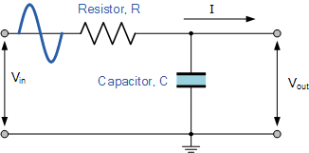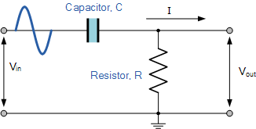

The values of the resistors and capacitors are as followed:

 | Resistor | Capacitor
Low pass filter | 10k$Ω$ | 560pF
High pass filter | 10k$Ω$ | 15nF
Figure 3. Table displaying the values for the resistors and capacitors of both high pass and low pass filters.

Results

Low pass filter:

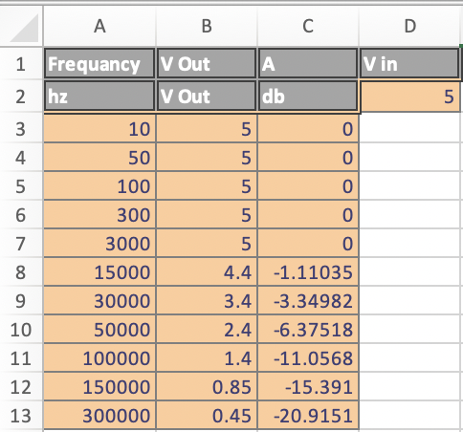
Figure 4. Excel spreadsheet displaying the frequency applied, Voltage in and voltage out and the attenuation recorded.

Frequency applied ranging between 10HZ and 300KHZ.

Figure 5. Scatter graph using a logarithmic scale plotting the voltage out recorded against the frequency applied to the low pass filter.

Figure 6. Scatter graph using a logarithmic scale plotting the attenuation values gained against the frequency applied to the low pass filter.

High pass filter:

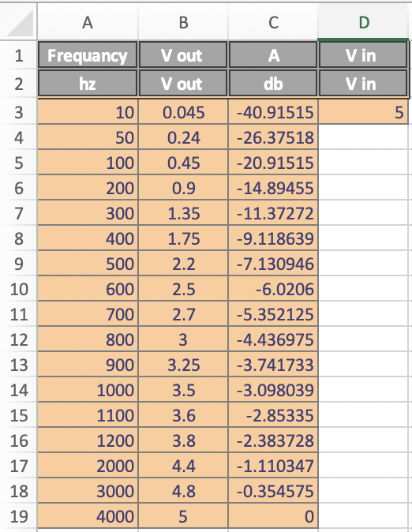
Figure 7. Excel spreadsheet displaying the frequency applied, voltage in and out and the attenuation recorded.

Frequency applied ranging between 10HZ and 4KHZ.

Figure 8. Scatter graph using a logarithmic scale plotting the voltage out recorded against the frequency applied to the high pass filter.

Figure 9. Scatter graph using a logarithmic scale plotting the attenuation values recorded against the frequency applied to the high pass filter.

Discussion

Low pass filter:

The figures shown on page 6 display all the results gathered from the experiment for the low pass filter. From figure 4 It can be seen that the frequency applied to the circuit reaches a maximum of 300KHz whilst attenuating at -20.9151Db. This proves that a low pass filter allows lower frequencies to pass through whilst attenuating at a higher frequency. For example, the filter allows a minimum of 3KHz to pass through before showing any attenuation. 3KHz is also the value of frequency that causes a decrease in voltage out. This is due to the drop in capacitor impedance. When looking at figure 6, it shows that the circuit attenuates -3.34982db at a frequency of 30KHz. This is as close to the cut off frequency of the low pass filter that could be acquired. The formula to calculate the cut off frequency is to find at what frequency the voltage out drops below 70.7% of the initial voltage applied. If this formula was used on the results for the low pass filter it would show 3.535V. The real result recorded from the lab shows 3.4V. The difference in the voltage values is caused by the 10KΩ resistor.

High pass filter:

Page 7 displays the results gathered and graphs plotted from the high pass filter experiment. Figure 7 shows that the frequency applied to the circuit only reaches a maximum of 4KHz while attenuating at 0Db. This proves that the high pass filter allows higher frequencies to pass through while attenuating at a lower frequency. This can be seen when looking at the initial frequency applied to the circuit. A 10Hz frequency will display an attenuation of -40.91515db. Looking back at the maximum frequency applied to the circuit (4KHz), it shows that this is the frequency at which the voltage out returns to the original voltage in value (5V peak-peak). When looking at figure 8, it can be gathered that the circuit attenuates -3.098039db at a frequency of 1Khz. This is the cut off frequency of this high pass filter. 1Khz shows a voltage out of 3.5V which is almost 70.7% of the initial input voltage (0.035V difference between theoretical and the results recorded). Similar to the low pass filter, the difference in voltage values is more than likely caused by the 10KΩ resistor used in the circuit.

Comparing both Circuits:

The first comparison that can be seen when analysing the results of both circuits is the difference in frequency values. The high pass filter reaches a maximum frequency of 4Khz, whereas the low pass filter does not attenuate or show a drop in voltage until a frequency of 3Khz is applied. This is due to the ability of the low pass filter to allow low frequencies to pass through while attenuating at a higher frequency than that of a high pass. Another difference that can be seen is the varying values of sound recorded from the two circuits. The high pass filter attenuates a maximum of -40.91515Db, almost double the value recorded for the low pass at -20.9151Db. This is due to the circuits attenuating different sounds at different frequencies. Figure 4 shows the decibels increasing with the frequency whereas figure 7 shows the attenuation decreasing as the frequency applied is increased. The last comparison to be made is the cut off frequencies of both circuits. Both filters have similar cut off frequencies showing 3.4V for the low pass and 3.5V for the high pass. Both values are almost 70.7% of the input value (the theoretical value). The slight difference in values could be caused by the tolerances of the equipment used. Both circuits were performed using different machines on two separate occasions.

Conclusion

In this experiment, it has been determined that low pass and high pass filters react to increasing frequencies very differently. Low pass filters allow 300Khz frequencies to travel through before the voltage out almost reaches 0V. the high pass filter only allows 4Khz to travel through before the voltage out returns to the original input voltage. The cut off frequencies for the filters display two very different results. The low pass filter shows a cut off frequency of 30KHz, a value that’s 29KHz larger than the cut off frequency of the high pass filter. Both sets of results gained from this experiment create very different graphs. Looking at all 4 graphs (Figures 5,6,8,9) it can be seen that the filters create almost opposite looking graphs. This can be explained by the functions and uses for both circuits briefly covered in the Introduction section of this report. This investigation has proved that both circuits should be used in radio receivers to filter out various frequencies.

References

- Schlette, R. (2021) Complete Guide to Audio Pass Filters: High, low & everything in-between, Pro Audio Files. Available at: https://theproaudiofiles.com/audio-pass filters/ (Accessed: February 14, 2023).
- Rajiv (2022) Low pass, high pass and band pass filters - simple explanation, RF Page. Available at: https://www.rfpage.com/low-pass-high-pass-and-band-pass filters-simple-explanation/ (Accessed: February 14, 2023).
- Storr, W. (2022) Low pass filter - passive RC filter tutorial, Basic Electronics Tutorials. Available at: https://www.electronics-tutorials.ws/filter/filter_2.html (Accessed: February 20, 2023).
- Keysight (2018) Waveform and function generators, Keysight. Available at: https://www.keysight.com/gb/en/products/waveform-and-function-generators.html (Accessed: February 20, 2023).

