Utilising the Entrecomp Framework, critically evaluate your own creativity and enterprise skills and consider how you might be able to develop the creative and enterprising skills of primary learners through your own pedagogy.
This assignment explores the Entrecomp framework with assessing my own creativity and enterprise skills and giving ways forwards to improve my skills. Through research and experience the way to develop children’s creative and enterprise skills will be considered through this essay whilst weighing up the benefits and limitations. Defining creativity can be difficult as many people have different views on the definition. Cowley (2005) suggests that creativity is not only an activity but an attitude enabling you to be imaginative and innovative in everyday life not just in lessons such as art and drama. This relates to lateral thinking (deBono, 1968) and brainstorming (Osborn, 1953) by using the mind to be creative which Boden (2009) and Johnson-Laird (1988) agrees as they suggest that creativity is the generation of ideas that are unique. However, Joubert (2001) suggests that even with a definition, creativity is interpreted in different ways which has led to creativity declining in schools with the lack of knowledge and skills about creativity, pressures on teachers to obtain targets and children to achieve in national tests (Desailly, 2015 and Thorne, 2007). Plowden (CACE, 1967) believes that creativity is influenced by social systems rather than attitudes as he suggested that creativity is child led learning, discovery learning and a cross-curricular curriculum. On the other hand, Wilson (2010) suggest there are challenges with Plowden’s pedagogy as children need knowledge in order to be able to use their imagination and connects play with creativity and not all play is actually creative.
Enterprise skills have an important connection with creativity as they equip children with the ability to put their creative ideas into action (Fumoto et al., 2012). Warwick University (2016) suggests that enterprise skills include creative, decisive, collaborative and confidence skills which are vital skills for learners to develop to be able to survive in the real world. Donaldson (2015) believes that both creativity and enterprise are the heart of modern life so need to be developed in schools and Estyn (2017) show good practice of Kitchener Primary School building enterprise skills into their curriculum by using local contexts and suggestions from the pupils in what they want to learn making it more meaningful in order to become enterprising, creative contributors. However, Sutton (2011) believes that enterprise and creativity is not always positive as it requires to fail a few times and therefore very time consuming and inefficient. Although in Successful Futures (Donaldson, 2015) the building of the resilience is key to success, so allowing learners to fail builds their resilience making them more likely to succeed in the future but it must be done in a safe environment that the learners are comfortable in (Erwin, 2016).
Creativity and enterprise have many benefits for a teacher as they allow learners to become independent learners and encourages their thinking skills. Giving learners the opportunities to use their thinking skills enables them to be able to construct their own knowledge rather than just listening to knowledge given to them by the teacher which allows the learning to be more memorable and being able to apply the knowledge to different contexts (Craft, Cremin and Burnard, 2008 and Dewey, 1938). It allows children to be able to think outside the box beyond the obvious solution and reach goals more quickly by becoming good problem solvers and resulting in more neural connections in the brain being made (Thorne, 2007 and deBono, 2016). Children are more inquisitive than adults by allowing them to think outside the box it will help them see things in different light to what the teachers see. The flexibility of children increases with the use of creativity and enterprise skills as they are more able to bounce back from mistakes, select which learning strategy they need and combine knowledge together in order to solve a problem increasing their attainment (Anderson 2002 and Deak and Wiseheart, 2015). Teachers exposing their learners to creativity allows them to produce more originality so that the learners are able to look at the same thing and see something different making teaching more exciting and widening their thinking skills (Von Oech, 2008). The relationship between teachers teaching creatively and learners’ development of creativity is vitally important as teaching creatively makes the learning more engaging and therefore learners’ creativity is more likely to be developed (Jeffrey and Woods, 2003 and Jeffrey and Craft, 2004). The creative teaching gives the school an welcoming ethos as the children have a more hands on approach to their learning developing not only their creativity and enterprise skills but also their independence and confidence which is vital to embed the four purposes of the new curriculum (Donaldson, 2015 and Craft, 2002).

On the other hand, there are challenges of teachers being creative and enterprising in the classroom as creativity traditionally originates in the arts and those teachers who have an arts background tend to be seen more creative, leaving those without an arts background feeling like they are not creative (Sawyer, 2015).The arts are believed to enable learners to deeper their understanding of other subjects by integrating the arts into other subjects as it enhances their creativity, enterprise skills and critical thinking engaging more learners (Efland, 2002 and Burnaford, 2007). However, this is not the case as creativity increases cognitive skills that can be used across the curriculum not only in arts, resulting in being able to be more flexible and open minded (Eisner, 2002 and Gardner, 2007). Creativity is not always what the teacher necessarily wants in learners as they want them to comply with what they are told and not to question the teacher as they should do as they are told therefore suppressing learners’ creativity (Todd et al., 2018). This also links to that creativity and enterprise are time consuming as learners need time to be able to explore, be curious and ask questions in order to deepen their understanding (Thorne, 2007) and 9% of teachers have left the workforce due to the pressure they are under as there is not enough time to do their basic teaching and being able to be creative in the current curriculum restricts creativity as there is a priority on numeracy and literacy (Tapper, 2018 and Craft, 2005). However, Estyn (2016) believe that teaching creatively and the use of enterprise skills are beneficial to learners as it develops their thinking skills and resilience in all areas of the curriculum improving their confidence and motivation to learn which is embedded in the new curriculum (Donaldson, 2015). Teachers find creativity hard to measure and assess as in the current curriculum there is no assessment for creativity however, there is believed to be two types of tests for creativity one which involves cognitive skills like the Torrance test and the other which observes personality traits such as the Alpha Biological Inventory (Plucker and Makel, 2010). It all depends on what an individual defines creativity as whether it is cognitive skills or personality traits so there is no consistency, but the two tests could be taken into consideration and give an overall score for the two tests combined.

The Entrecomp framework is a framework to make a connection between education and the workplace to enhance entrepreneurship skills and can be used in any context from schools to youth groups (Bacigalupo, M., 2016). However, entrepreneurship skills are not being looked at in this assignment but the framework identifies three competences areas that can be used for creativity and enterprise and could be embedded in a curriculum to help learners to actively participate in society and enter the job market once they have left school (Donaldson, 2015). Each area of competence is broken down into five competences with fifteen competences in total developing along an eight level progression steps which provide learning outcomes and ways forward. The framework would be useful for teachers in order to assess their learners’ creativity and enterprise skills as it gives hints and descriptors to elaborate each competence and gives the next steps which is vital for progression (Black and Wiliam, 1998). It is also useful to identify any gaps in learners’ knowledge and be able to see how to address the gaps and move forward (McCallum, et al., 2018). On the other hand, when assessing against the levels is not always clear what level to give as learners may have different elements of different levels which would then lead to the level of best fit. Also, levels seven and eight are more focused on business levels that teachers or learners would not reach but could be useful for those wanting to go into the business sector as it shows a continuum of learning from foundation to expert. The Entrecomp framework is an simple and easy overview of the framework through a simple diagram and connects competence together however, as there are fifteen competences it can be very confusing and hard to manage so many but this could be overcome by choosing two or three to concentrate on to allow less confusing and more depth into fewer competences as the framework is flexible. Using the Entrecomp framework allows teachers to deepen their understanding about how to develop their own and children’s creativity and enterprise skills and is easily adaptable to suit each individual learner as everyone has a different starting point (Bentley and Miller, 2006). Some of the competences and threads within the framework are vague and not always tailored towards the teaching of creativity and enterprise skills so can be difficult to use. The difficulty of teachers using this framework is being able to find the time and funding to train the teachers as this has not been the focus of the curriculum before. This could be done by having one leader for creativity and enterprise for each school, who is trained and then teaches the school how to use the framework and monitors the use of the framework throughout the school.

The creativity competence of the Entrecomp framework is encouraging the development of creativity and purposeful ideas. The creativity competence is then broken down into five threads that will be used to assess my own creativity. The first thread is to be curious and open; I would assess myself at level two which is I can explore new ways to make use of existing resources. Whilst on PTE, the class theme was animals habitats and the learners were learning the story about the three little pigs, I wanted to make the story more exciting for the children by them experiencing the wolf huffing puffing so I used a hairdryer with a picture of a wolf stuck on it to blow at the children (see Appendix 1). Duncker (1945) believes this is called overcoming functional fixedness as it is using an object other than its normal use to overcome a problem. The next level which is level three is to experiment with my skills and competences in situations that are new to me and be more willing to take risks. However, I do believe that in the situation with the hairdryer, I did take some risk using it as I did not know whether it would work well for the story and if the children would enjoy it. On the other hand, overall, I believe I do not take enough risks in situations that are new to me, so I have to be more open to risks and trust myself in order to improve my creativity and enterprise skills (Wilson, 2010). In order to take more risks I have to learn to fail as this is part of being able to take risks as they are not always going to succeed but the failures will allow me to be able to see them as challenges and help me to reflect on my own development enabling learners to see that failure can help us learn and is an adventure leading us to be more successful (Costa and Kallick, 2008). Knowing that sometimes we fail will allow me to come up with a plan if it does fail so that I am positive about taking risks so prepared for the worst and more excited about the outcome (Chang, 2017). Risk taking is important to increase motivation and cognitive development in order to solve problems by thinking creatively and using enterprise skills to enhance leadership skills (Clifford, 1991 and Gaissmaier and Gigerenzer, 2008). However, risk taking can lead to feeling unemotionally safe in an environment leading to withdrawal and not being to take risks (Ames and Archer, 1988 and Koh, Yeo and Hung, 2015) but this can be solved by immersing myself and creating an environment that is safe to take risks and learn from the mistakes.

The second thread of the creativity competence is to develop ideas which I believe I am at level three which is being able to experiment with different techniques to generate alternative solutions to problems, using available resources in an effective way by prototyping. When creating a Rube Goldberg machine in university, I had to collaborate which is part of level two with my peers to come up with solutions to pop a balloon with a pin in a complicated way (see lecture attendance). In order to develop on to level four which is to be able to test the value of my solutions with end user. I could achieve this by trialling the machine as I go along in order to know if it works. Kolb’s (1984) experimental learning cycle would be a model I could follow in order to improve my action research and trialling as it has four stages to the model: concrete experience, reflective observation, abstract conceptualisation and active experimentation. The use of this model would allow for me to be able to test hypothesis in the future resulting in new experience and testing the value. As the model is a continuous cycle, I could enter the cycle at any stage to suit my individual needs however, I could need to complete the cycle in order for the model to successfully improve my ability to test the value of my solutions. Action research allows teachers to become more effective when reflecting on their own work and giving solutions to their problems as a way forward and working more collaboratively (Watts, 1985 and Welsh Government, 2010). It is also beneficial in improving thinking skills and changing attitudes to become more willing to change as you learn about yourself and your learners in the process making it more worthwhile (Ferrance, 2000). On the other hand, Hammersley (2002) believes that action research contradicts itself as the two words portray to very different things and often the solutions cannot always be applied to everyday practice. But Hammersley (2002) does acknowledge that some of the ideas of action research such as Dewey’s idea that knowledge can be deepened through an experience by doing.

The third thread of the creativity competence is to define problems which I would assess myself at level one which is approaching open ended problems with curiosity. I had enjoyment when faced with the challenge of creating the highest sculpture with hard spaghetti with a marshmallow on the top (see lecture attendance). The challenge made me have a sense of awe and wonder of how I was going to complete the challenge making me more enthusiastic and passionate about the challenge in front of me (Costa and Kallick, 2008). Level two is being able to explore open-ended problems in many ways so as to generate multiple solutions which I was unable to do on the marshmallow challenge as I had one idea of how to complete it and did not think of anymore. In order to become level 2, I need to improve my divergent thinking by being more flexible and fluent in my thinking. Divergent thinking is the ability to give many solutions to an open-ended problem (Fumoto et al., 2012). Parnes (2004) suggests that divergent thinking should follow these guidelines of deferring judgement, combine and build, seek wild ideas and go for quantity which allows the brain to focus and generate numerous ideas. Parnes’ (2004) guidelines do allow for structure for divergent thinking however, divergent thinking should be more free flow where creative thinking is in deep concentration and more productive (Csikszentmihalyi, 1990). Brainstorming would allow me to develop my divergent thinking as it offers versality to solve problems and promotes creative thinking but also enables creative collaboration with others to explore everyone’s solutions (Osborn, 1953). Working with others allows to learn from each other and ensures a better outcome for everyone (Vygotsky, 1978 and Welsh Government, 2010). Osborn (1953) generated his idea of brainstorming for groups to find solutions for problems but on the other hand, I believe it would work well for individuals like myself how need more support to enable their divergent thinking.

The fourth thread of creativity is design value which I would assess myself at level one which is being able to assemble objects that create value for me and others. Whilst on PTE, the role play area was set up as a travel agents for the class theme travel so I assembled a chocolate stand from a supermarket to create a stand for travel brochures for the travel agents which created value for myself and the learners to make the travel agents more realistic (see Appendix 2). Norton, Mochon and Ariely (2011) believe that when assembling objects ourselves we see more value and pride in that object than preassembled objects which they call the ‘Ikea effect’. However, level three is being able to improve existing products, services and processes so that they better meet my needs or those of my peers and the community. In order to achieve level three of the creativity competence is using the SCAMPER technique (Eberle, 1971) which would enable me to develop or improve existing products for my own or other’s needs. This technique allows for seven different methods substitute, combine, adapt, modify, put to another use, eliminate and reverse/rearrange to find creative and unusual ways to solve problems. It is a learning tools that allows the development of originality, fluency and flexibility which are vital to creativity and enterprise (Fumoto et al., 2012 and Woods, 1995). On the other hand, the ideas that are created through SCAMPER must then be reflected on and most viable and feasible answers chosen but this does hinder the creativity by not exploring the least viable but this could be overcome by prototyping one or two least viable ideas to foster creativity and enterprise. Also, when using the SCAMPER technique, the environment must be taken into consideration as the application of creativity and enterprise is fostered by its environment so the staff and learners must allow for mistakes and take risks to create an enabling environment (Serrat, 2010).

The final thread of creativity is be innovative which I believe myself to be at level one which is to find examples of innovative products, services and solutions. On PTE, I wanted to make the introduction of the lesson more exciting for the learners and recap what they had learnt in the previous lesson so found an interactive quiz online called Kahoot! (see Appendix 3). Kahoot! uses one of SCAMPER methods of combining a quiz and the internet together to produce an innovative product (Eberle, 1971). To move on to level two is to describe how some innovations have transformed society would be assessing how the value product or service to society. Spencer, Lucas and Claxton (2012) created a five dimensional model of creativity which allows for the assessment of creativity which was originality created for teachers to be able to assess their students but I believe it can be used as a tool to describe how some innovations have transformed society. The five sections to the model are inquisitive, imaginative, persistent, disciplined and collaborative which direct thinking to particular areas in order to be able to describe it. This model also allows for the development of deeper understanding of innovations as it based in real world context and also develop the habits of mind (Lucas, 2016, Barnes, 2015 and Costa and Kallick, 2008). However, one dimension of the model is collaborative which not necessarily be applicable if working on your own so that could be adapted to inclusion to assess whether the product works for other people in order to describe how it transformed society.

The competence taking the initiative portrays being able to take up challenges, work independently and having the resilience to achieve goals. This competence has links to enterprise skills being able to generate ideas and having the skills to make them happen. The thread to be able to work independently I would identify myself at level five which is being driven by the possibility of being able to initiate simple value-creating activities as on PTE I created a penguin shape feeding game as the engagement and learning of the children gave me the drive to create the game (see Appendix 4). Through the creation of this activity gave me the resilience to succeed as I wanted to create something that made learning about shapes exciting for the children (Costa and Kallick, 2008). The next level 6 is being able to initiate value-creating activities alone and with others. Working with others allows for more divergent thinking increasing the fluency and flexibility of ideas (Guilford, 1967). Teamwork is often seen as the vehicle for creativity and enterprise (Sutton and Hargadon, 1996) and can help overcome blocks to creativity. When on PTE next, I will plan and share ideas with the class teacher to increase the amount of ideas and creativity in my teaching, making the learning more enjoyable for the children. However, Osborn (1953) believes that group work can sometimes lead people to not sharing their ideas as they do not think they will be valued in the group, but this can be resolved by ensuring that at the beginning of group sessions the group is reminded that any idea is valuable.

Creativity and enterprise skills are vital to children as they are believed to create new memory structures in the brain by the connecting of new and existing concepts (Mumford, Mobley, Uhlman, Reiter-Palmon and Doares, 1991 and Scott, Lonergan and Mumford, 2005). Education Scotland (2013) suggests that creativity and enterprise skills allow children to make connections with their learning and the real world, learn from their mistakes and enables them to use their imagination to explore new possibilities. Creativity is top of Bloom’s revised taxonomy (Anderson and Krathwohl, 2001 and Welsh Government, 2010) as he believes that learning is more than remembering facts, it is about the creation of new ideas and concepts which Donaldson (2015) has put at the heart of Successful Futures more about learning to than learning about. The world is becoming more dynamic and more complex, so children need to be able to be flexible, problem solvers and take risks even if they are wrong (Hunter-Wright, 2018). The use of enterprise and creativity skills allow children to have an improved self-esteem which helps to build their motivation and gives a sense of fulfilment improving their well-being with an example of Llanyafron Primary School have used creative and enterprise skills in a real-life context to improve pupils’ well-being (Cowley, 2005 and Estyn, 2014). The importance of creativity and enterprise is vital for the economy growth as businesses need creative and innovative employees who have more opportunities in the job market as businesses want to evolve and be original (Landry, 2017). Pink (2006) argues that creativity and enterprise skills are irreplaceable by computers as humans have empathy and innovation that enables you to have an advantage by adding value to a product or service which is needed for successful businesses. Welsh Government (2014) suggests that allowing learners to be more creative and to have enterprise skills it will allow them to improve their attainment in all areas of learning and experience, reduce the attainment gap as Successful Futures is a continuum of learning making it more inclusive for all learners to achieve and improve their confidence to go on to higher education.

The benefits of creativity and enterprise skills for children is vast as it enables them to problem solve especially in areas like science and technology to create new ideas and collaborate with others (Ugur, 2004). Woods (1995) suggests that it allows for children to have more control and ownership of their learning enabling them to be motivated and engaged in their learning (Bruner, 1973). Academic standards can rise by the use of creativity and enterprise as it does not concentrate on the children who are academic, creativity is inclusive, finding out what the children are good at and using that to improve their confidence will therefore raise their academic achievement (NACCE, 1999). It also allows for the children to express themselves, finding out who they are and how they fit into the world around them (Hobson, 2002) and builds their resilience in working alone to develop their creative thinking (Fumoto et al., 2012). When in a creativity and enterprise flow, children have a sense of enjoyment and fun which reduces stress and anxiety as they enjoy the process and sense of contentment (Csikszentmihalyi, 1990). It promotes children to be risk takers as it requires courage and fail and try again which is vital for the real world but must be done in an environment that they are supported by teachers (Wilson, 2010).

On the other hand, there are some challenges of creativity and enterprise skills for children as Oates (2018) believes that learning skills and not knowledge has huge implications to children as knowledge becomes lost. However, Gilbert (2010) believes that there is a great educational lie that you need knowledge to succeed, he believes that you need skills such as creativity and enterprise to be able to adapt to what the future holds and to make children indispensable. Also, time is a major problem with creativity and enterprise skills as children are not always given enough time to think creatively or given time limits which hinder the creativity as it takes time and can often be pressured to be creative at a particular time (Thorne, 2007). Giving children creative spaces and allowing them to move encourages creativity and not putting time limits on creativity would develop their motivation to be enterprising. In schools, children are encouraged to give the right answers not the wrong ones so many children find it difficult to take risks as teachers teach children to do things the right way and do not model making mistakes (Robinson, 2006).

With the assessment of my own creativity and enterprise skill, it will enable to develop my skills further in order to teach learners through my own pedagogy. In order for children to be creative they need to be aware of what creativity is and develop a creative frame of mind which is essential to in order to engage the children’s interest and take risks in their learning (Cowley, 2005 and Wilson, 2010). However, children to need to have built good relationships with the teacher in order to develop their creative thinking and enterprise skills as they need support and secure environment (Hobson, 2002). Therefore, I’m going to build trust with my learners by modelling myself making mistakes in front of them to show that making mistakes can be a learning experience, and help us grow (Bandura, 1977). Once the children feel supported and secure in the environment, to develop their creative thinking and enterprise skills I will give the children different scenarios with problems that need solving. To allow the children to use divergent thinking, a warmup activity I would give them would be a picture of a shoe and a time limit of 5 minutes to come up with many possible uses for a shoe, informing them the ideas can be as whacky as they like, by giving them explicit instructions encourages more creativity (Runco, 1986). On the other hand, although a time limit is given for the task it is important to portray to the children that I am not looking for a right answer but a variety of answers as they may not use their divergent thinking when under a time limit (Runco, 1990). After the warmup activity, I would give the children their different scenarios with problems to solve but to allow them to use divergent thinking I would give them the Whack pack cards with one each of the different roles, explorer, artist, judge and warrior. The use of the four roles would allow the children to put themselves in different frames of mind to ask different questions to then come to a creative solution exploring different elements of creativity and enhancing enterprise skills by searching for ideas and combining their knowledge and experience (Von Oech, 2008). Whilst the children complete this activity, the teacher would act as the facilitator to enhance their creativity by asking certain question to support the children’s thinking. Rogers (1967) believes that children learn through natural curiosity and through experiences that are encouraged by a teacher showing interest in their learning. However, when using the teacher as a facilitator it must be done with caution because Busch (2017) and Stevenson and Stigler (1992) believe that teachers are not always useful and can cause interruptions to children’s learning, stifling their creativity and having low expectations of their learners can led to a loss of motivation and their trail of thought. Therefore, I would recommend that teachers have high expectation of their learners, give them motivation by encouraging them that they can do it and listen to the children’s opinions and foster them showing that their opinions matter (Desailly, 2015). Through the use of the Whack pack cards it gives the children support they need in order to start thinking creatively and using enterprise skills. Once the children have completed many different scenarios using the cards in future activities, I would not use the cards but use the four roles that they have learnt to enhance their creative thinking. The Whack packs cards would be used for key stage two as it has been found that creativity and enterprise skills decline with age so they would need more support than foundation phase (Lau and Cheung, 2010). With foundation phase, I would change the roles to different types of animals, for example the explorer would be a cat, the artist would be a bird, the judge would be elephant and the warrior would be a tiger. Changing the roles for foundation phase allows the idea of the Whack pack more suitable for the younger children in order to develop and foster their creativity and enterprise. The use of these roles allows the children to assess their own creativity and enterprise skills resulting in the children becoming more independent in their learning, evaluate their own skills and see where they need to improve (Donaldson, 2015 and Black and Wiliam, 1998). On the other hand, getting the learners into the habit of using the roles and divergent thinking automatically will take time and repetition which teachers do not have much time but allowing children to become creative thinkers will be beneficial in the long term, so resilience is key.

In conclusion, I believe that the benefits of creativity and enterprise skills for both the teacher and the learner outweigh the challenges as they both deepen and develop their thinking in order to be successful in both education and the wider world. It is difficult to be a creative teacher when there are so many elements of teaching that you need to fit in but the importance for creativity and enterprise is priority. The world needs people who have different and original ideas in order to solve problems and have enjoyment in learning. I have found that I have many areas of weakness in creativity and enterprise skills, but I have identified ways forward to improve my skills which will also progress my professional development as a teacher. The framework is a useful resource to use for developing and assessing creativity and enterprise skills but levels are not always clear and not explicit enough so they can be interpreted differently. The use of divergent thinking is critical in improving both teachers and children’s creativity and enterprise skills which can be done through the use of Whack pack cards, brainstorming and the use of different creativity models such as Kolb’s (1984) experimental learning cycle. With the use of models and resources like Rube Goldberg’s machines helps to see the purpose and value of creativity and enterprise and enables thinking outside the box and reflecting on your own learning. Being more adaptable, seeing things differently helps to deal with uncertainty as creativity and enterprise skills enables teachers and children to adapt their thinking to the unknown preparing the for the real world.

References
Ames, C. and Archer, J. (1988) ‘Achievement goals in the classroom: Student’s learning strategies and motivation processes’, Journal of Educational Psychology, 80, pp. 260–267.
Anderson, P. (2002) ‘Assessment and development of executive function (EF) during childhood’, Child Neuropsychology, 8 (2), pp. 71-82.
Anderson, L. W. and Krathwohl, D. R. (2001) A taxonomy for learning, teaching, and assessing: A revision of Bloom's taxonomy of educational objectives. New York: Longman.
Bacigalupo, M., et al. (2016). EntreComp: The Entrepreneurship Competence Framework. Luxembourg: Publications Office of the European Union.
Bandura, A. (1977) Social learning theory. Englewood Cliffs: Prentice Hall.
Barnes, J. (2015) Cross-curricular Learning 3-14. 3rd edn. London: SAGE Publications.
Bentley, T. and Miller, R. (2006) ‘Personalisation: Getting the Questions Right’, in OECD (ed.) Schooling for Tomorrow – Personalised Education. Paris: OECD.
Black, P. and Wiliam, D. (1998) Inside the Black Box. Brentford: GL Assessment.
Boden, M.A. (2009) ‘Computer models of creativity’, AI Magazine, 30 (3), pp. 23-34.
Bruner, J. (1973) Going Beyond the Information Given. New York: Norton.
Burnaford, G. (2007) Arts integration frameworks, research and practice: A literature review. Washington: Arts Education Partnership.
Busch, B. (2017) ‘Research every teacher should know: setting expectations’, The Guardian, 10th November. Available at: https://www.theguardian.com/teacher-network/2017/nov/10/what-every-teacher-should-know-about-expectations (Accessed: 31st December 2019).
Central Advisory Council for Education in England (CACE). (1967) Children and their primary schools, Report of the Central Advisory Council for Education in England (The Plowden Report). London: HMSO.
Chang, J. (2017) ‘Afraid of Risks? How to be Bolder’, Success [blog]. 28th June. Available at: https://www.success.com/afraid-of-risks-how-to-be-bolder/ (Accessed: 23rd December 2019).
Clifford, M. M. (1991) ‘Risk taking: Theoretical, empirical, and educational considerations’, Educational Psychologist, 26 (3/4), pp. 263–297.
Costa, A. and Kallick, B. (2008) Learning and Leading with Habits of Mind: 16 Essential Characteristics. Virgina: ASCD.
Cowley, S. (2005) Letting the Buggers be Creative. London: Continuum International Publishing Group.
Craft, A. (2002) Creativity and Early Years Education. London: Continuum International.
Craft, A. (2005) Creativity in Schools: Tensions and Dilemmas. London: Routledge.
Craft, A., Cremin, T., and Burnard, P. (2008) Creative Learning 3-11 and How We Document It. Staffordshire: Trentham Books Limited.
Csikszentmihalyi, M. (1990) Creativity, Flow and the Psychology of Discovery and Invention. New York: Harper Collins.
Deak, G., ad Wiseheart, M. (2015) ‘Cognitive flexibility in young children: general or task-specific capacity?’, Journal of Experimental Child Psychology, 138, pp. 31-53.
deBono, E. (1968) New Think: The Use of Lateral Thinking in the Generation of New Ideas. New York: Basic Books.
deBono, E. (2016) Lateral Thinking: A Textbook of Creativity. London: Penguin.
Desailly, J. (2015) Creativity in the Primary Classroom. 2nd edn. London: SAGE Publications.
Dewey, J. (1938). Experience and education. New York: Macmillan.
Donaldson, G. (2015). Successful Futures. Cardiff: Crown.
Duncker, K. (1945) ‘On Problem Solving’, Psychological Monographs, 358 (270), pp. 1-113.
Education Scotland. (2013) Creativity Across Learning 3-18. Livingston: Crown.
Eisner, E. W. (2002) What can education learn from the arts about the practice of education? Available at: https://infed.org/mobi/what-can-education-learn-from-the-arts-about-the-practice-of-education/ (Accessed: 20th December 2019).
Efland, A. D. (2002) Art and cognition: Integrating the visual arts in the curriculum. New York: Teachers College Press.
Erwin, J.C. (2016) ‘Creating a Safe Environment for Students to Fail and Learn’, Free Spirit Publishing [blog]. 9th August. Available at: https://freespiritpublishingblog.com/2016/08/09/creating-a-safe-environment-for-students-to-fail-and-learn/ (Accessed: 17th December 2019).
Estyn. (2014) Business enterprise improving skills. Available at: https://www.estyn.gov.wales/effective-practice/business-enterprise-improving-skills (Accessed: 29th December 2019).
Estyn. (2016) Improving literacy through creative learning. Available at: https://www.estyn.gov.wales/effective-practice/improving-literacy-through-creative-learning (Accessed: 20th December 2019).
Estyn. (2017) A skills-based curriculum with more local contexts. Available at: https://www.estyn.gov.wales/effective-practice/skills-based-curriculum-more-local-contexts (Accessed: 17th December 2019).
Ferrance, E. (2000) Action Research. Rhode Island: LAB.
Fumoto, H. et al. (2012) Young Children’s Creative Thinking. London; SAGE Publications.
Gaissmaier, W. and Gigerenzer, G. (2008) ‘Statistical illiteracy undermines informed shared decision making’, ZEFQ, 102 (7), pp. 411–413
Gardner, H. (2007). Five minds for the future. Boston: Harvard Business School Press.
Gilbert, I. (2010) Why do I need a Teacher When I’ve Got Google? - The Essential Guide to the Big Issues for Every 21st Century Teacher. London: Routledge.
Guilford, J.P. (1967) The Nature of Human Intelligence. New York: McGraw-Hill.
Hammersley, M. (2002) ‘Action Research: A Contradiction in Terms?’, Proceedings of the Annual Conference of British Educational Research Association. University of Exeter, England, 12-14th September 2002. Available at: http://www.leeds.ac.uk/educol/documents/00002130.htm (Accessed: 24th December 2019).
Hobson, P. (2002) The Cradle of Thought: Exploring the Origins of Thinking. London: Macmillian.
Hunter-Wright, H. (2018) ‘The importance of creativity in education – developing creative intelligence’, Lord Wandsworth College [blog]. 11th January. Available at: https://www.lordwandsworth.org/news/2018-01-11/The-Importance-of-Creativity-in-Education-Developing-Creative-Intelligence (Accessed: 29th December 2019).
Jeffrey, B. and Craft, A. (2004) ‘Teaching creatively and teaching for creativity: distinctions and relationships’, Educational Studies, 30 (1), pp. 77-87.
Jeffrey, B. and Woods, P. (2003) The creative school: a framework for success, quality and effectiveness. London: Routledge.
Johnson-Laird, P.N. (1988) ‘Freedom and constraint in creativity’, in Steinberg, R.J. (ed.) The Nature of Creativity: Contemporary Psychological Perspectives. Cambridge: Cambridge University Press.
Joubert, M.M. (2001) ‘The art of creative teaching: NACCCE and beyond’, in Craft, A., Jeffrey, B. and Leibling, M. (ed.) Creativity in education. London: Continuum.
Koh, E., Yeo, J. and Hung, D. (2015) ‘Pushing boundaries, taking risks’, Learning: Research and Practice, 1 (2), pp. 95-99.
Kolb, D. A. (1984) Experiential learning: Experience as the source of learning and development (Vol. 1). Englewood Cliffs, NJ: Prentice-Hall.
Landry, L. (2017) The importance of creativity in business. Available at: https://www.northeastern.edu/graduate/blog/creativity-importance-in-business/ (Accessed: 29th December 2019).
Lau, S. and Cheung, P.C. (2010) ‘Developmental Trends of Creativity: What Twists of Turn Do Boys and Girls Take at Different Grades?’, Creativity Research Journal, 22 (3), pp. 329-336.
Lucas, B. (2016) ‘A Five-Dimensional Model of Creativity and its Assessment in Schools’, Applied Measurement in Education, 29 (4), pp. 278-290.
McCallum, E., et al. (2018) Entrecomp into Action: Get Inspired, Make it Happen. Luxembourg: Publications Office of the European Union.
Mumford, M.D., Mobley, M.I., Uhlman, C.E., Reiter-Palmon, R. and Doares, L.M. (1991) ‘Process analytic models of creative capacities’, Creativity Research Journal, 4, pp. 91-122.
NACCE (National Advisory Committee on Creative and Cultural Education). (1999) All Our Futures: Creativity, Culture and Education. Department for Education and Employment.
Norton, M.I., Mochon, D. and Ariely, D. (2011) The “Ikea Effect”: When labour Leads to Love. Boston: Harvard Business School.
Oates, T. (2017) ‘Individualised learning, personalised learning – just where did it come from and what does it mean?’, Council of British International Schools, 2nd May. Available at: https://www.cobis.org.uk/blog/individualised-learning-personalised-learning-just-where-did-it-come-from-and-what-does-it-mean (Accessed: 29th December 2019).
Osborn, A.F. (1953) Applied Imagination. Revised edn. New York: Scribner’s.
Parnes, S. (2004). Visionizing: Innovating your opportunities. (2nd edn.) Creative Education Foundation.
Pink, D. (2006) A Whole New Mind: Why Right-brainers Will Rule the Future. New York: Riverhead Books.
Plucker, J.A. and Makel, M.C. (2010) ‘Assessment of Creativity’, in Kaufman, J.C. and Sternberg, R.J. (ed.) The Cambridge Handbook of Creativity. New York: Cambridge University Press.
Robinson, K. (2006) Do schools kill creativity?: Sir Ken Robinson [video]. Available at: https://www.ted.com/talks/sir_ken_robinson_do_schools_kill_creativity?language=en (Accessed: 29th December 2019).
Rogers, C.R. (1967) ‘The Interpersonal Relationship in the Facilitation of Learning’, in Leeper, R.L. (ed.) Humanizing education: the person in the process. Virginia: Washington Publishers.
Runco, M.A. (1986) ‘Maximal performance on divergent thinking tests by gifted, talented, and nongifted children’, Psychology in the Schools, 23, pp. 308-315.
Runco, M.A. (1990) ‘The Divergent Thinking of Young Children: Implications of the Research’, Gifted Child Today Magazine, 13 (4), pp. 37-39.
Sawyer, K. (2015) ‘A Call to Action: The Challenges of Creative Teaching and Learning’, Teachers College Record, 117 (10), pp. 1-34.
Scott, G.M., Lonergan, D.C., and Mumford, M.D. (2005) ‘Conceptual combination: Alternative knowledge structures, alternative heuristics’, Creativity Research Journal, 16, pp. 361-388.
Serrat, O. (2010) The Scamper Technique. Washington, DC: Asian Development Bank.
Spencer, E., Lucas, B., and Claxton, G. (2012) Progression in creativity—Developing new forms of assessment: A literature review. Newcastle: CCE.
Stevenson, H.W. and Stigler, J.W. (1992) The Learning Gap: Why our schools are failing and what we can learn from Japanese and Chinese education. New York: Summit Books.
Sutton, B. (2011) ‘More reasons Creativity Sucks: Creative People Seen as Having Less Leadership Potential’, Bob Sutton Work Matters [blog]. 7th March. Available at: https://bobsutton.typepad.com/my_weblog/2011/03/another-reason-creativity-sucks-creative-people-are-judged-as-having-less-leadership-potential.html (Accessed: 17th December 2019). Sutton, R.I., and Hargadon, A. (1996) ‘Brainstorming groups in context: Effectiveness in a product design firm’, Administrative Science Quarterly, 41, pp. 685-718.
Tapper, J, (2018) ‘Burned out: why are so many teachers quitting or off sick with stress?’, The Observer, 13th May. Available at: https://www.theguardian.com/education/2018/may/13/teacher-burnout-shortages-recruitment-problems-budget-cuts (Accessed: 20th December 2019).
Thorne, K. (2007) Essential Creativity in the Classroom: Inspiring Kids. Oxon: Routledge.
Todd, K. et al. (2018) ‘Teachers’ Perceptions of Creativity in the Classroom’, Creativity Research Journal, 30 (2), pp. 164-171.
Von Oech, R. (2008) A Whack on the Side of the Head: How You Can Be More Creative. Revised edn. New York: Business Plus Imports.
Vygotsky, L.S. (1978) Mind in Society. Cambridge, MA: Harvard University Press.
Warwick University. (2016) What is enterprise? Available at: https://warwick.ac.uk/fac/cross_fac/enterprise/warwick/whatis/ (Accessed: 17th December 2019).
Watts, H. (1985) ‘When teachers are researchers, teaching improves’, Journal of Staff Development, 6 (2), pp. 118-127.
Welsh Government. (2010) How to develop thinking and assessment for learning in the classroom. Cardiff: Crown.
Welsh Government. (2014) Qualified for Life: An education improvement plan for 3 to 19-year-olds in Wales. Cardiff: Crown.
Wilson, A. (2010) Creativity in Primary Education. 2nd edn. Exeter: Learning Matters Ltd.
Woods, P. (1995) Creative Teachers in Primary Schools. Buckingham: Open University Press.

Appendices
Appendix 1
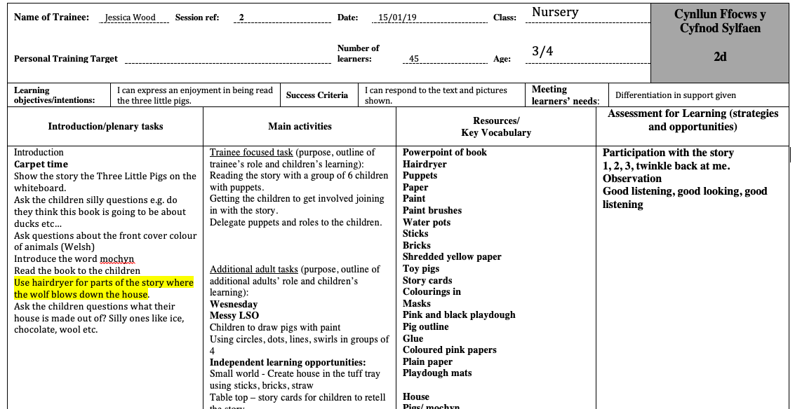

Appendix 2
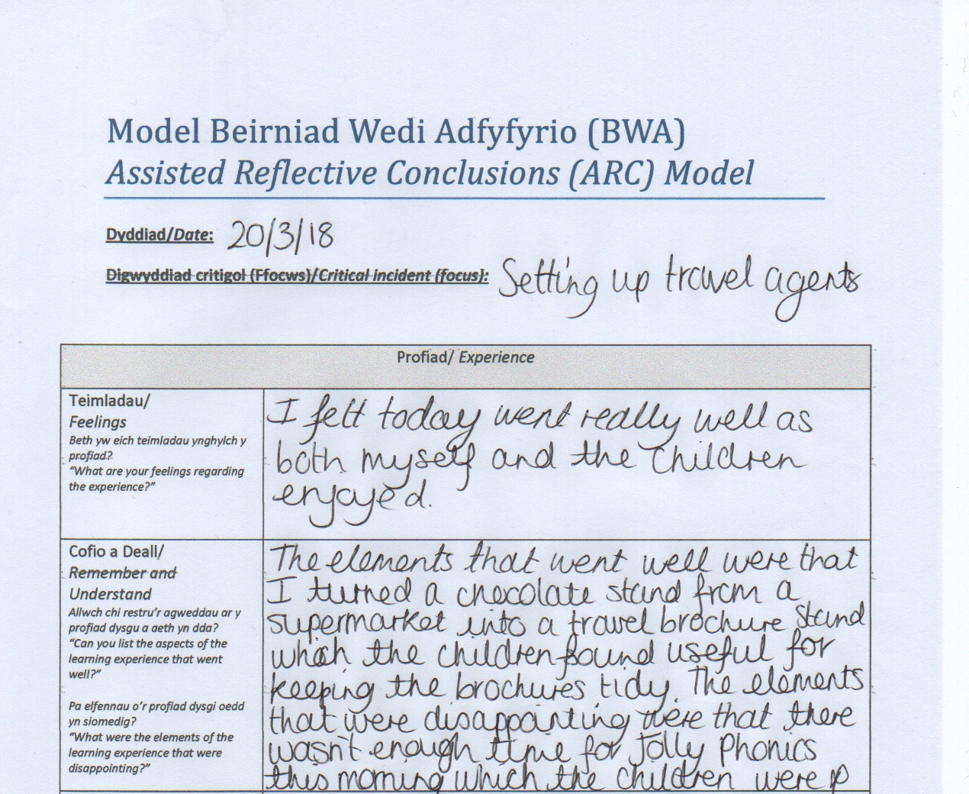

Appendix 3


Appendix 4


