7/30/2025
University of Wales Trinity Saint David
London campus
E-Portfolio Link:
Module Name: Learning In the Digital Era
Module Code: ACCA 4025

Student Name: MARK LAMPTEYHARDING
Student ID: 2538387
Group: 3

Lecturer’s Name: ANEES BAQIR

LDE Assignment 1
E-Portfolio
Table of Contents
Introduction 2
Main Body 2
Task 1: Essential Academic and Employment Skills for the future career Path 2
Task 1 (a): Report on Essential Academic and Employment Skills 2
Task 1 (b): Evaluation of Task 1 (a) based on Similarity report 2
Task 2: Collaborative Mind Map and Individual Poster 2
Mind Map (Collaborative) 2
Poster (Individual) 2
Task 3: Virtual Collaboration and RefWorks 2
Report on Virtual Collaboration 2
Step-by-step process of using RefWorks with visuals 2
Task 4: E-Portfolio Creation and Evaluation 2
Task 4 (a): E-Portfolio Creation 2
Task 4 (b): Illustrative Review of E-Portfolio tool Selection 2
Conclusion 2
References 2
Task 1 References: 2
Task 3 References: 2

Introduction.
The portfolio merges four core activities that highlights on essential academic and employment skills including teamwork, expert communication, virtual collaboration and the utilisation of automatic referencing tools and an online e- portfolio creation.
In building the portfolio usage of IEEE referencing, digital technology and communication and finally collaboration have been consulted.
The portfolio project will also provide the platform to encourage the development of transferable skills for example lone working, professional presentation and teamwork

Main Body

Task 1: Essential Academic and Employment Skills for the future career Path

Task 1 (a): Report on Essential Academic and Employment Skills

Cyber Security

Introduction
Skills required for employment and academic study in Cyber Security
Cyber security is the process of safeguarding digital devices, networks, systems from cyber-attacks.
- Technical knowhow of networks operations is essential Networks are the cyber-attacks places.
How devices exchange information knowhow is essential. Networks like IP addressing, routing study are essential [1] [2]
- CYBER SECURITY BASICS and CRYPTOGRAPHY.
. Encryption with integrity skill sin Basic Programming and Scripting is essential.
- SCRIPT WRITING AND BASIC COMPUTER PROGRAMMING SKILLS
The ability to read basic code and mastery of a tool such as python for repetitive tasks designing to analyse log files.
d) MASTERY OF OPERATING SYSTEMS.
A knowhow of the basic administration of Linux and Windows essential
Most servers being used by organizations are powered by Linux whereas Windows are used primarily in enterprises environments.
Learning a skill of how to deploy basic terminal commands to complete a task requires learning a skill like Bash. [1]
In Cyber Security,
. Critical thinking skill is the ability to analyse data and correct found faults.
. Attention to detail is the ability to conduct precise configurations.
. Technical communication is ability as a student to write and present reports to stakeholders.
Attaining and mastering all the skills are constructive for my future excellence in Cyber Security Career.

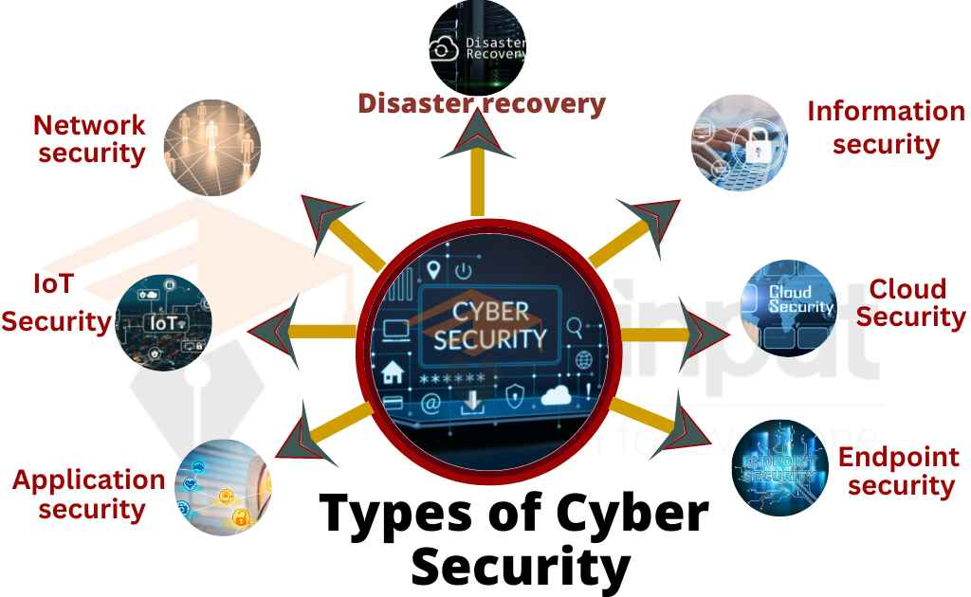

Task 1 (b): Evaluation of Task 1 (a) based on Similarity report
My similarity score was 41% and would award myself between 53% (very good).
I got the 41% score because it seems most of my work involved AI texts.
To improve my assessments next time, I will increase literature reading.

Task 2: Collaborative Mind Map and Individual Poster
Features; Mind mapping is a visual thinking technique utilised to express concepts, information and ideas about a main topic
Benefits: Mind mapping aids in studying and problem solving. It also stimulates critical thinking and makes note taking easier. Mind mapping optimises memory capacity to recall subjects previously read.
Limitations; Utilisation of mind mapping in academic work is a skill that takes long time to develop.
In mind mapping important information can be omitted creating a detailed mind map can take more time than writing simple notes

Mindmeister.com (Collaborative)
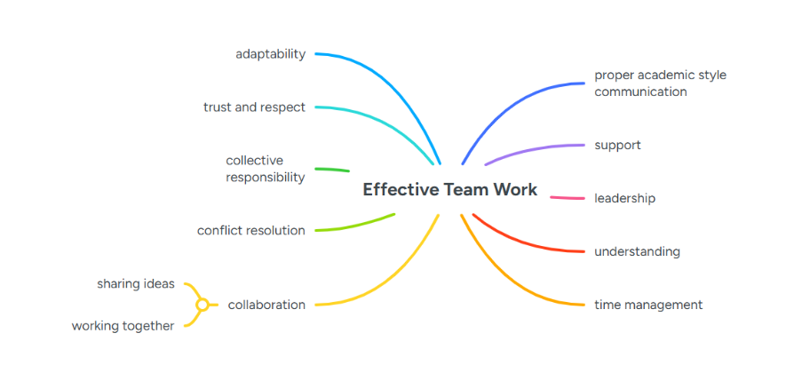

Poster 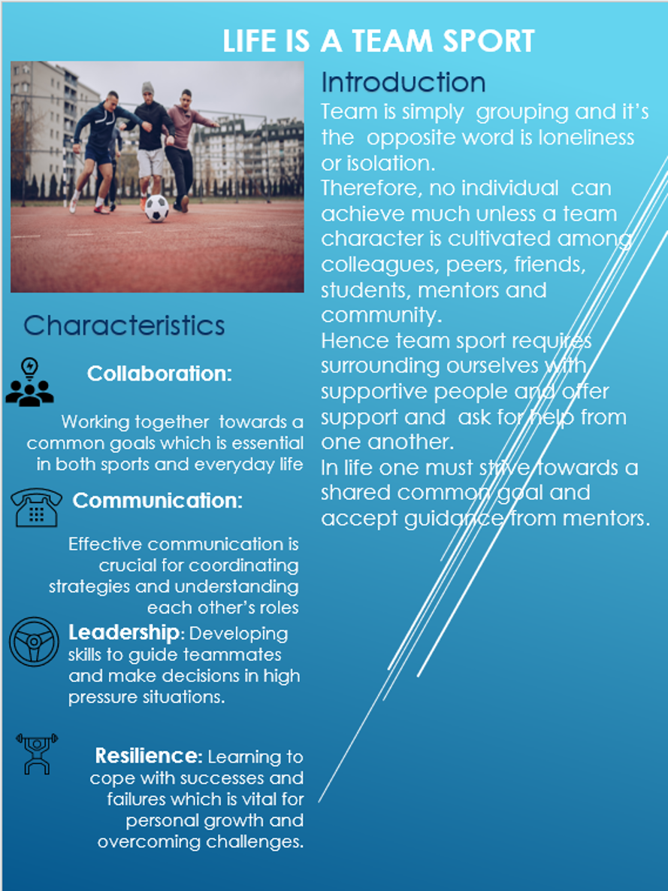divi

Task 3: Virtual Collaboration and RefWorks

Report on Virtual Collaboration
Riding the Storm – The Storming Stage of Tuckman's Team Development Model
The storming stage is the second stage of Tuckman’s model of team development. At this stage, team members begin to express different opinions, challenge ideas, and develop preferred ways of working. Although conflict is a natural part of team development, unmanaged disagreement can negatively affect collaboration and performance. In virtual teams, these difficulties can become greater because communication occurs mainly through digital platforms rather than face-to-face interaction [1].
Mullins [1] explains that storming can involve competitive behaviour, irritation between members, one-way communication, dominance by individuals, and the development of subgroups or alliances. Such behaviours can weaken teamwork if they are not addressed effectively. Virtual teams may also experience misunderstandings due to limited non-verbal communication, reduced motivation, and feelings of isolation, making disagreements more difficult to resolve.
Avoiding conflict can further damage team effectiveness. When trust is lacking, team members may avoid difficult discussions, reduce commitment and weaken decision-making. Lencioni identifies fear of conflict as one of five key team dysfunctions, together with absence of trust, lack of commitment, avoidance of accountability, and inattention to results [2]. Therefore, addressing disagreements openly and respectfully can improve relationships and collaboration.
Empathy is particularly important when managing conflict in virtual teams. Alhattab [3] explains that although conflict can sometimes have positive outcomes, managing it online can be more challenging because digital communication often lacks emotional cues and personal connection. Empathy encourages active listening, understanding of different perspectives, and support between team members, helping to develop stronger working relationships.
Clear roles and responsibilities can also help teams move through the storming stage. Mullins defines a role as the expected behaviour associated with a particular position within an organisation [1]. Recognising different strengths, such as leadership, creativity, and problem-solving, can improve team effectiveness. SWOT analysis can help identify individual strengths, weaknesses, opportunities, and threats, supporting more effective allocation of responsibilities [4].
Overall, although storming can be challenging, it is an important stage of team development. Trust, empathy, effective communication, and clear role allocation can help virtual teams manage conflict and develop into more cohesive and productive teams.

Step-by-step process of using RefWorks with visuals

Step 1: Login to RefWorks
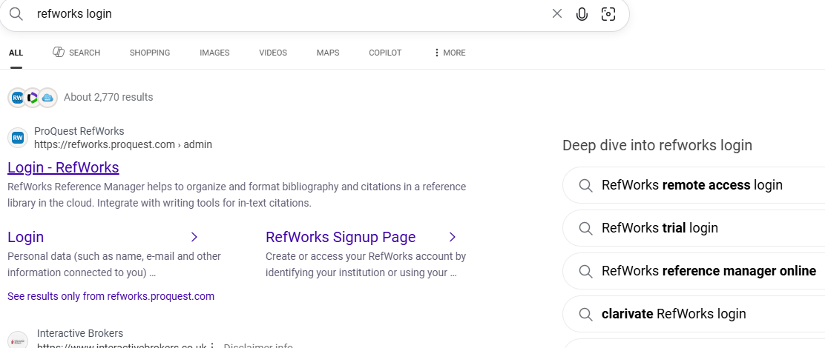
Step 2: Searching citation/reference for my work using google scholar.
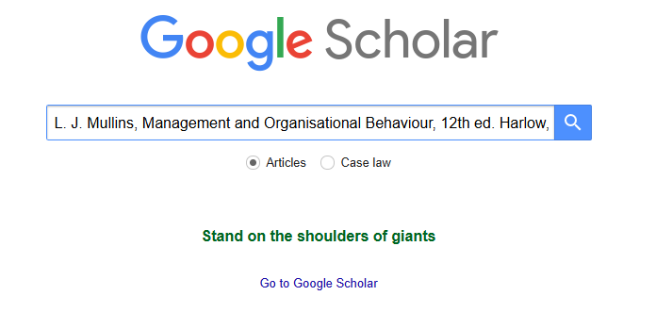

Step 3. Importing citation/reference to RefWorks.
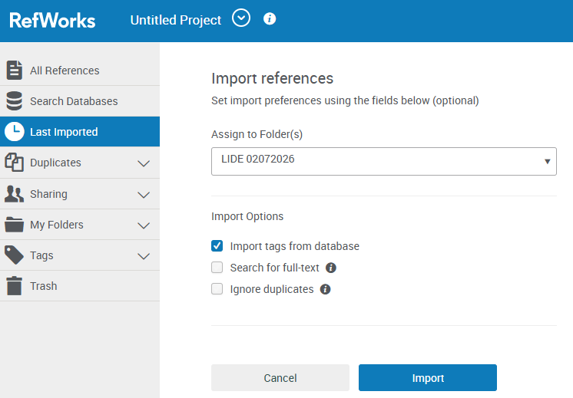
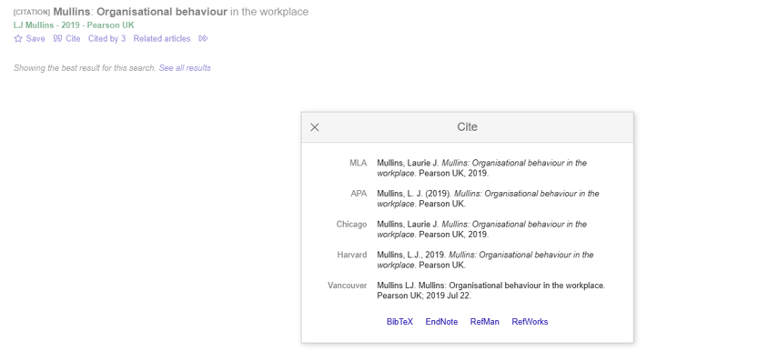

Step 4: How to insert citation into my work automatic reference.
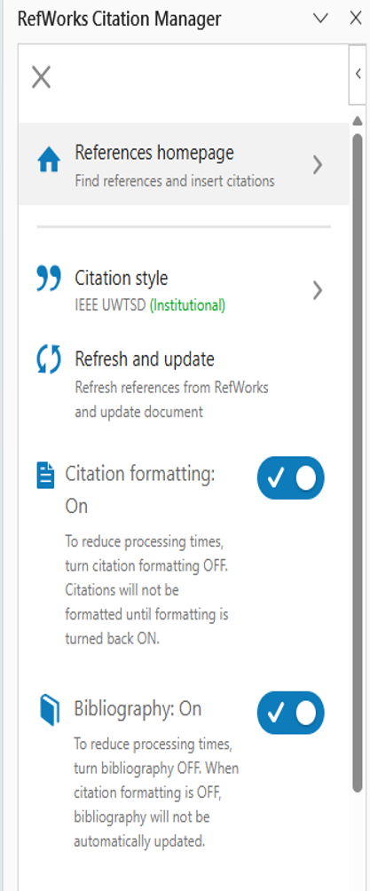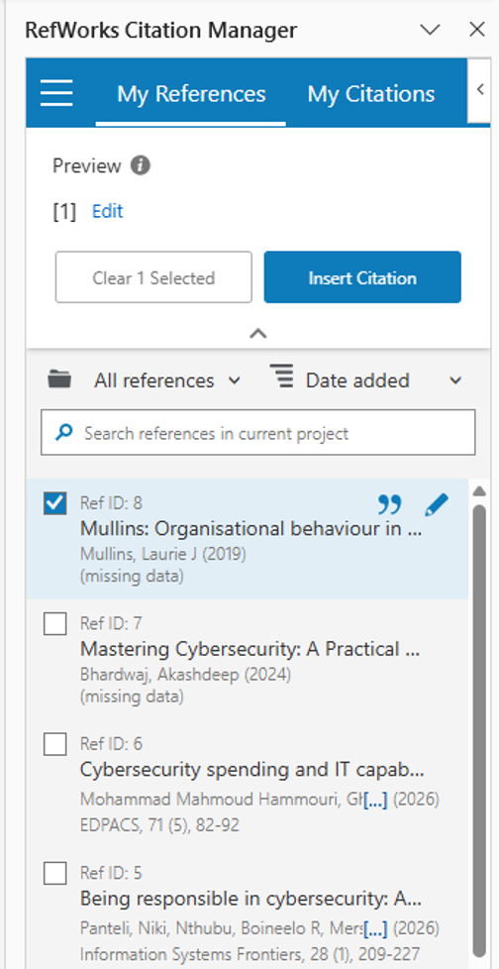

Task 4: E-Portfolio Creation and Evaluation

Task 4 (a): E-Portfolio Creation

Task 4 (b): Illustrative Review of E-Portfolio tool Selection

Conclusion
In general, the portfolio presents the development and application of series of professional, academic and digital skills attained during studying the course module Learning in The Digital Era.
The assigned four tasks enabled the probing into the importance of employability skills, virtual collaboration, automatic referencing, effective teamwork, professional academic communication and digital platform utilization.
Cohesively, the four tasks have bolstered the ability to communicate opinion clearly, research information, work not only collaboratively but also independently and present evidence in an organised format.
The course methodology has also demonstrated the importance of referencing accurately and the critical use of academic sources and finally a reflection of personal learning.

References

Task 1 References:

[1] | R. Vogel, “CLOSING THE CYBER SECURITY SKILLS GAP,” 2016.
[2] | Z. A. Y. W. U. F. F ULLAH, “what skills do cyber security professionals need?”.
Click or tap here to enter text.Click or tap here to enter text.

Task 3 References


