The Haverfordwest Priory

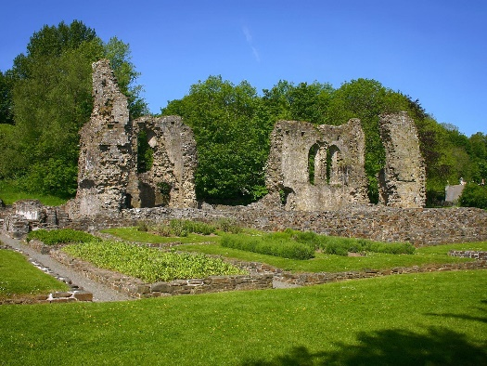
Haverfordwest Priory is a significant religious monument that may be seen in Pembrokeshire, Wales. Its origins are entrenched in the religious fervour and turbulent history of the Middle Ages. This essay aims to unravel the fabric of the monastery's beginnings, its location, and its role in numerous historical events, addressing the fundamental questions that surround the monastery's foundation and relevance in the process.

First, the Haverfordwest Priory was a member of the Order of the Augustinian Canons Regular. In the context of a monastery, the term "order" refers to the group of monks who follow a specific set of rules and regulations. Generally speaking, the term "order" refers to a collection of religious communities that are united by a set of agreed norms and practises. The Augustinians were not monks in the classic sense; instead, they were canons or priests who lived in a community and led a semi-monastic lifestyle in order to serve the faithful while also maintaining a monastic ethos. They lived according to the Saint Augustinian Rule, which emphasised a life of poverty, chastity, and obedience while also being actively connected with the communities in which they lived.

In many cases, the founding of such a monastery was made possible by the generosity of a patron or the participation of an influential person. Haverfordwest Priory was established in the 12th century by Robert Fitz Richard, a Norman nobleman. The monastery is located in Haverfordwest, United Kingdom. The Norman lord De Haverford was one of many who attempted to establish religious and territorial control in Wales under the banner of the Normans. This takes us to the motivation behind the establishment of the monastery in the first place.

During this time period, the establishment of religious homes was driven by a variety of different motivations. Quite frequently, these were deeds of religious devotion carried out by affluent and powerful persons as a means of ensuring their spiritual well-being and salvation in the afterlife. In addition, the establishment of a monastery might serve as a sign of grandeur and influence, displaying the founder's wealth as well as their commitment to the Christian faith. In the peculiar situation of Wales, where the Normans attempted to assert their rule, the establishment of ecclesiastical structures also became a technique of colonisation. This served both spiritual and political purposes for the colonisers. It is possible that Robert Fitz Richard's decision to establish the Haverfordwest Priory was influenced by both his personal religiosity as well as his political ambitions; nonetheless, the precise reasons for Robert Fitz Richard’s actions are still a subject of historical debate and interpretation.

There is no way to adequately express how important it is that the monastery is situated in Haverfordwest. The monastery's location along the Western Cleddau river afforded it a number of advantages, including those of a strategic and economic kind. The location of the priory near the river would have made it simpler to access resources and communicate with others during the medieval period, when waterways played an important role as crucial transit and commercial channels. In addition to that, Haverfordwest developed into a bustling market town at this time. Its importance would have been raised even further by the existence of the monastery, which would have turned it into a cultural and economic centre for the area.

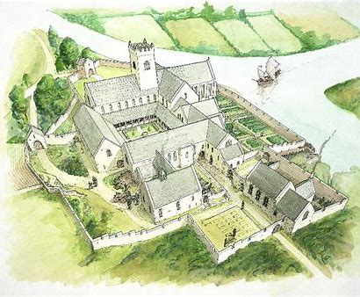
When looking back at the events that were recorded over the monastery's existence, it is clear that the Haverfordwest Priory, along with many other religious institutions of the time, encountered its fair share of difficulties. During the reign of King Henry VIII in the 16th century, a significant event took place during the destruction of the monasteries. The Haverfordwest Priory, along with a significant number of other monastic institutions, was eventually closed down, bringing an end to the pastoral role it had played. In the years that followed, the priory buildings went through numerous stages of use as well as decay. Nevertheless, the disintegration wasn't only the conclusion; it was also the start of something new. The grounds and relics of the monastery became a witness to the historical significance of the monastery, which attracted the attention of historians, archaeologists, and visitors. The dissolution serves as a devastating reminder of the larger historical upheavals that were taking place at the time. It illustrates the struggle that was taking place between religious orthodoxy and the growing powers of the monarchy.

Haverfordwest Priory, in conclusion, provides an intriguing prism through which one might investigate the larger ecclesiastical, political, and socio-economic storylines of medieval Wales. The priory is a living witness to the intricate web that is the history of Wales, from its Augustinian affiliation to the fact that it was founded by a Norman baron, from its advantageous location in a growing Welsh town to the fact that it was dissolved in the midst of wider ecclesiastical changes, the priory embodies all of these aspects of Welsh history. By gaining an understanding of this institution, one can gain vital insights into the relationship between faith, power, and location in the process of the formation of regional identities and histories.

