

Master of Business Administration

International Business Concepts (LCMB7034)

Report

Company – Porsche

Student Name- Panchal Urval Rajivkumar

Student ID- 2434583

Lecturer Name- Chung Lai Johnny Wan

Word Count - 5318

Submission Date- 21 November 2025

Table of Contents
1. Introduction to the report 3
2. Benefits and challenges of international operations 3
a. Justification of Porsche as an MNC 3
b. Global Operations of Porsche 4
c. Different entry modes used by this company 5
d. Key benefits obtained by the company from its international operations 7
3. Discuss the OLI factors' impact on the international market entry mode 9
Ownership advantages (O) 9
Location advantages (L) 11
Internalisation advantages (I) 13
4. Cultural Impact Evalution using Hofstede Cultural Dimensions 15
5. Critically discuss and recommend three major adjustments 18
Recommendations 22
6. Conclusion 24
References 25

1. Introduction to the report
This paper discusses the internationalisation activities of Porsche as applied to the context of its possible international expansion and partnership in Bangladesh. It looks at how the company is a multinational corporation and how its global value chain is structured in addition to the different modes of entry embraced in the different international markets. The analysis earmarks the tactical sense of choosing a joint venture with Walton Hi-Tech Industries Ltd. as a practical entry mode when Porsche aims to expand its business in Bangladesh in the developing market of electric cars. The research is also an assessment of the gains that Porsche makes due to its international operations, such as innovation, cost effectiveness, and market diversification. The research offers a detailed insight into the business practices of Porsche worldwide and the potential of its exploration of emerging markets.

2. Benefits and challenges of international operations

a. Justification of Porsche as an MNC
Porsche could be provided with a Multinational Corporation (MNC) or Transnational Corporation (TNC), because it has many global operations, a global production system, and a strong presence in various continents. With its luxury sports cars and outstanding engineering standards, this firm has spread its offices to over 100 countries in the world via subsidiaries, joint ventures and authorised dealerships (Porsche, 2025). It is this world integration that enables Porsche to access different markets, fit into regional consumer needs and retain an advantage in the global car market. Its production systems and supply chain are also much globalized with the main parts being sourced and assembled in various countries to maximize efficiency as well as its cost-effectiveness.
Porsche has exclusive dealerships and service networks in Bangladesh, which serves the rising demand of high-end cars by the wealthy population of the country (Anis Mahmud Anik, 2023). The development of new markets in new countries such as Bangladesh by the brand is an indication that the brand has a strategic intent of diversifying its consumers, and it has been consolidating its presence internationally. This portrays features of an MNC or a TNC, i.e. operating internationally, technology transfer, and marketing approaches to suit the local conditions without compromising a centralised control of the main operations.
Moreover, its transnational attribute is supported by the fact that Porsche engages in research and development in various regions. It works together with suppliers, technology partners and subsidiaries across the world to improve both innovation and sustainability during the design of automobiles. The international governance of the firm enables coordination of various jurisdictions, thus promoting uniformity in the quality of brands and coherence (Mirzaye Shirkoohi and Mohiuddin, 2025). Therefore, the global operation of Porsche, diversification in market and cross-border integrated management practices is a strong indicator that Porsche is a Multinational or Transnational Corporation, and able to balance a global integration with local sensitivity to maintain its status as a major producer of luxury automobiles.

b. Global Operations of Porsche
The global operation of Porsche demonstrates a very integrated and strategically controlled value chain which guarantees the premium quality, innovation and profitability in all the markets. Its research and development practices are the basis of its international success, and these are supported by highly developed plants in Germany, the US and China (Porsche, 2024). These centres are oriented towards performance engineering, electric mobility and digital innovation to fit in with global sustainability trends as well as technological advancement. Porsche keeps on expanding the design, efficiency, and security of vehicles via joint research and development collaborations with international suppliers and universities.
Another important activity of the global value chain in Porsche is sourcing. The company uses a more comprehensive network of suppliers all over the globe to obtain high-quality materials and advanced components to make sure that there is a balance between cost optimisation and quality assurance. Porsche focuses on sustainable and ethical sourcing, especially when it comes to sourcing of metals, electronics and battery materials necessary to support its hybrid and electric car models (Porsche, 2025).
Distribution of production is strategic to ensure efficiency in operations and close proximity to markets (Handoyo et al. 2023). The main manufacturing factories are still located in Germany, but some of the assembly and parts manufacturing are outsourced or shared with other plants of the Volkswagen group all over the world. This international manufacturing arrangement contributes to elasticity and economy.
The sales business is spread over 100 countries with a vast number of dealerships and online solutions. The sales strategy in Porsche rules out mass customisation and instead incorporates the principle of exclusivity and personalisation that gives their customers superior experiences by configuring their cars and providing after-sales services.
Financially, Porsche is a strong brand enjoying good financial backing by the Volkswagen Group and separate financial subsidiaries (leasing and financing services to consumers in the global market) (Porsche, 2024). This notion is evidenced by the strategic investment in innovation, sustainable production, and customer experience, which has allowed the company to have a well-integrated and well-coordinated global value chain that helps the company to remain a leader in the luxury automobile segment.
Bangladesh attractiveness
Bangladesh is becoming increasingly appealing to the global market of operations of Porsche because of the growing population with middle-income group, the burgeoning urbanisation, and the growing demand of premium brands. The strategic position of the country along with the major Asian markets, road infrastructure, and the government incentives in attracting foreign investments make it stronger. The growing automobile industry in Bangladesh and its interest in the electric vehicles generate the possibilities of the future market penetration. But because of such factors as regulatory delays, high importation duties and scarce networks of luxury-car servicing, cautious entry strategies are needed. In general, Bangladesh provides the long-term prospects of brand and operational growth of Porsche.

c. Different entry modes used by this company
Porsche has embraced various entry modes in order to establish its presence in different international markets, relying on economic potential, regulatory framework and consumer demand within that region (Porsche, 2024). The main strategies of internationalisation adopted by the company are wholly owned subsidiaries, joint ventures, and authorised dealership agreements.
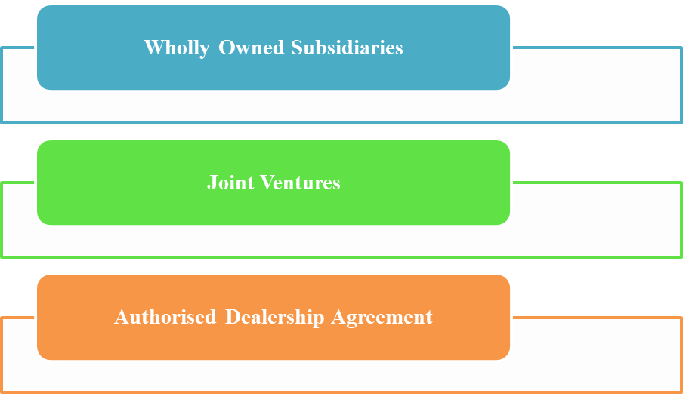
Figure 1: Different Entry Modes that are used by Porsche
(Source: Created by Author)
Porsche has developed wholly owned subsidiaries and regional headquarters in developed markets (like the United States, China) to ensure complete control over the marketing processes and operations as well as brand image (Porsche, 2025). These subsidiaries help Porsche to have first-hand control of the sales networks, research and development partnerships, and customer experience centres that they consistently align with the world standards of the brand.
Porsche has also strategically chosen joint ventures and dealership partnerships in other regions, especially emerging markets, to reduce risks and adapt to local market dynamics. The joint ventures have been found to be potential and effective entry modes as they enable the company to exchange resources, technological know-how, and local market knowledge with the local established one (Hsiao and Lin, 2023). These partnerships increase the effectiveness of operations and adherence to local laws and regulations and further cement the brand image in emerging markets.
The partnership concept would suitably be a joint venture between Walton Hi-Tech Industries Ltd. and Porsche under the partnership concept which is the joint venture concept as the dominant and strategically vital mode of entry in Bangladesh. The area of partnership would be Sales and Service Networks of Electric Vehicles (EVs) at the Porsche Experience Centres and authorized service centres, Electric Vehicle Charging infrastructure through fast-charging stations in major cities and battery manufacturing and recycling at a local lithium-ion battery assembly and recycling centre. This model of joint venture would allow the Porsche company to balance its technological superiority and brand image with the robust local manufacturing, distribution, and market orientation Walton has. This cooperation would support the sustainable growth of Porsche in South Asia, the increasing interest of Bangladesh in electric mobility, and its positive presence in the region in the long term.
In this context, this future partnership between Walton Hi-Tech Industries Ltd. and Porsche could be internally important for Porsche’s entry into Bangladesh. The partnership is anticipated to include the construction of a sales and service network for Electric Vehicles (EVs) through Porsche Experience Centres and authorized service centres, the building of EV chargers and fast charging stations (to be deployed in major metropolitan centres), and the commencement of local battery production and recycling through a lithium-ion battery assembly and recycling facility.
Such a future joint venture is expected to allow Porsche to merge its technological expertise and premium brand equity with Walton’s local manufacturing, distribution channels, and market intelligence. This will be a way for Porsche to attain a profitable and sustainable objective in South Asia while maintaining the region's electric mobility focus in Bangladesh. This will strengthen Porsche’s regional presence over the years.

d. Key benefits obtained by the company from its international operations
The international operations have made Porsche reap huge benefits, which have played significant roles on enhancing its global competitiveness, financial growth and advancement in terms of technology. The primary strength is that the company has a broad and a diversified market in various continents. Through its international operations, Porsche has been able to boost its market beyond the borders of its home country, Germany to encompass wealthy consumer groups in other parts of the world like North America, Europe, Middle East and Asia-Pacific (Porsche, 2024). This regional diversification not only boosts the level of sales, but also eliminates reliance on one market, a factor that helps in lessening the risks that relate to changes in the regional economy.
The second significant advantage of the global business is that it enhances the innovation ability of Porsche. Through the international research and development partnerships, the company is at a position to integrate technological knowledge, which enables the development of electric mobility, autonomous driving and digital connectivity. The availability of global suppliers and technological centres has helped Porsche to create a new and more efficient production system and sustainable behaviour that subsequently contributed to a higher quality of products and better efficiency of operations (Porsche, 2025).
Cost optimisation is also one of the main advantages. Porsche, through global sourcing and production alliances, attempts economies of scale and factors down production costs while retaining high quality standards (Porsche, 2025). More importantly, overseas activities promote the prestige of their brands and strengthen the image of Porsche as a luxury brand of high performance and innovation.
Porsche enjoys the advantage of early market entry in the emerging economies like Bangladesh through brand loyalty and using the local investment of their partners as a foundation to venture into the electric vehicle segment. Moreover, diversification of revenue through international sales and after-sales services leads to financial stability and long-term profitability. Comprehensively, global operations have helped Porsche to remain strategically flexible, promote continuous innovation, and conquer its status of leadership in the international luxury automobile market.

3. Discuss the OLI factors' impact on the international market entry mode
The discussion in the following section is a critical analysis of the applicability of the OLI (Ownership–Location–Internalisation) framework. It presents the discussion oo the feasibility and design of a Porsche with Walton Hi-Tech Industries Ltd. joint venture (JV) in Bangladesh. It will focus on consisting of an EV sales and service network, fast-charging infrastructure, and local battery assembly or recycling.

Ownership advantages (O)
Porsche transfers high-quality ownership-specific resources, premium brand equity, EV-knowledge of powertrains and batteries (Taycan success), worldwide supplier base, exclusive software or charging platforms and large sums of money to introduce the product (News TV, 2023; Market Data Forecast; 2025). These resources generate a competitive edge in the market to sell luxury EVs and influence a high-quality customer experience (global product/brand strength of Porsche).
The complementary assets Walton will bring to the partnership are of significant importance to justify the JV case; extensive local production capacities (estimated at 5 million sq ft of space, which serves 19 buildings) (Walton, 2024). In addition, distribution or retail system (Walton Plaza retail footprint) and expanding in-country battery initiatives (intended lithium-ion cell factory and relationships, such as with Huawei) (Babu, 2024). Walton's manufacturing footprint and supply chain expertise will make it cheaper and less risky to assemble locally and do after-sales business. The combination of these complementary resources will make a JV (as opposed to pure export or franchise) desirable since Walton provides tangible, locally inimitable assets.
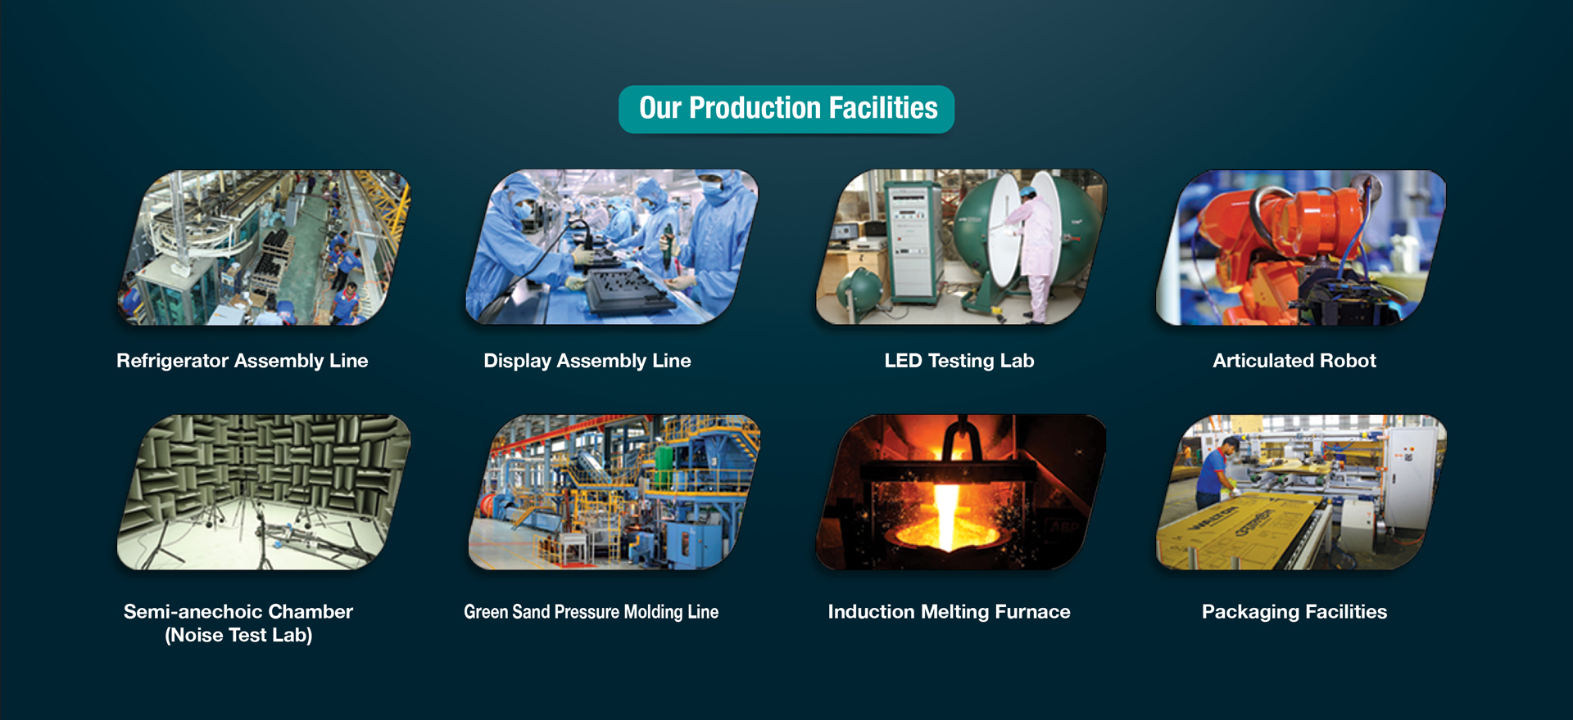
Figure 2: Production facilities, Walton Hi-Tech Industries Ltd
(Source: Walton, 2024)
The quality control and service standards in Porsche will a tight quality control as the company has a premium image. The benefits of ownership can only be had when the JV governance safeguards the IP, training procedures. Moreover, the service practices of Porsche will make the case of a carefully negotiated equity and governance division (technical governance, training covenants, serial audits). Investment guidance and KPMG indicate that 100 per cent foreign ownership is typically allowed in Bangladesh (KPMG, 2024). Although local alliances facilitate the ease of regulation negotiation, in favour of a JV arrangement (KPMG, 2024).
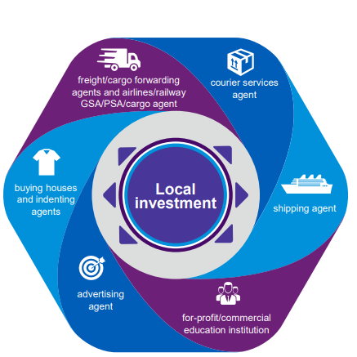
Figure 3: Local Investment in Bangladesh
(Source: KPMG, 2024)

Location advantages (L)
Bangladesh presents favourable location conditions for a JV with the target of electrification. It contains a large and young urban population with a growing energy policy attention to renewables and batteries (Unescap, 2025). There is already huge domestic demand for EV two and three-wheelers, and there is also interest in EVs among the passenger segment, particularly within urban elites, a traditional Porsche target market (Wresearch, 2025). UN or ESCAP and market reports record fast EV uptake in the light EV segments of Bangladesh and the presence of a potential battery market opportunity.
Nonetheless, there are material barriers in the form of policy and cost barriers. Charges on imported fully assembled vehicles are very high. The reported effective EV import tax rates are reported as close as the high-80 per cent range (Abdullah, 2024). Thus, direct importation of finished vehicles in Porsche form would be extremely expensive to most consumer groups and the profit margins of pure export brands (Customs, 2025). This tariff system is a material preference for local assembly or CKD or battery part imports over imported manufactured cars. This increases the rationality of a Walton manufacturing or assembly position within the JV.
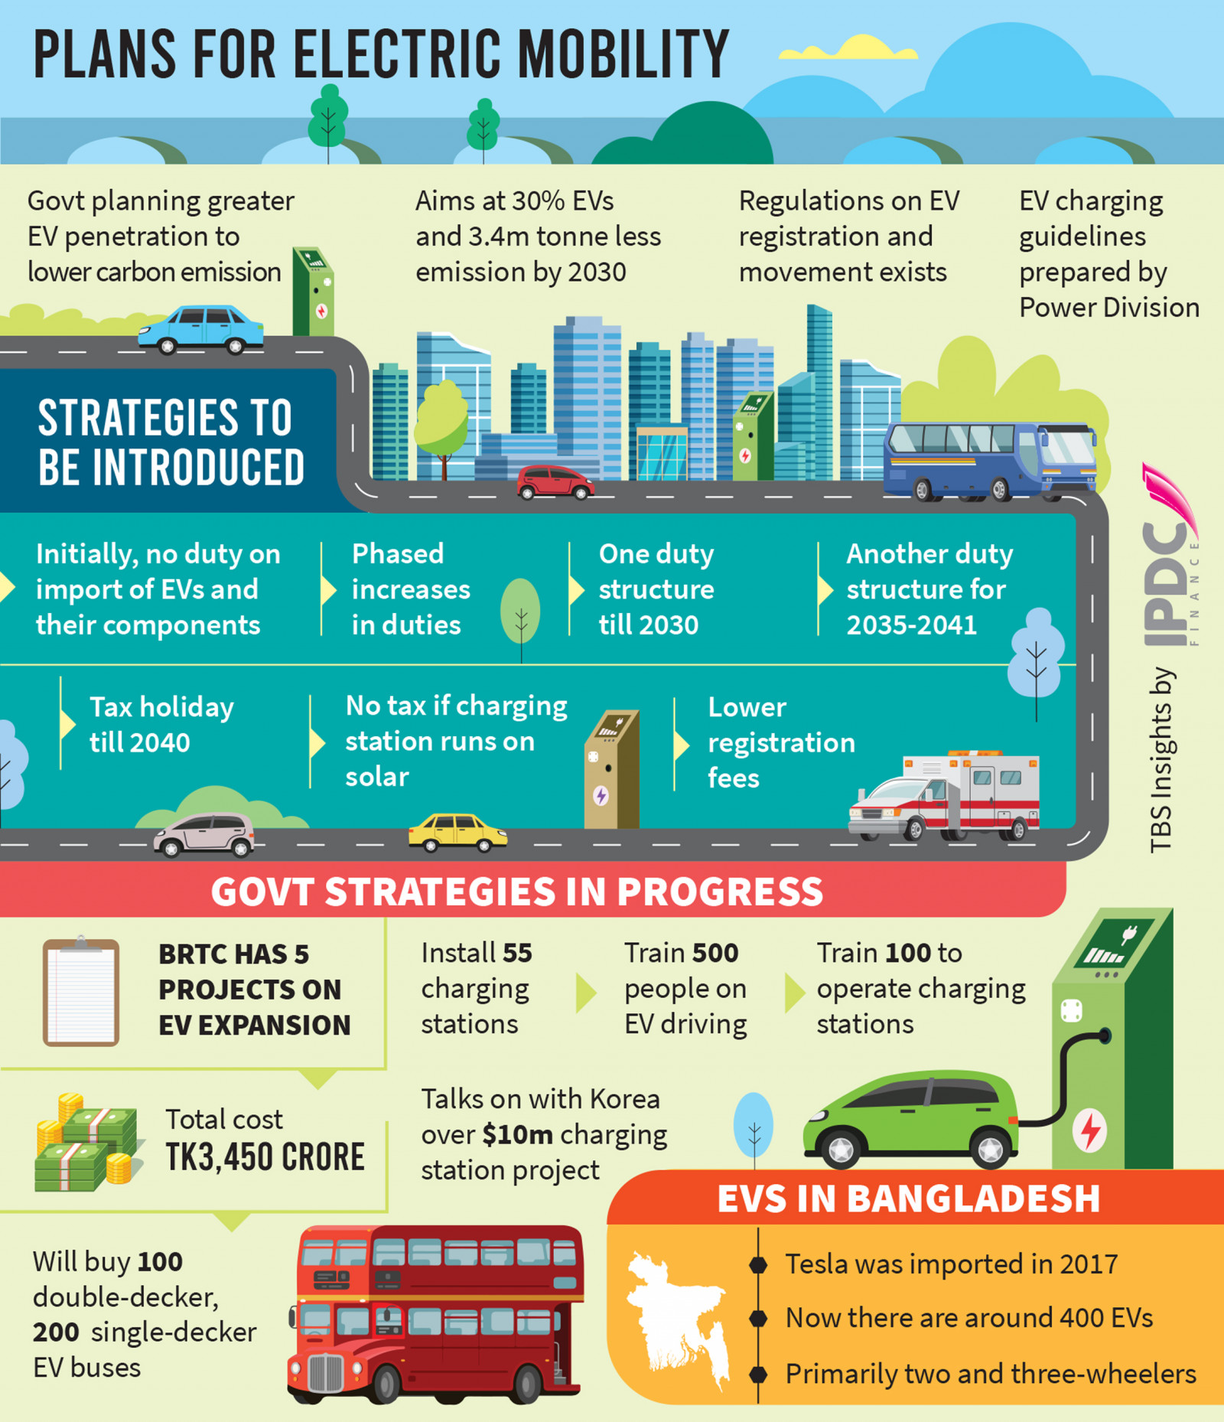
Figure 4: Plans for Electric Mobility
(Source: Abdullah, 2024)
Other geographical considerations: charging infrastructure and the dependability of energy is still constraints. Government indications of encouraging renewables (such as rooftop solar mandates and incentives) and battery manufacturing incentives would work towards medium-term assistance balancing infrastructure investment in EVs (Reuters, 2025). However, in the short term, grid capacity and slowness of the populace in rolling out charging make investment and working in capital and operations more hazardous. JVs need to incorporate energy integration (on-site solar + storage) and close energy regulator coordination, though.

Internalisation advantages (I)
Internalisation inquiries about the activities in the JV, should it be in-house (within the JV) or should it be licensing or outsourcing? In the case of Porsche and Walton, some of their functions are highly biased towards internalisation.
After-sales, service quality & brand control- Luxury brands are based on proprietary-repair processes, diagnostics, brand experience calibration, and best internalised in JV service centres with Porsche-trained personnel and managed spare parts pipelines. This cushions quality of service and brand in a market where there is a growing trust.
Charging & energy management- By internalising a network operator or energy management platform (commonly owned), the JV can optimise the load on more constrained grids, monetise charging, and piggyback the Walton local smart-tech solutions, which is better done than a licensing model, which could disintegrate customer experience.
Battery cell assembly and recycling- Relating to high import duty in Bangladesh and increasing the incentive of local production, internalising subject to battery assembly and closed-loop recycling in the JV maintains IP, quality and value throughout the lifecycle (second-life storage, recycling revenues) (The daily Star, 2025). The announced lithium-battery investments and Huawei tie-ups of Walton make internalised cell/intermediate assembly possible.
Thus, in Costs of internalisation, construction manufacturing, certification, and recycling capacity are heavy in terms of capital investment, labour and qualifications as well as regulatory permits. The JV has to compromise internalisation of strategic functions and outsourcing of commoditised components (Like as non-strategic components) as a method of capex control.
Synthesis of optimal entry design
The following section presents the synthesis by combining O, L and I for Joint Venture.
Equity JV with capability rings- Product design, EV powertrain IP, training and brand governance are provided by Porsche, and Walton provides land, manufacturing, local sourcing and retail network (Walton, 2024). The administration should guard against Porsche IP and impose service requirements (technical audits, performance KPIs).
Local assembly with battery cell facility- To circumvent punitive importation tax and value creation, the JV must focus on CKD or compatibility assemblies to passenger cars (The daily Star, 2025). Also, domestic lithium-ion cell assembly or recycling within the Hi-Tech Park of Walton, riding on battery plans announced by Walton and volume of operations.
Internalised service with managed charging network- Run Porsche Experience Centres and approved service centres (internally owned), which Walton would operate and site acquisition (Reuters, 2025). The two would create a charge network operator arm, which would include building on-site renewables that would reduce grid risk.
Policy engagement and phased rollout- Pressure for gradual cut tariffs/subsidies towards local assemblies, and initiate pilot rollouts in urban locations to high-net-worth customers, as the process of scaling up charging and battery operation commences.

4. Cultural Impact Evalution using Hofstede Cultural Dimensions
Power Distance
Germany scores an amazing (35) in power distance that refers to the egalitarian corporate culture of having flat hierarchies, consultative decision-making process and employees who do not fear taking charge. Porsche achieves this through decentralized and empowered teams. The score of 80 by Bangladesh means that there is the presence of a very hierarchical society where status symbols are very significant and power is rarely questioned. This presents strategic fundamental issues to the entry of Porsche into the market. The difference of 45 point is among the largest cultural differences in these markets (Country comparison, 2025). The luxury products are consumed in Bangladesh as a key marker of social status and power but on the other hand in Germany the luxury brands emphasize on engineering quality and performance.
Individualism
Germany receives a low index (5) which denotes the collectivism quality of an organizational nature, but the index appears to come in conflict with the popular Western individualism. The score of Bangladesh (79) shows that individualistic achievement orientation of the elites is very high and the individualistic gap of 74 points that is generated is unexpected and scores the largest variation cutting across all dimensions (Country comparison, 2025). This provides a complex implication to the positioning of Porsche in the market. Though the affluent members of the Bangladesh society are targeting self-differentiating, this individualism is operating within collectivistically paradoxical networks of family businesses and relationship-based business. The organisational culture of Porsche, which is the German culture that relies on teamwork and the overall performance of the engineering, is compared to the system of elites in Bangladesh, who specialise in status differentiation on an individual level.
Motivation Towards Achievement and Success
Achievement motivation, the German work ethic, engineering accuracy, and success-oriented culture-values are 66 in Germany, and Porsche has been producing such culture-values over the years of its victory in the racing and technical innovation world. The fact that Bangladesh scored a lower score (55) is a sign that the country has a humbler achievement orientation, but urban elites are unlikely to be guided by the national means. A difference of 11 points is an indication that this is a moderate form of cultural non-compliance in the definition and the pursuit of success (Country comparison, 2025). German achievement culture glorifies the performance of a meritocratic nature that has quantifiable performance indicators- lap times, horsepower numbers, engineering awards. The cultural misfit suggests that the traditional promotional strategy of Porsche, concentrating on the theme of racing and engineering superiority, may not generate the required emotional connection, and it may require a complete re-invention of the brand that loses brand recognition and competitive advantages in the luxury car market.
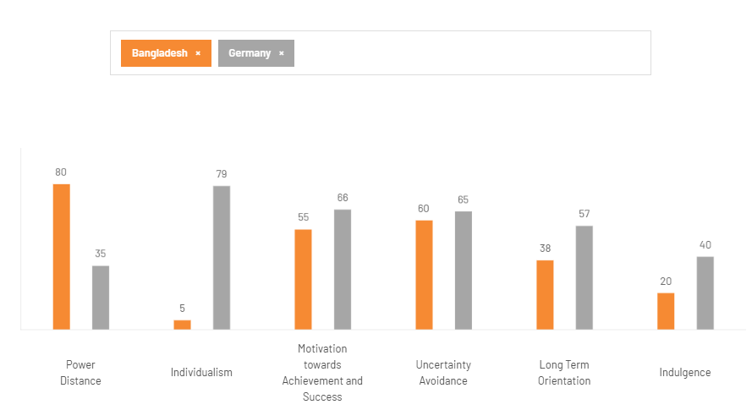
Figure 5: Hofstede Cultural Dimensions Between Germany and Bangladesh
(Source: Country comparison, 2025)

Uncertainty Avoidance
Germany (60) and Bangladesh (65) have somewhat similar uncertainty avoidance of moderate-high and only a 5-point difference in scores- the nearest cultural fit of all dimensions. Both cultures like organization, forethought and reduction of risks in key purchases. This resemblance may help Porsche enter the market easily because, both the Germans and Bangladeshi consumers rely on the reputation of the brand, guarantee of quality and reliability rather than the untested and untried products (Country comparison, 2025). This perceived strength is, however, tainted by the lack of development in automotive infrastructure, patchy regulatory framework and unpredictable importation policies in Bangladesh. The cultural desire to have certainty conflicts with the market conditions of infrastructure shortfalls and policy unpredictability.
Long-Term Orientation
The difference between the low score of Bangladesh (38) and Germany (57) shows a difference of 19 points in the way of time that essentially affects the consumption behaviors and brand affiliations. Germans think long-term, they invest into sustainability and attach importance to long-term relationships, which is the 100-year-old Porsche strategy and engineering philosophy with its focus on durability and timeless design (Country comparison, 2025). The Bangladeshis are more short-term oriented, so they want to see faster payoffs and gratification when making a business or consumption choice. This is a strategic weakness to Porsche caused by this temporal misalignment. The value proposition that is implicitly introduced by the brand presupposes a long-term increase in the cost of ownership the concepts that are not particularly popular among present-oriented consumers in the Bangladesh setting.
Indulgence
The reserved score (40) indicates that Germany has cultural values that focus on discipline, delayed gratification and controlled pleasure which is associated with Protestant influence of work ethic embedded in corporate culture. The fact that Bangladesh had an extremely low score (20) implies even further restraint, and a difference of 20, implies that there exists a fundamental difference in attitude towards enjoyment and self-indulgence (Country comparison, 2025). This is the greatest challenge facing the culture of Porsche. Luxury sports cars are a symbol of the indulgence in pleasure, conspicuous consumption, and pleasure-seeking which is not a culturally accepted value in the conservative society of Bangladesh. The product itself is contrary to the cultural values that primarily focus on being modest and self-contained.

5. Critically discuss and recommend three major adjustments
Critically discuss
The opportunity and challenges that are inherent to partnerships in emerging markets are seen on the potential opportunity of Porsche to have a joint venture (JV) in Bangladesh with Walton Hi-Tech Industries Ltd. using the OLI (Ownership-Location-Internalisation) concept.
The ownership perspective (O) is that Porsche has significant brand recognition, international companies in their suppliers, as well as innovative EV technology, including the successful example of its Taycan models (News TV, 2023; Market Data Forecast, 2025). These properties will be very differentiating in a market where luxury segment is underdeveloped. Walton with its complementary advantages, including mass scale production, local distribution (with over 19 buildings and 5 million sq ft of space), and future lithium-ion battery factory in collaboration with Huawei, provide essential local infrastructure and market access (Walton, 2024; Babu, 2024). The JV would facilitate risk sharing between the two partners, as Walton has familiarity with the market, enabling locals to be relevant to the market and having fewer obstacles to operations than a wholly foreign-owned company would have.
Bangladesh has a potential of increasing market growth in long term due to its fast urbanisation, increasing middle-class incomes, and encouragement of renewables by the government (UNESCAP, 2025). The great demand of two- and three-wheeler EVs indicates that the consumer will tolerate electric mobility (Wresearch, 2025). Moreover, the current tariffs on fully built EVs (almost 80 percent, Abdullah, 2024) imply that it is economically viable to assemble the vehicle locally by using a JV, and it helps to avoid the damage to the margin and facilitates domestic value generation. These policies coupled with the closeness of Walton to manufacturing tools make an environment conducive to the growth of EVs.
Nevertheless, characteristic of emerging economies, several location-specific issues is still there. There are operational risks that are short-term in nature and involve infrastructure constraints, insecure power supply, and slow installation of charging networks (Reuters, 2025). Regulatory and tax environment In Bangladesh, even though the policies are intended well, the environment is still uncertain when making long term decisions regarding investments. Financial exposure is increased due to high entry barriers to infrastructure, especially energy integration and recycling plants, even in an immature market.
From an internalisation perspective (I), although controlling service quality, brand experience, and proprietary technology internally ensures Porsche’s standards, it also increases capital expenditure and regulatory hurdles (The Daily Star, 2025). Over-internalisation could burden the JV with high upfront costs and slow scalability. The success of the Porsche-Walton JV will also be based on the ability to coordinate the cross-cultural integration and adjust business practices to the institutional environment in Bangladesh. The widespread cultural difference in the dimensions of power distance and indulgence (Hofstede, 2025) suggests the fact that the flat, performance-oriented management culture within the Porsche company can be a source of friction with regard to Bangladesh which is characterized by a hierarchical system and status orientation. Thus, it will be necessary to conduct cross-cultural training and develop a hybrid system of leadership, which would combine the participative decision-making process of Porsche with the localized principle of managing the situation, as adopted by Walton. Moreover, the relations in government and policy advocacy should be valued as regulatory uncertainty, energy security, taxation system, etc. may have a direct effect on the profitability of JV.
Porsche ought to consider lobbying policymakers to popularize EV-friendly policies and incentives by building on the domestic reputation of Walton to be easier to navigate through the regulations. Lastly, technical transfer and local competency should be embraced overtime to safeguard Porsche intellectual property and at the same time, enable Walton workers through progressive technical education. Such a two-fold interest in localization and brand safety will contribute to the overall sustainability of the business, making sure the JV will pull in both economic and environmental value in the dynamic EV environment in Bangladesh. Overall, the OLI analysis demonstrates that while Bangladesh offers significant market potential and manufacturing synergies, risks tied to infrastructure, governance, and cultural disparities such as hierarchical management and conservative consumption values must be carefully mitigated for Porsche’s JV to succeed in this emerging economic context.
Justification of Bangladesh as a potential market
The economic fundamentals country are about to grow its automotive market. Bangladesh is forecasting a GDP of about 459billion USD, 5.8% annual growth of the GDP, which shows the country is macro-economically resilient. The income per capita of 2800 USD and is projected to become Upper Midnight from the current 4000 USD to about 2031.
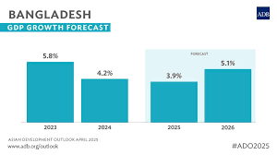
Figure 6: GDP Growth of Bangladesh
(Source: AsianDevBank, 2025)
By 2025, the country will have more than 34 million Middle and Affluent Class (MAC) and a substantial growth of purchasing power (Khan, 2021). Demand for durable goods and mobility solutions is increasing.
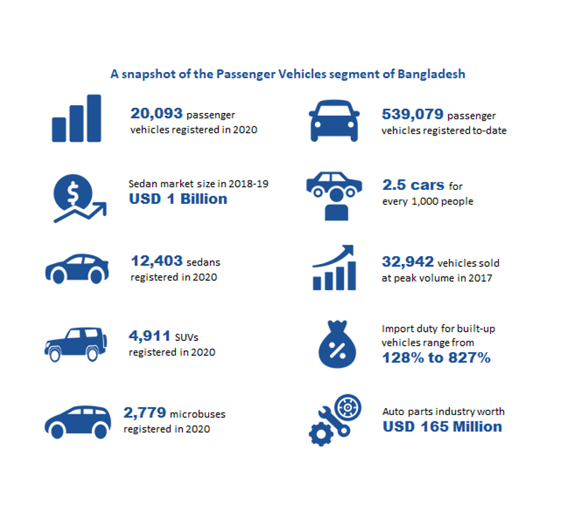
Figure 7: Bangladesh Automotive Industry
(Source: Wing, 2021)
The country has a low automobile concentration, 6 vehicles per 1000 people, which is low compared to peer countries. Demand for 4-wheel vehicles will be more than 100,000 per year, which is a clear market potential (Wing, 2021). Bangladesh is one of the best markets for premium brands. It will be the 9th largest consumer market by 2030. For mobility and battery manufacturing solutions, the first adoption stage will have 400 electric vehicles registered out of over 6 million vehicles. This is an advantage to be a market-first promoter.
International technological expertise, along with strong local manufacturing and local market orientation, positions any partner to tap into Bangladesh’s accelerating growth in mobility, manufacturing, and consumer markets.

Recommendations
Localised Workforce Training and Skill Development SOP
Porsche should review the SOPs to focus on multi-level local development and capacity building processes of the workforce according to the industrial capacity of the Bangladesh setting. Despite all the automation and developed technologies of the German subsidiaries of Porsche with technical individuals, the automotive industry of Bangladesh is in its early phase. The SOPs should include organized apprenticeship plan, bilingual technical manuals (English and Bangali) and liaison with local technical institutes so far as imparting the skills are concerned. Such an adaptation culturally holds reverence to local learning patterns that are also inclusive of hierarchy relationship-based learning mentorship. In addition, adoption of flexible working hours, which consider local working hours and vacation days, will enhance employee satisfaction and retention (Rahardja et al. 2025). Localisation plays a role in the Ownership advantage of Porsche due to transfer of knowledge whilst the Location advantages such as cheap labour exploits. Overall, the shift in the SOP will help in the assurance of efficiency of operation, maintenance of the quality of the brand and creating sustainable human capital in Bangladesh.
Supplier Quality Assurance and Sustainability SOP
The company should also initiate a SOP that integrates quality assurance with sustainability compliance to make sure that Porsche upholds the global standards of quality in their partnership with Walton as well as with the local suppliers. Bangladesh and Germany cannot have the same ecosystem in terms of quality assurance, environmental sustainability and ethics. Therefore, the new SOP should contain the introduction to the regular audits of suppliers, the definite principles concerning the sustainable usage of materials, and the transparent records in compliance with the international policies of Porsche and the domestic laws of Bangladesh. When the sustainability metrics such as carbon footprint reporting and fair labour compliance are incorporated, the internalisation asset of Porsche will be extended, since it does not require it to go to the extent of vertical integration to dictate quality (Runtuk et al. 2024). Also, this change of the SOP is in line with the local cultural proclination towards relationship-based business transactions by introducing collaborative supplier development workshops in lieu of punitive inspections. The strategy will lead to the establishment of trust, alignment of activities with the global ESG goals of Porsche and enhance the validity of the brand within a local economy.
Cross-Cultural Communication and Management SOP
The linguistic differences between the German and Bangladeshi business establishments make it suitable to entail a formal SOP that involves the guidelines of the cross-cultural communication and management. Germany has a direct, punctual and process-oriented culture as opposed to Bangladesh which is a hierarchal and relation culture of work. The new SOP should include mandatory intercultural training, conflict resolution principles with no disregard to the principles of the local communication culture, and a mixed leadership style combining the German efficiency and Bangladeshi collectivism (Okuboye, 2021). The confusion can be addressed by conducting frequent cross-functional discussions via online and face-to-face communications and the local managers can act as cultural brokers. By establishing such norms of communication as a strategic control system, internalising the notion of cultural alignment, Porsche will be able to leverage its ownership strength in terms of organisational excellence. Such transformation will contribute to the enhancement of the collaboration between the German engineers and the Bangladeshi teams, a lower rate of friction between the joint activity and the morale that will ultimately lead to the effortless realization of the goals of the JV operations and the permanence on the market competitiveness in Bangladesh.

6. Conclusion
This report was prepared to examine the proposed joint venture between Porsche and Walton hi-tech industries ltd in Bangladesh and the report was identified to have outlined some significant opportunities and challenges in the expansion process. The findings indicated that the ownership benefits enjoyed by Porsche such as brand equity, hi-tech EV technology, and engineering background have the potential to provide a positive competitive advantage in the new Bangladeshi market. It was however also found out that the differences in cultures, infrastructural gap and bureaucracies’ complexity can also hinder smooth operations. It was also determined in the analysis process that certain strategic adjustments in the Porsches Standard Operating Procedures (SOPs) were vital towards ensuring that a balance between the local workforce in places, quality standards and ethical management was maintained. Overall, the report found that the capability of combining the innovation with the local flexibility would result in success of the Porsche developing each other in a reciprocating way under the culture sensitive and efficient operational joint venture strategy.

References
Abdullah, S., (2024). Duty cuts in plan to promote electric vehicles. [online] The Business Standard. Available at: https://www.tbsnews.net/bangladesh/transport/duty-cuts-plan-promote-electric-vehicles-811858
Anis Mahmud Anik., (2023). Rise of Brand New Car Sales in Bangladesh - Business Inspection BD. [online] Business Inspection BD. Available at: https://businessinspection.com.bd/rise-of-brand-new-car-sales-in-bd/ [Accessed 5 Nov. 2025].
AsianDevBank., (2025). Bangladesh Economy to Slow to 3.9% Growth in FY2025 Before Rebounding in FY2026. [online] Asian Development Bank. Available at: https://www.adb.org/news/bangladesh-economy-slow-3-9-growth-fy2025-rebounding-fy2026
Babu, M.U. ed., (2024). Walton, Huawei partner to manufacture lithium batteries for mobile towers. [online] The Business Standard. Available at: https://www.tbsnews.net/bangladesh/walton-huawei-partner-manufacture-lithium-batteries-mobile-towers-940221
Country comparison., (2025). Country comparison tool. [online] Theculturefactor.com. Available at: https://www.theculturefactor.com/country-comparison-tool?countries=bangladesh%2Cgermanyc [Accessed 5 Nov. 2025].
Customs., (2025). Government of the People’s Republic of Bangladesh National Board of Revenue National Customs Tariff, FY:2024-2025. [online] Available at: https://customs.gov.bd/files/TRF_2024_2025_06062024.pdf
Handoyo, S., Suharman, H., Ghani, E.K. and Soedarsono, S., 2023. A business strategy, operational efficiency, ownership structure, and manufacturing performance: The moderating role of market uncertainty and competition intensity and its implication on open innovation. Journal of Open Innovation: Technology, Market, and Complexity, 9(2), p.100039. https://www.sciencedirect.com/science/article/pii/S2199853123001415
Hsiao, Y.C. and Lin, J.Y., (2023). Knowledge management and innovation: evidence of international joint venture. Scientometrics, 128(1), pp.87-113. https://link.springer.com/article/10.1007/s11192-022-04562-9
Khan, S., (2021). Higher middle class density helps inclusive growth. [online] The Financial Express. Available at: https://thefinancialexpress.com.bd/home/higher-middle-class-density-helps-inclusive-growth-1610808805
KPMG., (2024). Investment Guide Bangladesh. [online] Available at: https://assets.kpmg.com/content/dam/kpmg/bd/pdf/-investment-guide/KPMG_Bangladesh_Investment_Guide_General_%28Sep_2024%29.pdf.
Market Data Forecast., (2025). Europe Luxury Car Market Report. [online] Market Data Forecast. Available at: https://www.marketdataforecast.com/market-reports/europe-luxury-car-market [Accessed 5 Nov. 2025].
Mirzaye Shirkoohi, S. and Mohiuddin, M., (2025). Creating Value in Metaverse-Driven Global Value Chains: Blockchain Integration and the Evolution of International Business. Journal of Theoretical and Applied Electronic Commerce Research, 20(2), p.126. https://www.mdpi.com/0718-1876/20/2/126
News TV., (2023). Porsche AG Capital Markets Day. [online] Porsche.de. Available at: https://newstv.porsche.de/en/article/217311.html [Accessed 5 Nov. 2025].
Okuboye, A., (2021). Cross-cultural variability in workforce optimization: A BPM perspective on remote and hybrid teams. International Journal of Multidisciplinary Futuristic Development, 2(1), pp.15-24. https://www.transdisciplinaryjournal.com/uploads/archives/20250812131130_MFD-2025-1-011.1.pdf
Porsche., (2024). CEO Oliver Blume: ‘Porsche is a Way of Life’. [online] Porsche.com. Available at: https://newsroom.porsche.com/en/annual-sustainability-report/in-conversation-with-oliver-blume/dynamically-porsche/.
Porsche., (2024). Porsche AG Business Development 2024. [online] Porsche.com. Available at: https://newsroom.porsche.com/en/annual-sustainability-report/combined-management-report/business-development/.
Porsche., (2024). Porsche. [online] porsche.com. Available at: https://www.porsche.com/international/locations-and-contact/porsche-ag/.
Porsche., (2025). Combined Management Report. [online] Porsche.com. Available at: https://newsroom.porsche.com/files/Combined_Management_Report_2024_Porsche_AG.pdf.
Porsche., (2025). Porsche - Sustainability - Porsche Great Britain. [online] Porsche Cars Great Britain - Dr. Ing. h.c. F. Porsche AG - Porsche Great Britain. Available at: https://www.porsche.com/uk/aboutporsche/responsibility/.
Porsche., (2025). Porsche AG - Dr. Ing. h.c. F. Porsche AG. [online] Porsche AG - Dr. Ing. h.c. F. Porsche AG. Available at: https://www.porsche.com/international/.
Rahardja, U., Lutfiani, N., Juliansah, M.A.D. and Aptman, E., (2025). Strategy of production efficiency and improving the quality of wooden sofa legs in the manufacturing industry. Startupreneur Business Digital (SABDA Journal), 4(2), pp.155-164. https://journal.pandawan.id/sabda/article/download/867/597
Reuters., (2025). Bangladesh orders solar panels installation on public buildings to tackle energy woes. Reuters. [online] 26 Jun. Available at: https://www.reuters.com/business/energy/bangladesh-orders-solar-panels-installation-public-buildings-tackle-energy-woes-2025-06-26/.
Runtuk, J.K., Ng, P.K. and Ooi, S.Y., (2024). Challenges and Solutions in working with green suppliers: Perspective from a Manufacturing industry. Sustainability, 16(20), p.8744. https://www.mdpi.com/2071-1050/16/20/8744
The daily Star., (2025). The Daily Star. [online] The Daily Star. Available at: https://www.thedailystar.net/business/news/walton-plans-tk-114cr-lithium-battery-factory-3882671 [Accessed 5 Nov. 2025].
Unescap., (2025). ELECTRIC MOBILITY AND SHIFT TO THE ELECTRIFICATION OF PARATRANSIT IN BANGLADESH. [onlin] UNESCAP.ORG Available at: https://www.unescap.org/sites/default/d8files/event-documents/22%20_Electric%20_mobility%20_%26%20_shift%20_to%20_electrification%2C%20_Bangladesh.pdf
Walton., (2024). About Walton. [online] waltonbd.com. Available at: https://waltonbd.com/about.
Wing, L.A., (2021). Bangladesh Automobile Industry Overview and Emerging Trends - LightCastle Partners. [online] LightCastle Partners. Available at: https://lightcastlepartners.com/insights/2021/05/bangladesh-automobile-industry-overview-and-emerging-trends/
Wresearch., (2025). Bangladesh Electric Vehicle Battery Market (2025-2031) | Value & Companies. [online] 6wresearch.com. Available at: https://www.6wresearch.com/industry-report/bangladesh-electric-vehicle-battery-market [Accessed 5 Nov. 2025].

