A
Authenticity and the role of the leader (bmpf7021)
Aled Williams

November 12, 2021
Welsh Ambulance Service NHS Trust

Component 1

Introduction
I am currently a Senior Paramedic working for the Welsh Ambulance Service. I have been in the service for 16 years and undertaken various roles in this time, ranging from trainee Emergency Medical Technician followed by Paramedic and Clinical Team Leader. Working collaboratively with my respective Duty Operations Manager the principle role of the Senior Paramedic is the clinical leadership of a defined group of ambulance clinicians. Undertaking a clinically active role, operating on both an Emergency Ambulance (EA) and a Rapid Response Vehicle (RRV) resources and ensuring the safe delivery of clinical care from all ambulance clinicians but more specifically from my respective clinical team. With the majority of rostered time spent in a patient facing capacity, the Senior Paramedic works to an extended scope of paramedic practice. This involves working at a level over and above that of a paramedic with a skill set suitable to manage the critically ill and injured. This includes an extended drug formulary and further clinical interventions. Delivering clinical care alongside other frontline ambulance clinicians, the Senior Paramedic is the lead Paramedic and has responsibility to ensure excellent patient care is delivered at all times. The level of experience in my team varies greatly ranging from newly qualified EMT and paramedics to staff who have been paramedics for over 20 years.
For this assessment I will be critically evaluating at least five leadership theories and their relevance to my workplace. The five theories I have decided to evaluate are: McGregor’s X – Y theory, Tannenbaum and Schmidt Leadership continuum, Servant Leadership, Hersey and Blanchard Situational Leadership and finally a more modern style of Authentic Leadership. Some of these theories have been around for around 60 years therefore I intend to explore whether they still have a relevance to the workplace. To balance it out I will also include the more modern authentic leadership style to see if this has relevance.

McGregor’s X-Y Theory

According to Douglas McGregor’s book ‘The Human Side of Enterprise’ (1960), he proposes that there are two theories by which managers can perceive and address worker’s motivation. He called these theories X and Y. According to McGregor Theory X relies on the authoritarian style of management, where the managers are required to give instructions and keep a close check on each employee. As it is assumed, the employees are not motivated, and they dislike working. This theory is based on the assumptions that the employers dislikes work and are not motivated enough to carry out their work so they have to be micromanaged and supervised often to make sure they are carrying out their work.
Theory Y: Theory Y relies on the participative style of management, where the managers assume that the employees are self-directed and self- motivated to accomplish the organisational objectives. Thus, here the management attempts to get the maximum output with least efforts on their part. This in essence is the opposite of theory x and management in the whole will allow employees to get on with the job in hand with minimal supervision.
The picture below shows how the both theories work (edu-article.blogsport.com):
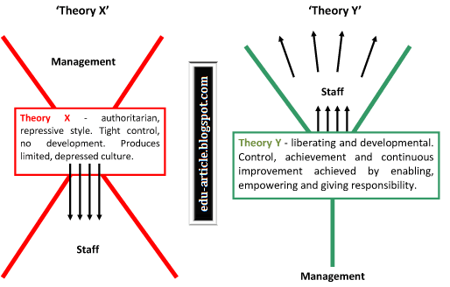

My initial thoughts on this theory was that it was too simplistic just to have two opposing views on how to motivate staff. It doesn’t seem to take into account the level of experience or grades of staff or the situation or task that needs to be carried out. It doesn’t seem to take into account that motivation of staff can vary within a group and even at different times due to other factors going on at the time. Although I’m not going to discuss them here, models such as Maslow’s Hierarchy of Needs and Herzberg’s Motivator – Hygiene Theory states that motivation can be changed and not a fixed state to be assumed.
I would say that in the past the managers in the ambulance service would very much use the theory x style management and when I initially became a clinical teal leader in the ambulance service I did feel pressure to use an autocratic style to lead my team. However I didn’t feel that I would be Myself if I used this style of leadership and in turn that my team would see right through this and also that if I was being someone that I wasn’t then this would also affect my wellbeing. What I came to find was that by being open and honest with my team and asking people to do something rather than telling them that I would get a lot more from them. I also think that when using an autocratic style then staff would not be open and honest with the leader and try to hide if they made any mistakes so they wouldn’t get into trouble.
I find that using more of a y theory leadership, staff are more open and honest and this works well in my opinion when carrying out ride outs with my team. Due to the fact that we only carry out one or two ride outs a year, we will never have a full understanding of how well each team member performs. However when the team member is confident in my ability to be supportive and understanding their difficulties, they can then be open about their weaknesses and which areas they need to improve on.

Tannenbaum and Schmidt Leadership Continuum
This theory suggest that management style is more of a continuum as shown in the diagram below. Rather than two opposing theories there are 7 ways to lead highlighted at the bottom of the arrows in the diagram. (expertprogrammanagement.com)
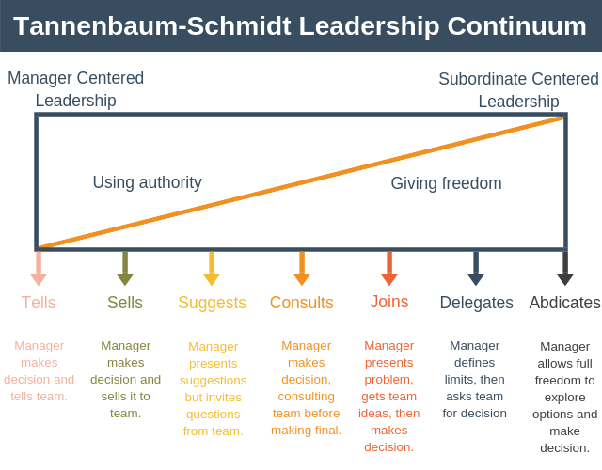
In my opinion you could look at it that on the left side of the chart is very much like theory x from McGregor and the right side of the chart like theory Y. Although this does give you more stages on way to lead from the McGregor’s theory, it still doesn’t take in to account the manager, the employee or the situation and as such I would need to change my leadership style to match any of those situations. For example if I was leading on a cardiac arrest, I would very much be using the tell approach since time is of the essence but in a different situation I would more than likely use the other range in the continuum as the situation might be different. Also I would argue that when you delegate or abdicate tasks there is the danger of staff abusing the trust you have given them therefore you would have to know the team member very well in order to know if the member could be trusted to carry out the task to the required standard. In my line of work, when it could be a matter of life or death decision then it becomes very important that the correct style is picked.
There is also a consideration to be made about staff becoming task focused during a cardiac arrest and by that I mean if I have asked a team member to manage the airway and breathing in a resuscitation attempt then they would be focused on that skill and forget potentially on other things like checking the ECG rhythm or administering drugs. This isn’t due to the fact that they are not motivated to do well but rather they were concentrating so hard about one task therefore it’s important to have someone stand back and have a general overview of the situation.
Servant Leadership
The term itself was first used by Robert Greenleaf in his 1970 essay, “The Servant as Leader.” However it is not necessarily a new style and as described in the book ‘Servant Leader In Action’ Jesus Christ would have used this style over 2000 years ago. Mahatma Gandhi, Dr. Martin Luther King Jr., and Nelson Mandela are also described in the book as more modern examples of leaders who used this style of leadership to good effect.
It means that a servant leader focuses on the growth and well-being of employees and other stakeholders in their organisation. Servant leaders seek to help the people they serve grow as individuals. The picture below tries to explain some of the differences between servant leaders and traditional leaders (http://www.web3us.com/non-technical/what-servant-leadership)

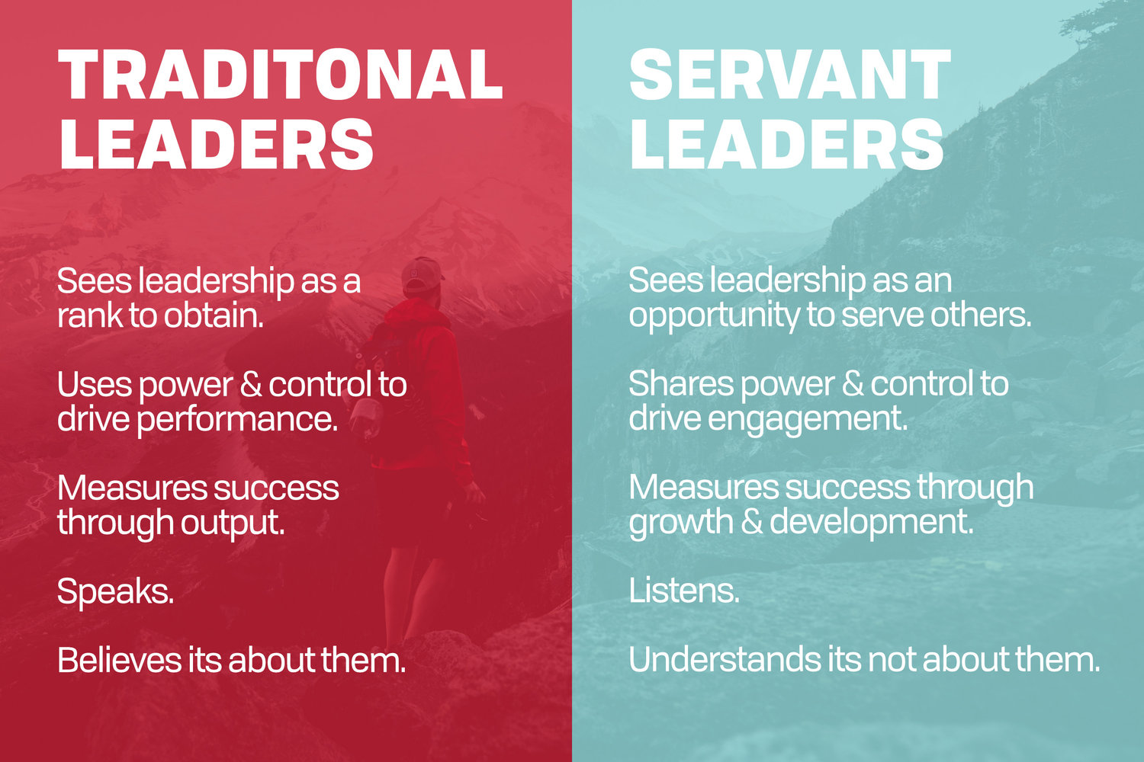

I believe that this style of leadership could lend itself well to my role as a senior paramedic since the line of work that we are all involved with in healthcare could be deemed as serving others. My team in general serve their patients and this could make them appreciate this leadership style in their leader. As a senior paramedic I can relate to the points on the right hand side in the diagram above as being a productive and rewarding way to lead their team. As a general day to day way to lead I would find this an effective style although it does lack any guidance regarding the situation or group of people you are leading.
I can also think of negatives in this style of leadership. Trust is a big part of this leadership style in that you must have trust in your team to be motivated and being their best. As a senior paramedic I do not have a say in picking my team and I can say that in the past team members have been known to take advantage of the trust I give them and therefore a different style of leadership may then be needed with these members.
Also from reading about servant leadership there is a lot of religious undertones to it, which personally doesn’t fit in with my beliefs. However a lot of the values such as honesty and integrity do go along well with my values. I wonder if these values is down mainly to my personality or if it was down to the way I was brought up. According to Oliver and Mooradian (2003), they state that personality traits are largely endogenous characteristics, while personal values are learned adaptions strongly influenced by the environment. I feel then that this style of leadership could fall down if the leader does not display strong values and beliefs or if they did not match up with members of the team.
There are also times where we do have to measure success through various performance indicators set by the Welsh government and therefore we cannot give total control to the team and feel we still have to set various objectives for the team to meet to help meet these performance targets.
According to Boone (2019) a servant leader creates an environment where followers want to come to work and do their best and as this means that a lot of followers improve their work, then the company thrives in achieving meeting a common goal. I can see this being a very useful way of increasing productivity or our case in the ambulance service creating better care for our patients. Although most of the guidelines and protocols for treating patients are set for us I believe there are still other aspects of the role such as providing training and encouragement to our team that can help with their motivation.

Hersey and Blanchard Situational Leadership
The Hersey-Blanchard Model is a leadership model that focuses on the ability and willingness of individual employees. It was developed by Paul Hersey and Kenneth Blanchard, the model is also referred to as the Situational Leadership Model. It was first introduced in 1969 and called ‘life cycle theory of leadership’. The model states effective leadership varies, not only with the person or group that is being influenced, but it also depends on the task, job, or function that needs to be accomplished. The diagram below (https://wikispaces.psu.edu/display/P5PFLB/SITUATIONAL+Theory+Page) shows 4 quadrants labelled S1 to S4 and these indicate the experience of staff.

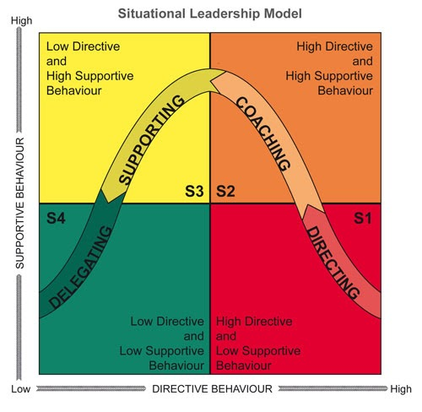
From my leadership experience, I would say that this model will work well, when undertaking ride outs with our team as we should know them well and have a good understanding of their level of experience and motivation. Knowing these things will help guide which style of leadership to use. A newly qualified paramedic for example would gain more from a directing or coaching style whereas an experienced paramedic in the S4 quadrant could be delegated work as you would know they would be capable of carrying out the task without supervision. This in turn would help improve their motivation in their role. Things would be slightly different if we turn up to support crews in a cardiac arrest situation whereas I might not know the staff or their level of experience and the obvious time critical nature of this type of call would need a more directing style. This was shown in a study which looked at styles of leadership in 28 paediatric residents who carried out emergency simulations. In these scenarios 54.4% used a coaching style, 35.6% directing style and in comparison only 4.4% used delegating style and 5.5% using supporting style.
I believe much can be taken by this style of situational leadership in my role of senior paramedic since we find ourselves in many different situations in our day to day role and in fact I might even have a different style with the same individual depending on the situation we were faced with. As discussed above a cardiac arrest would be managed in more of a directing or coaching style whereas I might use a more delegating style for less time critical or important tasks.

Authentic Leadership
Authentic leaders are seen as genuine or real according to an article from Pennsylvania University. It is still forming as a theory but more research has been done over the last few decades due to the desire to have leaders who are honest and good. Bill George has developed a model of authentic leadership concentrating on 5 dimensions. These 5 dimensions can be best seen in the diagram below. (Five Characteristics of Authentic Leadership (psu.edu))

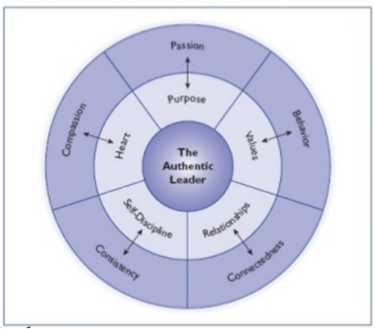
Northouse (2017) stated that authentic leaders have a sense of purpose, knowing what they’re about and where they are headed. Purpose manifests itself as passion. Passionate people are interested in what they are doing, are inspired and intrinsically motivated and care about the work that they are doing. Secondly authentic leaders have values, know what they are and don’t compromise on those values. This quality manifests itself through the leader’s behaviour, acting in accordance with their values. Thirdly authentic leaders build relationships with others and connectedness with their followers. They are willing to share their experiences and listen to others and communicative with their follower. The fourth dimension is self-discipline, which gives leaders focus and determination: ability to focus on a goal and move forwards towards that goal even in the face of setbacks. This is consistency and self -disciplined leaders remains calm during stressful situations. Finally authentic leader have heart, which shows in their compassion. They are sensitive to others and are willing to help them.
In addition to these dimensions by Bill George, John Adair (2013) lists 7 leadership qualities to becoming a successful leader. These are Enthusiasm, Integrity, Toughness, Fairness, Warmth, Humility and Confidence. He does not specifically mention authentic leadership when he lists these qualities but I believe if a person displayed these qualities then this would make them more authentic.
Western, S. (2007) describes a time in the USA that there was a lot of distrust in leaders and points to many examples of corrupt leaders and even arguments for having leaderless groups. This can highlight the importance of an authentic leader in trying to avoid this type of thinking.
To be a good authentic leader, the leader must first be good at knowing themselves and various insights questionnaires such as Myers Briggs can help with this. Once you start to know yourself better I believe it is also important to be yourself when leading others and in turn members of the team can also be themselves in front of you, which will allow for better communication in an open and honest way.
There has also work been done in trying to measure a person’s development in authentic leadership. Chan (2005) looked at 4 perspectives in which to measure development, which are:
- Intrapersonal: Considers authentic leadership as a system of internal process such as self-awareness, self-regulation, meta-cognition and values.
- Interpersonal: Considers authentic leadership as a positive relational influence by means of relational transparency, behavioural consistency and relational orientation.
- Developmental: Considers authentic leadership as a personal journey of growth by means of narratives, life stories, insight, themes and self-reflection.
- Pragmatic: Considers authentic leadership as a means of veritable outcomes by means of growing performance beyond the usual.

Tineke also describes in her book about different levels of development as authentic leader with periods of growth and stability at the different levels. It explains that leadership development level 1 is pre-adult and goes with periods of stability and growth from leadership development levels 2 to 5.

I think this leadership style works well in my role and any other role as I think that people in general are a good judge of character and would see through any leader that was trying to pretend what they were doing and didn’t have the necessary knowledge, ability and values to carry out the role. Once this trust from the team was lost then the team would lose all respect for the leader and would be less likely to want to follow and develop.
I have a strong belief that a leader should lead by example and I think that this ties in well with the model of authentic leader. It would be very difficult to motivate a team if you as leader would not display values that you would expect of your team.

Conclusion

I have described and reflected on 5 leadership models, which were McGregor’s X-Y Theory, Tannenbaum and Schmidt Leadership Continuum, Servant Leadership, Hersey and Blanchard Situational Leadership and Authentic Leadership. I don’t necessarily think there is any one right or wrong model to use when leading a team and a variety of these models can be used depending on the situation and personalities involved. I do think however that it is essential that an effective leader is authentic and elements of a servant leader is also important. I have explained that values and leading by example are important not just for leaders but for team members as well.
I have also stated that McGregor’s X-Y theory may be too simplistic and not of much value in this day and age although this has led the way to other more complex models to be developed. Although the Schmidt leadership continuum gives you more stages in between to pick from, I still think it is lacking the situational and experience of the team in its aspects.

Component 2

For this aspect of the assignment I will be exploring and critically reflecting on personal leadership styles and behaviours and interpersonal skills and their impact on workplace relationships. I will be concentrating these aspects from a leader’s perspective since I became a clinical team leader in 2012, where I was looking after a team of around 15 staff. When I started this role I was not given any formal training in leadership apart from some self-directed reading of leadership books. I have also had a spell of around 2 months of acting up to locality manager for Gwynedd & Anglesey, where I was leading a team of 12 clinical team leaders, who in turn had around 120 staff working in the region. Finally I will reflect on my current role of senior paramedic, which is a new post within the Welsh Ambulance service and is currently very much in its infancy and still developing.
When I first started as a clinical team leader I was very much conscious of the fact that senior management at that time in the Welsh Ambulance Service used more of an autocratic style of leadership and I did feel under pressure to follow this approach and felt that the eyes of my line manager was on me to follow this approach. However the little leadership knowledge I had at this time from reading books on the subject stated I had to be myself and when considering this, I became aware that using the autocratic or authoritarian did not match my personality. I had no knowledge of leadership styles or social styles at this point and was relying very much just on instinct in the way I was leading the team.
One of the things that I reflect on in this early part of being a leader is the fact that one of my moving away from values is conflict and I tried to avoid this as much as possible. I have since come to understand that all conflict is not bad and can sometimes be beneficial but I still found this a very uncomfortable aspect of my role.
When undertaking the Thomas Kilmann model questionnaire on my Institute of Leadership and Management (ILM) course in 2018 I found out that I came out as an avoider. After reflecting on this I thought this was not the best way to lead the team and indeed this did affect my confidence in being a leader. The diagram below from challengingcoaching.co.uk website should show the differences in dealing with conflict.

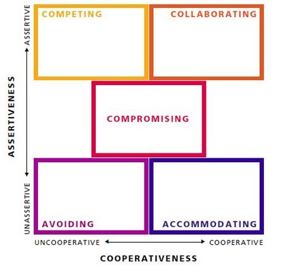
Since gaining this knowledge I have tried to see that not all conflict as a bad thing and that challenging members of the team does have to happen on occasion and have tried to move to more of a collaboration or compromising when dealing with staff members. I would still say however that I find it uncomfortable and stay away from competing with team members.
I think in the early days as a clinical team leader my team had respect for me and I believe this was mainly down to my moving towards values such as integrity, trustworthiness and committed. Before I became a leader, I had completed some further training through the open university to improve my clinical knowledge so I think this helped my team look up to me. I was a strong believer at the time that I had to lead by example and that the word ‘clinical’ in my job title was important to me. In fact this had a big part to play in my recent decision to become a senior paramedic rather than a Duty Operational Leader when the role split into two different roles.
To be an effective leader it is important to know yourself first before you can know your team and know how to get the best out of them. One test, which can help with this is the Myers Briggs personality test, which looks at four component. The four components are Introversion / Extroversion, Sensing / Intuition, Thinking / Feeling and Judging / Perceiving. The four components can also be assigned a letter E/I, S/N, T/F and J/P. The first time I had come across this test was during my ILM course and when completing a simple quiz I sometimes found it hard to pick an option as an answer. I wondered why this was therefore I looked online for a more thorough test with more questions asked of me for all the components. This was called an MMDI questionnaire, which stands for Mental Muscle Diagram Indicator. This lead me to have the results shown below, which not only gives me which components I tend to lean towards but also how far over I am. As you can see from diagram I am very much down the middle on the four components, which I believe explains why I was sometimes having trouble picking an answer on some of the questions from a basic Myers Briggs test. In practical terms of being a leader I believe this does give me some advantage when dealing with my team members because I can see things from both perspectives and help me empathise with a certain point of view.
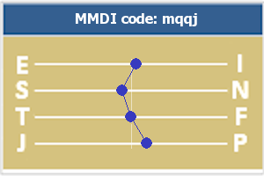

To delve even further into my personality I have also undergone an insights psychometric model, which has gone much further in highlighting my strengths and weaknesses. I will look at trying to incorporate some of the information into my personal development plan later in this assignment. The insights results showed that I am very much more on the introvert side of the scale when it comes to this aspect of the Myers Briggs and would say this to be more accurate than the above MMDI diagram, which has me only just on that side of the scale. As part of my development I will look to spend time with periods at the centre of attention by running more training events for staff and even doing some clinical presentations. These tasks do not come easy to me but I believe from doing some events in the past that they do become easier the more I do them therefore I will incorporate more of these events to help my team. One of the weakness the insights has suggested is being too slow to express my thoughts and feelings and I think that this can be linked in with me worrying too much about my colleagues feelings in that I sometimes do not give them as accurate a feedback as I could about their performance in case I upset them. I am not suggesting that I intentionally go out of my way to upset someone but sometimes I would say that I avoid telling them the truth to protect their feelings. As part of my development I would say that I can still give accurate feedback and still do it in a more constructive way.
One of the statements that resonates with me is ‘takes over work of others rather than leaving jobs undone’ due to the fact that when I acted up to locality manager I remember I was very poor at delegating work to other team leaders. I found that this could be completed when just working as a clinical team leader in Bala but when I was leading a team of over 120 staff then this was simply not possible. Although I was only doing this role for around 8 weeks, I was finding myself feeling exhausted and burnt out but it did teach me how to improve prioritising my work and how to delegate more. In fact one of the development areas identified in my insights study was ‘Being less willing to take too many additional tasks’ therefore I believe I still need to learn to say no more often.
With regards to decision making I have always found it difficult to make these in a timely manner and waiting until I had all the facts before making them. This is highlighted in my insights study as an area to improve on and trusting my decisions more. One example I can think of in the past that didn’t help my confidence with decision making was when I was acting as locality manager and we were short of ambulance crews in one particular area on one Friday. I decided that to help out that I would sign on a rapid response vehicle to increase our response to 999 calls but during a conference call on the Thursday to discuss our resources, one of the other locality managers questioned my decision and asked who would be looking after the locality. I replied that I had no meeting planned for that day and that I would still pick up emails as best as I could and would work on into the night to reply to them should I need to. This questioning of my decision didn’t make me feel too good but my decision did seem to be vindicated a few weeks after, when senior managers asked all locality managers to respond to emergencies at least 1 day a week due to the pressures we were under.
The insights study also states that I need to recognise the need for heightened urgency in some projects. I feel that in my line of work this shouldn’t be too much of an issue. The reason I believe this to be the case is that the majority of work that we do is emergency care therefore there is always an urgency to the work. In a management of a cardiac arrest for example, there are clear timescales for treating the patient in respect to pulse checking and administering certain drugs for example. In other calls however I must admit that I do like to take my time in gaining as much history as possible about the patient before deciding on the best course of action. Sometimes spending an extra 5 minutes at scene assessing the patient may lead to the decision that an alternative pathway would be more suitable rather than taking the patient to the emergency department. The insights study can be split into 4 different colours, which gives a broad description about our behaviours. The wheel can be seen below.
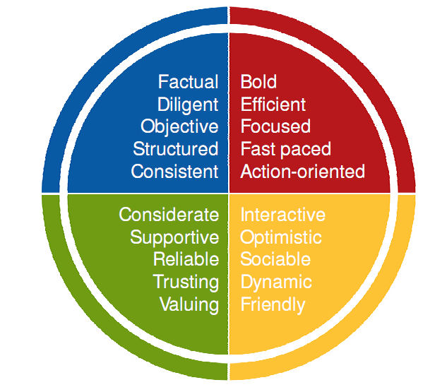
My results have come back as shown below, which has me bordering on the green and blue. This has me down as a co-ordinator.

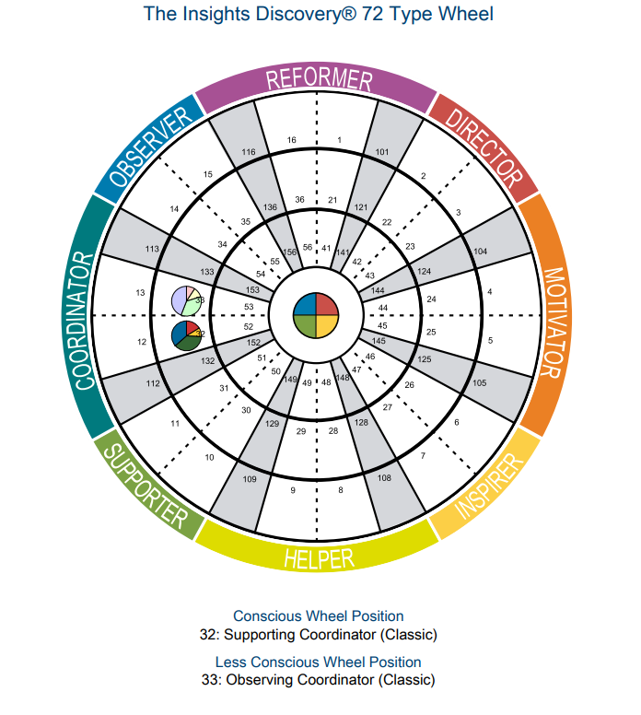
Words that normally describe a co-ordinator include careful, thoughtful, diplomatic, sincere, loyal, precise, disciplined, high standards and expectations of self and strong value system. I see these as positive traits in a leader although co-ordinators will generally not impose their thinking on others, which I believe this to be true of myself. A way around this in my role I have found is directing my team to trusted policies and guidelines rather trying to impose what I am thinking. I also often use a coaching style when undertaking ride outs with my team members and encourage them to think where they can improve their performance in an open and honest way. I have found this to work well, especially since I am only doing one or two ride outs with each member of the team per year and will be impossible to witness them in every situation since we cannot control what type of patients and types of injuries or illnesses we get called to during the shift. I therefore have to try to encourage honesty on what they think they need to work on. It’s difficult to know exactly how honest they have been with me so far but my impressions are that they have been very honest and it looks like the team trust me enough to know there will be no repercussions to what they tell me, up to a point, and they feel supported in me aiding their development. It has also been interesting to see some staff have very little experience in reflecting on their own practice so I hope this is something they can take from the ride outs and continue to do even informal reflections in the future.
Another model to help me understand myself and relationship with others is the Johari window developed by Joseph Luft and Harrington Ingham in 1955. This is a simple model that helps interpersonal relationship by giving a greater insights to myself and of what I share with others. The window has 4 panes, which are, things that are known to me and others or shared, things that are known to me but not others or hidden, things that are not known to me but are to others or blind and finally something not known to me or others or the unknown.
From doing a questionnaire, which looks at soliciting feedback and willingness to self-disclose / gives feedback, I had scores of 32 and 23 out of 50 respectively. When I plot this out it comes out as shown below:
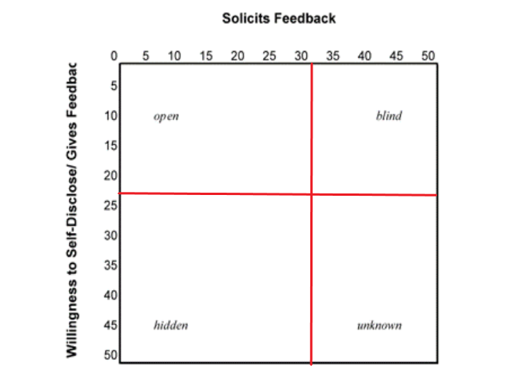
What I have learned from this exercise is that I am better at soliciting feedback than willingness to self-disclose and I need to improve on this aspect of my interpersonal relationships. I believe this goes hand in hand with my personality as described in the insight study above. I will endeavour to improve this aspect in the future and include this in my personal development plan although I will have to give some thought to how I’m going to measure this when making the objective specific, measurable, achievable, relevant and time (SMART). By increasing this willingness to self-disclose and giving feedback I can then hope to decrease the hidden and unknown aspect of the window, which will hopefully help me communicate with my team during my ride outs. I think the best way to measure this will be to undertake the questionnaire again at a set time to see if my scores have changed.

I have also looked at my learning style and the most efficient way that I can learn new information. I used the ‘Honey-Mumford Learning style questionnaire’ and after totalling up the final scores my results were: Activist 14, Reflector 19, Theorist 13 and Pragmatist 16. This highlights that my preference is towards a reflecting approach to learning. I would say this to be true since I do like to look back and take my time in learning new material and I don’t do as well when rushed in a classroom setting and much prefer to go over things in my own time afterwards. Activities suggested for reflectors are observing others perform activities, paired discussions, receiving feedback from others and coaching. I think this learning style aligns itself quite well to carrying out ride outs with my team on a one to one basis and I’m much more comfortable doing this than talking in front of the whole team. One criticism of the Honey-Mumford questionnaire however that it’s more of a personality test rather than a true learning style questionnaire. I can see when comparing this learning style and the information from the insights questionnaire that there are a lot of similarities. These would include preferring to take my time in gathering information and not being very comfortable in front of big groups. Another criticism I have of this type of questionnaire is the danger of ignoring all other types of learning once you have found out it’s not my preferred style. Even though I have scored lowest in the activist and theorist categories I am sure that I could still learn new things using methods suited to them such as brainstorming sessions for activists and having the opportunities to ask questions for the theorist. I would also say that I like to see the purpose behind everything I learn, which is more of a theorist trait. All in all though I think it’s a useful model to learn about and to be aware of and am sure I can still gain information from different methods but I know that reflection is likely to work better for me.
In looking at my own leadership style I have completed various questionnaires over the years and they indicate that I am a democratic leader. I am always keen to involve the team in decision making however in the line of work that I’m in, we are always guided by a policy from pretty much every scenario so the scope to make some decision is limited and from a clinical perspective we are limited from guidelines and protocols and it would be difficult for myself or the team to deviate from these without good reason. The main areas in the past that I have been able to make decisions is in how some things at station level was run when I was clinical team leader in Bala station. I was always keen to have different people involved with various tasks such as checking drug or equipment expiry dates to even somebody looking after the tea kitty. I felt it was important that everyone felt involved with the day to day running of the station. Although democratic leaders can promote creativity and ideas, these things aren’t really relevant in our line of work as we have to stick to policies and guidelines as mentioned above but I would hope that this style of leadership does lead to better morale and does allow for staff to be more open with me. I think that moving forwards in the new senior paramedic role this will be of great benefit. I believe you do have to be careful however when using a democratic style of coaching in that you have to set certain boundaries as there is a risk of some staff taking advantage. For years as team leader in Bala I had quite a settled team with minimal turnover of staff but I did find that around 2 years ago we had a large turnover of staff due to retirements and other staff transferring to stations closer to home and I did find that this altered the balance of the station to some degree and I had to make sure that some boundaries were re-enforced as some of the newer staff were trying to influence changes in the station that some of the older staff were not happy about. As a leader I have to acknowledge that change does have to happen but making sure that this change doesn’t reduce performance and also that it doesn’t disrupt morale too much for the older staff. I found it best to try and have a compromised approach when introducing any of these changes and to do it on a timescale where everyone can adapt to them.

Another aspect I have looked at previously is social style. Social styles theory was developed by two psychologists – Reid and Merrill (1981). They came up with four styles, which everyone had a preference in using when communicating with other people. The four styles are determined by looking at responsiveness and assertiveness. For example high responsiveness and low assertiveness is classed as amiable. High responsiveness and high assertiveness is expressive. Low responsiveness and low assertiveness is analytical and finally low responsiveness and high assertiveness is classed as a driver. From my completion of various questionnaire I come out as analytical. This seems to fit in with the insights and learning styles that I have in that I like to look at all the data before making a decision and in fact can appear indecisive at times. I think with most of these models it’s unlikely that we fit exactly as the model explains but that I would tend to have more of those characteristics. It could be useful to also know what social style other members of the team have to help with interpersonal skills but also I believe it’s important not to type cast people either as this can have limitations.

An important aspect of being a leader and indeed being successful in any part of life is emotional intelligence. Before completing my ILM course I had not really come across this aspect so had not given it any thought. According to Mayer and Salovey (1997) there are four branches to emotional intelligence, which are Perceiving, Using, Understanding and managing our emotions. It looks like to me that the best test out there to calculate your emotional intelligence is the Mayer-Salovey-Caruso Emotional Intelligence Test. I have not been able to find a resource to carry out this test but I have found a simple emotional intelligence test online (shown in Appendix A). From the 15 questions I have come out with a score of 109, which is slightly above average. I seem to score well on the aspects regarding self-awareness and relating to empathy but I did get lower marks in teaming with others and activation. From these results it looks like I need to improve teaming with others and my activation. It’s likely that that teaming with others might be related to the fact that I tend to lead more on the introvert side. From a leadership aspect and checking on staff wellbeing after a difficult job I tend to find that I do have empathy with them, which shows in the test results. I think also that it’s easier to empathise with the vast range of emotions we can face in the role since I am out there also attending similar circumstances and this helps me have an understanding of what they are feeling. However everyone reacts differently to various stimulus and also I am mindful of the accumulation of serious incidences can also catch up with people and therefore we have to make sure we refer staff for follow up counselling and support if we think they need it. When trying to improve the aspect of activation and motivation just completing a personal development plan will help due to having a time limit on completing my development tasks. In general I don’t have problem with motivation but the question in the test did ask whether I had to do something I didn’t want to do I tend to put it off until later and I do think that this is true of me. Also I believe I could improve this aspect by changing my mind-set to getting a task done to get it out of the way now that I know that I can have a tendency to procrastinate at times.
You would think that emotional intelligence would be at its most important when dealing with critically ill patients but I have found that when these incidents happen myself and staff just get on with the task at hand and probably the hardest aspect of these jobs can be breaking bad news to Family members following a death of loved ones. I think it’s important at these times to show empathy and compassion but at the same time trying to distance yourself from your feelings and not get too emotionally involved otherwise we would burn out from the potentially frequent encounters we have of these situations. It can sometimes be more challenging I have found when I have been sent to the hospital to deal with delays to check on crew welfare and try to liaise with hospital staff to try and offload patients as fast as possible. I have tried to balance the strong emotional feelings of anger that staff have when they have been waiting outside hospital for hours and are tired and hungry and I have to be careful not to pass that anger on to hospital staff who are doing their best to get our patients into the department when a bed comes up. It is a balancing act between being able to put some pressure on in the form of trying to agree to plans to offload patients but at the same time showing empathy towards them in acknowledging they are also working under extreme pressure. Other challenging times when we need to use our emotional intelligence is when patients have been waiting a long time for an ambulance and you have to pick up from the patient’s Family as early as possible about the level of anger we will be facing and trying to get an apology over as soon as possible. I have generally found this to be effective and the vast majority understand that it’s not our fault that there’s a long delay and that we have arrived as soon as we can.

One aspect of being a leader that I think I have had limited exposure to is chairing a meeting or conference call. I therefore feel that I need to develop in this area. I have chaired 2 to 3 conference calls in my time when acting up as locality manager and felt that it went well but I did have a set template to follow. I felt that although I followed the set template I didn’t feel comfortable being the one that led it but I guess this would feel more natural the more I become exposed to it. Following the call I would then have to produce a Common Recognised Information Picture (CRIP) report. The information included in the CRIP would be our red call performance that day, any fleet issues, staffing levels for the day, current demand and hospital capacity for those in North Wales. Any issues identified would be discussed and solutions found. An example of one of my CRIP report can be found in Appendix B.
One of the ways I feel I could improve as a chairperson is to hold some small meetings locally with my team to discuss clinical matters. Also there could be opportunities outside of the work setting that could give me more exposure. An example of this is an upcoming vacancy for chairperson of a local junior rugby club so volunteering for this position could help me get more exposure to chairing meetings.

Conclusion

During this reflection I have undertaken a number of questionnaires and tests to try to better understand myself and why I do things certain ways and why I feel uncomfortable in certain situations. I believe that gut instinct in how to lead can be useful but the learning I have completed in leadership over the past few years has given me a better understanding of how best to lead and also when and how to use various styles of leadership depending on the situation. The personal development plan (PDP) shown in Appendix D will hopefully reflect areas I need to work on over the next 6 to 12 months when looking to improve my leadership knowledge and skills to help me in my role as senior paramedic. The task highlighted in the PDP will be Specific, Measurable, Achievable, Realistic and a timescale element attached to it. As well as the PDP itself I have also included a SWOT and PEST analysis (Appendix C), which will help highlight areas to work on and also prepare for possible future challenges within the organisation. These have highlighted the fact that since we work under two directorates in clinical and operational this can raise conflict in that the clinical directorate has no budget and therefore the operational directorate will be making sure they have the best value for money from us rather than clinical outcomes. This has led us to have to arrange meetings to iron out problems in our role already. Lack of funding has also meant that a shortage of senior paramedics means we have much larger teams to manage and hence we will only be able to do one ride out per year with each member of staff rather than at least 2. I have tried to counter act this in my PDP by making sure I will go around each of the 6 ambulance stations I cover at least twice a year to carry out training with staff so that they continue to improve. This will mean that these training events will be carried out once a month. I will also carry on with the PG Cert in clinical leadership to improve my leadership knowledge. One other thing I have identified in my SWPT analysis is not all senior paramedics have assessing qualification, myself included. I think this could prove a threat in the future if staff question our qualification to asses them during our ride outs. I will aim to rectify this by completing a Level 3 Certificate in Assessing Vocational Achievement. Another threat I have identified is both the senior paramedic and the duty operational manager (DOM) role being merged as it was previous to the senior paramedic role being implemented. I believe this has happened before in other ambulance trust since there was an overlap in both roles. To manage with this I will keep up to date with the role of the DOM and I will do this by monitoring emails and conference calls that the DOM manages. I have put this as a low priority since I am sure some catch up training would be provided should I have to return to this role.

Appendix A
Emotional Intelligence Test
by Bill Gaultiere
Your Emotional Intelligence (EQ) is a hidden aspect of your personality, like the part of an iceberg that’s underwater. It’s foundational to your life and key to your success in life and relationships. Surprisingly, it’s actually more important to your well-being and effectiveness than your IQ. The great thing about EQ is that it can be improved if we work on it. Here’s an Emotional Intelligence Test I developed inspired by Daniel Goleman’s research.
Each question below asks how you act of feel in certain situations. Answer how often it is true of your actual (not desired) behaviour or attitude.
- When I feel bad I’m not sure what it is that is bothering me.
Always (3) Usually (5) Sometimes (7) Rarely (9) Never (11)
- When faced with a disappointment or a loss I try not to feel sad.
Always (3) Usually (5) Sometimes (7) Rarely (9) Never (11) 3. I put high priority on understanding how I feel when I make an important decision.
 | Always (3) Usually (5) Sometimes (7) Rarely (9) | Never (11)
4. | When I am upset it takes a long time for me to feel better.
 | Always (3) Usually (5) Sometimes (7) Rarely (9) | Never (11)
5. | When someone criticizes me unfairly I feel bad about myself.
 | Always (3) Usually (5) Sometimes (7) Rarely (9) | Never (11)
6. | My emotions are up and down.
 | Always (3) Usually (5) Sometimes (7) Rarely (9) | Never (11)
- It’s hard for me to wait to get what I want even if I know it’s for the best.
Always (3) Usually (5) Sometimes (7) Rarely (9) Never (11)
- When working on a challenge I struggle to feel hopeful, energetic, and confident. Always (3) Usually (5) Sometimes (7) Rarely (9) Never (11)
- If I have to do something I don’t want to do I put it off till later.
Always (3) Usually (5) Sometimes (7) Rarely (9) Never (11)
- When people share a problem with me I think more about how they could solve it then about how difficult it feels for them.
Always (3) Usually (5) Sometimes (7) Rarely (9) Never (11)
- In situations of conflict I have trouble understanding other people’s emotions. Always (3) Usually (5) Sometimes (7) Rarely (9) Never (11)
- I am unable to sense other people’s unspoken feelings on important issues. Always (3) Usually (5) Sometimes (7) Rarely (9) Never (11)
- I avoid engaging in conversation with people I don’t know well.
Always (3) Usually (5) Sometimes (7) Rarely (9) Never (11)
- I say things to other people that I regret later.
Always (3) Usually (5) Sometimes (7) Rarely (9) Never (11)
- In social situations it’s hard for me to build rapport with others.
Always (3) Usually (5) Sometimes (7) Rarely (9) Never (11)
Your Total EQ Score _________
EQ scores range from 45 to 165 with 105 being average. A score of 120 and above is exceptional.
MART Components of EQ
S Self-Awareness Questions 1-3
M Managing Emotions Questions 4-6
A Activation (Motivation) Questions 7-9
R Relating with Empathy Questions 10-12
T Teaming with Others (Social Skills) Questions 13-15

Appendix B

Appendix C
Appendix D

References
- McGregor, D. (1960). The Human Side Of Enterprise, New York: McGraw-Hill.
- Tineke, Wulffers. Authentic Leadership Effectiveness: For Individuals and Teams – A Coaching Approach, KR Publishing, (2017). ProQuest Ebook Central,
- Cherniss, C. and Goleman, D. (eds) (2001) The Emotionally Intelligent Workplace: How to Select for, Measure, and Improve Emotional Intelligence in Individuals,
Groups and Organizations. San Francisco: Jossey Bass
- Northouse P. G. (2013) Leadership: Theory and Practice,
(6th ed) Los Angeles: Sage.
- Western, S. (2007) Leadership: A Critical Text. London:
Sage
- Adair, J. (2013) Develop your Leadership Skills. London:
Kogan Page.
- Tineke, W (2017), Authentic Leadership Effectiveness: For Individuals and Teams – A Coaching Approach, KR Publishing, Randburg.
- Chan, A., (2005). Authentic leadership measurement and development: challenges and suggestions. In W. L. Garner, B. J. Avolio, & F. O. Walumbwa (Eds.), Monographs in leadership and management volume 3: Authentic leadership theory and practice: Origins, effects and development (pp. 227-250). Amsterdam: Elsvier.
- Blanchard, K. et al. (2018) Servant leadership in action: how you can achieve great relationships and results. 1st edition. Oakland, California: Berrett-Koehler Publishers, Inc.
- Boone, L. W. (2019) Servant leadership: attitudes, skills and behaviours. Newcastle upon Tyne, England: Cambridge Scholars Publishing.
- Sullivan, G. S. (2019) Servant Leadership in Sport Theory and Practice. 1st ed. 2019. [Online]. Cham: Springer International Publishing.
- James M. Oliver, Todd A. Mooradian, (2003), Personality traits and personal values: a conceptual and empirical integration, Personality and Individual Differences, Volume 35, Issue 1
- Mayer, J.D. and Salovey, P., (1997). What is emotional intelligence. Emotional development and emotional intelligence: Educational implications, 3, p.31.
- Merrill, D. W., & Reid, R. H. (1981). Personal styles & effective performance

