Programme: MSc (Operational and Strategic Leadership)

Module 2 (Yr2) Operational Leadership

Course Code: BMP07001
Date: 30.04.25
HANNAH DURHAM Student No. 2116876

Background

Through examining an operational leadership challenge, this reflective essay explores how theories of leadership translate into practice and the challenges faced. Reflective practice is the ‘ability to reflect on your actions and improve the way you work’ (College of Policing, 2025).

Policing is unique. It is a profession that is complex by its sheer nature, with officers encountering a plethora of challenges daily. It is widely accepted that policing has faced unprecedented change such as ‘rapid transformations in technology, cultural values and legitimacy’, which has contributed to the challenge (Vito, 2018). Every situation demands a unique skill base to navigate those challenges, not exclusive but including skills such as decision making, effective communication, situational awareness and emotional intelligence.

In the year 2023/2024 the IOPC received more than 7.000 referrals from police forces which is a record high, 72% more than when they were established in 2018 (Gov.Uk, 2025). It has been argued that this is due to the ease of reporting and increased public awareness of their role. However, I am not certain this is entirely the reason behind the record numbers and don’t believe that this should be considered in isolation. In my opinion leadership plays a significant role here, a view shared by the College of Policing who has identified that ‘the investment in police leadership has been neglected and undervalued for too long’ (College of Policing, 2025). In my opinion, we are seeing an inexperienced workforce, progressing the ranks quickly and not ‘learning the tricks of the trade’ before progressing to lead others, leading to a lack of effective management and the increase of police complaints.

In October 2024 an Independent Review of the Police Disciplinary System in England was conducted. This identified that discipline issues arose within policing due to several contributory factors; it is the ‘sum of governance, leadership, management, ethos, ethics, training, culture and behaviors’ which creates the challenge’ (Gov.Uk, 2025). Reflecting on the challenge presented, there are certainly elements of each which contributed to the initial failings of the project.

The sheer volume of contributory factors that many outline contributes to ‘good leadership’ outlines the complexity of leadership. In recent decades academics have also defined ‘complexity leadership theory’ which looks to address how organizations lead under significant pressures. Whilst its name suggests an emphasis on leadership is it far broader and does not ‘fixate on the leader as being the key player’ but emphasizes the whole system and how all parties within a team help to manage and navigate complexity. (Keele University, 2025). On reflection, this review supports the Indepependant Review recognizing the multi-faceted influences of effective leadership which were evident in the challenge presented.

As an organisation we have the opportunity to participate in more leadership courses than ever before however we are still struggling to establish and develop effective leaders. This, similarly, raises the question of whether leaders are born or created, which has attracted much debate. Most research has concluded that ‘on the whole leaders are ‘mostly made’. The studies generally conclude that leadership is about one third nature and two thirds made or developed’ (Chartered Banker, 2025). Reflecting on my personal leadership journey I would concur with this. Many of my early experiences growing up have transcended into my adulthood style of leadership. I came from a very inclusive family with no real hierarchical structure, however, historically the police service when I joined was a very disciplined organisation with a hierarchical rank structure, designed to ensure there was clear command and control. However, I feel my style of leadership style, as explored in the report is reflective of those early experiences but has developed over time through contrasting work experiences, therefore supporting the theory above that leadership can be developed over time. Each operational challenge from a leadership perspective demands a spectrum of skills to be able to effectively manage both the dynamic events and to also implement long-term change successfully.

Leadership ‘the action of leading a group of people or an organisation and taking risks and challenging the status quo’ (Pandey, 2025). Leadership is not solely about directing and delegating, it requires an in-depth situational awareness to ensure effective decisions are made which inspire officers and staff to deliver the service that the public expect from policing. Leadership directly impacts that success. Leadership theories will be explored throughout this report, looking at how theory translates into action.

This essay is going to explore a unique operational challenge using the Gibbs reflective cycle of learning. The Gibb’s reflective cycle is a popular model, structured to enable leaders to think sequentially about the experiences they had during a defined operational challenge. This was my preferred model for operational challenges, however there are other models, such as Kolb’s Experiential Learning Cycle which could have been used.

The Gibbs reflective cycle consists of six distinct stages: description, feelings, evaluation, analysis, conclusion, and action plan. Each stage prompts the individual to examine their experiences ‘through questions designed to incite deep and critical reflection’ (Structural Learning, 2025).

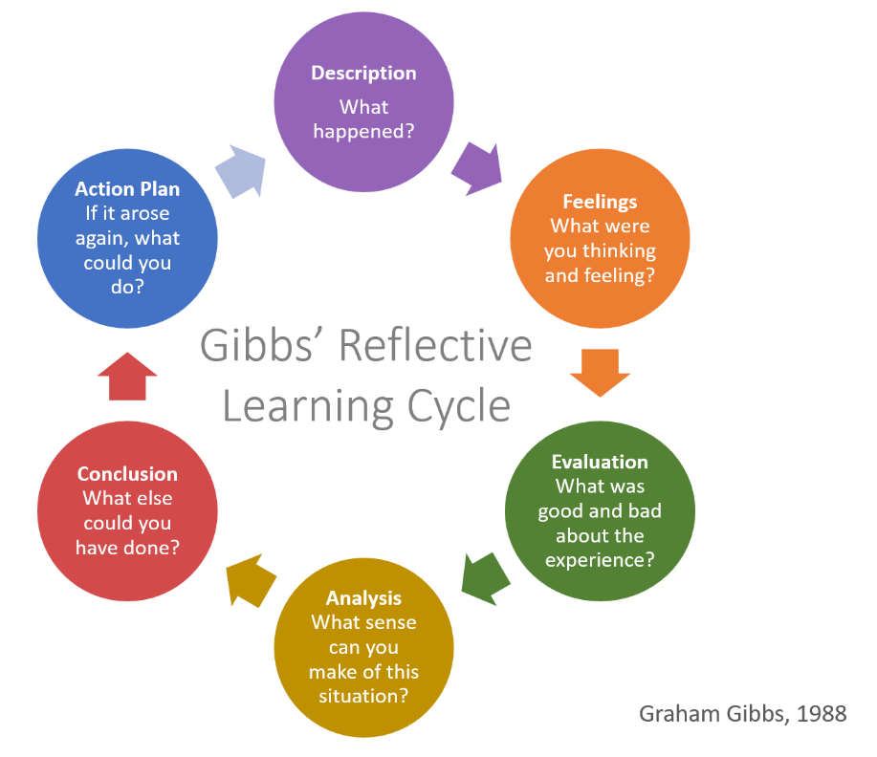

(Martin, 2025)

The Challenge / Description

Documented in the 2021-2025 South Wales Delivery Plan, Chief Constable Jeremy Vaughan outlined his commitment to ‘being the best at understanding and responding to our communities’ needs’ (South Wales Police, 2025) and his policing purpose to ensuring that we are ‘pulling in the same direction and focusing on victims’ (South Wales Police, 2025).
The operational challenge explored in this essay, captures the importance of having that clear purpose and the support of Senior Officers. This is supported by Punit Renjen, the Deloitte CEO who believes setting a clear purpose is paramount to achieving long term success (Leading for Organisational Change).

During 2024, South Wales Police (SWP) experienced a significant increase in the volume of calls reported into the Public Service Centre. Despite this rise, SWP continued to answer the calls within the national metrics, however the deployment time to calls significantly increased. This was a significant concern to the force and was not in line with the Chief Constables purpose of ensuring we maintain a focus on victims.

Once identified, the Continuous Improvement Team, was tasked with reviewing and formulating a plan. There was a realisation and acceptance that officer deployment times were rising, impacting public confidence and our service delivery. The review project was acknowledged by Chief Officers as a critical area of business.

An initial scoping exercise identified that we should attempt a ‘task not ask’ directed deployment approach, deploying officers to calls directly rather than allowing the officers the autonomy to select the calls they attended.

It has been identified that ‘changing processes do not, by themselves, make things better, or necessarily make a difference: a change in ethos and culture are the main drivers of change in any transformational programme’. (Gov.Uk, 2025). On reflection, I agree with this statement, whilst we understood the need for the change, which was well supported with data, what we didn’t fully understand was the culture within the teams and the dynamics across shifts that were contributing to the failure to attend calls. This view is supported also by the College of Policing, from their research from the Police Foundation, which found that they way police forces manage change has a significant impact on the police workforce, their wellbeing and how effective any implemented change is (The Police Foundation , 2025).

Upon reflection, the project potentially should have been a joint enterprise between the Control room and front-line staff. That would have allowed the team to understand and support the wider teams affected. The fact that the project team comprised solely of control room staff, in my opinion led to the dis-trust and initial failure of the project. Research has shown that ‘collaborative problem-solving leads to better outcomes’ (Middleton, 2025) which I agree with. However, similarly, if the pool of people had been too broad, I foresaw a risk of paralysis by analysis, with delays in implementation and a lack of decision making.

Throughout this paper I will identify my failings through this challenge and how this impacted on the organisation, the workforce and myself and the learning that I have taken from this experience.

Feelings

I knew that implementation would be contentious. We were essentially assigning calls to officers shown as available on the mapping system, rather than asking for their availability, thereby removing their choice and control.

As the Senior Officer within the Control Room, once the decision had been made to trial ‘directed deployment’ what we witnessed was officers ‘hiding from calls’ and in particular high harm high risk DVA calls, which I initially found wholly unacceptable. I joined SWP some 25 years ago, to serve the public and provide the best service possible what I was observing went against everything I believed in, at that moment I believed SWP to have a significant cultural and leadership issue.

I felt disheartened as obstacles were clearly being put in the way, not everyone was giving 100% to make the project work and some were actively avoiding work. However, on reflection, I had not held a response role for several years, my personal and historic views of policing marred and tainted my view of officer engagement in this project. If I had included and ‘collaborated’ with colleagues at the outset it would have allowed me to have a greater awareness of front-line policing, and the pressures faced. Listening to staff, I could see that the steep increase in calls and the pressures to respond was putting significant pressure on officers.

Historically, we would respond to a call and deal with it from cradle to grave. That is now no longer the case, and we were seeing officers simply going from call to call. It is no wonder that some officers are suffering ‘compassion fatigue’. Compassion fatigue has been described as a feeling that you no longer care about people, since you are repeatedly looking after people in distressing or difficult circumstances (Mind, 2025). Having spent the time talking to staff, I could see this unfolding.

I had not considered this. On reflection, by implementing ‘directed deployment’ we were compounding this issue, we had now taken away the opportunity for officers to decided when they were fit and ready for their next call. This was adding additional pressure on the officers. The Police Federation have argued that mental health amongst officers is of significant concern and that ‘resilience in the service is at an all-time low’ (Police Federation, 2025).

In contrast some academics have argued that that there is a real need to address disengagement, labelling it “quiet quitting” which they believe is ‘infecting the world of policing’, that this refers to the point when employees “do the bare minimum at their job. They often appear to be disengaged from their work and chose not to go the extra mile while doing just enough to avoid being fired’ (FBI, 2025). Whilst I can accept that there are certain individuals within any organisation that this may apply to, the general police population are fighting against significant demands as opposed to retreating from work. This is supported by the year-on-year increase in calls attended.

As time passed, I began to see the project’s actual impact on the frontline: the loss of control and the sheer volume of work sitting behind simply attending the call. I began to understand the concerns of their management teams, and rather than perceiving them as blockers to effective implementation, I realized that their input could refine the project plan not discredit it. By doing so, the wider SMT added additional supervisors, reviewed processes, and restructured the bronze Inspector role.

It was a very emotional journey, and I shifted from being very defensive to understanding and then to supporting. The whole experience gave me an opportunity to explore my leadership style, and the challenges presented.

Evaluation / Analysis

It has been widely identified that project implementation is primarily centered around staff. Therefore, as leaders, we must recognise the importance of motivating and leading our team effectively (Webster, 2017). I absolutely concur with this, and whilst the Continuous Improvement Team were fully briefed as were the control room staff before go-live, the change in process was not fully explained and briefed to frontline staff. Whilst we had clear objectives of the project, we failed to acknowledge the risk of key stakeholders i.e. the frontline officers and the impact the changes would have on them. This point was highlighted further by Bryson, who identified that we must consider the ‘pathways already in existence within audience heads’, which we potentially failed to do. (Bryson, 2018). Whilst I accept that staff engagement plays a significant part in project implementation, for implementation to be a success I agree that there are far more variables that need to be navigated, such as identifying and prioritizing the tasks and ensuring you have sufficient resources for the project (Pandey S. , 2025).

Ultimately, the strategy, primarily was resource-based. The resource-based view of strategy has been identified as building on resources and competencies (capability) and looking at the long-term direction of an organisation, which I agree was our aim. It has been identified that such decisions are often made in situations of uncertainty, affect operational decisions and require an integrated approach. It has been recognised that managers often need to cross boundaries to address problems, often with different interests and different priorities (Johnson, Scholes, & Whittington, 2004). On reflection, the lens wasn’t wide enough, we failed to see the impact that decisions within one area of business would have on the wider organisation.

Having reflected on the strategic model, the ABC Model, whilst it is simplistic in nature, it has a clear roadmap giving direction.

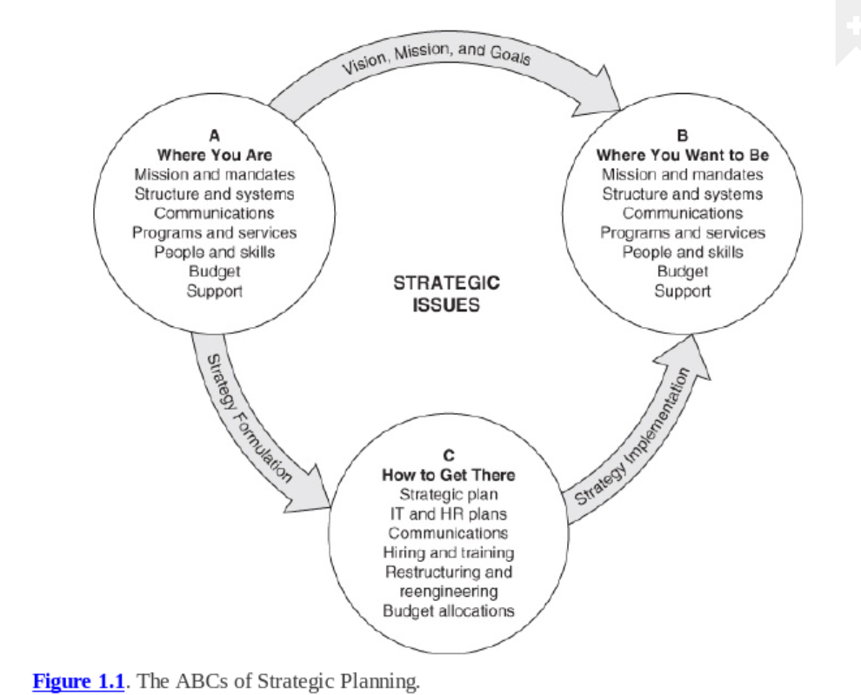

(Webster, 2017)

It has been identified that getting from ‘A to B involves clarifying vision, mission, and goals. Getting from A to C is the process of strategy formulation; getting from C to B is strategy implementation’ (Webster, 2017). I agree with these observations, in my opinion it should not be a regimented approach and requires effective leadership and communication at each stage. However, at each stage, the considerations are quite vast and broad, therefore to ‘keep track’ of progress may be difficult and time consuming.

It has been argued that project managers potentially have ‘seven different powers which can be used either singly or in a mix of two or more, coercion, legitimate, referent, reward, information, connection, and/or expert power’ (Webster, 2017). I have reflected on the powers identified, and whilst I recognise that all may be available, I believe that certain leaders will have preference to certain powers, however on reflection I recognize that a deciding factor in determining which power to use will be the intended audience.

The importance placed on effective leadership cannot be understated. It has been identified that ‘Leaders are those who are not averse to responsibility, based on the way a person weighs the evidence before making a decision’ (Sutherland, 2018). Kouzes et al state that leaders ‘envision the future by imagining exciting and ennobling possibilities’ (Kouzes & Posner, 2017). I agree with this view, you need firstly to understand where you are and more importantly understand what you are seeking to achieve before you try to sell that belief.

Leadership within policing is complex with many differing opinions as to the most effective leadership approach. The policing landscape has changed dramatically and the dominant autocratic and transactional leadership styles, appear to have given way to transformational models that are thought to ‘best encourage and foster greater workforce participation in the process of cultural change’ and that in fact the ‘command and control’ leadership style has given way to calls for ‘purposeful and ethical leadership models’. (Muir, Hansen, Bronte, & Krueger, 2024).

There has been a fundamental rethink around rank and hierarchy ‘rank and hierarchy sit alongside powerful discourse urging police leaders to critically reflect upon their use of rank, and how the authority of rank is experienced by junior officers’ (Ramshaw, Silvestri, & Simpson, 2019). This explores the notion that as senior leaders we need to rethink how we lead, if we want new policies and practices to be embraced and accepted.

However, Davis and Bailey (2018) point to the challenging and multifaceted pressures faced by contemporary police leaders as barriers to the development of progressive and innovative leadership practices (Muir, Hansen, Bronte, & Krueger, 2024).This is an interesting point, and certainly worthy of debate. With the contemporary transformational style of leadership, if the audience isn’t correct, you can see just a block on decision making and it can stifle innovation. I have no doubt if front-line officers had been engaged at the planning stage, a transformational leadership approach adopted, would probably still have seen limited progress, as those officers predominately are very inexperienced and work daily in a very command and control environment. Whilst the more transformational styles are my preferred style, I can also recognise the importance and need on occasions for the more dominant styles of leadership, and certainly in the challenge that I encountered this was necessary. This leadership style has a place in front-line policing. Therefore, I don’t believe that there can ever be a complete shift away from any one style.

There is a raft of reasons as to why the implementation process was difficult. My personal views are that leadership within policing, is far more complex than ever before, we certainly have a performance-driven culture, and we often hear the comments delivering ‘more for less’. Whilst this projects aim, was to improve the service that we provide to victims of domestic abuse, by some skeptical individuals it may have been seen as a ploy to achieve more from the work force who we already know are under significant pressures. It has been recognised that ‘meeting mismatched demands and conflicting expectations result in police leaders experiencing high levels of pressure and place them in an unenviable situation’ (Ramshaw, Silvestri, & Simpson, 2019).

Over the years I have undertaken many leadership courses, and I am acutely aware that my preferred leadership style is that of the transformational leader. Transformational leadership is defined as ‘behaviours that seek to develop, share, and sustain a vision intended to encourage employees to transcend their self-interest and achieve organizational goals’ (Cecchini, Pederson, Bech, Jacobsen, & Hansen, 2024). My small team suits this style perfectly. All the individuals are highly motivated, knowledgeable, and are
attentive to the needs of senior officers. However, whilst this was appropriate in the discovery stage, once we progressed to the implementation stage, the reach was far greater, with a different workforce demographic. Therefore, the transformational style, when addressing front line in-experienced staff was no longer appropriate. There needed to be a switch to a more transactional leadership style, particularly during the intervention exercises.

‘Transactional leadership requires middle managers to take on their role by specifying expectations and goals’ (Cecchini, Pederson, Bech, Jacobsen, & Hansen, 2024). This was exactly, what was required, albeit this would have been far more effective in my opinion if it had been undertaken at the planning stage. In contrast Whitmore argues that a ‘Shortage of time and excess fear drive us into command and control’ (Whitmore, 2009). Whilst I recognise at times this may be the case, I don’t wholeheartedly agree with this comment, there are times when that style of leadership is appropriate, and I am not certain it is underscored by fear.

Many authors have written about the concept and importance of ‘Leadership Identity’, which is often defined as “the extent to which an individual views himself or herself as a leader” (Cecchini, Pederson, Bech, Jacobsen, & Hansen, 2024). It is believed that there are benefits associated with a strong leadership identity. That ‘identities provide the individual with directions for how to behave in certain situations and what to expect of other individuals’ (Cecchini, Pederson, Bech, Jacobsen, & Hansen, 2024). In my opinion individual leadership identity develops over time and becomes established through experience.

As leaders, we are continually trying to make the organisation more effective in the face of significant pressures. Practices become ingrained, and it is quite startling to see how individuals / departments continue to operate in wholly ineffective ways. As highlighted by Edgar, ‘as we try to get things done that involve other groups, we often discover that they do not communicate with each other and that the level of conflict between group is often astonishingly high’ (Edgar, 2010). I can relate with this, I think due to the lack of effective communication, this created tensions and conflict.

Kotter outlines an eight-stage process for change. However, the process assumes a degree of hierarchy and command and control, which as discussed is getting rarer in organisations today. That the influence of millennials in the workforce, supports the view that there needs to be an ‘inclusive and collaborative field of leadership’ (Emery, 2019). Others have argued that Kotter’s staged approach leads you to conclude that employees are those to whom change is enforced upon. In a 2012 critique of Kotter’s model, Applebaum et al emphasized the importance of ‘granting as much autonomy and control as possible and allowing change to be owned and delivered locally’ (Emery, 2019). Reflecting on my challenge, I certainly feel that there is an element of failure on my part to engage the wider force with the changes ahead and ultimately their lack of initial buy-in was evident.

Higgs and Rowland explored the change concept and identified several key areas. That there is a need to create the case for change. This was evidenced within my challenge, there was an operational need to improve, and the need to create what they describe as ‘structural change’, that the processes and tools were in being to make sure that the outcome could be achieved. They too explore the importance of engaging others and facilitating and developing capability (Goffee & Jones, 2000).

It is important to consider the organisational culture when implementing change. It has been recognised that ‘part of the potency and value of an organisation’s culture is that it is unique’ (Emery, 2019).The culture of a group can be defined as the shared learning journey. ‘This accumulated learning is a pattern or system of beliefs, values, and behavioural norms that come to be taken for granted’ (Schein & Schein, 2017). As leaders, we can be influential in shaping the culture that if we ‘understand ourselves better and recognise some of the forces acting within us that define who we are’ (Edgar, 2010). Within my challenge, there was clearly evidence of an embedded culture within the teams that was hard to navigate. It was also clear that culture varied between teams, which supports the above concept that dominant individuals can shape a culture, both for the positive and negative.

It has further been argued that the most effective and successful leaders are those that are emotionally aware. Emotional intelligence has been defined as the ‘ability to understand and handle one’s emotions when dealing with others’. Further defined by Tomlinson as the ability ‘to perceive, integrate, understand and reflectively manage your own and other people’s feelings’ (Tomlinson, 2004). Golemans Emotional Intelligence Theory emphasizes self-awareness as a foundational component of emotional intelligence ‘One thing is certain, emotional intelligence increases with age. There is an old-fashioned word for the phenomenon: maturity’ (Goleman, 1998). I completely concur with this view. In the challenge presented, as a newly promoted Chief Inspector, I would undoubtedly not have been as emotionally aware as I am now and probably would have maintained my initial defensive response and not reflected on my actions.

It is argued that emotional intelligence is built on three driving forces ‘values in action, vision in action, and vitality in action’ (Tomlinson, 2004). Within my small team I have worked extremely hard to build trust within the department, motivating the team, by recognizing their fantastic contributions, especially under pressure.

There is a recognition that operational management and project management are different and therefore require different skills. Operations are about continuity, whereas projects are linear. They have a defined start and finish point (Webster, 2017). However, within policing both often overlap. Given the challenge presented the issue is an operational matter, however it needed a dedicated project team to evaluate and review the problem. However, in my view project management, and the initial oversight then leads into business as usual, which will then become operational management.

I completely agree that it is important that the ‘project’ is well defined and that the ask is understood. That it is clear as to why the change is needed and how it fits in with the organisational objectives. What we were hoping to achieve, from the outset, was improved deployment times, enhanced BCU / PSC engagement through refined structures, improved service delivery and greater support for staff through enhanced and clearer policy.

However, it was clear that the lack of effective engagement and then communication at the early stages led to skepticism, as to the motives behind the review. ‘Communication is the key, being as open as possible in communication is important for organizational health’ (Tomlinson, 2004) which I completely concur with. Due to the lack of effective communication, arguments and disagreement between staff, at both operational and senior level began to occur. It wasn’t until the intervention exercises, when the senior management teams came together that they were aware of the challenges being faced. On reflection, we should have brought both senior management teams together at Go-Live, and not when things started to go wrong which possibly would have prevented the arguments that played out.

As a result of this failure what we started to see was the opposite to what we were seeking to achieve, which was a short-term increase in deployment times. Staff were becoming de-motivated and stress levels were increasing, ‘over air’ arguments requiring management action were taking place. Some of our own staff, especially those younger in service found the concept of directing officers challenging. Whereas the more experienced members of staff found it empowering.

This identified the need for a learning and development strategy. It has been argued that there are several elements to such a strategy, real-time experiences and the review of such coupled with the support from the very top of the organisation, ‘which encourages managers to reflect, to conceptualise, to coach, to give feedback, and to develop both themselves and those who work for them’ (Thomson, 2006). My operational challenge certainly had the support of the Chief Constable who was the figure head for the launch, so it left no-one in any doubt of his commitment to the project. Similarly, this helped when there was animosity between management. In respect of the learning, we have included a ‘hot topic’ section with live-time experiences to discuss as a group, which proved extremely valuable.

In my opinion, the importance of effective leadership is key. ‘Leadership is the pivotal force behind successful organizations’ (Burke, 1985). There has been much debate about what qualities inspirational leaders possess, many of which contradict each other. It has been argued that inspirational leaders show their weakness, by exposing ‘some vulnerability, they reveal their approachability and humanity’ (Goffee & Jones, 2000). However, Bennis and Naus state that the most important ingredient is ‘power’. ‘Leaders exercising their power are desperately needed for any significant and positive change to occur’ (Burke, 1985). I have reflected on both, I agree that we need effective leadership to embed any new initiative, similarly we need the ‘right people’ but I also agree with the view that the person driving the change needs the ‘power’ and status to be able to drive change.

Bennis and Nanus talk of the three ‘C’s’ – commitment, complexity and credibility. Sadly, they believe that followers are less committed than ever before, stating that their research shows that ‘25% of workers today work at their full potential and that 60% believe that they do not work as hard as they used to’ (Burke, 1985). I am not sure I agree with these findings, policing has changed significantly over the last two decades, and whilst this challenge identifies that staff are selective in what they choose to respond to, I don’t believe this is due to individuals avoiding work, I believe they are already at capacity so try to protect themselves by being selective.

The above accepts the concept that there are leaders and followers. However, some argue that we have seen the emergent of a “group dynamics” concept, with its focus on members of the group rather than solely on the leader. This was exactly what occurred at the early roll-out stage, strong individuals within some teams began questioning the project and there was a need to gather senior managers together to unite and reinforce the message. I accept that teams can effectively ‘accomplish more than individuals, and that through working in teams, employees will be more motivated and energized’ (Spencer, 1993). I also agree that ‘all working groups, provided they have been together for some time, develop a group personality (Adair, 2009).

I have considered the continuum of leadership behaviour theory, and I agree with the concept that each action is related to the degree of authority used and the amount of freedom available. What we saw within the challenge was individuals’ freedom to some degree being curtailed by individuals imposing their authority. There, is an acceptance that the successful leader can direct when required, but if participative freedom is called for, he is able to provide such freedom (Tannenbaum & Schmidt, 1958).

The project team, responded well to the transformational leadership approach, however as we progressed to the implementation phase, it was clear, that given the impact and fast-paced environment, there was a real need for intervention, and we took on a far more transactional approach, challenging officers availability and ordering attendance where required. Transformational leadership ‘encourages individuals to challenge the status’ (Higgs, 2003) which is exactly what we did.

On reflection, perhaps the project team would have been better received if it had been branded and led as a force project, not under the Control Room Continuous Improvement Team. It could be argued that our team was too invested in achieving the results and therefore we weren’t impartial in reviewing the problem. Consideration should have been given to a clear decision making and communication strategy to align everyone’s understanding and expectations. I accept that this may have mitigated the conflict experienced and could have provided valuable insights into how to have managed the project more effectively to achieve the objectives earlier. ‘Practitioners are frequently embroiled in conflicts of values, goals, purposes and interests’ (Schon, 2016). In the challenge identified, it was clear that there were other elements at play.

Identifying specific areas for improvement, set out a clear direction. It has been recognised that ‘change of one kind or another seems, paradoxically, to be a constant which complicates organisational life across all contemporary public services’ (Wallace, Fertig, & Schneller, 2007). With the volume of change I believe there is a need for evidence-based policing, that there is a need to test and critically evaluate practices, seeking the most effective to address and meet policing priorities.

Evidence-based policing, ‘helps you to move away from your own experiences, subjective opinions and ideas and instead uses evidence to support decision-making’ (Spooner, Hughes, & Jones, 2022). It has been recognised that the ‘idea of planning and executing research to inform directly police policies and practices is now commonplace in police forces (Fielding, Bullock, & Holdaway, 2020). It is hoped that ‘policy and practice decisions informed by evidence will lead to better service to the public. Resources are always limited, and we need to use them to maximise utilities. Evidence can have the power to persuade (Knutsson & Tompson, 2017). In the challenge outlined, the move to ‘task not ask’ was supported by evidence, showing the need for the move to this tactic.

Conclusion

On reflection the overall experience was generally positive. The project was both resource and evidence based providing a strong foundation for change. Staff certainly understood the long-term goals from a control room perspective however on reflection this needed to be force wide.

I believe I contributed to the project’s success through a structured and sequential rollout, and there was a clear project plan. Overall, the project was completed successfully and met the key the objectives and chief officer expectations. A key learning point was the need for a better communication strategy from the offset, and middle management buy-in throughout.
Updates were not timely, leading to frustration, confusion and ultimately disagreements.

Through the operational challenge I learnt valuable lessons. Reflecting upon the experience, I learnt the importance of adapting and amending my leadership style to suit the audience and situation. That whilst I may be more comfortable with a specific style there is a need to adapt, if I am to develop and enhance my leadership. I recognised that I am most comfortable with a transformational leadership style, however I need to be more situationally aware and not adopt this style per se. I also learnt that effective communication is crucial, that I need buy-in from others and need to be mindful of the challenges of empire building. ‘Leadership needs to start by listening and learning, finding out where people are, valuing what is best in what they already know, and do, and build from there’ (Fullan, 2020).

I recognised that I needed to establish a clear framework and robust project timeline. That I should have had early consultation with the key stakeholders to gather their input and gain their trust and buy-in. That I needed clear communication channels to improve efficiency.

I learnt the importance of personal development, which came from this experience and reflecting upon my actions, the need for self-understanding and self-management. As I result, I have taken part in a programme called the Senior Leaders Experience.

I also learnt the importance of having individuals who have current in depth operational experience form the offset, as on reflection there were areas that I believe could have been improved, such as experienced floor walkers at the time of go-live.

This experience taught me that there is no right or wrong leadership style, all have a part to play, dependant on the circumstances / situation and individuals concerned. Whilst the transactional style was not my preferred style, I saw value in leading and directing during the intervention exercises. This allowed me to maintain order and discipline whilst deploying quickly and effectively.

Action Plan

The key areas for future projects are:

- Establish a clear framework and robust project timeline for all future projects.
- Consult and engage with key stakeholders at the earliest opportunities on all future projects – to achieve buy-in.
- Create a comprehensive Communication Strategy.
- Reflect and adapt leadership style to suit the individual and situation.
- Ensure that any future learning is captured and learnt from, ensuring that post project reviews are documented and conducted.
- Develop preventative strategies – such as key check-ins / intervention exercises at key milestones.
- Personal and Team development.
- Implement changes by setting SMART goals that are clear, attainable and timely. Develop a detailed plan to record reflections, creating a clear path for future growth and improvement.
- Review and adjust through a reflective cycle, such as Gibbs.

Bibliography:

Adair, J. (2009). How To Grow Leaders: The Seven Key Principles of Effective Leadership Development. Kogan Page.

Bryson, J. B. (2018). Strategic Planning for Public and Nonprofit Organizations: a guide to strengthening and Sustaining Organizational Achievement. Wiley.

Burke, W. W. (1985). Leaders: The Strategies for Taking Charge. Human Resource Management.

Cecchini, M., Pederson, L. D., Bech, M., Jacobsen, C. B., & Hansen, A.-K. L. (2024). What Makes A Leader? Leadership Identity and Leadership Behaviour among Highly Prfessionalized Public Leaders. International Journal of Public Administration , 495-506.

Chartered Banker. (2025, March 22nd). Are Leaders Born or Made? Retrieved from Chartered Banker: https://www.charteredbanker.com/resource_listing/knowledge-hub-listing/are-leaders-born-or-made.html#:

College of Policing. (2025, April 14th). A Commitment to Change - The Future of Police Leadership . Retrieved from College of Policing : https://assets.college.police.uk/s3fs-public/2023-06/A-commitment-to-change-the-future-of-police-leadership.pdf

College of Policing. (2025, March 13th). Resources for Reflective Practice. Retrieved from College of Policing: https://assets.college.police.uk/s3fs-public/2020-11/Resources_for_reflective_practice_v1_0.pdf

Edgar, H. S. (2010). Organizational Culture and Leadership . Jossey-Bass.

Emery, J. (2019). Leading for Organisational Change: Building Purpose, Motivation and Belonging. Wiley.
FBI. (2025, March 26th). Leadership Spotlight. Retrieved from FBI Law Enforcement Bulletin: https://leb.fbi.gov/spotlights/leadership-spotlight-addressing-disengagement

Fielding, N., Bullock, K., & Holdaway, S. (2020). Critical Reflections on Evidence-Based Policing. Routledge, Taylor & Francis Group.

Fullan, M. (2020). Leading in A Culture of Change. Jossey-Bass.

Goffee, R., & Jones, G. (2000). Why Should Anyone Be Led By You? Harvard Business Review.

Goleman, D. (1998). What Makes A Leader? Harvard Business Review.

Gov.Uk. (2025, March 26th). An Independent Review of the Police Disciplinary System in England and Wales . Retrieved from Gov,Uk: http://assets.publishing.service.gov.uk

Gov.Uk. (2025, March 22nd). IOPC Annual Report and Accounts: 2023 to 2024. Retrieved from Gov.Uk: https://www.gov.uk/government/publications/independent-office-for-police-conduct-annual-report-and-accounts-2023-to-2024

Higgs, M. (2003). How Can We Make Sense of Leadership in the 21st Century? Leadership and Organization Development Journal .

Johnson, G., Scholes, K., & Whittington, R. (2004). Exploring Corporate Strategy: Text and Cases . Prentice Hall .

Keele University. (2025, March 26th ). What Does Complexity Leadership Mean? Retrieved from Keele University: https://online.keele.ac.uk/what-does-complexity-leadership-mean/

Knutsson, J., & Tompson, L. (2017). Advances in Evidence-Based Policing. Routledge.
Kouzes, J., & Posner, B. Z. (2017). The Leadership Challenge: How To Make Extraordinary Things Happen in Organizations. John Wiley and Sons.

Martin, H. (2025, March 22nd). Slowing Down to Speed Up. Retrieved from Gibb's Reflective Learning Cycle: https://helendenheld.com/tag/gibbs-reflective-learning-cycle/

Middleton, T. (2025, March 26th). Atlassian. Retrieved from The Importance of Teamwork (as proven by Science): https://www.atlassian.com/blog/teamwork/the-importance-of-teamwork

Mind. (2025, March 26th). Coping With What You Experience in the Police . Retrieved from Mind : https://www.mind.org.uk/news-campaigns/campaigns/blue-light-programme/blue-light-information/coping-with-what-you-experience-in-the-police

Muir, A. M., Hansen, M. J., Bronte, C. R., & Krueger, C. C. (2024). What Makes a Leader? Aquatic EcoSystem Health & Management , 61-65.

Pandey, N. (2025, March 16th ). Emeritus. Retrieved from https://emeritus.org/in/learn/what-is-leadership

Pandey, S. (2025, March 27th ). How To Identify Critical Success Factors in Project Management . Retrieved from Project Central :
https://www.projectcentral.com/blog/critical-success-factors/

Police Federation. (2025, March 26th). Mental Health. Retrieved from Police Federation: https://www.polfed.org/our-work/wellbeing/mental-health/

Ramshaw, P., Silvestri, M., & Simpson, M. (2019). Police Leadership: Changing Landscapes. Palgrave Macmillan.

Schein, E. H., & Schein, P. (2017). Organizational Culture and Leadership. Wiley.

Schon, D. A. (2016). The Reflective Practitioner: How Professionals Think In Action . Routledge.

South Wales Police. (2025, February 19th). Chief Constables Delivery Plan 2021-2025. Retrieved from BOB: https://bob.swp-

rest.police.int/sorce/beacon/default.aspx?pageid=ChiefConstablesDeliveryPlan
South Wales Police. (2025, February 19th). Policing With Purpose. Retrieved from South Wales Police: https://bob.swp-
rest.police.int/sorce/beacon/default.aspx?pageid=policingpurpose

Spencer, K. L. (1993). The Wisdom of Teams: Creating The High-Performance Organization. . Academy of Management Perspectives .

Spooner, E., Hughes, C., & Jones, P. (2022). Police Research and Evidence-based Policing. Critical Publishing.

Structural Learning. (2025, February 19th ). Structural Learning. Retrieved from Structural Learning: https://www.structural-learning.com/post/gibbs-reflective-cycle

Sutherland, M. E. (2018). What Makes A Leader? Nature Human Behaviour.

Tannenbaum, R., & Schmidt, W. H. (1958). How To Choose a Leadership Pattern. Harvard Business Review.

The Police Foundation . (2025, April 14th). Police Wellbeing could be improved through good change management, report finds. Retrieved from The Police Foundation: https://www.police-foundation.org.uk/news/police-wellbeing-could-be-improved-through-good-change-management/

Thompson, B. (2009). Dont Just Do Something, sit there!: An Introduction to Non-Directive Coaching . Chandos Publishing.

Thomson, B. (2006). Growing People: Learning and Developing from Day to Day Experience . Chandos Publishing.
Tomlinson, H. (2004). Educational Leadership: Personal Growth for Professional Development. Sage Publications.

Vito, W. (2018). Police Leadership and Administration: A 21st Centruy Strategic Approach . Taylor and Francis Group.

Wallace, M., Fertig, M., & Schneller, E. (2007). Manging Change in Public Services . Blackwell.

Webster, G. (2017). Managing Projects at Work. Routledge.
Whitmore, J. (2009). Coaching for Performance Growing Human Potential and Purpose: The Principles and Practice of Coaching and Leadership. Nicholas Brealey.

