Coexistent Perspectives (ADCD7001)

Question6-Design Thinking
Analysis of the influence of Pop Art on graphic design

Student number：1915381
Name: Yucheng Wang
Submission Date: Thursday December 15, 2022
Word Count: 3864

What is Pop art
The meaning of Pop style
In the early 1950s, pop art was born in Britain in the 20th century. Admired by some artists in Britain and the United States after the mid-1950s, at that time in the field of art has an important position, in the heyday of development Period. Pop art has an avant-garde artistic style, which is accepted by the public and is widely accepted Be popular. Pop art works bold bright colors, graphic novelty, performance of the hand. The method is novel and has a strong visual impact. As a result of these factors, At that time, graphic design in color, expression technique, layout, way of thinking and so on. (1997) In terms of breaking through the traditional design style and concept, gradually into the public Life, more common, every day. Pop art is "popular art", advocating everyone can understand, people Each person can design. Distinctive artistic features, rich creation carrier characteristics. Pop art has influenced many areas of design, such as graphic design and architecture Design, product design, etc. There was a lot of bop in the work of designers at that time Art style, merchandise packaging leaflets, shop walls, cinema Propaganda posters and even discarded objects are the vehicles for their creations. The English critic Lawrence Alloway used the same term to describe a group of artistic phenomena that started to appear in New York as early as 1955, but that exploded into public awareness in around 1960, in some key galleries on New York’s artistic scene, from Leo Castelli to the Stable Gallery, Sidney Janis, the Green Gallery, etc.1（2022）

Artistic features of Pop style
From the perspective of the development of The Times, the concept of pop art is a challenge to the inherent social system at that time, which is confirmed by the ideological propositions and style characteristics of Pop art. Pop art advocates color jumping and does not care about color harmony; The material is popular and can be seen everywhere, not confined to the form; Variable modeling and unlimited quantity; And so on, the works of pop designers fully embody these characteristics. Eye-catching colors are used to cover a large area, and corresponding colors are used locally as embellishments. Through a large range of orderly arrangement, the work has a great visual impact. This design approach is also now seen as groundbreaking. (2017) Pop art makes extensive use of reconstruction, covering, copying and other techniques. Initially, pop designers extract the graphics or patterns in materials such as posters and photos in daily life, change them through their own design, and then form design works with the characteristics of pop art through constant repetition, change of color and orderly arrangement. On this basis, there is another expression technique, that is, to change the local design, including recombination, exaggerated reduction or amplification. In the way of expression, designers constantly innovate.

Possibility of pop-oriented design thinking
Diversity of pop-oriented design thinking
Some scholars have studied the relationship between pop art and modern design in the same era background, and the argument shows two They influence each other and cannot be separated in the process of their emergence and development. However, the inseparable relationship between art and design is not limited to the same historical period. The unique concept and expression of pop art is still inspiring to today's modern design after more than half a century of growth. Art and design are different in nature. Although they have something in common, they are still independent disciplines with different functions, different connotations. Art tends to emphasize individual thoughts and feelings and is an emotional means for artists to express their inner self. As a cultural phenomenon, design pays more attention to functional practicability and belongs to modern practical art. In addition, the design process is inseparable from the intervention of rational factors. For example, in the early stage of preparation, on-the-spot investigation must be carried out to cater to the tastes of consumers, accurately meet the material needs and promote economic development, and then in the formulation of the scheme, constraints and feasibility and other conditions should be considered. (2007) Therefore, compared with art, design is more "down-to-earth", so design is life. The profound and lasting influence of Pop art on today's design lies in two main points. The first point is nothing
Pop art overlaps with contemporary design both in terms of concept and subject matter. The second point is that the public influence and additional commercial value brought by pop art is exactly one of the pursuits of modern design. Many successful cases of the combination of contemporary design and art seem to have explained that cross-border cooperation between art and contemporary design is of great help to improve design taste. Based on the characteristics of pop art, it is not difficult to see that it focuses its lens on popular culture, while the people-oriented pursuit of modern design fundamentally determines that the content of design expression should be popular or even superficial, so that it can be favored by the public and become popular all over the world. (2014)
Modern art design is a new cultural phenomenon along with industrial production and market goods, is a kind of Urban mass as the media, with modern technology as the production orientation of the mass consumption form, with a strong commercial color, changed the social aesthetic fashion. The main forms of modern art design culture include film, clothing, packaging and so on. These cultural forms often have the style of pop art. Pop art is constantly updated and developed, and the commercial value of these cultural forms is also constantly improving. (2011) Pop art comes from modern design culture and is used for reference by contemporary design, while the wide spread of modern art design in turn promotes the rapid development of Pop art. Pop artists take popular commercial cultural images and things that can be seen everywhere in urban life as the objects of creation, and their art forms are full of characteristics of industrialization and commercialization. Their purpose is to dig out this modern art design culture from the category of entertainment, debauchery, turn vulgar to elegant, rise to the category of beauty. Pop artists use their divine hand to make their products colorful, exaggerated in shape and unique in style, which not only meets the aesthetic needs of the public, but also spreads the design concept of Pop art.
Infinite possibilities of pop-oriented design thinking
As the product of commercial society, the expression form of pop art must be accompanied by a certain commercial atmosphere. The rapid development of market economy deepens the desire of business to make money, and it is necessary to obtain considerable profits by constantly stimulating the mass consumption. Pop art also induces this kind of consumer culture from the side, arouses the public's excessive attention to popular products and entertainment culture, and stimulates the public's desire for material possessions. Consumer society provides people with very rich visual resources, brand LOGO, newspaper cover, image and sound, advertising, cartoons and other commercial images directly appear on the screen or in front of the public, while presenting art, but also produce huge economic benefits. In the case of pop art, the commercial nature of pop art is conducive to the market, that is, what the market needs, what kind of works are created. At this time, art is developed to meet the needs of capital, with an obvious commercial atmosphere. (2002)
Since the 1980s, with the acceleration of social modernization and the rapid development of popular art, the confrontation between "noble art" and "folk art" in traditional art has been transformed into the separation of "elite art" and "popular art" (1995). However, the reason for the development and success of Pop in the contemporary era is that it can reflect the unity of high popularity, popularity and entertainment in both commodities and art, which all meet the needs of modern cities. Popular characteristics make the expression of contemporary art has infinite expansion of the theme, and the performance of more close to the public. In the past, traditional art was far away from the ordinary people, just to meet the needs of a specific class, so the one-sided pursuit of elite. The art of elitism does not always exist in life. After all, the elite is only a small part of the society, and the public is the majority, which is the real social subject. Art is for the social service, will inevitably meet the needs of the public, naturally will be integrated into the public life.
Pop art often extends the insatiable greed of the small citizen class and reflects the ugly kitsch of the lowest level of society. Pop art works come from life and have the function of satirizing society, alerting people and transmitting life philosophy through the works. Take pop artist Roy Lichtenstein's "Girl with Ball" as an example (Figure 1). In the process of reworking the theme, the author used the method of comic strip to reprocess the advertising photos. The painting is made up of four colors: white, black, yellow and red. The bold and bold lines depict the girl's curly hair and the curves of her figure. The simple and bright aesthetic result is a metaphor for the deceptive nature of the painting. A girl's round cherry mouth is reminiscent of a child, not a woman; Whatever sexual appeal she once had became as fake as a beach volleyball.
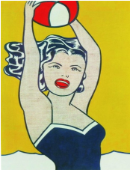
(Figure 1) The Girl With the Ball by Roy Lichtenstein Image from the Internet

Andy Warhol, the representative figure of Pop Art
Representative works of Andy Warhol
Although pop art was born in Britain, it was Andy Warhol, the "originator of pop art" in the United States, who pushed Pop art to its peak single-handedly. Andy Warhol believed that art and life in nature had the same or similar structure. He used unique ways of expression to explain the world outlook, values, consumption outlook, anti-traditional consciousness and aesthetic cultural taste of the young generation who grew up under the background of industrial mass production in Western society at that time. (1968)
Andy Warhol was born in 1928 in the small European country of Slovakia and immigrated to the United States with his parents as a child. After high school, he studied art at Carnegie Mellon University and became the art editor of Cano, the school's art magazine. After graduation, Andy Warhol became a commercial illustrator. From the early days of his work, Warhol demonstrated an independent and distinctive style of painting, using paintings to interpret the everyday objects that would eventually become the foundation of pop art. In 1955, at the age of 27, he was designing women's shoes for a famous women's shoe company, just as the Pop movement was beginning to emerge in Britain. Inspired by the idea, Andy Warhol bought 32 kinds of fast-food soup cans to create his book Campbell's Soup Cans (Figure 2), which made him famous. Andy Warhol went on to create classics such as "Coca-Cola" and "Marilyn Monroe."
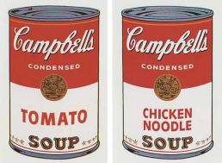
(Figure 2) Campbell's Soup Cans by Andy Warhol
With the help of star effect and the public's psychology of celebrity worship, Andy Warhol often used popular or obviously controversial figures as the subject of artistic creation. For example, the classic series of Marilyn Monroe created by him, such mass-produced and copied portrait works, have become the complex of culture and commerce in the consumer society at that time. On the one hand, they arouse the material desire of the public, on the other hand, they can potentially express the fragility and loss of the deep heart of the public.
In this series, Warhol used strong primary color tones and flat paint to repeat the image of Monroe, whose pretty face and far-off smile never seem to fade away, revealing to the viewer the illusion surrounding the actress's public image. The contrast of bright colors with black and white, and the use of fading effects, allude to the star's falling fate. Andy Warhol tried to do away with the simple depiction of the model in art portraiture, and instead showed Monroe's combination of fame and tragedy in the most mechanical way possible. He depersonalized and repeatedly arranged the head of Marilyn Monroe into a nine-palace grid and took it as the basic element of the whole picture. (1993) He constantly changed the background color, and at the same time matched it with the corresponding color, presenting the same theme in the picture for many times with different effects, to emphasize the design elements. This novel approach fully caters to the emotional needs of the public under the fast-paced life in the United States. A single pattern is difficult to attract attention, but when many the same graphics at the same time on a picture, often can form a strong visual impact. Early artists like Monet also liked to repeat the same thing repeatedly to illustrate the change of light and color at different times, while Warhol used this method to highlight similarities between things. The size, expression and Angle of Monroe's head are the same in each panel. "Marilyn Monroe" also from the side of the satire as a "star-making dream factory" Hollywood to create stars are the same, no characteristics. (Figure 3)
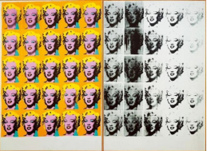
(Figure 3) Andy Warhol, Marilyn Diptych
Infinite possibilities of pop-oriented design thinking
Warhol chose well-known images as his painting subjects, such as the dollar, Coca Cola bottles, movie stars, etc. He began to combine his painting methods with screen printing. He used photocopying technology to screen print his paintings and repeated them constantly. Of course, what this paper mainly discusses is not Andy or Andy's works themselves, but his breakthrough of combining painting and silkscreen printing, which has completely changed the form of art, changed people's feelings about painting, and eliminated the boundary between business and art, the public and the elite. Before art design formed its own academic field and status, a lot of early design work was done by painters, especially in poster design, ...... Posters at that time had a strong painterly character, the poster itself was like a painting work, the author also signed the name. Commercial design was almost dependent on painting. And modern art design has gradually developed into an independent practical art category, with the dual attributes of commerce and art, which is closely related to the development of modern art. As one of the most important figures in modern art, Warhol's idea of copying art has become a social trend of thought in the United States, arousing the public's desire for art consumption, and the importance of art design promotes the commercial use of art to develop the industry. The most important thing is that art design began to gradually get rid of the title of commercial art design or printing art, both in connotation and extension began to extend to a broader field, thus greatly promoting the development of modern art design. My poster is a tribute to Warhol. It uses the head of a popular musician in Asia as the background and adds a lot of pop culture, which is also the greatest respect for Warhol. (Figure 4)
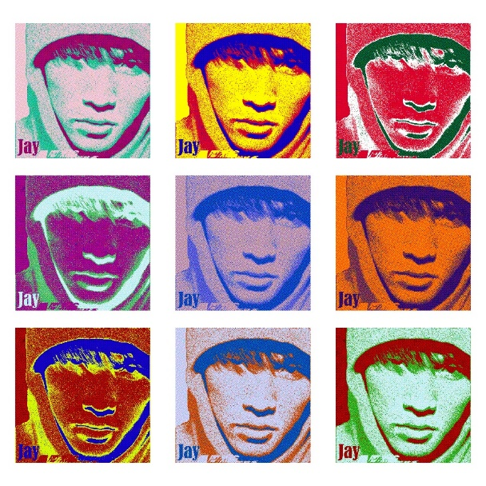
(Figure 4) My poster

The representative figure of Pop art -- Keith Haring
The representative works of Keith Haring
Keith Haring, the core representative figure of American pop culture, has spread his perception of life and freedom through his works through his concise flat language and flat creation style. Under the pressure of modern fast-paced life, people are more eager to pursue inner freedom and express their own personality in a simple and straightforward way. This is also the same original intention of Keith Haring's art, which is to free themselves and show their individuality. With the deepening of democratization nowadays, Keith Haring's playful and interesting art form can be more widely displayed and better integrated into life. Make art more than just an exhibit on a wall.
In 1978, Keith Haring studied painting in the School of Visual Arts in New York. This city opened the door for Haring and his creative passion, and he was completely immersed in such an artistic environment. At that time, his works were mostly composed of black and white line planes. Modeling is relatively simple, eliminating the internal image of the object is only the contours of the change and distortion. In 1980, Keith Haring started doodling on blank blackboards in the New York City subway. He began to reveal the throb and rebellion of his self-consciousness in his graffiti creations. Keith Haring was influenced by his father, who drew cartoons. In his graffiti, he often uses bold, bold lines to draw hollow figures. He created many characters in various forms. (1992) Although the characters in his works have no expression or dress state, they express their social and inner state through the depiction of outline. In addition to the figure form graffiti, he also drew many auxiliary images such as animals, daily necessities and monsters to enrich the picture and achieve a richer expression. By adding short or long lines and broken lines around the form to render the picture circumference, the whole work is given a vivid picture sense. The silent lines make people feel the meaning of sound, and people can feel the dog barking, the baby crying, the flying saucer buzzing, the people singing and dancing, the TV broadcasting news, the light bulb flashing alarm and so on. His famous painting "Radiant baby" (Figure 5) A crawling baby, a strong silhouette of a child on her belly, surrounded by a line of equal length, as if surrounded by the rays of the sun, is the image of a child in the pure world, It's like a Keith Haring self-portrait again. His works seem simple and easy to read, even like children's paintings, but contain his attitude towards the world through pure expression I can release my heart and express the situation I observed in daily life and the love, war, humanity and peace of the world through my brain processing into a free form, which makes the whole picture full of childlike jumping feeling, and each line seems to have its own movement.
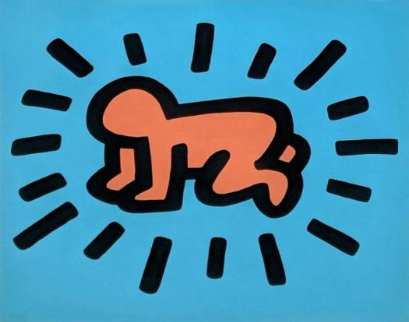
(Figure 5) "Radiant baby"
Keith Haring's influence on modern times
The artistic images of Keith Haring have distinct personal characteristics. Instead of using the conventional three-dimensional perspective painting method, he creates the images he wants to paint by using the outline of lines in the two-dimensional space. The images created by Haring are also very easy to be distinguished in specific places, which is due to the influence of old experience. All visual experiences are included in the context of space and time. The image in the picture will be affected by the image in the adjacent space, and the time sequence of the viewer's viewing has an important impact. But we clearly realize that when we are familiar with something, we can draw on our old experience to experience things in the current environment. The interaction between the shapes of these objects and the objects seen before is not natural; it depends on whether the two have been perceived before. (2007) This is also because of the obvious similarity in the structure between the two. In daily images, speech will change the visual memory trace, and when our memory trace also makes the picture and the language description become very close, so the linguistic description and the picture are also related. Although Haring did not describe the image in the painting in too much detail, the viewer can still identify the image conveyed according to the old experience. Therefore, based on this feature, I also adopted two-dimensional expression in my painting creation. This form of artistic creation contains more formal content under the premise of seeming simple, and it needs to echo the content in the creation process. Keith Haring drew a variety of human figure patterns through bold and bold lines, leaving more artistic thinking for later generations, as well as the designer's English alphabet innovation according to the continuation of the human figure design he created when paying tribute to Keith Haring's graffiti art works, although the letter color The figure is more flexible, the overall shape is elongated, the Keith Haring graffiti style into the font design innovation. In addition to the graffiti art design of text design, there are also innovations in the packaging of cosmetics. The co-branded lipstick of Keith Haring and Bianca has also aroused the pursuit of many women, opening a new marketing way, which materialized women's personality, Avant grade and fashion on the packaging of cosmetics products, making the sales model of celebrity endorsement no longer has irreplaceable advantages. The art style of Keith Haring is better integrated with modern graphic design.

Conclusion
Pop art makes extensive use of reconstruction, covering, copying and other techniques. Initially, pop designers extract the graphics or patterns in materials such as posters and photos in daily life, change them through their own design, and then form design works with the characteristics of pop art through constant repetition, change of color and orderly arrangement. On this basis, there is another expression technique, that is, to change the local design, including recombination, exaggerated reduction or amplification. In the way of expression, designers constantly innovate. In graphic design, the representation of reconstruction is more conducive to the expression of the information transmission function of graphic design. (2015) The designer extracts the main information and sets it off with the auxiliary pattern, which breaks the original regular mode of information transmission of graphic design, enables the audience to obtain information faster and more accurately, and greatly improves the information transmission function of graphic design. Pop designers mostly use different media to express pop art design works. Influenced by the popular concept of pop art, designers mostly use objects that are closer to people's lives, such as discarded newspapers, discarded glass bottles and low-cost plastics, etc. They cut and melt these media and shape them in different ways to create many novel and unique works. Influenced by Pop art, graphic design constantly pursues new styles, emphasizes the innovation of techniques, and pays attention to the combination of emotion and form. Designers advocate freedom, the pursuit of unique beauty, so that graphic design more emotional communication function. With the development of science and technology, the expression of pop art design is not limited to screen printing. Designers consider more about how to break through the inherent pop art thinking, constantly try new media, and constantly create new expression techniques.
In the modern era of continuous development of industrial level and economic level, the influence of pop art on graphic design is not limited to this. It is the beginning of mass art. Pop art has opened people's thoughts, innovated people's thinking, and prompted people to form the attitude of pursuing beauty and creating beauty. Especially in the contemporary era, the rebellious spirit of pop art against tradition is worth learning for contemporary graphic designers. Contemporary graphic designers should strive to promote contemporary design to create more possibilities for the development of design.

Bibliography

Steven Henry Madof (1997); Pop art : a critical history; University of California Press

Orlandini, Marisa Volpi.Abingdon (2022): Routledge.Art in translation,

Stephen Coppel editor; Catherine Daunt editor; Susan Tallman editor; Isabel Seligman contributor (2017): The American dream : pop to the present. British Museum

Alex Coles (2007); Design and art .Whitechapel

Christian Brändle editor; Karin Gimmi editor; Barbara Junod editor; Christina Reble editor; Bettina Richter editor (2014) :100 years of Swiss graphic design. Museum für Gestaltung Zürich, associated with work

Drew De Soto (2011); Know your onions: graphic design; BIS Publishers

Lesley Jackson (2002):20th century pattern design : textile & wallpaper pioneers. M. Beazley

Wesley Shrum (1995):Fringe and Fortune The Role of Critics in High and Popular Art. Princeton University Press

Warhol in translation, Stockholm (1968): “many works and few motifs”. Department of Art History, University of Birmingham. Journal of art historiography,

Thomas Kellein; Callie Angell; Kunsthalle Basel.; Andy Warhol (1993):Andy Warhol, abstract ; Prestel

Germano Celant (1992); Keith Haring. Prestel-Verlag

Phillips, Natalie E (2007); The Radiant (Christ) Child: Keith Haring and the Jesus Movement. The University of Chicago Press American art

Jessica Morgan; Flavia Frigeri editor; Elsa Coustou author (2015);The world goes pop : the EY exhibition. Tate Modern (Gallery)

