Q1. Explain what evidence-based practice is and provide two examples of how Company X
could apply it. (AC 1.1)

Evidence-based practice (EBP) is an approach to decision-making that uses high-quality evidence to guide actions rather than relying on personal opinion or assumptions. Barends, Rousseau and Briner define EBP as professional decision-making informed by four sources of evidence: organisational data, professional expertise, stakeholder perspectives and scientific research. Using evidence in this structured way supports more reliable, transparent and principle-led decisions.
The CIPD recommends a six-step evidence-based decision model: Asking, Acquiring, Appraising, Aggregating, Applying and Assessing.
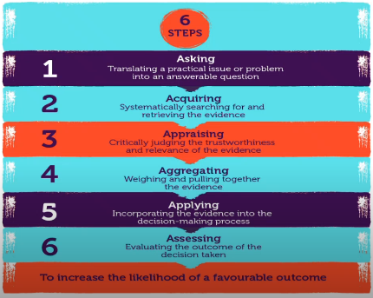

One way Company X could apply EBP is when supporting a client with sickness absence management. This would begin with the Asking stage, by developing a focused question such as: “What are the underlying causes of increased short-term absence over the last six months?” Company X could then gather relevant internal data, including absence records, shift patterns, manager reports and employee survey results. Reviewing this evidence reduces the risk of assumptions and enables informed recommendations, such as improving wellbeing initiatives, adjusting workloads or enhancing line-manager capability.
A second example is reviewing the effectiveness of a client’s disciplinary policy. Where inconsistent outcomes are reported, Company X could apply the Appraising stage to assess the quality and reliability of evidence such as trends in disciplinary cases, investigation times, managerial decisions, employee feedback and grievance patterns. This helps identify whether issues relate to policy design or inconsistent application. For example, inconsistent decision-making may highlight a need for clearer guidance or additional manager training rather than policy changes.
By following evidence-based steps such as Asking and Appraising, Company X can ensure its recommendations are objective and credible. Embedding EBP enables the organisation to deliver high-quality people analytics aligned with professional standards.

Q2. Explain the importance of using data at Company X to accurately determine problems and
issues. (AC 1.2)
It is important for Company X to make evidence-driven recommendations, which relies on using accurate and reliable data to correctly identify problems and issues. High-quality data enables people professionals to understand what is genuinely happening within a workforce rather than relying on assumptions. This strengthens decision-making, ensures insights are meaningful, and helps maintain client satisfaction, supporting Company X’s reputation as a trusted and credible partner.
Accurate data allows Company X to identify the root causes of people issues, prioritise interventions, evaluate the effectiveness of existing policies and processes, and support informed HR decision-making. Without accurate data, recommendations may be misguided. For example, misinterpreted absence data could result in unnecessary policy changes, while inaccurate turnover figures may suggest a retention issue when the reality is internal movement such as promotions or transfers.
The data provided to clients can significantly influence organisational culture, performance and employee perceptions. Staff survey data can either strengthen morale and trust or, if misinterpreted, cause unnecessary concern. Turnover data helps identify early warning signs of workforce instability, while grievance, exit interview and performance data support fair decision-making and effective change management.
To ensure balanced analysis, Company X should draw on multiple sources of evidence, including scientific research, organisational data, practitioner expertise and stakeholder perspectives. Using these sources together provides a more complete and reliable understanding of workforce issues.
Reliability refers to the consistency of data over time. If data is unreliable or poorly appraised, it may lead to incorrect recommendations, wasted resources and reputational damage. Therefore, Company X must appraise evidence carefully by considering how it was gathered, its quality, sufficiency and potential bias. By ensuring data is accurate, reliable and properly evaluated, Company X can confidently diagnose issues and deliver well-supported recommendations that add value to clients.

Q3. Explain the different types of data measurements that people professionals at Company X
could use. (AC 1.3)
The types of data I would use as standard in a People Analytics role are quantitative and qualitative data. Both are essential when working in people analytics and enable Company X’s clients to make informed, evidence-based decisions.
In a People Analytics role at Company X, I would use both quantitative and qualitative data both of which are essential in supporting evidence-based decision-making for Company X’s clients.
Quantitative data is numerical and measurable and is useful for identifying trends, patterns and comparisons over time. It enables objective analysis of workforce issues and supports data-led recommendations. Examples include labour turnover data to identify departmental hotspots, absence rates to analyse short- and long-term sickness trends, and recruitment data such as applicant numbers, time-to-hire and recruitment costs. Equality, Diversity and Inclusion (EDI) data, including workforce representation, pay gaps and promotion patterns, as well as health and safety data such as accident and incident reports, would also be analysed to identify risks and inequalities.
Qualitative data focuses on experiences, perceptions and opinions and helps explain the reasons behind trends identified in quantitative data. This includes analysing employee engagement survey comments, disciplinary and grievance investigation notes, performance review feedback, and exit interview data to identify themes, cultural issues and retention opportunities.
By using quantitative and qualitative data together, more accurate analysis can be produced, enabling Company X to provide meaningful insights and well-informed recommendations that support effective people practices.

Q4. Explain how the application of policies and procedures can inform Company X’s decisions.
(AC 1.6)
The application of policies and procedures can inform Company X’s decisions by providing clear guidance on how people-related issues should be handled within an organisation. Policies and procedures play a key role in supporting decision-making and help ensure that people matters are managed fairly and consistently. They set the tone for an organisation’s values and expectations and underpin employee practices such as equality, attendance, conduct, performance and wellbeing.
From my previous experience, when policies and procedures are applied correctly they help encourage positive behaviour. For example, a disciplinary policy explains the expected standards of conduct, while the associated procedure ensures that any issues are dealt with fairly and by following the correct steps.
Policies and procedures inform decisions by giving managers and HR clear guidance to follow. The CIPD highlights that HR policies and procedures support consistent decision-making and help organisations put their HR strategy into practice. Reviewing outcomes from policies, such as absence cases or grievances, also helps organisations identify patterns and decide whether changes or improvements are needed.
The benefits of using policies and procedures effectively include fairer treatment of employees, reduced legal risk, clearer guidance for managers and increased trust across the organisation.
In my role at Company X, I would support clients by guiding them on the effective use of their policies and procedures, helping them to make informed, consistent and defensible decisions when managing people.

Q5. Explain how the people professionals at Company X can create value for their people, their organisation and their wider stakeholders. (AC 2.1)
The people professionals at Company X play a key role in creating value for employees, the organisation and wider stakeholders by supporting effective people practices and using insight to influence positive outcomes. Their work helps ensure that people are managed fairly, developed effectively and aligned with organisational goals.
People professionals support fair, consistent and supportive people practice by ensuring robust recruitment and selection processes. Hiring the right people for the right roles helps ensure new employees are well suited to both the role and the organisation’s culture. This allows new hires to feel confident, capable and engaged in their work. People professionals also support employee development by identifying strengths, weaknesses and development needs, and using this information to provide training, upskilling and career development opportunities. This people-focused approach helps employees grow, feel valued and motivated, and encourages trust and positive behaviours. In addition, gathering employee views through surveys and feedback allows employees to have a voice in decisions that affect them, increasing engagement and job satisfaction.
People professionals also help improve organisational performance, productivity and sustainability. Effective recruitment reduces turnover and recruitment costs by ensuring the right people are hired. Developing employee skills ensures the organisation has the capability it needs both now and in the future. People professionals support the consistent use of policies and fair people practices and use data to identify issues early and improve performance. Encouraging employee autonomy and involvement further improves engagement and productivity.
Value is also created for wider stakeholders. People professionals support a positive workplace culture, which leads to better customer service and stronger organisational reputation. They promote equality, diversity and inclusion, helping to build trust and credibility. They also help manage change during periods of uncertainty and reduce conflict caused by poor management or lack of communication. An engaged and well-managed workforce ultimately leads to better outcomes for customers and other stakeholders.

Q6. Imagine that you have been successful in your application for the role at Company X. Summarise the ways that you could be customer focused and standards driven in your new role, drawing on your previous experience, as necessary. (AC 2.2)
If successful in my application, I would maintain a strong customer-focused approach by providing a high-quality and reliable service to Company X’s clients. I understand the importance of building trust, satisfaction and long-term relationships, and I would do this by delivering a consistent, efficient and professional service.
I take pride in my organisational skills and would ensure deadlines are always met without compromising quality. I would maintain confidentiality and integrity at all times and ensure I am trustworthy when handling data and insights. I am flexible and adaptable in my approach, allowing me to meet different client needs while maintaining high standards. I also value teamwork and would always support colleagues, understanding that collaboration is key to the success of both individual projects and the wider business. While I am confident working independently, I am equally a strong team player who looks to take initiative, solve problems and improve processes where possible.
In terms of standards, I would ensure that my work is accurate, follows agreed processes and policies, and meets Company X’s quality expectations. I would raise any concerns early if something does not look right and ensure that any data shared with clients is reliable and thoroughly checked before insights are provided.
I understand the importance of Company X’s services and how people analytics supports clients in making informed decisions. I would take responsibility for my own learning and development and continue to build my product and service knowledge. In my previous role, I was known for going the extra mile by double-checking data, providing clear explanations and taking a solution-focused, proactive approach rather than reacting to issues after they arise.
Overall, my values align strongly with a customer-focused ethos. I am keen to support Company X’s reputation and growth and understand that high customer satisfaction leads to loyalty and repeat business. Being customer focused and standards driven helps Company X maintain trust, quality and strong client relationships, and I would welcome the opportunity to contribute to that journey.

Q7. The excel table inserted below shows the hours of overtime worked over a four-week period
for one of Company X’s clients, Blue Mountain Patisserie.
Your task is to:
- calculate the average number of overtime hours worked by each employee during the four-week period.
- calculate the average overtime hours as a percentage of the normal working hours.
- analyse the results and provide written comments on any issues that the data has revealed suggesting potential problems and solutions. (AC 1.4)
The calculations show that the average overtime hours worked per employee over the four-week period range from approximately 4.75 to 12.75 hours per week. When measured against normal working hours, average overtime ranges from around 22% to over 63%, with the highest percentages seen among employees contracted for 16–20 hours per week. These figures highlight a significant reliance on overtime within the business.
From analysing the data on overtime hours worked at Blue Mountain Patisserie, it is clear that some employees are working very high levels of overtime. B Sykes, H Barrel and K Pathos have all worked over 60% above their contracted hours, which is more than half of their normal weekly working hours. The data also suggests that employees on lower contracted hours (16–20 hours) are working the highest percentages of overtime.
This analysis indicates that Blue Mountain Patisserie may be experiencing issues such as understaffing during peak periods, poor scheduling, or a lack of awareness of workload demands. The data raises concerns regarding the risk of employee burnout, which could result in low morale and reduced productivity. This, in turn, could negatively affect employees’ ability to deliver high standards of customer service and quality of work.
In addition, employees working consistently high levels of overtime are likely to be receiving significant overtime payments, which may negatively impact the company’s profitability. A continued reliance on overtime could also lead to non-compliance with working time regulations and inefficient rota planning, potentially contributing to a negative workplace culture.
I would recommend that staffing levels are reviewed, with consideration given to recruiting additional staff or increasing the contracted hours of existing employees who regularly work overtime. A review of rota planning should also take place to identify peak trading periods and ensure staffing levels are appropriate during these times. Overtime should be carefully monitored and capped, as employees working excessive overtime may experience burnout. It is important that employee wellbeing is prioritised and that regular wellbeing checks are carried out. Finally, Blue Mountain Patisserie would benefit from ongoing reviews of overtime data to identify trends and take preventative action.

Q8. Finally, present your findings using at least two different types of diagrammatic forms (for
example, pie charts, bar graphs, or line graphs) to make the information easier to
understand. (AC 1.5)
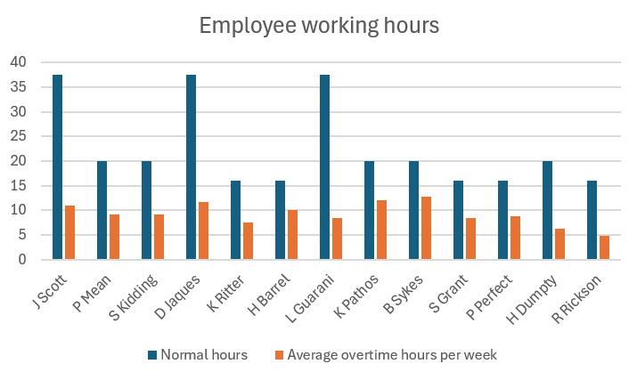
Fig. 1.
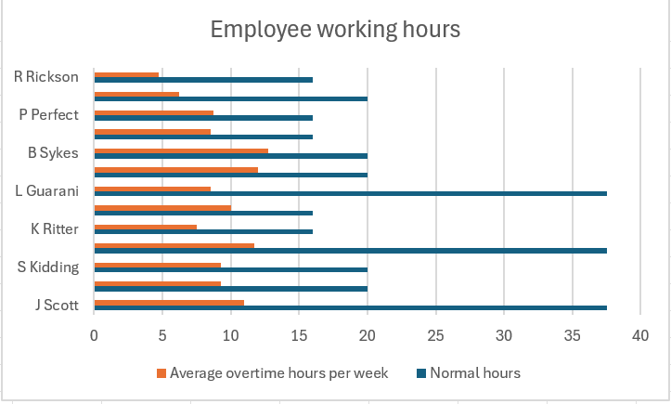
Fig. 2.
From the evidence presented in Figures 1 and 2, it is clear that Blue Mountain Patisserie is relying heavily on employees working excessive overtime to meet operational demand. Several part-time employees are consistently working high volumes of overtime, in some cases exceeding 60% of their normal working hours. This suggests that the business may be experiencing issues such as understaffing, ineffective rota planning, or insufficient awareness of peak operational and trading periods.
If this trend continues, there is a risk of employee burnout and wellbeing concerns, which could negatively impact productivity and staff morale. In addition, continued high levels of overtime payments may affect the business’s overall profitability. There is also a potential risk of non-compliance with working time regulations if excessive overtime is sustained over a prolonged period.
It is recommended that staffing levels are reviewed to better align with operational demand. The business may consider recruiting additional staff or increasing the contracted working hours of existing employees who regularly work overtime. More effective rota planning should be implemented to ensure staffing levels reflect peak operational demand. Regular employee wellbeing checks should also be introduced, particularly for employees working excessive overtime hours.

