Strategic Management

Assignment 1

Author: Adrian Ambrozy
Student number: 1912409
Course: Strategic Management
Submission Date: 14/12/2020

Abstract

The aim of this report is to analyse and critically evaluate the strategy of the Hitachi Rail STS company (Hitachi Rail, the company). The report is divided into the four main chapters which analyses the organisation, current strategy, performance and strategic position of organisation.

Chapter “Strategy of Organisation” looks into the strategy of the organisation on Corporate, Business and Functional level. The “Performance” chapter helps us to understand the company’s strong and weak side, and gives the reader suggestion whether the company is properly diversified. “Strategic Position” helps us to understand the strategic purpose and define the key stakeholders of the organisation. Overall, the report aims to analyse the current strategy and give a recommendation for the future direction of the organisation.

As the Hitachi Rail STS is the global company with presence in diverse markets, it faces a numerous short term and long term challenges which most of them are considered in this report.
This report builds on the strong foundation, core values of the organisation and remarkable reputation that name Hitachi carries, and by implementing recommended steps aims to boost the overall organisational performance and achieve the edge over the competitors.

Table of content

Abstract 2
Table of content 3
1. Introduction 4
2. About the Company 5
2.1 Introduction of the Company 5
2.2 Mission and Products 5
3. Strategy of Organisation 6
3.1 What is Strategy 6
3.2 Strategy on Corporate level 7
3.3 Strategy on Business level 8
3.4 Strategy on Functional level 9
3.5 Strategic Direction 11
4. Performance 12
4.1 Resource Based View (RBV) of the Company 12
4.2 SOAR Analysis 13
4.3 The Strategy Clock 14
4.5 Diversification 16
4.6 Vertical Integration 18
5. Strategic Position 19
5.1 Corporate Social Responsibility (CSR) 19
5.2 Stakeholder Mapping 20
5.1 Strategic Purpose 21
6. Conclusion and recommendation 22
7. Limitations 23
8. Reference list 24
Annex I. - Rolling Stock Overview 26

1. Introduction

Hitachi Rail STS is a global company involved in transportation, railway signaling, metro and other mass transit market. It is originally Italian company now owned by Japanese Hitachi, Ltd., which is the parent company of the Hitachi Group. Company offers design, manufacturing, installation, integration and maintenance of railway and metro systems and solutions (Hitachi Rail STS, 2020).

The company was founded in 2006 under the name of “Ansaldo STS” as a result of merger of Ansaldo Trasporti Sistemi Ferroviari and Ansaldo Signal. In October of 2018, Hitachi gained control of 99% shares of Ansaldo STS and became an owner of the company. On January 2019, Ansaldo STS was delisted from Italian Stock Exchange and renamed to “Hitachi Rail STS” and became a part of the Hitachi Group (Wikipedia, 2020).

2. About the Company

2.1 Introduction of the Company
Hitachi Rail STS is a global company operating in the railway sector through its offices spread across 38 countries and 3 continents. The company belongs to Hitachi Group, which is the portfolio of its parent company - Hitachi Ltd. At the time of writing, the company has three business units in America, Asia Pacific and EMEA. The company has in total three headquarters, two on the business level in Italy, and one on corporate level in Japan and overall employs over 12 000 full-time employees. In the fiscal year of 2019, the company achieved the revenue of ¥580.3bn, with the 80% coming from the area outside of the domestic Japan (Hitachi Rail STS, 2020).

2.2 Mission and Products
The company’s focus lies mainly in the following five elements of the railway market:

Rolling Stock is one of the key market segments for the company. The company offers a wide range of the rolling stock products including monorail, driverless, metro, commuter, intercity, high-speed, battery and tram vehicles.

The company offers a range of Operation & Maintenance (O&M) services through its Intelligent Asset Management, O&M of mass transit systems, O&M of signaling systems and rolling stock refurbishment and maintenance.

Digital Signalling & Systems is represented by Signaling, Traffic Management, Station and Information systems. ERTMS/ECTS, satellite positioning technology, CBTC and driverless solutions are among the key products for the market segment.

The company is one of the global leaders in the delivery of railway turnkey projects. The company is a leader in the designing and building of the automatic fully unmanned driverless transportation systems. At the time of writing, the company is delivering the key projects in Copenhagen, Riyadh, Genova, Taipei, Honolulu, Milan and Lima.

Furthermore, the company offers a wide selection of railway components including switch machines, level crossing, interlocking systems, rolling stock components and on-board interfaces.

The company states that its mission is to bring innovation into everything they do and to its entire product line (Hitachi Rail STS, 2020).

3. Strategy of Organisation

3.1 What is Strategy
Collins and Rukstag suggests that a good strategy statement has three main elements: objective, scope and advantage. The objective element should represent a clear vision of what the strategy wants to achieve and defines a time frame allocated to achieve it. The scope defines a boundaries or so-called circle of competence in which company will operate. They further claim that the advantage element of the strategy statement is the key and essential part for the strategy in order to be complete. It aims to define what the company will do in different way than competitors in order to achieve the objective (vision) within the company’s scope (Collis and Rukstad, 2008). Oliver suggests that strategy means the understanding of the an industry structure, dynamics and position of organisation within the structure, and afterwards taking steps to change industry’s structure or position of organisation with the intention to improve the results of the organisation (Oliver, n.d.).

3.2 Strategy on Corporate level
Furrer suggests that the aim of Corporate level of the company is to answer the question: “What set of business should we be in?”. He claims that the purpose of the Corporate level should be to create a value through the configuration of the company. The importance of Corporate level Strategy lies in defining: 1) the scope of the company 2) the relationship between the scope and performance 3) management systems and leadership (Furrer, 2016).

In addition, Bowman and Ambrosini offers an idea that Corporate level activities should in some way positively impact the profitability in order to be valuable. They further claim that four main tasks of Corporate level lies in integration, learning, consolidation, and leveraging of the company’s assets and resources (Bowman and Ambrosini, 2003).

By pursuing a leveraging strategy, such as in case of the Hitachi Rail STS, the company aims to duplicate a human, intellectual and physical resources to the new locations based on the demand for the product. The company does that by either reconfiguration (providing resources from other projects) or by creating new resources through hiring and learning (Bowman and Ambrosini, 2003). The Corporate level strategy for the Hitachi group is set and defined in the parent organisation Hitachi Ltd. which governs its 846 companies in the group (Hitachi, 2020). Furthermore, the Hitachi Rail STS itself has a global Head Office located in London.

Figure 1: Global Head Office (Hitachi Rail STS, 2020).

3.3 Strategy on Business level

The strategy on business level is set and overseen in three Hitachi Rail STS headquarters which are strategically located in Italy and Japan, and are overseeing a performance of the entire company. The company has three business based on the region of the operation: America, EMEA and Asia Pacific.
Figure 2: Map of Headquarters (Hitachi Rail STS, 2020).
Furrer suggests that strategy on Business level and Corporate level is highly correlated and should be aligned together in order to maximize the benefit for the company and create the value. He further stress the importance of coordinating the units within the company, which could significantly improve costs effectiveness among other benefits (ie. by ordering material in bulks, therefore lowering the price) or by offering wider range of products to the common customer (Furrer, 2016).
Ghobanian et al. suggests that in order for strategy to be successful on business level, it must be aligned with the environment of the company. Furthermore they claim that the business environment and trends presents a wide range of opportunities and challenges that the company must actively monitor and react, in order to maintain its competitiveness on the market (Ghobanian et al., 2010). While analyzing the Hitachi Rail STS products, we can see that company actively monitor the current trends and offers a wide range of portfolio. As an example, we can mention that company offers a battery powered train as an answer to the green energy trend.

3.4 Strategy on Functional level

The strategy on functional level in Hitachi Rail STS is set in its 26 main offices and 21 plant and maintenance sites spread across America, EMEA and Asia Pacific.

Figure 3: Map of Main Offices (Hitachi Rail STS, 2020).

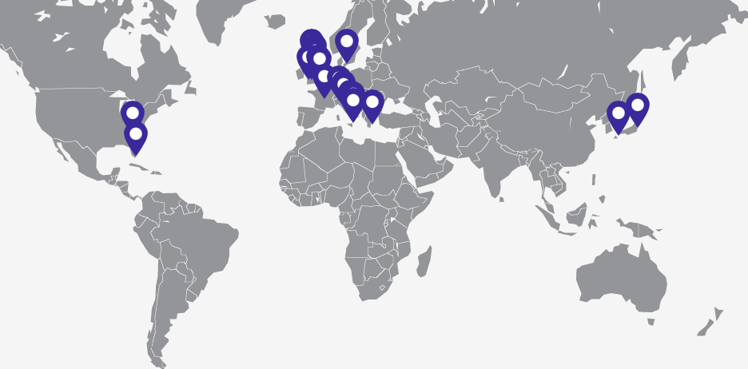
Figure 4: Map of Plant and Maintenance (Hitachi Rail STS, 2020).

The main benefit of the current set-up lies in the fact that the wide global presence of main offices and plant and maintenance sites provides the Hitachi Rails STS with the accessibility to its existing customers as well as flexibility in case of new or relatively small projects. In the company, the objective of strategy on functional level is to set the targets and goals in order to deliver the projects within the assigned area of competence. Furthermore, the goal of functional level strategy in Hitachi Rail STS is to support the strategy on corporate and business level.

3.5 Strategic Direction
Spacey described a Strategic Direction as a set of fundamental ideas that give a consistency to a strategy over a time. He claims that there are seven important factors of the strategic direction and those are: mission, vision, culture, ideology, principles, values and grand strategy (Spacey, 2019).
Rotemberg and Saloner supports the claim of Spacey by suggesting that in order to set a direction, it is necessary that the leader need to first envision the future of the company. However, they further argue that the vision might cause a missing of opportunities due to bias and the fact that leader might prefer certain projects over the others and miss out on the projects that he either dislikes or feels that does not fit into the vision.

Hitachi Rail STS does have its mission, vision, value and purpose clearly identified on its company website as well as clearly communicated to its employees. The mission of the company is to contribute to the society through the development of superior original technology and products. The vision of the company is to deliver the innovations that answers the society’s challenges. The value of the company is represented by ambitious approach and valuing employees, stakeholders and shareholders. The purpose of the company is to to deliver the superior original technology and products that will power the sustainable connectivity (Hitachi Rail STS, 2020). Analyzing the company’s vision, value, mission and purpose we can conclude that the they are aligned with the company’s product line and activities.
While setting up a strategic direction, company might be exposed to negligible or transformational change. Gill highlights that in order for a change to be successful an effective leadership skill must be involved, especially due to risk involved in the change process. He further suggests that the leadership of change, as well as strategic direction, requires vision, strategy, shared value and culture skills (Gill, 2003).

Taking into the consideration the fact that Hitachi Rail STS does have its strategic direction selected, communicated and aligned well, Lawrence argues that despite the fact that company does select its overall strategy correctly, there are “little” changes happening constantly, therefore it is crucial for the company to possess the resources with effective leadership in terms of change process (Lawrence, 1969).

4. Performance

4.1 Resource Based View (RBV) of the Company
Bowman and Ambosini describes the Resource Based View as a competitive strategy that examines a link between the company’s characteristics and its performance. They suggest that a company is bunch of resources that needs to work together, in order to create a competitive advantage. The VRIN model helps to assess the resources based on Value, Rarity, Inimitability and Non-Substitutability (Bowman and Ambrosini, 2003).

The resources are only valuable for the company if they are able to create any value. The resources that are rare, might provide additional benefit to the company that owns them and generate superior margins. Inimitability criterion is assessing how difficult it is for the competitors to replicate the resources that generates the benefits for the company. Non-Substitutability means that the resource cannot be easily replaced by the other resource, which is able to generate the same outcome (Bowman and Ambrosini, 2003).

Reviewing the Hitachi Rail STS through the requirements of the VRIN model, we can conclude that the resources are highly valuable, rare, not easily imitable and non-substitutable. The company offers highly technologically advanced products and services like for instance driverless metro therefore it makes both human and intellectual resources highly valuable and important.

4.2 SOAR Analysis
Capela and Brooks-Saunders describes SOAR analysis as a power tool for creating a strategy for the organization. SOAR analysis mostly focuses on the positive side of the business and cheers the opportunities (Capela and Brooks-Saunders, n.d.) SOAR analysis stands for strength, opportunities, aspirations and results and can be alternative to classic SWOT analysis that represents strengths, weaknesses, opportunities and threats. Silbert and Silbert suggests that the SOAR analysis might be considered as an entire system approach instead of the top-down approach represented by the SWOT analysis (Silbert and Silbert, 2007).

By using the SOAR analysis as a planning tool for the strategy, the company will benefit from this choice by understanding what the company do well and build on it. By analyzing the opportunities, the company should be forced to understand and reframe the threats or weakness into the opportunities. Aspirations should be viewed as a factor that is critical in building a competitive advantage. The company should be able to understand how it can differentiate itself from the competitors. In case of the Hitachi Rail STS, this is represented through a wide range offering of niche products, such as battery trains or driverless metro. The results measure the how the strength, opportunities and aspiration are transformed into the tangible assets (Capela and Brooks-Saunders, n.d.)

4.3 The Strategy Clock
The clock strategy was introduced by the Bowman (1992) as an alternative to Kottler’s model, as he perceived the original model to be too static and that it did not consider the environment’s influence. Cacho describes the clock strategy as the accurate and appropriate theoretical tool for analyzing the competitive strategy (Cacho, 2012).

Shakhshir stress the importance and relevance of the Bowman’s clock model due to the fact that in today’s market, the competition has rapidly increased and the entire market has evolved. The market environment is experiencing a shift in trends, as well as the pace of the production has been increased. He claims that it is extremely important for the company to correctly position itself in the demographic, social, geographic or economic market in order to select the right strategy and strategic direction. Furthermore, he suggests that to understand the position of the company is important for the strategic generation, evaluation and monitoring (Shakhshir, n.d.).

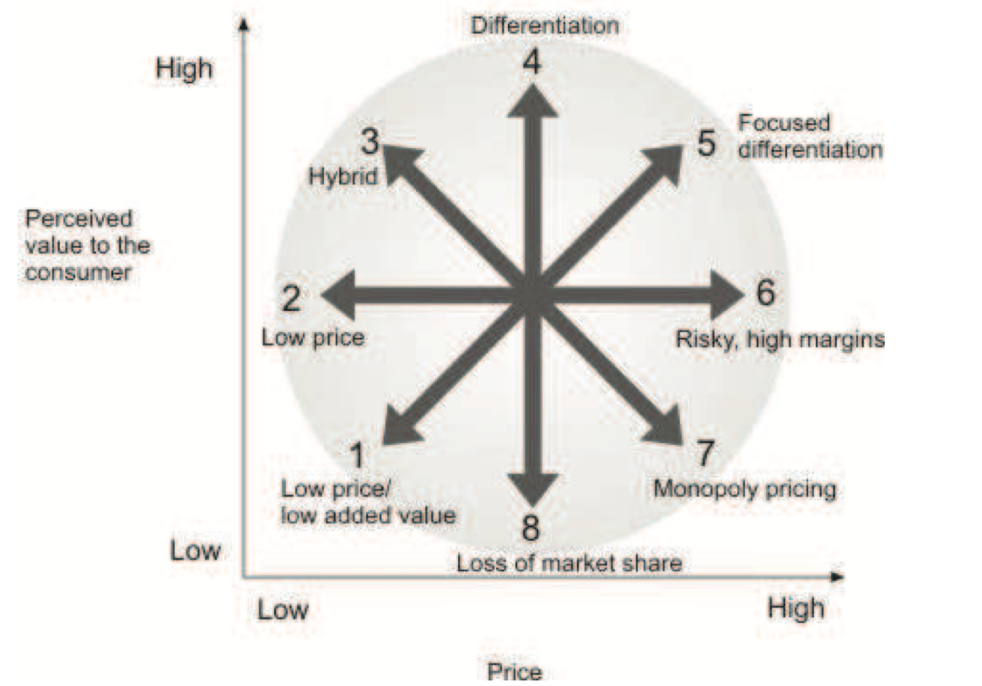

Figure 5: Bowman’s strategy clock (Bowman and Faulkner, 1997).

The products and services offered by the company would mostly fit between the position 4 “Differentiation” and position 5 “Focused Differentiation”, therefore pointing towards higher margins and justifying charging premium. The reason is that the company offers an innovative product that are aiming to take a market share from niche markets. In case of company’s most unique product, driverless metro trains, the customer might expect to pay premium due to the improved effectiveness, increased safety, as well as increase in city’s reputation due to product’s rarity. Shakhshir suggests that the competitive advantage can be enhanced by the ability of the company to effectively achieve and track a series of strategic initiatives (Shakhshir, n.d.). Based on Bowman’s clock model, we can conclude that the narrow specialization of the company and strong presence in the niche markets is where the company is gaining its competitive advantage.

4.5 Diversification
Kim et al., suggests that the diversification can be divided into two main elements: international market diversification and product diversification. He further claims that both of the elements have numerous approaches to strategic diversification with the various impact on profitability of the company and various level of risk protection (Kim et al., 1989).

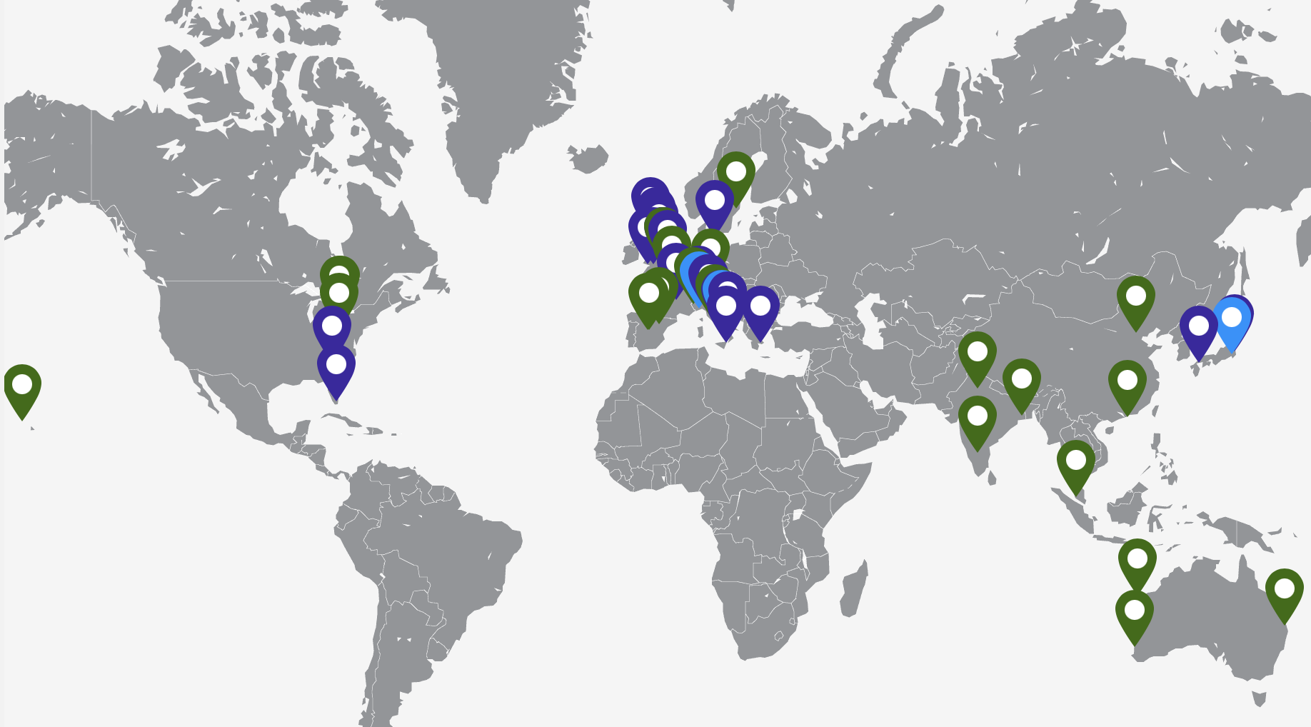
As the company has currently presence in 38 countries, and has 11 manufacturing sites on three locations, the current state of international market diversification seems to provide a sufficient level of protection against the risk of downturns in local markets. Despite the fact that company is global, it still provides an opportunity for the company to pursue a growth strategy as the company does not have any presence in Africa, Middle East, West coast of USA nor Latin America.

Figure 6: Hitachi Rail STS presence (Hitachi Rail STS, 2020)

In terms of product diversification, while the parent company Hitachi, Ltd. is widely diversified in several markets including the construction machinery, real estate, railway, hydro, mining and medical sectors through its 846 companies, the Hitachi Rail STS has more narrow focus (Hitachi Ltd., 2020). The company offer a railway product in five main categories: Rolling Stock, Operation & Maintenance, Digital Signaling & Systems, Turnkey and Components.

Through these five categories, the company is aiming to cover the main part of railway sector market including niche sector such as driverless metro, monorails, high-speed and battery-powered trains. While the company seems to be sufficiently diversified with its product offerings within the railway market, Delios and Beamish suggests that the product diversification has little to no impact on performance or market power of the company and argues that widely diversified companies instead tends to compete in the less attractive markets (Delios and Beamish, n.d.). Chang agrees that unrelated diversification has a mixed effect on the company performance, however he argues that the companies with related product diversification, such as in case of Hitachi Rail STS, might have positive influences on performance of the organisation (Chang, 2007).

Furrer proposes an ABC model of diversification where: A) represents low level of diversification, B) represents moderate level of diversification, and C) represents high level of diversification. Based on the model below, the product line of Hitachi Rail STS, could be described as the “Related linked” and therefore belong to the group B, offering moderate level of diversification.
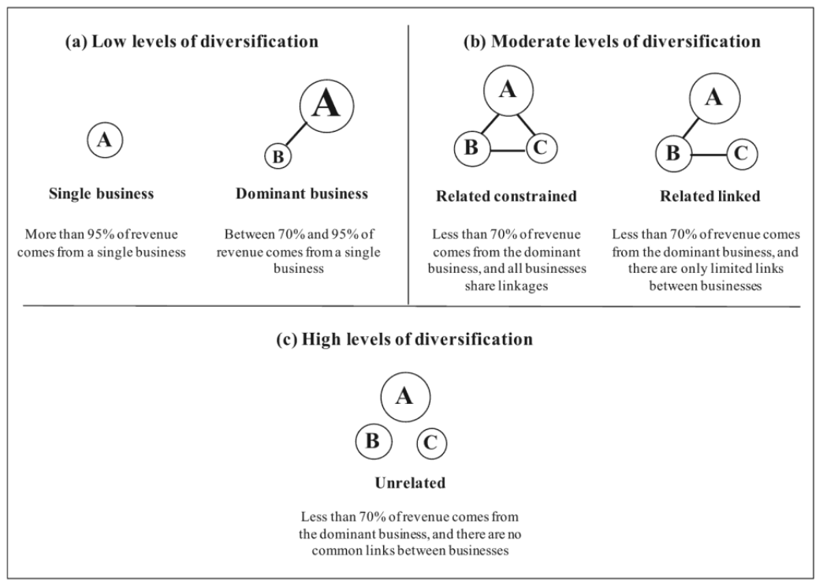
Figure 7: ABC model of diversification (Furrer, 2016)

4.6 Vertical Integration
Grossman and Hart suggests that in order for vertical integration to be successful, its transaction cost together with integration cost must be offset by the benefit that the new acquisition will provide (Grossman and Hart, 1986). Harrigan states that vertical integrations require a collaboration of multiple business units in order to be truly effective. She further claims that in some scenarios, some business units can be temporary subsidized on the expense of other. Furthermore, she suggests that vertical integration increases company’s ability to achieve product differentiation and create credibility for new products, which contributes to improved technological intelligence (Harrigan, 1984).

This is particularly important for Hitachi Rail STS, as it provides to company greater flexibility during the design process. While Hitachi Rail STS does not directly acquire companies, the vertical integration is achieved through the Hitachi Group and its parent company Hitachi Ltd. One of the latest acquisitions from Hitachi Ltd. is the acquisition of ABB Power Grid, which is the provider of high voltage power transformation and battery systems (John, 2020), which apart from physical assets offers a know-how and intellectual property to the group.

5. Strategic Position

5.1 Corporate Social Responsibility (CSR)
As described by Windsor, the aim of Corporate Social Responsibility should be, as originally suggested by Bowen in 1953, to answer the question how the interest of business merge in the long run with the interest of society (Windsor, 2001). It is therefore important to review the company’s Corporate Social Responsibility and analyze whether it is aligned with the society’s needs and the trends that are set for the foreseeable future (ie. lower the carbon footprint).

Hitachi Rail STS does have defined its Corporate Social Responsibility and Sustainability approach as “Think Responsibly, Act Sustainably”. The company is aiming to contribute to CSR in multiple ways including providing innovative solutions, building a better future for the societies and its employees, as well as aiming for low carbon future by aiming to reduce CO2 emission by 50% by fiscal year of 2030 (Hitachi Rail STS, 2020). The company is reporting the progress in its sustainability activities in annual Sustainability Report.

5.2 Stakeholder Mapping
The company is currently operating under the Stakeholder model, where the ownership of the company is controlled by the parent company Hitachi Ltd. through Hitachi Group. Gerry et al. suggest that the benefits of Stakeholder model lies in long-term horizon of investments from the stakeholder. On the contrary, the fewer alternatives to raise finances, transfer of some management competencies towards the stakeholder and decreasing decision power might be regarded as disbenefit (Gerry et al., 2011).

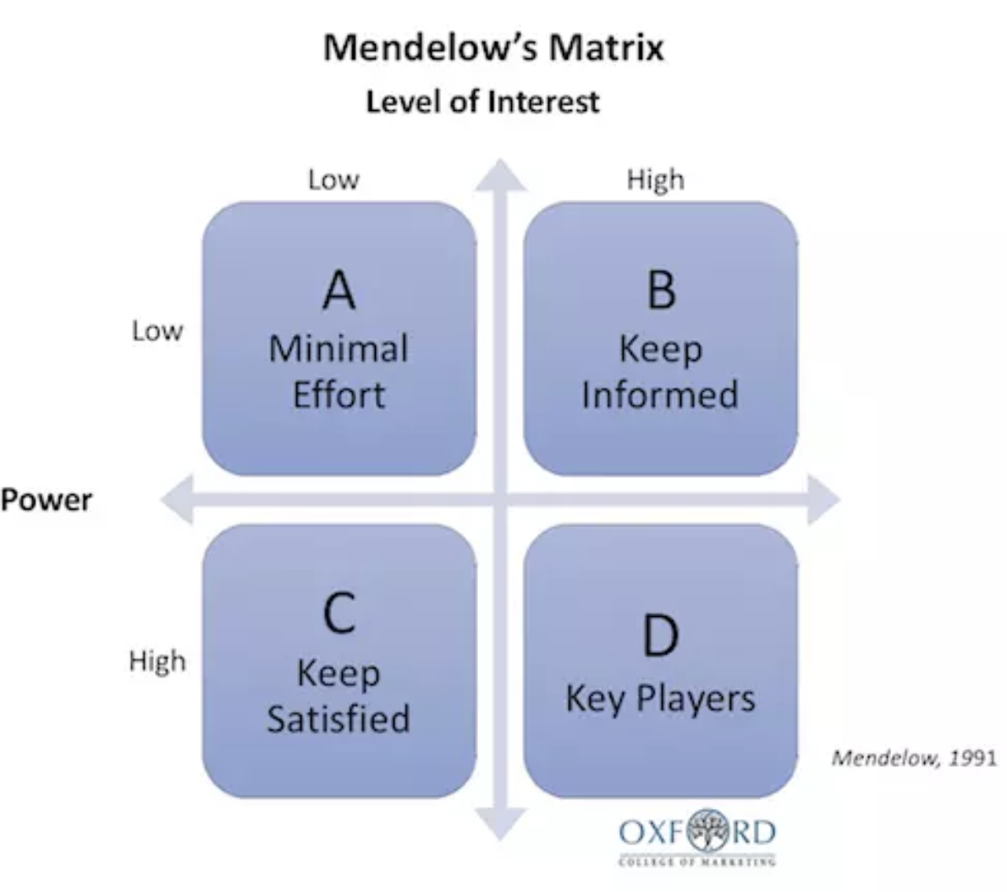

Figure 8: Mendelow’s Matrix - 1991 (Erikssen-Coats, n.d.)

Based on the Mendelow’s Matrix above, we can see that the Hitachi Ltd. might be regarded as the key player due to their full ownership of the company. It is therefore important for the management of Hitachi Rail STS to report the progress on important activities and achievements. As a key player, Hitachi Ltd. has a high power on the decision-making process and possibility to influence the strategy and strategic direction.

5.1 Strategic Purpose
Strategic purpose is being affected by the three main factors: governance structure, stakeholders’ expectation and social responsibility and ethics. Strategic purpose is highly correlated with the Strategic Direction (chapter 3.5) and takes into account company’s mission, value, and vision further described on page 11. The mission statement provides a stakeholder with the description of the purpose of the company, therefore in-directly ensure that the right set of investors are involved.

The corporate governance represents the structure of the organisation and guarantees the control and accountability for the individuals with legitimate stake, in Hitachi Rail STS case, the parent company. Gerry et al. suggests that the chain of corporate governance should be clearly defined. Furthermore, he claims that the strategy is directly influenced by the expectations of the stakeholders. He suggests that for the large companies, this might be a challenging as various stakeholders might have different expectations (Gerry et al., 2011). This challenge is almost completely eliminated in the case of the Hitachi Rail STS as the company is owned by the sole owner, therefore it makes it easier for the company to be aligned with stakeholders, then it would in case of multiple owners. Due to this, the overall effect of Hitachi Ltd. on the strategic purpose of the Hitachi Rail STS is unified and highly influential.

6. Conclusion and recommendation
Hitachi Rail STS is a strong global company that competes in the railway market. Based on the analysis of this report and on its product line we can see that the company indeed does what they say in their mission, vision and value description. The Hitachi Rail STS positioned itself as a strong and innovative company that is able to reach the wide spectrum of the market through its global presence and deliver the innovative products to the societies all over the world. Due to the company’s innovative spirit, author recommends using the SOAR analysis instead of the SWOT to focus on the positive side of the business and to further highlight the vision of the company.

As described in chapter 4.5 “Diversification”, in terms of global expansion, the company has numerous opportunities to enter the new markets where it currently does not have the presence particularly in rapidly growing emerging markets. This is highly recommended as it will vastly improve accessibility to the existing and potential new clients. This should highly contribute to improving of the customer care as the on-site support will be more accessible, and cost-effective. In regard to product diversification, it is recommended to follow the current strategy and diversify strictly within the railway market sector with related products. It is due to the fact that the Hitachi group is widely diversified across the markets through the parent company Hitachi Ltd. and its 846 companies.

It is also recommended to introduce and follow the set of management systems that is purpose driven instead of relying solely on financial/budget driven management systems. Kaplan describes a management system as a set of processes or work frames that are helping company to be aligned and to set procedures for measuring the performance (Kaplan and Norton, 2006). These systems and procedures should help the company to plan the operating phase and should be designed to achieve the objective of the strategy. As Kaplan and Norton further suggests, these management processes should not rely solely on financial systems as it can result in the scenario where short-term financial considerations might overwhelm long-term strategic goals (Kaplan and Norton, 2006).

Due to the nature of the business, author suggests that it is not necessary to directly invest into the chatbot, help desk etc. This is based on the fact that the products that company offers are technically complex and company provides on-site technical support through its maintenance programs. In railway market, the new clients are typically approached through tenders and bidding process to ensure fair competition among the competitors, therefore author assumes that addition of chatbots or help desk will provide minimal to no benefit and will not justify the cost.

7. Limitations
This report is based on the publicly available information gained from Hitachi Rail STS and Hitachi Ltd. website as described in the reference list below. Due to the limitations of the report, author’s analysis is made strictly from the strategic point of view. At this point, author did not perform any cost analysis of the recommended or not recommended actions, instead focuses on the theoretical part of the assignment.

8. Reference list

- Collins, D. and Rukstad, M. (2008) Can You Say What Your Strategy Is? USA: Harvard Business Review
- Cacho, P. (2012) How Does Strategic Choice Affects Business Results? A Case Study Of Mutual Guarantee societies. Spain: Universidad de Jaén
- Oliver, R. (n.d.) What is Strategy Anyway? (n.p.)
- Kaplan, R. and Norton, D. (2006) How to Implement a New Strategy Without Disrupting Your Organisation. USA: Harvard Business Review
- Lawrence, P. (1969) How to Deal With Resistance to Change. USA: Harvard Business Review
- Gill, R. (2003) Change management - or change leadership EBSCO Publishing
- Wikipedia (2020) Hitachi Rail STS. Available at: https://en.wikipedia.org/wiki/Hitachi_Rail_STS (Accessed: 01st December 2020).
- Hitachi Rail STS (2020) Our Company. Available at: https://www.hitachirail.com/our-company/ (Accessed: 01st December 2020).
- Hitachi Ltd. (2020) Group Companies. Available at: https://www.hitachi.com/corporate/about/group/index.html (Accessed: 06th December 2020)
- Kim, W. and Hwang, P. and Burgers, W. (1989) Global diversification strategy and corporate profit performance. USA: The University of Michigan and Michigan State University
- Delios, A. and Beamish, P. (n.d.) Geographic scope, product diversification and the corporate performance of Japanese firms. London: University of Western Ontario and Hong Kong University of Science and Technology
- Harrigan, K. (1984) Formulating Vertical Integration Strategies. USA: Colombia University
- Grossman, S. and Hart, O. (1986) The Costs and Benefits of Ownership: A Theory of Vertical and Lateral Integration. USA: The University of Chicago
- John, J. (2020) Hitachi Completes Acquisition of ABB Power Grids to Tackle Renewable Energy’s rise. Available at: https://www.greentechmedia.com (Accessed: 07th December 2020)
- Furrer, O. (2016) Corporate Level Strategy. USA: Routledge
- Bowman, C. and Ambrosini, V. (2003) How the Resource-based and the Dynamic Capability Views of the Firm Inform Corporate-level Strategy UK: Cranfield University
- Ghobanian, A., and Nandakumar, M. and O’Regan, N. (2010) Business-level strategy and performance. UK: Henley Business School
- Spacey, J. (2019) 7 types of Strategic Direction Available at: https://simplicable.com (Accessed: 12th of December 2020)
- Rotemberg, J. and Saloner, G. (1998) Visionaries, Managers, and Strategic Direction USA: Stanford Graduate School of Business
- Capela, S. and Brooks-Saunders, A. (n.d.) A Different Approach to Strategic Planning: SOAR - Building Strengths-based Strategy. HearthShare Human Services
- Silbert, J. and Silbert, T. (2007) SOARing from SWOT: Four Lessons Every Strategic Plan Must Know. International Journal of AI Best Practice
- Shakhshir, G. (n.d.) Positioning Strategies Development. Romania: University of Babes-Bolyai
- Bowman, C. and Faulkner, D. (1997) Competitive and corporate strategy. UK: Irwin
- Gerry, J. and Whittington, R. and Scholes, K. (2011) Strategic Purpose Harlow: Financial Times Prentice Hall
- Eriksen-Coats, F. (n.d.) What is Mendelow’s Matrix and How Is It Useful? Available at: https://blog.oxfordcollegeofmarketing.com (Accessed: 13th December 2020)
- Windsor, D. (2001) The Future of Corporate Social Responsibility USA: Rice University

Annex I. - Rolling Stock Overview


