

Title: A comparison of the marketing methods of two multinational hotel brands
Name: Oana-Andreea Puscuta
Student ID number:2232738
The module title: Marketing Essentials BMIH4005
Lecturer’s name: Scott James
Word Count: 1532

The hospitality industry has been dominated by some of the major players, all in competition to gain the desired share. The current essay focuses on comparing two multinational hotels, Holiday Inn and Six Senses, using situational, communication and marketing tools, thereby determining the similarities and differences between the two. The situational analysis is carried out using SWOT and PESTLE frameworks, while marketing mix and STP frameworks have been used for further examining marketing communication strategies, with specific emphasis on traditional and digital marketing. Holiday Inn has developed its position as a hotel aimed at the provision of services in accordance with market conditions and desired positioning (Holiday Inn, 2023). On the other hand, Six Senses has always been more inclined towards creating its image as a sustainable hotel (Six Senses, 2023).
Situational analysis involves the evaluation of the information regarding the internal and external environment of an organisation (Namugenyi et al., 2019). For the multinational hotels, the analysis is carried out considering SWOT (internal) and PESTLE (external) frameworks. The strengths of Holiday Inn lie in its strong brand portfolio and the delivery of quality services and amenities, including large rooms to spas, fitness centres and even all those luxuries that a customer desire. However, at the same time, the fact cannot be ignored that the hotel has not focused much on differentiation (He et al., 2019). As far as the strengths and weaknesses of Six Senses are concerned, the hotel has developed a strong, sustainable brand image. On the other hand, customers also prefer Six Senses over others for its personalised approach for all, either travelling for business purposes or leisure. The major weakness, however, lies in being dependent on customers who can exclusively afford luxury (Gong, 2020).
The political environment of the UK has already been significantly impacted by Brexit and the pandemic, which in turn, further affected overall economic conditions. The current invasion of Ukraine by Russia also has similar effects, as evident in terms of restrictions on airspace and high food and fuel cost. The current situation has significantly hit the confidence of travellers as well as their disposable income (Balli et al., 2022). In addition, the hospitality industry is also struggling due to inflation, as the number of visitors has decreased by 40% due to rocketing prices (Butler, 2022). Therefore, it can be stated that the current economic condition could be a threat to the hotels. At the same time, it is undeniable that social and technological factors, specifically those concerned with changing consumer preferences, are also impacting the hospitality industry. Some of these changes have been reported in the form of sustainable practices and contactless services incorporating technology. These changes can further be considered with regard to the environmental impact of hotels in terms of carbon emissions and waste generation (Sota et al., 2020). These aspects can be regarded as opportunities for the hotels to develop their image in front of the target audience. In addition, hotels are also bound to ensure compliance with laws and regulations, whether in regard to equality for employees and customers or environmental protection.
Marketing Mix is centred on a combination of seven elements that are controlled by an organisation to offer the desired customer value (Jobber and Ellis-Chadwick, 2019). As mentioned before, Six Senses is committed to sustainability, and therefore, its eco-friendly focus is reflected in all aspects, whether suitable accommodation, dining, wellness and fitness or spa treatment. However, at the same time, it is undeniable that all these facilities are available in high price ranges, and therefore, Six Senses is mainly targeting high-end customers (He et al., 2019). Compared to this, Holiday Inn also offer all these facilities, which further include the availability of electronic appliances as complimentary amenities. The differentiating aspect of the hotel, however, is its reasonable prices, changes which are often made in accordance with rapidly altering market conditions (Holiday Inn, 2023). With regards to the place element, it has been observed that Holiday Inn is located at some of the most well-known or busiest locations, such as tourist sites. Six Senses, however, has differentiated itself in terms of its presence in main cities as well as remote areas, including mountains and the seaside (He et al., 2021). Chaffey and Ellis-Chadwick (2019) have defined promotion as advertising aimed at reaching the desired audience, either using traditional or digital marketing strategies. Traditional marketing tools, such as offline media, including newspaper ads, billboards and other print ads, are now rarely incorporated by hotels (Aydin, 2020), and a similar situation has been found in the case of Six Senses Hotel. Holiday Inn, however, is still relying on such strategies to a significant extent. This, in turn, is further concerned with the fact that hotels have started emphasising digital marketing communications (Gong, 2020). With regards to the process aspect, the two hotels differ in terms of comfortability and standardisation for Holiday Inn while convenience and engagement for Six Senses. Based on these aspects, hotels are offering distinctive experiences to their customers, resulting in high satisfaction (He et al., 2021). The hotels of Holiday Inn, as well as other respective properties, are consistent, irrespective of the location. Six Senses greatly differs in this aspect, as evident from its distinctively designed hotels.
Before further digging into marketing communications, it is crucial to determine the customer segments targeted by the brand. Mody et al. (2019) have defined STP (segmentation, targeting and positioning) as the framework that enables better positioning of a product or service for targeting different customer groups. With regards to the geographic segmentation, it has been observed that Holiday Inn has covered around 53.4% of the area of the UK, compared to 46.6% for Six Senses. However, there do not exist significant differences when it comes to demographical analysis, except that Holiday Inn is increasingly preferred by 53.5% of females, while the proportion of the male population (49.19%) is high for Six Senses. In addition, the major targeted customers for both of these hotels are determined to be those between 25 and 34 years of age (Similarweb, 2023) (refer to Appendix A). Positioning is concerned with the place a brand or product is placed within a particular market (Kalam, 2020). Comparing the two hotels in accordance with their price and quality, it has been observed that both of these hotels are equally concerned about quality, whether in terms of products or services. However, there lies a difference in terms of price, as Six Senses emphasise premium pricing compared to the reasonable prices of Holiday Inn (Similarweb, 2023) (refer to Appendix A).
Aydin (2020) has stated that marketing communications are the techniques incorporated by organisations for conveying promotional messages. For the two multinational hotels, communications can be analysed in terms of digital marketing strategies adopted by them. Hotels are using a range of marketing channels, among which organic search is the most prioritised by Six Senses, compared to paid search for Holiday Inn. In addition, hotels have also incorporated direct marketing (Similarweb, 2023) (refer to Appendix B). Hristoforova et al. (2019) have postulated that direct marketing is more concerned with the distribution of sales pitches to customers, either through mail or texting. However, it has also been observed that the two hotels are not much reliant on email, as compared to other channels (Similarweb, 2023) (refer to Appendix B). Aydin (2020) has argued that social media marketing is an important part of brands operating in the hospitality industry. This, in turn, is associated with the fact that it facilitates increasing visibility by means of paid and organic discovery. There lies a significant difference in the use of social media by multinational hotels. Six Senses can be considered efficient in this regard, being concerned with the fact that the hotel is using a combination of different social media channels, ranging from Facebook to Instagram, YouTube and Pinterest; on the other hand, Holiday Inn has shown increasing reliance on Facebook, after which only YouTube and Instagram are focused to some extent (Similarweb, 2023) (Refer to Appendix C). Engagement through a website is also a significant aspect of digital marketing (Mody et al., 2019). Holiday Inn might not be able to capture the attention of the audience through social media; however, its website is updated enough to generate traffic from all over the world. Six Senses might have more unique visitors but also has a high bounce rate, indicating adversely impacted website performance (Similarweb, 2023) (refer to appendix D).
The comparison and analysis of the two hotels confirmed the initial points highlighted. It has been observed that Six Senses is in the lead in several aspects, be it services or a sustainable approach to target customers. Furthermore, Six Senses is also more inclined towards digital marketing communications. On the other hand, Holiday Inn is more focused on standardisation and follows the same criteria throughout. Furthermore, the hotel might not be involved in social media marketing; however, it has developed its reputation with greater engagement through the website. In addition, the hotel is also greatly preferred for its reasonable pricing. For future studies, discussion can be carried out in terms of environmental consciousness and the extent to which the emphasis has proven to be successful for hotels.
References
Aydin, G., 2020. Social media engagement and organic post effectiveness: A roadmap for increasing the effectiveness of social media use in the hospitality industry. Journal of Hospitality Marketing & Management, 29(1), pp.1-21.
Balli, F., Billah, M. and Chowdhury, I., 2022. Impact of the Russia–Ukraine War on hospitality equity markets. Tourism Economics, p.13548166221133493.
Chaffey, D and Ellis- Chadwick, F., 2019. Digital Marketing. 7th ed, Pearsons, London.
Gong, J., 2020, November. The Enterprise in the Emerging Market Influenced by Coronavirus: Experience From IHG. In 2020 2nd International Conference on Economic Management and Cultural Industry (ICEMCI 2020) (pp. 157-160). Atlantis Press.
He, J., Morrison, A.M. and Zhang, H., 2021. Being sustainable: The three‐way interactive effects of CSR, green human resource management, and responsible leadership on green employee behaviour and task performance. Corporate Social Responsibility and Environmental Management, 28(3), pp.1043-1054.
He, J., Zhang, H. and Morrison, A.M., 2019. The impacts of corporate social responsibility on organisation citizenship behaviour and task performance in hospitality: A sequential mediation model. International Journal of Contemporary Hospitality Management, 31(6), pp.2582-2598.
Holiday Inn, 2023. Holiday Inn Hotels & Resorts - our brands - intercontinental hotels. [online] IHG. Available at: [Accessed 13 May 2023].
Hristoforova, I.V., Silcheva, L.V., Arkhipova, T.N., Demenkova, A.B. and Nikolskaya, E.Y., 2019. Improvement of digital technologies in marketing communications of tourism and hospitality enterprises. Journal of Environmental Management and Tourism, 10(4), pp.829-834.
Jobber, D. and Ellis-Chadwick, F., 2019. EBOOK: Principles and Practice of Marketing, 9e. McGraw Hill.
Kalam, K.K., 2020. Market segmentation, targeting and positioning strategy adaptation for the global business of Vodafone Telecommunication Company. International Journal of Research and Innovation in Social Science, 4(6), pp.427-430.
Mody, M., Suess, C. and Lehto, X., 2019. Using segmentation to compete in the age of the sharing economy: Testing a core-periphery framework. International Journal of Hospitality Management, 78, pp.199-213.
Namugenyi, C., Nimmagadda, S.L. and Reiners, T., 2019. Design of a SWOT analysis model and its evaluation in diverse digital business ecosystem contexts. Procedia Computer Science, 159, pp.1145-1154.
Similarweb, 2023. Similarweb identity. [online] SimilarWeb Identity. Available at: [Accessed 13 May 2023].
Six Senses, 2023. Luxury resorts, wellness spas, and Five-star hotels: Six senses. [online] Luxury Resorts, Wellness Spas, and Five Star Hotels | Six Senses. Available at: [Accessed 13 May 2023].
Sota, S., Chaudhry, H. and Srivastava, M.K., 2020. Customer relationship management research in the hospitality industry: a review and classification. Journal of Hospitality Marketing & Management, 29(1), pp.39-64.

Appendices
Appendix A: STP
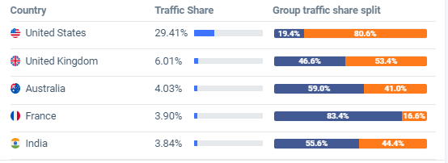
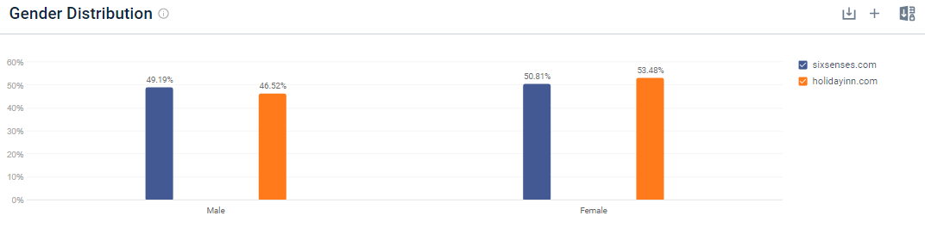

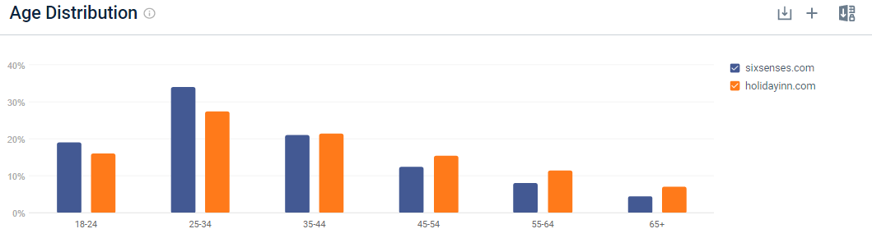
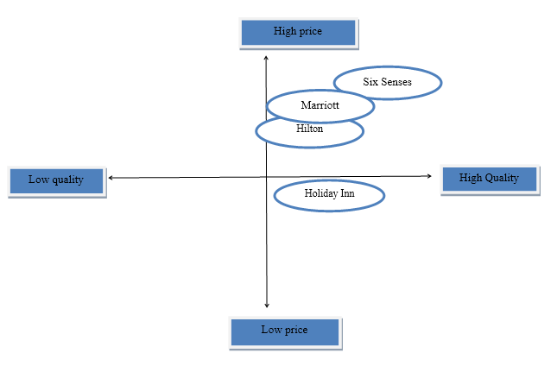
Appendix B: Marketing Communications channels
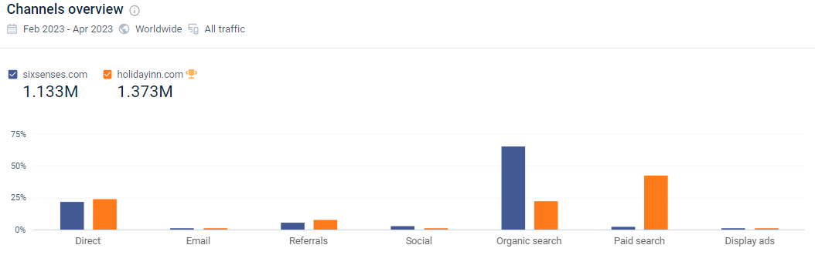
Appendix C: Social Media
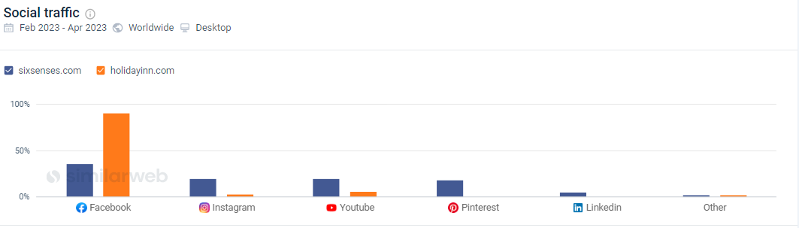
Appendix C: Website


