An Early Years Practitioners Handbook:
A guide to Transitions



Source: clipground.com

Contents

Introduction P. 3
Transitions P.4
The needs of the child P.5
Role of the adults P.7
Interventions P.9
Reference list P.11

Introduction

This handbook has been produced to aid transition of children starting a nursery school setting, these children will be 3 or 4 years of age. The guide is intended for childcare professionals to guide them on providing effective transition and the best possible outcomes through connection and communication. This handbook will deliver what are transitions and how effective communication is important when supporting children and their families during transitions. What the role of the adult is? Children and their needs, how outcomes are affected by transitions and the theories that support why positive transitions are important and the practical interventions that take place to ensure smooth transitions for children in the early years setting.
Following the guidance in this handbook will allow the practitioner to ensure there is effective and successful communication during the transition process. Assisting in guiding practitioners to understand the reasoning for the guidance and ensure practice and intervention are adequate to aid a positive transition process resulting in the best outcomes for all involved.

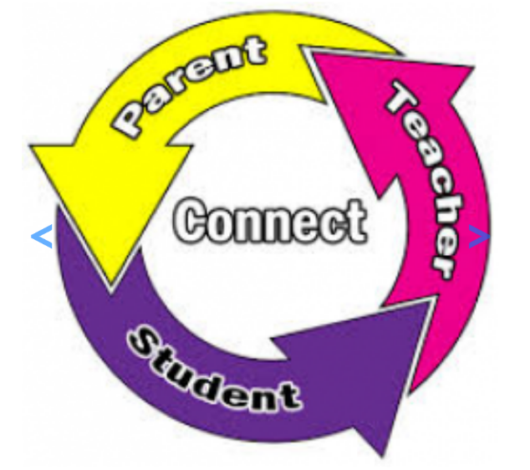

Transitions

Transition is “a change from one state to another.” Collins’s dictionary and thesaurus 2016.

According to Dunlop, A. and Fabian H. (2007) educational transitions have become an important topic when considering success within the education system. How successful transition is when starting a setting or moving through the education system can be a critical in how a child develops and progresses.
Early years matters (2021) state that transition within the early years is the process of starting a setting for the first time, relocating settings, starting school, or moving to a new class. This process of transition is a normal part of the lives of children, however how these transitions occur can impact the development of the child. These times can be exciting, but also a time of uncertainty and the role of the keyworker within this process will impact on how successful the transition will be. Hayes, N. O'Toole, L. and Halpenny A. (2017) discuss that within the education sector positive transitions are crucial to the development of children socially, educationally, and emotionally. Transitions and how they are delivered and received may have long term effects on children and their future education. It is the role of the keyworker to ensure positive experiences early in the transition period allowing the child to see school as a place of positive influence and impacting the child’s perception of school and helping them be ready to learn and succeed.
Taking into consideration the ‘unique child’ where no two children are the same even when being brought up in the same environment Gopnik, A (2016) suggests that children grow and develop in their own way where some are resilient and others sensitive. This difference influences how the child experiences transitions and differences in their surroundings. Understanding that every child is unique it is essential that practitioners communicate with the child and their family to provide a smooth transition for both child and carer.

The needs of the child
When working within any setting that cares for children it is important to understand and implement the rights of the child. Considering these rights set out by the United Nations Convention on the rights of the child (UNCRC) will enable transitions to be more effective. According to UNICEF (no date) children have the right to an opinion and to be listened to. It is important to ensure all early year’s staff listen to children and their wants and needs during transitions this is a priority. Pichère and Cadiat, (2015) discuss that children have needs that need meeting and that the theory known as Maslow’s theory identifies these needs. There are five levels of needs:
- Physiological needs- the basic first needs vital to survival, eating, drinking, clothing, shelter, sleeping and breathing. Whilst not limited to these needs, they are the primal needs to ensure survival and are the most important needs that need to be met.
(source simply psychology 2018)
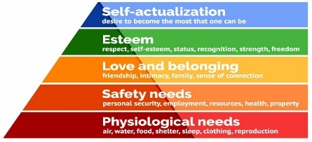
- Security needs- physical integrity and protection from theft and damage, security instils the preference of familiarity. This can be in the form of job security, family, and health security.
- Recognition needs- with the above two needs comes the sense of belonging, for this to develop a person needs their basic needs met and to feel secure. A person also needs to be able to feel love, affection, and friendship.
- Esteem needs- two types of needs are seen, internal where self-respect confidence and freedom are needs and external esteem needs and a sense of recognition, status, admiration, and attention.
- Accomplishment needs- this need a personal need that isn’t dependent on the perception of others it is individual process based on the wishes of the person. This allows a person to think about what they would like to achieve with a need relating to achieving this goal naturally appearing.
Considering these needs, it is important to consider how these needs are being met and whether a child has had positive attachment experiences. Attachment according to Lindon (2012) is a bond between two people where security and commitment build the relationship. Holmes, (2006) discusses Bowlby’s theory of attachment, a bond formed with another person. A baby forms a bond with their primary caregiver because that caregiver has met the child’s physiological needs in line with Maslow’s theory. This first bond has an impact on the child throughout its life. Attachment is considered by Bowlby’s theory as an evolutional process considering attachment to be a process that is learnt; however, children are born with the instinct to form attachments that result in their basic needs being met to improve their chance of survival. The theory of attachment researched by Bowlby and Ainsworth is considered where Aubrey and Riley (2019) state that if a child’s attachment isn’t secure it can impact on the child’s ability to bond and maintain relationships, a secure attachment leads to healthy development.
As early years caregiver’s careful consideration needs to be given to attachments and how a child transitions into the setting. Looking at Bronfenbrenner’s theory of child development according to Jumpfoundation (no date) the environment impacts development in conjunction with biology. There are many influences on child development starting with:
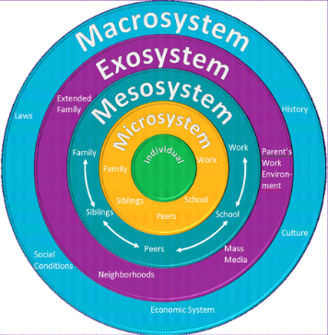
- The child
- Microsystem: the closest influences such as family, school, and friends.
- Mesosystem: wider friends, family and school staff like the microsystem influences however in a wider context.
- Exosystem: those seen in this system don’t have direct effect on the child, but do influence those who are in direct contact, such as financial influences, neighbourhood environment and extended family.
- Macrosystem: the outer layer of the model which consist of culture, history, laws, and social condition influences.
Source: Blogspot.com
Looking at this structure the child is constantly influenced either directly or indirectly by their surroundings. Taking this into consideration children who have a positive transition into the nursery school environment are more likely to transition successfully again as considered by Bronfenbrenner (1981). Bronfenbrenner (1981) considered positive transition should lead to children developing a successful learning experience. As early years practitioners creating an environment that is nurturing with time taken to build relationships with each child as an individual will enhance the growth, learning and development of the child. Lindon, (2012) talks about Bowlby’s conclusions that the mother is heavily involved with their young child forming a secure attachment and disrupting that crucial attachment could put the child at emotional risk, in current times this attachment can be formed with any primary care giver. To transition positively early years practitioners will welcome children to visit the nursery with their caregivers to slowly introduce them to the new environment. Whilst this is taking place the child’s individual needs are to be considered and discussed to enable effective planning to complete the transition smoothly. As an early year’s worker building that secure attachment with the child whilst using the setting will reinforce their stability and allow them to settle to be able to develop and grow. This may be a difficult process for some children and as a setting it is key to gather information about each child, their needs, their culture their likes and dislikes to enhance the transition making it a positive experience. The above theories can support transitions and allow practitioners to understand what needs are needed to be met to enable a child to progress and what may influence these needs being met.
The role of the adult

Working within the early years sectors children need to be fully supported throughout the transition process with appropriate planning made for this. Children according to UNICEF (no date) children have rights which aren’t discriminated against regardless of their ethnicity, race, gender, language, ability, or family background. Keeping this in mind practitioners must assist the transitions of the child with the differences of each child in mind. There may be a language barrier which could hinder a positive transition, it is important to make sure families and children understand the process of entering Nursery school and are able to communicate their needs and wishes without discrimination. The needs of each child once met will enable them to gain independence within the setting and grow confidence in their learning. Transition into nursery is not the only process the children will encounter whilst at the nursery setting, towards the end of the academic year staff will need to prepare the children for moving to their next year group. This will involve children meeting their new teacher, visiting their new setting and staff working with carers and other members of staff to communicate the individual child’s needs.
A skill required when working with children is communication, good communication with children and their families according to the children’s workforce development council, (2010) otherwise referred to as the CWDC helps build trust. This process of establishing and maintaining a relationship with involve skills such as:
- Listening- to the child and their families, a person who feels they are listened to will result in them trusting the setting.
- Questioning- understanding that question may need to be asked to clarify something, to understand someone’s needs and cultures deeper to enable the practitioner to respect and adhere to these differences.
- Understanding- why children are displaying behaviours.
- Responding- to the needs and behaviours of a child to ensure their transition process is positive.
Using these skills will allow for effective communication between child, family, and the setting, communication not only in the verbal form but also using body language to allow others to see that you are sincere, have empathy and are listening to them. using effective communication will involve listening to the children and their careers with regards to how their child will transition into Nursery and allowing them to be a part of the decision-making process ensuring they feel listened to and valued.
According to Gasper (2009) there will be times when working as a practitioner where multi-agency communication will take place to address needs of individual children and their families. Partnership working will involve children, their families, and relevant services such as speech and language teams, social services, families first, health, housing amongst many others to allow a range of support for children. This support will help all involved identify:
- What the child’s needs are
- Enable access to appropriate help from relevant agencies
- Assist skills to develop and extend education
- Enable the child to live a more fulfilled life and access society fully.
Partnerships aim to encourage effective communication of the care and needs of those involved and will allow for plans to be made ensuring equality care and education being delivered.

Being a role model
When working with children once the children have had time to meet staff and become familiar with their new surroundings, the early years nursery staff establish family groups. Children are assigned to an adult (family leader) with other children and that grouping is referred to as their class family. The purpose of the family group within the setting is like that of a key worker, where children have a familiar adult who will deliver tasks, observe, and assess them. The transition into a new setting can potentially be a difficult one for some children and having that key adult will allow the child to settle better and for the adults to form an attachment to help them feel secure.
It is important as the family leader and other members of staff within the setting to be good role models. Bandura’s theory (2003) that children learn through observation is important to consider as key role models children will shape their thoughts and feelings on what they have seen displayed by others around them. Issacs (2021) agrees with Bandura’s theory and explains that as practitioners setting a good example through the use of:
- Positive language- communicating clearly and positively what is expected and why. Praising and positive reinforcement helps children feel accepted and like encouraging them to try their best.
- Routines
- Consistency
- Positive notions- behaving the way we expect children to behave, if the adult is shouting the child will be led to think that this is acceptable behaviour.
These actions will contribute to a positive atmosphere modelling to the children how to behaviour. Consistency and routines will help children establish good behaviour and this will enable a positive learning experience.
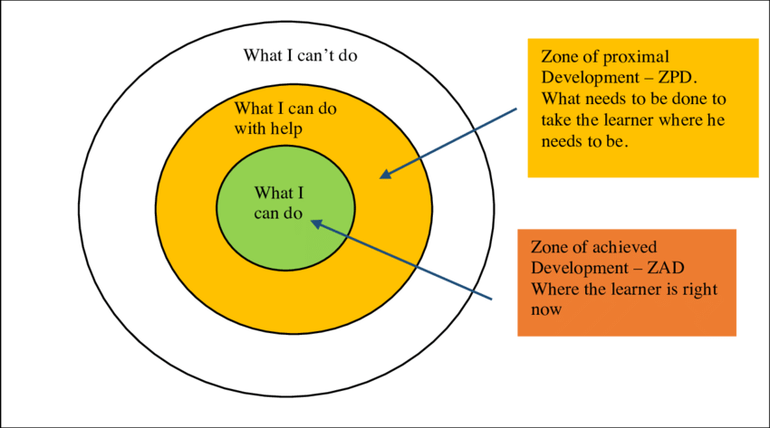
(source: researchgate.net)
To enhance the learning experience Vygotsky’s theory of working within the zone of proximal development (ZPD) Lindon (2012) explains how Vygotsky was interested in how adults could help children to learn. He saw play as crucial for children in aiding them to learn, and the adult as a resource to guide children sharing ideas and approaches to learning. As early years practitioners the ZPD should be considered when guiding children’s learning. The child will have an area of ZPD that is what they can do, it is then the responsibility of staff to guide and assist to allow the child to widen their knowledge in a supportive gradual movement, building on the child’s existing capabilities, and skills. In practise we can do this by observing a child and the skills they possess and then planning activities to broaden those skills and increase their level of understanding.
This should be done by supporting to enhance the learning, then gradually retreat from supporting and allowing the child to achieve independently. Adults are the scaffold to the child’s learning and development.
Interventions
(Source: dreamstime.com)
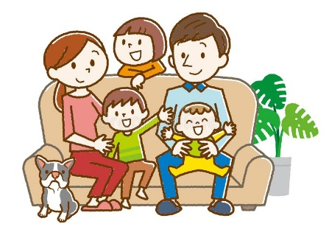
Interventions are steps taken to enable a smooth positive transition to Nursery. The first step taken within the setting is first point of contact with the family and the child. An appointment is made for the nursery teacher and teaching assistant to visit the child and their family in their family home. The nursery teacher will speak to the caregivers whilst the teaching assistant will have brought a bag of interesting things to help engage with the child. This home visit introduces the school staff to the child in their comfort zone, showing that they are trusted adults who have been invited into the family home. This will allow the child to be most comfortable and will usually behave in a more natural way, where they can discuss and show their likes and dislikes with ease. Following this meeting the family will be invited into the Nursery classroom to visit the setting and to explore the new environment. They will receive a welcome pack with all the necessary paperwork in readiness for starting nursery. For the first week of term Nursery children will attend the setting for one hour a day to gradually introduce them to their new surroundings with their peers.
Transitions can create many challenges for children, to achieve successful transitions the child’s well-being is crucial as Simmonds (2015) discusses allowing young children to feel connected when transitioning will make the process easier. Children are encouraged to bring a photo of their family which is displayed on the home corner wall in a frame, this wall is the family wall where staff and children place pictures of their families then once the school year progresses and nice photos taken when working in family groups are also displayed. Throughout the year family workshops are run inviting carers into nursery to share a learning activity with their child. Family members are also encouraged to come into nursery and share any talents they have or cultural experiences.
Outcomes
In line with the new Curriculum for Wales Welsh Government (2021) state that schools should aim for their curriculum to support learners in becoming:
(Source: own picture)
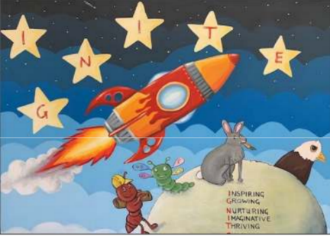
- Ambitious and capable learners
- Health and Confident Individuals
- Create and Enterprising
- Ethically informed citizens
To enable this new approach the school has created its own curriculum IGNITE where it aims to be an inspiring, growing, nurturing, thriving and enjoyable environment for children to learn. As practitioners according to the Welsh Government (2021) supporting this should consist of:
- Forming positive and respectful with children and their families
- Respond to all learners and their needs
- Plan engaging and appropriate learning
- Actively engage with families and the wider community as partners in learning
Observing and assessing children will be done in the form of progression steps set out by Welsh Government (2021) who state progression through learning is developing and improving skills and knowledge. Making progression in all areas will be individual to the learner and as a setting to be mindful that learners progress at different points in their learning journey. As an early year’s practitioner observing children throughout the transitions to ensure they are experiencing successful positive transitions and be mindful that transition can be difficult for some and respond to the difficulties with nurture and intervention. If a child is observed to not be transitioning will discussion with family and the Nursery teacher will take place to assess any causes for this and the best way forward to help that child. It could result in a referral for additional support for example if a child has speech delay, they may struggle transitioning to a new setting where they cannot convey their needs and wants verbally. As an early year’s worker whilst waiting for support strategies such as picture cards may prove beneficial in helping the child communicate. Using this guide will assist in providing positive transitions for all involved and enable a wider understanding into why positive transitions are important.

Early years matters (2021) Transitions. Available at: https://www.earlyyearsmatters.co.uk/eyfs/positive-relationships/transitions/ (Accessed: 15 November 2021).
Gilmour, L. McKeown, C. and Summers, E. (2016) Collins English Dictionary and Thesaurus. Glasgow: HarperCollins Publishers.
Pichère, P and Cadiat, A-C. (2015) Maslow’s Hierarchy of Needs. Lamur: Lemaitre Publishing.
Hayes, N. O'Toole, L. and Halpenny A. (2017) Introducing Bronfenbrenner : A Guide for Practitioners and Students in Early Years Education. Oxton: Taylor & FrancisGroup.
Gopnik, A. (2016) The gardener and the carpenter. New York: Farrar, Straus and Giroux.
Dunlop, A. and Fabian, H. (2007) Informing transitions in the early years research, policy and practice. London: Open University Press.
Brooker, L. (2008) Supporting Transitions in the Early Years. London: McGraw-Hill Education.

Simply Psychology (2018) Maslow’s Hierarchy of Needs. Available at: https://www.simplypsychology.org/maslow.html (Accessed: 1st December 2021).
Holmes, J. (2006) John Bowlby and Attachment Theory. London: Routledge.
Aubrey, K and Riley, A (2019) Understanding and Using Educational Theories. London: Sage publishing.
PetoneKindergarden. (2013) Special Friends Day. [Image] Available at: http://petonekindergarten.blogspot.com/2013/03/special-friends-day.html. (Accessed: 27 November 2021).
Jumpfoundation. (no date) Bronfenbrenner’s biological model of human development. Available at: http://experience.jumpfoundation.org/brofenbrenners-biological-model-of-human-development/ (Accessed: 02 December 2021).
Bronfenbrenner, U. (1981) The Ecology of Human Development: Experiments by Nature and Design. United States of America: Harvard University Press.
Lindon, J. (2012) Understanding Child Development: 0-8 years. London: Hodder.
UNICEF (no date) United Nations Conventions Rights of the Child. Available at https:// downloads.unicef.org.uk/wp-content/uploads/2016/08/unicef-convention-rights-child-uncrc.pdf (Accessed: 29th November 2021).
The children’s workforce development council. (2010) The common core of skills and knowledge. Leeds: The children’s workforce development council.
Gasper, M. (2010) Multi-agency Working in the Early Years: Challenges and Opportunities. London: SAGE publications, Ltd.
Isaacs, B. (2021) Being a positive role model. London: Teach Early Years. https://www.teachearlyyears.com/positive-relationships/view/being-a-positive-role-model accessed on (27 November 2021).
PetoneKindergarden. (2013) Special Friends Day. [Image] Available at: http://petonekindergarten.blogspot.com/2013/03/special-friends-day.html. (Accessed: 27 November 2021).
Khan, S. (2018) Vygotsky’s Model of the Zone of Proximal Development. [Image] Available at: https://www.researchgate.net/figure/Vygotskys-Model-of-the-Zone-of-Proximal-Development_fig1_328433370. (Accessed: 27th November 2021)
Dreamstime. (2021) Cheerful family at home sitting on sofa. [Image] Available at: https://www.dreamstime.com/vector-illustration-original-paintings-drawing-cheerful-family-home-sitting-sofa-image134450380 (Accessed on: 04 December 2021)
Simmonds, J. (2015) Understanding School Transition : What Happens to Children and How to Help Them. Abingdon: Taylor & Francis Group.
Welsh Government. (2021) Developing a vision for curriculum design. Available at: https://hwb.gov.wales/curriculum-for-wales/designing-your-curriculum/developing-a-vision-for-curriculum-design/#curriculum-design-and-the-four-purposes. (Accessed on: 01 December 2021)
Clipground. (2019) Multicultural Clipart. [Image] Available at: https://clipground.com/multicultural-children-clipart.html. (Accessed on: 05 December 2021)
Phillips, T. (2021) Ignite curriculum.[Image]. Available at: own image.

