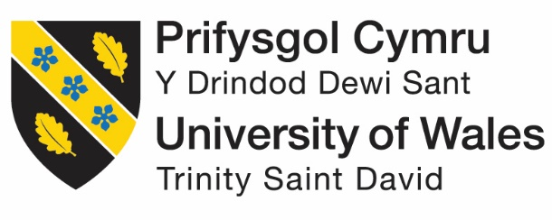

MODULE: MARKETING MANAGEMENT
MODULE CODE: LCMB7001
ASSESSMENT 2

Assignment Title: Marketing Management - Assignment 2
Student Name: Drashti Sorathiya
Student ID: 2240378
Lecturer Name: Tushara Balendran
Submission Date: 01/09/2023

TABLE OF CONTENTS
Table of Contents 1
1. Introduction: 3
2. PESTLE Factors: 4
2.1 Political Factors: 4
2.2 Economic Factors: 5
2.3 Social Factors: 5
2.4 Technological Factors: 5
2.5 Legal Factors: 5
2.6 Environmental Factors: 5
3. Porter 5 Forces Model: 6
3.1 Threat of New Entrants: 6
3.2 Bargaining Power of Suppliers: 6
3.3 Bargaining Power of Buyers: 7
3.4 Threat of Substitutes: 7
3.5 Competitive Rivalry within the Industry: 7
4. SWOT analysis & its limitation 8
4.1 Unilever’s Strengths (Internal Strategic Factors) 8
4.2 Weaknesses 9
4.3 Opportunities for Unilever 9
4.4 Threats Facing Unilever 10
4.5 Facts and Figures: 11
5. Segmentation, Targeting and Positioning: 12
5.1 Segmentation: 12
5.2 Targeting: 13
5.3 Positioning: 13
6. Marketing Mix Strategy 4p's of Unilever: 14
6.1 Product: 15
6.2 Price: 15
6.3 Promotion: 15
6.4 Place: 16
7. Recommendations for the Future of Unilever: 17
8. Conclusion: 18
9. References 19

“List of figures”

Figure 1 The Unilever 3
Figure 2 PESTEL Analysis 4
Figure 3 Porter 5 Forces Model of Unilever 5
Figure 4 SWOT analysis of Unilever 7
Figure 5 Segmentation, Targeting and Positioning 10
Figure 6 Marketing Mix Strategy 4p's of Unilever...……………………………………………..11

Introduction:
When it comes to FMCGs, the fast-moving consumer goods industry, Unilever is unrivalled on a worldwide scale. Unilever was established in 1930 when the British soap manufacturer Lever Brothers and the Dutch margarine business Margarine Unite merged to form what is now a global behemoth. Unilever is an international conglomerate with headquarters in London, United Kingdom, and Rotterdam, Netherlands. Its goods may be found in more than 190 countries, and the company serves a wide variety of markets. The commitment to improving people's lives all around the world while simultaneously reducing Unilever's environmental impact is at the heart of the company's purpose. Dove, Lipton tea, Knorr mayonnaise, and Hellmann's mayonnaise are just a few of the household names that can be found in Unilever's product line-up. The continuous commitment of Unilever to promoting positive social and environmental change is reflected in these products. (Clarke, 2017)
The Sustainable Living Plan is a prime example of Unilever's commitment to ethical business practises. In order to simultaneously increase the company's good social impact and divorce its growth from its environmental impact, this ambitious programme was launched. Improving health and wellbeing, reducing environmental impact, and strengthening livelihoods are the three key pillars of the strategy. Unilever plans to drastically cut its carbon footprint, reduce its waste output, and promote sustainable sourcing by setting specific, quantifiable goals.
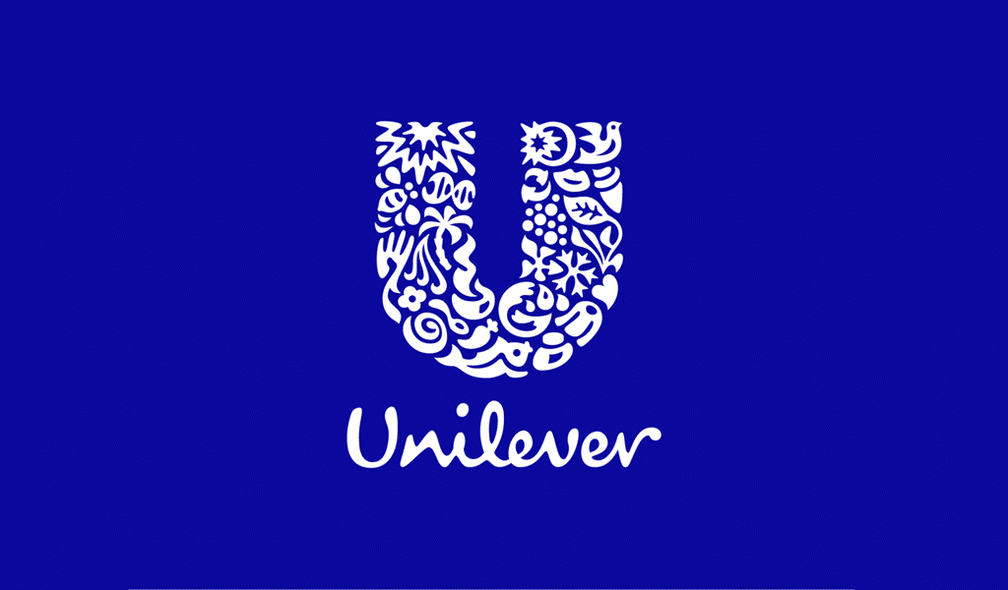
Figure 1 The Unilever
https://turbologo.com/articles/unilever-logo/

PESTLE Factors:

Without a doubt, PESTLE analysis is a tool for investigating the many macro environmental elements that may have an impact on a company or other entity. PESTLE refers to the interplay of political, economic, social, technological, legal, and ecological elements. The potential impact of these variables on Unilever is discussed below.

Figure 2 PESTEL Analysis
https://www.business-to-you.com/scanning-the-environment-pestel-analysis/

Political Factors:
The political climate in each country where Unilever operates varies. The company's operations, supply chains, and distribution networks might be impacted by political stability, government regulations, trade policies, and taxes. Unilever's business strategies and profits may be impacted by a change in political leadership or a movement in government goals.

Economic Factors:
Unilever's success is significantly influenced by macroeconomic conditions such as inflation, currency exchange rates, economic growth, and consumer purchasing habits. The demand for Unilever's products is sensitive to shifts in consumers' discretionary income because of the impact on consumers' tastes and spending habits.

Social Factors:
The product development, branding, and marketing strategies of Unilever are significantly impacted by societal trends, cultural shifts, demography, and consumer preferences. Unilever's dedication to health, sustainability, and ethical sourcing is becoming increasingly important as consumers become more aware of these issues.

Technological Factors:
Unilever may face both possibilities and problems as a result of rapid technological progress. Improvements in production efficiency, expansion of distribution channels, and establishment of digital channels for consumer interaction are all possible thanks to technological advancements. New technological developments and cyber security issues must be taken into account, though.

Legal Factors:
Legal regulations, such as those governing product quality, labelling, intellectual property, and advertising, may have an impact on Unilever's business. To prevent legal issues and protect the company's reputation, it is essential for the business to comply with the numerous rules and regulations in different markets.

Environmental Factors:
Environmental considerations such as climate change, resource scarcity, waste reduction, and sustainable sourcing practises are becoming more and more crucial to Unilever as sustainability becomes more and more significant. The company has made a commitment to reducing its environmental impact, which is in line with both consumer expectations and worldwide measures to address environmental concerns. (Lieu, n.d.)

Porter 5 Forces Model:

The Porter's Five factors model is a tool for assessing the competitive factors that influence an industry and its members. Applying this framework to Unilever, we find:
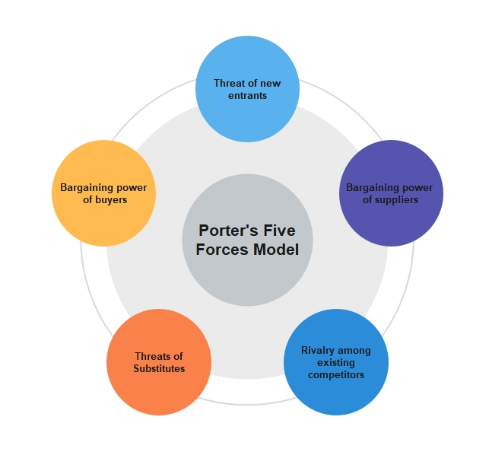
Figure 3 Porter 5 Forces Model of Unilever
https://www.edrawmind.com/article/porters-five-forces-analysis-definition-and-examples.html

Threat of New Entrants:
Because of Unilever's size, famed brands, and global reach, it is difficult for new companies to enter the market and compete with the giant. A competitive edge is provided by the company's large distribution networks, long-standing partnerships with suppliers, and economies of scale. Yet, smaller specialised firms concentrating on certain market segments—especially those highlighting sustainability and unique value propositions—could pose a threat.

Bargaining Power of Suppliers:
Unilever has some bargaining power over its suppliers due to its size and variety of products. Suppliers may have more influence in sectors with unique or scarce resources. As the company works to secure responsible supply chains, Unilever's dedication to sustainable sourcing and ethical practises may have an impact on supplier relationships. (LIWANG, 2020)

Bargaining Power of Buyers:
Due to the availability of alternative products and brands, consumers in the consumer goods industry, including retailers and distributors, have some bargaining power. Customers' decisions might be influenced by factors such as price and brand loyalty. The company must continue to adapt to shifting consumer tastes and expectations despite its strong brand portfolio and reputation helping to offset this power to some extent.

Threat of Substitutes:
Particularly in the food and personal care sectors, the fast-moving consumer goods industry is marked by a proliferation of similar products. On the basis of price, quality, or perceived value, consumers can readily move to alternative brands or products. Unilever is able to stave off this threat thanks to its emphasis on innovation, product diversification, and brand loyalty. (Nahar, 2019)

Competitive Rivalry within the Industry:
With multiple international and domestic firms striving for market share, the FMCG industry is extremely competitive. Both larger, more established companies like P&G and Nestlé and more nimble start-ups pose threats to Unilever's bottom line. Intense competition frequently results in price wars, new product development, and marketing campaigns to distinguish products and draw in consumers.

SWOT analysis & its limitation

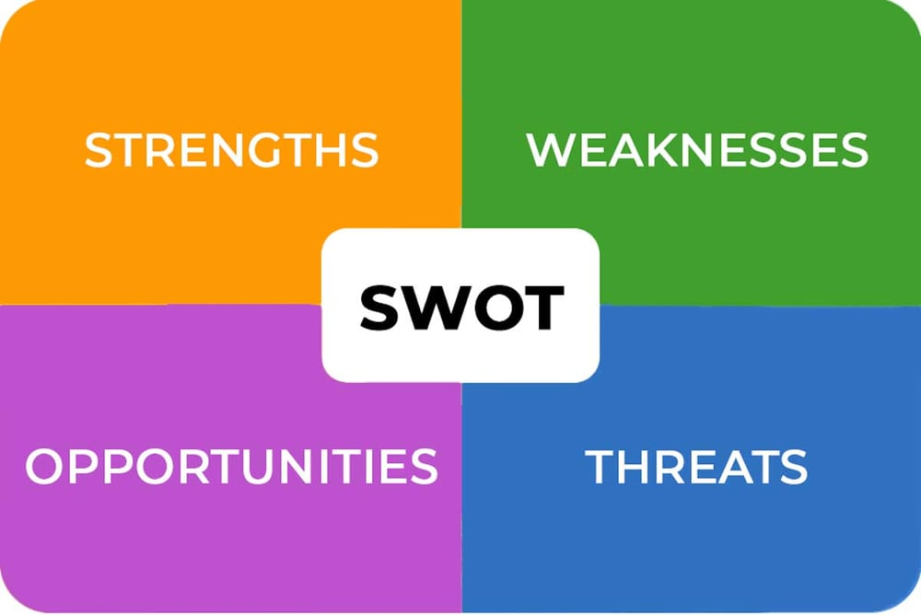
Figure 4 SWOT analysis of Unilever
https://blog.reputationx.com/brand-swot-analysis

Unilever’s Strengths (Internal Strategic Factors)
As a result of the SWOT analysis, Unilever's hierarchy and business characteristics are highlighted. In the organisation, qualities include HR, creation forms, hierarchy, and speculations. When it comes to Unilever's consumer goods division, the associated attributes:
- Brands that are
- A wide range of products
- Cost-cutting measures
- Presence on the worldwide market
Brands owned by Unilever are among the strongest in the consumer goods sector. When a company has this characteristic it can penetrate the market and compete effectively with other companies. It's easy to see how Unilever's business has grown as a result It's a good example of a company that has extended its product line through a series of mergers and acquisitions, resulting in authoritative growth and a Unilever's ad campaign illustrates how economies of scale may boost production productivity, which is crucial for aggressive pricing tactics. The organization's market reach has also increased as a result of its global expansion, which is a characteristic that enhances the brand's reputation. When Unilever looks at the internal important elements in this section of its SWOT analysis, it sees traits that it can employ to drive international growth and success in the consumer products (Browne, 2013)

Weaknesses
However, despite its strong market position, Unilever suffers from a number of weaknesses that When it comes to hierarchy and corporate development, this part of the SWOT analysis focuses on the internal factors that A number of issues must be addressed by Unilever i.e. :
- Products that are
- Business diversification is limited.
- Duties of retailers

For example, Unilever's products have an unoriginal concept. For example, despite the fact that Dove and Rexona devote a lot of resources to product development, other companies can copy their products. The fact that Unilever's product mix is so diverse, however, does not compensate for the lack of innovation in companies outside of the consumer Apart from that, the business needs to have a direct, positive impact on its consumers, since retailers are the ones that directly affect customers. As a result, Unilever's weaknesses in this area of the SWOT analysis highlight the need of expanding, advancing, and improving advertising efforts. (Dirisu, 2013)

Opportunities for Unilever
In order to grow, Unilever must take advantage of development opportunities in customer merchandise displays when it comes to the SWOT analysis, this section focuses on opportunities or external variables that might stimulate corporate growth when looking at Unilever's exterior state, it's worth noting:
- It's time to
- Innovating products in the
- Sustainable business practises to protect the environment
- Market expansion

It is possible for Unilever to grow by entering organisations outside of the consumer products sector Broadening reduces the risks associated with a narrow focus and increases company agility. Unilever's item advancement, on the other hand, can enhance its item engaging quality by meeting the needs of more health-conscious clients. For the company to attract and retain environmentally conscious clients, it must make its operations more controllable and earth friendly. Moreover, Unilever's firm may benefit from advertising enhancement by increasing sales of its current products in new market segments. When it comes to Lipton products, for example, the company may market them as health beverages for those who are trying are actual opportunities to grow Unilever's business despite its flaws based on the external essential variables in this area of the SWOT (performance, 2010)

Threats Facing Unilever
Variables outside of Unilever's control can affect the company's business performance However, these external elements are viewed by the SWOT Analysis as potential risks that the business has to As a result of Unilever's consumer goods sector, Unilever faces a number of threats which are as follow:
- There is a bitter rivalry
- This is a
- Retailers' house brands are becoming increasingly popular.

In order for Unilever to be successful, it must be able to deal with a variety of risks, such Competitors reduce the organization's share of the pie by comparing financial performance. Item impersonation is also a significant threat to Unilever's business Unilever's products, for example, can be made by local companies. A retailer's own brand also forces them to take a risk. As a result, they are referred to as 'house brands' The Kirkland Signature house brand is used by Costco, while Walmart has its own house brands that directly compete with Unilever's products. In this section of the SWOT analysis of Unilever, approaches must focus on increasing the organization's upper hand because of the external important variables. (Thompson, 2015)

Facts and Figures:
- Revenue and Profits:

- Unilever is one of the biggest consumer products firms in the world, both in terms of revenue and profits.
- Unilever estimated total 2020 revenue to be at €50.7 billion.

- Global Presence:

- Global Presence: Unilever currently operates in more than 190 different nations.
- The company is very visible in both established and developing economies.

- Brand Portfolio:

- Brand Portfolio: Unilever has a wide range of well-known brands in the personal care, food and beverage, and home care industries.
- Dove, Lipton, Knorr, Hellmann's, Axe, and Lux are just a handful of its well-known trademarks.

- Sustainability Initiatives:

- Corporate Sustainability Initiatives: Unilever is a pioneer in responsible business practises and corporate sustainability.
- In order to lessen its environmental impact and increase societal well-being, the company developed the Sustainable Living Plan. One of the goals is to have all plastic packaging that can be recycled, reused, or composted by 2025.

Segmentation, Targeting and Positioning:

Segmentation:

To efficiently respond to the varied demands and interests of its worldwide client base, Unilever uses a wide range of segmentation strategies. Its segments are typically defined by demographic, geographical, psychographic, and behavioural criteria. For instance, Unilever divides its clientele into distinct segments based on demographic characteristics such as age, income, lifestyle, and purchasing patterns. The company may tailor its products and marketing efforts to specific consumer groups thanks to this strategy.
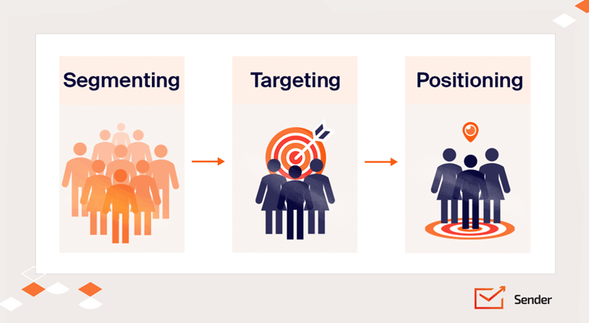
Figure 5 Segmentation, Targeting and Positioning
https://www.sender.net/blog/stp-marketing/

Targeting:
Unilever is able to target a wide range of consumer segments thanks to the breadth of its product line. For instance:
- Unilever's personal care and hygiene products are marketed to consumers of all ages, genders, and socioeconomic backgrounds.
- Food and Drink: The Company’s target market consists of consumers who are interested in a wide range of food and drink alternatives, from high-end to more affordable ones.
- Home Care: Unilever targets people and families who are seeking cleaning supplies and hygiene products.
Targets who are environmentally sensitive have grown to be a sizable consumer market in recent years, and Unilever's emphasis on sustainability and responsible business practises appeals to them as well.

Positioning:
To differentiate its brands in the minds of consumers, Unilever uses a number of characteristics and advantages. Some important positioning strategies are:
- Unilever's personal care and hygiene products are marketed to consumers of all ages, genders, and socioeconomic backgrounds.
- Food and Drink: The Company’s target market consists of consumers who are interested in a wide range of food and drink alternatives, from high-end to more affordable ones.
- Home Care: Unilever targets people and families who are seeking cleaning supplies and hygiene products.
- Targets who are environmentally sensitive have grown to be a sizable consumer market in recent years, and Unilever's emphasis on sustainability and responsible business practises appeals to them as well.
- Attributes and advantages are used in tandem by Unilever to place its products in the eyes of consumers. Some important positioning strategies are:
- Many Unilever Brands Market Their Products as Trustworthy and High-Quality Options. Luxury personal care is a key emphasis for companies like Dove and Lux.
- Value: Some Unilever brands, like Knorr and Lifebuoy, market themselves as providing affordable, high-quality products.
- Sustainable practises: Unilever stresses its dedication to sustainability and responsible business. Consumers who place a premium on moral and environmental factors will be drawn to this posture.
- Innovation: Consumers seeking cutting-edge personal care solutions frequently turn to brands like AXE and Vaseline that emphasise innovation. (Sharma, 2021)

Marketing Mix Strategy 4p's of Unilever:
Unilever's strategy for reaching and satisfying its target customers is based on a well-coordinated approach to the four pillars of the marketing mix (4Ps): product, price, promotion, and location. It is advised to refer to the company's official sources for the most up-to-date information because specific information may have changed after my previous update in September 2021. This is how Unilever's 4Ps strategy works in a nutshell (Reza, 2020)
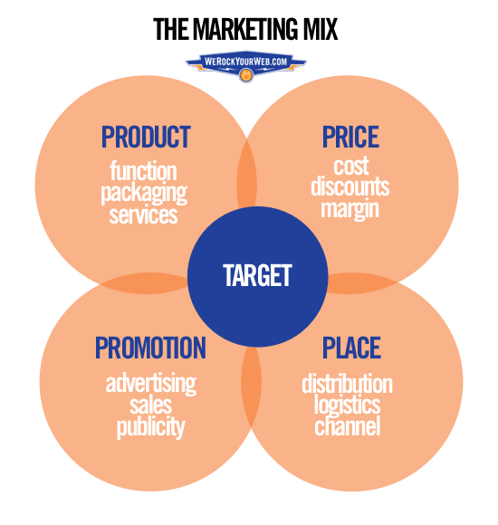
Fig 6 Marketing Mix Strategy 4p's of Unilever
https://jessewillms.com/what-are-the-4-ps-of-marketing/

Product:
Unilever provides a wide range of consumer items under the headings of food and drinks, personal care, and home care. The company's products are made to suit a wide range of consumers' wants, needs, and tastes. These are all parts of Unilever's product strategy.
- Creating cutting-edge products to meet new consumer trends and demands.
- Providing a range of brands at various price ranges and quality levels to cater to various market segments.
- Product development should have an emphasis on sustainability and responsible sourcing.

Price:
The product category, brand positioning, and target market all play a role in Unilever's pricing strategy. The company strives to balance offering value to customers with making a profit. A few examples of pricing strategies are:
- Price Points Reflecting Quality and Exclusivity Premium brands are marketed as high-end alternatives to mainstream products.
- Value Pricing: Other brands focus on competitive brand products at price sensitive consumers.
- Unilever frequently employs psychological pricing strategies, such as placing prices just below a round figure, to increase the perception of value.

Promotion:
In order to raise awareness, influence consumer attitudes, and increase sales, Unilever uses a thorough promotion strategy. Aspects of its advertising strategy that are crucial include:
- Unilever spends money on ads across several mediums, including traditional and online television, internet media, and print publications.
- Digital Marketing: The Unilever engages with consumers, shares brand stories, and develops interactive campaigns using social media and internet platforms.
- Sponsorships and partnerships: Unilever frequently works with celebrities, influencers, and organisations to increase brand awareness and reputation.
- Promotions and Discounts: To boost sales and draw customers, periodic promotions, discounts, and loyalty programmes are employed.

Place:
In order to get its products out to consumers all over the world, Unilever relies on a sophisticated distribution system that includes wholesalers, retailers, and online marketplaces. The company's location strategy concentrates on the following:
- Wide Range of Outlets: Unilever's products are sold in a variety of places, from grocery stores and drugstores to specialty shops and e-commerce websites.
- The company places a premium on penetrating new areas to capitalise on their rapidly increasing consumer bases.
- Unilever is committed to ensuring the timely delivery of its products to diverse markets across the world by working to maintain an efficient supply chain.

Recommendations for the Future of Unilever:
Some suggestions may be offered to help Unilever maintain its reign as a retailing powerhouse while also catering to consumers' wants and requirements.
To maintain its competitive advantage and ensure the longevity of its growth, Unilever should consider the following future directions.
- Continued Sustainability Focus: Unilever's commitment to sustainability has been a major differentiator. The company should step up its efforts to lessen its environmental impact, increase the openness of its supply chain, and investigate new methods of eco-friendly packaging as the demand for sustainable and ethical products continues to rise.
- Refer to Innovation for Changing Consumer Preferences: Unilever needs to keep up with changing consumer preferences, especially those involving health, wellness, and convenience. It may help preserve and grow its market share by constantly reinventing its product offerings to align with their preferences.
- Expanding Unilever's digital footprint may increase customer interaction, pave the way for direct-to-consumer connections, and yield useful data about shoppers' online habits. The expansion and efficiency of e-commerce may be aided by adopting and employing digital marketing strategies.
- Customer Loyalty and Engagement Can Be Increased By Customising and Personalising Products and Marketing Strategies to Specific Market Segments. Unilever can better understand consumer preferences and provide personalised experiences by utilising data analytics and artificial intelligence.
- Growth in Emerging Markets There is tremendous room for development in emerging markets, such as Asia and Africa. To effectively capture these markets, Unilever might put resources into learning about local preferences and adjusting products and marketing strategies accordingly.
- Unilever's ability to innovate and remain ahead of market trends depends on the company's continued investment in R&D. The company may gain a competitive edge by creating new products that align with trends in health, sustainability, and convenience.
- Partnerships and Collaborations: Working with new businesses, tech giants, and other industry leaders can help you gain access to innovative tools and information. With the help of partnerships, Unilever can discover untapped potential for expansion and innovation.

Conclusion:
Unilever is a prominent entity within the global consumer products sector, characterised by a notable legacy centred on innovation, ethical conduct, and a dedication to enhancing the quality of daily existence. The company has effectively established a strong consumer base worldwide with its wide range of products in many sectors such as personal care, food and drinks, and home care.
Unilever's strategic endeavours, shown by its Sustainable Living Plan, demonstrate the company's commitment to tackling urgent global issues while concurrently fostering corporate expansion. Unilever has strategically positioned itself as a prominent exemplar of corporate responsibility and constructive transformation through its emphasis on sustainability, ethical sourcing, and creative approaches.
In the face of a constantly shifting market environment, the company's capacity to adjust to developing consumer preferences, harness technological advancements, and cultivate collaborative relationships will play a crucial role. The enduring influence of Unilever's commitment to excellence, ingenuity, and active involvement in the community will persistently guide its trajectory, enabling it to sustain its prominent position as a catalyst in the fast-moving consumer goods industry.
Unilever demonstrates a steadfast dedication to sustainability, innovation, and customer-centricity, positioning itself to not only influence its own achievements but also motivate others to adopt responsible business strategies that provide advantages for both society and the environment. As we contemplate the future, the trajectory of Unilever is anticipated to encompass sustained expansion, constructive influence, and perpetual metamorphosis in its endeavour to contribute to a more improved global condition.

References
Browne, J. a. N. R., 2013. Beyond corporate social responsibility: Integrated external engagement.
Clarke, H. D. a. G. M. J. a. G. M. a. W. P., 2017. Brexit.
Dirisu, J. I. a. I. O. a. I. O., 2013. Product differentiation: A tool of competitive advantage and optimal organizational performance (A study of Unilever Nigeria PLC).
Lieu, P. T. H. a. A. N. a. B. S. a. N. D., n.d. Unilever Company Strategic Business Analysis.
LIWANG, B. A. a. S. L. P. a. T. J. J., 2020. THE INFLUENCE OF DEBT POLICY, DIVIDEND POLICY, AND PROFITABILITY TO COMPANY VALUES OF PT. UNILEVER.
Nahar, S. a. Z. N. M., 2019. An Analysis of the Impact of Remuneration on Employee Motivation: A Case Study on Unilever, Bangladesh. International Journal Fam Busi Manag.
performance, T. i. e. o. i. a. e. f. o. a. p. e. s. a. i. i. o. a. f., 2010. The interactive effect of internal and external factors on a proactive environmental strategy and its influence on a firm's performance.
Reza, M. H., 2020. Marketing Strategy and Sustainable Plan of Unilever. International Journal of Scientific Research and Engineering Development.
Sharma, R. R. a. K. T. a. S. A. S., 2021. Market Segmentation, Targeting and Positioning. In: Sustainability Marketing. s.l.:Emerald Publishing Limited, pp. 119-132.
Thompson, A. a. S. A. J. a. G. J., 2015. Crafting and executing strategy: Concepts and readings. s.l.:s.n.

Image References
https://turbologo.com/articles/unilever-logo/
https://www.business-to-you.com/scanning-the-environment-pestel-analysis/
https://www.edrawmind.com/article/porters-five-forces-analysis-definition-and-examples.html
https://blog.reputationx.com/brand-swot-analysis
https://www.sender.net/blog/stp-marketing/
https://jessewillms.com/what-are-the-4-ps-of-marketing/

