Landscape analyses

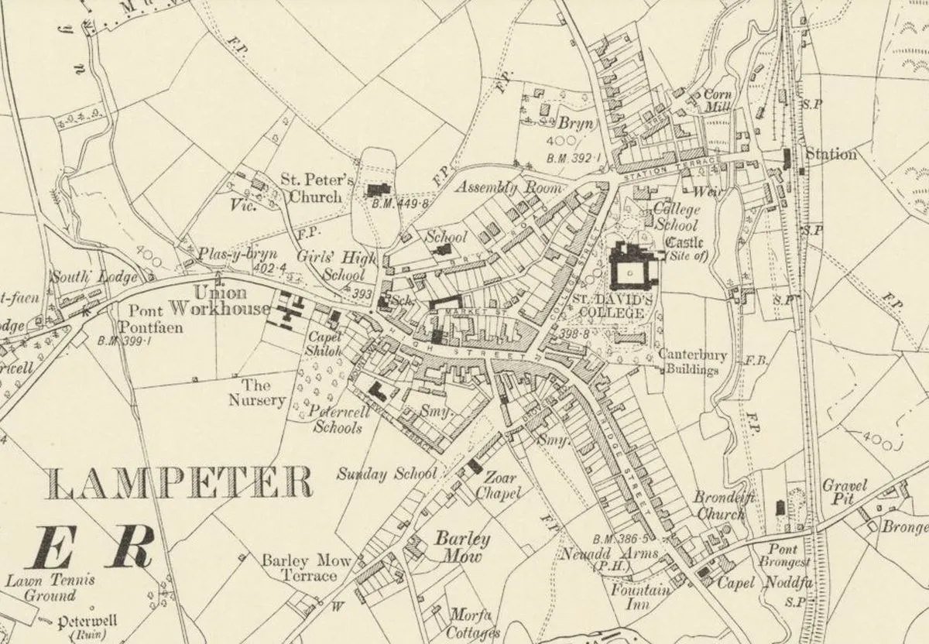
Figure 1/map of Lampeter/Ceredigion historical society

A town or any place that hopes to have any chance of staying for a long period of time would need roads to connect the town as well as a reason to go to the village in first place. Which leads to Lampeter, a small village located in west Wales in the county of Ceredigion. A village known for its over two-hundred-year-old university and (now shut down) live-stock market. This town has been around for hundreds of years and has survived many changes to not just the town but the roads that have connected the town in the and how those paths have evolved. From toll booths and unkempt roads all the way to the train station in Lampeter and its eventual decommission in this essay there will be a discussion on the paths that flow through Lampeter and Ceredigion in a Landscape analyses.

The roads that flow thorough Ceredigion have stories to their own. As these roads came to be known as turnpike and pre-turnpike roads(‘turnpikes’, 2016). Which means that the pre turn pike roads are all roads that are locally kept up by non-government bodies and unfortunately were not well maintained, which made travel by anything with wheels borderline impossible of people who needed to get to another town, greatly limiting trading and people potential for travel. The roads , after minor improvements, over 150 trusts have been established t in order for these roads to be regulated and synergised by 1750 and actually became quite useful and had potential to travel around(‘turnpikes’, 2016). Although the southwestern turn pike roads were the first to appear. The roads in Lampeter would have been erected around the time the roads in southwest Wales were erected. Evidence of this can be seen in the Lampeter check points that were left over from these pre turn pike roads as well as the rebellions that took place due to these roads and their poor conditions.
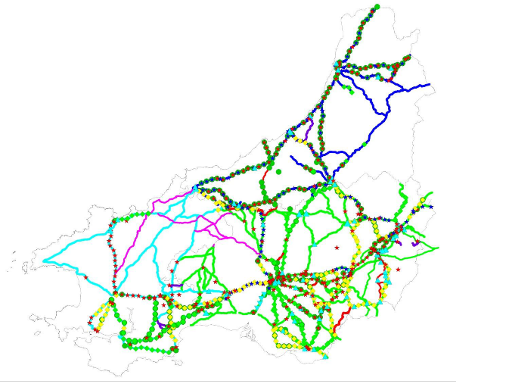
Figure 2/map showing the Dyfed region/Dyfed archaeological trust

This lead to the Rebecca riots which were the result of these poorly maintained roads in 1839-1843(Robert Crowcroft and John Cannon, 2015) actually lead to men dressing up as women and destroying the toll booths in protests which lead to the destruction the tollbooths as these systems fundamentally did not works, these riots hurt the farmers the most as many of these farmers were people who already did not earn much money, due to the low income that this class of people made. The farmers were using roads to for sell their goods and also went to purchase lime which is a type of mineral that can be used in order to fertilise crops and grow them better. This led to the roads being used a lot, which meant spending money on this toll consistently, which then lead to the farmers losing money and the toll for these roads never getting approved or repaired. This inherent unfairness in the roads in Lampeter eventually led to the destruction of these turnpikes roads and leading to the end of these taxed roads which. Interestingly Lampeter did not really see as much as these riots as other places did as it was concentrated mostly in Pembrokeshire and other rural places in west Wales, but this actually still affected the town as the toll booth was decommissioned but it is still there as a monument to the past and the history of Wales.(Robert Crowcroft and John Cannon, 2015)
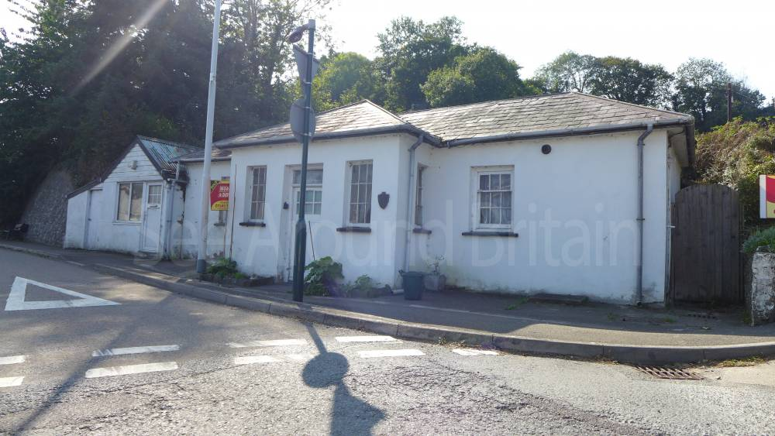
Figure 3/Lampeter toll booth/see around Britain.

Lampeter has also been defined by the other modes of transportation such as the trainline that existed in Lampeter since 1866(Lampeter Railway Station, Lampeter | Coflein, no date) which makes it only about 44 years younger than Lampeter’s university and six years after the line (Aberyswyth-Camarthen)that it was on opened. Although there were only three trains everyday this was huge for Lampeter as this meant that people could easily travel to the nearest, despite the fact that the cost of building this railway nearly bankrupt them(October 18 and Reply, 2011). Other railway lines to Lampeter were actually built in 1911 a branch line between Lampeter and Aberaeron was constructed. During world war two it was incredibly common for children to come down to small villages as evacuees which were children from areas deemed unsafe such as major cities like London or Glasgow (‘Evacuees | History of the Battle of Britain | Exhibitions & Displays | Research’, no date) Lampeter received a surplus of children that came down by train and transport these 330 children where evacuated to Lampeter where they stayed until the end of the war but they did get to enjoy the scenic views that Lampeter allows you to bask in(October 18 and Reply, 2011).due to the nationalisation of the railways in1951 passengers of the Aberaeron trainline ceased due to excessive flooding and never where it closed down and never actually resumed, effectively closing down the (Lampeter Railway Station, Lampeter | Coflein, no). This sadly eliminated a means of travel on this line for good Lampeter (October 18 and Reply, 2011) ways to be expected. Although milk traffic was still on going for this rail line all the way until 1973 where it had been change from delivery by train to delivery via car and roads. The lines were then lifted due to not needing that rail line anymore. But you can still see the effects the train station has on the land and the store house that the train station used in Lampeter to store goods for trade and other purposes. All these monuments to the roads and rail lines of Lampeter can be seen even today as and have been standing since it was first built in the 1900s, and although there are calls by the town to rebuild and reinstate the rail way the local and national governing body has not relinquished and sadly there is no hope in sight of rebuilding this potentially very useful and convenient mode of transportation for not only the students of Lampeter’s university but also the residents of Lampeter as a town to reside in.
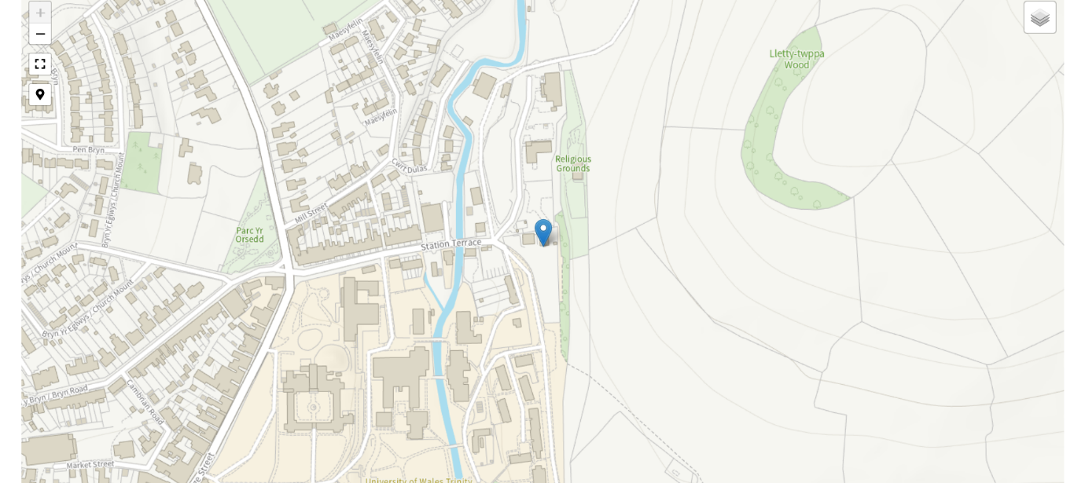
Figure 4/SN54NE/location of Lampeter train station/coflein
The Ceredigion bus network suffers from the same issues that many of the bus networks suffer from which is the lack of funding and lack of solid counter measures to extreme events. This can be seen in the Ceredigion travel network report which states that due to the affects of covid 19 the bus networks in the area have lost a significant amount of money due to the population avoiding risk of infection with covid-19. there are also a people who just are not willing to travel along the same route or be continually take the same route as for some there are no reason to at all. There is also a shortage of people who want to be a part of the bus service and take the job of driving buses over and over, this leads to less people driving an less time to train people how to properly use and drive these buses. Of course, the bus service in Lampeter runs (CEREDIGION COUNTY COUNCIL, 2023) small rural town runs, these buses run on the schedule of one every hour Monday through Saturday and on Sundays it runs every two hours due to Christian traditions and people being used to doing less hours on Sunday as most people in Britain are accustomed too. (CEREDIGION COUNTY COUNCIL, 2023)
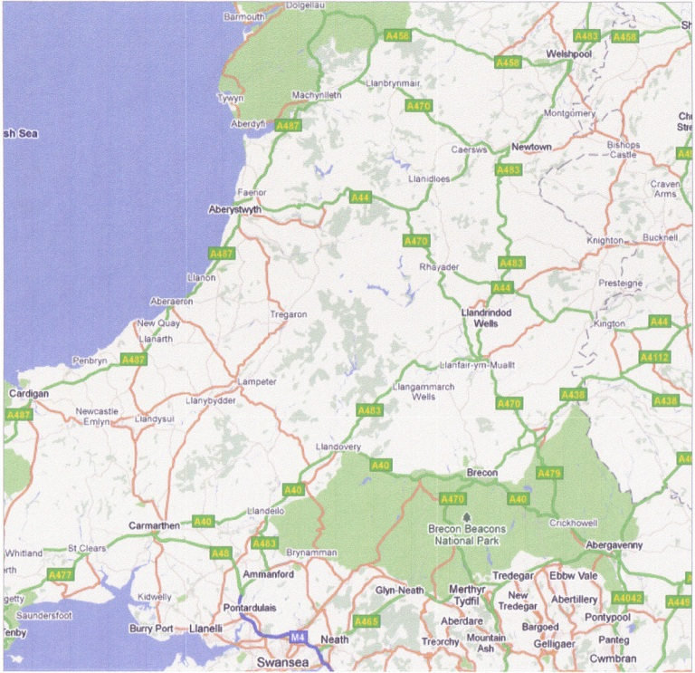
Figure 5/national railway aberysyth-camarthen line/wordpress.com
In conclusion the different modes of transportation that Lampeter has seen has been numerous and we can see how this has affected Lampeter. for example the turnpike roads that moved in Lampeter and the rest of the of Wales put a great strain on the farmers and their wallets but that thankfully did not last long as the toll booths got decommissioned sue to the Rebecca riots and then then the roads were made significantly better as a result of the common people coming together towards a common goal, granted this goal was to dress up as women in order to disguise themselves during a riot but it certainly was a goal worth fighting for. Of course, the train line that went through Lampeter and delivered evacuees and milk for so long has also had a huge impact on the people of Lampeter and had an affect onto the landscape of Lampeter Aswell. Finally the buses in Lampeter and Ceredigion in general are although running it has taken some hits from things like the lack of jobs being taken I the public transit centre as well as the ripple affects of the covid-19 pandemic that swept the world in 2020.although all of these events and types of transport all makes up Lampeter and the roads and tracks that flow into this place, creating a picture of a storied history that truly shows just how old and storied this town has become.

‘Evacuees | History of the Battle of Britain | Exhibitions & Displays | Research’ (no date) RAF Museum. Available at: https://www.rafmuseum.org.uk/research/online-exhibitions/history-of-the-battle-of-britain/evacuees/ (Accessed: 16 February 2024).
Lampeter Railway Station, Lampeter | Coflein (no date). Available at: https://coflein.gov.uk/en/site/41360/ (Accessed: 16 February 2024).
October 18, D.M.| and Reply, 2013 at 11:52 am | (2011) ‘Some Early Lines – Carmarthen, Lampeter and Aberystwyth Line’, Chasewaterstuff’s Railway & Canal Blog, 16 December. Available at: https://chasewaterstuff.wordpress.com/2011/12/16/some-early-lines-carmarthen-lampeter-and-aberystwyth-line/ (Accessed: 8 February 2024).
Robert Crowcroft and John Cannon (2015) ‘Rebecca riots’. Oxford University Press.
‘turnpikes’ (2016) Early Tourists in Wales, 14 January. Available at: https://sublimewales.wordpress.com/practicalities/travel/roads/turnpikes/ (Accessed: 1 February 2024).

CEREDIGION COUNTY COUNCIL. (2023). Ceredigion Bus Network.

