University of Wales Trinity Saint David
School of Engineering

Engine Performance Characteristics
  - Tomos Cole
  - 205508

Motorsport Engineering
Vehicle / Motorsport Technology

17/03/2024



Table Of Contents
1. Introduction 2
2. Equipment & Method Used 3
3. Graphs & Questions 5
Graph 1 5
Graph 2 6
Graph 3 8
4. Conclusions from Test Results 8
5. Evaluation 9
6. References 10

1. Introduction

The aims of the dyno test were to get an understanding of the principles of engine and vehicle technologies and practices and to perform an analysis of powertrain and chassis systems using the data collected.
The report include data obtained in a laboratory environment and with the aid of research, relevant conclusions are drawn.

2. Equipment & Method Used

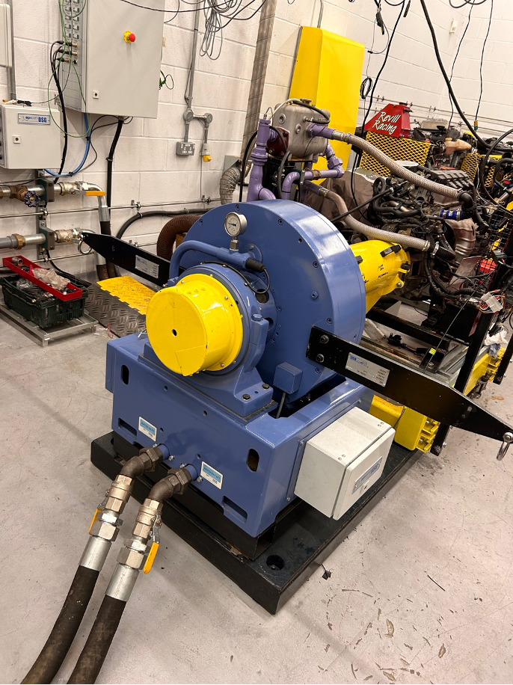
Figure 1 - Engine Dynamometer (own photo)

The image above shows the dynamometer system that was used. It is a SCHENK WS230. It can reach a maximum of 10,000rpm and a maximum load of 230kW.

All the data that the computers receive comes from the engine setup behind this dynamometer. The only information it receives from the dynamometer is through a strain gauge that restricts the whole thing from turning. The strain gauge sends a signal between 0-10V to the computer.

The calibration arms are put in place as shown in the image above, for a couple of things. The first one being, it gives you a radius value which is engraved on the arm of 815.776mm or 0.815776m. The second reason they are there is so you can hand a mass on one end so you can work out the torque value.

Once a mass was added to one of the calibrations arms the machinery is ready to run. In the computer room, there is 3 screens, the one on the left shows the lambda and the dyno torque. On the right screen, there is dyno speed and a few other numerical values. The centre screen just shows what is happening currently. There are also 2 dials where you control the dynamometer and another for the engine. To experiment with the machinery freely, the machine was put on its manual setting.

3. Graphs & Questions

Graph 1
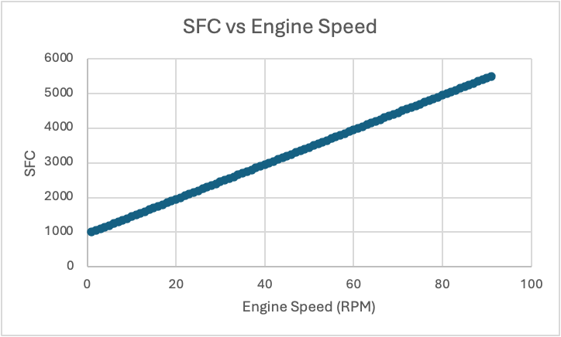
Figure 2 - SFC vs Engine Speed Graph (own photo)

Q). Suggest reasons why the SFC varies as it does with Engine Speed.

The graph above shows that as the engine speed increases, the SFC increases proportionally. A reason as to why this happened could be down to throttle position. To get a better understanding of this, it would have been good to record data with the engine speed decreasing / having data with the amount of pressure on the throttle slowly decreasing to see the trend of the sfc values. Normally the graph would show the most efficient engine speed.

Graph 2
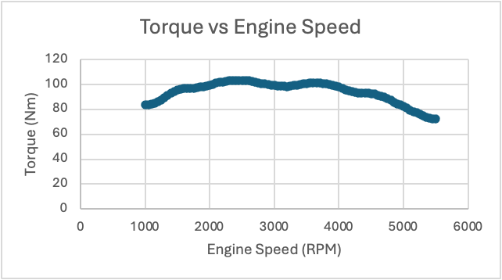
Figure 3 - Torque vs Engine Speed Graph (own photo)
Q). Suggest reasons why Torque varies as it does with Engine Speed.

The graph shows that as the engine speed increased, the torque increased. However, the torque load started to decrease, and the engine speed continued to increase resulting in the horsepower needing to overcome the force.
A reason as to why the torque eventually decreases whilst the engine speed continues to rise is because at higher RPM things like; friction, air flow complications etc come into play.

A normal Torque vs Engine Speed graph would look like a smooth curve whereas the engine speed increases, the torque would increase and then at a certain RPM the torque would decrease at a similar rate whilst the engine speed continues to rise. In this graph it does eventually do that but there are lots of bumps along the way.
This is also why on a vehicle technical specification, the torque values they give in RPM are always lower than the max RPM as shown in the image below:
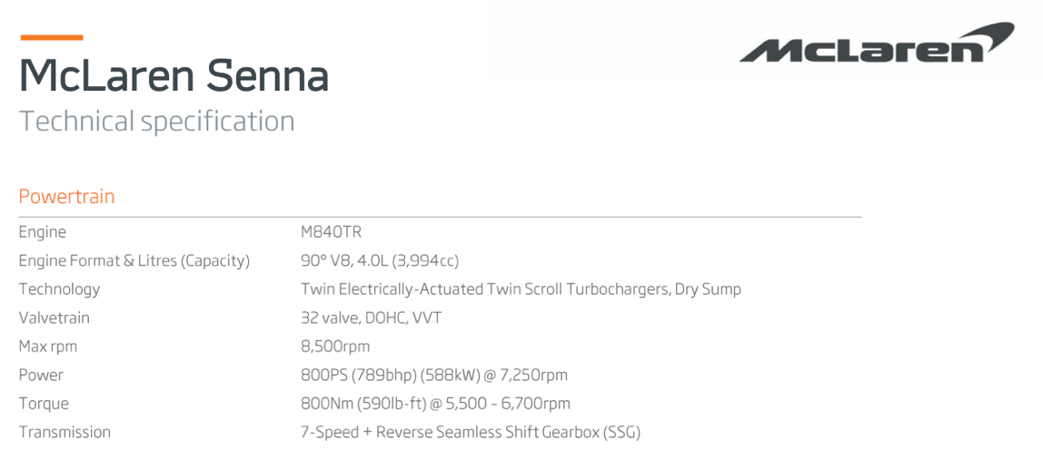
Figure 4 - McLaren Seen Technical Specification

Graph 3
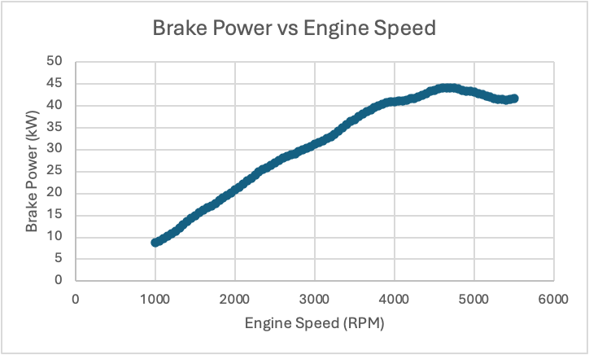
Figure 5 - Brake Power vs Engine Speed Graph (own photo)

Q). Suggest reasons why Brake Power varies as it does with Engine Speed.

Brake power increases as the engine speed increases because an increase of engine speed with a constant load result in an increase in torque which is shown marginally in Figure 3 - Torque vs Engine Speed Graph.
According to Prof. Dr. Md. Mustafizur Rahman (2024), the reason for the eventual decrease in the brake power is due to the “engine running out of air” and because the engine speed keeps on increasing the amount of air being able to get back into the engine significantly decreases. It is like the engine is an air pump.

4. Conclusions from Test Results

The data gathered was overall confusing, the trends seen from the graphs above was not what I was expecting. The only thing that I was satisfied with was the comparison between brake power and engine speed shown in Figure 5 - Brake Power vs Engine Speed Graph (own photo).
I was expecting the SFC vs Engine Speed graph to show a slight curve so a value for the most efficient engine speed would be picked out from it.
Also, I was expecting a straighter curve from the Torque vs Engine Speed graph.

Despite all of that. It is clear to me from the data that as the engine speed increases, everything else whether it is the brake power or the sfc also increases but nearer to the higher rpm, there is a sudden drop in values.

5. Evaluation

Overall, the tasks performed went well and the equipment was easy to get to grips with. If I were to change anything about it, I would make it either more complicated or add more things to measure because majority of the session was about what the machinery is and what it does, which left truly little time operating the machinery.
Another session in there if I were to do this again so I could have more time to play around with the machinery and therefore try to discover any trends that are missing from the data that was collected.

6. References

Brake mean effective pressure made Easy | Auto expert John Cadogan | Australia (2018) YouTube. Available at: https://www.youtube.com/watch?v=yQaLAqnaG1g (Accessed: 24 March 2024).

Prof. Dr. Md. Mustafizur Rahman (2024) Figure 5. variation of brake engine torque against engine speed. Available at: https://www.researchgate.net/figure/Variation-of-brake-engine-torque-against-engine-speed_fig3_269819440 (Accessed: 24 March 2024).

McLaren Senna specs - top speed, 0-100, engine, brakes, BHP: McLaren Automotive (2024) McLaren Senna Specs - Top Speed, 0-100, Engine, Brakes, BHP | McLaren Automotive | GB. Available at: https://cars.mclaren.com/gb-en/ultimate-series/mclaren-senna/specification . (Accessed: 24 March 2024).

