Models of Communication

Student’s Name: Mihai Cozma
Student’s ID: 2125171
Lecturer’s Name: Soban Sadiq
Module Code: BMSW4002_LON

Table of Contents
Report Summary 3
Introduction 3
Models of Communication 5
Shannon and Weaver Model 5
Schramm’s Model of Communication 6
Berlo’s Model of Communication 8
Communication Skills 9
Verbal communication 10
Non verbal communication 10
Listening 10
Technology in Communication (Advantages and Disadvantages) 11
Conclusion 12
References 13

Report Summary
The conversations that took place during the module on the Communication Process and how effectively it works in the workplace as well as in everyday encounters have culminated in the writing of this report. The Berlo, Scharmm, and Shannon and Weaver models, in addition to the model developed by Shannon and Weaver, will be presented to demonstrate an understanding of communication. This will allow the reader to differentiate between how prominent figures in the business world have understood the communication process and what these figures have presented in terms of disturbance factors that can make communication inefficient. The theory will be accompanied with examples that reflect the level of comprehension had by the writers and stress the learning outcome that is intended to be accomplished by the module. Details on the nonverbal aspects that may influence both the quality of the communication process and its effectiveness will be included in this section. This section will demonstrate how important verbal communication is, as well as how the receiver can better perceive nonverbal features and comprehend information. Listening will be discussed in the report as an important component of the communication process. This is because listening is necessary for the production of a successful communication process and is therefore an integral part of the communication process. We'll go over how and why technology is having an impact on communication, as well as why it's so important, in light of the fact that technology has evolved to the point where it's an essential component of our day-to-day lives. In addition to this, there will be a conclusion that provides a synopsis of the entire process of communication as well as the author's feelings regarding the information in its entirety.

Introduction
We say that we are communicating when we are passing information from one person to another, and the purpose of communication is to understand the information that is being handed along. Because communication in an organization, for example, helps to facilitate the flow of information and understanding between various people and departments via various media using all of the channels and networks, it is essential that both parties fully comprehend one another in order for communication to serve its intended purpose. Because they are required to communicate with the heads of various departments, employees and workers, and union leaders, managers of human resources in particular rely on this information flow to be effective and to make decisions that are in the best interests of the organization. This communication not only educates people concerned but also clears up any confusion that may have existed, improves clarity of thinking and speech, and eliminates misconceptions. Whether it's written or spoken, formal or casual, formal or informal; upward or downward; horizontal or diagonal; interpersonal, intrapersonal, interdepartmental, or Intra organizational; or any combination of these and more. Communication, which is one of the most important aspects of management, is inextricably linked to all of the other functions of management because it acts as a conduit for the exchange of information and promotes mutual comprehension between individuals and organizations. Because of how important communication is, the manager, for instance, needs to schedule time in order to collect, examine, understand, and remember information that may be used in decision-making and in the day-to-day operations of the business. (Lee, 2021)
The development of creative thinking is made easier when communication between coworkers is made easier. This leads to the invitation and encouragement of ideas from subordinates. A sense of belonging to the company is fostered when subordinates are recognized and rewarded for their contributions to the firm. It's important for managers and subordinates to be aware of each other's thoughts and feelings so that they can encourage each other to openly share information with their superiors. Communication has become increasingly important in today's world because of the rapid expansion of telecommunications, information technology, and increasing competition and complexity within the manufacturing industry. This means that effective communication is essential for efficient management and to improve industrial relations. A corporate executive must be able to communicate clearly and effectively with his superiors, colleagues in other departments, and subordinates in order to do his job successfully and give his all to the organization for which he works. (Etherington, 2020)

Models of Communication

Shannon and Weaver Model
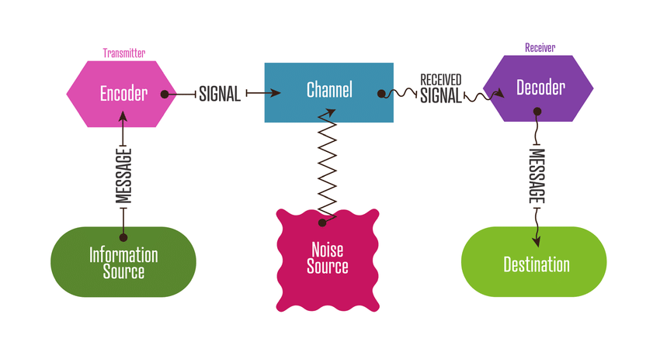

It is encrypted and sent through a technological channel like the telephone or telegraph by the sender. Due to the fact that messages are encoded and sent through a medium, this is the case. Receipt can also serve as decoder in some situations. Messages must be decoded before they are understood and interpreted. As an example, the brain of one person could serve as the sender, the mouth as the encoder, the air as the channel, the ear as the receptor, and the brain of the receiver as the decoder and receiver. As a result, communication may be hampered. However, the mouth could serve as an instance of the brain. Whoever transmits a message is referred to as the "sender" in this context. Source of information is another name for sender.
Anyone who uses a machine to convert text into binary data, such as an encoder, is referred to as a "transmitter." Alternatively, it could refer to the machine.
When we talk about "channel," we're referring to the method by which data is transmitted.
This is a Decoder (Receiver). There are two types of decoders: those that process and decode signals and those that receive and decode signals.
Both the individual who gets the communication and the intended recipient might be referred to as "receivers." The receiver decodes the message and then responds with information it has gleaned. (Businesstopia, 2018)
Within the study case with Pedro and Maria, The sender was Maria, and the receiver was Pedro. The mobile phone was the channel used by Maria to transmit her message to Pedro in order him to bring chicken when he gets home from work. The method of Pedro’s to decode the message was not good enough in order to understand what Maria wanted to say and for this reason a misunderstanding was created.

Schramm’s Model of Communication
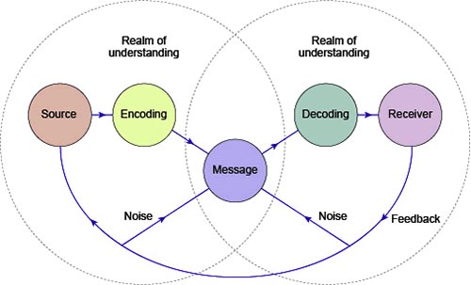

The fundamental fault of the linear model is that it depicts communication as a unidirectional process. This not only provides the idea that speakers never listen to one another and only ever speak to one another, but also gives the sense that listeners never communicate and do nothing but listen. Schramm proposed an interactive technique in which the person speaking the message, also known as the sender, would pay attention to the answer offered by the person receiving the message, also known as the receiver. This is illustrated by the following scenario: the person delivering the message, also known as the sender, pays close attention to the answer provided by the person receiving the message, also known as the listener. The one who is listening and the person who is speaking take turns speaking and listening to one another. Due to the fact that feedback can be offered verbally, non-verbally, or in both verbal and non-verbal forms, we can conclude that this model also predicts that the speaker and the listener are more likely to interact effectively if they have similar or overlapping areas of expertise. The source, which in Schramm's model of communication is also referred to as the encoder, the message, or the signal, and the destination, which is also referred to as the decoder, are the three components of the model, which takes social elements pertinent to communication into consideration. (Haynes, 2008)
Actually, in the case of Maria and Pedro, the misunderstanding was due to the lack of feedback from both parties while speaking on the phone. As Schramm is describing the communication’s vital aspect the feedback, it should be used as a clarification that the message was understood and by this, Pedro should have realized that he did not receive Maria’s message well and clarified the situation.

Berlo’s Model of Communication
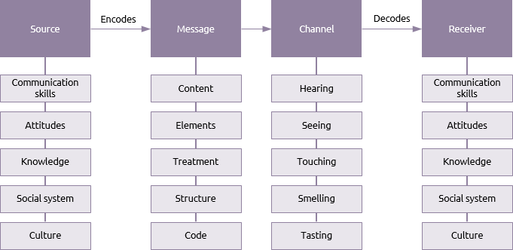

According to Berlo's model of communication, the most important factor in determining how well a message is sent is not the content of the message but rather the ability of the sender and the recipient to communicate. Because the capability of the sender to communicate effectively is directly proportional to the quality of the message being sent. Because communication involves more than just talking, but also listening and comprehending, if the message is not structured effectively, the recipient will be unable to understand it if he lacks communication skills. This is because communication involves more than just talking, but also listening and comprehending. The communication process will fail if the communicator does not have adequate communication skills. Communication skills are essential to other skills such as listening, writing, and reading, amongst others. It is of the utmost importance to keep in mind that the five human senses—sight, hearing, touch, smell, and taste—correspond to the five Berlo channels. The effectiveness of the message that is communicated through the channel can be influenced, or at the very least largely attributed to, these five senses. (Bowers, 2021)

Communication Skills

Verbal communication
Spoken communication is effective because it permits input from all aspects of the social communication model, as you encode your thoughts into the spoken word and rely on your audience to decode and comprehend the message you are providing. In a world when most communication occurs by email or text, it is refreshing to be able to directly request feedback to ensure that your message has been understood. Using the power of spoken communication, you can build rapport and trust with your audience, and it also makes it easier to ensure understanding by addressing objections and clearing up misunderstandings: you can adjust your message based on the feedback you receive from your audience as you deliver it. (Griffith and Dunham, 2015)

Non verbal communication
Nonverbal communication includes nodding, making facial gestures, and leaning toward the speaker. Body language can affirm or contradict spoken statements. Happiness, sadness, and rage can help you communicate. When speaking and listening, it's easy to forget about your facial expression. When speaking, a gesture can add emphasis. Effective nonverbal communication is calling attention to something you want the audience to look at more closely. Body language is another example. Using gestures like waving at a coworker who merits appreciation or forming a fist to show displeasure or fury can help engage your audience. The distance you retain from an audience delivers a nonverbal message. If you're a big person and keep a modest distance from listeners, your nonverbal communication may be menacing. If you keep a bigger distance from your listeners, your nonverbal communication will be weaker. Giving someone too much space is a rare nonverbal cue that may mislead your listener. (Griffith and Dunham, 2015)

Listening
As a result of actively listening, the listener tries to understand the other person or group and eliminates preconceptions about them. Therefore, you should take the speaker at his or her word, because they are offering you with their perspective, and as the lecture progresses, you may find that the speech makes more sense. The core of poor communication is a lack of listening skills, because people are more prone to make assumptions and misunderstand each other if they don't actively express their opinions or listen to one another. Therefore, it is quite easy to mistake or misinterpret information if listening skills in communication are not honed. As a rule, you should try to imitate the speaker's emotions as closely as possible when listening well. As an example, if the speaker's face shows sadness or joy, your facial expressions and words should portray the same sentiments. Empathizing with the speaker needs focus and energy, which facilitates open communication. (Griffith and Dunham, 2015)

Technology in Communication (Advantages and Disadvantages)

As a first advantage of the technology in communication is the fact that all business owners should invest in communication technology since, despite the fact that using technology in communication may initially appear costly, in the long term it will become significantly cost-effective by streamlining an organization's managerial and operational operations. Information and communication technology allows organizations to accomplish more with less resources without sacrificing quality. Through the use of subscription databases and social networks, businesses may organize, evaluate, and disseminate data in unprecedented ways. This has provided businesses with unparalleled access to consumers and customers, enabling them to design superior products. Traditional files will always have a place in the corporate sector, but keeping a paper trail for sensitive information may not be the greatest choice. Identity thieves can exploit even the most basic information, such as a victim's name or date of birth, to commit fraud. Because victims of identity theft often discover the source of the theft, information technology helps avert lawsuits. In matter of disadvantages, when technology is applied in the production procedures of a corporation, the organization views the technology as a superior "employee." Nevertheless, not only is it possible to finish the work on time, but also certain processes can be automated so that they are easier to operate. This drop in the demand for human labor may be good news for business employers, but it is not good news for human employees, as commercial organizations see no sense in hiring humans when technology is deployed in place of humans. People are now able to speak with one another even if they are not physically located in the same area thanks to technological advancements. This is made possible by a range of communication methods such as Skype, and as a consequence, business partners from different regions of the world are able to hold conference sessions from their respective locations.
It is general known that technological instruments can be helpful in the process of automating complicated company procedures. This is great news for any company, but you should be aware that manufacturing processes can be halted abruptly whenever a machine experiences a malfunction for any one of a number of different reasons. (White, 2021)

Conclusion
Communication has to be more than just the transmission of information in order for it to be effective; it has to also take into account the feelings and intentions that are underlying the information that is being communicated. The capacity to comprehend what the other person is attempting to say and then communicate that comprehension back to them is just as essential as being a good listener and a good speaker in general. One of the most important skills necessary for good communication is the capacity to pay attention to what other people have to say and take it into consideration.

References
- Businesstopia, (2018), Shannon and Weaver Model of Communication, Updated: 06/01/2018, [Available at: https://www.businesstopia.net/communication/shannon-and-weaver-model-communication, Accessed on July 27/07/2022
- Bowers J., (2021), Communication: The Effective Guide to Effectively Improving Your Social Skills ( The Science of Effective Communication), pp. 55-70
- Etherington, T. (2020) Effective Communication in Health and Social Care. Available at: https://www.theaccessgroup.com/en-gb/blog/hsc-effective-com
- Griffith, B. A. and Dunham, E. B. (2015) Working in teams: moving from high potential to high performance. Chapter 2& 3: Verbal and Non- verbal communication. Los Angeles, (California]:SAGE2015
- Griffith, B. A. and Dunham, E. B. (2015) Working in teams: moving from high potential to high performance. Chapter 4 : Listening communication. Los Angeles, (California]:SAGE2015
- Haynes A., (2008), Using Communication Theory. An Introduction to Planned Communication., pp. 177-200
- Lee, E. (2021) Effective Communication in Health and Social Care. CPD online College. Available at: https://cpdonline.co.uk/knowledge-base/care/effective-communication/
- White D., (2021), 5 Advantages and Disadvantages of Information and Communication Technology in Business, Available at: https://www.techfunnel.com/information-technology/5-advantages-of-information-and-communication-technology-in-business/, Posted: 14/04/2021, Accessed 27/07/2022

