Software Development
ACCA4017
Matthew James
1809299

Table of contents:
Introduction: 3
Part A 3
A1. 3
A2. 3
A3. 4
Part B 5
Exercise 1 5
1.1 Action plan breakdown: 5
1.2 Annotated code: 5
1.3 Testing 6
Exercise 2: 7
2.1 Action plan breakdown: 7
2.2 Annotated code: 8
2.3 Testing: 9
Exercise 3: 10
3.1 Action plan breakdown 10
3.2 Annotated code 10
3.3 Testing 11
Exercise 4 12
4.1 Action plan breakdown 12
4.2 Annotated code: 12
4.3 Testing 16

Introduction:
Throughout this report the author will cover what they have learnt during the module.
Content in this report include, understanding variables and how important they are within programs, the different types of functions and how they can be used to assist in non-repetitive coding, Arrays, for-loops, while loops and headers.

Part A

A1.
What is a variable and why are they important in writing programs?
Computers main purpose are to run programs which are based on a collection of data and processing that data. A computer can change what it does depending on that data, this is why we have data referred to as variable data. This data can change at any given point via user input, calculations, databases or hardware; other variables such as fixed variables are variables that can not be changed via those inputs. [1]

A2.
Explain why the for-loop can also be referred to as a counting-loop and give an example of when you would use it. [2]
A for loop is also called a counting loop due to it being used most to count until a point.
The header #include <stdio.h> is needed when coding in C as this provides the majority of base functions used such as “printf” and “scanf”; Other headers may be used if needed such as windows.h, time.h and stdlib.h.
E.G
#include <stdio.h>
int main () {
int a;
/* for loop execution */
for( a = 10; a < 20; a++ )
{
printf("value of a: %d\n", a);
}
return 0;
[2]
In this example the variable a is declared, a for loop is started with A = 10 and if a is less than 20 add 1 to the value of a.
A while loop can be attempted but it is less restricted thus errors can be made

A3.
Explain what an array is, what their features are, and give an example of when you would use one.
An array is a way for us to use multiple objects base in one variable. These objects can be altered the same as a normal variable and can be used in conjunction with for loops, while loops and other functions.
Each object in an array is called an array element. E.G
void main()
{
int i, input;
int total = 0;
int tempature[12];
int average;

for (i = 0; i <= 11; i++)
{
printf("input your temp values: ");
scanf("%d", &tempature[i]);

}
for (i = 0; i <= 11; i++)
{
printf("%d\n", tempature[i]);
}
printf("Which array value would you like to see?\n");
scanf("%d", &input);
input = input - 1;
printf("%d\n", tempature[input]);

for (i = 0; i <= 11; i++)
{
total = total + tempature[i];

}
average = total / 12;
printf("the average is: %d", average);

} [4]
Features of an array
- Hold elements of the same data type
- Arrays size are declared, it is a constant expression and not a variable
- Array elements values can be changed through the code via usual input methods (user input, calculations etc.) [5]
- All values in the array are stored within the main memory of the program therefore arrays can contain a large amount of data and will consume a large amount of main memory.
- An individual value can be retrieved by specifying the correct index value e.g code[5]

An array can be used in many situation, in this report we will be using the example of temperature as shown above in the array code, this can be used to find out the average temperature over 12 days.

Part B

All code will include <stdio.h> as a header, additional headers unique to the program will be shown

Exercise 1
Show how variables can contain different types of values by declaring three variables that contain a name, a measure of height (e.g. 1.81cm) and a person's age (e.g. 32). Input these values and display them on the screen.d

1.1 Action plan breakdown:
- Declare variables
- User enters name
- Store in variable name(char)
- User enters age
- Store in variable age(int)
- User enters height
- Store in variable height(float)
- Print all data entered on screen

1.2 Annotated code:
#include <stdio.h>
void main()
{
char name[9]; // stores the input characters
int age; // stores age
float height; // stores height
printf("What is your name?\n"); // asks user to input
scanf("%s", name); // takes user input characters and stores in "name"

printf("What is your age?");
scanf("%d", &age);

printf("What is your height in metres?");
scanf("%f", &height);

printf("The information you enter was\n You name is: %s\n your age is: %d \n your heigh is %f", name, age, height); // prints all values that was stored within name, age and height
}

1.3 Testing

1.3.1 Normal values
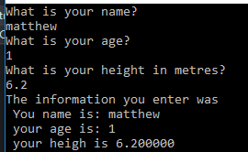

Result: Ran as expected with correct values and characters. Program success

1.3.2 Normal values (negative where applicable)

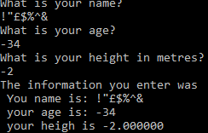
Result: Ran as expected with negative and special characters. Program success

1.3.3 Wrong data type values - float in int

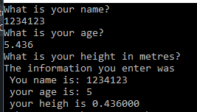
Result: ran as expected height values were skipped for some reason. Program failed.

Exercise 2:
Allow the user to enter the dimensions of shapes shown below (Figure 1), then calculate the area of the blue shaded part. Note: The triangular area in the centre is empty.

Figure 1 Calculate Shaded Area

2.1 Action plan breakdown:
- Declare variables
- Function for user input
- Stored in “enterfloat” prototype
- User input radius value
- Stored in radius in radius (float)
- Calculate circle area using formula (PI multiply radius multiply radius)
- Print user radius area
- User input base of triangle
- Stored in base (float)
- User input height of triangle
- Stored in height(float)
- Calculate triangle area using formula (base multiplied by height divided by 2)
- Print user the triangle area
- Compare values
- If triangle if is greater than circle area then
- Print “The circle area must be bigger than the triangle area”
- Print “the shaded area (value)”
- If circle area is greater than triangle
- Print “The area of the shaded area is (value)”

2.2 Annotated code:
#include <stdio.h>

#define PI 3.142 // makes PI a permenant value that can not be changed via the code

float enterfloat();// prototype this allows the use of functions within a program

void main()
{
float base, height, calctriangle, radius, calccircle, shade; // these values store the relevant data within them, the values will be unser inputted throughout the program

printf("Please input value for circle\n");
radius = enterfloat(); // radius is now equal to the value inputted in "enterfloat" function
calccircle = PI * radius * radius; // calculates circle by using formula PI(3.142) times radius times radius
printf("Circle area is: %f\n", calccircle);

printf("Please enter your base\n");
base = enterfloat(); // base is now equal to the value inputted in "enterfloat" function - this applies to all = enterfloat()
printf("Please enter your height\n");
height = enterfloat();
calctriangle = base * height / 2; // calculates traingle by using the formula base times height divided by two
printf("triangle area is: %f\n", calctriangle);

if (calctriangle > calccircle) // if the calculated traignle is greater than the circle the program will run the first line of code and stop the program
{
shade = calccircle - calctriangle; // calculates teh shaded area
printf("The circle area must be bigger than the triangle area\n");
printf("The is the shaded area %f\n ",shade);
return; // stops the program from continuing
}
shade = calccircle - calctriangle; // calculates the shaded area
printf("the area of the shaded area: %f", shade);
}

float enterfloat() // enters float values
{
float thevalue; // decalares variable "thevalue"
scanf("%f", &thevalue); // takes user input and stores in "thevalue"
return thevalue; // returns the value back to main
}

2.3 Testing:

2.3.1 Normal values:
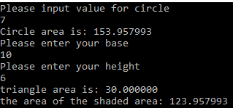

Result: Ran as expected with correct values. Program success

2.3.2 Normal values (negative where applicable)

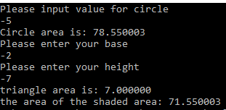
Result: Ran as expected with negative values. Program success

2.3.3 Wrong data type values – letters in integer
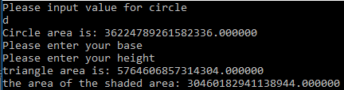
Result: ran as expected, wrong data types break program. Program failed.

2.3.4 triangle area bigger than circle area.

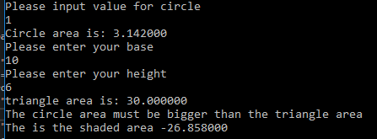
Result: ran as expected, if statement successful. Program success.

Exercise 3:
Write a program that allows the user to enter the price of 5 products into an array. Once all the prices are entered calculate the total price, and then calculate the total price plus 20% VAT.

3.1 Action plan breakdown

- Declare variables
- for statement for 5 product values to be inputted (counter less than 5 add one each time
- user inputs product value 5 times
- stored in mynumbers[5] array (float)
- for loop to print values after all being inputted
- print “value (number in loop) is : (value)
- for loop to add up values to make a total
- store values in total (float)
- total value multiplied by 1.20 (20%)
- stored in total (float)
- print “total with VAT (value)”

3.2 Annotated code

#include <stdio.h>

void main()
{
float mynumbers[5]; // this declates mynuymbers as an array
float total; // to store the sum of the array
int i; // declare i as an integer and total
total = 0;
i = 1;
for (i = 0; i < 5; i++) // this starts at 0 and increments untill it hits 4. This will take 5 values
{
printf("Please input value %d: ",i+1); //
scanf("%f",&mynumbers[i]); //get input from user

}
for (i = 0; i < 5; i++) // takes numbers from previous for loop and displays them
{
printf("value %d is : %.2f\n", i + 1, mynumbers[i]);
}

for (i = 0; i < 5; i++) // adds up all values that have been inputted in first for loop
{

total = total + mynumbers[i]; // adds all the numbers in the array up and stores in total
printf("the total is: %2.f\n", total);

}

total = total * 1.20; // adds 20% to the total
printf("Total with VAT : %2.f\n", total);
}

3.3 Testing

3.3.1 Normal Values
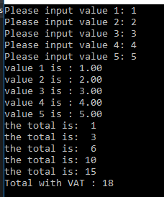
Result: Ran as expected with correct values. Program success

3.3.2 Normal values (negative where applicable)
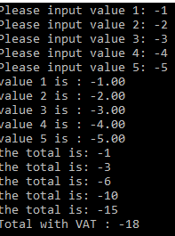
Result: Ran as expected with negative. Program success

3.3.3 Wrong data type values – letters in integer
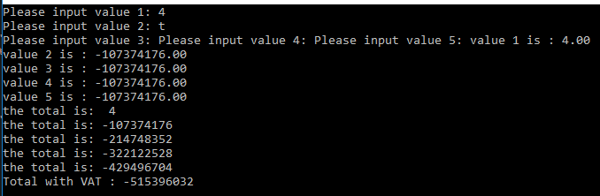
Result: ran as expected, wrong data types break program. Program failed.

Exercise 4

4.1 Action plan breakdown
- user input y to start jackpot
- random generated values (function, pass back into main)
- store generated value in variable (randv1,randv2,randv3)
- print “(value1, value2, value3) from variables randv1,randv2,randv,3
- if statement for the outcome
- print score based on outcome
- user inputs n to stop jackpot
- prints users accumulative score
- end program

4.2 Annotated code:

#include <stdio.h>
#include <time.h>
#include <stdlib.h>
#include <Windows.h> // enables windows api functions - allows the use of sleep

int randnumber1(); //prototype
int randnumber2();
int randnumber3();

void main()

{
// stores the delay amount

int score0 = 0, score100 = 100, score2000 = 2000, score20 = 20; // stores score
int accscore= 0; // stores accumalative score
srand(time(NULL)); // seed random with system clock ONCE ONLY
int randv1, randv2, randv3; // stores values
char input = 'y';
char run = 'y';
char stop = 'n';
while (run == 'y')
{
printf("would you like to play?\n y/n \n ");
scanf(" %c", &input);

if (input == 'y')
{
randv1 = randnumber1();
printf("no.1 %d\n", randv1);
randv2 = randnumber2();
printf("no.2 %d\n", randv2);
randv3 = randnumber3();
printf("no.3 %d\n", randv3);

if (randv1 == 5 && randv2 == 5 && randv3 == 5) // checks if all values are 5
{
printf("Congrats! JACKPOT you get %d\n",score2000);
}
else if (randv1 == 4 && randv2 == 4 && randv3 == 4) // checks if all values are 4 - this code was initially tried with rand (randv1 == 4 && randv2 == 4 && randv3 == 4),(randv1 == 3 && randv2 == 3 && randv3 == 3)
// and also like in an array form but was prevented when trying to call as it would only use the last value entered into the array.
{
printf("Congrats!, you hit 3 of the same values! you get %d\n", score100 + score20);
}
else if (randv1 == 3 && randv2 == 3 && randv3 == 3) // checks if all values are 3
{
printf("Congrats!, you hit 3 of the same values! you get %d\n", score100 + score20);
}
else if (randv1 == 2 && randv2 == 2 && randv3 == 2) // checks if all values are 2
{
printf("Congrats!, you hit 3 of the same values! you get %d\n", score100 + score20);
}
else if (randv1 == 1 && randv2 == 1 && randv3 == 1) // checks if all values are 1
{
printf("Congrats!, you hit 3 of the same values! you get %d\n", score100 + score20);
}
else if (randv1 == 5 && randv2 == 5 && randv3 != 5) //check if values are 5,5,?
{
printf("Congrats!, you hit 2 of the same values! you get %d\n", score100);
}
else if (randv1 == 5 && randv2 != 5 && randv3 == 5) //check if values are 5,?,5
{
printf("Congrats!, you hit 2 of the same values! you get %d\n", score100);
}
else if (randv1 != 5 && randv2 == 5 && randv3 == 5) //check if values are ?,5,5
{
printf("Congrats!, you hit 2 of the same values! you get %d\n", score100);
}
else if (randv1 == 4 && randv2 == 4 && randv3 != 4) //check if values are 4,4,?
{
printf("Congrats!, you hit 2 of the same values! you get %d\n", score100);
}
else if (randv1 == 4 && randv2 != 4 && randv3 == 4) //check if values are 4,?,4
{
printf("Congrats!, you hit 2 of the same values! you get %d\n", score100);
}
else if (randv1 != 4 && randv2 == 4 && randv3 == 4)//check if values are ?,4,4
{
printf("Congrats!, you hit 2 of the same values! you get %d\n", score100);
}
else if (randv1 == 3 && randv2 == 3 && randv3 != 3) //check if values are 3,3,?
{
printf("Congrats!, you hit 2 of the same values! you get %d\n", score100);
}
else if (randv1 == 3 && randv2 != 3 && randv3 == 3) //check if values are 3,?,3
{
printf("Congrats!, you hit 2 of the same values! you get %d\n", score100);
}
else if (randv1 != 3 && randv2 == 3 && randv3 == 3)//check if values are ?,3,3
{
printf("Congrats!, you hit 2 of the same values! you get %d\n", score100);
}
else if (randv1 == 2 && randv2 == 2 && randv3 != 2) //check if values are 2,3,?
{
printf("Congrats!, you hit 2 of the same values! you get %d\n", score100);
}
else if (randv1 == 2 && randv2 != 2 && randv3 == 2) //check if values are 2,?,2
{
printf("Congrats!, you hit 2 of the same values! you get %d\n", score100);
}
else if (randv1 != 2 && randv2 == 2 && randv3 == 2)//check if values are ?,2,2
{
printf("Congrats!, you hit 2 of the same values! you get %d\n", score100);
}
else if (randv1 == 1 && randv2 == 1 && randv3 != 1) //check if values are 1,1,?
{
printf("Congrats!, you hit 2 of the same values! you get %d\n", score100);
}
else if (randv1 == 1 && randv2 != 1 && randv3 == 1) //check if values are 1,?,1
{
printf("Congrats!, you hit 2 of the same values! you get %d\n", score100);
}
else if (randv1 != 1 && randv2 == 1 && randv3 == 1)//check if values are ?,1,1
{
printf("Congrats!, you hit 2 of the same values! you get %d\n", score100);
}
else
{
printf("Unlucky, you didnt get anything\n");
}
}
else if (input == 'n')
{
printf("Thanks for playing you total score was!: %d \n",accscore); // accscore will have the accumulated values of the game once stopped
return;
}
}

}

int randnumber1()
{
int low = 1; // bottom of range
int high = 5; // highest of range
int myrand1; //stores the 3 values in the array myrand
int delayrand1; // stores the delay amount after being calculated
int result1; // stores the return value after calculations

delayrand1 = rand() % 1000;// makes a random delay using 1000
Sleep(delayrand1); // sleeps for the random ammount
myrand1 = rand() % (high - low + 1) + low; // generate random number
result1 = myrand1; // didnt need this to create result1... but may choose to change randomness later by doing other calculations such as result1 = myrand1+ myrand2;
return result1; // sends result1 back into main as randnumber1
}
int randnumber2() // same randnumber1()
{

int low = 1;
int high = 5;
int myrand2;
int delayrand2;
int result2;

delayrand2 = rand() % 1000;
Sleep(delayrand2);
myrand2 = rand() % (high - low + 1) + low;
result2= myrand2;
return result2;

}
int randnumber3() // same randnumber1()
{
int low = 1;
int high = 5;
int myrand3;
int delayrand3;
int result3;

delayrand3 = rand() % 1000;
Sleep(delayrand3);
myrand3 = rand() % (high - low + 1) + low;
result3 = myrand3;
return result3;
}

4.3 Testing

4.3.1 run program
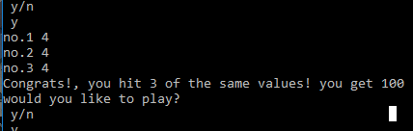

Result: Ran as expected with correct values. Program success

4.3.2 run program with 2/3 same values
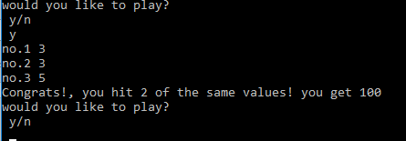

4.3.3 run program with 0/3 same values
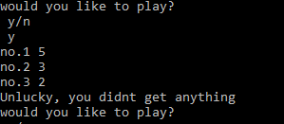

4.3.4 exit program
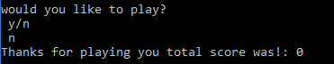

Conclusion
During the module, the author has gain insight on how the basics of coding with the language C. understanding the syntax when trying to implement code as code is structured as such. By learning the basic knowledge, the author was able to carry out complex coding techniques such as for-loops, arrays and creating functions for use.

Reference list

[1] | bbc, “Constants, variables and data types,” BBC, [Online]. Available: https://www.bbc.com/bitesize/guides/zc6s4wx/revision/1. [Accessed 24 02 2019].
[2] | I. Barnard, “Why is a for loop called a counter control loop?,” Quora, [Online]. Available: https://www.quora.com/Why-is-a-for-loop-called-a-counter-control-loop. [Accessed 24 February 2019].
[3] | “for loop in C,” tutorialspoint., [Online]. Available: https://www.tutorialspoint.com/cprogramming/c_for_loop.htm. [Accessed 24 02 2019].
[4] | tutorialspoint, “C - Arrays,” tutorialspoint, [Online]. Available: https://www.tutorialspoint.com/cprogramming/c_arrays.htm. [Accessed 25 February 1029].
[5] | D. Thakur, “Characteristics of Arrays in C,” ecomputernotes, [Online]. Available: http://ecomputernotes.com/what-is-c/array/what-are-the-characteristics-of-arrays-in-c. [Accessed 25 Feburary 2019].

