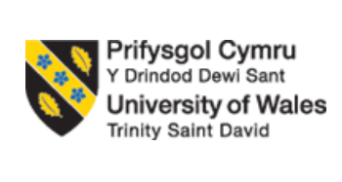
Programme: BA (Hons) Business Management
Module: Strategic Management and Sustainability

Strategic Management Analysis of McLaren Automotive Limited: Developing a Sustainability Strategy for Long-Term Competitive Advantage

Student Name: Cristina Ropota
Student ID:2439122

Executive Summary
Fast-paced car industry technical innovation, environmental regulations, consumer demand and the transition to electric vehicles (EVs) are all part of the major change that the UK car industry is experiencing. It can be the boost they need to get on top of such challenges and remain competitive with strategic management. It has been a critical analysis of the Strategic Position of McLaren Automotive Limited (United Kingdom) in the luxury sports car business with emphasis on Sustainability Strategy. The PESTLE framework has been used to discuss the external business environment of McLaren and the Porter's Five Forces have been explored to identify opportunities and threats for McLaren. All in all, the results show that there are several possibilities, such as market potential for sustainable luxury goods, technological development as well as government support for LEGVs. There are plenty of hurdles though, including tougher standards in the Environmental category, and adaptation of the supply chain to growing new products and the competition with existing luxury EV manufacturers. Broadly use the Value Chain Analysis, the Resource-Based View (RBV) and the VRIO framework to conduct an internal analysis of McLaren's strategic resources and capabilities. Obviously, McLaren knows a lot of engineering, has a famous brand and is using an advanced carbon fibre chassis, but there are only so much money and production that he has -- and it's a limitation of the competition. The report ends with strategic recommendations, including an acceleration of the shift towards electrification, investments in sustainable manufacturing, as well as concrete strategic partnerships and access to new luxury segments. These will help strengthen McLaren's position and drive additional expansion in the challenging automotive market.

Table of Contents
Introduction: 4
Vision: 4
Mission: 4
Strategic Objectives: 4
Strategy Analysis: 5
External Environment Audit: 5
External Environment Summary: 7
Internal Environment Audit: 7
Value Chain Analysis: 7
Resource-Based View (RBV): 8
VRIO Analysis: 8
SWOT Analysis: 9
Strategy Formulation: 10
Strategic Alternative 1: Accelerate Electrification (Product Development) 10
Strategic Alternative 2: Sustainable Manufacturing (Operational Excellence) 11
Strategic Alternative 3: Strategic Partnerships and Innovation 11
Strategic Alternative 4: International Market Expansion (Market Development) 11
Porter's Generic Strategy: 11
Conclusion: 12
Recommendations: 12
References: 13

Introduction:
Strategic management is the decision-making process to assist the organisation to meet its long-term goals and remain competitively successful (Johnson, Scholes and Whittington, 2020). The change and shift that is occurring in the automotive industry – in which McLaren Automotive resides – involves sustainability, electrification and technological innovation. Although it has a solid Formula One background and engineering prowess, McLaren needs to continue to improve on its sustainability plan in order to keep pace with some of the world's leading luxury automotive companies (SMMT, 2024; McLaren Automotive, 2024).

Vision:
To achieve its goal of being ‘the world's best in class creator of high-performance luxury supercars through continuous innovation and engineering excellence and sustainable mobility' (McLaren Automotive, 2024).

Mission:
To deliver uncompromising technology, engineering and sustainable innovations that exceed customer expectation, delivering world class driving experiences of state-of-the-art technology (McLaren Automotive, 2024).

Strategic Objectives:
Most important strategy goals of McLaren are:
- Making up the shortfall in the performance of the automotive technologies.
- To speed up the shift to hybrid and electric vehicle technology.
- Develop solutions for sustainability in the whole value chain.
- Additional market share gain(s) on a global level.
- Working towards sustainable financial success and Operational Excellence by Innovation.
Therefore, strategic management is an integral part of how McLaren operates today, and will be crucial in their bid to remain competitive in a rapidly evolving, greener, and very technology-driven automotive industry.

Strategy Analysis:

External Environment Audit:
PESTLE Analysis:
It offers an insight on the external Macro Environment using the PESTLE framework which could impact the performance of the organisation (Johnson et al., 2020).
- Political Factors:
To incentivise investment in EV charging stations and the use of low emission vehicles, the UK Government have already created policies. The automotive sector specifically has been more spotlighted due to the 2050 Net Zero Target which the UK has set itself (Department for Transport, 2024) and has seen focus on how to decarbonise the sector, with a specific focus on car manufacturing. Thanks to the government subsidies on green tech, McLaren has an opportunity to invest in hybrid / electric super sports cars.
- Economic Factors:
Global consumers' spending has been impacted by the economic uncertainty and by high inflation and increasing interest rates (SMMT, 2024). But the near total financial crises could lead to a slowing down of demand for luxury vehicles, including the McLaren's car sales. In contrast, the growth opportunities could lie in the success of emerging markets like China, Middle East and so on, when it comes to expanding to emerging markets for luxury cars (OICA, 2024).
- Social Factors:
The change of consumer preference is huge. However, if the product is a luxury product, the “environmentally friendly” products are not likely to have any effect on the performance of the product (Kotler and Keller, 2022). The younger generation (still luxury buyers), like the millennial generation, are among those that appreciate sustainability and state of the art technology. As the number of developing economies is increasing, so the number of the high standard classy and quality vehicles, required by the consumers is also on the rise.
- Technological Factors:
Electrification, autonomous driving, artificial intelligence, lightweight materials, connected vehicle technologies are the few examples out of myriad technologies that are transforming the car industry (Grant, 2022).
- Legal Factors:
International environmental legislation continues to be further tightened. From 2015, the European Commission has made ever tougher demands on vehicle security and sustainability – to the manufacturers.
- Environmental Factors:
The greatest of those outside of the control of the automotive manufacturers is climate change. There is an increasing demand for companies to have less carbon footprint when manufacturing, by consumers, investors and even governments. (IPCC, 2023).
Porter's Five Forces Analysis:
- Threat of New Entrants – Low:
Large capital investment, high degree of engineering capacity, brand name and overseas sales network are required in the luxury automotive business. All these barriers considerably decrease the potential of prosperous new entrants (Grant, 2022).
- Bargaining Power of Buyers – Low:
McLaren is dependent on some specialist suppliers to provide their products: These include carbon fibre materials, semiconductors, battery and high-performance components. Fewer suppliers means that they have greater bargaining power, and the higher the production costs (Lynch, 2021).
- Bargaining Power of Buyers – Moderate:
With all the products that the competitions have, the McLaren buyers wield a lot of purchasing power. A more quality, innovation & personalisation is also wanted by customers. However, being a popular brand and a tech brand, the buyers can't control that to a large extent.
- Threat from Substitute Products – Moderate:
Other luxury cars including different brands such as Ferrari, Porsche, Aston Martin, Lamborghini and new electric car brands, like Tesla will be available for vertical customers. Overcome with the change in the tastes and preference of the consumers, substitution threat is another prevalent threat.
- Competitive Rivalry – Very High:
The competition in the worldwide luxury car segment is quite high. Major investment in innovation, electrification and motorsport technology and brand building, by the big guys. Businesses battle on product performance and design, customer experience, and technological innovation instead of price (Porter, 1980).

External Environment Summary:
The external analysis shows that McLaren has a great deal of opportunities and at the same time there are significant risks. Government policy in favour of electric vehicles, car industry growth and the need for sustainable luxury car trends on the global stage are all favourable conditions for the continuing increase of the number of electric cars.

Internal Environment Audit:
Internal analysis focuses on the firm's resources, capabilities and competences that can be used in developing a sustainable competitive advantage (SCA) (Barney, 1991). Engineering magic, technological sophistication, brand marketing and efficiency is all McLaren is about. Value Chain Analysis, Resource-Based View (RBV) and VRIO framework is used to analyse the internal environment of McLaren, followed by summarizing the same using SWOT analysis.

Value Chain Analysis:
It indicates that the main activities of McLaren are optimised and if it is applying Porter's model of value chain (1985) it can achieve competitive advantage. Due to good inbound logistics, complex manufacturing, global distribution, excellent marketing and after-sales support, the company becomes history and adds value, which boosts the satisfaction of customers and fosters brand loyalty. It also has a collection of support activities around knowledge/expertise in HR/people management, continuous research/development, strategic sourcing and proper corporate infrastructure which all add layers of innovation, and the ability to operate at peak capacity.
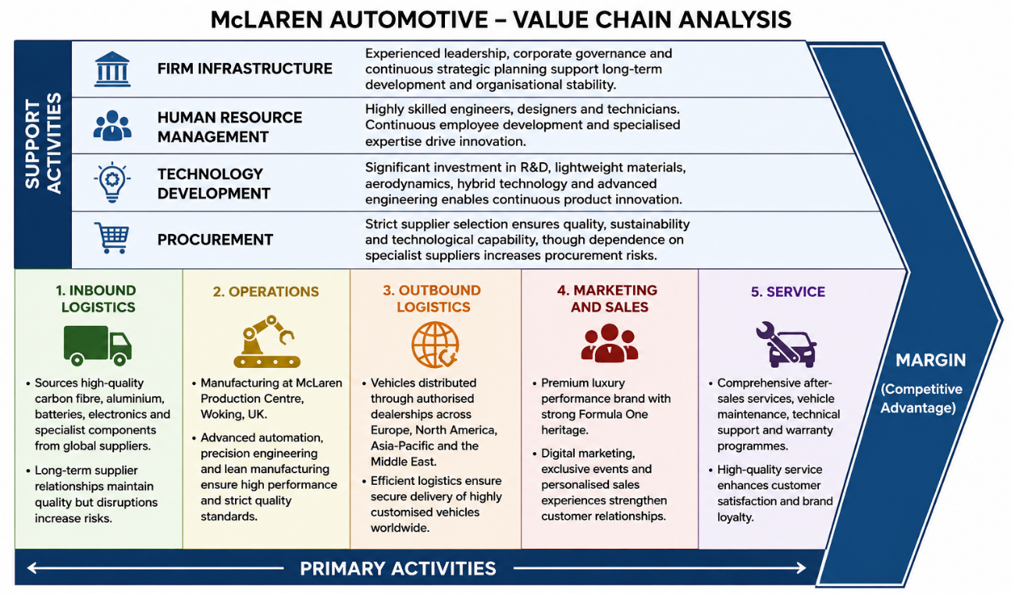

Resource-Based View (RBV):
According to Barney (1991) valuable, rare, inimitable and well organised resources are the sources of sustainable competitive advantage in resource-based view of sustainable competitive advantage. Many of the assets which McLaren owns are quite valuable, including state of the art manufacturing facilities, R&D facilities and an international network of dealerships.

VRIO Analysis:
According to Barney and Hesterly (2021), the VRIO framework can be used to make the decision on whether organisational resources provide sustainable competitive advantage or not: Value, Rare, Inimitable and Organised. What is important, unique, hard to copy and well managed are the assets of carbon fibre technology at McLaren and the knowledge of applying the technology to Formula 1 which will give McLaren long term competitive advantage (Grant, 2022).
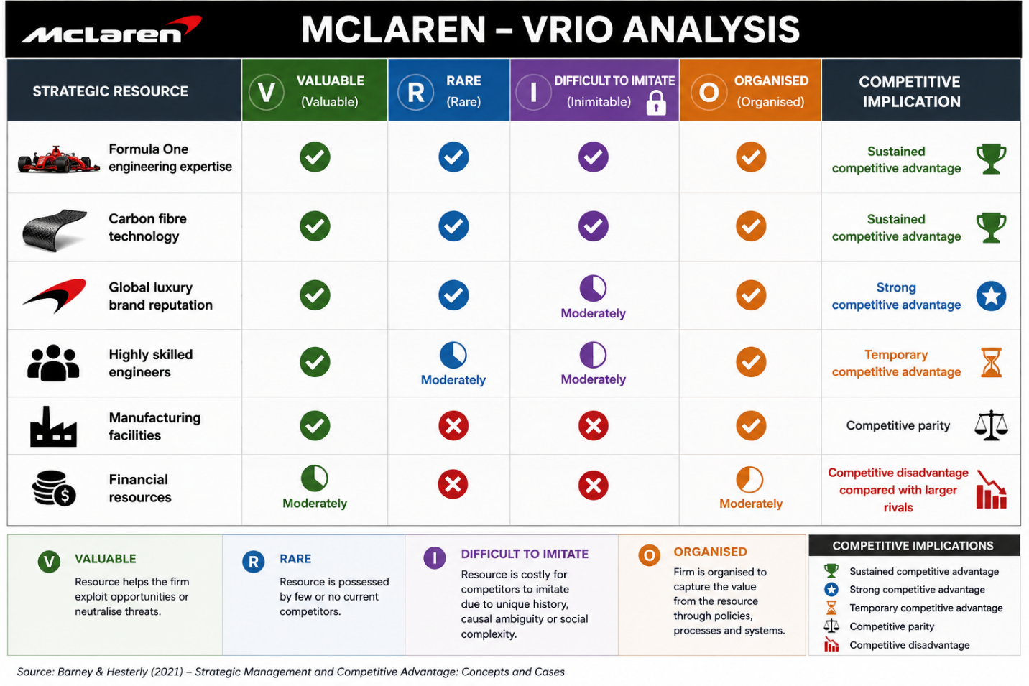

SWOT Analysis:
Strengths | Weaknesses | Opportunities | Threats
Strong global luxury brand | Limited production capacity | Growing luxury electric vehicle market | Intense industry competition
Formula One heritage | Financial instability in recent years | Government support for sustainable mobility | Increasing environmental regulations
Advanced carbon fibre technology | Dependence on specialist suppliers | Expansion into emerging luxury markets | Supply chain disruptions
Excellent engineering capability | Limited electric vehicle portfolio | Strategic technology partnerships | Rapid technological change
Continuous innovation culture | Smaller global market share than major competitors | Increasing demand for sustainable products | Global economic uncertainty

The SWOT analysis will reveal strengths McLaren has that will allow it to develop a competitive advantage – it is a prestigious luxury brand, it has a Formula One background, engineering and constant innovation. Its production capacity is, however, limited and there is still no financial stability for the company as the supplier's dependency and relatively small EV portfolio are hampering the company's growth. The company will be able to benefit from a boom in the luxury electric vehicle market, government plans to promote environmentally friendly transport and collaborations with technological companies. However, in the long-term, the competition, a change in environmental legislation, the supply chain disruption and quickly evolving technologies as well as international economic uncertainty can impact the result. As a whole McLaren should get improvement in the areas, they're weak and reinforce their strengths in operation and finance in order to maintain the competitiveness (Gürel and Tat, 2017).

Strategy Formulation:
The strategy formulation process helps organisations to think about some strategic alternatives which will help them to achieve their future goals and get sustainable competitive position. Given the external and internal analyses it can be gathered that McLaren's growth strategy should be about sustainability and should incorporate: Electrification, Innovation, Operational excellence and international markets expansion. The proposed strategies are evaluated by the using of Ansoff's Matrix and Porter's Generic Strategies.

Strategic Alternative 1: Accelerate Electrification (Product Development)
Ansoff (1957) states product development to be the introduction of new products to the same markets. But with an increase in both legislation and desire to have a green environment, McLaren will have to accelerate the process if it is going to become reality anytime soon. The market for luxury EVs is experiencing a rapid surge, fuelled by various factors such as rising demand for sustainable transportation, technological progress, and government programs to encourage the uptake of EVs (ACEA, 2024). This brings the battery technology, lightweight carbon fibre engineering and aerodynamics experience to the McLaren brand from Formula One to create sustainable high-performance cars, as well as offering the British company a technological leadership position and revenue stream over the long-term.

Strategic Alternative 2: Sustainable Manufacturing (Operational Excellence)
McLaren needs to enhance the sustainability of its manufacturing processes by boosting the use of renewable energy, introducing more recycled carbon fibre, minimising waste and optimising energy and water consumption (Johnson et al, 2020). This not only helps to create environmental responsibility but also results in long-term cost savings, and a positive company image to customers, regulators and investors (Porter and Kramer, 2011).

Strategic Alternative 3: Strategic Partnerships and Innovation
Partnering with various technology suppliers and providers, such as battery technology firms, AI companies, sustainable material vendors and leading universities can help access complementary skills and expertise to achieve technological innovation. This type of cooperation brings down the cost of R&D, enhances the performance of batteries, efficiency of vehicles and innovation of products (Johnson et al., 2020).

Strategic Alternative 4: International Market Expansion (Market Development)
The McLaren's Market Development strategy (based on Ansoff's) states that the strategy should target the growth luxury markets – China, UAE, Saudi Arabia, India and Singapore. The possibilities of authorised dealerships can be broadened – both in their numbers and quality – in terms of their digital marketing, customer service and sustainability work and different revenue streams can be taken on to help attract demand from high-net-worth consumers (OICA, 2024).

Porter's Generic Strategy:
According to Porter (1985), Differentiation can be a strategy for the company to compete on the other dimension such as unique product, higher value, etc. For McLaren, differentiation will be the key, and with top quality carbon fibre production, Formula One know-how in the design, as well as luxury craftsmanship and sustainable innovation and customer experiences, the road to success is made easier.

Conclusion:
This report critically analysed the strategic position of the McLaren Automotive Limited in the automotive industry in the United Kingdom (UK) using the strategic management frameworks of the PESTLE, Porter's Five Forces, Value Chain Analysis, Resource-Based View (RBV), VRIO and SWOT analysis. As can be seen from the results, McLaren finds itself in a very dynamic and competitive business environment where technology seems to be changing, customer preference seems to be changing and environmental regulations seem to be changing. When the policy of the government is to promote low emission cars there is scope for a sustainable future for luxury cars, however there can also be challenges when a policy is implemented, such as potential competition, supply chain issues and complete transition to electric vehicles.

Recommendations:
Looking ahead and sustainable growth, a choice should be made to invest in vehicles that are fully electric and on new battery technology for McLaren. The company should also boost sustainable manufacturing through increased use of renewable energy and recycled materials and a decrease in carbon emissions. In addition, collaborations with technology suppliers and research institutes can help speed up innovations and development costs. Expansion of the market to the emerging markets, such as Asia and Middle East (AM) will be done in order to diversify the company's revenue and increase its competitiveness in the global market.

References:
ACEA (2024) Economic and Market Report: Global and EU Automotive Industry Full Year 2024. Brussels: European Automobile Manufacturers' Association.
Ansoff, H.I. (1957) ‘Strategies for diversification’, Harvard Business Review, 35(5), pp. 113–124.
Barney, J.B. (1991) ‘Firm resources and sustained competitive advantage’, Journal of Management, 17(1), pp. 99–120.
Barney, J.B. and Hesterly, W.S. (2021) Strategic Management and Competitive Advantage. 7th edn. Harlow: Pearson.
Department for Transport (2024) Decarbonising Transport: Annual Progress Report. London: Department for Transport.
Grant, R.M. (2022) Contemporary Strategy Analysis. 11th edn. Oxford: Wiley.
Gürel, E. and Tat, M. (2017) ‘SWOT analysis: A theoretical review’, Journal of International Social Research, 10(51), pp. 994–1006.
Intergovernmental Panel on Climate Change (IPCC) (2023) Climate Change 2023: Synthesis Report. Contribution of Working Groups I, II and III to the Sixth Assessment Report of the Intergovernmental Panel on Climate Change. Geneva: IPCC.
Johnson, G., Scholes, K. and Whittington, R. (2020) Exploring Strategy. 12th edn. Harlow: Pearson.
Kotler, P. and Keller, K.L. (2022) Marketing Management. 16th edn. Harlow: Pearson.
Lynch, R. (2021) Strategic Management. 9th edn. Harlow: Pearson.
McLaren Automotive Limited (2024) Annual Review and Sustainability Report 2024. Woking: McLaren Automotive Limited.
OICA (2024) 2024 Production Statistics. Paris: International Organization of Motor Vehicle Manufacturers.
Porter, M.E. (1980) Competitive Strategy: Techniques for Analysing Industries and Competitors. New York: Free Press.
Porter, M.E. (1985) Competitive Advantage: Creating and Sustaining Superior Performance. New York: Free Press.
Porter, M.E. and Kramer, M.R. (2011) ‘Creating shared value’, Harvard Business Review, 89(1–2), pp. 62–77.
Society of Motor Manufacturers and Traders (SMMT) (2024) UK Automotive Sustainability Report 2024. London: Society of Motor Manufacturers and Traders.

