

In What Ways Can VR Game Environments Be Used as a Therapeutic Tool for Mindfulness?

by
Rebecca Burrows

Supervisor: Adam Head

Project submitted as part of the requirements for the award of
BA (Hons) Computer Games Design

April 2025
Declaration

I, Rebecca Burrows, declare that I am the sole author of this Project; that all references cited have been consulted; that I have conducted all work of which this is a record, and that the finished work lies within the prescribed word limits.

This work has not previously been accepted as part of any other degree submission.

Signature: Date: 24/04/2025

Form of Consent

‌
‌
I, Rebecca Burrows, hereby consent that my Project, submitted in candidature for the BA Computer Games Design degree, if successful, may be made available for inter-library loan or photocopying (subject to the law of copyright), and that the title and abstract may be made available to outside organisations.

Signature: Date: 24/04/2025

Content
1.0 Project Introduction……………………….………………………………….….PAGE 5
1.1 Introduction…………………………………………...……………………..…...PAGE 5
1.2 Abstract………………….….……………………………………..………………..PAGE 6

2.0 Literature Review…………………………………………………………………..PAGE 7
2.1 Definitions/Abbreviations……………….…………………………………..PAGE 7
2.2 Theories………………………………………………………………………………PAGE 10
2.3 Measurements of Mindfulness……………..…………………………….PAGE 13
2.4 Games That Promote Mindfulness………………..…………………….PAGE 15
2.5 VR In the Modern Era………………………………………..………………..PAGE 17

3.0 Case Studies and Methodologies………………..…..……………………….PAGE 19
3.1 Ecopsychology Case Study ……….…………..…………………………….PAGE 19
3.1.1 Ecopsychology Methodology……..……..………………………..PAGE 21
3.2 Mindfulness and Wellbeing Case Study…..….…………………..…..PAGE 28
3.2.1 Mindfulness and Wellbeing Methodology………..………...PAGE 31
3.3 VR Emotional Affects Case Study……..……………..…………………..PAGE 37
3.3.1 VR Emotional Affects Methodology…….…..…….……….…..PAGE 42
3.4 Summary of Case Studies………………………………………………….…PAGE 44

4.0 Project Conclusion…………..………………………………..………………….….PAGE 45
4.1 Analysis……………………………………………………………………………….PAGE 45
4.2 Conclusion …………………..………………………………………..…………...PAGE 46
4.3 Reference List…………………………………………………………..………….PAGE 47
4.4 Bibliography……………………..………………………………………….….….PAGE 60
4.5 Appendices……………………………………………………………..….….……PAGE 64
1.0 Project Introduction

  - Introduction

This dissertation will cover Virtual Reality game environments and how it can be implemented as a therapeutic tool to aid mindfulness. The aim of this project is to collate data from credible sources and primary research on how a VR environment would be able to promote peace and mindfulness to players. Chapter 2 will look at Psychology and Media theories that are relevant to the creation of a virtual environment and measurements of mindfulness. It will also cover present games that are to aid mindfulness and the current usage and development of VR. Chapter 3 will discuss the importance of theory and the promotion of mindfulness through distinct case studies, each followed by a unique methodology with the creation of primary research and evidence. Chapter 4 will then analyse how the research and literature reviewed can aid with the creation of a therapeutic tool for mindfulness within VR and conclude the dissertation by summarising key findings and discussing potential implications.

  - Abstract

This dissertation investigates the potential of Virtual Reality (VR) game environments as a therapeutic tool for promoting mindfulness. It synthesizes relevant psychological and media theories, and reviews existing mindfulness-based games and VR technology to establish a theoretical framework. A case study approach, incorporating primary research methodologies, examines the impact of virtual environments on stress and mindfulness. Key findings suggest a capacity for immersive, nature-simulating VR experiences to promote relaxation; however, limitations, including small sample sizes and lack of existing research , are acknowledged. The dissertation concludes by stating what features of a VR environment would be needed to induce mindfulness and therapeutic techniques, whilst also emphasizing the need for further future research to validate these findings and inform the design of effective VR mindfulness applications.

2.0 Literature Review

2.1 Definitions/Abbreviations

Cortisol – The main stress hormone that controls mood, motivation, fear, and metabolism. High stress levels increase cortisol which leads to inflammation, high blood pressure, poor sleep, increased blood sugar and other symptoms [1].

Mindfulness – A state of internal awareness and surroundings, the ability to focus on the present moment only, without judgement or reaction, just observation [2].

GNT - Abbreviation of Gestalt Nature Therapy, discussed as a part of the Gestalt Nature Theory [3].

HRV – Abbreviation of Heart Rate Variability. A common method of measuring stress by looking at how much the heart fluctuates [4].

5 Point Likert Scale - A rating scale that quantitatively assesses opinions from participants, from giving answers on a scale of 1-5. With one being the lowest rating, and five being the highest [5].

Parasympathetic Activity – The role your parasympathetic nervous system plays to carry signals to relax and digest. Works alongside your sympathetic nervous system to keep the body in balance. Parasympathetic activity follows sympathetic activity in response to danger, allowing the body to calm down when safe [6].

Sympathetic Activity – The role your sympathetic nervous system plays to carry signals to activate fight or flight. Works alongside your parasympathetic nervous system to keep the body in balance. Sympathetic activity becomes dominant when the body believes it is in danger. Anxiety and high stress strain this system which damages parasympathetic activity also [6].

MAAS – Abbreviation of Mindfulness Awareness and Attention Scale. The most frequently used measurement of mindfulness [7].

Sound Frequencies – The vibrations that create sound, measured in hertz (Hz). Specific frequencies are shown to affect the brain in different ways and can induce calmness and relaxation [8].

Binaural Beats – Auditory illusions created by playing two different frequencies at the same time. The brain perceives the difference as a new frequency that can influence brainwave frequencies to promote relaxation or altered states [9].

AILE Oximeter- The specific heart rate monitor that will be used throughout this study. NHS approved, MHRA registered [10]

VR – Virtual Reality. An environment that can be perceived to be real through the immersivity of the surroundings. VR is accessed by using a VR Headset [11].

VR Headset – a technology device that is used for VR [12].

Oculus Quest 2 – The specific VR Headset that will be used throughout this study [13].

2.2 Theories

Ecopsychology Theory [14]
Ecopsychology is a psychological theory, created by novelist Theodore Roszak in 1992 [15], that suggests synergistic interplay between personal well-being and the natural environment [14]. Ecopsychology can be a tool for mindfulness through exploring the depth of the interconnection between human and nature. Ecopsychology is a component of the Gaia Theory [16], However, a key difference is that Ecopsychology states that our relationship with nature affects psychological and emotional health [15].

Gaia Theory [16]
The Gaia Theory, or the Gaia Hypothesis, is named after the ancient Greek Goddess of Earth, created in the seventies by inventor James Lovelock and biologist Lynn Margulis [16]. Rather than viewing life as passively adapting to a static planet, The Gaia Hypothesis states that Earth is a closely connected system where living things and their environment are deeply intertwined, changing and evolving together. Life actively influences the planet's conditions, and these conditions affect life. This interconnectedness helps regulate Earth's environment, suggesting that life itself plays a key role in maintaining a habitable planet, and this relationship between life and nature affects our physical health [17].

Gestalt Nature Therapy (GNT) [3]
Gestalt Therapy, developed by Fritz and Laura Perls in the 1940’s, emphasizes the individual's experience within their environment and was developed as a distinct form of therapy, diverging from some of the core tenets of psychoanalysis. These principles, when applied outdoors, create Gestalt Nature Therapy (GNT). [18] GNT views individuals as interconnected wholes within their environment, stressing the importance of the mind-body connection and the impact of interactions with nature. It suggests that identity forms through choices made in response to surroundings, when practiced in nature, GNT emphasises the individual's direct sensory experience and interaction with the environment to enhance self-awareness, promote healing, and foster a deeper connection with the world. [3]. This form of therapy is often used to treat mental health disorders such as anxiety and depression [19].

Objectification Theory [20]
Barbara Fredrickson and Tomi-Ann Roberts' 1997 objectification theory posits that media representations can significantly influence an individual's self-perception, potentially leading to self-depreciation, body image issues, and heightened self-consciousness. The theory specifically states women who are subject to these representations, which are often from a sexual nature, are the most at risk for developing mental health disorders and body issues. Research has consistently linked self-objectification to various negative outcomes, including increased body dissatisfaction, anxiety, disordered eating, and diminished psychological well-being. It is recognized that other factors beyond objectification theory also play a role in these effects [20].

Theory of Place Illusion and Plausibility [21]
Mel Slater’s theory of Place Illusion and Plausibility [21] explains the realistic responses individuals have to virtual environments through the concepts of place illusion and plausibility. Place illusion is the strong feeling of being truly present and immersed, even while acknowledging the illusory nature of the constructed reality. Plausibility, on the other hand, concerns whether the VR environment feels believable and coherent, working in tandem with place illusion to enhance the sense of reality. A strong sense of Place Illusion can be undermined if the environment lacks Plausibility, and vice versa. The degree to which a user experiences place illusion and plausibility can directly impact the intensity of their emotional reactions within the VR environment. Slater's theory [21] is paramount for VR development as it underscores the critical psychological factors of presence and believability that determine the effectiveness and impact of virtual experiences across diverse applications [22].

Transportation Theory [23]
Green and Brock’s Transportation Theory [23] explains how narratives or environments can influence individuals. Deep immersion, or "transportation," into these experiences can alter attitudes, and emotions. When transported, individuals may experience heightened emotions, reduced critical thinking, and stronger connections with the narrative's elements. The theory suggests that greater immersion increases a narrative's persuasiveness [24]. In VR, this implies that highly transporting environments can shape user responses and acceptance of presented information. While the theory is influential in media studies and related fields, its application and empirical testing within VR contexts is still developing [24].
2.3 Measurements of Mindfulness

Cortisol Levels [1]
While direct tests of cortisol levels are not a measurement of mindfulness, it serves as a physiological indicator that may be influenced by or in relation to mindfulness practices. Testing cortisol levels are primarily assessed through blood and saliva samples, these tests can determine if an individual has too little or too much cortisol, with elevated levels indicating heightened stress. It is important to note that cortisol levels are influenced by a multitude of factors beyond psychological states, including circadian rhythms, physical activity, and acute stressors, necessitating cautious interpretation when relating them to mindfulness. Consequently, it is inaccurate to directly conclude that cortisol levels fully represent the extent of a person's mindfulness [25].

Heart Rate Variability (HRV) [4]
Heart Rate Variability measures the variation of time between successive heartbeats and deals with the balance of the body’s parasympathetic and sympathetic activity. Parasympathetic activity promotes rest and digestion functions, whereas Sympathetic activity activates fight or flight response, preparing the body for action and for the release of adrenaline. [6] High HRV indicates a healthy balance with parasympathetic influence, however low HRV indicates stress. When the heart rate becomes less variable than usual, it can suggest a shift in the balance between these two systems, often indicating elevated sympathetic activity and a reduced influence of the parasympathetic resting response [4].
Mindfulness Awareness and Attention Scale (MAAS) [7]
The most common method of measuring mindfulness. The MAAS is a self-report questionnaire, usually consisting of Likert scale questions. The scale surveys the two components of mindfulness, observing and attending to present moment, and secondly, an attitude of curiosity, acceptance, and lack of judgement. Due to this method being subjective and self-reporting, its accuracy and efficacy is limited. Despite these limitations, MAAS is widely used in research due to its good internal consistency and validity of the scores obtained from participants opinionated answers [7].

2.4 Games That Promote Mindfulness

Calm App [26]
Calm is a mobile application available on Android and IOS systems and it widely used by over four million paying subscribers [27] and over 150 million downloads worldwide [28]. Key features of the app include guided meditations, bedtime stories and ambient music using binaural beats, though a paying subscription is needed to access the full range of features, limiting its accessibility. The subscription is £39.99 annually [29].

Headspace [30]
Headspace is a mobile application available on Android and iOS systems and it is widely used by eighty million users worldwide [31]. Key features of the app include guided meditations, animated videos designed to teach mindfulness techniques, and dedicated courses focused on specific life areas such as stress, sleep, and focus. Access to the full library of content, including these specialized courses, is primarily available through a paid subscription, which may affect accessibility. The subscription is £49.99 annually [32].

NatureTreksVR [33]
NatureTreks VR is a virtual reality application that utilizes immersive environments to enhance mindfulness practice. The application provides virtual nature walks and guided meditations within VR. Its strength lies in using VR to create a strong sense of presence, potentially making mindfulness more accessible and engaging. NatureTreks VR is available on SteamVR and Meta Quest VR headsets [34] at a price of $9.99 [35].

TRIPP [36]
TRIPP is a virtual reality and mobile application that utilizes immersive and visually engaging environments to enhance mindfulness and well-being [36]. The application distinguishes itself by integrating guided meditations and breathing exercises with interactive and often psychedelic-inspired experiences, facilitating a unique approach to stress reduction and emotional regulation. TRIPP's focus on active participation with breathing and dynamic visuals offers an alternative to more passive forms of VR mindfulness. TRIPP is available on PSVR and Meta Quest VR Headsets [37] at a price of £44.99 annually [38].

2.5 VR in the Modern Era

Primary Usage
The current primary usage of VR applications and VR headsets are to immerse further into virtual spaces, in comparison to consoles and PC’s using flat screen monitors [39]. Eighty-eight percent of individuals who own a VR headset use the product for a distinct purpose, and the global market for VR is projected for substantial growth, increasing by over 1300% from $16 Billion [39] to $229 Billion by 2030 [40]. VR has grown to be diverse in the modern era with almost endless uses. There is a current upward trend in VR being used for fitness purposes and being used to practice surgery and modelling organs [41]. Archaeologists explore virtual recreations of ancient ruins; therapists to treat phobias and fears, and increasingly, to explore mindfulness and wellbeing [41].

Popular Headsets
The most popular headset currently is the Meta Quest 2, estimated to have sold over ten million units, generating over $2 billion revenue [42]. The Quest 2 offers the most diverse range of apps and games. The current most top-rated VR headset is the PSVR2, which offers superior visual fidelity in comparison the Meta Quest range of VR headsets. However, the PSVR2 requires a wired connection to a PlayStation 5 console, in contrast to the Meta Quest range, which are wireless and standalone devices [43].

Limitations
VR Headsets are expensive to buy, making them inaccessible to many. Extended use of VR is not recommended due to eye strain, discomfort, motion sickness and fatigue [44]. The lack of standardisation of VR, coupled with the complexity of development platforms [45] limits the applications available, making well researched, evidence-based applications to aid with therapeutic or medicinal advantages to be difficult to access [46].

Future Plans for VR
It is expected that companies will begin to use VR for training exercises more commonly soon, with headsets soon to provide retina-level visual fidelity [47]. The exploration of VR treadmills will open the opportunity of further immersion and experience, especially with exercise and training simulations [48]. The advancements in VR and the increase in usage should provide improved accessibility and affordability for at home use and clinical settings [49].

3.0 Case Studies and Methodologies

3.1 Ecopsychology Case Study

Many studies have shown that spending time in nature significantly reduces cortisol levels, a primary stress hormone [50] a 20–30-minute period surrounded by nature appeared to drop cortisol levels at the greatest rate [51]. Lowering cortisol can help to produce a feeling of calmness and promote mindfulness through reducing symptoms of anxiety, mood swings as well as acute and chronic stress [1].
The Theory of Ecopsychology [14] is often studied when looking at benefits of mindfulness. Many studies suggest that the link between Nature and Humanity is vital for wellbeing [52]. Gestalt Nature therapy (GNT) focuses on this connection through cultivating awareness of the whole body in the present moment, using all five senses and deepening a connection between human and nature, GNT is often practiced outside surrounded by nature. [3]. Individuals who have practiced GNT have shown increased mindfulness capability [53]. GNT thrives in diverse natural environments. Forests, Mountains, Rivers, and Lakes are great for promoting self-awareness, personal growth, and connection with nature, as these environments offer unique sensory experiences, symbolic meaning, and opportunities for mindfulness and reflection [18].
However, many psychologists state that GNT can worsen individuals through the increased self-awareness techniques. clients with PTSD may struggle to engage in the moment, listen to their thoughts, emotions, and sensations as this could be traumatic [54].
The changing of seasons affects individual psychology through changes in temperature, visuals, and daylight. [55] Spring is associated with renewal and growth, whilst summer means vitality and energy. Autumn symbolises gratitude and reflection whilst winter is a time of introspection and increased focus. [56] Stress reduction theory suggests that spending time in nature can lower stress levels, reduce anxiety, and improve mood. Aligning ourselves with the seasons encourages spending more time outdoors and engage in seasonal activities, which can promote relaxation and well-being. For example, taking a walk in the park during autumn or gardening in the spring can help reduce stress and improve our overall mental health. [57]. According to the According to the World Happiness Report of 2024, Nordic countries continue to top the chart with the highest amount of well-being [58] from investigating, I was able to find what these scandic countries have in common; four distinct seasons. [59]. However, a study by WellnessPulse [60] shows that the countries with the highest rates of Seasonal Affective Disorder are within Europe, with the top three countries being Scandinavian. [61] This is most likely due to the lack of daylight and the cold climate during the long winter season.
It is the interplay between the four different seasons in Scandinavia that sustains mental well-being; thus, it has been suggested that engagement in activities likely to place people in close contact with the natural cycles of change would facilitate healing. A typical case in point is plein-air painting practiced in Norway [62]. It is in the natural environment that the artists encounter, which to a great extent forms and trains them in the very essence of seasons. In other words, creation itself is active mindfulness in an environment, and not surprisingly it plays a very important role in Scandinavia when it comes to well-being [62]. That offers a unique case study to investigate ecopsychology and mindfulness in different geographic areas.
A common practice that occurs in societies across the Nordic countries, is the importance of art and wellbeing. A study from Oregon University showed that Art plays a pivotal role within education systems within Scandinavia, contributing a therapeutic effect which may help with consistently low crime rates [63].

3.1.1 Ecopsychology Methodology

To adhere to the aim of researching into environments that create a sense of calmness and promote mindfulness, a SMART format that was previously outlined in the project proposal was followed. The conducted primary research involved the implementation of A/B testing and observational methods within a focus group setting. Participants utilized Google Earth, to explore environments while their engagement with ecopsychology and mindfulness principles was observed. The ten participants were university students residing in Swansea. This focus group was chosen based on location due to the tests being held in person. The use of university students was used due to higher stress levels often being present, according to a study conducted by the National Library of Medicine [64]. The aim of the test was to explore what environmental factors lowered cortisol within the participants, which was measured through fluctuations of heartrate (HRV) [4].
The test depicted four locations, each with different aspects of nature used within gestalt nature therapy [3]. Lakes, mountains, forests, and waterfalls. Participants were asked to rate the locations using the 5-point Likert scale [5], on how much peace each atmosphere emitted to them. Control measures were added to ensure the efficacy of the investigation, with the same locations being shown for the same duration and the same order for each participant. All participants heartrates were recorded with the AILE Oximeter [10] to show if the ecopsychology of the locations aided with reducing or adding stress [14]. Depicted below are the locations used within testing, from Google Earth [65].
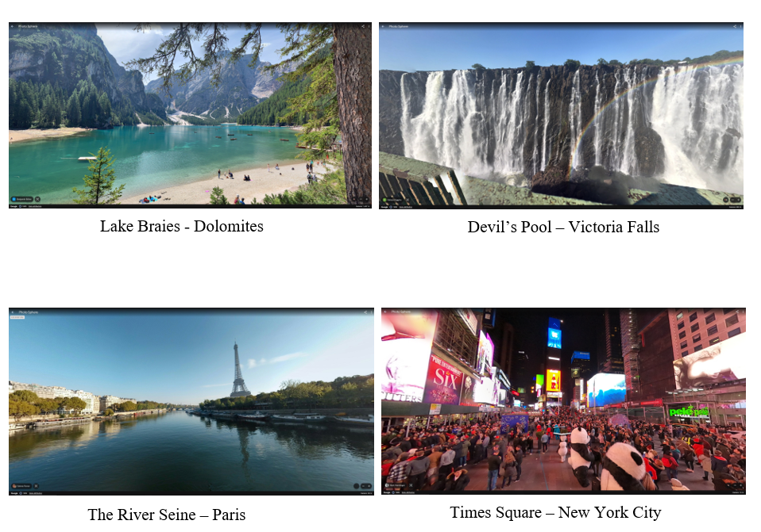
Image depicting chosen test locations [66]

1st Test Results – 19/12/2024

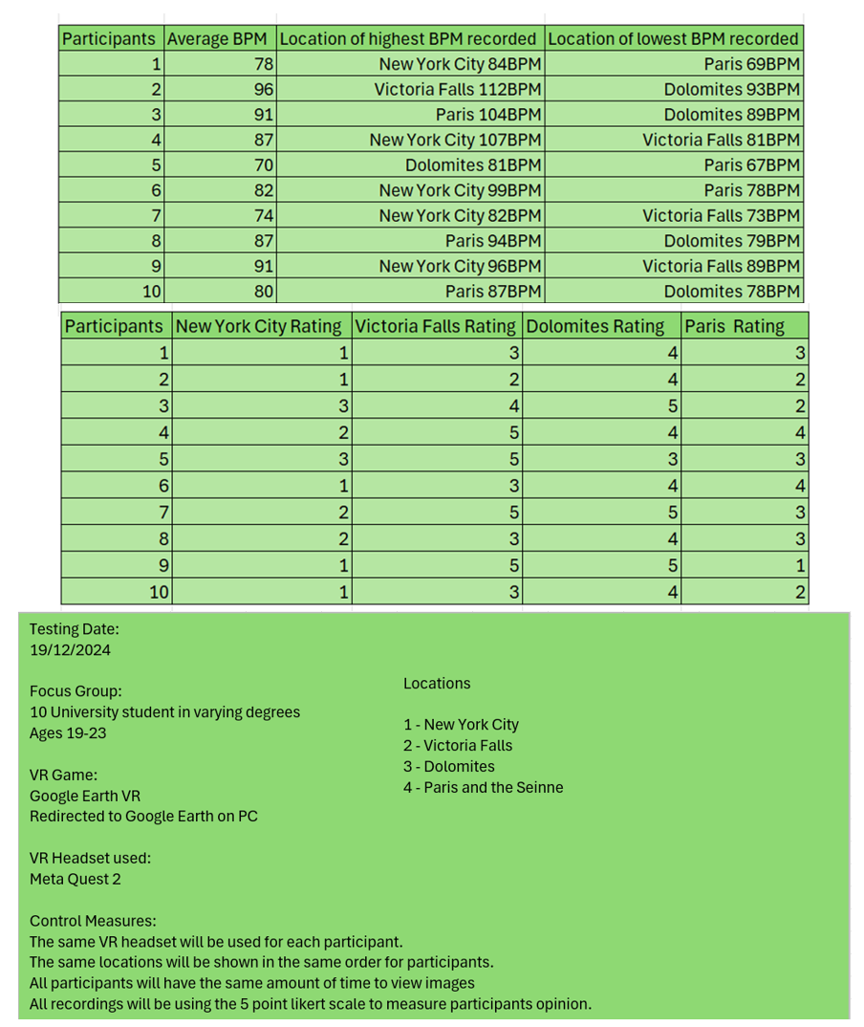
Test Results 1 [67]

2nd Test Results – 29/01/2025

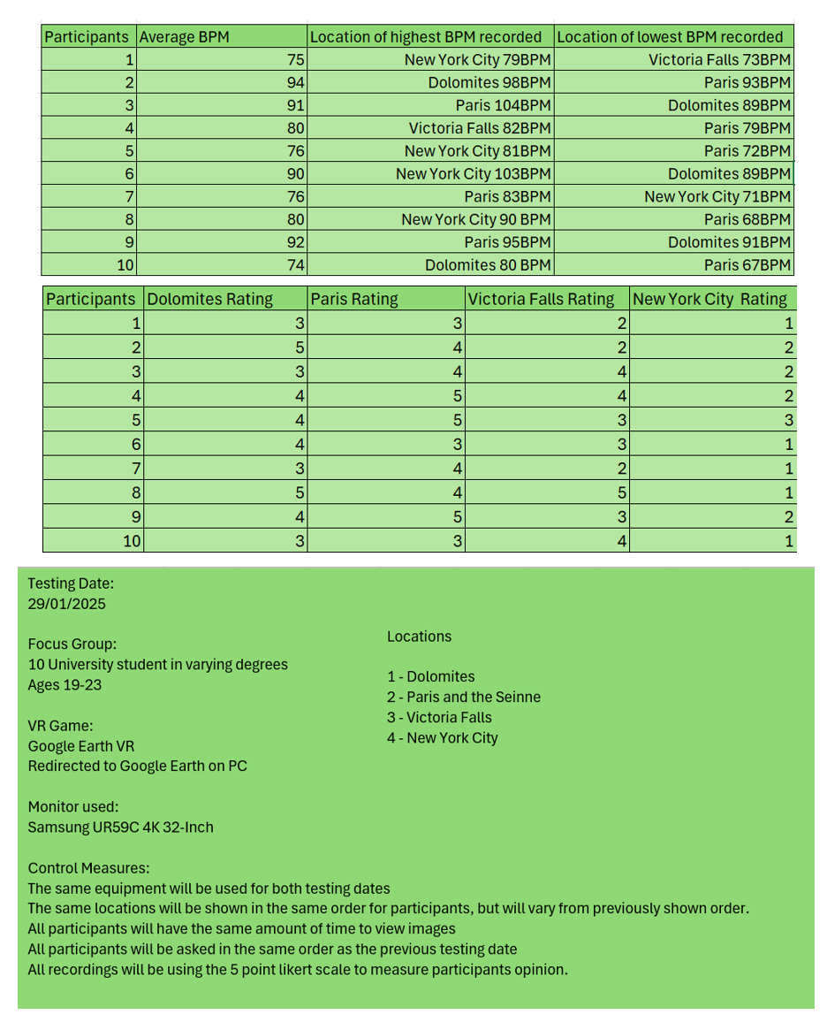
Test Results 2 [68]

The Likert Scale [5] used was named 1=Least Peaceful and 5=Most Peaceful. From the gathered results, the most peaceful scenery that lowered heart beats was Lake Braies, in the Dolomites region of Italy. The most stressful scenery that increased heartrates was Times Square in New York City. However, as participants were shown Times Square as their first location, their heartrate may have been higher due to external factors such as just sitting down and not having time to relax. To avoid this, I tested the same ten participants a month after and showed the locations in a different order than before. The results still steadily show that Times Square was the most stressful location. Interestingly, The River Seine in Paris was the most peaceful within the second round of testing. Although this location is within an urban atmosphere, there is no crowding and a lot of nature within the location, with the calm river and many trees surrounding the roads around, which may be why the location appears to calm people more than Victoria Falls. Although Victoria Falls is a remote location consisting of GNT features [3], the large cliffs and loud sounds of the water may induce stress.
The focus group were sent a screening survey to ensure they were the right fit for the test [69]. The test was originally to be conducted using a Meta Quest 2 VR [42] , however the Google Earth VR application was unavailable, so the test was conducted on a PC. The monitor used was a 4K Curved 32 Inch screen [70], which was chosen to be the closest way to maintain the immersivity of the experience of a VR application. The VR experience would have allowed for further immersivity, and more accurate results. To implement more improvement with this test, the focus group could have been narrowed down further to participants with diagnosed or self-diagnosed mental health issues, such as anxiety or depression. Focusing research on individuals with mental health disorders presents a valuable opportunity to directly assess the therapeutic efficacy of ecopsychology [14] and mindfulness within this specific population. However, ethical considerations would be paramount, including safeguarding participant well-being, ensuring informed consent, and mitigating potential risks, given the potential vulnerability of this participant group due to their mental health status.
From the conducted tests, it was discovered that the unique sensory experiences of mountains, lakes, forests, and rivers [3] were the top contenders of lowering cortisol levels [1]. These features conform to Gestalt Nature Therapy [3] and provide calmness and mindfulness from the opinion of the participants.

3.2 Mindfulness and Wellbeing Case Study

Through a randomised controlled trial, leading research publisher Frontier [71], found that as little as 20 minutes of practicing mindfulness provided an increase within a myriad of positive effects, including decreased cortisol levels and more balanced emotions. However, there was greater evidence that suggested a longer period practicing mindfulness gave further benefits to both body and mind, with increasing cognitive function and longevity [72].
While mindfulness has gained popularity for its potential mental and emotional benefits, scientific evidence supporting long-term neurophysiological changes remains limited. While some studies suggest short-term brain activity changes that aid memory and mood [73], the extent of long-term impact of mindfulness and the brain is still under investigation, with the longest study lasting only 18 months [74]. Fifteen scholars under the National Library of Medicine [75] worked to create an article disproving long-term mindfulness and meditation. The research conducted that mindfulness-based therapy showed a mixture of moderate, low and no efficiency when treating mental health disorders [76].
The objectification theory suggests that media portrayals can negatively impact self-perception, potentially causing body image issues and increased self-consciousness. [20]. Studies have demonstrated that incorporating physical movement into mindfulness practices can enhance their therapeutic efficacy and help to provide a more positive outlook on an individual’s outlook on their self. For instance, research conducted at Washington State University has shown that yoga practices incorporating physical activity, breathing exercises, and meditation can effectively improve mindset and reduce self-objectification in young adults [77]. Furthermore, a study by Jianchun Yin, a Doctor of Physical Education, published in ScienceDirect [78] found that a single session of yoga had a significant effect on reducing anxiety within participants [79]. The rise of practices like Yoga Nidra and Pranayama, which emphasize mindfulness and breathwork without requiring significant physical movement, provides further inclusivity for individuals with physical limitations, potentially contributing to the global rise in yoga's popularity and overtake of meditation [80].

With social media being used by 63.9% of people globally [81] , and by 98% of children within the ages of 12-17 [82], it is crucial to evaluate how the current trends and expectations posted online will affect adolescents and their view of themselves. However, it could be argued that social media is a great asset for providing support to those in need through the ease of networking, reposting, and sharing content [83]. Within the 2020’s googles searches including the word ‘mindfulness’ skyrocketed by . The highest number of searches were from April 2020, when the world went into lockdown, indicating a global change in routine had affected the mental health of much of the population [84]. Depicted below is the google trends search of ‘mindfulness’ from 2004-2025 [85].
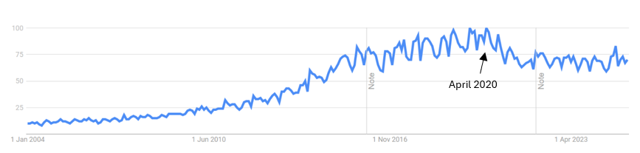
Image of google trends mindfulness [86]

The number one app for mindfulness currently is Calm [26]. The app contains guided meditations, sleep stories and music tracks to help calm individuals. The full version of the app costs $50. From a study that analysed the demographic of calm subscribers by the National Library of Medicine [87], showed that most calm subscribers used the app just before bed to aid with sleep, and had an annual income over 100,000 dollars [87]. With studies on annual income and mental health proving that lower incomes significantly deal with poor mental health [88], this suggests that the Calm app’s features are inaccessible for many wanting to improve their mental and emotional well-being due to the cost [29]. The app offers a free version that has limited access to features.
Calm uses sound frequencies [8] and binaural beats [9] to aid users into a meditative and mindful state. Vibroacoustic therapy uses specific sounds to help with mental and physical well-being [89]. The therapy uses binaural beats [9] to synchronize brain waves to chosen frequencies [8] that hone different results. An instrument that is often used to create these frequencies is singing bowls [90]. Calm's large user base indicates public acceptance of mindfulness apps, relevant to research into VR and mindfulness coherency.

3.2.1 Mindfulness and Wellbeing Methodology

A survey was sent out to find out the awareness and understanding of mindfulness with a total of twenty-one participants. The conducted survey was distributed across various online platforms and university channels. From extrapolating the data found, 80% of respondents indicated they knew what mindfulness is. Regarding the familiarity of specific practices and techniques of mindfulness 65% indicated a positive response of knowing some. The most common response was meditation, followed by breathwork and yoga. Seventy-five percent of respondents claimed to be interested in playing a VR video game surrounding mindfulness, with a significant portion expressing definite interest and another portion being potentially open to it. These preliminary findings indicate a significant level of awareness and perceived benefits of mindfulness. Furthermore, there is a considerable degree of interest in exploring VR as a potential medium for engaging with and enhancing mindfulness practices. These findings provide initial support for the dissertation's investigation into the potential of VR as an engaging tool for mindfulness interventions. The data revealed an equivalent distribution of responses from participants enrolled in the BA Games Design course regarding their preference for the visual environment of VR mindfulness games. Specifically, an equal proportion of this subgroup indicated a preference for VR games featuring a stylized environment and those favouring a realistic environment. Depicted below are screenshots of the survey from SurveyMonkey [91].
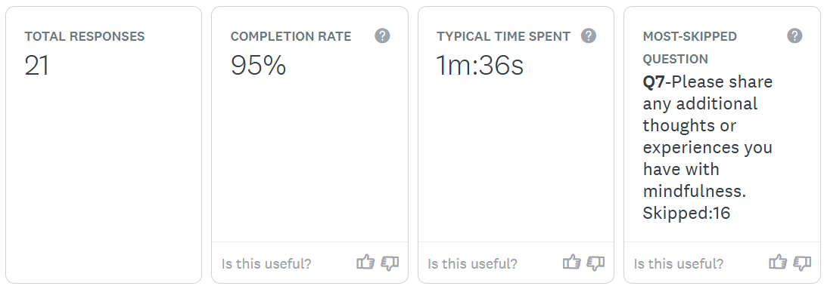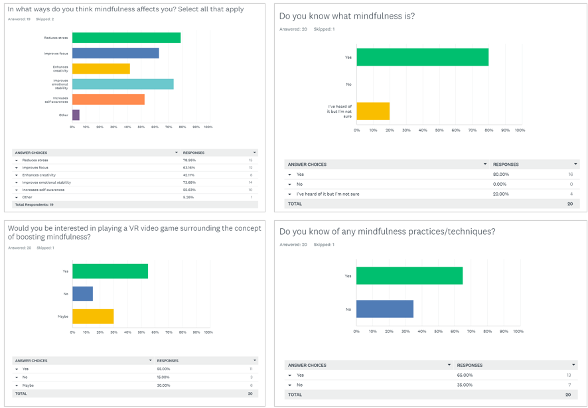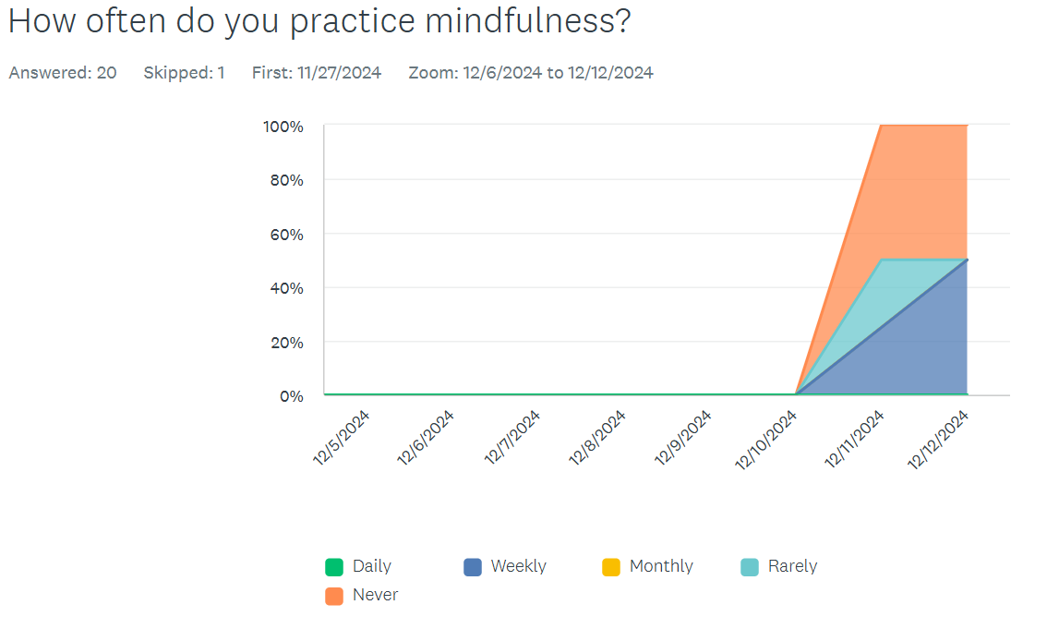
Results from Mindfulness Survey [92]
To enhance the credibility of this study, a larger participant pool would have been beneficial. However, the SurveyMonkey platform [91], through which the survey was administered, restricted the number of respondents to twenty-five. Despite this limitation, SurveyMonkey [91] was selected for its ease of use, accessibility for the target audience and features relevant to the survey design.
A Single-Subject Trial Investigating the Effects of Weekly Yoga Practice on Resting Heart Rate was conducted over the course 4 weeks from 1st December 2024 until 1st January 2025. The individual participant dedicated 20 minutes to partake in Yoga 3 times a week. Blood pressure and blood oxygen was measured before the trial. The individual also conducted an ECG test to monitor any signs of Atrial Afilibriation, however this measurement may not have been accurate due to the participant not being of the age of twenty-two, which the FDA approves as the minimum age for the most accurate ECG measurements [93]. Depicted below are the results from Microsoft Excel [94].

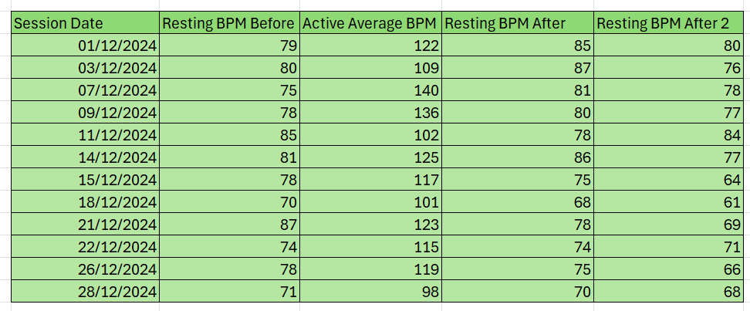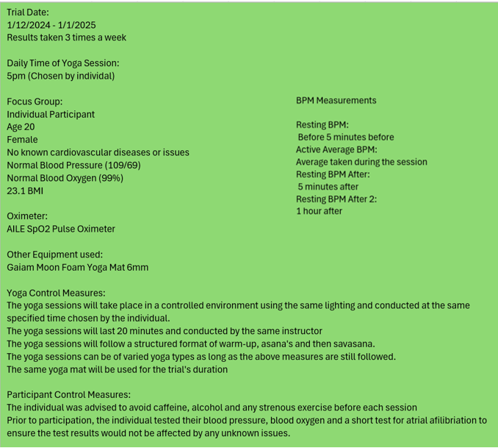
Results of Single Subject Trial [95]

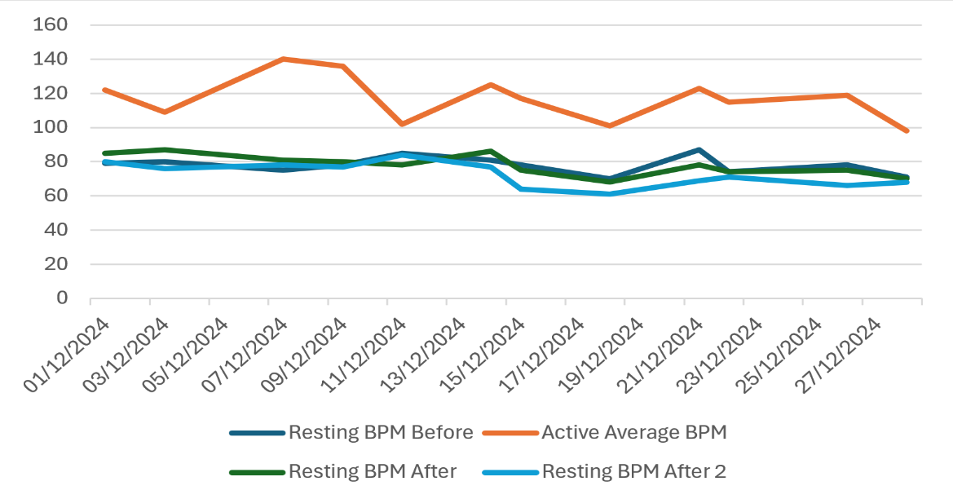
Visualisation of the slight decrease in resting heartrate presented in a line graph in Microsoft Excel [94][96]

While direct HRV measurements are not present, potential changes are inferred by observing the consistency or variability of the resting heart rate at different time points. At 60 minutes post-yoga, the ‘Resting BPM After 2’ indicates a further return towards the individual's baseline resting heart rate. In many instances, the heart rate at this point is very close to or even slightly below the pre-yoga resting heart rate. This suggests that the cardiovascular system recovers significantly within an hour after the yoga session and could indicate a temporary reduction in physiological stress levels immediately following the yoga practice and its recovery period. However, this is not consistent across all sessions. In some instances, the post-yoga resting heart rate (both at 5 and 60 minutes) remains slightly elevated compared to the pre-yoga rate. This variability might be influenced by factors not captured in this data, such as the intensity of the yoga session or external stressors on that particular day. Over the observed month, there is not a strong, consistent downward trend in the ‘Resting BPM’ Before the ‘Active Average BPM.’ While there are fluctuations, the overall baseline resting heart rate does not show a clear pattern of decrease. This suggests that within this one-month timeframe, we cannot definitively conclude a significant change in cortisol levels through any inferred HRV, however it is indicated by some lowering of the resting heart rate after each session. While this data tracks short-term heart rate changes, consistent yoga practice, as indicated by the results being recorded three times a week, could potentially contribute to lower overall resting heart rate and improved cardiovascular health over a longer period, which complies to studies conducted by Frontier [72]. However, this cannot be directly concluded from this one-month trial.

3.3 VR Emotion Effects Case study

Slater’s theory of Place Illusion and Plausibility [21] explains the realistic responses individuals have to virtual environments through the concepts of place illusion and plausibility. The degree to which a user experiences place illusion and plausibility can directly impact the intensity of their emotional reactions within the VR environment. [22] Empirical support for Slater's theory [21] is provided by studies such as that conducted by Taylor and Francis [97].
Taylor and Francis [97] worked to prove slaters theory [21] through assessing the emotional states of participants who were tested within different virtual environments. One group of participants were placed within a ‘natural’ VR environment, whilst the other group was placed within a ‘built’ VR environment. The qualifications for a natural environment consisted of aspects of nature such as forests, parks, mountains, and bodies of water. The built environments contained urban features of man-made structures, dense cities, and concrete flooring. The study concluded that exposure to virtual reality natural environments resulted in statistically significant increases in positive affect and decreases in negative affect among participants. This suggests that immersive and believable virtual natural settings can evoke emotional responses. Conversely, exposure to virtual reality built environments did not result in statistically significant changes in either positive or negative affect. Depicted below is a bar chart displaying the contrasting results of positive effects with natural and built environments [97].
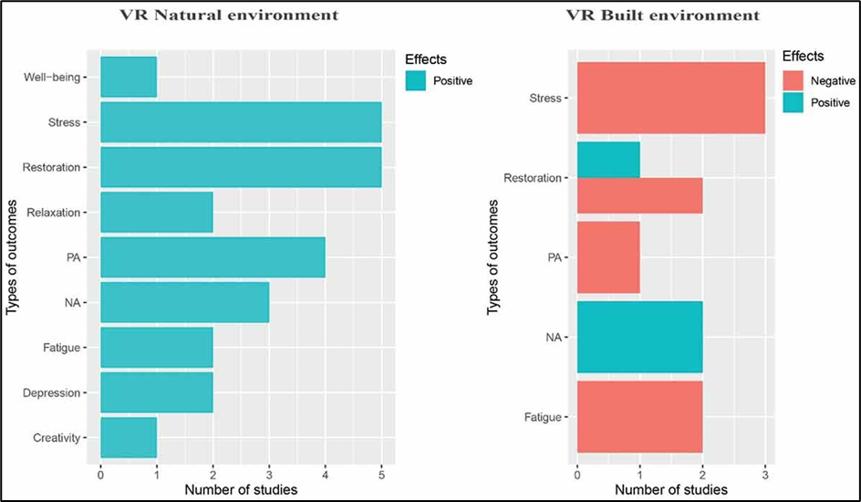
Bar chart of results [97]

Drawing from the established understanding within Ecopsychology [14] that human well-being is inherently connected to the natural world; these results indicate a potential transfer of psychological benefits to virtual natural settings. Consequently, the positive emotional responses elicited by VR natural environments offer a promising foundation for developing VR games specifically designed to enhance well-being and cultivate mindfulness, creating a unique and accessible aid.
A media theory that holds similarities to Slaters theory [21] is Green and Brock’s Transportation theory [23] which posits that deep immersion into narrative or environment can connect individuals to the atmosphere and renders them susceptible to significant emotional and cognitive effects. Given its focus on creating a strong sense of presence within natural landscapes, the NatureTreks VR game [33] provides a potential platform for exploring this transportation phenomenon in the context of well-being. A research article published by Sage Journals [98] delves into the efficacy of NatureTreks VR [33] and inducing a positive mood to NHS staff impacted by workplace stress. The study used subjective measures of emotional states through measuring HRV. The study reported promising findings, with reports of increased happiness from participants, however the research lacked a control group, had a very small sample size, and had no clear connection between the correlation of the VR experience and the participants mood [99]. These limitations impact the strength of the research findings, yet it offers preliminary insights into the benefits of VR for mindfulness.
A current VR mindfulness game on the market is TRIPP [36]. It is a tool for guided meditations that includes interesting visuals and minigames but offers little interactivity. The platform of VR aids users with immersing into a meditative state, yet this is potentially compromised by visual elements that may not consistently foster a sense of presence or believability. This instability may contribute to feelings of discomfort and disorientation within the application as users have reported experiencing motion sickness due to the application’s ‘trippy’ psychedelic visuals and the camera movements, which often occur without prior indication or user control [100].
Furthermore, the limited interactive affordances of TRIPP [36] may impede user engagement and the depth of immersion, potentially diminishing its effectiveness as a mindfulness tool. This contrasts with the understanding from Slater’s theory [21] that place illusion enhances impactful VR experiences and Green and Brock’s [23] concept of transportation fostering engagement.
Consequently, the shortcomings evident in present virtual reality mindfulness experiences, like TRIPP [36], reveal a noticeable gap in the market for a VR mindfulness application that successfully harmonizes calming visuals, user engagement, and comfort to optimally utilize the capacity of virtual reality for nurturing mindful states.
A study from ResearchGate [101] compared 4 VR games with how immersive they were and how much they lowered perceived anxiety [102]. Fuji [103], Nature Treks [33], TRIPP [36], and Real VR Fishing [104]. Depicted below are the graphs of the study [102].

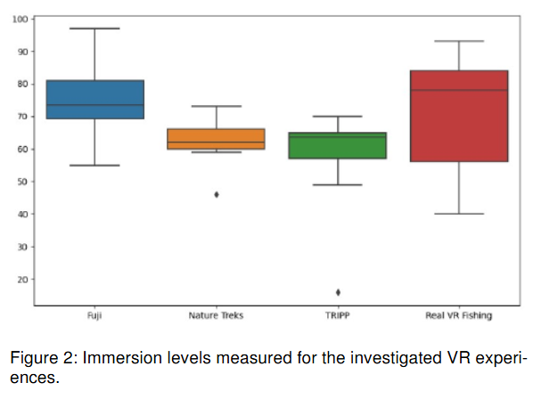
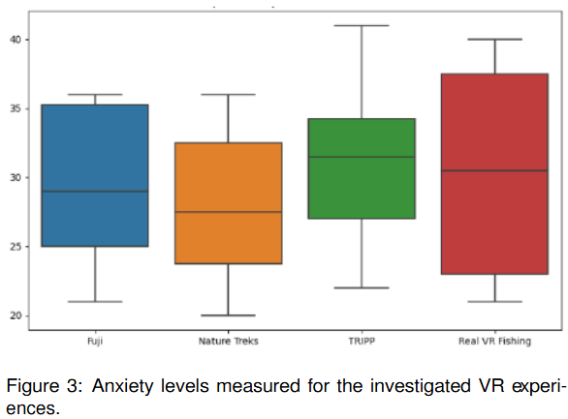
Charts showing immersion and anxiety [105]
A comparison of Nature Treks [33] and TRIPP [36] reveals a notable difference in median immersion levels, with Nature Treks [33] exhibiting a higher degree of immersion than TRIPP [36]. This finding aligns with the potential for Nature Treks [33]to create a stronger sense of presence and transportation, as theorized by Slater [21] and Green & Brock [23], which are crucial for effective VR mindfulness. Furthermore, the shown data shows a possible link towards lower median anxiety levels in Nature Treks [33] compared to TRIPP [36], hinting at the possibility that the greater immersion provided by Nature Treks [33] might be associated with a reduction in anxiety, a key aim of mindfulness practices.
While TRIPP [36] did achieve a mid-range level of immersion within the studied games, and its anxiety scores occupied a central point in the distribution, indicating a moderately affective response, its limitations in interactive elements, as discussed earlier, may prevent users from fully engaging with the virtual environment. Consequently, although TRIPP [36] demonstrates some capacity to induce a sense of presence and influence anxiety, the evidence suggests that its design may not leverage the full potential of VR for cultivating mindful states as effectively as experiences like Nature Treks [33], which appear to offer a more deeply immersive and potentially calming encounter.

3.3.1 VR Emotion Effects Methodology

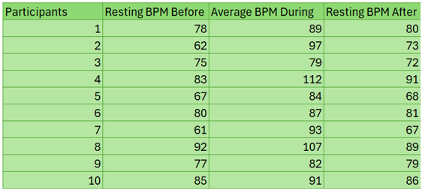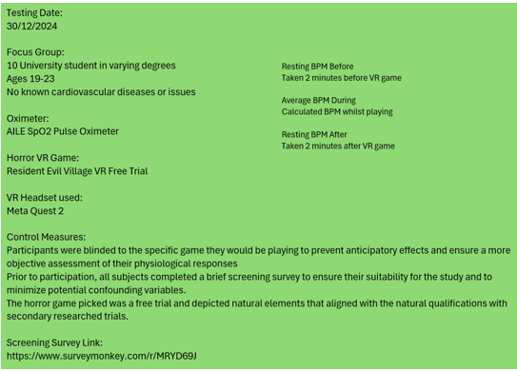
Results of Horror VR study [106]

The primary research methodology involved ten university student participants, aged 18-23, with no known cardiovascular issues, who underwent a brief screening survey. Each participant experienced the Resident Evil Village VR Free Trial [107] using a Meta Quest 2 headset [13]. Heart rate was measured at three intervals: resting baseline before gameplay, average BPM during gameplay, and resting BPM two minutes after. The change in BPM across these intervals was recorded and analysed to assess physiological responses to the VR horror experience. All participants experienced an increase in heartrate during gameplay compared to their resting rate before the game. This indicates a physiological arousal response likely triggered by the horror elements and immersive nature of the VR experience. The average increase in BPM across all participants was +16 BPM, this provides a general measure of the overall physiological impact of the VR horror game on heart rate. Most participants held a higher BPM after the game compared to their initial resting BPM, this could indicate lingering stress or excitement. However, the elevation of heartrate could be attributed to the physical movement and standing of the participants during the test, rather than the horror elements of the VR environment and immersion. To determine if the observed changes in heartrate are relevant and significant, further tests with a larger focus group would be needed for more credibility and accuracy. The study could have also collected subjective data on the participants to indicate a correlation between heartrate and if the participants felt scared or stressed during the test. Depicted below are the test results and control measures.

3.4 Summary of Case Studies

The case studies reveal a consistent trend suggesting that natural environments, both physical [50] and virtual [97], are associated with reduced stress, supporting principles of ecopsychology [14]. While mindfulness practices demonstrate immediate calming effects [72], the extent of their sustained physiological impact requires further research [74][76]. Virtual reality is shown to elicit strong emotional responses [21], and immersive virtual natural environments [33][23] appear promising for fostering calm and mindfulness, potentially more effectively than some existing VR applications [36][102]. Acknowledging the limitations of each study, the collective findings indicate a significant interplay between environment, mindfulness, and well-being, with virtual reality presenting a novel avenue for exploration [21][23].

4.0 Project Conclusion

4.1 Analysis
To translate the dissertation's findings into practical game design, a clear emphasis on natural environments is paramount. Given the observed stress-reducing effects of settings like lakes, mountains, and forests, a therapeutic game should immerse players in detailed, visually rich natural landscapes. This immersion should extend beyond the visual, incorporating multi-sensory elements such as realistic ambient. Drawing from the principles of place illusion and plausibility [21], the game environment must feel believable and coherent, achieved through high-fidelity graphics, interactive elements that promote player agency, and a consistent virtual world. Furthermore, the game could integrate mindfulness techniques directly into the gameplay, offering guided meditations, interactive breathing exercises, and gentle, movement-based activities. To cater to individual needs, personalization options, such as environment selection and adjustable sensory input, would be beneficial. The game should strive to create a virtual space that feels both calming and engaging, drawing on the therapeutic potential of nature and mindfulness practices within an immersive VR context.

4.2 Conclusion

In conclusion, this dissertation has explored the potential of VR game environments as therapeutic tools for mindfulness. The research indicates that VR's capacity to create immersive experiences can promote relaxation and reduce stress, with findings suggesting that both real and virtual natural environments have a calming effect. However, the reliance on small case studies with methodological limitations, including the use of Google Earth as a substitute for Google Earth VR, necessitates cautious interpretation of these results. Future research should address these limitations through larger, more diverse samples and rigorous methodologies, particularly focusing on more long-term tests for effectiveness and should target populations, such as those with anxiety or PTSD, who are more in need of mindfulness and therapy. While preliminary evidence suggests VR may offer a valuable approach to promoting mindfulness and improving mental health, further high-quality research is essential to confirm its therapeutic potential and inform the development of effective applications.

4.3 Reference List

[1] Cleveland Clinic, “Cortisol: What It Is, Function, Symptoms & Levels,” Cleveland Clinic, Oct. 12, 2021. https://my.clevelandclinic.org/health/articles/22187-cortisol
[2] American Psychological Association, “Mindfulness,” American Psychological Association, 2022. https://www.apa.org/topics/mindfulness
[3] “Gestalt Nature Therapy,” GESTALT EQUINE INSTITUTE OF THE ROCKIES, 2024. http://www.gestaltequineinstitute.com/gestalt-nature-therapy.html (accessed Dec. 07, 2024).
[4] D. Caha, “Heart Rate Variability: What It Is and How to Use It Correctly,” Uphill Athlete, Oct. 03, 2023. https://uphillathlete.com/recovery/what-is-heart-rate-variability-and-how-to-use-hrv/
[5] SurveyMonkey, “Likert Scale: Examples and how to use it,” SurveyMonkey. https://uk.surveymonkey.com/mp/likert-scale/
[6] Cleveland Clinic, “Sympathetic nervous system (SNS),” Cleveland Clinic , Jun. 06, 2022. https://my.clevelandclinic.org/health/body/23262-sympathetic-nervous-system-sns-fight-or-flight
[7] K. F. Wong, S. A. A. Massar, M. W. L. Chee, and J. Lim, “Towards an Objective Measure of Mindfulness: Replicating and Extending the Features of the Breath-Counting Task,” Mindfulness, vol. 9, no. 5, pp. 1402–1410, Jan. 2018, doi: https://doi.org/10.1007/s12671-017-0880-1.
[8] “Benefits of Music based on 7 Solfeggio Frequencies,” Meditative Mind, May 16, 2017. https://meditativemind.org/benefits-of-music-based-on-7-solfeggio-frequencies/
[9] H. D. O. Perez, G. Dumas, and A. Lehmann, “Binaural Beats through the Auditory Pathway: From Brainstem to Connectivity Patterns,” eNeuro, vol. 7, no. 2, Mar. 2020, doi: https://doi.org/10.1523/ENEURO.0232-19.2020.
[10] “AILE Pulse Oximeter Oxygen Meter Adults Accurate Fast Easy Larger Red Screen Oxygen Monitor with Lanyard Blood Saturation Monitor -O2 Saturation Meter Pulse-Oximeter : Amazon.co.uk: Health & Personal Care,” Amazon.co.uk, 2025. https://www.amazon.co.uk/AILE-Oximeter-Approved-Monitor-Oximeter-Monitor/dp/B08TTYG32S (accessed Apr. 27, 2025).
[11] H. Lowood, “Virtual Reality,” Encyclopædia Britannica. Nov. 16, 2018. Available: https://www.britannica.com/technology/virtual-reality
[12] H. Lowood, “Virtual Reality,” Encyclopædia Britannica. Nov. 16, 2018. Available: https://www.britannica.com/technology/virtual-reality
[13] “Meta Quest 3S,” Meta.com, 2014. https://www.meta.com/gb/quest/quest-3s/?utm_source=www.google.com&utm_medium=organicsearch
[14] T. Roszak, M. E. Gomes, and A. D. Kanner, Ecopsychology : restoring the earth, healing the mind. San Francisco, Calif.: Sierra Club Books, [Ca, 1997.]
[15] “Ecopsychology | EBSCO,” EBSCO Information Services, Inc. | www.ebsco.com, 2024. https://www.ebsco.com/research-starters/psychology/ecopsychology (accessed Apr. 18, 2025).
[16] P. J. Boston, “Gaia Hypothesis - an overview | ScienceDirect Topics,” www.sciencedirect.com, 2008. https://www.sciencedirect.com/topics/earth-and-planetary-sciences/gaia-hypothesis
[17] J. E. Lovelock and L. Margulis, "Atmospheric homeostasis by and for the biosphere: the gaia hypothesis," *Tellus*, vol. 26, no. 1-2, pp. 2-10, 1974.
[18] Psychology Today, “Gestalt Therapy | Psychology Today UK,” Psychology Today, 2019. https://www.psychologytoday.com/gb/therapy-types/gestalt-therapy
[19] R. E. Kaisler, M. Fede, U. Diltsch, T. Probst, and Y. Schaffler, “Common mental disorders in Gestalt therapy treatment: a multiple case study comparing patients with moderate and low integrated personality structures,” Frontiers in Psychology, vol. 14, no. 1304726, Dec. 2023, doi: https://doi.org/10.3389/fpsyg.2023.1304726.
[20] B. Frederickson, “Objectification Theory,” Ragged University, 1997. https://www.raggeduniversity.co.uk/wp-content/uploads/2018/04/FredricksonRoberts-ilovepdf-compressed1.pdf
[21] M. Slater, “Place illusion and plausibility can lead to realistic behaviour in immersive virtual environments,” Philosophical Transactions of the Royal Society B: Biological Sciences, vol. 364, no. 1535, pp. 3549–3557, Dec. 2009, doi: https://doi.org/10.1098/rstb.2009.0138
[22] M. Slater, “Place illusion and plausibility can lead to realistic behaviour in immersive virtual environments,” Philosophical Transactions of the Royal Society B: Biological Sciences, vol. 364, no. 1535, pp. 3549–3557, Dec. 2009, doi: https://doi.org/10.1098/rstb.2009.0138.
[23] M. C. Green, T. C. Brock, and G. F. Kaufman, “Understanding Media Enjoyment: The Role of Transportation Into Narrative Worlds,” Communication Theory, vol. 14, no. 4, pp. 311–327, Nov. 2004, doi: https://doi.org/10.1111/j.1468-2885.2004.tb00317.x.
[24] “APA PsycNet,” psycnet.apa.org. https://psycnet.apa.org/record/2000-00920-003
[25] Cleveland Clinic, “Cortisol Test: What It Is, Types, Purpose & Results,” Cleveland Clinic, Feb. 21, 2022. https://my.clevelandclinic.org/health/diagnostics/22417-cortisol-test
[26] Calm, “Experience Calm,” Calm, 2023. https://www.calm.com/
[27] M. Espada, “TIME100 Most Influential Companies 2022: Calm,” Time, Mar. 30, 2022. https://time.com/collection/time100-companies-2022/6159416/calm/
[28] Calm, “Calm Blog,” Calm Blog, 2024. https://www.calm.com/blog/about
[29] Calm, “Calm - Subscription Plans,” www.calm.com, 2024. https://www.calm.com/freetrial/plans
[30] “Headspace,” Headspace, 2024. https://www.headspace.com/?gad_source=1&gad_campaignid=917256451&gbraid=0AAAAADLlnJ0E-YiykUIkJ4SQYGle0ZIRo&gclid=CjwKCAjwq7fABhB2EiwAwk-YbCnIqR9JMq0b4lpkFOLzVoclLhtmZOd-mkZc07kvmuewAHwQBbVGtBoCFrwQAvD_BwE (accessed Apr. 27, 2025).
[31] D. Curry, “Headspace Revenue and Usage Statistics (2020),” Business of Apps, Aug. 28, 2020. https://www.businessofapps.com/data/headspace-statistics/
[32] “Subscribe to Headspace,” Headspace, 2025. https://www.headspace.com/subscriptions?gad_source=1&gad_campaignid=917256451&gbraid=0AAAAADLlnJ3MoQkAP6n-oYhbeZdPSP72K&gclid=Cj0KCQjw5azABhD1ARIsAA0WFUE9jWrv8uN6H6TPYn3QxtyTTxoi1kdM___oCGs2LkCZ9I6ul5ewHEsaAlSNEALw_wcB (accessed Apr. 25, 2025).
[33] “Nature Treks,” www.greenergames.net. https://www.greenergames.net/nature-treks
[34] “Nature Treks VR on Steam,” store.steampowered.com. https://store.steampowered.com/app/587580/Nature_Treks_VR/
[35] J. Carline, “Nature Treks VR,” Meta.com, 2022. https://www.meta.com/en-gb/experiences/nature-treks-vr/2616537008386430/?srsltid=AfmBOorvGp-9QPcF8-pIOcUviyxFXkvYVao0wzwDqPFCGumhFSyISHkG (accessed Apr. 25, 2025).
[36] “TRIPP: Fitness for your Inner Self,” TRIPP. https://www.tripp.com/
[37] “TRIPP,” Tripp.com, 2025. https://my.tripp.com/?_gl=1 (accessed Apr. 25, 2025).
[38] “TRIPP,” Tripp.com, 2025. https://my.tripp.com/?_gl=1 (accessed Apr. 25, 2025).
[39] T. Alsop, “Virtual reality (VR) - statistics & facts,” Statista, Dec. 12, 2024. https://www.statista.com/topics/2532/virtual-reality-vr/#topicOverview
[40] A. Chakraborty, “The Prominent Use Cases of Virtual Reality Beyond Gaming,” Mobile Game Development Company India, USA, Nov. 20, 2024. https://www.redappletech.com/blog/prominent-use-cases-of-virtual-reality-beyond-gaming/ (accessed Apr. 25, 2025).
[41] mersusglobal, “non-gaming-VR,” Mersus Technologies, Oct. 25, 2024. https://mersus.io/beyond-gaming-exploring-the-diverse-uses-of-vr-technology/ (accessed Apr. 25, 2025).
[42] “Which Popular VR Headsets Have Generated the Most Revenue?,” VR.Space. https://vr.space/news/equipment/which-popular-vr-headsets-have-generated-the-most-revenue/
[43]“GamesRadar+,” gamesradar. https://www.gamesradar.com/uk/
[44] Abhinav Girdhar, “The Limitations of Virtual Reality,” Appy Pie, Feb. 03, 2025. https://www.appypie.com/blog/virtual-reality-limitations
[45] A. Miller, “7 Challenges in VR Product Development,” AR Insider, Jun. 01, 2022. https://arinsider.co/2022/06/01/7-challenges-in-vr-product-development/
[46] VIAR, “Standardization Could Be a Major Problem for Virtual Reality,” Medium, Apr. 18, 2016. https://medium.com/@viarbox/standardization-could-be-a-major-problem-for-virtual-reality-9250efae1848
[47] R. Carter, “The Future of VR in the Workplace: What to Expect in the Next 5 Years - XR Today,” XR Today, Jan. 15, 2025. https://www.xrtoday.com/virtual-reality/the-future-of-vr-in-the-workplace-what-to-expect-in-the-next-5-years/
[48] “VR Treadmill is Leading the Future and New Era for VR Fitness!,” KATVR, Sep. 28, 2022. https://www.kat-vr.com/blogs/news/vr-treadmill-is-leading-the-future-and-new-era-for-vr-fitness?srsltid=AfmBOoq1b4FaYa-9FjcXQhYW5MHtlApRvCknsIXGsiy85bFjpWaatF4q (accessed Apr. 25, 2025).
[49] “Victoria VR (VR) Price Prediction 2025, 2026–2030 | CoinCodex,” Coincodex.com, 2022. https://coincodex.com/crypto/victoria-vr/price-prediction/ (accessed Apr. 25, 2025).
[50] “Stressed? Take a 20-minute nature pill,” www.frontiersin.org. https://www.frontiersin.org/news/2019/04/09/20-minute-nature-pill-relieves-stress
[51] M. C. R. Hunter, B. W. Gillespie, and S. Y.-P. Chen, “Urban Nature Experiences Reduce Stress in the Context of Daily Life Based on Salivary Biomarkers,” Frontiers in Psychology, vol. 10, no. 1, Apr. 2019, doi: https://doi.org/10.3389/fpsyg.2019.00722.
[52] M. Jimenez, “Associations between Nature Exposure and Health: a Review of the Evidence,” International Journal of Environmental Research and Public Health, vol. 18, no. 9, Apr. 2021, doi: https://doi.org/10.3390/ijerph18094790.
[53] Chris, “So what will it do for Me? - The Gestalt Mindfulness Website,” The Gestalt Mindfulness Website, Jun. 2018. https://www.gestalt-therapy.co.uk/so-what-will-it-do-for-me/ (accessed Dec. 07, 2024).
[54] Arie Cohen, Ph.D., “Gestalt Therapy and Post-Traumatic Stress Disorder: The Irony and the Challenge,” Gestalt Review, vol. 7, no. 1, p. 42, 2003, doi: https://doi.org/10.5325/gestaltreview.7.1.0042.
[55] “How the Seasons Affect Our Psychology | Psychology Today,” www.psychologytoday.com. https://www.psychologytoday.com/intl/blog/unserious-psychology/202306/how-the-seasons-affect-our-psychology
[56] Luke, “Understanding the Spiritual Meaning of Seasons: A Guide for the Curious | Spirituality Shepherd,” Spirituality Shepherd, Aug. 04, 2023. https://spiritualityshepherd.com/spiritual-meaning-of-the-seasons/ (accessed Nov. 27, 2024).
[57] “Stress Reduction Theory - Thrive,” Thrive, 2016. https://www.thrive.org.uk/how-we-help/social-therapeutic-horticulture-resource-centre/therapeutic-opportunities-in-sth/stress-reduction-theory
[58] Z. Smith, “World Happiness Report 2024: Which countries are the happiest?,” ITN Business, Mar. 26, 2024. https://business.itn.co.uk/world-happiness-report-2024-which-countries-are-the-happiest-in-the-world/
[59]“Best time to Visit Scandinavia and the Nordic Countries | VisitNordic,” Visitnordic.com, 2024. https://www.visitnordic.com/en/article/when-to-visit-nordic-countries (accessed Dec. 19, 2024).
[60] “Global Map of Winter Depression Index: Risk by Country | Wellnesspulse,” Wellnesspulse, Nov. 14, 2024. https://wellnesspulse.com/research/a-global-map-of-winter-depression-2024-index-reveals-top-risk-nations/#a-risk-of-winter-pattern-sad-global-trends (accessed Mar. 08, 2025).
[61] T. L, “The top countries with the highest risk of winter SAD are from Europe,” Voronoiapp.com, 2025. https://www.voronoiapp.com/other/The-top-countries-with-the-highest-risk-of-winter-SAD-are-from-Europe-4292 (accessed Mar. 08, 2025).
[62] “Plein air painting in Norway,” Pleinairpaintinginnorway.com, 2025. https://pleinairpaintinginnorway.com/ (accessed Apr. 27, 2025).
[63] mosleyj, “Honors College Democracy Project 2023: Nordic dispatches, week three,” SOU Academic Programs, Oct. 16, 2023. https://sou.edu/academics/honors-college-democracy-project-2023-nordic-dispatches-week-three/
[64] S. Asif, A. Muddassar, T. Z. Shahzad, M. Raouf, and T. Pervaiz, “Frequency of depression, anxiety and stress among university students,” Pakistan Journal of Medical Sciences, vol. 36, no. 5, pp. 971–976, Jul. 2020, doi: https://doi.org/10.12669/pjms.36.5.1873.
[65] Google Earth, “Google Earth,” Google Earth, 2025. https://earth.google.com/web/
[66] SEE APPENDIX Image of google earth test.
[67] SEE APPENDIX Image of google earth results.
[68] SEE APPENDIX Image of google earth results two.
[69] SEE APPENDIX Screening Survey
[70] “Samsung UR590 32 Inch UHD Curved Monitor | Samsung UK,” Samsung uk, Sep. 18, 2020. https://www.samsung.com/uk/monitors/high-resolution/uhd-curved-monitor-with-1-billion-colors-32-inch-lu32r590cwuxen/ (accessed Apr. 27, 2025).
[71] “Frontiers | Mission,” www.frontiersin.org. https://www.frontiersin.org/about/mission
[72] Y.-Y. Tang, R. Tang, and J. J. Gross, “Promoting psychological well-being through an evidence-based mindfulness training program,” Frontiers in Human Neuroscience, vol. 13, no. 237, Jul. 2019, doi: https://doi.org/10.3389/fnhum.2019.00237.
[73] B. K. Hölzel, S. W. Lazar, T. Gard, Z. Schuman-Olivier, D. R. Vago, and U. Ott, “How Does Mindfulness Meditation Work?
[74] M. Coddington, “The Latest Research News on Meditation, Well-Being and the Brain,” Neuroscience from Technology Networks, Jul. 13, 2024. https://www.technologynetworks.com/neuroscience/articles/the-latest-research-news-on-meditation-well-being-and-the-brain-388441
[75] National Library of Medicine, “National center for biotechnology information,” Nih.gov, 2024. https://www.ncbi.nlm.nih.gov/
[76] N. T. Van Dam et al., “Mind the Hype: A Critical Evaluation and Prescriptive Agenda for Research on Mindfulness and Meditation,” Perspectives on psychological science : a journal of the Association for Psychological Science, vol. 13, no. 1, pp. 36–61, 2018, doi: https://doi.org/10.1177/1745691617709589.
[77] “The Role of Mindfulness During Yoga in Predicting Self-Objectification and Reasons for Exercise | Psychology of Physical Activity | Washington State University,” Wsu.edu, 2015. https://labs.wsu.edu/psychpa/2015/02/17/the-role-of-mindfulness-during-yoga-in-predicting-self-objectification-and-reasons-for-exercise/
[78] Science Direct, “ScienceDirect.com | Science, Health and Medical journals, Full Text Articles and books.,” Sciencedirect.com, 2024. https://www.sciencedirect.com/
[79] J. Yin, L. Tang, and R. K. Dishman, “The effects of a single session of mindful exercise on anxiety: A systematic review and meta-analysis,” Mental Health and Physical Activity, vol. 21, p. 100403, May 2021, doi: https://doi.org/10.1016/j.mhpa.2021.100403.
[80] J. N. Davies, J. N. Davies, J. N. Davies, and J. N. Davies, “Prevalence and 20-year trends in meditation, yoga, guided imagery and progressive relaxation use among US adults from 2002 to 2022,” Scientific reports, vol. 14, no. 1, Jul. 2024, doi: https://doi.org/10.1038/s41598-024-64562-y
[81] D. Chaffey, “Global Social Media Research Summary 2024,” Smart Insights, Feb. 14, 2025. https://www.smartinsights.com/social-media-marketing/social-media-strategy/new-global-social-media-research/
[82] Ofcom, “Children and Parents: Media Use and Attitudes,” Mar. 2023. Available: https://www.ofcom.org.uk/siteassets/resources/documents/research-and-data/media-literacy-research/children/childrens-media-use-and-attitudes-2023/childrens-media-use-and-attitudes-report-2023.pdf?v=329412
[83] Z. Zitner, “Mindful Consumption of Social Media Can Support Our Mental Health,” Active Minds, Jul. 15, 2022. https://www.activeminds.org/blog/mindful-consumption-of-social-media-can-support-our-mental-health/
[84] T. I. Bureau, “Relaxation, meditation dominate Google’s 30-day search trends,” TechRadar, May 12, 2020. https://www.techradar.com/news/relaxation-meditation-dominate-googles-30-day-search-trends (accessed Apr. 11, 2025).
[85] “Service unavailable,” Google.com, 2024. https://trends.google.com/trends/explore?date=all&q=mindfulness&hl=en-GB (accessed Apr. 11, 2025).
[86] SEE APPENDIX Image of google trends search.
[87] J. Huberty, A.-M. Vranceanu, C. Carney, M. Breus, M. Gordon, and M. E. Puzia, “Characteristics and Usage Patterns Among 12,151 Paid Subscribers of the Calm Meditation App: Cross-Sectional Survey,” JMIR mHealth and uHealth, vol. 7, no. 11, p. e15648, Nov. 2019, doi: https://doi.org/10.2196/15648.
[88] L. Shields-Zeeman, D. F. Collin, A. Batra, and R. Hamad, “How does income affect mental health and health behaviours? A quasi-experimental study of the earned income tax credit,” Journal of Epidemiology and Community Health, vol. 75, no. 10, pp. 929–935, May 2021, doi: https://doi.org/10.1136/jech-2020-214841.
[89] T. Wigram, “The Psychological and Physiological Effects of Low Frequency Sound and Music,” Music Therapy Perspectives, vol. 13, no. 1, pp. 16–23, Jan. 1995, doi: https://doi.org/10.1093/mtp/13.1.16.
[90] A. Alva, “Vibro-Acoustics of Tibetan Singing Bowls,” Nov. 10, 2021. https://www.researchgate.net/publication/356087105_Vibro-Acoustics_of_Tibetan_Singing_Bowls
[91] SurveyMonkey, “SurveyMonkey: the World’s Most Popular Free Online Survey Tool,” SurveyMonkey, 2024. https://uk.surveymonkey.com/
[92] SEE APPENDIX Image of mindfulness survey results.
[93] Center, “Diagnostic ECG Guidance (Including Non-Alarming ST Segment Measurement,” U.S. Food and Drug Administration, 2020. https://www.fda.gov/regulatory-information/search-fda-guidance-documents/diagnostic-ecg-guidance-including-non-alarming-st-segment-measurement-guidance-industry
[94] Microsoft, “Microsoft Excel, Spreadsheet Software,” www.microsoft.com, 2024. https://www.microsoft.com/en-gb/microsoft-365/excel
[95] SEE APPENDIX image of results from single subject trial.
[96] SEE APPENDIX image of results from single subject trial visualised.
[97] SEE APPENDIX A. Bolouki, “The impact of virtual reality natural and built environments on affective responses: a systematic review and meta-analysis,” International Journal of Environmental Health Research, pp. 1–17, Oct. 2022, doi: https://doi.org/10.1080/09603123.2022.2130881.
[98] Sage Journals, “SAGE Journals: Your gateway to world-class research journals,” Sagepub.com, 2023. https://journals.sagepub.com/
[99] S. Stuart, B. Larson, and S. Scott, “Why virtual reality nature can’t provide the same wellness benefits as the real thing,” Phys.org, Sep. 24, 2024. https://phys.org/news/2024-09-virtual-reality-nature-wellness-benefits.html
[100] Thegamer.com, 2025. https://www.thegamer.com/ps-vr2-meditation-app-tripp-stressful/
[101] ResearchGate, “ResearchGate | share and discover research,” ResearchGate, 2024. https://www.researchgate.net/
[102] G. Wrońska, R. Sterna, Grzegorz Łukawski, and M. Igras-Cybulska, “Exploring User Preferences of VR Relaxation Experiences: A Comparative Mixed-Methods Study,” 2022 IEEE Conference on Virtual Reality and 3D User Interfaces Abstracts and Workshops (VRW), pp. 877–878, Mar. 2024, doi: https://doi.org/10.1109/vrw62533.2024.00235.
[103] F. Labs, “Fujii - A Magical Gardening Adventure,” Meta.com, 2019. https://www.meta.com/en-gb/experiences/fujii-a-magical-gardening-adventure/2033429253367669/?srsltid=AfmBOoqlFJEnXA9ZYJFhCdUIw8hK-ydPJ9lkKTFPMtNg_fGjt5GHkLxH (accessed Apr. 27, 2025).
‌[104] MirageSoft, “Real VR Fishing,” Meta.com, 2019. https://www.meta.com/en-gb/experiences/real-vr-fishing/2582932495064035/?srsltid=AfmBOopBk-BZUBTsBV1OTwBkVMsgr0eHHBc-QCU3lwnDkRXhdluwjTcd (accessed Apr. 27, 2025).
[105] SEE APPENDIX Image of bar chart results.
[106] SEE APPENDIX Image of Horror VR Results
‌[107] “Resident Evil Village VR Mode Gameplay Demo,” Playstation.com, 2023. https://store.playstation.com/en-gb/product/EP0102-PPSA01557_00-DEMOVILLAGEVR004 (accessed Apr. 27, 2025).

‌

‌

‌

‌

‌

‌

4.4 Bibliography

Reddit.com, 2025. https://www.reddit.com/r/gamedesign/comments/6g7u0i/game_design_dissertation/ (accessed Apr. 27, 2025).
‌
https://www.researchgate.net/figure/Illustration-of-the-four-nature-treks-VR-environments-used-in-the-Study-A-Orange_fig3_358749225

‌Kundan, “The Explosive Growth of the Global Yoga Industry,” SQ Magazine, Oct. 17, 2023. https://sqmagazine.co.uk/statistics/yoga-industry-statistics/

Harvard health publishing, “Yoga for better mental health,” Harvard Health, Apr. 29, 2024. https://www.health.harvard.edu/staying-healthy/yoga-for-better-mental-health

M. St.Clair, “Zenlife Center for Healing,” ZenLife Center for Healing, Nov. 07, 2022. https://zenlifehealing.com/is-yoga-better-than-meditation/ (accessed Dec. 20, 2024).
Proposing Mechanisms of Action From a Conceptual and Neural Perspective,” Perspectives on Psychological Science, vol. 6, no. 6, pp. 537–559, Oct. 2011, doi: https://doi.org/10.1177/1745691611419671.

“APA PsycNet,” Apa.org, 2024. https://psycnet.apa.org/buy/2018-51771-001

H. Alger, “3.3 Estimating Energy Expenditure,” pressbooks.calstate.edu, 2022, Available: https://pressbooks.calstate.edu/nutritionandfitness/chapter/estimating-energy-expenditure/

yogaearth, “50 Blissful Yoga Statistics for 2021,” Yoga Earth, Sep. 20, 2023. https://yogaearth.com/yoga-research/yoga-statistics/

M. Remskar, M. Western, E. L. Osborne, O. Maynard, and B. Ainsworth, “Effects of combining physical activity with mindfulness on mental health and wellbeing: Systematic review of complex interventions,” Mental Health and Physical Activity, vol. 26, pp. 100575–100575, Mar. 2024, doi: https://doi.org/10.1016/j.mhpa.2023.100575.

H. W. Schroeder, “Place experience, gestalt, and the human–nature relationship,” Journal of Environmental Psychology, vol. 27, no. 4, pp. 293–309, Dec. 2007, doi: https://doi.org/10.1016/j.jenvp.2007.07.001.

Kevin, “How to Write a Case Study | Examples & Methods,” Wordvice, Feb. 21, 2023. https://blog.wordvice.com/how-to-write-a-case-study/

W. Van Gordon, E. Shonin, and M. Richardson, “Mindfulness and Nature,” Mindfulness, vol. 9, no. 5, pp. 1655–1658, Jan. 2018, doi: https://doi.org/10.1007/s12671-018-0883-6.

“Climate comparison: compare any regions of the world with each other,” Worlddata.info. https://www.worlddata.info/climate-comparison.php

“Web of Science,” Webofscience.com, 2025. https://www.webofscience.com/wos/woscc/full-record/WOS:000496895900007 (accessed Apr. 27, 2025).

Emily, “the value of four distinct seasons,” emily hopcian, Jun. 18, 2017. https://emilyhopcian.com/2017/06/18/the-value-of-four-distinct-seasons/ (accessed Dec. 19, 2024).

“News - New study shows people’s moral values change with the seasons - University of Nottingham,” Nottingham.ac.uk, 2024. https://www.nottingham.ac.uk/news/new-study-shows-peoples-moral-values-change-with-the-seasons (accessed Nov. 27, 2024).

RockLeeSmile, “Indie Impressions - Zen Bound 2,” YouTube, Nov. 27, 2012. https://www.youtube.com/watch?v=KqFvu1FVAaw (accessed Nov. 23, 2024).

M. Goleniewski·#read+watch, “8 Video Games to Practice Mindfulness,” Shut Up & Yoga, Aug. 01, 2019. https://shutupandyoga.com/8-video-games-to-practice-mindfulness/

“10 Mindfulness Games for Adults (and Children!),” Breathworks, Mar. 07, 2023. https://www.breathworks-mindfulness.org.uk/blog/10-mindfulness-games-for-adults-and-children

J. Sutton, “Polyvagal theory explained (& 18 exercises & resources),” PositivePsychology.com, Oct. 17, 2023. https://positivepsychology.com/polyvagal-theory/

Heart, “FitMind,” FitMind, Apr. 2021. https://fitmind.org/blog-collection/heart-rate-variability-hrv-meditation-training (accessed Nov. 23, 2024).

https://www.ecopsychology.org/journal/ezine/archive4/Art-of-Transmutation.pdf

https://uphillathlete.com/recovery/what-is-heart-rate-variability-and-how-to-use-hrv/ (accessed Nov. 23, 2024).

J. Vine, “15 Examples of How Social Media Helps Charities Spread Their Message,” Delivered Social, Jun. 21, 2023. https://deliveredsocial.com/15-examples-of-how-social-media-helps-charities-spread-their-message/

“Measuring Mindfulness: Ancient Awareness for Modern Research - BIOPAC Blog,” BIOPAC Blog, Feb. 28, 2024. https://blog.biopac.com/measuring-mindfulness/ (accessed Nov. 23, 2024).

A. Kyvelou, K. Antonopoulou, G. Kleftaras, A. Verdis, and G. Tsitsas, “The Impact of a Mindfulness-Gestalt Based Counseling Group on Undergraduate College Students,” Psychology, vol. 14, no. 8, pp. 1268–1287, Aug. 2023, doi: https://doi.org/10.4236/psych.2023.148070.

S. Bennett, “How the Seasons Shape Our Psychology: A Closer Look,” Psychreg, Jul. 20, 2023. https://www.psychreg.org/seasons-shape-psychology-closer-look/

Mindsplain.com, 2021. https://mindsplain.com/what-is-ecopsychology/

S. Meed, “Ecopsychology: Exploring the Relationship & Mutual Benefits of Human Beings with The Natural World,” Scientific Origin, Dec. 04, 2024. https://scientificorigin.com/ecopsychology-exploring-the-relationship-mutual-benefits-of-human-beings-with-the-natural-world

P. Plesa, “A theoretical foundation for ecopsychology: Looking at ecofeminist epistemology,” New Ideas in Psychology, vol. 52, pp. 18–25, Jan. 2019, doi: https://doi.org/10.1016/j.newideapsych.2018.10.002.

F. Lymeus, P. Lindberg, and T. Hartig, “Building mindfulness bottom-up: Meditation in natural settings supports open monitoring and attention restoration,” Consciousness and Cognition, vol. 59, pp. 40–56, Mar. 2018, doi: https://doi.org/10.1016/j.concog.2018.01.008.

C. Ackerman, “11 Mindfulness Questionnaires, Scales & Assessments for Measuring,” PositivePsychology.com, Feb. 08, 2017. https://positivepsychology.com/mindfulness-questionnaires-scales-assessments-awareness/

T. Huynh and J. C. Torquati, “Examining connection to nature and mindfulness at promoting psychological well-being,” Journal of Environmental Psychology, vol. 66, no. 66, p. 101370, Dec. 2019, doi: https://doi.org/10.1016/j.jenvp.2019.101370.

A.Chen and Y. Tang, “Exploring the Facilitating Environment for Mindfulness Meditation: Establishing a Framework through Analysis of Means and Exploratory Factor Analysis,” Mindfulness, Sep. 2024, doi: https://doi.org/10.1007/s12671-024-02442-2.

A. Olszewska-Guizzo, A. Sia, A. Fogel, and R. Ho, “Features of Urban Green Spaces Associated with Positive emotions, Mindfulness and Relaxation,” Scientific Reports, vol. 12, no. 1, Nov. 2022, doi: https://doi.org/10.1038/s41598-022-24637-0.

“Virtual Reality Best Practices | Unreal Engine 4.27 Documentation | Epic Developer Community,” Epic Games Developer, 2025. https://dev.epicgames.com/documentation/en-us/unreal-engine/virtual-reality-best-practices?application_version=4.27 (accessed Apr. 27, 2025).

“The Role of Mindfulness During Yoga in Predicting Self-Objectification and Reasons for Exercise | Psychology of Physical Activity | Washington State University,” Wsu.edu, 2015. https://labs.wsu.edu/psychpa/2015/02/17/the-role-of-mindfulness-during-yoga-in-predicting-self-objectification-and-reasons-for-exercise/ (accessed Dec. 26, 2024).
4.5 Appendices

[66]

[67]

[68]

[69]

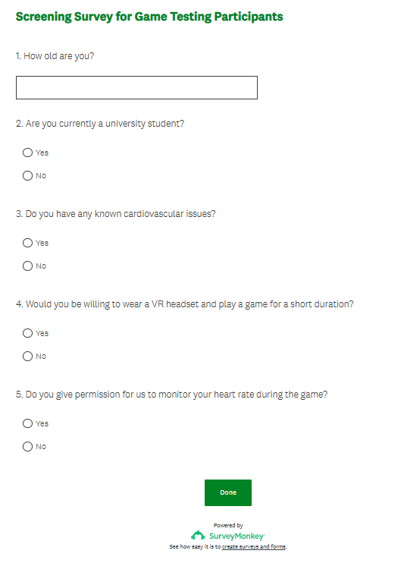

[86]

[92]

[95]

[96]

[97]

[105]

[106]

