2118883@student.uwtsd.ac.uk
method statement on single storey building
2118883
Reference
UK-UWTSD-DEM-MST-10001

Table of Contents
Introduction 2
2.0 SITE ARRANGEMENTS 3
2.2 Working Hours 3
2.3 Regulations in place 3
2.6 Plant Equipment and PPE 4
2.6.1 Plant equipment 4
2.6.3 Asbestos 5
3.0 Methodology 5
3.1 Roof demolition methodology 5
3.1 Methodology for installation of scaffolding 7
4.0 How method statements can be used to manage quality at the construction stage. 9
5.0 References 10
‌6.0 Appendix 11

Introduction

This method statement will undergo a detailed guidance to carrying out the demolition of a single-story roof demolition and the erection of scaffolding by using a safe working methods and following all regulations that are related to the construction work. As work progresses on site, this method statement will be updated with new revisions to ensure it matches the work that is carried out on site or with changes in the site arrangements.

The project undergoing is 12 Church Road, Cardiff, CF3 3BB. Site is based in a residential area that has an alley way on the side of the property. Property was built in 1980s and has no asbestos history (after following the asbestos register), but site investigations and assessments are to carry out prior to starting all construction work. If asbestos is to be evident whilst carrying out the work, competent removal team will be sub-contracted to remove professionally. Further details of asbestos are highlighted below in 2.6.3.

Site welfare facilities and fire assembly points to be carried out in site arrangements 2.0 and to be updated in the method statement if placement requires changing.

Site induction to be carried out on a weekly basis and required for entry to site for employees and visitors. Site induction needs to be arranged with construction manager before visiting the construction site. Daily briefings will be in place every working day at the contractor’s office with weekly TBT (toolbox talks) every Wednesday.

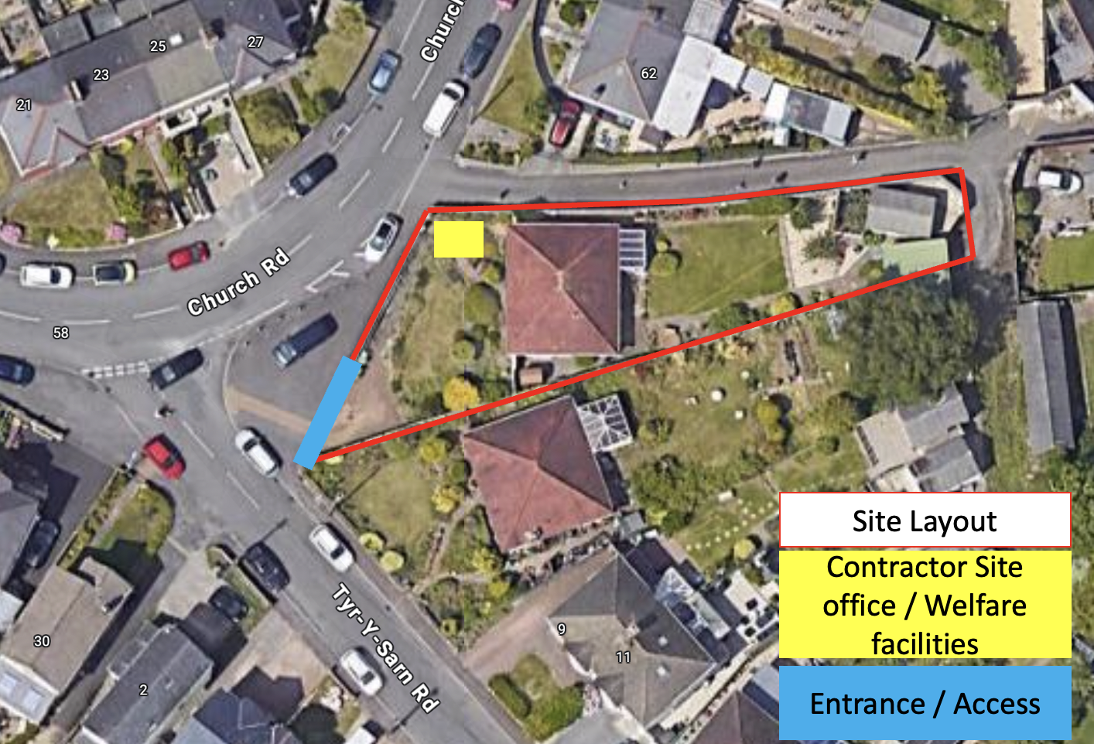
Figure 1: Showing layout of site highlighting. Google Maps. (n.d.).

2.0 SITE ARRANGEMENTS

The contractor is a member of the NFDC (National federation of Demolition Contractor). The appointment of the contractors on site will be adhere to whilst the work is carried out on:

Role (Quantity) | Minimum qualification Required | Responsibility
Construction Manager (1) | NVQ Level 6 in Construction Management  Demolition manager NVQ Level 06  SMSTS | Updating Method statements, documents, Programs and Site safety procedures (Fire exits routes and assembly points)
Site Supervisor (1) | SSSTS  Demolition chargehand NVQ Level 03  First Aid and TMIC qualified. | Managing work to follow program, ensuring safety measures are followed on site and operatives are competent to carry out role responsibility.
Plant Operative (2) | Demolition operative. NVQ required.  CPCS, IPAF | Minimum 2no operatives on shift at a time. Rotation in use of machinery to prevent fatigue.
Scaffolders (3) | CISRS Level 02 | Installation of scaffolding across the perimeter of the job, when required.  Scaffolding supervisor to be qualified and competent for scaffolding inspection and tagging.
General Operative (2) | CSCS  Demolition Laborer Level 01 | Keeping housekeeping clean on site, providing support to plant operatives when required.
Table 1: Showing roles required and minimum requirements from employees.

2.2 Working Hours

Working hours for the site are 08:00 – 16:00 Monday to Friday, with optional Saturday work that is agreed with local council to be maximum of twice per month to avoid disturbance to local neighborhood and stakeholders. Employees to give minimum 1 week notice on Saturday working.

2.3 Regulations in place

The Construction (Design and Management) Regulation 2015 (CDM)
Code of Practice for full and partial demolition (BS 6187:2011)
The Provision and Use of Work Equipment Regulation (PUWER)
Work at Height Regulation 2005
Control of substances hazardous to health 2002 (COSHH)
Scaffolding (BS1139)
Temporary works equipment part 1 – Scaffold. (BS EN 12811-1)
Control of Asbestos Regulation 2012

2.4 Welfare Facilities and Health & Safety

Welfare facilities to be provided in the site office including hot & cold water, providing eating area and toilets. First Aid kit, defibrillation kit and eye wash treatment to be in the site office. All permit to be located at site entrance.

2.5 Safety measures for Services and public domain

All main services (gas & electricity) to the property are to be disconnect or removed (if possible) by third party contractor prior to demolition work carried out. This is to be arranged by the client of the property and confirmed once completed by the client. Utility company to be provided with a site plan showing the planned demolition and advised of the proposed start date. If disconnection is not possible, any live cables or pipework is to be barriered or highlighted in site induction to avoid disturbance. (aefaulks (2021). Services that are found to be live whilst work has started without knowledge, there will be an immediate stop to our work until it is confirmed to be disconnected by third party client. Emergency services will be called if required. Construction site will be fenced with ‘Heras fencing’ across the perimeter to ensure no once can access site excluding site entrance. Site entrance to be gated for entrance for machinery.

2.6 Plant Equipment and PPE

2.6.1 Plant equipment
A list of equipment will be required for the job being carried out. The equipment below will be hired onto site when applicable:

Equipment | Details | Quantity
Excavator | 10T including necessary bucket and shears (Figure 5) | 1
Dumper Truck | 10T JCB Dumper Truck (Figure 4) | 1
MEWP | Nationwide – Niftylift HR15NBS | 2
Waste skips | Metal, Timber and General | 3
Fencing | Heras Fencing (Figure 2) | Minimum requirement
Table 2: Highlighting equipment required to carry out job. Photos in Appendix.

All scaffolding equipment required including tubes, clamps, couplers, and boards to be followed with British Standard BS1139 and BS12811-1 (‌Temporary works equipment – Part 1: Scaffolds -Performance requirements and general design. (n.d.).

2.6.2 PPE Required
A list of PPE (Personal Protection Equipment) required for the job carried out. All PPE will be supplied by the employer. The below will be always required mandatory on site:
- Hard hat
- Hi-Vis Trousers, long sleeve shirt, gloves, and glasses.
- Ear Defenders and dust makes when applicable.

2.6.3 Asbestos
If any potential asbestos materials are to be found on the construction site during any time and may contain asbestos the work must immediately stop and the employer / contractor carrying out the work must investigate to find out if it is asbestos. The employer is to check if the building is registered on the asbestos register. If asbestos is broken or disturbed during the construction phases, this must be dealt with appropriately. Survey and checks to be required prior to work undergoing. Employer to provide employees with awareness training for all workers in case of any found on the property. (www.hse.gov.uk. (n.d.).

3.0 Methodology

3.1 Roof demolition methodology

Roof Demolition | Description
Structural assessment | Prior to carrying out the demolition, a structural assessment is required to be carried out to understand the best approach for the demolitions of the roof. The construction manager will identify vulnerable areas of the building that could have more risk of injuries to employees and look to demolish this area first as they could be an increased danger further down the job. This assessment should include the roof, retaining walls and foundation of the building. In the structural assessment, the main structure of the roof should be noted to understand the roofing material. For example, roof trusses, beams, or other supporting materials. Prior to the work starting, the site team will be briefed of the working activities using a VTS (Visual task sheet) to show the sequence of the work and will be aware of any risks that are involved in the site operations. This will be signed by all employees once briefed.
Clear and prepare the area | Remove any debris from the surrounding area to provide a sufficient working area prior to starting the job. Any obstacles that can cause injury or risk to employees needs to be removed. Once completed, the perimeter of the site can be barriered up using fencing. This will prevent unauthorized access entering the premises. Heras will be installed across the perimeter of the building as the roof is demolished to prevent dust. (Figure 2)
Removal of roofing materials | Prior to demolition, all roofing materials such as tiles, metal sheeting and shingles are to be removed from the roof using the appropriate tools. Peri-Up scaffolding will be used if access is required manually. If asbestos is found in this step, process [2.6.3] to be followed.
Main dismantle of roof structure | After the assessment of the main roof structure is known, the employer can start removing the roof structure using the 10T excavator using the correct bucket or shear. This area will be barriered off for all employees whilst undergoing demolition. 10T dumper truck to be parked behind the excavator for efficient waste management. If identified that there are areas the 10T are unable to get to, general operative will use manual handled tools to assist such as saws or cutting tools. Excavator will be required to be turned off if stakeholders are involved manually in the demolition in proximity.  The work commencing the demolition will be in sequence starting from one side of the property and work towards the end. It is identified to start the demolition towards the back of the property to prevent the effects of dust and noise pollution around residents and neighboring properties.  The demolition process will be a ‘top to bottom’ method avoiding the potential of any large structural collapsed areas and recognizes a safe working method when operatives are using MEWPs around the building to assist in removal of debris.
Removal of Roof Trusses | The 10T excavator will be predominantly used for the removal of the roof trusses by individually bringing them down to the ground. Whilst the trusses are dismantled, the materials will be segregated and disposed or salvaged depending on the condition of the material.
Waste removal and management | Once demolition work is completed, waste will be segregated into the individual skips mentioned in [2.6.1] Plant equipment. This will be regulated by the construction manager to ensure that environment regulation on site is being adhere to and stops all materials going into general waste. There will be an environment inspection around the perimeter to confirm no environment incidents have occurred and all dust is removed or sprayed down on the site. COSHH kits will be ready for disposal.
Inspection of work | An inspection of the work prior to finalizing the job will be carried out by the construction manager and operatives to guarantee the removal of any hazards or potential unexpected circumstances. Once confirmed, construction manager to inspect with the client to ensure satisfaction of the job. Any deviation that may have occurred due to access or job workability will be agreed with the client in this time to verify satisfaction with the work. A completion report will be signed by both the client and contractor to verify the agreement of the work carried out is sufficient work.
Table 3: Methodology for Demolition work

3.1 Methodology for installation of scaffolding

Installation of Scaffolding
Design scaffolding system and plan sequence. | Design scaffolding system for the areas requiring the scaffold and considering the height of the property, best access points and load bearing capacity.  Distance from the scaffold to the demolition work should be taken into consideration. A sequence of installation and dismantle for the scaffolding needs to be planned around the demolition work to avoid interfering with any demolition work or unsafe areas. This is to be adjourned with the construction manager.
Inspect scaffolding materials | All scaffolding materials should be inspected prior to use by a competent person to check suitability. This includes checking scaffolding tubes, braces, frames, and platforms are in good condition. If equipment does not pass the inspection, wait until provided new supply.
Erect scaffolding / Access points | Scaffolders to follow the sequence of work planned and ensure all scaffolding is followed by drawings provided. Scaffolding to be plumb after installation and anchored to the ground. To provide support, diagonal tubes will be installed connecting elevated scaffolding. Fall arrest harnesses must be used during the process of erecting scaffold as access points have not been installed yet as well as edge protection on going. Once completed, access points will be installed onto the scaffolding using Peri-up stairs to prevent the use of ladders in the property. (Figure 3)
Inspections | Regular inspections to be carried out throughout the demolition works of the scaffolding and the escalib. Any concerns will be immediately address by the scaffolding team during inspections. Scaffold tags to be signed once inspection completed to provide proof of inspections.  If any changes are noticed on the scaffold that do not show on drawings provided or were in original design, a TFCR (Temporary field change request) will be filled in and approved by the appointed TWS.
Dismantle Scaffold | Dismantle the scaffolding following the sequence provided prior to work undergoing. Ensure safety measures are taken to prevent accidents occurring.
Table 4: Methodology for scaffolding erection

4.0 How method statements can be used to manage quality at the construction stage.

Method statements are used in the construction industry to help manage the work in a safely manner and allows the employer to control the work by following the assigned health and safety procedures. A method statement will include all details about the job carried out starting from the introduction to finishing the job. It will provide evidence that all health and safety risks are identified (either prior to the work or as the job in undergoing). It will also be reviewed and signed by all employers and stakeholders that enter the work perimeter to make certain that everyone is aware of the sequence of work and the risks involved in the job.
A method statement can be significantly used to manage the quality of the job as it provides a clear scope and objective for the work. For example, a step-by-step guidance is provided in the methodology so that as the work progressives, all workforces will understand exactly what the next step of the work is intended. This directly prevents that work going off-board which could result in not only increased amount of accidents, but also a rise in cost.
Method statements are not a requirement of the CDM 2015 regulations but are identified by the HSE as a very competent way of managing the safety of the job as it will assess all risks involved and is briefed to the workforce. (www.designingbuildings.co.uk. (n.d.). This provides quality to the job as when an employer is writing a method statement for the work. All regulations involved in this area will be adhere to and procedures required will be followed leading to an increase in quality and safety of work.
As the method statement is written, management theories can be applied to this method statement to improve the quality and efficiency of the work being carried out. For example, Henri Foyal theorist of ’14 principles of management’ is based upon authority, discipline, and division of work by allocating resources effectively and will ensure that construction projects are executed in a timely manner as everything is coordinated on the job. By using this theory, it will benefit the construction work as it will improve employee morale and customer satisfaction, reduced costs and increase productivity. (Simplilearn.com (2021).
Method statements can be used to manage quality during construction as it will provide the opportunity to resource allocation at the correct time of construction. For example, not all personnel or equipment will be required throughout the construction phase. Therefore, when required they can be brought in leading to less time hiring sub-contractors to carry out the jobs or hiring machinery for less time meaning reduce costs for budgeting. Proper resourcing will also contribute to tasks being more efficient and at better quality as there will be an increased amount of area to work as they will be less requirement for storage of materials on the work front causing disruption. Method statements are precedent before the work begins in construction but can change during construction if other methods are seen upon to provide higher quality workability. By using method statements on the job, this will provide continuous reviews as the job progresses and allow for improvements on quality as well as potentially reduce the duration of the construction work. This can then be reflected upon in a ‘Lesson’s learn’ method and be brought on to future jobs.

5.0 References

aefaulks (2021). What Should Be Considered Before Demolition | AE Faulks. [online] AE Faulks Ltd. Available at: https://www.aefaulks.co.uk/what-should-be-considered-before-demolition/#:~:text=General%20procedures%20that%20should%20be [Accessed 6 Dec. 2023].

www.crowdcontrolsolutions.co.uk. (n.d.). Heras Fence Panels - Temporary Mesh Fence Panels. [online] Available at: https://www.crowdcontrolsolutions.co.uk/shop/heras-fence-panels/85.htm [Accessed 6 Dec. 2023].

www.designingbuildings.co.uk. (n.d.). Method statement for construction. [online] Available at: https://www.designingbuildings.co.uk/wiki/Method_statement_for_construction#:~:text=Method%20statements%20are%20not%20a [Accessed 6 Dec. 2023].

Google Maps. (n.d.). Google Maps. [online] Available at: https://www.google.com/maps/place/Church+Rd.

www.hse.gov.uk. (n.d.). A worker’s guide to asbestos safety - HSE. [online] Available at: https://www.hse.gov.uk/asbestos/workers.htm [Accessed 6 Dec. 2023].

www.jarvieplant.co.uk. (n.d.). 10t Midi Excavator. [online] Available at: https://www.jarvieplant.co.uk/product-catalogue/171-10t-midi-excavator [Accessed 6 Dec. 2023].

PERI (n.d.). PERI UP Stairs. [online] PERI UP Stairs. Available at: https://www.peri.com/en/bauma-2022/trade-fair-stand/topics/peri_up_stairs.html [Accessed 6 Dec. 2023].

Simplilearn.com. (2021). 14 Principles of Management by Henri Fayol | Simplilearn. [online] Available at: https://www.simplilearn.com/principles-of-management-by-henri-fayol-article#:~:text=Henri%20Fayol.

‌Temporary works equipment - Part 1: Scaffolds -Performance requirements and general design. (n.d.). Available at: https://www.wm-scaffold.com/wp-content/uploads/2021/06/BS-EN-12811-1-British-Standard-Scaffolding-Performance-Requirement.pdf.

Thomas, T. (2019). 10 Ton Dumper Hire Nationwide | Front Tip or Swivel Tip Dumper Hire. [online] Ridgway Rentals. Available at: https://www.ridgwayrentals.com/plant-hire/10-ton-dumper-hire/ [Accessed 6 Dec. 2023].

‌6.0 Appendix

References | Photos
Figure 2: Heras Fencing (www.crowdcontrolsolutions.co.uk. (n.d.). | 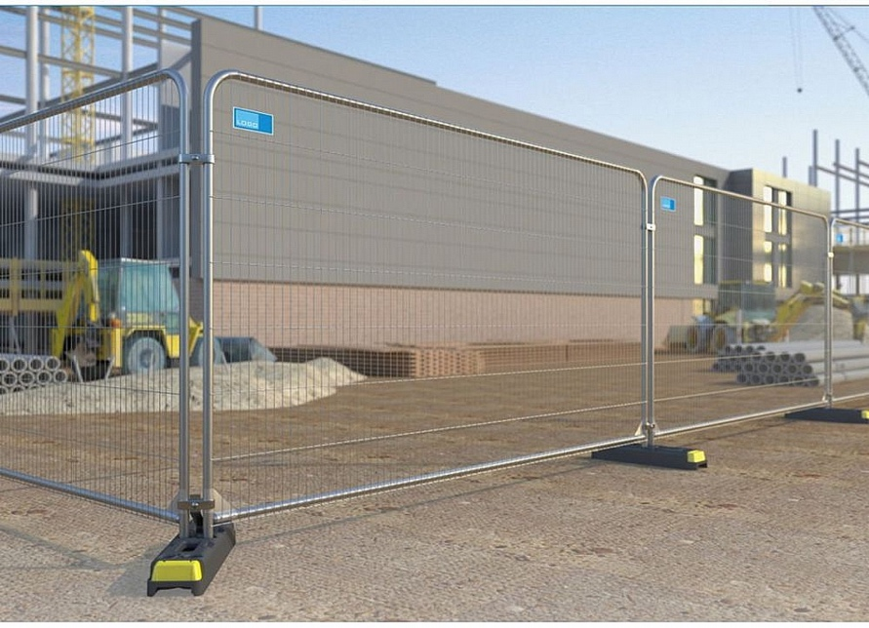
Figure 3: Peri-up scaffolding stairs (PERI (n.d.). | 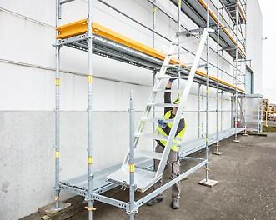
Figure 4: 10T Dumper Truck (Thomas, T. (2019). | 
Figure 5: 10T excavator (www.jarvieplant.co.uk. (n.d.). | 

