
Skills for the Workplace
Module Assignment Submission
Student Name: | Melissa Davies
Student Number: | 1911024
Module No: | BMSK4001
Module Title: | Academic and Employability Skills

Statement of Confirmation of Authenticity
By the act of making this submission, the student declares that this is the work of the student named above. The work has not, in whole or in part, been knowingly presented elsewhere for assessment, or where assessment has been built on a previous assessment, this has been identified. Where materials have been used from other sources it has been properly acknowledged. If this statement is untrue, the student acknowledges that an assessment offence has been committed.
Attention is drawn to the plagiarism and unfair practice policies of both the University and of ILM.

Table of Contents
Introduction 3
Part 1 Employability 3
1.0 Explore ‘Leadership Employability Skills’ in general 3
1.2 Evaluate own Leadership Employability skills 4
1.2.1 Current Employability skills 4
Gap Analysis to identify ‘gaps’ in knowledge/skills 4
1.2.2 Action Plan for Improvement 5
Part 2: Academic Skills 6
2.0 Reflection on Academic Skills required for University Level Study 6
2.1 Evaluate own Academic Skills 6
2.1.1 Current Academic Skills 6
Gap Analysis to identify ‘gaps’ in knowledge/skills 6
2.1.2 Action Plan for Improvement 7
Conclusion 7
References 8
Appendix 9

Introduction

The author is a 25-year-old full time deputy manager in a children’s residential home managing a 3-bedroom home and a staff team of 20 employees. The author is currently undertaking a higher education skill for the workplace course as one of her future goals which she has identified in other previous assignments that her aim is to open her own business.
Employability and academic skills are important for both professionals and non-professionals to gain relevant experiences and participate in different jobs which widen the chances for career development. In this report, the author is going to analyse and summarize the different academic skills required at a leadership and management level and the outcomes of achieving skills and personal development for employment. A simple but a detailed reflective writing will be carried out through the report by the author which she will then produce an effective academic writing ensuring that she includes relevant and accurate references which will include a variety of references from internet sources, journals and books. The author will evaluate and think about her own personal development plan and will identify her own skills she currently has alongside the identified skills she should have to enable her to develop further in her career. The author aims for her writing to be reflective throughout and that her personal development plan will be effective and efficient enough for her own career development. The creator will ensure she evaluates her skills through a gap-analysis based action plan which will be identified several times throughout her assignment.

Part 1 Employability

1.0 Explore ‘Leadership Employability Skills’ in general

Employability skills are skills that apply to a variety of organisations for jobs advertised. They are also known as skills which are required for someone to gain employment or enhancing progression. (Rao 2010) states that over the year’s skills have been implemented and can be categorised in different groupings relevant to the specific job. For example, the author will have her own categorised employability skills to enable her to lead and be at a required management level.
Additionally, the author has identified the following as categorised employability skills such as communication skills, reporting skills, leadership skills, PC skills, problem solving skills, organisational skills, ability to use initiative, numeracy, negotiation skills, ability to learn and adapt.
Having identified examples above of general employability skills the author has chosen three employability skills to describe further which she believes are relevant skills to herself to ensure she is at a leadership and management level.
The author strongly feels communication skills is a significant role in developing a positive working relationship with team members. Without communication the author would not be able to give out clear information or instructions to her staff team which would therefore cause a barrier whereby the author will be unable to manage or lead her team. As a deputy manager the author is expected to demonstrate clear and precise instructions. Although (Ward 2002) states that communication is a shared understanding between more than one individual, which doesn’t necessarily have to be verbal communication it can include written communication. The author is also expected to have communication skills in her higher education course as they are relevant when communicating with her fellow students and tutors. Communication skills are implemented to help create a rapport, in verbal communication there are elements such as eye contact and body language. Communication is so broad and involves many examples such as; negotiation, conflict management, and mirroring.
All organisations require leadership skills, which is a demanded skill and can be acquired in higher education courses to help create effective management. (Adair 2007) states that an individual identified as a good manager is a leader but to become a leader you require leadership skills. The author can relate to this as despite her being a deputy manager she has identified a weakness through a SWAT analysis that she lacks confidence, but this doesn’t determine she isn’t a good manager. Following on from this the author is eager to learn which has been identified by her enrolment in the higher education course. However (Dugan and Komives 2007) argues against the author and states that leadership skills are not developed by education but are in fact acquired through experience. Leadership skills demonstrated by the author include supporting her team members, carrying out regular meetings, implementing policies and procedures, ensuring staff team are adhering to appropriate protocols.
Team working is highly recognised, the authors employer seeks that the author can work effectively with other people. The author can identify that her staff team consist of different backgrounds and disciplines. (Orner 2009) states that working in partnership with other individuals is a mandatory requirement for any organisation. The authors organisation has a strict policy which implements that there is no “I” in team to ensure all team members can work effectively together maintaining a high standard. There are two terms which can be defined regarding teamwork and that is “groups” and “teams”. (Muchinsky, 2003) has argued the belief that groups, and teams are nearly the same thing. The author agrees with this as she believes both definitions identify that individuals work together either as a group or team to accomplish something.
Leadership and management are two ways of organizing people effectively in organisations. The author believes that managers think incrementally, and leaders think radically. Fortunately for the author she has experienced being both a leader and manager, so she is able to evaluate both from her personal experiences. She has identified that a leader can remove obstacles for the purpose of growth, development and the performance of a team. A leader has the skill to motivate their teams to want to carry out their roles. Whereby a manager has the skills and ability to put themselves in their team’s shoes to gain knowledge and experience of their daily challenges, they also exemplify the more structured, controlled and analytical person. (Ricketts, 2009) states that he believes there is a difference between both leadership and management but explains an individual can be both with the right knowledge. However, an argument can be opposed as (Kotter, 2001) believes that leadership and management are both equally important for aims to be achieved. The author strongly feels that a leader is just as important as a manager in an organisation, with an identified difference that in her line of work a manager is always held responsible for the outcomes of any member of team within the organisation.

1.2 Evaluate own Leadership Employability skills

As a deputy manager the author is required by her organisation to have categorised employability skills as previously identified in 1.0. The author can identify her own employability skills and her own areas of improvement by carrying out a SWOT analysis and a Gap analysis. The (confederation of British Industry 2008) states that employers expect higher education students to have developed employability skills so that they can make an immediate contribution to the organisation when recruited. The author has been very fortunate within her organisation due to them providing relevant training to build her employability skills.
The author can often be too hard on herself when she self-evaluates, she often forgets to evaluate her strengths as well as her weaknesses. Fortunately, by carrying out a Gap analysis this will enable her to identify her current positions as well as creating actions to complete to overcome her objectives and deficiencies. The author can learn and adapt and is always enthusiastic about her work ethic, and always tries to find a way of learning from her mistakes. The author believes that she will become a better leader or manager by developing further with self-evaluation, so she is able to see herself exactly how others see her. As the author is too quick to self-evaluate all her weaknesses and believes that other people also see her weaknesses over her strengths.
The author can communicate effectively whereby she is able to clearly and succinctly explain relevant information to her employees. This can be demonstrated through phone, email, social media. Effective communication skills enable the author to have the ability to listen, so she takes on board her employees views and opinions. During her self-evaluation she has identified that an improvement required to be made is for the author to not allow herself to engage too much into conversation with her employees as this can create a barrier whereby she becomes more of a friend than a leader/manager. This can cause unwanted atmospheres and breakdown of working relationships.
Following on from the author identifying that she needs to remain professional with her team members, she has also recognised that she needs to work on the ability of giving her team members feedback and constructive criticism if required. The author is competent to carry out positive feedback to her team but always dreads giving constructive criticism as she doesn’t want to upset or offend people. This is where she needs to sit with her manager to gain confidence and seek further support to be able to develop the skill for her to become a stronger leader and manager.
Leaders like the author are expected to delegate roles and responsibilities to other employees, the author takes on too many tasks by herself as she often fears that when she delegates it is demonstrating a weakness whereby in fact it can be seen as a sign of a strong leader. The author needs to start assigning job roles to her team so she can identify their employability skills and weaknesses. This will also enable the author to work on her time management as by delegating tasks will free up time for the author to carry out other duties. (Geotsch & Davies 2014) states believes that organising, planning and delegating are imperative skills needed to become a leader. The author believes she is organised and can plan, but as stated above needs to improve on her delegation skills.

1.2.1 Current Employability skills

Gap Analysis to identify ‘gaps’ in knowledge/skills

Objective | Current Position | Deficiency | Action
What do I want to do? | What can I already do? | What am I lacking? | How do I fix this?
Become a registered manager | Manage a staff team of 20 people  Lead a team  Ensure staff adhere to relevant protocols  Paperwork is to a high standard  Implement and update policies and procedures | Confidence  Haven’t got relevant qualifications required | Continue undertaking relevant qualifications required  Make myself known  Check in monthly with management team
Resit numeracy GCSE | Use brief numeracy equations  Completed numeracy essential skills (level 2) | Failed GCSE  Patience  Time management | Look into undertaking numeracy GCSE
Confidence | Decision making  Leading a team  Providing support | Self-confidence  Doubting own ability | Supervisions  Feedback  Self-evaluations

The author has carried out a gap analysis to identify gaps in her own knowledge and skills to help her recognise objectives and her current position which will benefit her for her to find actions of improvement.
For the author to become a deputy manager she is required to be level 5 qualified; the author is aware of this and is currently already undertaking the relevant qualification. Despite the author being academic enough to complete relevant qualifications the author needs to have required employability skills for her to progress further. The gap analysis carried out has identified the author needs to build up her confidence and seek support from her manager with regular supervisions for her to have targets set to enable her to build up her confidence. The author is confidently able to lead a team and be supportive but needs to work on her own self-confidence in order to better herself ready for when she is qualified to progress further in her career. Fortunately, enough numeracy is not a mandatory requirement within the organisation the author works for. The author has an essential numeracy skill level 2 but would like to re-sit her numeracy GCSE to have under her belt for future progression.

1.2.2 Action Plan for Improvement

Objectives | Tasks | Success Criteria | Time Frame | Resources
List your Goals | What do you need to do to achieve these goals? | How will you identify your success? | When do they need to be done by? | Who or what do you need to help you?
Time management | Schedule balance between work and studying | Less stressed  Won’t feel so tired | End of year 2020 ready for level 5 | Diary  Action plans  Support from manager
Confidence | Believe in myself  Remember achievements  Take risks and chances | Positive feedback  Less worried | End of year 2020 ready for level 5 | Family, friends and manager  Supervisions and appraisals

The author has chosen to only complete an action plan for two objectives as she believes these are her biggest weaknesses that need to be improved. As you will read throughout out the assignment the author has reflected several times on time management and confidence being her weaknesses, these have been identified through both SWOT and GAP analysis which you will visually see in her Appendix C for the SWOT analysis and her GAP analysis is located on 2.1.
The author has been very fortunate throughout her career journey and has gained employability skills and knowledge along the way. The author has always faced on going battles with her confidence and never believes she is good enough or is able to carry out a task despite receiving positive feedback daily from her manager and staff team. The author aims to take on board her own self-evaluation and act on her action plan she has created.
Recently the author has taken on a second qualification which was her NVQ level f as well as undertaking her higher education course. The author was unaware of the time required for each of her courses and has recently encountered battles whereby she has been unable to balance work with her study time. Which has been reflected on both her employability skills and academic skills.

Part 2: Academic Skills

2.0 Reflection on Academic Skills required for University Level Study

For the author to excel in her higher education studies she should be able to demonstrate skills such as reading and writing, critical thinking, analysis and evaluation, reporting, research, communication, leadership skills which are all significant and mandatory skills. The skills are required for the author to be able to undertake several elements of her higher education course. These skills can be deployed for her by supporting the other students on her course.
During the authors journey on her higher education course she has learnt that the academic skills required are communicating and presenting information ensuring correct grammar is used, the structure and layout of the information is correct, having the ability to analyse facts, opinions and arguments. For this academic skill to be maintained the author is required to take on board feedback from each assignment ensuring she takes on board and actions any constructive criticism.
Whilst carrying out previous assignments the author has included digital technologies to support her writing such as CRAAP tests ensuring the information she has used is accurate and has relevance to what she is talking about.
Information techniques have also been demonstrated by the author during her journey whereby she has learnt basic research methods, data handling where she has gained knowledge of qualitative and quantitative data and has demonstrated her ability to use graphs to analyse and evaluate her findings from different research topics.
In higher education courses research is undertaken a lot, this requires the ability for students to have the skills to carry out research tasks. If research is carried out inaccurately the outcome will be the results will also be inaccurate.
Citations, referencing and plagiarism are all academic skills required for university students. They will enable the author to be responsible, enable her to acknowledge her research, and to demonstrate to the readers that she is able to carry out quality research by listing the source of information. The understanding of plagiarism is vitally important as it’s illegal, so the author needs to continue ensuring her published work is her own unless referenced or citated.
Following on from plagiarism and referencing, all the author’s University assignments are submitted electronically via the internet where a computer, laptop or smart phone is required. It is non that the internet and computer literacy is growing throughout the world. (Jennifer, 2016) states that most of the population has a social media account or email address and has a computer or technology which accesses the internet. It is known that communication via computers or smart technology is remotely over the internet. The author regularly keeps in contact with her University tutor and fellow students, where messages are exchanged straight away, instead of posting something through the mailbox which could take days. The author agrees with Shapova (2014) as she states that it is a necessity that university students should have knowledge and understanding of different forms of ICT programmes. E.G publisher, word, online databases etc. They need the competency of resolving problems and using different tools to succeed grades.

2.1 Evaluate own Academic Skills

The author has undertaken her higher education course as she wants to progress further within the organisation she is currently with. (Watts, 2006 p.3) states that students who join higher education courses gain a better position of progressing further with careers due to receiving educated skills and knowledge. This can be argued as not all higher education graduates progress further in the industry they graduated in.
While the author has been reflecting, she has used a reflective diary sheet, see Appendix A and B. Having a reflective journal can gain knowledge and understanding on an incident which has occurred, which helps to progress further in being able to conclude the incident and solidify that the incident will not happen again, or if it was to arouse again you would deal with it differently (Stevens & Cooper, 2009, p. 3). While the authored reflected on an incident; Time management, it was verified that it work-life balance. The reasoning for this is that the author is a deputy manager and is unable to attend university due to the fact she is a full-time worker, who follows a four on- four off Rota days and nights. If you look at Appendix A and Appendix B it is a running occurrence that communication is a common factor and has given me a positive experience that the author is able to address, her problems to higher management. However, the author had received negative feelings. (Scott, 2020) has stated, Negative feelings can create negative stress to your mind which you want to escape the feeling. Evaluating and analyzing your incident has taught the author that it is a good way of solving a problem, as you can pin-point areas in which you have struggled with and give yourself constructive criticism for the incident to more re-occur.
With the author being in full time work and studying higher education, she has put together two SWOT analysis for both areas. A SWOT analysis is a framework which looks at external and internal factors that can affect a person. It looks at strengths, weaknesses, opportunities and threats. It looks at setting her goals and gives her personal objectives for short (next 12 months), medium (2-3 years) and long-term goals (3-5 years). From both SWOT analysis Appendix C and Appendix D, the author has concluded that her strengths are good communication skills, she has a good work ethic as she is completing both high education and her NVQ level 5 in children and young people. With these strengths the author believes she can complete her higher education year and her NVQ Level 5 if her weaknesses are addressed.
However, everyone is human and is not good at everything. The author has stated from her Appendix C and D overall that her weaknesses are work-life balance, she has no confidence and due to no work-life balance she is struggling with university assignments regarding Harvard referencing and presentation skills, due to no time being able to concentrate on these skills.
Linking with her strengths and weaknesses, both opportunities and threats depending on who you are as a person. Opportunities can arise during this process of SWOT analysis. However, threats are also lurking if you’re too fixed on a weakness you want to change. For example, the author has no drive, and if she constantly puts herself down it could lead to a threat of not having any drive-in order to overcome her confidence issue.

2.1.1 Current Academic Skills

Gap Analysis to identify ‘gaps’ in knowledge/skills

Objective | Current Position | Deficiency | Action
What do I want to do? | What can I already do? | What am I lacking? | How do I fix this?
Being able to speak in front of large groups and taking lead | Communicating with other agencies. E.G. handovers and Uni groups | Confidence in speaking in large groups | Supervisions with both management and Uni tutors
Graduate with a 2:1 or above | Already achieving 2:1 through assignments | Time management with a full time job and university attendance | Work life balance and pre-planning in accordance to work, university and social life commitments

As stated in the authors reflection piece. Gibbs model (1988) has been used in order to reflect. Above the author has used a table to identify her strengths and weaknesses in her academic knowledge and how she is able to minimise these issues. All these issues are fixable and can be accomplished if the author is able to stick to her plan. With confidence of the author lacking it sets her back as she is unable to be confident in her own abilities. However, as a positive of this is that she is achieving a 2:1 level in her assignments, meaning it is doable and is within her range of abilities accordingly. To conclude with her gaps in knowledge, the author is accountable for her own learning and the amount of work she puts in., the more she will gain knowledge and understanding of her own academic learning.

2.1.2 Action Plan for Improvement

Objectives | Tasks | Success Criteria | Time Frame | Resources
List your Goals | What do you need to do to achieve these goals? | How will you identify your success? | When do they need to be done by? | Who or what do you need to help you?
Referencing | Understand UWTSD Harvard referencing | Tutors comments | End of year 2020 ready for level 5 | Harvard referencing handbook  Uni tutor
Researching | Plenty of practice  Group meet ups | Tutor comments and feedbacks  Use of research when relevant | End of year 2020 ready for level 5 | Online and library  Uni tutor
Presentations | Practice in front of an audience or in front of a mirror | Confidence increasing  Tutors positive comments and feedback  Taking on constructive criticism | End of year 202 ready for level 5 | Family/friends  Asking people for personal experiences

Having evaluated the authors academic skills, she come up with three potential factors which are illustrated in her action plan above: referencing, researching and presentations. All three goals need to be achieved by the end of this academic year 2020, in order to successfully identify her success, tutors’ comments will be a big factor in order to reach target grades and push for higher grades each time. This will increase the authors confidence in academic abilities which will help her to strive to reach her goals. All three goals listed has a requirement of practice and understanding the universities regulations of the UWTSD Harvard referencing booklet

Conclusion

The author has no doubt that employees who have achieved a high degree will gain an excellent starting point considering a good degree helps employees to find a job. However, a degree alone unfortunately isn’t enough, employers are looking for much more from graduates in the 21st century. They want employees who can bring benefits to their organisations who can be placed in an invincible position with the desired academic skills and experiences.
Team work, communication skills, problem solving are all examples of key elements of interpersonal skills that is essential for the author to have in her role as a deputy manager, the author can conclude that these skills mentioned above are essential to have as they help her demonstrate a better performance and improve her overall productivity. The author believes that problem solving strategies has an impact on her organisation as it helps improve the culture and builds a strong team which currently needs improving as her team morale is low. Over a duration of time it can be identified that having strong interpersonal skills will be the necessary skill to improve the overall employability factor.
The author believes that the higher education course she is currently undertaking should provide an option whereby students can carry out placement hours to gain relevant academic skills and experiences to enable them to progress in their future career goals. Fortunately for the author her job role provides her with leadership and management skills which puts her in an advantage to carry out her studies. (Holmes, 2013) states that universities can and should produce graduates to be academically skilled ready for employability. The author agrees with this as during her first assignment she was educated on how to create a professional CV and cover letter for when she graduates ready for her career progression.
The author has conducted her own views on the difference between leadership and management to which she believes that leadership is essential for commitment from employees. She feels that without a leader, employees lose hope which results in employees not being fully committed to the organisation they work for. Inspiration is required so they are encouraged. The author has encountered several issues in her own organisation whereby there has been a turnover in management which has resulted in senior members of staff stepping up and taking lead. (Lunenburg, 2011; Ricketts, 2009) state that leaders often find themselves managing. The author is proof of this as her career progression progressed from her stepping up to leader level which led her to be promoted to management level.
To conclude with following on from the reflective summary, looking at both Appendix A and B is that I have concluded I need to speak to higher management above me to illustrate my problems, and not be afraid to speak up if a problem encounters within the work place regarding university or work colleagues. The author had both negative and positive feeling she had to evaluate on. Having both these experiences (Scott, 2020) says that having some of these feelings can be unpleasant, but they have existed for a reason and they can be beneficial as you can learn from them, wanting to either feel like that or not.

References

Adair, J., 2007. Develop your leadership skills (creating success). London: Kogan page.
Confederation of British Industry (2008) Taking Stock. CBI Education and Skills Survey 2008. Available at www.cbi.org.uk/pdf/eduskills0408.pdf (accessed 8 July 2009) [Google Scholar]
Crosling, G. and Ward, I., 2002. Oral communication: The workplace needs and uses of business graduate employees. English for specific purposes, 21(1), pp.41-57.
Gibbs G (1988) Learning by Doing: A guide to teaching and learning methods. Further Education Unit. Oxford Polytechnic: Oxford.
Goetsch, D. L., & Davies, S. B. (2014). Quality management(/solutions/unit-17-quality-management-toyota-assignment) for organisational excellence.
Holmes, L. (2013). Competing perspectives on graduate employability: Possession, position or process? Studies in higher education, 38(4), 538-554. Doi: 10.1080/03075079.2011.587140
Jennifer (2016) Information You need. 2016. 5 Reasons Why World Computer Literacy Is Critical. [online] Available at: <https://www.esoftload.info/5-reasons-world-computer-literacy-critical> [Accessed 13 March 2020].
Kotter, J. P., (2001), “What leaders really do?“, Harvard Business Review, Vol. 79 Issue 11, p.85-96
Lunenburg, F. C., 2011. Leadership versus Management: A Key Distinction—At Least in Theory. International Journal of Management, Business, and Administration, 14 (1), p. 1-4
Muchinsky, P. (2003). Psychology applied to work (7th edition). Pacific grove, CA: Brooks-Cole.
Orner, M., 2009. Employability skill acquisition of career and technical education students. Java: Duquesne University.
Rao, M, 2010. Soft skills: enhancing employability: connecting campus with corporate. New Delhi: I.K. Publishing.
Ricketts, K. G., 2009. Leadership vs. Management. [pdf] Lexington, KY: University of Kentucky College of Agriculture. Available at: http://www2.ca.uky.edu/agc/pubs/elk1/elk1103/elk1103.pdf
Scott, E. (2020). Can Embracing Negative Emotions Make You Happier?. [online] Verywell Mind. Available at: https://www.verywellmind.com/embrace-negative-emotions-4158317 [Accessed 7 Mar. 2020].
Scott, E. (2020). Can Embracing Negative Emotions Make You Happier?. [online] Verywell Mind. Available at: https://www.verywellmind.com/embrace-negative-emotions-4158317 [Accessed 7 Mar. 2020].
Shapova, T., 2014. DIGITAL LITERACY OF STUDENTS AND ITS IMPROVEMENT AT THE UNIVERSITY. 7th ed. [PDF] p.pg 28. Available at: <http://DIGITAL LITERACY OF STUDENTS AND ITS IMPROVEMENT AT THE UNIVERSITY> [Accessed 13 March 2020].
Stevens, D., & Cooper, J. (2009). Journal keeping: how to use reflective writing for effective learning, teaching, professional insight, and positive change. Sterling, VA: Stylus Publications. WorldCat: http://mcgill.worldcat.org/oclc/646821096 [Accessed 7 Mar. 2020].
Watts, A.G., 2006. Career development learning and employability.

Bibliography

Acemoglu, D., & Autor, D. (2011). Skills, tasks and technologies: implications for employment and earnings. Handbook of labour economics, 4, 1043-1171
Bennett., Dunne, E. and Carre, C. (2000). Skills development in higher education and employment Buckingham England: Society for research into higher education & open University press.
Bornstein, A. and Bornstein J. (2016) 22 Qualities That Make a Great Leader, [online] available at https://www.entrepreneur.com/slideshow/299443 (accessed 07.03.20)
Borton, T. (1970) Reach, touch, and teach: Student concerns and process education. New York,: McGraw-Hill Paperbacks.
Clanchy, J. and Ballard, B., 1995. Generic skills in the context of higher education. Higher education research and development, 14(2), pp.155-166.
Clarke, A. (1997) survey on employability. Industrial and Commercial Training, 29 (6), 177-183
Cooper, K. (2006) personal developmental planning at Oxford Brookes- Still developing? Brookes journal of learning and teaching, 1.
Driscoll J. (1994) ‘Reflective practice for practise’, Senior Nurse, Vol.13 Jan/Feb. 47 -50
Dugan, J.P. and Komives, S.R., 2007. Developing leadership capacity in college students. College Park, Md.: National clearinghouse for leadership programs retrieved June, 21, p2012.
Trought, F., 2011. Brilliant skills. Harlow: Prentice Hall.
Woodcock, B. (2017) Analyse your employability skills, [online] available at https://www.kent.ac.uk/careers/sk/skillstest.html (accessed 20.02.20)

Appendix

Appendix A
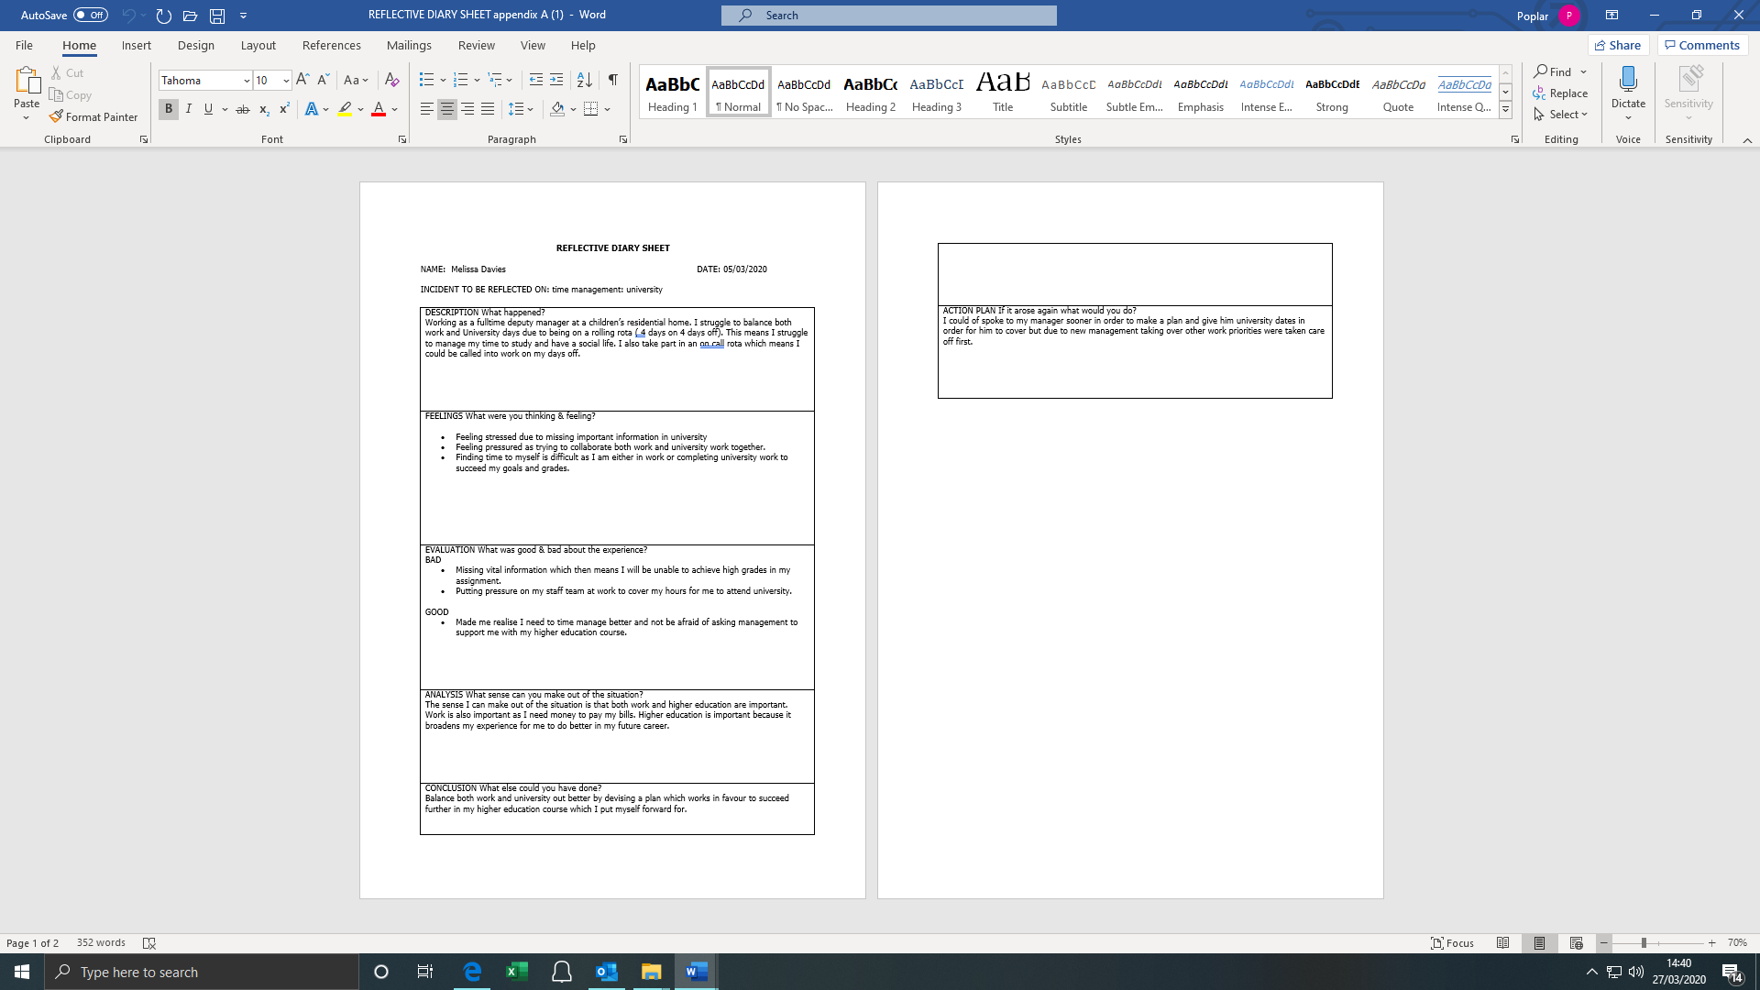

Appendix B
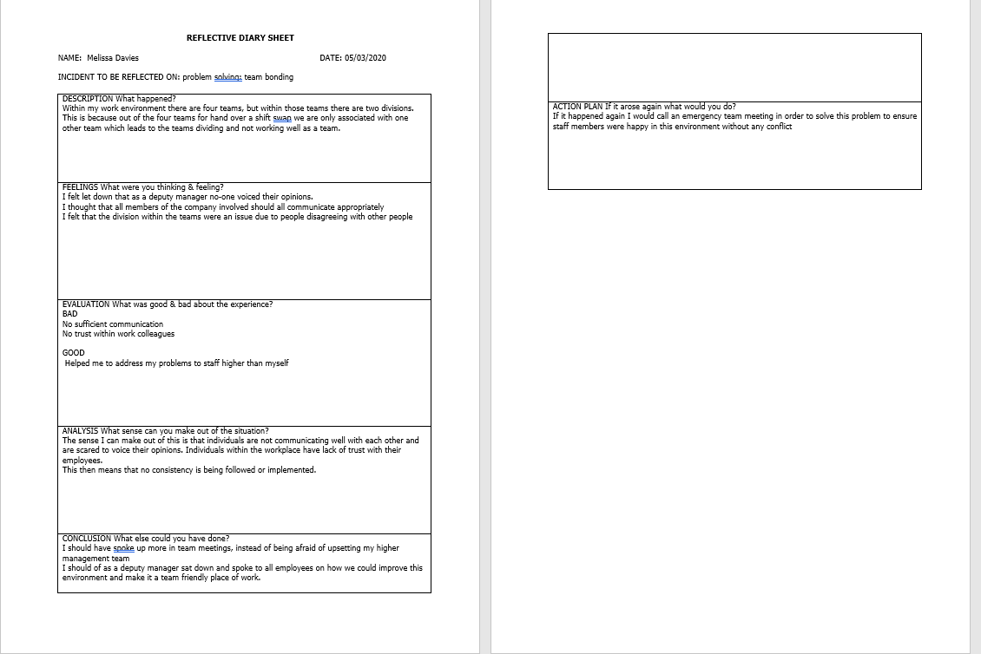

Appendix C
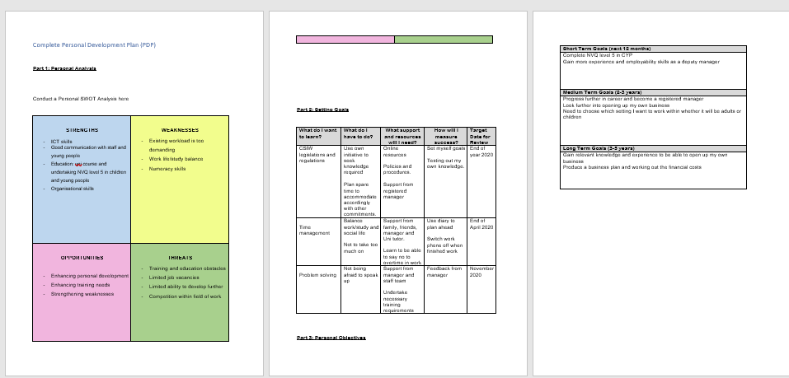

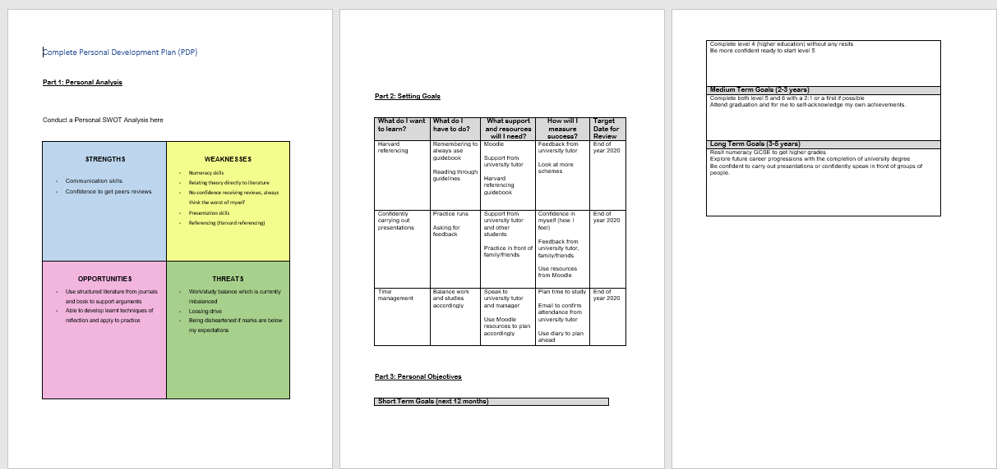
Appendix D

