
French Culture Report
Foreign Languages and Cultural Awareness, BMIH5003
Alina Cristina Pruteanu Student Number 2209886 | 1100 words | Lecturer Giulia Chifari


Executive Summary
The upcoming opening of Diversity Hotel & Spa in France necessitates a strategic preparation that is based on intercultural competence and leadership. This report offers a thorough analysis of the cultural and operational environment in France, consolidating important findings from the GLOBE Project to ensure that the General Manager's strategy is in line with local customs and expectations. The General Manager's success in France relies on an in-depth understanding of power distance, individualism versus collectivism, uncertainty avoidance, assertiveness, performance orientation, and humane orientation. The report emphasises the importance of cultural intelligence and sensitivity to prevent offensive behaviour that may isolate employees and guests. The General Manager must adeptly manage these cultural dynamics to cultivate an atmosphere of respect, productivity, and cohesion by the esteemed brand standards of Diversity Hotel & Spa. This document offers practical suggestions for the General Manager to navigate various aspects of daily interactions, including greetings, business card etiquette, and dining protocols. These recommendations seek to promote a respectful approach towards the intricate business and social customs of French culture. Following these recommendations is crucial to avoiding mistakes and ensuring that the General Manager demonstrates a high level of cultural knowledge.

Table of Contents
1. Introduction .......................................................... 3
1.1. Importance of Avoiding Offensive Behavior
2. French Culture Overview ...................................... 4
2.1. Greetings and Communication
2.2. Business Etiquette and Personal Space
2.3. Social Norms and Conversational Topics
3. GLOBE Project: France Analysis ............................. 5
3.1. Power Distance and Leadership Styles
3.2. Individualism and Collectivism in the Workplace
3.3. Uncertainty Avoidance and Organizational Adaptability
3.4. Assertiveness and Gender Egalitarianism
3.5. Performance Orientation and Quality of Service
3.6. Humane Orientation and Community Involvement
4. Importance of Cultural Intelligence .......................... 6
4.1. Impact on Staff and Guest Relations
4.2. Influence on Leadership Acceptance
5. Recommendations .............................................. 7
5.1. Professional Greetings and Conduct
5.2. Business Card Etiquette 6.3. Conversation Guidelines and Dining Etiquette
6. Conclusion ............................................................ 8
6.1. Summary of Intercultural Leadership Imperatives


Diversity Hotel & Spa's entry into the French market necessitates both business expertise and cultural sensitivity. The General Manager plays a crucial role in this transition, as they are responsible for effectively navigating a multifaceted cultural environment with diplomacy and awareness. French culture is known for its rich traditions and focus on etiquette. To navigate the business world in France, it is important to have a grasp of their distinct communication styles, hierarchical norms, and the skill of cultivating relationships. Understanding these cultural subtleties is vital as a mistake in etiquette or an unintentional faux pas can have lasting consequences (Scroope, 2017). This report seeks to offer the General Manager a comprehensive understanding of French culture, which is crucial for avoiding potentially offensive actions and promoting respectful and successful interactions with both employees and customers in France.

French Culture Overview:
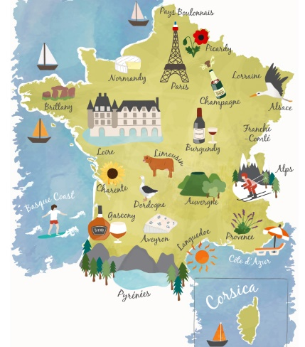
French culture exhibits a distinctive business etiquette landscape due to its complex balance between formality and directness. According to Bowe, Martin, and Manns (2014), effective communication is characterised by clear and logical articulation, while also maintaining a level of politeness, particularly in the initial stages of a relationship. It is important to exercise caution when becoming too informal too soon. Addressing someone by their first name without permission can be seen as arrogant or disrespectful.
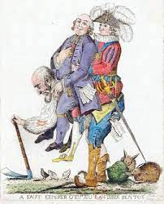
Hierarchical Sensibilities: In terms of hierarchical dynamics, the French exhibit a notable inclination towards respecting authority and adhering to structured systems. Questioning a superior's decision or bypassing the chain of command in a public manner is considered offensive and undermines the established hierarchy. In a professional context, the omission of appropriate titles may be regarded as a significant breach of etiquette (Scroope, 2017).
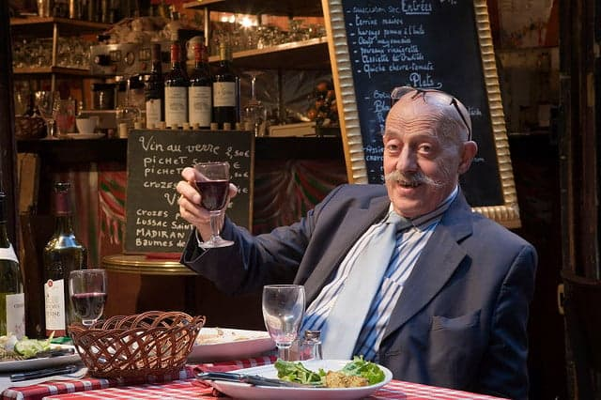
Cultural Taboos in Gestures and Expressions: Gestures possess both significance and the potential to offend. The American gesture known as the 'OK' sign, which involves creating a circular shape by joining the thumb and index finger, may be perceived as an offensive gesture in France. According to Amendoeira, and da Cunha Nascimento (2023), excessive hand gestures or physical contact, such as backslapping, which may be considered harmless in other contexts, can be perceived as intrusive.
Relationship Building: In French business culture, relationship-building is highly valued and should not be rushed or dismissed. Taking the time to establish a strong relationship is essential before embarking on any significant business discussions. Patience in connecting shows recognition of French professional values (Clegg, 2023).
GLOBE Project Overview: The GLOBE Project offers an in-depth investigation of cultural variations and their impact on leadership and organisational procedures. Consider it as a cultural guide that assists international leaders in adapting their management approach to align with the cultural customs of the country in which they are operating (Hanges, Dorfman, Ruiz-Quintanilla, and Javidan, 2020).

France Analysis According to the GLOBE Project:
Understanding Power Distance: In France, where power distance is significant, there exists a distinct societal norm in which leaders are expected to assume leadership roles while subordinates are expected to comply and follow (Javidan, Dorfman, De Luque, and House,2016).
Yang, Tossan, and Law (2022) state that GM should not anticipate junior staff to voice their opinions or question decisions in public contexts. This behaviour may not only cause discomfort among the staff but also be perceived as a disregard for authority.
Individualism Versus Collectivism: Balancing the French lean towards individualism with their appreciation for collectivism can be delicate. A GM should, for example, encourage individual initiative but within the context of team objectives, making sure that collaborative meetings allow time for individual voices to be heard (Javidan, Dorfman, De Luque, and House,2016).
Approach to Uncertainty Avoidance: According to Lee (2013), the moderate French approach to uncertainty avoidance recommends a methodical but responsive workplace. Thus, GMs should give defined plans with clear goals and promote adaptability. In a hotel crisis, a GM should have a strategy but be open to unexpected answers from the staff.
Assertiveness and Gender Egalitarianism: French assertiveness requires composure. A GM should firmly express expectations without force. Bringing men and women into leadership posts shows a commitment to gender equality, which is important to French culture (Goehlich, Wüst and Palm, 2015).
Performance Orientation: Performance orientation is critical, and a GM can manifest this by celebrating the ‘art de vivre’ in services, highlighting the hotel's dedication to excellence in customer experience—a value deeply rooted in French culture (Javidan, Dorfman, De Luque, and House,2016).
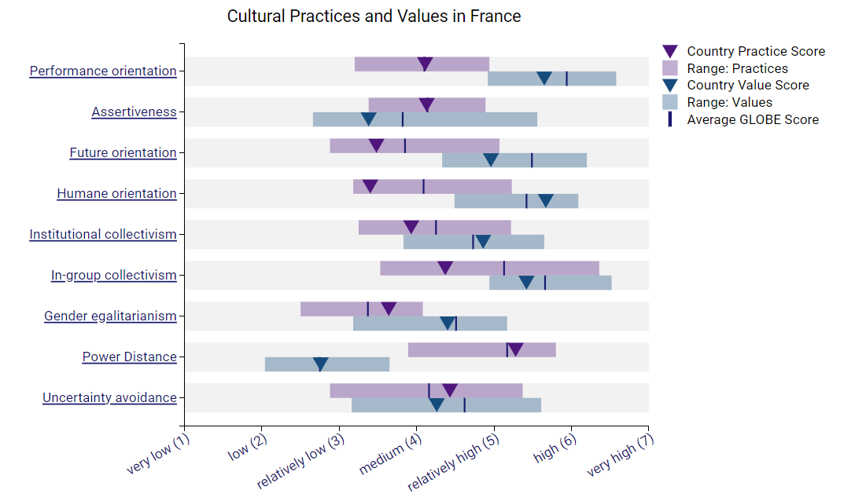
Humane Orientation: In practice, a General Manager may show compassion by sponsoring local community activities or causes, which would match French values and build a strong community presence. By using the GLOBE Project framework, a General Manager can confidently navigate France's cultural differences, minimise cultural offences, and engage in effective and appreciated leadership practises (Javidan and Dastmalchian, 2009).
Figure 1

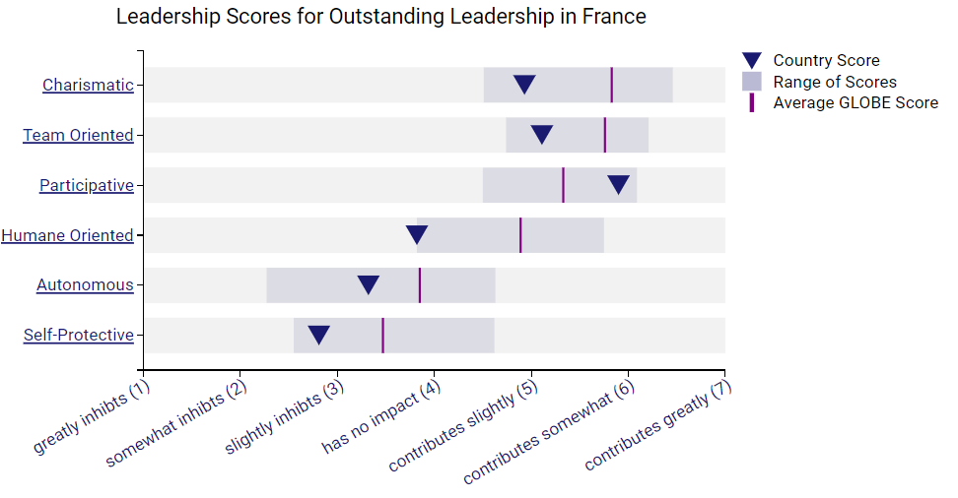
Figure 2
Finally, the General Manager's cultural awareness is essential for success in France. The GM's acceptability and leadership depend on understanding and respecting France's cultural complexities to avoid alienating staff and guests. According to the GLOBE Project, adapting to France's communication techniques, hierarchy, and social conventions would build trust and respect among the staff and clients, allowing Diversity Hotel & Spa's high standards to blend with France's rich culture.

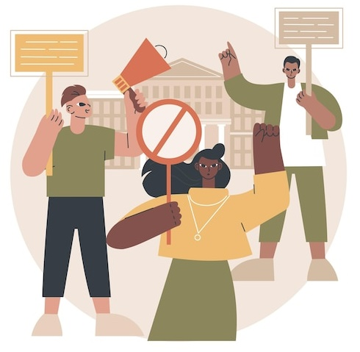
Recommendations for Navigating French Culture
Planet Depos explains French business culture and provides examples of how interactions should be conducted:
• To avoid cultural misunderstandings that might damage employee and visitor relations, the General Manager must have a deep understanding of French culture. Here are particular suggestions for courteous and productive interactions:
• Professional Greetings: In France, a handshake is the standard professional greeting. However, cultural etiquette dictates that a man should wait for a woman to extend her hand first.
• Handling Business Cards: When exchanging business cards, present and receive them with both hands or with the right hand, never with the left alone. Take a moment to examine the card before putting it away as a sign of respect for the person giving it to you.
• Conversational Caution: Discussions about personal wealth or earnings are taboo in French culture. Steer conversations away from such topics to avoid making your interlocutor uncomfortable.
• Personal Space: Respect personal space by maintaining an arm's length distance when conversing. Unlike some cultures, the French do not appreciate close physical proximity with acquaintances.
• Time Sensitivity: Punctuality is expected for business occasions. Arriving late without prior notice can be interpreted as a sign of disrespect.
• Gift Giving: If invited to a French colleague’s home, it is customary to bring a gift, such as wine, flowers, or chocolates. However, do not give chrysanthemums, as they are associated with funerals.
• Dining Etiquette: When dining, keep your hands on the table rather than on your lap. Remember, bread is placed directly on the tablecloth, not on a plate.
• Cultural Empathy: Show interest and appreciation for French culture, history, and traditions. This demonstrates respect and a willingness to integrate into the local way of life.
By adhering to these recommendations, the General Manager will exhibit cultural awareness and sensitivity, laying a solid foundation for building trust and respect within the French branch of Diversity Hotel & Spa.

References
- Amendoeira, F.R. and da Cunha Nascimento, T., 2023. Taboos and euphemisms in foreign language conversations. Multimodal Communication in Intercultural Interaction.
- Bowe, H., Martin, K. and Manns, H., 2014. Communication across cultures: Mutual understanding in a global world. Cambridge University Press.
- Clegg T., 2013. 6 Ways To Be Brilliant At Business Etiquette In France. Online Available at: https://ling-app.com/fr/business-etiquette-in-france/
- Goehlich, V., Wüst, K. and Palm, S., 2015. Gender Egalitarianism and Career Expectations: Comparing China, France, Germany, Mexico, Russia, and Turkey. International Journal of Organizational Diversity, 15(2).
- Hanges, P., Dorfman, P.W., Ruiz-Quintanilla, S.A. and Javidan, M. (2020) 'Cultural Influences on Leadership and Organizations: Project GLOBE'. Available at: https://www.researchgate.net/publication/347942968_Cultural_Influences_on_Leadership_and_ORGANIZATIONS_PROJECT_GLOBE
- Javidan, M. and Dastmalchian, A., 2009. Managerial implications of the GLOBE project: A study of 62 societies. Asia Pacific Journal of Human Resources, 47(1), pp.41-58.
- Javidan, M., Dorfman, P.W., De Luque, M.S. and House, R.J., 2016. In the eye of the beholder: Cross-cultural lessons in leadership from Project GLOBE. In Readings and cases in international human resource management (pp. 119-154). Routledge.
- Javidan, M., Dorfman, P.W., De Luque, M.S. and House, R.J., 2016. In the eye of the beholder: Cross-cultural lessons in leadership from Project GLOBE. In Readings and cases in international human resource management (pp. 119-154). Routledge.
- Lee, D., 2013. Beliefs on “avoidant cultures” in two French multinational corporations. Cross Cultural Management: An International Journal, 20(1), pp.20-38.
- Planet Depos, 2023. French Business Etiquette. Online Available at: https://planetdepos.com/trending/content/french-business-etiquette
- Scroope, C., 2017. 'Business Culture', Cultural Atlas. Available at: https://culturalatlas.sbs.com.au/french-culture/french-culture-business-culture
- Yang, I., Tossan, V. and Law, F., 2022. French leadership: exploring organizational leadership in French contexts. European Journal of Work and Organizational Psychology, 31(1), pp.128-144.

