University of Wales Trinity Saint David School of Engineering

ACMA4007
Analysis of Student Grades
using Statistical Methods in
MATLAB


P. Craig Bartle

1808882

Contents
1 Introduction ii
2 Literature Review iii
3 Data Import and Summary Statistics iv
4 Correlation Analysis v
5 Data Grouping & Hypothesis Testing vi
6 Conclusion viii
7 References ix
8 Appendix x

Introduction

We were tasked with generating a functioning MATLAB script. The objective of the script is to statistically analyse a data set. The data set was supplied by the university. This analysis aims to calculate and interpret statistical measures such as the mean, median and modal averages as well as the range and standard deviation. Additionally, a correlation analysis of different variables within the dataset was conducted, with the data grouped in order, to identify patterns and trends, i.e., if gender effects exam grades.

Literature Review
Through my research, I discovered MATLAB is a programming platform designed specifically for engineers and scientists to analyse and design systems and products that transform our world. The heart of MATLAB is the MATLAB language, a matrix-based language allowing the most natural expression of computational mathematics (MathWorks, n.d.). MATLAB is used around the world to develop algorithms, modelling and analyse data.
MATLAB has a handy search function that I discovered whilst reading MATLAB for dummies (Mueller, 2021). I used the search function in MATLAB, figure 2.1 (Mathworks, 2022), to find the correct argument for the function I required.
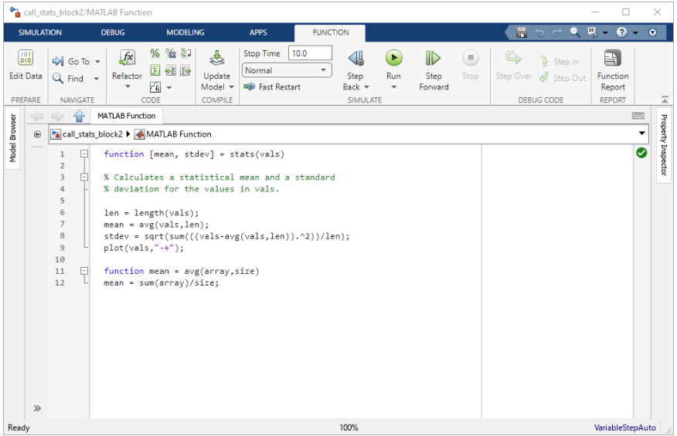
Figure 2.1. Search function indicated with red arrow (Mathworks, 2022).
In order to refresh myself with some of the mathematical knowledge i.e. cumulative frequency, correlation coefficient and standard deviation I required to complete this assignment, I referred to the online Physics and Maths Tutor (Anon., 2024) and (Etter, 1997).

Data Import and Summary Statistics

Data import is an imperative step in the data analysis process. You can load data into MATLAB in a variety of different ways, including (but not limited to) text files and spreadsheets. MATLAB script can easily be adapted to import data from external sources such as .CSV. The data set used for this assignment consists of numerical data that represents students scores in two separate exams. This data set was used to highlight the application of various statistical functions in MATLAB, such as Ogives, Cumsum and Corrco. The score can be used to provide a practical example of how statistical analysis can be applied in in engineering environment. Table 3.1 show a simple analysis of the data set taken from the command window within MATLAB. It shows the data set ordered by age, attendance and exam results, with the mean average, median average, mode average, range and standard deviation calculated and displayed in a simple table. I have attached my code to the appendix showing how I attached the .CSV file into my script.

Table 3.1 – Data ordered into a simple table with the mean, median, mode, range and standard deviation calculated.
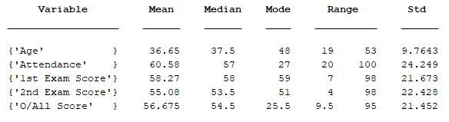

Correlation Analysis

Correlation analysis is a way of measuring the strength and direction of a relationship between two variables. It helps us how to understand changes in one variable associates with changes in another. In my analysis, I explore the correlation between scores in Exam 1 and Exam 2, and their impact on overall results.
The correlation coefficients calculated are as follows:
- Exam 1 and Exam 2: 0.89
- Exam 1 and Overall: 0.97
- Exam 2 and Overall: 0.97
The coefficients range between -1 and 1, where value closer to 1 or -1 indicate a stronger relationship.
Exam 1 and Exam 2 (0.89) shows a strong correlation indicating that Exam 1 scores significantly contribute to the overall performance.
Exam 1 and Overall (0.97) shows a very strong correlation indicating that Exam 1 scores significantly contribute to the overall performance.
Exam 2 and Overall (0.97) shows a very strong correlation indicating that Exam 2 scores significantly contribute to the overall performance.
Visualising representations help to understand correlation and statistics in general.
Visual representation of my results table and correlation matrix taken from MATLAB are shown in table 4.1 and figure 4.1 below.

Table 4.1 Results from Experiment.
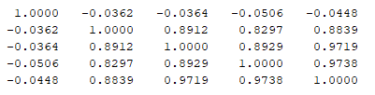
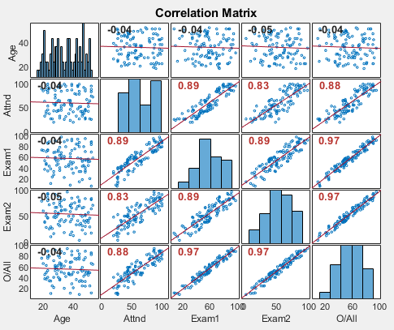
Figure 4.1. Correlation matrix images.

The scatter plot for exam 1 vs. exam 2 indicates a clear positive trend, confirming the strong correlation. The plots for exam 1 vs. Overall and exam 2 vs. overall both show a positive slope with even more tightly clustered results. Indicating a higher correlation.
It must be noted that this form of analysis does have it limitations. Variables such as outliers and extreme values can have a dramatic effect on the scatter plot when a limited number of results have been used. A way to combat this is to record more results to get a better average or do not plot outliers.

Data Grouping & Hypothesis Testing
Grouping data into categories can help to reveal patterns that are not easily seen in raw data from the given individual data points. It helps to simplify complex and detailed data and allows us to quickly work out certain statistics such as the median value. Grouping data has several other advantages such as:
Simplification. This allows us to convert continuous data into discrete categories, making analysis and interpretation easier (Etter, 1997).
Trend Identification: This helps us identify trends and patterns (Etter, 1997).
Targeted Interventions. This allows educators to focus on specific groups that may need additional support or resources (Mathworks, 2022).
As part of the assignment, I was tasked with producing visual representation of my results in the form of bar charts and ogives. The results are as follow.
Bar charts are effective for visualising grouped data. They provide a clear comparison of different categories, as shown in figure 5.1.
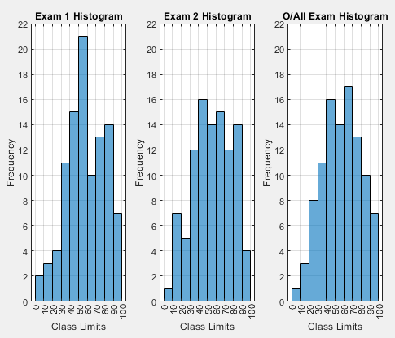
Figure 5.1. Bar chart graphical representation of my results.

An ogive (figure 5.2) is sometimes called a cumulative frequency polygon, that shows cumulative frequencies. The cumulative percents are added to the graph from left to right. An ogive is used to plot cumulative frequency on the y-axis and class boundaries along the x-axis (A., 2014). An ogive is similar to a histogram, only it uses a single point as a reference in place of a rectangle.
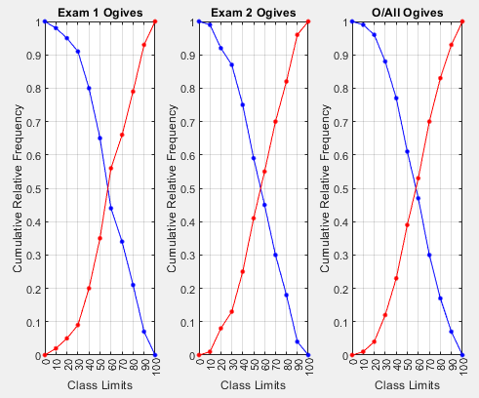
Figure 5.2 Ogives from MATLAB using dataset.

Conclusion
In my report, I have used the data set to demonstrate some of the applications of MATLAB for statistical analysis of numerical data, including the calculation of summary statistics, correlation analysis, and data grouping. My findings provide valuable insights into the world of data characteristics, the relationship between variables and some performance trends observed. The provided MATLAB script in my appendix can be copied and pasted into MATLAB and will run and produce the required statistical analysis (when used with the data set in a .csv format).
The analysis highlights the importance of understanding variability and tendencies within a given data set, along with the relationships between different variables. Grouping data into categories allows us to easily and efficiently simplify complex data sets and make it easier to interpret. This factor allows us to make informed decisions in critical applications. Overall, the statistical methods and visualisations contained within this report provide a comprehensive framework for analysing date effectively. It must be noted that MATLAB does have some disadvantages. MATLAB is expensive, requires a computer of sufficient memory and can be tricky to use. Coding is effectively a language. If you make a simple mistake, for example, forgetting a comer – the script will not run, and it can take a long time to find your mistake.

References
A., A., 2014. Ogive Graph / Cumulative Frequency Polygon in Easy Steps. [Online]
Available at: https://www.statisticshowto.com/ogive-graph/
[Accessed 12 may 2024].
Anon., 2024. Physics and Maths Tutor. [Online]
Available at: https://www.physicsandmathstutor.com/maths-revision/a-level-statistics-1/
[Accessed 10 May 2024].
Etter, D. M., 1997. Engineering Problem Solving with MATLAB. 2 ed. New Jersey: Simon and Schuster.
Mathworks, 2022. MATLAB Function Block Editor. [Online]
Available at: https://uk.mathworks.com/help/simulink/slref/matlabfunctionblockeditor.html
[Accessed 14 May 2024].
MathWorks, n.d. What is MATLAB?. [Online]
Available at: https://uk.mathworks.com/discovery/what-is-matlab.html
[Accessed 12 May 2024].
Mueller, J. P., 2021. MATLAB for dummies. In: Making Everything Easier. Hoboken: John Wiley and sons.

Appendix
clc % Resets all the variables in the workspace.
clear % Clears the command window.
close all % Closes all the open figures.

% TASK 1 - Data import and summary statistics.

% A - Import the data into MATLAB.
student_Data = readtable("student_grades.csv"); % Load the grades from the CSV file
% Calculate the overall (average) score and add it to the student data
student_Data.("Overall") = (student_Data.("Exam_1") + student_Data.("Exam_2")) / 2;

gender_Data = student_Data(:, "gender"); % Create a separate table for student genders (to be used later)
% Separates useful numerical date (age, attendance, scores, etc) (column 3 onwards) and converts it into an array/matrix
numerical_Data = table2array(student_Data(:, ["age","attendancePercentage", "Exam_1", "Exam_2","Overall"]));
% Manually grabbed by name rather than index to minimise error

% B - Compute summary statistics for numerical variables
mean_Array = mean(numerical_Data)'; % Calculate the means for each of the numerical variables
median_Array = median(numerical_Data)'; % Calculate the medians for each of the numerical variables
mode_Array = mode(numerical_Data)'; % Calculate the modes for each of the numerical variables
min_Array = min(numerical_Data)'; % Calculate the mins for each of the numerical variables
max_Array = max(numerical_Data)'; % Calculate the maxes for each of the numerical variables
range_Array = [min_Array, max_Array]; % Calculate the ranges for each of the numerical variables
std_Array = std(numerical_Data)'; % Calculate the std deviation for each of the numerical variables

% C - Display the summary statistics
% Create a cell of strings to be used as the left-most column to label variables
Names_Cell = {'Age'; 'Attendance'; '1st Exam Score'; '2nd Exam Score'; 'O/All Score'};
% Another cell of strings labelling headings for each column
col_Headings = {'Variable'; 'Mean'; 'Median'; 'Mode'; 'Range'; 'Std'};
% Combines into single table, using the previous strings as headings and label
summary_Table = table(Names_Cell, mean_Array, median_Array, mode_Array, range_Array, std_Array, VariableNames=col_Headings);
disp(summary_Table) % Displays on a seperate line to clean up asthetics

% TASK 2 - Correlation Analysis

% A - Return a matrix of the pairwise linear correlation coefficients between variables
% Create simple matrix to use with corr function, stacks the numerical data
corrCo_Matrix_Raw = [numerical_Data(:,:);numerical_Data(:,:)];
% Use the Corr function using pairwise rows
corrCo_Matrix = corr(numerical_Data(:,:), "rows", "pairwise");

disp(corrCo_Matrix) % Displays on a separate line

% B - Use corrplot to produce the matrix's results
figure Name 'Correlation Coefficient' % Create a figure window for the corrplot

Names_Cell = {'Age', 'Attnd', 'Exam1', 'Exam2', 'O/All'}; % Create a cell of strings used to identify variables
% Use the corrplot function to generate a visual correlation matrix, using testr on to help identify high correlation coefficients
corrCo_Plot = corrplot(numerical_Data(:,:), 'VarNames', Names_Cell, TestR = 'on');

% C - Investigate relationship between Gender and overall score using hypothesis test

% Organise the data, by gender and overall exam score in 1 table
% Create a table for gender and overall score
gender_Score = table(student_Data{:, "gender"}, student_Data{:, "Overall"}, VariableNames={'Gender', 'Overall'});

% Group the data
% Seperate male scores by filtering
male_Score = gender_Score(gender_Data{:,1} == "Male", "Overall"); % Return the overall value when Gender = 'Male'
female_Score = gender_Score(gender_Data{:,1} == "Female", "Overall"); % Return the overall value when Gender = 'Female'

% Convert Table to matrix
male_Score = table2array(male_Score); % Converts the previous tables to array / matrix
female_Score = table2array(female_Score);

% Hypothesis Test
% use ttest2 to conduct an hypothesis test for male and female scores, h0 being same/similar means
[h,p] = ttest2(male_Score, female_Score);

%If h=0 promote the null hypothesis
if h == 0
hVal_Str = "which suggests the means are approximately equal given the samples";
%Else Suggest an alternative hypothesis
else
hVal_Str = "which suggests that the means are not equal given the samples";
end

% If p is greater than 0.05 (default alpha values), state it is more likely that the means are equal
if p > 0.05
pVal_Str = "which is greater than alpha 0.05, gender has an influence";
%Else Suggest an alternative hypothesis
else
pVal_Str = "which is less than alpha 0.05, it is likely h0 can be disproven";
end

% Display the results
% fprint responses based on the hypothesis test result
fprintf("The hypothesis test returned a value of h = %i which %s\n", h, hVal_Str)
fprintf("The hypothesis test also returned a value of p = %f which %s\n", p, pVal_Str)

% D - Identify strongly related variables to exam results
% Using the generated correlation matrix as suggested 'TestR' which
% highlights values in red, exam scores are likely to be strongly related
% (which is expected) as well as the attendance of the student with a
% correlation coefficient 0.89 to exam1, 0.83 to exam2, and 0.88 to the
% overall exam score.
% Also as shown by the hypothesis test, it is unlikely that gender is
% related.

% E - Discuss the implications of the results
% The implications of this would be that in general, a higher attendance
% would suggest that a student would achieve a higher exam score, with
% Little no interference by any other variable that has been identified
% within the given data

% TASK 3 - Visualise grouped data for exam1, exam2, and overall score

% A - Use histcounts to determine frequency
% Use histcounts on the numerical data, with a bin width of 10, to return the count of each bar as well as the edges for exam 1
[Exam1_Count, Exam1_Edges] = histcounts(numerical_Data(:, 3), "BinWidth", 10);
[Exam2_Count, Exam2_Edges] = histcounts(numerical_Data(:, 4), "BinWidth", 10); % Same as above but for Exam 2
[Overall_Count, Overall_Edges] = histcounts(numerical_Data(:, 5), "BinWidth", 10); % Same as above but for the Overall score

% Calculate Edges for all exams just so everything is accounted for

% B - Use histogram to plot histograms in a single figure
figure Name 'Histograms' % Generate a figure window to use with histograms. Name accordingly.

subplot(1, 3, 1) % Use subplot to place items in figure (1 row, 3 columns, 1st position)
% Use the histogram function to create a histogram using the previous values for Exam1 as the count and edges
histogram('BinCounts', Exam1_Count, 'BinEdges', Exam1_Edges)
title('Exam 1 Histogram') % Assign an appropriate title for the histogram
xlabel('Class Limits') % Assign label to the x axis
ylabel('Frequency') % Assign label to the y axis
ylim([0, 22]) % Set the ylimit appropriately to compare histograms
xticks(Exam1_Edges) % Set tick spacing
grid on % Turn gridlines on

subplot(1, 3, 2) % Use subplot to place items in the figure (1 row, 3 columns, 2nd position)
% Use the histogram function to create a histogram using the previous values for Exam2 as the count and edges
histogram('BinCounts', Exam2_Count, 'BinEdges', Exam2_Edges)
title('Exam 2 Histogram') % Assaign an appropriate title for the histogram
xlabel('Class Limits') % Assign label to the x axis
ylabel('Frequency') % Assign a label to the y axis.
ylim([0, 22]) % Set the ylimit appropriately to compare to the other histograms
xticks(Exam2_Edges) % Set tick spacing (Makes grid look nicer)
grid on % Turn gridlines on

subplot(1, 3, 3) % Use subplot to place items in the figure (1 row, 3 columns, 3rd position).
% Use the histogram function to create a histogram using the previous values for the overall score as the count and edges
histogram('BinCounts', Overall_Count, 'BinEdges', Overall_Edges)
title('O/All Exam Histogram') % Assign an appropriate title to the histogram
xlabel('Class Limits') % Assign an appropriate label for the x axis
ylabel('Frequency') % Assign an appropriate label to the y axis.
ylim([0, 22]) % Set the ylimit appropriately to compare to the other histograms
xticks(Overall_Edges) % Set tick spacing (Makes grid look nicer)
grid on % Turn gridlines on

% C Use plot to plot, in a single figure, more than and less than Ogives for exam1, exam2, and overall score

% Calculate the Exam 1 < & > Ogives
% Get the cumulative sum (cumsum) of the frequency/count (as a percentage) for the < Ogive
Exam1_LessThan = cumsum(Exam1_Count/sum(Exam1_Count));
Exam1_LessThan = [0, Exam1_LessThan]; % Add a zero to the beginning because 0 is minimum, nothing < 0
Exam1_MoreThan = 1 - Exam1_LessThan; % 1 - the matrix to calculate the > Ogive

% Calculate the Exam 2 < & > Ogives
% Get the cumulative sum (cumsum) of the frequency/count (as a percentage) for the < Ogive
Exam2_LessThan = cumsum(Exam2_Count/sum(Exam2_Count));
Exam2_LessThan = [0, Exam2_LessThan]; % Add a zero to the beginning because 0 is minimum, nothing < 0
Exam2_MoreThan = 1 - Exam2_LessThan; % 1 - the matrix to calculate the more than Ogive

% Calculate the Overall Exam Score Ogives
% Get the cumulative sum (cumsum) of the frequency/count (as a percentage) for the < Ogive
Overall_LessThan = cumsum(Overall_Count/sum(Overall_Count));
Overall_LessThan = [0, Overall_LessThan]; % Add a zero to the beginning because 0 is minimum, nothing < 0
Overall_MoreThan = 1 - Overall_LessThan; % 1 - the matrix to calculate the > Ogive

figure Name 'Ogives' % Generate a figure window ready for the Ogives.

subplot(1, 3, 1) % Use subplot to place items in the figure (1 row, 3 columns, 1st position)
% Plot the more than and less than Ogives for exam2, using the previous Ogive data and the edges calculate from the histcount (Marker settings by preference)
Exam1_OgivePlot = plot(Exam1_Edges, Exam1_MoreThan, Exam1_Edges, Exam1_LessThan, Marker='.', MarkerSize=10);
Exam1_OgivePlot(1).Color = 'blue'; % Set the Exam1 > Ogive (first line) to blue
Exam1_OgivePlot(2).Color = 'red'; % Set the Exam1 < Ogive (second line) to red
title("Exam 1 Ogives"); % Title plot
xlabel("Class Limits") % Label x axis appropriately
ylabel("Cumulative Relative Frequency") % Label y axis appropriately
xticks(Exam1_Edges) % Set tick spacing (Makes grid look nicer)
grid on % Turn gridlines on

subplot(1, 3, 2) % Use subplot to place items in the figure (1 row, 3 columns, 2nd position)
% Plot the more than and less than Ogives for exam2, using the previous Ogive data and the edges calculate from the histcount (Marker settings by preference)
Exam2_OgivePlot = plot(Exam2_Edges, Exam2_MoreThan, Exam2_Edges, Exam2_LessThan, Marker='.', MarkerSize=10);
Exam2_OgivePlot(1).Color = 'blue'; % Set the Exam2 > Ogive (first line) to blue
Exam2_OgivePlot(2).Color = 'red'; % Set the Exam2 < Ogive (second line) to red
title("Exam 2 Ogives"); % Give the plot an appropriate title
xlabel("Class Limits") % Assign an appropriate label for the x axis
ylabel("Cumulative Relative Frequency") % Assign an appropriate label for the y axis
xticks(Exam2_Edges) % Set tick spacing
grid on % Turn gridlines on

subplot(1, 3, 3) % Use subplot to place items in the figure (1 row, 3 columns, 3rd position)
% Plot the more than and less than Ogives for the overall exam score, using the previous Ogive data and the edges calculate from the histcount (Marker settings by preference)
Overall_OgivePlot = plot(Overall_Edges, Overall_MoreThan, Overall_Edges, Overall_LessThan, Marker='.', MarkerSize=10);
Overall_OgivePlot(1).Color = 'blue'; % Set the overall score > Ogive (first line) to blue
Overall_OgivePlot(2).Color = 'red'; % Set the overall score < Ogive (second line) to red
title("O/All Ogives"); % Title plot appropriately
xlabel("Class Limits") % Assign an appropriate label for the x axis
ylabel("Cumulative Relative Frequency") % Label y axis
xticks(Overall_Edges) % Set tick spacing (Aesthetics)
grid on % Turn gridlines on

