Contributing to coaching and mentoring in the organisation

Jodie Barnett

CIPD course number: 5ADCM

CIPD Membership number: 2224083X

Word count: 3,027 words

By signing below, I confirm that the work/evidence presented is my own, unaided work. I understand the regulations pertaining to candidate malpractice and the action that may be taken as a result.

Signed: 
Date: 15th March 2021

Contents page
- Personal statement LO1
- Personal statement LO2
Appendices
- Learning, Training and Development programme 2019-2020 (first few pages)
- Solace (external training organisation website)
- LM programme example
- NPTCBC senior management recruitment over past 5 years
- NPTCBC Workforce Strategy plan 2018-2022 (first few pages)
- NPTCBC line manager survey results
- Focus group meeting notes taken on 20th February 2020
- 1:1 meeting template

EVIDENCE MATRIX

Personal statement for LO1 (including reference list)
LO1 – Be able to assess the impact of coaching and mentoring activity within an organisation and make recommendations for further development

Brighthr (2021) refers to the need for coaching and mentoring within an organisation and highlights many of the benefits for implementing such methods. It is noted that coaching and mentoring can develop and enhance employee skills and make them feel valued within an organisation. Showing an interest in the growth of employees, can help an employee feel cared and in turn, increase their loyalty towards the organisation.
CIPD (2020a) argues that there is a need for coaching and mentoring programmes within any organisation as implementing and managing such programmes is pivotal to assisting with performance management, supporting people through change as well as promotes the organisational learning and development.
The CIPD profession map highlights a ‘Learning and development’ section within the specialist knowledge area.
Neath Port Talbot County Borough Council (NPTCBC) has its own Learning, Training and Development Section that sits within the structure of the Human & Organisational Development Service. The team provides learning, training and development support to all services across the Council which includes:
- Learning, Training and Development Programme
- Corporate Training Courses
- Management Development
- Health & Social Care Qualifications
- Seminars and Conferences
- Modern Apprenticeships/Work Experience Placements
- Essential Skills in the Workplace
- Health and Safety Training
- Social Work/Post Qualifying/Practice Teaching
- Social Care Wales Workforce Development Programme
Their training programme is updated and published annually (appendix 1) to take into account any legislative developments.
“Corporate and Management” is included within the contents of this programme which refers to the development and leadership with coaching being included within this. At present within NPTCBC, any approach on coaching is offered only at senior management level. NPTCBC current approach to coaching is provided by an external organisation known as Solace (appendix 2). Solace (2021) is a well-established membership network used by local government and public sector professionals. Solace offers a range of personal and organisational development services. Such a service is offered on the basis of a request to the Learning, Training and Development Section, therefore, much emphasis is placed on management being proactive in this field. I feel this approach somewhat places a reliance on the management to identify and furthermore, plan for their workforce in the future.
As well as using an external organisation, NPTCBC’s Training and Development Officer’s offer Leadership and Development courses across all services within the Authority based on any requests being sent to the team.
Such courses include holding a regional Leadership week for Senior Managers and Directors across the region offering those leaders working in Public Services to attend workshops and masterclasses. These type of courses are delivered in conjunction with Solace. I have attached an example of the programme that is used during these courses (appendix 3).
Reissner (2014) highlights the need for coaching and mentoring within an organisation context if used for the benefit of an individual, team as well as a long term talent management process. Coaching is often typically accessible to individuals with a high potential with an element of support to fully achieve this – this tends to be individuals in a management or leadership role thus leaving little opportunity to develop younger talent. This is very much NPTCBC’s approach with precise little opportunity offered to develop the skills of those occupying a lower graded position/starting careers.
The implementation of coaching and mentoring has attracted much attention in recent years as a method of developing senior managers. CMI (2020) refers to these methods being a popular tool for not only developing employee prospective, but increasing work performance. Adopting these methods can provide pivotal in improving employee engagement and can be a cost-effective approach with focus being given on identifying specific individual development needs and skills, rather than recruiting new employees. Developing within can improve motivation and reduced staff turnover as well as sending a positive message on the organisational values.
CIPD (2015) Learning and Development annual report identified key elements in regards to coaching and mentoring. Such approaches are currently offered by over three-quarters of organisations with 13% planning to offer and most expect to increase the use of coaching. They found that many organisations adopt In-house methods with the most popular development being on the job training, programmes and coaching received by line managers or peers.
They argue that coaching and mentoring as well as other buddying schemes are among the most generally used and most effective for organisational talent management.

It is evident that within NPTCBC (2021a), that the senior management structure including Directors and Heads of Service have all been recruited and developed within the Council (appendix 4). All of those current post-holders have been recruited through promotional opportunities and such a statistic is encouraging to see, especially for those in less seniority positions who are career driven and looking to develop in the coming years. Adapting such an approach allows for the Council to retain key individuals with essential skills and knowledge.

When identifying the statistics it was clear that these vacancies had initially arisen through 85% of employees retiring, with 15% leaving NPTCBC due to increase in pay. One concern for further implementation of coaching and mentoring is the lack of promotional opportunities due to low levels of staff turnover in senior roles.
CIPD (2020b) refers to the development of coaching and mentoring very starts with the culture. They note the importance for considering a range of points, all of which are driven by the organisational context. These points include the following as a minimum:
- What is the organisation’s strategy?
- How does the organisation position itself?
- What are the organisation’s priorities?
- Who supports coaching and mentoring?
Once the above have been ascertained, focus will be very much on the practical aspects, such as who will deliver coaching and how this will be implemented.
NPTCBC is a public sector organisation which is very much driven and dictated to by public spending money from the Welsh Government. Therefore, resources for such approaches are very much limited and dependent on budget priorities. NPTCBC (2021b) Workforce strategy plan 2018-2022 (appendix 5) outlines key focus that includes “Leadership, Succession Planning and Developing Future Skills” but understand that this is very much reliant on budget provision, which in turn dictates any approach in coaching and mentoring programmes.

As well this budget issues, there are currently limited resources available within the Learning, Training and Development Section, who have been set training priorities for Social Care roles across the Authority due to recent legislative changes. The section have also recently become one member less due to a recent retirement, such factors all have an adverse effect on promoting and undertaking coaching and mentoring.
NPTCBC’s current approach to coaching and mentoring can be said to be infrequent. It has been identified that the Learning, Training and Development Section are very much involved in any leadership programmes but coaching and mentoring is externally sourced. There are cost implications to undertaking such an approach with the Council reliant on public spending money and with expenditure being heavily scrutinised for this reason, therefore, there is very little recommendation for improvement on this basis.
CIPD (2020b) refers to coaching and mentoring as methods for effectively developing employees. These methods are seen to enhance the performance, skills and knowledge; especially in those roles that require specific skills and goals.
Currently coaching and mentoring is offered at senior management level, however, I feel that this should be cascaded down to many other employees looking to develop their careers. Such an approach will not only upskill individuals but will build trust and loyalty between employee and employer.

References
Brighthr. (2021). What are the benefits of coaching and mentoring in the workplace? (Online) Available at: https://www.brighthr.com/articles/training/coaching-mentoring/benefits-of-coaching-and-mentoring-in-the-workplace/ (Accessed 26 February 2021)
CIPD. (2015). Learning and Development annual report (Online) Available at: https://www.cipd.co.uk/Images/learning-development_2015_tcm18-11298.pdf (Accessed 02 March 2021)
CIPD. (2020a). Learning and skills at work (Online) Available at: https://www.cipd.co.uk/knowledge/strategy/development/learning-skills-work (Accessed 26 February 2021)
CIPD. (2020b). Coaching and Mentoring (Online) Available at: https://www.cipd.co.uk/knowledge/fundamentals/people/development/coaching-mentoring-factsheet (Accessed 09 March 2021)
CMI. (2020). Coaching for improved performance (Online) Available at: https://www.managers.org.uk/knowledge-and-insights/resource/coaching-for-improved-performance/ (Accessed 09 March 2021)
NPTCBC. (2019). Learning, Training and Development programme 2019-2020
NPTCBC. (2021a). Bi-query report run 09 March 2021.
NPTCBC. (2021b). Workforce strategy plan 2018-2022 (Online) Available at: http://umbraco.npt.gov.uk:700/1996 (Accessed 10 March 2021)
Reissner, S. (2014). Coaching, Professional Development and Practice In: G. Watson & S. Reissner, eds. Developing Skills for Business Leadership. London: CIPD, pp. 183-208.
Solace. (2021) About Solace (online) Available at: https://solace.org.uk/ (Accessed 27 February 2021)
Wilkinson, K. & Taylor, S, 2016. Managing and co-ordinating the HR function. In: Studying Human Resource Management. London: CIPD, pp. 21-41.

APPENDIX 1
Learning, Training and Development programme 2019-2020 (first few pages)
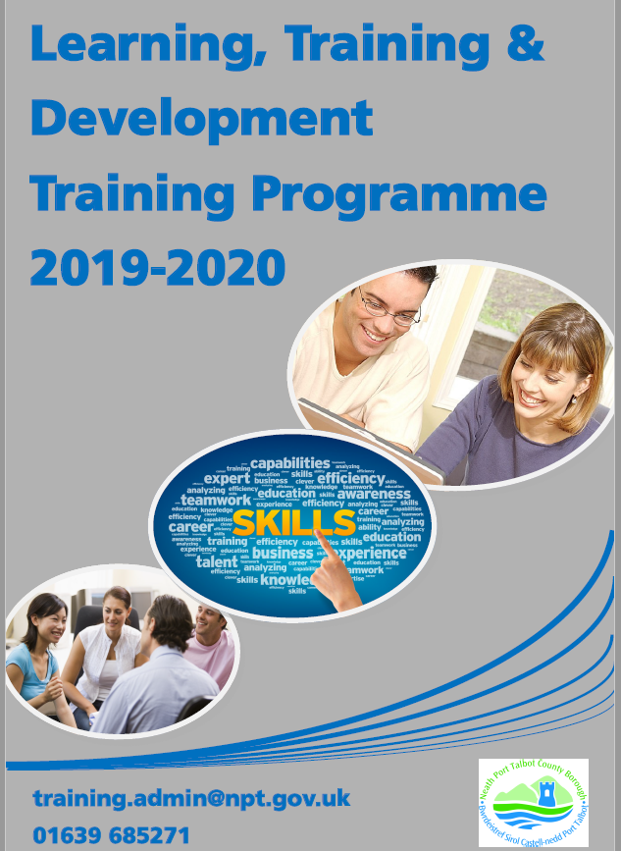



APPENDIX 2
Solace (external training organisation website)
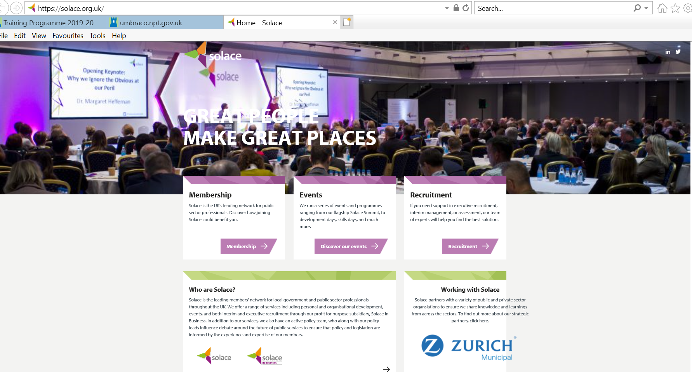

APPENDIX 3
LM programme example

APPENDIX 4
NPTCBC senior management recruitment over past 5 years

APPENDIX 5
NPTCBC Workforce Strategy plan 2018-2022




LO2 – Be able to support the implementation of coaching and/or mentoring programmes within an organisation.
There are many benefits of implementing coaching within the organisation with the Institute of Coaching (2021) referring to some of these as:
- Empowers employees and encourages them to take responsibility
- Increases both employee and team engagement
- Improves individual work performance
- Supports and develops those high potential employees
- Helps identify both organisational and individual strengths and development opportunities
- Aids with motivating and empowering individuals to achieve
- Establishes organisational commitment to HR development

Deloitte (2020) report on Human Capital trends argues that organisations needs to plan for an upskilled workforce over the next three years due to fast-changing skills landscape. Organisations will need to enhance their workforce development needs in order to accommodate constant shifting of skills and capability needs. They state that the economic shift from production to more imagination means that the current qualities that both employees and organisations need to survive and flourish are somewhat different from those needed in the past.
73% of survey respondents identified their organisation as the primarily responsibilities for their development than identified any other stakeholder. Coaching and mentoring programmes can enhance workforce skills and capabilities as well as support adaptation of working environments.
It is not always the responsibility of the organisation to effectively coach and mentor as this includes the individual’s contribution. Reissner (2014) refers to the coachee/mentee’s needs and aspirations causing a potential constrain on the quality of coaching. Some individual’s consider past experiences with professional development and find it difficult to be open, engage and take coaching serious – all having an effect on the process. The coach will also be limited should the coachee be reluctant to engage in self-directed learning and not agree to commence such a process to begin with.
NPTCBC’s approach to coaching and mentoring programmes is very much dependant on the intuition of the line manager, and currently there is little or none understanding of such processes. I carried out a survey questionnaire randomly selecting 75 line managers, of which, I received 50 responses (appendix 6). It is clear from these results, that the majority of the line managers that conducted this survey have none or little knowledge of the Council’s approach to coaching and mentoring this noticeably being a potential barrier.
Line manager’s need to have a better understanding of coaching and mentoring and the potential benefits on the organisation.
It is worth noting that coaching may differ from any connected concepts such as mentoring, with there being a considerable overlap but will have distinguishing functions in an organisation. In order to develop any coaching processes within the organisation, it is important to firstly understand its process as well as providing practical guidance for a line manager.
Ressiner (2014) refers to a coaching process consisting of key mechanisms:
Preparation
- Deciding on coaching
- Selecting the coach(es)
- Contracting
Coaching intervention
- Coaching relationship
- Coaching skills
- Coaching supervision
Follow-up
- Evaluation of coaching intervention
Having an understanding of how coaching works will help promote such a process as a means of development within an organisation. Additionally, evaluating is a fundamental part of any coaching supervision, which can support coaches with HR professionals playing a key role in managing coaching effectively within the organisation.
Prior to the current pandemic, February 2020, NPTCBC had commenced the development of a mentoring scheme working closely with Chwarae Teg. Chwarae Teg (2021) is a FairPlay Employer, established in 1992, where they have been working to ensure that women in Wales can enter the workplace, develop their skills and build rewarding careers. Myself and another HR colleague attended an initial focus group meeting with a selected number of employees from a variety of roles to identify and discuss whether they would consider developing a mentoring programme.
The focus group was successful in that all attendees provided their voice and ideas on the implementation of a programme. Notes were taken and feedback provided to the HR Management team (appendix 7). Unfortunately, under these unprecedented circumstances, nothing further has been developed following this meeting, however, the HR Management team are looking at re-commencing such discussions through the use of an online platform.
Upon the organisation’s implementation of a coaching/mentoring programme, it is about identifying the suitability of a coach/mentor. It is important that any effective coach/mentor possesses important workplace coaching techniques – skills/knowledge include:
- Communication skills
- Active listening skills
- Building rapour/trust
- Asking open-ended questions
- Effective goal-setting
- Providing constructive feedback
- Supporting throughout development
- Maintaining an outcome focus
There are many coaching tools that can be implemented including the coaching tool, known as “Johari’s Window Model” (figure1) invented by Joseph Luften and Harry Ingham. Such a model is an effective tool for developing communication skills. The use of this model can minimise disruptive behaviour within the workplace, by encouraging self-awareness and mutual understanding between individuals. It is used widely to enhance relationships and develop group dynamics.

(Figure 1 – MindTools.com)
As a coach, one of the most important roles is to help an individual achieve their best. By doing this, you are support better decision-making, learn new skills, problem solve and enhance career development.
Encouraging such an approach, is through using best practice models such as the GROW model and OSKAR model. MindTools (2021) argues that the GROW model is a simple, yet powerful coaching tool used to structure any coaching/mentoring session. GROW is an acronym for:
Goal, Current Reality, Options (for any obstacles), Will (or way forward)
Different coaches adapt different coaching styles with Wilson (2021) arguing that any coaching style is about stimulation, building confidence and teaching the skills required in order to develop and maintain effective working relationships. It is important that the coachee/mentee feel’s supported throughout the journey.
Wilson (2021) argues that successful coaching leaders will use one or several different coaching styles, recognising that any style should be tailored to an employee, team, or the organisational culture.
As a coach, one of the most important roles is to help an individual achieve their best. By doing this, you are support better decision-making, learn new skills, problem solve and enhance career development.
He has identified five different coaching styles for this purpose:
- Democratic coaching
This method allows a team the freedom and responsibility or an individual self-empowerment and control to give input. Coach will only get involved when needed.
- Authoritarian coaching
This method is very much all coach related with decision made on what, when and how to do it – can produce good, fast results. Can leave employees feeling excluded.
- Holistic coaching

This method is highly rated for developing life coaching, with the employee being encourage to grow in all aspect of their life.

- Autocratic coaching
This methods strives for excellence and perfectionism with the coach telling the employee what to do rather than asking.
- Vision coaching
This method has similarities to that of a personal trainer, with the employee being encouraged to set clear goals and objectives.
In my current role as HR Business Manager, I line manage a team consisting of 8 employees. It is important to understand that each employee has different individuality, with many requiring different coaching styles – whether it is due to their abilities or behaviours. This includes how I approach each employee’s 1:1 meetings and team meetings. In my 1:1 meetings, I will discuss and review any goals and objectives previously discussed, with the aim of identifying further targets – this is very much similar to the Vision coaching approach (appendix 8).
Although I am responsible for the management of the team, I consider myself a team colleague, helping out in the day-to-day tasks as well as being approachable and leading/directing where necessary. I feel that this approach assists with increased engagement and motivation of the team.
Any individual being considered for development through a coaching/mentoring programme should be both fully aware of the process and in agreement of this. It is worth noting that there are many other means of professional development and any potential coachee should be assessed on whether coaching is indeed required in this case.
Croner-i (2021) states that coaching and mentoring are two different development techniques that focuses on a 1:1 relationship between the coachee/mentee receiving coaching or mentoring, and the coach or mentor. It is important that the coachee/mentee fully understands what is required of them – this includes:
- Identifying their continuing professional development and learning requirements.
- Actively partake in activities to address these learning needs.
- Ensure that any learning activities have relevance to their role.
Making any individual fully aware of the benefits in partaking in any coaching or mentoring programme can increase both engagement and motivation.
Once it has been agreed in principle to begin any mentoring and coaching programme, both the coach/mentor and the individual need to discuss some key issues. Michael (2008) outlines some of the key topics for discussion:
- Determining the area
- Agreeing the overall objectives
- Identifying realistic outcomes through devising an action plan for achievement
- Devising a suitable programme, which could include observation, shadowing, supervision.
- Agree a suitable timescale
- Agree a strategy for an evaluation and assessment.
The implementation of a coaching framework such as the GROW or OSKAR model can help structure any coaching and mentoring sessions.
A rigorous approach to evaluating coaching is crucial for the organisation as well as the professional coach. Not only can this promote coaching by a way of identifying that such a development has contributed to both organisational and individual performance, but can account for expenditure.
Reissner (2014) argues that any evaluation has many factors to consider including the purpose and context of coaching intervention. There are many ways in which an evaluation can be carried out, through Key Performance Indicators (KPIs) or performance appraisals.
NPTCBC have an evaluation process that includes completion of a questionnaire upon the conclusion of any training programmes. The Learning, Training and Development Team collate this information retrieved and use this as a method on improving training courses going forward. Whether it is the course structure, venue, materials provided at any training event. I was unable to obtain a copy of the training evaluation form prior to the submission of this assignment deadline.
It is clear that improvement is required for identifying and providing information on any coaching/mentoring programmes available within NPTCBC. Line managers need to have a better understanding of these programmes and this could be done through the introduction of induction training for line management roles. Having an awareness and understanding of these programmes can offer individuals the chance for career development, promote performance and enhance existing skills and knowledge.

References
Croner-i. (2021). Coaching and mentoring: in-depth (Online) Available at: https://app.croneri.co.uk/topics/coaching-and-mentoring/indepth-0 (Accessed 14 March 2021)
Chwarae Teg. (2021). About us (Online) Available at: https://chwaraeteg.com/about/mission/ (Accessed 12 March 2021)

Deloitte. (2020). The social enterprise at work: Paradox as a path forward: 2020 Deloitte Global Human Capitala Trends (Online) Available at: https://www2.deloitte.com/content/dam/Deloitte/cn/Documents/human-capital/deloitte-cn-hc-trend-2020-en-200519.pdf (Accessed 11 March 2021)

Michael, A. (2008). Mentoring and coaching – topic gateway series No. 50. CIMA.

Reissner, S. (2014). Coaching, Professional Development and Practice In: G. Watson & S. Reissner, eds. Developing Skills for Business Leadership. London: CIPD, pp. 183-208.
Wilson, G. (2021). What are coaching styles and how do they work? (Online) Available at: https://www.thesuccessfactory.co.uk/blog/coaching-styles-and-how-they-work (Accessed 14 March 2021)

APPENDIX 6
NPTCBC line manager survey results

APPENDIX 7
Focus group meeting notes taken on 20th February 2020


APPENDIX 8
1:1 meeting template



