

Waldrich Slab Miller –
Process Efficiency Improvements

University of Wales Trinity Saint David – Waunarlwydd
B.Eng. Mechanical and Manufacturing Engineering (Hons)
Dissertation
Harley Oulton 2025

Declaration of Authenticity
This thesis is the result of the author’s original research. It has been composed by the author and has not been previously submitted for examination which has led to the award of a degree.

Signed: H.Oulton Date: 19/05/2025

Acknowledgements
I would primarily like to thank my project mentor Andrew Thorne for their continual support and guidance throughout this process. His extensive subject knowledge and assistance have been an invaluable resource to guide my major project. Secondly, I would like to thank Mark Thomas (Apprentice Liaison Officer) for his advice and support during the final weeks of writing the report.
An additional thank you must go to my friends and colleagues at TIMET Waunarlwydd. Their financial, resource and most importantly personal support has been fundamental to the success of my project. A noteworthy thanks must go the Paul Thomas (Manufacturing Engineering) for his support and machining expertise during the project and Richard Bowen (Manufacturing Engineer Manager) for the initial opportunity and their continued support.

Abstract
This project explores the integration and optimisation of a new Waldrich Slab Miller commissioned in TIMET Waunarlwydd with the aim of enhancing process efficiency, reducing cycle times, and improving throughput. The project employs Lean Manufacturing and Six Sigma techniques such as Value Stream Mapping (VSM), SMED, and Spaghetti Diagrams in highlighting and rooting out inefficiencies in the milling process. Data processed from the existing Witton site and the Factory Acceptance Testing (FAT) provided a baseline for comparison analysis.
The major areas of improvement were tooling changeover processes, material movement processes, and feed rate optimisation. Pilot trials showed a 43.08% decrease in overall cycle time, with tool changeover time enhanced by 88.9% and material handling time lowered by 62.6%. The incorporation of operator-driven improvements, standard operating procedures, and offline tooling initiatives were vital to improving the process.
While machine downtime during pilot testing restricted the volume of yield data collected, the implemented interventions delivered substantial gains in throughput and operational efficiency. The findings validate the application of Lean Six Sigma principles in high-value, aerospace titanium machining environments and demonstrate the viability of structured, data-driven process improvement in industrial manufacturing.
Future efforts must place greater emphasis on statistical data analysis by process capability measures (Cpk, Ppk) and investigate other improvements by experimentation with feed rates, collaborative insert prototyping with ISCAR, and further cell layout changes for optimising operator movement. Additionally, there is room for applying the improvement methodology created here to other machining operations at TIMET's facilities, thereby enabling greater manufacturing excellence and planned phasing out of older equipment.

Contents
Declaration of Authenticity i
Acknowledgements ii
Abstract iii
Contents iv
List of Figures vi
List of Tables vii
Acronyms and Abbreviations viii
1.0 Introduction 1
1.1 Company Background 1
1.2 Material Information 2
1.2.1 Alpha Case Removal 3
1.3 Process Information 4
1.4 Aims and Objectives 7
1.5 Report Structure 7
2. Timing Plans 8
2.1 Project Schedule 8
2.2 Commentary on Timing and Adjustments 8
2.3 Milestone Tracking 9
2.4 Summary 9
3. Literature Review 10
3.1 Overview 10
3.2 Lean Manufacturing 10
3.2.1 Historic Development 10
3.2.2 Fundamental Principles 10
3.2.3 Value 11
3.2.3 Industrial Applications and Advantages 12
3.3 Six Sigma 16
3.3.1 Origins and Development 16
3.3.2 Methodology and Tools The DMAIC process constitutes the backbone of many Six Sigma projects: 16
3.3.3 Industrial Applications in Aerospace 17
3.4 Integrated LSS Approaches 18
4. Methodology 20
4.1 Witton Process Analysis 20
4.2 Identification of waste 20
4.3 Improvement Techniques 21
4.4 Data collection and analysis 21
4.5 Pilot Testing and Total Implementation 22
4.6 Assumptions and Limitations 23
5. Project Activities 24
5.1 Witton Process Assessment 24
5.2 New Miller Cycle Time Estimates (FAT) 26
5.3 Waldrich Miller Initial Process Assessment 30
5.4 NVA Improvements 32
5.4.1 Tool Changing Operation Improvements 32
5.4.2 Material Movements Improvements 37
5.5 VA Improvements (Program Tool Selection) 44
6. Results 45
6.1 NVA Improvement Results 45
6.1.1 Tool Changing Operation Improvement Results 45
6.1.2 Material Movement Improvement Results 45
6.2 VA Improvement Results 46
6.3 Total Cycle Time Improvements 47
7. Conclusion 49
8. Future Work 51
8.1 Process Yield Improvements 51
8.2 Further Integration of Offline Tooling Strategies 51
8.3 Feed Rate and Cutting Strategy Refinement 51
8.4 Cell Layout Improvements 52
References 53

List of Figures
Figure 1: Optical micrographs showing (a) as-received Ti-6Al-4V and (b) the alpha case layer formed after heat treatment at 700 °C for 500 hours. Source: Sefer (2014) 2
Figure 2: Current Machines at Witton 4
Figure 3: Example of OGV_S_ Process Steps Transferred to TIMET Waunarlwydd 5
Figure 4: Kano Model Example (American Society for Quality, n.d.) 11
Figure 5: Lean manufacturing eight wastes (Lean Enterprise Institute, 2018) 13
Figure 6: Example of a Spaghetti Diagram 13
Figure 7: Summary Report for Cycle Time 25
Figure 8: Summary Report of Actual Yield of Process 26
Figure 9: 12º High Feed Tool 27
Figure 10: 30º Medium Feed Tool 27
Figure 11: ISCAR Cutting Tip 28
Figure 12: Current VSM 31
Figure 13: Spaghetti Diagram of Operator Tool Change Movements 33
Figure 14: Guarding Mod for Trolley pre trolley mod 34
Figure 15: Trolley with Tool Holders 34
Figure 16: Updated Tool Change Operation Spaghetti Diagram (Red=Man, Blue=Tool Trolley) 35
Figure 17: Workstation Tool Holder 36
Figure 18: Atlas Copco Pistol Cordless Screwdriver BCP (Atlas Copco, 2025) 36
Figure 19: Waldrich Miller Fixture and Control Cabin 37
Figure 20: Rotomax Unit with Slab in Vertical Position being Loaded on to Fixture 38
Figure 21: Material & Man Movements Spaghetti Diagram for Loading/Turn Over/Unloading (Material in Blue, Man in Red) 39
Figure 22: Modification of Existing Guarding 40
Figure 23: Completed Modifications to the Guarding 40
Figure 24: New Safety Guarding Blocking Existing Walkway 41
Figure 25: New position of Fixture Controls and view of Slab in Fixture 42
Figure 26: Updated Spaghetti Diagram Post Guarding Change for Loading/Turn Over/Unloading (Material=Blue, Man=Red) 43
Figure 27: Future VSM 48

List of Tables
Table 1: Table of Slab/Product Type Dimensions 6
Table 2: Gantt Table of Tasks 8
Table 3: Visual State Map Signs (Thomas, 2018) 15
Table 4: Summary of Lean/Six Sigma Differences and Complementarities 19
Table 5: Witton Slab Milling Time Study 24
Table 6: Cutting Tool Parameters 29
Table 7: Cutting Tool Cycle Time and NVA Time Comparison 29
Table 8: Gemba Walk Observations 30
Table 9: Initial Time Study of Process 30
Table 10: Updated Medium Feed Tool Parameters 44
Table 11: 1st Tool Change Time Improvement 45
Table 12: 2nd Tool Change Improvement 45
Table 13: Material Movement Improvement Results 46
Table 14: VA Improvement Results 46
Table 15: Updated Process Time Study 47

Acronyms and Abbreviations
CNC - Computer Numerical Control
COPQ – Cost of Poor Quality
CTQ - Critical to Quality
C/T - Cycle time
C/O - Changeover
DMAIC - Design, Measure, Analyse, Improve, Control
HFT – High Feed Tool
KPI – Key Performance Indicator
LSS – Lean Six Sigma
MFT – Medium Feed Tool
NVA - Nonvalue added
SAP (System Applications and Products in Data Processing)
SMED - Single Minute Exchange of Dies
SOP - Standard work procedures
TPM - Total Productive Maintenance
TPS - Toyota Production System
VA – Value added
VSM – Value stream mapping
VOC - Voice of the Customer
WIP - Work in progress

Introduction
In modern manufacturing industry, equipment and processes are continually changing, with new equipment being introduced that offers increased capabilities to enhance production efficiency, product quality, and throughput. In the heavy industrial sector, which involves metal-forging and processing operations, large millers are vital for machining to precise dimensions or removing unwanted material before further processing. Deploying new equipment successfully is crucial for achieving production targets and maintaining product consistency. However, introducing new equipment often comes with its challenges and its own learning curve. In situ performance of equipment does not always meet performance specifications from the vendor, or data gathered from off-site testing.
This project focuses on the evaluation and optimisation of a soon-to-be-commissioned Waldrich Siegen miller at TIMET UK Waunarlwydd. The miller is being introduced to replace existing, outdated equipment at TIMET Waunarlwydd sister site, TIMET Witton. This machine and the project were initiated to improve material throughput through the slab milling process and to increase yields of the process.
A capital case for the new machine was completed in 2023, and the installation for the machine began in August 2024. Initial commissioning of the machine was originally scheduled for the end of October 2024, but due to delays, full commissioning was not completed until January 2025. This delay did affect the project, which is reflected in the timing plan found later in the project.

1.1 Company Background
The project this report reflects on was undertaken at the Waunarlwydd plant of TIMET UK. TIMET UK is the UK part of the global titanium production company Titanium Metals Corporation (TIMET), which is one of the world’s largest producers of titanium metal and titanium alloy products. Founded in 1950, TIMET has played a central role in developing and expanding the global titanium industry. With its’ headquarters in Dallas, Texas, the company provides a fully integrated production chain encompassing everything from sponge production to the manufacture of mill products such as ingots, slabs, bars, plates, and sheets (TIMET, 2024).
Operations within TIMET are structured to serve several demanding sectors, mainly aerospace, defence and power production, but also marine chemical processing and medical. As mentioned, one of the main sectors it serves is aerospace, being noted for its aerospace grade titanium alloys, such as TIMETAL 6-4 (Ti-6Al-4V), which is widely used in engine components, airframes and other high-performance components. This is due to the high strength-to-weight ratio and excellent corrosion resistance of the material (Donachie, 2000; TIMET, 2024).
TIMET has been a world leader in research and development of titanium, making it central to their operations. The company has pioneered advances in vacuum melting, alloy development and thermos-mechanical processing of titanium. Integrating quality systems and high-purity production of processes ensure compliance with stringent standards of both the aerospace and medical sector (Leyens and Peters, 2003; TIMET, 2024).
Precision Castparts Corp (PCC), a global leader in complex metal components, acquired TIMET in 2012. Following the acquisition, PCC became a subsidiary of Berkshire Hathaway in 2016, reinforcing the financial and operational capacity of TIMET within a highly competitive market (Reuters, 2012; Berkshire Hathaway, 2016).

Material Information
Titanium metal is known for its combination of mechanical strength, low density (approximately 4500 kg/m³) and high corrosion resistance. These properties make it highly suitable for use in demanding structural and chemical environments. Titanium is a transition metal with a high melting point (1668ºC) which allows it to maintain its strength at elevated temperatures, characteristics which are beneficial in aerospace and industrial gas turbine applications (Donachie, 2000). It has a high biocompatibility and resistance to bodily fluids making it the material of choice for medical implants and surgical tools (Wang et al., 2023).
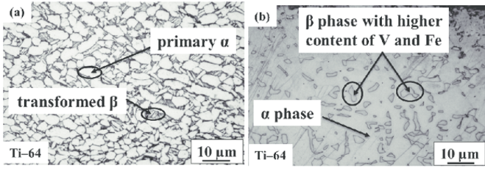
Figure 1: Optical micrographs showing (a) as-received Ti-6Al-4V and (b) the alpha case layer formed after heat treatment at 700 °C for 500 hours. Source: Sefer (2014)
The main titanium alloys produced at TIMET are alpha phase microstructure alloys. During thermal processing, for forging or rolling, exposure to elevated temperatures in an oxidising environment such as a furnace causes a brittle oxygen-enriched layer to form on the metal (Lütjering and Williams, 2007). This layer is known as alpha case, resulting from interstitial diffusion of oxygen into the titanium matrix, leading to a hardened but brittle phase. This phase has significantly reduced ductility and toughness compared to the base metal (Donachie, 2000; Seth et al, 2022).
During rolling, as the material is harder, the alpha case promotes crack initiation and propagation, which poses a risk in high-cycle fatigue environments commonly associated with aerospace structures (Boyer, 1996). Research by Rao et al. indicates that alpha case significantly reduces fracture toughness, leading to premature failure under cyclic loading conditions where stress concentrations increase the impacts of surface defects (2015).
Minimising the cause of surface defects is vital to producing quality parts and, therefore, offers a significant cost benefit at TIMET Waunarlwydd. If not removed before further working of the material, these cracks will grow and be revealed further along the product route leading to component failures, additional rework cost and COPQ.

Alpha Case Removal
TIMET Waunarlwydd have three methods for removing alpha case from the material surface, two mechanical and one chemical.
- Machining
- Grinding
- Chemical etching
This project will focus on machining. Milling is employed as a primary removal method technique, as it can remove a large amount of material in a short period. Grinding does allow for more precise depth control of the material removed but is more time consuming.
Due to the inherent characteristics of the material, low thermal conductivity and high hardness causing high tool wear, specific considerations are required to mill titanium (Ezugwu & Wang, 1997).
Coated carbide tools are preferred due to their superior wear resistance and ability to handle the high cutting forces associated with Ti64 machining (Ezugwu & Wang, 1997). Carbide tools with TiAlN or AlTiN coatings help reduce oxidation-induced adhesion, improving tool longevity.

Process Information
In Timet Witton, slabs (base product for fan blade/plate/sheet rolling products) are produced by forging an ingot to a thick rectangular plate (typically 5.0x0.9x0.23m) and are subsequently machined to remove forged surface defects and alpha case for further rolling at TIMET Waunarlwydd to final product. Table 1: Table of Slab/Product Type Dimensions below lists the dimensions of different products/slabs machined at TIMET Witton. This project will focus on OGV_S_ slabs, as these products were the first to pass approval on the Waldrich Miller.
Currently, machining of slab is carried out within the Witton facility on two large conventional milling machines. With these two machines, typically 21% of machining work is required to be outsourced to Summercliff, to meet production rates.
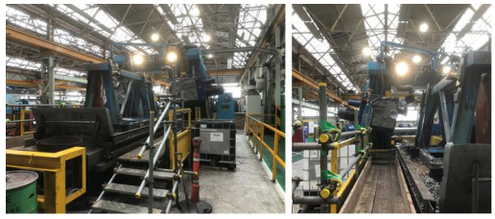
Figure 2: Current Machines at Witton
Although recently guarded to modern standards, these millers are constrained by 65-year-old technology and capability resulting in reduced yield and productivity. The outsourced machining at Summercliff is costly and swarf cannot be reclaimed because of inability to guarantee segregation.
The new miller would be situated in TIMET Waunarlwydd, as the next step in the operational process, slab rolling, is performed at the site, and the limited space at the Witton site.
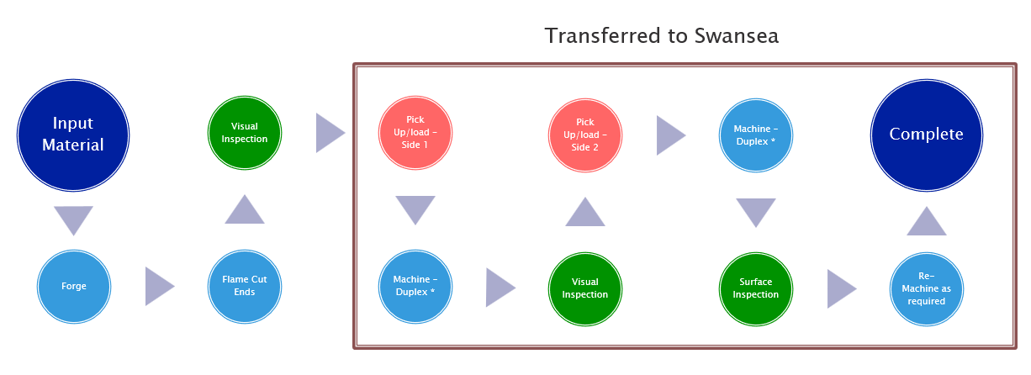
Figure 3: Example of OGV_S_ Process Steps Transferred to TIMET Waunarlwydd
As the business is transitioning from using two, albeit older machines, to a single newer machine, productivity of this new machine must match the existing rates ready for the decommissioning of the older machines. Following a successful trial period of 6 months on the Waldrich Miller, one of the current machines at Witton will be decommissioned, with the other left as backup to mitigate against a single point of failure. Thus, it is vital that the new machine reach the required run rates to allow the decommissioning and cause no production issues.

Table 1: Table of Slab/Product Type Dimensions
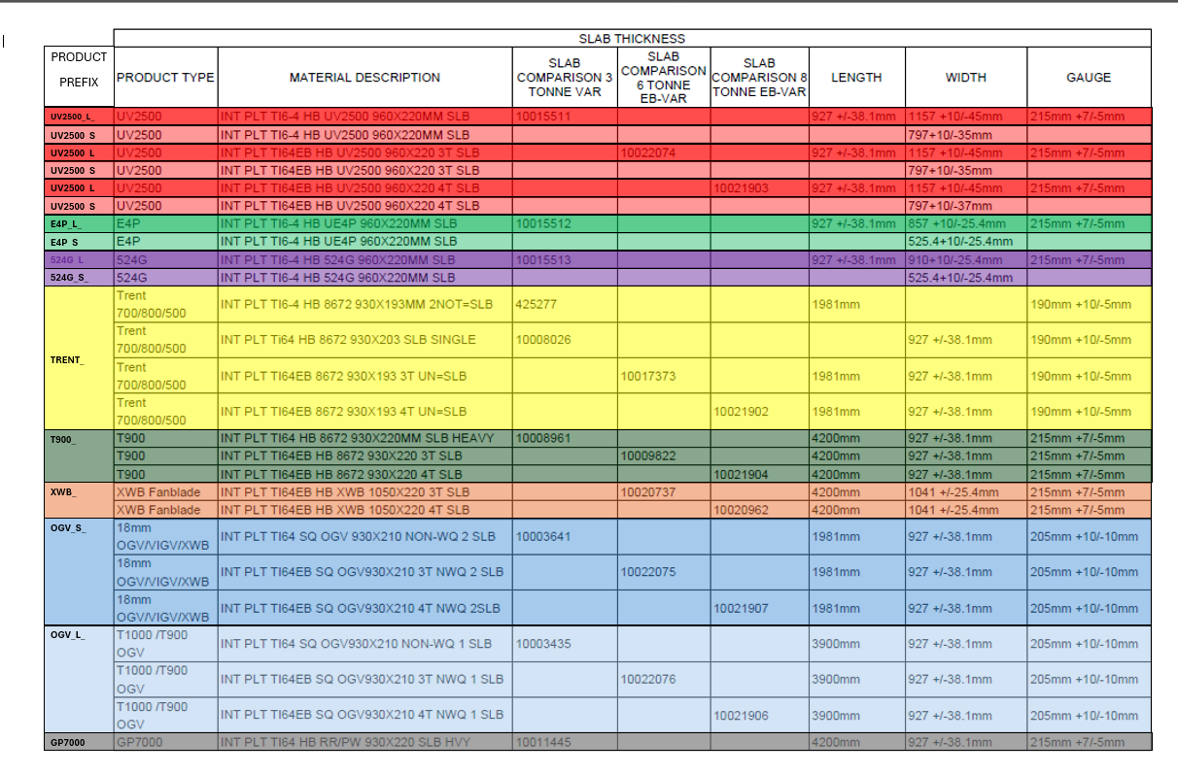

Aims and Objectives
- Establish cycle time and yields of current process.
- Calculate a theoretical baseline cycle time of Waldrich Miller.
- Asses operational performance of Miller against theoretical data and historical performance of current process.
- Identify sources of inefficiency in process.
- Apply Lean principles to improve process throughput, material yields, and reduce cycle times.
- Validate the efficacy of the process changes through comparative data analysis on KPIs such as cycle time, NVA reduction, and yields.

Report Structure
This project follows a structured approach in addressing the above aims. Section 3 is a literature review, discussing known process improvement methods and their application in comparable industrial environments. Section 4 outlines the methodology applied, detailing the data collection methods, process analysis, and improvement techniques applied. Section 5 describes the implementation stage, both the early pilot trials and the later large-scale rollout. Chapter 6 reports on the results of these interventions, backed up by quantitative and qualitative analysis. Finally, Chapter 7 provides conclusions based on the research and makes recommendations for further work. Section 8 draws from the study to suggest and set out recommendations for future work.

2. Timing Plans
A comprehensive plan was prepared to direct the implementation of this project, guaranteeing timely completion of goals and proper resource allocation. This project was organised into eight key phases, encompassing planning, execution, and reporting tasks. Specific time slots, such as start and completion dates, and important milestones, were assigned to each phase.

2.1 Project Schedule
The table below outlines the major activities and their corresponding durations:
Table 2: Gantt Table of Tasks
Each activity was linked to a defined output, including completion of a Value Stream Map (VSM), standard operating procedures (SOPs), and execution of pilot studies.

2.2 Commentary on Timing and Adjustments
Although the timing plan was generally adhered to, two significant constraints emerged:
- Commissioning Delay: The Waldrich Miller installation at TIMET Waunarlwydd was delayed from October 2024 to January 2025. This impacted early implementation activities, requiring the use of Factory Acceptance Test (FAT) data to proceed with process planning and tool selection.
- Machine Downtime: Unforeseen equipment downtime during pilot testing, led to a reduction in the number of slabs processed and limited yield analysis, pushing data analysis and result validation later in the timeline.
Despite these challenges, adaptive planning allowed for the reordering of tasks. For instance, literature review and process mapping continued during periods of operational disruption. In this way, delays were mitigated, and overall project momentum was preserved.

2.3 Milestone Tracking
Key milestones achieved during the project include:
- October 2024 – Project scoping and definition complete.
- November 2024 – Literature review finalised.
- December 2024 – Initial process data collected from TIMET Witton and FAT trials.
- January 2025 – Waldrich Miller commissioned; first full slab machined.
- April 2025 – SOPs and Lean improvements trialled.
- May 2025 – Final time studies and comparative analysis performed.

2.4 Summary
The formal timeline offered a realistic model for project management and was invaluable to monitoring progress against targets. Although there were several external delays that impacted the execution process, careful sequencing and early planning ensured essential objectives, most importantly the implementation of Lean interventions, were met within the defined scope. The final write-up and analyses regarding yield are still in progress at the time of submission, with recommendations for further research identified in Chapter 8.

3. Literature Review

3.1 Overview
Process improvement methods such as Six Sigma and Lean Manufacturing have taken root in high-precision industries. In particular, the aerospace industry demands high-quality parts, complex assemblies, and cost-sensitive production environments demand operational excellence. This review examines the origins, principles, and applications of the two methods and their relevance to metal machining and equipment integration scenarios such as at TIMET.

3.2 Lean Manufacturing

3.2.1 Historic Development
Lean Manufacturing has its roots in the Toyota Production System (TPS), which was established in Japan after the Second World War (Herron & Hicks, 2008). With limited resources available, Toyota engineers, most notably Taiichi Ohno and Shigeo Shingo, sought to remove inefficiencies from manufacturing processes to achieve optimum productivity with minimal waste (Ohno, 1988). As opposed to the American mass production systems, which were focused on economies of scale, Toyota focused on flexibility, quality, and continuous improvement, which resulted in a model that would later be termed "Lean" by Western researchers.
The application of "Lean" was first made widespread by Womack, Jones, and Roos (1990) in The Machine That Changed the World, an account of Toyota's dominance in car manufacturing. Womack and Jones's subsequent book, Lean Thinking (1996), codified the Toyota method in a portable process-improvement system that could be applied to all sectors.

3.2.2 Fundamental Principles
Lean Manufacturing is based on five key principles, as described by Womack and Jones (1996):
- Define Value – Define value from the perspective of the customer, typically in terms of features, lead time, and cost.
- Identify the Value Stream – Outline all tasks (both value-creating and non-value-creating) to deliver a product to the customer.
- Create Flow – Ensure production processes occur in a seamless and uninterrupted succession, with no halts or delays.
- Implement Pull – Move away from forecast-based production to a system that is driven by real time demand.
- Strive for Excellence – Actively engage in continuous improvement (Kaizen) to reduce waste and increase efficiency in all processes.
These are rolled out using tools such as VSM, 5S workplace organisation, Standard Work, Just-in-Time (JIT), and Visual Management. The tools all assist in identifying inefficiencies, streamlining workflow, and engaging employees with improvement initiatives.

3.2.3 Value
In lean manufacturing terms, value assessment starts from the customer's point of view. For Wilson (2015), the VA to a specific product is what encourages customers to pay for it. A core of the Six Sigma methodology is comprised of an overall understanding of customers' requirements, also called the Voice of the Customer (VoC) (Griffith & Hauser, 1991). Finding the VoC is vital in gathering the needed information to deliver a product or service meeting customers' expectations (Martin, 2008). This kind of information is typically called Critical to Quality (CTQ), which defines key requirements of customers for a product or service.
Lean methodology utilises numerous tools to evaluate and meet customer requirements. One of these tools is the Kano model, which Wang and Ji (2010) feature as critical to the evaluation of the level of customer satisfaction. The Kano model consists of five unique categories that reflect various dimensions of customer satisfaction: basic, performance (primary), excitement, indifferent, and reverse.
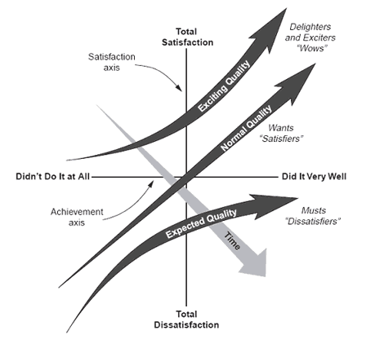
Figure 4: Kano Model Example (American Society for Quality, n.d.)
VSM is a lean methodology technique for analysing processes by disassembling them into separate components and then segmenting these components as either value-added (VA) or non-value-added (NVA) (Onofrejova & Janekova, 2015). VA activities add to the product's and/or service's development, while NVA activities do not add value. Crawford (2016) emphasises the importance of having thorough knowledge of customers' demands to differentiate between VA and NVA activities effectively. In addition to this, NVA activities can be categorised into two types: the required and the unnecessary.
Finally, customers will not tolerate spending on any form of waste or unnecessary non-value-added (NVA) components in a process. Davis and Davis (2011) state that non-value-added activities don't add value; instead, they drain resources. Furthermore, Fernández-Solís and Rybkowski (2012) assert that providing value requires the service provider to effectively meet customer requests.

3.2.3 Industrial Applications and Advantages
The benefits of Lean practices are well documented, particularly in the field of aerospace manufacturing, where complex assemblies, tight tolerances, and high material costs magnify the impact of inefficiencies. Prominent benefits include:
- Lead times were cut by removing delays and non-value-added activities.
- Improved product quality due to defect prevention rather than inspection.
- Lower levels of inventory, freeing up working capital and reducing storage requirements.
- Enhanced employee involvement through shared problem-solving and skill development.
- Increased equipment utilisation and operating uptime, achieved through better scheduling and preventive maintenance techniques.
Implementation of Lean Manufacturing techniques across a wide range of industrial sectors, especially in aerospace machining and high-precision manufacturing environments, has yielded quantifiable enhancements in operational efficiency, production volumes, and process stability. A key competency in the success of Lean is its focus on methodical removal of waste (muda), i.e., unnecessary material handling, extended setup times, and inefficient workflow configurations. According to Chahal & Narwal (2017) these wastes are interlinked, and their classification was central to the success of the TPS system.
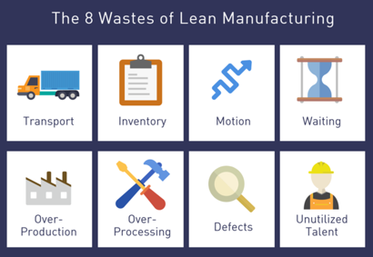
Figure 5: Lean manufacturing eight wastes (Lean Enterprise Institute, 2018)

3.2.3.1 Optimisation of Material Movement in Aerospace Manufacturing
In aerospace machining plants, the physical movement of material, manning and components is one of the most common sources of inefficiency. Items like titanium slabs or pre-machined parts are routinely transported between discrete process areas, not only a waste of time but also an additional risk of damage due to handling or loss. Consequently, lean initiatives have concentrated on minimising transport distances, removing the intricacy of internal logistics, and redesigning facility layouts to permit continuous flow.
Rolls-Royce conducted a Lean transformation in its compressor blade factory. A detailed VSM analysis identified excessive internal handling and queuing between machining and inspection operations. Reorganisation into cellular manufacturing layouts, assisted by kanban-part replenishment and line-side kitting, led to a reported 70% reduction in material handling time and improved traceability (Bicheno and Holweg, 2016).
Similarly, GKN Aerospace applied Lean logistic techniques to its composite lay-up and trimming operations. Using spaghetti maps to trace operator movement, the team reshaped the shop-floor transportation system with tugger trains, fixed transfer points, and visual pull signals. The intervention resulted in 25% less part movement time, improved layout efficiency, and lower handling-related defect rates (Womack and Jones, 1996).
Figure 6: Example of a Spaghetti Diagram

3.2.3.2 SMED for Machining and Minimisation of Changeover
One of the most effective Lean tools for high-precision manufacturing is Single-Minute Exchange of Dies (SMED). This method seeks to minimise the time to change between machining setups, which is especially applicable to high-mix, low-volume aerospace manufacturing. Setup time reduction not only enhances machine utilisation but also allows for smaller batch sizes, improved responsiveness, and lower inventory. In machining titanium fasteners at one aerospace subcontractor, a SMED project reduced lathe changeovers from 95 to 30 minutes. Time studies revealed that tool presetting, fixturing, and loading CNC programs were operations performed during idle machine time. Idle time was slashed by distinguishing between internal and external setup operations, introducing quick-change tooling, and computerising setup sheets (Shingo, 1985).
Airbus UK applied the SMED methodology to its big gantry CNC cells for wing part machining. The initial changeover procedures involved manual setting of huge fixtures and time-consuming part verification operations. By introducing preset fixture mountings, automatic coordinate calibration techniques, and preloaded CNC programs, Airbus achieved reduction in changeover time by more than 50%, thereby enabling multi-variant production under less disruption (Murman et al., 2002). Beyond assembly lines, Lean principles have been effectively transferred to machining operations, even those that include difficult-to-machine alloys like titanium. For example, Lean initiatives at a UK aerospace subcontractor saw machining sequences optimised, tool changeovers minimised, and maintenance routines become more efficient, leading to improvements in overall equipment effectiveness (Knowles et al., 2005).

3.2.3.3 Value Stream Mapping in Machining Environments
VSM is a fundamental Lean tool that enables the visualisation and analysis of the entire flow of materials and information in a production system. Its use in machining shops gives key insights into inefficiencies that might not easily be exposed with the use of conventional production reporting methods (Rother and Shook, 2003).
The expression ‘value stream’ was established by Womack, et al, (1991) in his renowned work titled ‘The Machine that changed the World’. Martin & Osterling (2014) describe VSM ability to reduce waste, transform management rational, identify strategy/priority and finally ensure customer satisfaction.
In a machining environment, especially where complicated materials like titanium are being worked on, VSM is utilised to recognise value-adding activities (e.g. material removal) and non-value-adding activities (e.g. waiting time, unnecessary transport, tooling changes, and inspection delays). By charting every process step from raw material input to completion of finished parts, engineers can evaluate cycle times, set-up times, queue lengths, and work-in-progress build-up at every station.
Table 3: Visual State Map Signs (Thomas, 2018)

For instance, in high-precision aerospace machining activities, Knowles et al. (2005) described how VSM was applied in mapping the flow of the production of structural components. Through the exercise, they noted substantial waiting time between milling and quality checking caused by batching policies and schedule inefficiencies. The company, consequently, rearranged the workflow in small, continuous batches, achieving 40% less total lead time and increased part throughput.
VSM is also effective when new equipment—i.e., slab millers—is being brought online or incorporated into operations. By mapping the current state before full integration, one can seek out disruptions in material flow, unneeded buffer zones, or replicated inspection points created by the new asset. From that point, one can design a future-state map to target specific improvements, including streamlining material handling tendencies, synchronising upstream and downstream tasks, and reducing tool idle time.
The method is particularly valuable in low-volume, high-mix machining operations, which are prevalent in aerospace, where production runs are often custom and small timing deviations can snowball into larger delays. Combined with time studies and standard work documentation, VSM allows teams to move beyond symptom treatment and toward root-cause elimination of process waste.
Lastly, VSM use in machining promotes a systems-level view of production, enabling data-driven decision-making on layout changes, automation, and staffing adjustments. Its strength, according to Bicheno and Holweg (2016), lies in revealing not only what is happening, but also why it is happening—rendering it a basis for long-term Lean implementation.

3.3 Six Sigma

3.3.1 Origins and Development
Six Sigma is a statistically driven process improvement methodology that seeks to reduce process variation and defects to a statistically negligible extent—i.e., to 3.4 defects per million opportunities (DPMO). The idea was developed at Motorola during the mid-1980s by of engineer Bill Smith and was subsequently established as a strategic business effort by Jack Welch at General Electric during the 1990s (Harry and Schroeder, 2000). Unlike the previous quality control methods that had concentrated mainly on end-of-line inspection, Six Sigma incorporates quality in every stage of the process lifecycle. Six Sigma is both a philosophy of continuous improvement as well as an analytical method, usually executed using the DMAIC approach (Define, Measure, Analyse, Improve, Control) to drive existing process optimisation or DMADV (Define, Measure, Analyse, Design, Verify) to create new processes (Pyzdek and Keller, 2014).

3.3.2 Methodology and Tools
The DMAIC process constitutes the backbone of many Six Sigma projects:
Define – Identify project goals, customer requirements, and the process scope to be improved.
Measure – Gather baseline information on how current processes stack up on key measures like defect rates, process capability, and throughput time.
Analyse – Utilise statistical instruments to determine root causes of variation or inefficiency. Typical methods involve cause-and-effect analysis, hypothesis testing, and regression analysis.
Improve – Develop and test potential solutions, often using Design of Experiments (DOE) or pilot studies to make the process more efficient.
Control – Implement monitoring systems, control measures, and records to ensure the progress is sustained in the long term.
Six Sigma utilises a broad array of analysis tools such as Statistical Process Control (SPC), Failure Modes and Effects Analysis (FMEA), Control Charts, and Capability Analysis (Cpk, Ppk).

3.3.3 Industrial Applications in Aerospace
The aerospace industry, characterised by its stringent quality requirements, expensive materials, and strict regulatory oversight, has been a prolific consumer of Six Sigma methods. The requirement to minimise defects, achieve process stability, and improve the reliability of aerospace components—most of which are exposed to extreme environments—makes Six Sigma the optimal methodology for process improvement.
Honeywell Aerospace, for instance, introduced Six Sigma under a company-wide operational excellence initiative across several plants. Their deployment included the training of hundreds of Black Belts and Green Belts to manage formal DMAIC projects. One of these initiatives was aimed at the minimisation of defects in avionics circuit board assemblies. By using failure data analysis, process inconsistency detection while soldering, and taking remedial measures like real-time process monitoring and standardised reflow profiles, the company reduced its internal failure rates by over 60% within 12 months (Pande et al., 2000). Additionally, Honeywell utilised FMEA and Control Charts for predicting failure risks in advance and establishing more robust process controls in final assembly lines.
Lockheed Martin used Six Sigma tools on the manufacture of the F-35 Lightning II, a fifth-generation, multirole fighter aircraft. One of the areas targeted was supply chain variability reduction and improving the dimensional consistency of structural assemblies. A significant project was conducted to correct the variation in rivet hole position on fuselage panels, where normal drill processes introduced variability that caused misalignment and rework. Using the DMAIC approach, the team instituted high-accuracy jig fixtures and laser-guided measurement systems. This had a measurable decrease in non-conformances and resulted in much-improved first-pass yield (Antony, 2006).
In the context of machining operations, Six Sigma has also been applied to optimise cutting parameters and reduce tool wear in the production of titanium airframe components. With machining of titanium being challenging—due to its low thermal conductivity and high resistance to cutting—process variability is a frequent issue. In a Greek aerospace subcontractor, Besseris (2010) conducted a Six Sigma project on the bore concentricity of titanium parts using Taguchi techniques and statistical modelling for identifying optimal settings for feed rate, cutting speed, and coolant use. The changes led to a 40% increase in part consistency and a 25% decrease in scrap rates.
Another from Rolls-Royce, which incorporated Six Sigma into its manufacturing and maintenance overhaul divisions. One of the projects in the turbine blade repair division used Six Sigma techniques to reduce the turnaround time and variability in the application of the coating. During the Measure and Analyse phases, the engineers discovered that fluctuations in temperature control during coating were resulting in rework. By reconstructing the thermal profile and implementing tighter control limits, the team achieved a 30% reduction in rework and a higher level of process reliability (George, 2002).
Together, these applications illustrate the range of Six Sigma in aerospace manufacturing—ranging from defect reduction at the component level to systems-level integration. The union of discipline statistical tools and systematic improvement methodology makes Six Sigma especially adaptable to environments in which process repeatability and traceability are paramount.

3.4 Integrated LSS Approaches
The convergence of Lean and Six Sigma into a single methodology—popularly known as LSS—has received much praise in high-value, process-oriented industries like aerospace manufacturing. Where Lean concentrates on eliminating waste and process speed, Six Sigma takes an interest in minimising variation and enhancing quality by using statistical robustness. The combination of these two techniques creates a more even and successful strategy for continuous improvement, allowing organisations to strive for operational excellence on a wide variety of measures.
The greatest benefit of LSS is its two-way capability: Lean tools like VSM, 5S, and Standardised Work enable quick workflow and material flow improvements, while Six Sigma's DMAIC (Define, Measure, Analyse, Improve, Control) methodology guarantees that the gains are data-driven and maintained in the long run (George, 2002). This combination works to balance the drawbacks of using each approach alone. For instance, Lean gains will at times create unstable processes if variation is not controlled well, whereas Six Sigma projects will at times be sluggish and stubbornly focused without Lean's greater process view (Pyzdek and Keller, 2014).
For real-world aerospace use, LSS has been used to realise short-term gains and long-term cultural transformation. Akbulut and Motwani (2005) presented a detailed case study of an aerospace company that used LSS to rectify inefficiencies in component assembly and quality control. The firm began with Lean tools to map waste and redesign the shopfloor layout, followed using Six Sigma to remove variation in torque settings and dimensional tolerances by using control charts and capability indices. The project yielded quantifiable gains, a 40% decrease in the production cycle time and a 30% decrease in the level of rework.
The same findings were observed in the study of Thomas et al (2022), which captured a LSS intervention at a UK-based aerospace supplier that manufactures machined components. The company first applied VSM to identify wasteful movement between machining centres and inspection points. Through the application of Lean work cells and SMED practices, setup time decreased by 35%. Dimensional conformity problems were also reviewed by a Six Sigma team using Fishbone diagrams and Measurement System Analysis (MSA), which resulted in tooling adjustment and operator training. This synergistic method not only enhanced first-pass yield but also normalised operating procedures shift-to-shift.
LSS is a powerful approach to addressing efficiency and quality problems in aerospace and high-precision engineering contexts. Its strength lies in the synergistic combination of Lean's velocity and nimbleness with the analytical power and rigour of Six Sigma. Successful implementation is not only a matter of appropriate sequencing and application of tools, but also of strong leadership, cross-functional collaboration, and commitment to data integrity and problem-solving discipline.
Table 4: Summary of Lean/Six Sigma Differences and Complementarities
Feature | Lean Manufacturing | Six Sigma
Primary Goal | Waste elimination | Variation reduction
Focus | Process speed and flow | Process precision and quality
Tools | VSM, 5S, Kaizen, JIT | SPC, DOE, FMEA, Control Charts
Methodology | Continuous flow, pull systems | Structured DMAIC approach
Data Dependency | Low to moderate | High (statistical analysis)
Implementation Timeframe | Short to medium | Medium to long
Best Use Case | High WIP, long lead times | Chronic defects, high variability
Aerospace Application Example | Streamlining assembly lines | Reducing machining deviations

4. Methodology
In this chapter, the methodological framework utilised in examining and enhancing the operational efficiency of the newly installed slab miller in TIMET's production facility will be described. A hybrid methodology employing a combination of qualitative and quantitative techniques was employed in uncovering inefficiencies and making focused improvements. The framework is anchored on Lean Manufacturing philosophy, chosen due to its established efficiency in eliminating waste, smoothing process flow, and increasing value in high-reliability manufacturing setups, particularly in aerospace titanium production. (Womack and Jones, 1996; Bicheno and Holweg, 2016)

4.1 Process Analysis
The initial phase focused on a systematic analysis of the slab milling process to establish a benchmark and identify inefficiencies. The process involved the detailed documentation of the whole operational process related to the new slab milling machine that included both upstream and downstream interactions. For objective evaluation, key performance indicators (KPIs) were set, which included parameters of cycle time, machine availability, changeover time, and scrap rate (Slack et al., 2020).
A VSM and time study with detailed descriptions was developed to outline all the steps in the milling process—from slab loading to slab output—bottlenecks and non-value-adding activities were identified. Working with operators to perform the process allowed for hands-on information about sources of delay, variation, and waste (Rother and Shook, 2003).
Operational data was collected over a number of weeks, from both Witton and Waunarlwydd, through both manual logbooks, first hand timing of process and TIMET's production management system. Close attention was given to the tooling changeover procedures, tooling selection, and material handling procedures, which were repeatedly identified as areas for improvement.

4.2 Identification of waste
After process mapping, the waste was classified according to the seven types of Lean waste: overproduction, waiting, transport, overprocessing, inventory, motion, and defects, referred to as ‘Muda’ in Lean terminology (Liker, 2004).
Some of the main problems identified in the slab miller process:
- Excessive idle machine time between Tool changeovers, caused by non-standardised changeover procedures and poor use of operator time.
- Inadequate floor planning and guarding causing excessive and difficult material and manning movements.
- Overprocessing and yield loss, caused by incorrect tooling selected
These findings formed the basis for targeted Lean interventions to improve cycle time and reduce throughput variability.

4.3 Improvement Techniques
The following Lean techniques and methods were applied to address the identified inefficiencies that exist within the slab milling process:
A current-state value stream map of the slab miller process was built to identify NVAs. A future-state map was then built to guide process redesign activity that will reduce lead times and eliminate wasteful activities.
The workspace was reorganised into a dedicated manufacturing cell, grouping related equipment and workstations to minimise transportation distances for both materials and operators. This reduced walking distances and material handling time, enabling a smoother, more continuous flow (Womack and Jones, 1996), but did have negative effects on manning movements during the material loading/unloading.
A sequence of Kaizen workshops was conducted with operators and the project team to develop improvement opportunities and test small-scale process improvements. These improvements involved moving and improving the tooling transport, the workstation, and modifications to slab handling practices.
Standard operating procedures (SOPs) were created for key activities performed at the Waldrich Miller, such as tool change and material movements. These were created in collaboration with operators to ensure they reflected best practices and were straightforward to understand and execute.
Lean tools such as VSM and Spaghetti Diagrams were prioritised due to their visual clarity and their proven effectiveness in revealing flow inefficiencies in manufacturing processes. While 5S and TPM were considered, they were deemed less relevant during the initial cycle-time-focused phase of project.

4.4 Data collection and analysis
The gathering of data to quantify enhancements by means of KPI changes:
- Historical data from Old Process (Witton)
- Results from Factory Acceptance Test (FAT)
- Cycle time per slab
- Machine availability and uptime
- Operator utilisation
Data was collected manually and automatically by using log sheets, operator logs, and data exports from TIMET's SAP system. Pre- and post-intervention data was analysed using time-series comparisons to determine the efficacy of the Lean interventions. Further improvements were evaluated through operator feedback and observation of process stability over a duration of time.
Alongside real-time data, analysis of historical performance data from the existing slab milling process was conducted in preparation to establish a sound foundation for comparison (Slack et al., 2020). Production records of 41 slabs and their cycle times and yields were extracted from TIMET's SAP system were analysed by statistical trend analysis to identify average cycle times and yield. Additionally, off-site measurements of key milling parameters were conducted during the FAT on the Waldrich Miller. The measurements were taken from tests conducted on the machine, on an OGV_S_ slab, using selected tooling setups and feed rates to confirm the optimal settings determined for the future process (Bicheno & Holweg, 2016). Findings from both data sets informed target metric selection and Lean intervention development, to help guide the improvements of the future process.

4.5 Pilot Testing and Total Implementation
Trial runs and testing were performed on shift to validate the suggested enhancements, gathered from Gemba observations, VSM, and Spaghetti Diagram analyses of operator and material movements. These pilots evaluated the viability and effect of newly created SOPs, amended layout designs, and changes to operator utilisation.
Each pilot was carefully planned to monitor key performance indicators such as tool changeover times, operator walking distances, and reduction in NVA. Data was collected through direct observation and time studies, allowing comparison with baseline measurements (Liker, 2004). Operators were actively engaged during the trials, providing real-time feedback on the practicality and ergonomics of the changes, consistent with Lean’s emphasis on frontline involvement in continuous improvement (Womack and Jones, 1996).
Feedback from the pilot phase was positive, with quantified reductions in tool changeover time and improved utilisation of manning and equipment. Adjustments were made based on operator and engineers feedback to further optimise the process. Following fine-tuning, Lean improvements were embedded into the process.

4.6 Assumptions and Limitations
The following limitation and constraints apply to this study. The pilot testing period window was limited to eight weeks and hampered by downtime and an unexpected failure of a critical machine part, which restricted the number of slabs processed and reduced the volume of usable yield data. This led to an inability to perform a full yield analysis, which had initially been identified as a key objective. As a result, it was not possible to carry out statistical capability studies such as Cpk or Ppk, which are essential for understanding process consistency and material loss trends over time. The absence of this data limits the current study’s ability to quantify improvements in yield.
The research was confined to the newly commissioned slab miller line only, and the results were not necessarily transferable to the other machining centres in TIMET operations. While the project only focused on a single slab type, the improvements are applicable to all slabs that will be machined on the Waldrich Miller.
It was presumed that there would be no major modification to the slab miller's equipment or cell layout throughout the study period. The only modifications to the layout would be driven by the data gathered from the project. This was not the case as guarding around the Milling cell was modified to improve operator safety which negatively affected the operator movements, discussed further in 5.4.2 Material Movements Improvements.
Finally, any additional capital improvements were beyond the scope of this project and were put on to a further development capital case that required approval from business stakeholders.

5. Project Activities

5.1 Witton Process Assessment
Using historical logs and data gathered from Witton, the capability of the old process, situated at Witton, was calculated to assess the output that the new process would be required to match.
First, a time study of the processes operations was completed. This time study gives a breakdown of each step the operator takes to fully machine a slab on the Witton Duplex Millers.
Table 5: Witton Slab Milling Time Study
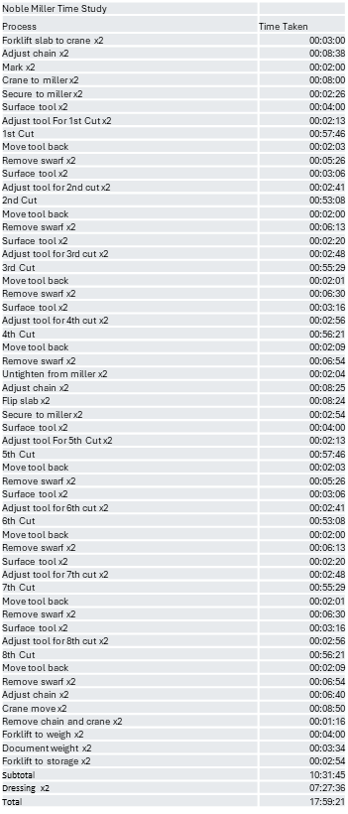
This time study shows the expected time (18 hours) to fully machine two slabs. It is two slabs as the machine is a duplex miller, allowing two slabs to be processed at the same time, equating to average 9 hours per slab. This time study does not factor in any additional defect removal into the process.
Due to the limitations of the machines, the cutting tool is manually set to cut depth by the operator. The machines can cut to a depth of 7mm, at a feed rate of 50mm/min. This is a slow process which does not allow for high accuracy of material removal, leading to excess yield loss.
Although the cutting operations are slow, they only equate to 43% of the total process time, meaning that 57% of the process is NVA time. The aim of the future process should be to maximise the VA time and limit waste time.
By examining process booking logs on the companies SAP system, a summary report was created to display the average cycle time that were booked in for the slab machining process.
Figure 7: Summary Report for Cycle Time
As you can see from the summary report, the mean cycle time for the process is 23.6 hours (11.8 hours per slab). This mean time is 31.1% longer than the expected time. This increase over the expected time is explained by additional passes required to remove cracks or defects from the slabs. To perform defect removal, the machine must complete a full cut along the length of the slab. The machines do not have the capability to perform spot defect removal. This is a major limiting factor, and a cause of additional yield loss. Every 1mm of material removed per side equals 0.91% yield loss. Using the Summary Report displayed below, the mean yield for the historical process is 91.7%, totalling an average of 9.12mm removed from the slab per side.
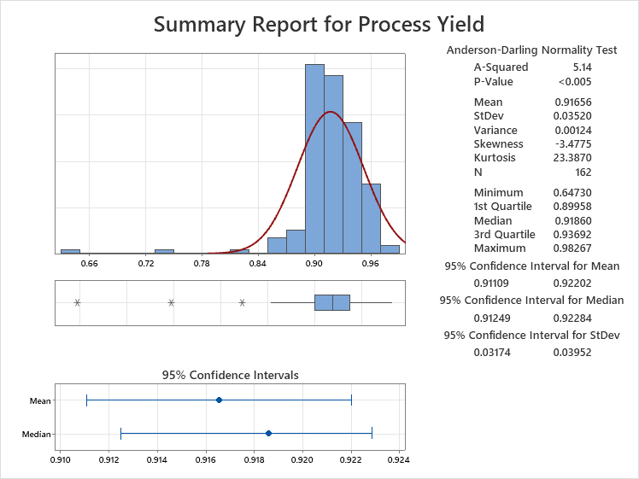
Figure 8: Summary Report of Actual Yield of Process

5.2 New Miller Cycle Time Estimates (FAT)
Before the Waldrich Miller was accepted a Factory Acceptance Test (FAT) was completed, during which test cutting cycles were completed to assess the machines capabilities. The tests were performed on an OGV_S_ slab (dimension listed in Table 1: Table of Slab/Product Type Dimensions).
In the lead up to the FAT, ISCAR another company under the PCC umbrella, were contacted to supply the tooling and inserts required for the test. If successful, they would be used in the Waldrich Miller for the future process.
ISCAR outlined two different tools that would be appropriate for TIMETs requirements. The specifications and design of these tools and the inserts are shown in the Figures below.
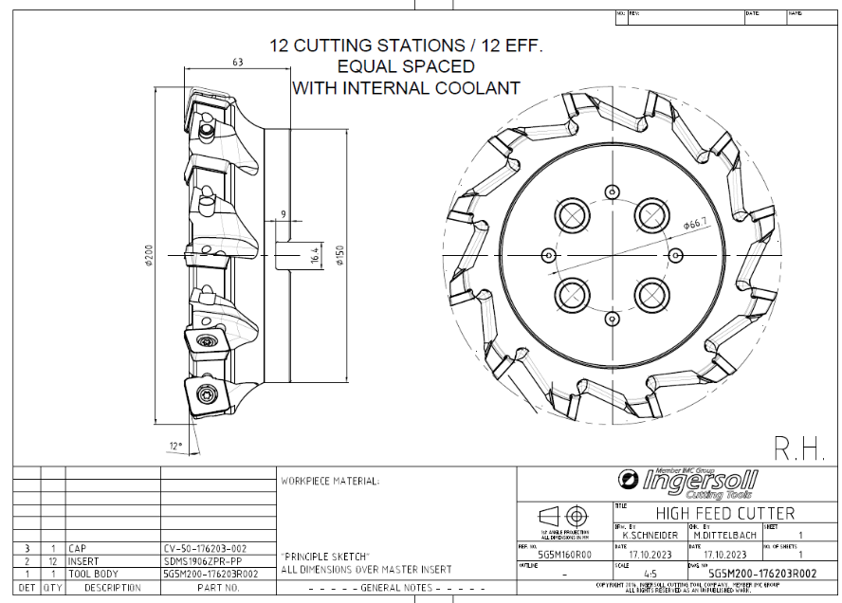
Figure 9: 12º High Feed Tool
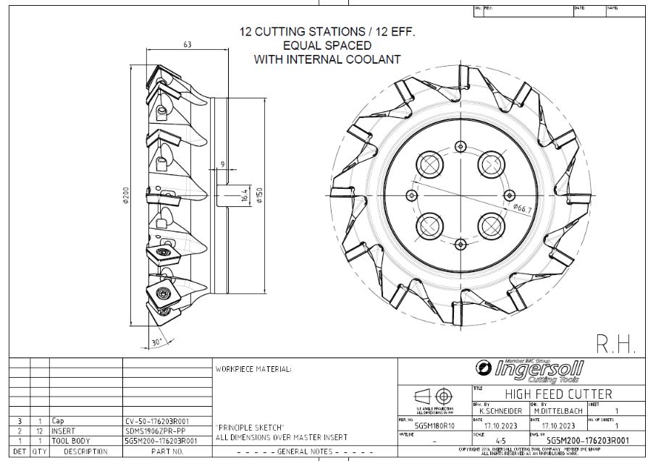
Figure 10: 30º Medium Feed Tool
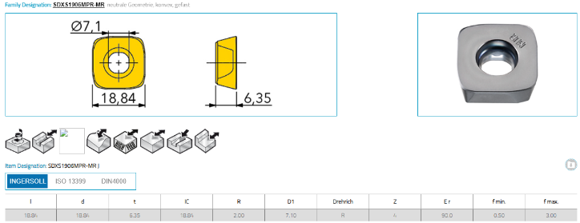
Figure 11: ISCAR Cutting Tip
These two tools were selected to allow for high feed cutting. While the spec sheet for the 30º Cutting tool lists it as a high feed cutter, this was designated by TIMET as the MFT, due to the slower feed rate that it ran at. While it had a slower feed rate, the depth of cut that the MFT was double that of the HFT, 6mm versus 3mm, giving it the benefit of increased material removal.
The cycle times for both cutters are listed below in Table 7: Cutting Tool Cycle Time and NVA Time Comparison. This table includes the loading, turn-over and unloading times that were required during the testing.
Table 6: Cutting Tool Parameters
Table 7: Cutting Tool Cycle Time and NVA Time Comparison
Table 6: Cutting Tool Parameters displays the different cutting parameters for each tool. The HFT had a feed rate double that of the MFT 500mm/min vs 250mm/min but was only able to remove a maximum of 3mm of material vs 6mm of the Medium Feed per pass.
No difference in insert life was seen between the two tools. The inserts completed 2 passes before being spent and required indexing to the next cutting face. This matched the manufacturers estimates of an expected lifespan of a cutting length of 4000mm.
While the NVA time operations, were not respective of the setup that would be used when the miller is installed on site at TIMET Waunarlwydd, they gave a good indication in the potential benefit of applying Lean techniques to the future process. The High Feed cycle time (3.43hrs) was 28.3% quicker than the Medium Feed, although the NVA for HFT equalled 44% of the total time. Any reduction in this percentage would greatly increase the throughput of the machine. This became the first focus of the project upon the machine’s installation and commissioning.

5.3 Waldrich Miller Initial Process Assessment
Following the commissioning and handover of the machine from the manufacturer to TIMET, the machine was available to start the initial assessment of the current process.
The author, with the help of operators, began by performing a complete run through of the process, during which a Gemba walk was conducted. Gemba, a Japanese term meaning "the real place," refers to the actual location where value is created, such as the shop floor in manufacturing. Gemba walks involve supervisors or engineers directly observing operations to gain insight into real-world challenges and engage with frontline staff to identify improvement opportunities (FourJaw, 2024).
Table 8: Gemba Walk Observations
During the Gemba walk, timings for each step of the process were recorded and used to create an initial Time Study of the process. The process was performed using the MFT. See Table 6: Cutting Tool Parameters for Tool feed rate.
Table 9: Initial Time Study of Process

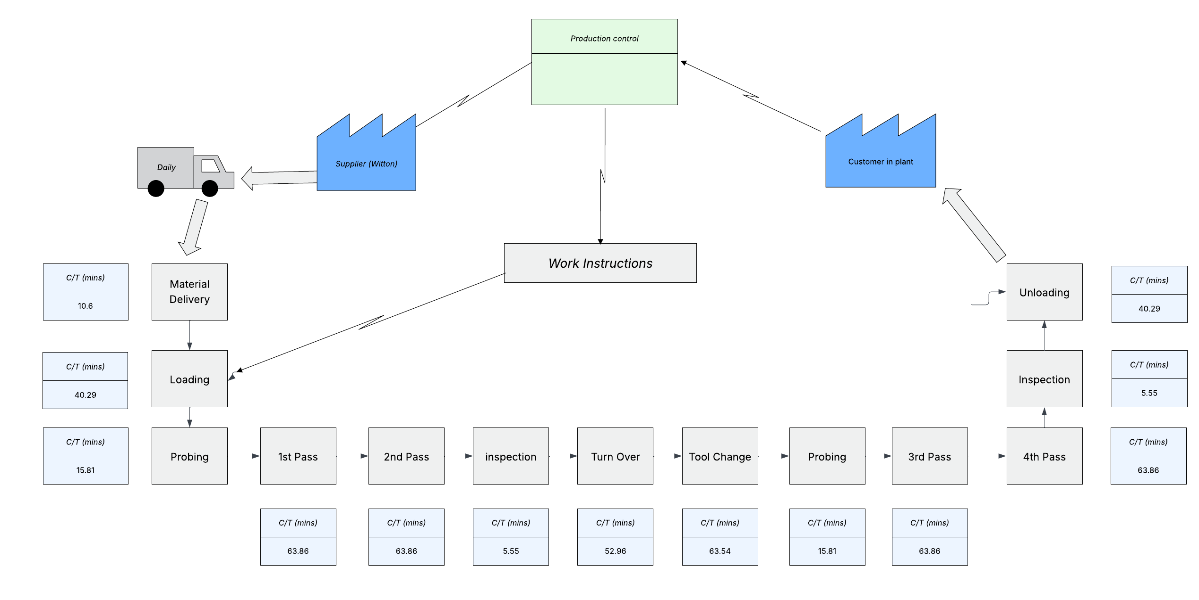
Figure 12: Current VSM
The process took a total of 505.84 minutes (8.43hrs), from delivery of slab to unloading. While this is 52% longer than the cycle time from the FAT, the process includes additional steps not completed in the FAT. As this was the first time completing the process, no SOPs had been completed, combined with an untrained operator made the process slow.
In Table 9: Initial Time Study of Process, NVA steps are highlighted in yellow and VA in green. NVA accounted for 50% of the process, which is 80% higher than the FAT results. Again, this is explained by the addition of extra process steps. From the study, the main bottleneck of the initial process was step 8, Tool Change, with the material movements (steps 2, 7 and 13) being the other bottlenecks.
Using the results from the time study and the observations gathered from the Gemba walk, improvements for the major bottlenecks were the first focus of the project.

5.4 NVA Improvements

5.4.1 Tool Changing Operation Improvements
The Tool Change operation of the process was the largest source of NVA, and a major bottleneck. Initially, the company purchased 6 of each tool (Medium and High Feed) all of which were loaded into the machine. 6 tools allowed for a 1st and 2nd pass to be completed, the required amount for a single face to be machined without the need for a tool change between each pass.
The initial trial completed two passes using the MFT, as the program was written to only call MFTs. This depleted the life of the one cutting face of the inserts. All six tools required indexing of the inserts to the next cutting face.
Removal of the tools and transportation to the tool workstation presented a high amount of wasted movements for the operator. A single tool was removed from the tool changer at a time, transported by hand around guarding to the workstation, indexed and then transported back to the tool changer to load back into the tool changer. These movements are displayed in Figure 13: Spaghetti Diagram of Operator Tool Change Movements. As the can be seen, the movement of the operator was highly wasteful.
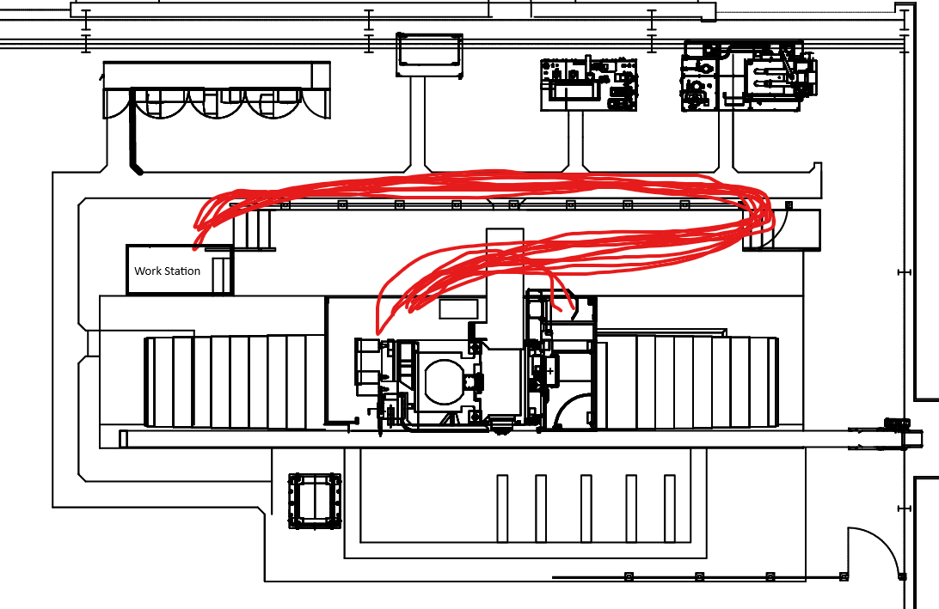
Figure 13: Spaghetti Diagram of Operator Tool Change Movements
To reduce operator movements and improve the transport of the tools, modifications were made to the guarding by the tool changer area, a trolley was purchased and modified to allow easier transport of the tools to the workstation.
The trolley storage had capacity to hold six tools, allowing it to be loaded with all depleted tools and all transported to the workstation in one journey. The guarding modification also streamlined the movement of the trolley, not requiring the operator to transport it with them.
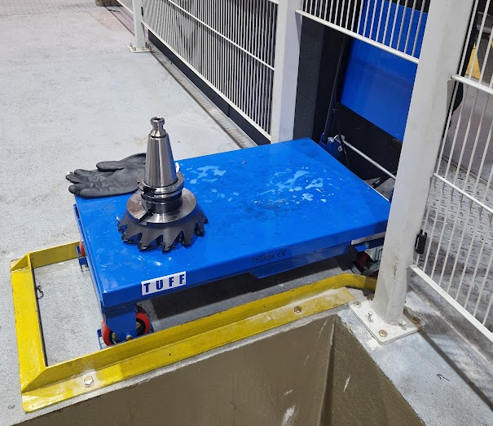
Figure 14: Guarding Mod for Trolley pre trolley mod
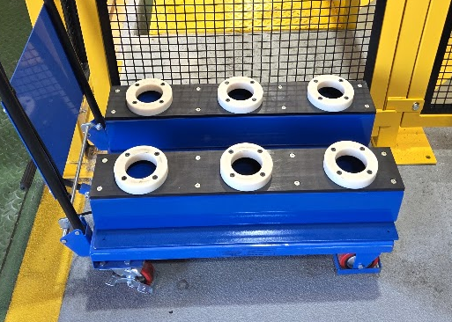
Figure 15: Trolley with Tool Holders
These changes limited the operator movements to only travelling to and from the workstation once, instead of 6 individual times. The use of specific tool trolleys and workstation changes reflect the 5S and standard work principles advocated by Womack and Jones (1996) and Bicheno and Holweg (2016).

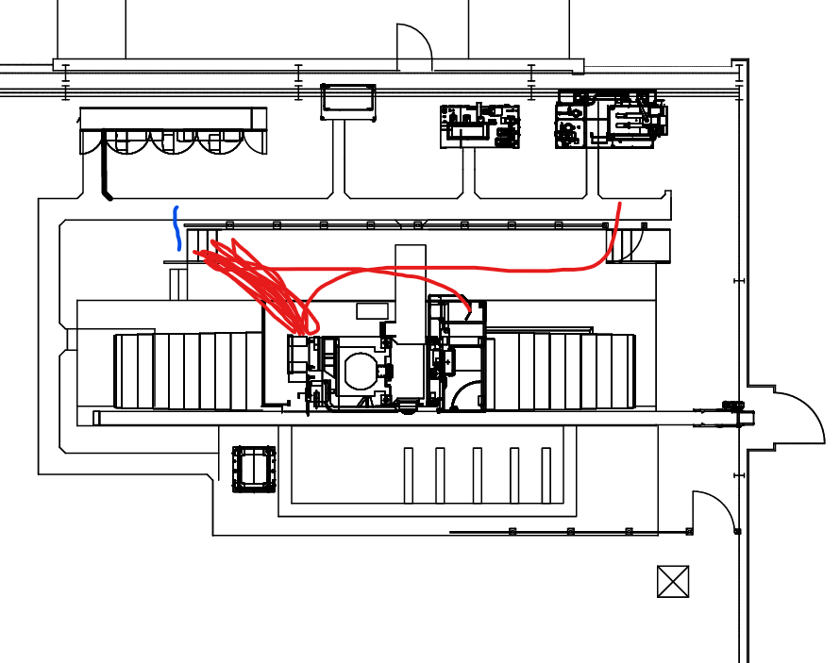
Workstation
Figure 16: Updated Tool Change Operation Spaghetti Diagram (Red=Man, Blue=Tool Trolley)

Secondly, it was found that indexing the inserts was difficult as there was no means of supporting the tool while on the workstation. The tool was rested on top of workstation and required a high amount of manual handling to move from one insert to the next.
A toolholder like the trolley was created, but with 2 additional pockets, and fixed to the workstation. This reduced and limited manual handling of the tools while indexing the tips, reducing the indexing time. A specialist torque tool was also purchased to further improve the operation and ensure the correct torque setting for the insert screw (4Nm).
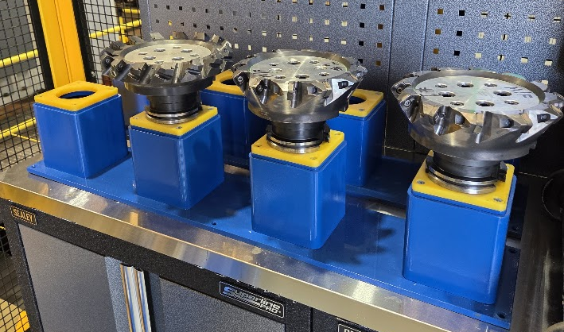
Figure 17: Workstation Tool Holder

Figure 18: Atlas Copco Pistol Cordless Screwdriver BCP (Atlas Copco, 2025)
Although the improvements were successful, there was still a high amount of idle time for the machine. An observation from the Gemba walk, raised the possibility of purchasing additional tooling, allowing for an offline set, and utilising the time of the operator more efficiently. During the cutting operation, the operator was situated within the control cabin unable to complete any other activities.
A cycle start button was installed outside the guarding by the manufacturer, allowing the operator to load the program, pause it, exit the cabin and guarded area, and start the program once guarding was secure. This allowed the operators time to be better utilised, now able to index the inserts of an offline set of tooling, among other tasks. The indexed tools were loaded into the trolley and the trolley positioned within the guarding, ready for the tool change operation.
The purchase of additional MFTs was not completed within the time frame of the project, but the improvement concept was trialled by utilising 3 of both tools. 3 MFTs and 3 HFTs were loaded into the tool changer and the rest kept offline. The cutting program was altered to utilise a roughing pass with the MFT and a finishing pass with the HFT, discussed further in section 5.5 VA Improvements (Program Tool Selection). Creation of an offline tooling strategy and utilisation of two-pass programs mirrors SMED practices in reducing changeover time in aerospace manufacturing (Shingo, 1985; Murman et al., 2002).

5.4.2 Material Movements Improvements
This section will discuss the improvements made to the material movements involved in loading, turn-over and unloading the slab on the fixture.
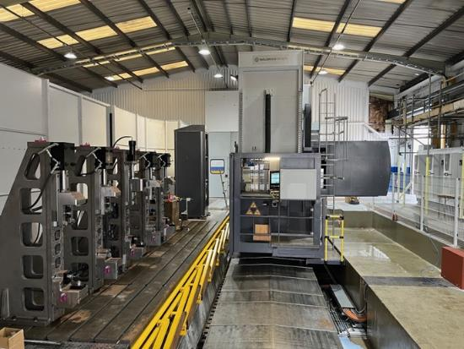
Figure 19: Waldrich Miller Fixture and Control Cabin
The Waldrich Miller was supplied with an already designed guarding layout, and the fixture was designed and installed by a separate company. The fixturing is orientated vertically as only the direct drive spindle of the machine has the required torque to machine through the alpha case of titanium. The need to load slabs vertically on the fixture caused the loading operation to be difficult, as the slabs are delivered and stored horizontally in the WIP area. To vertically position the slabs, a specialist lifting device was purchased, a Rotomax unit. The unit allowed the slab to be picked up horizontally and rotated into a vertical position, using looped slings, displayed in Figure 20: Rotomax Unit with Slab in Vertical Position being Loaded on to Fixture.
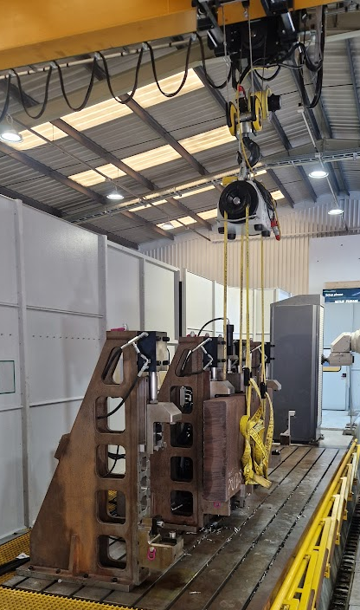
Figure 20: Rotomax Unit with Slab in Vertical Position being Loaded on to Fixture

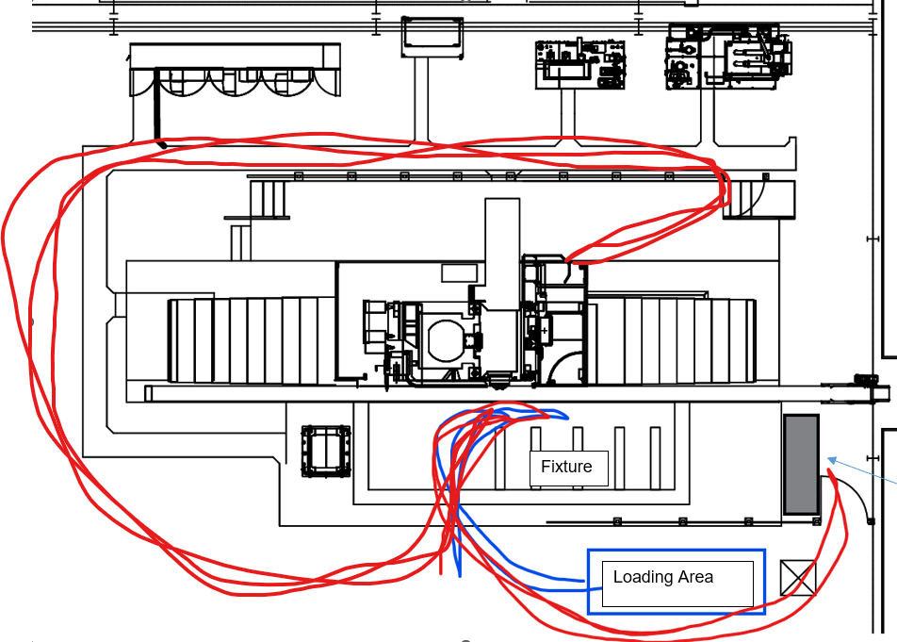
Fixture Controls
Figure 21: Material & Man Movements Spaghetti Diagram for Loading/Turn Over/Unloading (Material in Blue, Man in Red)

The delivered guarding required the material to be moved through a sliding door, built into the guarding, seen in on the left of Figure 22: Modification of Existing Guarding. Positioning and movement of a 2000mm length, 2mT slab through this opening, presented a difficult task. Gantry movements and rotation of the material were slow to avoid contact with the machine and guarding.
TIMET employs a no touch policy on all material. Due to the safety concerns and difficulty of this operation reported by the operators, a decision was made by the business and project stakeholders to modify the existing guarding.
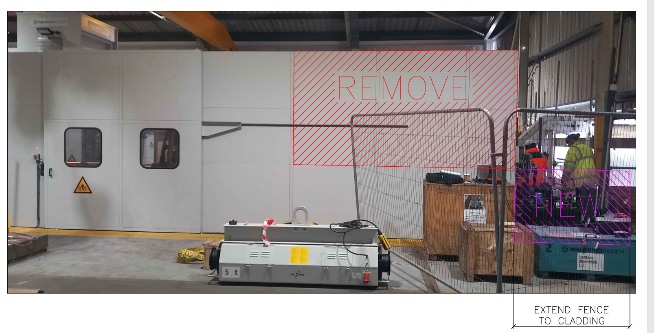
Figure 22: Modification of Existing Guarding

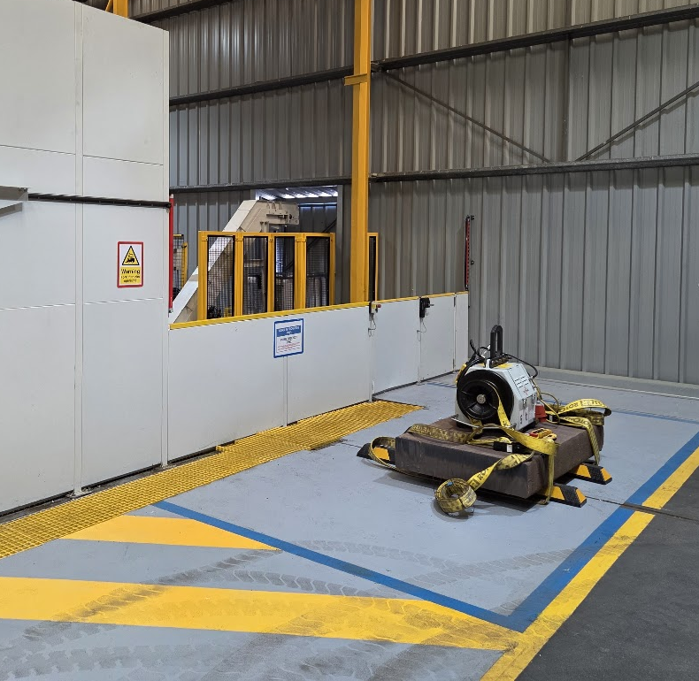
Figure 23: Completed Modifications to the Guarding
The modifications allowed the slab to be lifted horizontally over the dropped guarding into the milling cell, in the correct alignment for the fixture. The gantry hook was also fixed in place to avoid unwanted rotation, removing the need for any touching of the material during the movement. The restructuring of operator and guarding route paths is a product of Lean's focus on motion and transport wastes, two of the eight wastes identified by the Lean Enterprise Institute (2018).
Operators move the slab into the milling cell and use the Rotomax unit to orientate vertically on to the fixture. When up against the fixture, the fixture loading sequence is commenced. While these changes improved the loading process, additional safety amendments were introduced for the cell guarding and fixture control panel position. The fixture control panel was repositioned to avoid the slab travelling over it, and a walkway into the cell was fully guarded, causing man movement to increase. The new route to the Fixture Controls pathed the operator out of the building and through an outside access door. This change, while detrimental to the project goals, was unavoidable due to safety risks of manning being exposed to passing Forklift trucks while working at the workstation.
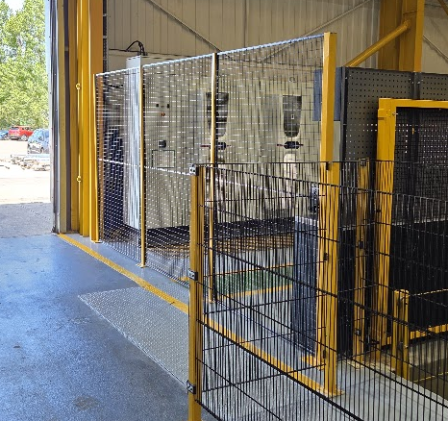
Figure 24: New Safety Guarding Blocking Existing Walkway
A benefit from an improvement made in 5.4.1 Tool Changing Operation Improvements, the addition of a program start button outside the guarding, allowed the operator to be ready waiting by the entry door ready to re-sling the material following completion of milling a face. The machine returns to a safe home position on completion of a face and the program is paused until the operator resumes it.
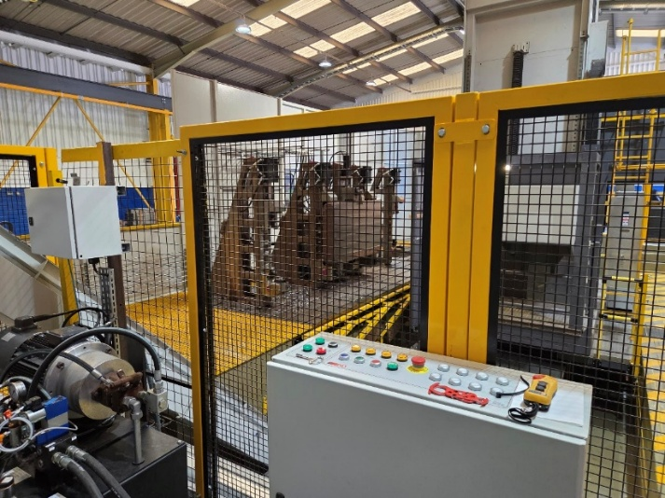
Figure 25: New position of Fixture Controls and view of Slab in Fixture
During the initial turn over operation, the slab was moved outside of the guarding to flip over to the second face. Following the modification and the growing experience of the operator, this was no longer required, and the SOP changed to allow turn over within the cell, further reducing material movements.

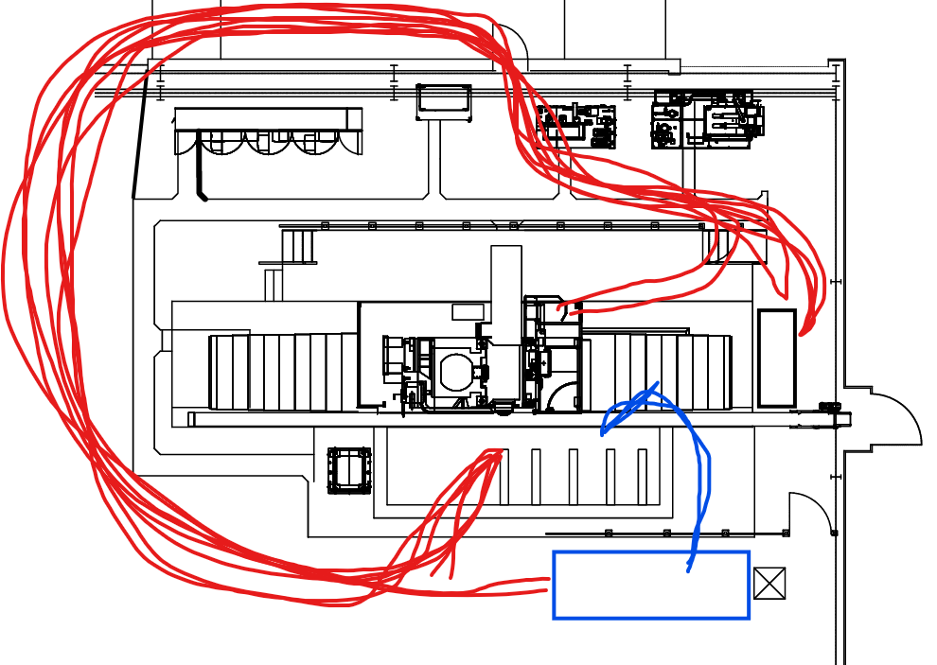
Additional Guarding
Fixture
Loading Area
Fixture Controls
Figure 26: Updated Spaghetti Diagram Post Guarding Change for Loading/Turn Over/Unloading (Material=Blue, Man=Red)

5.5 VA Improvements (Program Tool Selection)
Initially, the CNC Milling Program was programmed to use only the MFT. This was due to the need to prove out the process, forgoing yield. The need for a full offline set of tooling, discussed in 5.4.1 Tool Changing Operation Improvements. The program was amended to include a roughing pass with the MFT and a finishing pass with the HFT. This two-stage strategy reduced cycle time due to the HFT’s faster feed rate. This approach reflects the Lean principle of optimising value-added activities to streamline process flow (Womack and Jones, 1996) and aligns with Ezugwu and Wang (1997) which emphasises that tailored cutting strategies are essential when machining titanium alloys. Use of the HFT for both roughing and finishing was not possible as the measured alpha case on the initial slabs was measured to be deeper than the HFT two pass max depth (6mm).
This change saw an instant reduction in milling cycle times due to the higher feed rate of the HFT. Further improvements for the VA operations were targeted, to improve throughput. While the FAT proved the capability of the machine, tools and inserts, the feed rate remained constant, no additional testing was undertaken to test higher feed rates.
Higher feed rates for the MFT were tested. Spindle torque and times were gathered from the machines HMI, and the condition of the cutting inserts were visually inspected to compare the wear rate. An increase to 300mm/min was proven viable during the testing. Spindle load remained in a safe working range and insert condition showed no detrimental change. Higher feed rates caused premature tip failures and breakages, this in turn contaminated the swarf collected lowering the selling price.
Similar trials were conducted using the HFT but were unsuccessful. Like the Medium Feed, insert failures and breakages became more frequent at higher feed rate. ISCAR, the insert manufacturer, was contacted to further develop the inserts in the hope of further improving the feed rates and in turn improve throughput.
Table 10: Updated Medium Feed Tool Parameters

6. Results

6.1 NVA Improvement Results

6.1.1 Tool Changing Operation Improvement Results
The results from the first and secondary pilot tests are displayed below.
Table 11: 1st Tool Change Time Improvement
Table 12: 2nd Tool Change Improvement
An initial improvement of 25% was measure following the 1st improvements changes, during pilot tests. Successful but the process remained a bottleneck for the process with high idle time.
As the results from Table 12: 2nd Tool Change Improvement show, the secondary improvements were highly successful, reducing the time by 88.9%. While tool changeover time reduced by 88.9% across pilot tests, variations of ±5% were observed depending on the operator and time of day. This indicates that further standardisation and training are required to sustain improvements across shifts.
The 88.9% reduction in tool change time is comparable to Lean-driven changeover reductions reported by Airbus in gantry CNC applications (Murman et al., 2002), demonstrating the transferability of SMED principles. No further work was undertaken on this step, focus was moved to the next process bottleneck, material movements.

6.1.2 Material Movement Improvement Results
Following the completion of the guarding modifications, pilot tests were completed and time studies repeated on the processes. The results from these tests/studies are listed in the table below.
Table 13: Material Movement Improvement Results
Although modifications made to the guarding, did cause increased distance to cover for the operator, the changes along with fixing the gantry hook rotation successfully reduced the time taken to complete the task. The time taken reduced by 62.56% to complete the 3 processes. These results are consistent with projects run at other aerospace companies where layout reorganisation based on spaghetti diagrams and VSM (Bicheno and Holweg, 2016; Womack and Jones, 1996) have reduced movement times.

6.2 VA Improvement Results
The results for the optimisation of cutting tools used and the increased feed rate for the MFT are presented below. Again, pilot tests were run to validate the changes during which time studies were completed to record the findings.
Table 14: VA Improvement Results
While the improvements seen in this section of the project were not as large as the previous sections, they still proved successful. A reduction of 22.67% in VA processes. This reduction was largely attributed to the use of the HFT for the finishing pass for each face, due to its higher feed rate. The additional work completed to improve the medium feed rate, did contribute to some reduction, and poses an avenue for future improvement work.

6.3 Total Cycle Time Improvements
All the process improvements have been inputted into Table 9: Initial Time Study of Process to create a new table displaying the updated process time, and NVA%.
Table 15: Updated Process Time Study
The overall cycle time for the process was reduced from 8.43hrs to 4.80hrs, a decrease of 43.08%.
Like the Witton process time study, Table 5: Witton Slab Milling Time Study, the Updated Time Study does not consider any defect removal operations. This allows the results from both to be compared. Witton process was able to machine 1 slab per 9hrs from one machine, compared to the 1 slab per 4.80hrs from the Waldrich Miller, meaning that the process is 87.5% more efficient when compared to the output of one Witton Miller, but is 6.25% less efficient when compared to the output of both Witton Millers. This second data point relies on both Witton Millers being functional, which due to increased maintenance is not always the case. Nevertheless, further work is needed to match the output of both Witton Millers and remove the need for outsourcing of machining.
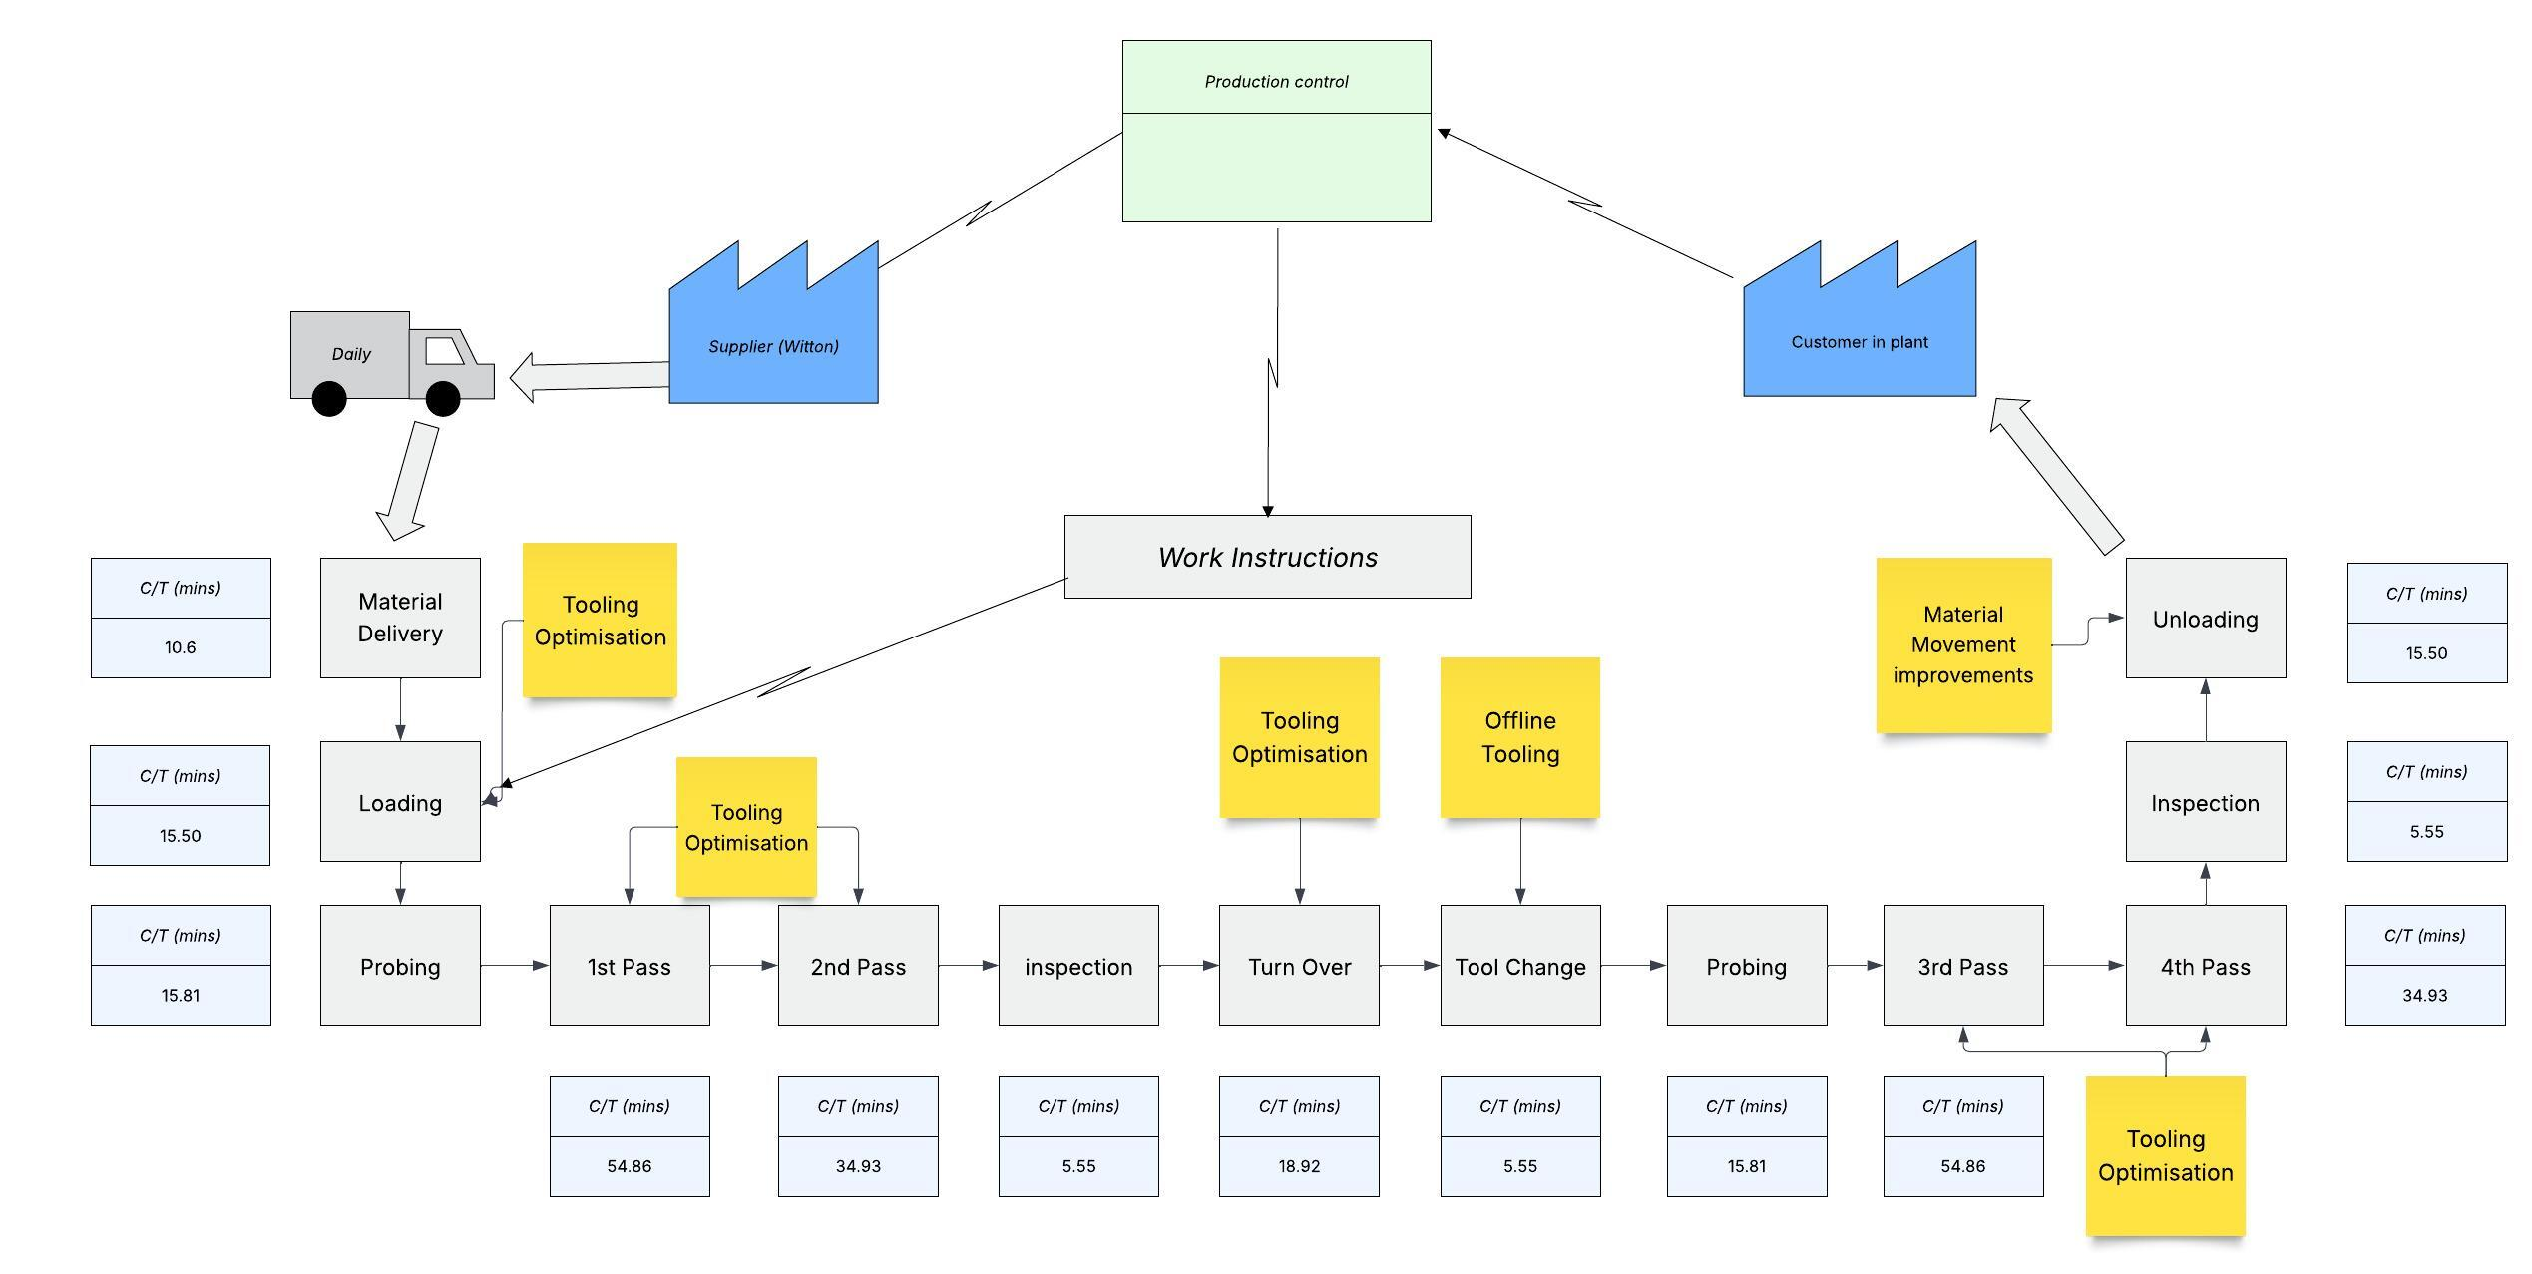
Figure 27: Future VSM

7. Conclusion
The installation and optimisation of the Waldrich Miller at TIMET Waunarlwydd has provided a case study for the analysis of the integration of Lean Manufacturing methods in the aerospace metals industry. The main objective of this project was to analyses the performance of the Waldrich Miller against current process located at TIMET Witton, identify sources of inefficiency, and implement measurable improvements in cycle time, yield, and throughput. Two goals were realised, with the optimised process having led to an overall reduction in cycle time by 43.08%, despite being subjected to delays in equipment and limitations in operations, which limited work on the final goal.
The approach utilised during this project is consistent with the Lean and Six Sigma principles adopted in the academic literature. The use of VSM, Kaizen workshops, and waste identification uses the fundamentals of Lean in terms of removing waste, optimising flows, and continuous improvement (Womack and Jones, 1996; Bicheno and Holweg, 2016). Additionally, application of tools like Spaghetti Diagrams and Gemba walks complies with best aerospace practices as seen in cases of companies such as Rolls-Royce and GKN Aerospace where process transparency and simplicity have yielded corresponding gains in material movement efficiency (Murman et al., 2002; Bicheno and Holweg, 2016).
In addition, the use of time studies is rooted in Six Sigma methodology, specifically under the DMAIC process (Define, Measure, Analyse, Improve, Control) framework, which provides a roadmap for process improvement (Pyzdek and Keller, 2014).
This decision to combine Lean and Six Sigma approaches is supported by modern academic research that calls for the integration of the two into a hybrid unified framework, referred to as LSS. Empirical research by Akbulut and Motwani (2005) in conjunction with Thomas et al. (2022) reveals that the integration of Lean's focus on process flow with Six Sigma's analytical rigor enables both timely and sustainable improvements. This two-pronged strategy is particularly beneficial in high-mix, low-volume environments like TIMET, where flexibility and reliability are of the utmost priority.
From a practical point of view, this project illustrated how NVA time in tool changeovers and slab transport created substantial process inefficiencies. Improvements in these aspects were not only made through the implementation of Lean methodologies but also through operator input incorporation as advocated in the Toyota Production System's approach of active involvement of line workers (Liker, 2004). Redesign of guarding and tool change activities made possible an 89% reduction in tool change time required, and material handling operation time reduced by more than 62%, thereby emphasising the impact of lean workplace layout pushed by operator input and trialling. While guarding improvements enhanced safety, they introduced layout inefficiencies, highlighting the trade-off between safety and efficiency.
The value-added process improvements realised through HFT implementation in finishing operations and increases in MFT feeds are indicative of optimisation concepts outlined in aerospace machining research. These efforts are akin to those utilised at Airbus and Honeywell where machining process performance and tool life were optimised through similar iteration testing protocols and operator collaboration (Besseris, 2010; Pande et al., 2000).
While the limited time and unexpected downtime hampered an in-depth examination of yield improvements, the preliminary efforts laid down the groundwork for further work and process control. In addition, the involvement of vendors such as ISCAR in the development of new inserts demonstrates the best practice in industrial collaboration in terms of mutual process innovation (Donachie, 2000; Froes, 2015).
Looking ahead, the recommendations for TIMET involve broader application of these improvements to other slab types and machining centres. These recommendations align with LSS's emphasis on sustaining improvements and promoting cultural transformation across operations (George, 2002; Antony, 2006).
Aside from proving the effectiveness of LSS process for the field of cutting-edge manufacturing, the research from this project also presents tangible evidence that can be used for future technological breakthroughs in the aerospace and titanium industries. By basing the interventions in both theory and frontline experience, this study underscores the enduring value of continuous improvement philosophies in delivering real-world manufacturing excellence.

8. Future Work
This project achieved the project goals of improving the process efficiency and throughput. Lean techniques applied reduced material movements and limited idle time caused by changeover, reducing the cycle time by 43%. However, further opportunities to improve the process, primarily addressing the unachieved goal of improving process yield, remain viable.

8.1 Process Yield Improvements
A key objective of this project, improving process yield, was not achieved during the project time, due to unplanned downtime limiting the pilot period and the data set. Future work should prioritise capturing statistical data from extended production runs. This would enable the calculation of process capability indices (Cpk, Ppk), thereby quantifying the stability and capability of the slab milling process (Pyzdek and Keller, 2014).
During the pilot period, the finishing cut was set to its’ max depth of cut for all finishing passes, sometimes removing more material than was required, lowering the final yield. By adding in an inspection step between roughing and finishing passes, the CNC program could be tailored to machine to the correct depth to remove all final alpha case or surface cracks. Each 1mm of material preserved across both sides equates to approximately 0.91% improvement.
Additionally, the creation of a spot defect removal program would allow only the areas with defects present to be machined. This would remove the need to fully finish machine a whole face. This future work would present a greater yield benefit to the process.

8.2 Further Integration of Offline Tooling Strategies
The concept of offline tooling preparation was trialled but not fully implemented due to time constraints. Future capital investment, allowing the purchase of additional MFT and HFTs, would allow for better flexibility in the depth of cut in the finishing pass. Currently the finishing pass is limited to 3mm due to the HFT parameters. This strategy, validated in other aerospace machining cells such as those at Airbus (Murman et al., 2002), would enable tool preparation concurrent with machining operations, thus eliminating idle time due to tool indexing when a 3rd pass is required.

8.3 Feed Rate and Cutting Strategy Refinement
Although the feed rates were successfully raised for the MFT without sacrificing the integrity of the insert, additional development into the cutting parameters is suggested. Cooperation with ISCAR to develop inserts specifically for higher velocities and loads could provide further throughput increase. Further research work should incorporate Design of Experiments (DoE) methods to test variable combinations of feed rate, cutting depth, and tool geometry systematically with a view to optimising metal removal rates while minimising tool wear and swarf contamination concurrently (Besseris, 2010). Limiting swarf contamination will lead to a cost saving, as the price of scrap will be recouped by the business.

8.4 Cell Layout Improvements
Finally, further work is needed to improve the manning movements during the process. A capital case has been raised to extend the building, and gantry rails, to allow material to be loaded from within the cell, removing the need for the operator to exit the building and enter through a single point. Also, safety improvements to the machining bed to reduce risk of falls from height is underway. This would allow an exit door from the control cabin directly on to the machine bed to be utilised, allowing for more direct path to re-sling the material.

References
Akbulut, Y. and Motwani, J., 2005. When Lean and Six Sigma converge: A case study of a successful implementation of LSS at an aerospace company. The TQM Magazine, 17(1), pp.34–40.
Al-Aomar, R. (2012) ‘A Lean construction framework with Six Sigma rating’, Benchmarking: An International Journal, 19(4/5), pp. 538–558.
American Society for Quality (n.d.) What is the Kano Model? Available at: https://asq.org/quality-resources/kano-model (Accessed: 10 May 2025).
Antony, J. (2006) ‘Six Sigma for service processes’, Business Process Management Journal, 12(2), pp. 234–248.
Atlas Copco (2025) BCP Cordless Screwdriver. Available at: Atlas Copco (Accessed: 01 May 2025).
Berkshire Hathaway (2016) Berkshire Hathaway completes acquisition of Precision Castparts Corp. Available at: https://www.berkshirehathaway.com/news/jan1616.pdf (Accessed: 01 March 2025).
Besseris, G.J. (2010) ‘Robust machining process design using Taguchi and Six Sigma’, The International Journal of Advanced Manufacturing Technology, 50(9–12), pp. 993–1001.
Bicheno, J. and Holweg, M. (2016) The Lean Toolbox: A Handbook for Lean Transformation. 5th edn. Buckingham: PICSIE Books.
Chahal, V. & Narwal, M. S., 2017. An empirical review of lean manufacturing and their strategies. Management Science Letters, 7(7), pp. 321-336.
Crawford, M., 2016. 5 Lean Principles Every Engineer Should Know. [Online]
Available at: www.asme.org [Accessed 12 May 2025].
Davis, C. E. & Davis, E. B., 2011. Managerial Accounting for Strategic Decision Making, Preliminary Edition. USA: Wiley and Sons.
Davis, J.R. (2003) Handbook of Materials for Aerospace Applications. Materials Park, OH: ASM International.
Donachie, M.J. (2000) Titanium: A Technical Guide. 2nd edn. Materials Park, OH: ASM International.
Ezugwu, E.O. and Wang, Z.M. (1997) ‘Titanium alloys and their machinability—A review’, Journal of Materials Processing Technology, 68(3), pp. 262–274.
Fernández-Solís, J. L. & Rybkowski, Z. K., 2012. A Theory of Waste and Value. International Journal of Construction Project Management, 4(2), pp. 89-105.
Froes, F.H. (2015) Titanium: Physical Metallurgy, Processing, and Applications. 2nd edn. Materials Park, OH: ASM International.
FourJaw (2024) Lean Management: Mastering Gemba in Manufacturing. Available at: https://fourjaw.com/blog/lean-management-mastering-gemba-in-manufacturing
George, M.L., 2002. LSS: Combining Six Sigma Quality with Lean Speed. New York: McGraw-Hill.
Griffith, A. & Hauser, J., 1991. The Voice of the Customer. Marketing Science, 02.
Harry, M. and Schroeder, R. (2000) Six Sigma: The Breakthrough Management Strategy Revolutionizing the World’s Top Corporations. New York: Doubleday.
Herron, C. & Hicks, C., 2008. The transfer of selected lean manufacturing techniques from Japanese automotive manufacturing into general manufacturing (UK) through change agents. Robotics and Computer-Integrated Manufacturing, Volume 24, pp. 524-531.
Knowles, G., Whicker, L., Femat, J. and Canales, F. (2005) ‘A conceptual model for the application of Six Sigma methodologies to supply chain improvement’, International Journal of Logistics: Research and Applications, 8(1), pp. 51–65.
Leyens, C. and Peters, M. (2003) Titanium and Titanium Alloys: Fundamentals and Applications. Weinheim: Wiley-VCH.
Liker, J.K. (2004) The Toyota Way: 14 Management Principles from the World's Greatest Manufacturer. New York: McGraw-Hill.
Lütjering, G. and Williams, J.C. (2007) Titanium. 2nd edn. Berlin: Springer.
Martin, K. & Osterling, M., 2014. Value Stream Mapping: How to visualise work and align leadership for organisational transformation. London: McGraw-Hill.
Murman, E., Allen, T., Bozdogan, K., Cutcher-Gershenfeld, J., McManus, H., Nightingale, D. et al. (2002) Lean Enterprise Value: Insights from MIT’s Lean Aerospace Initiative. New York: Palgrave.
Ohno, T. (1988) Toyota Production System: Beyond Large-Scale Production. Portland, OR: Productivity Press.
Onofrejova, D. & Janekova, J., 2015. Value Stream Mapping and its Significance in the Production Process. Acta Logistica, 2(3), pp. 13-16.
Pande, P.S., Neuman, R.P. and Cavanagh, R.R. (2000) The Six Sigma Way: How GE, Motorola, and Other Top Companies are Honing Their Performance. New York: McGraw-Hill.
Pyzdek, T. and Keller, P.A. (2014) The Six Sigma Handbook: A Complete Guide for Green Belts, Black Belts, and Managers at All Levels. 4th edn. New York: McGraw-Hill Education.
Rao, P., Liu, Y., Yadav, S. and Ramanujan, R. (2015) ‘Surface modification of titanium alloy components for aerospace applications’, Journal of Materials Processing Technology, 221, pp. 201–213.
Reuters (2012) PCC to buy titanium maker TIMET for $2.9 billion. Available at: https://www.reuters.com/article/us-precisioncastparts-timet-idUSBRE8BA0RV20121211 (Accessed: 29 April 2025).
Rother, M. and Shook, J. (2003) Learning to See: Value Stream Mapping to Add Value and Eliminate Muda. 2nd edn. Cambridge, MA: Lean Enterprise Institute.
ScienceDirect Topics (2023) Titanium Alloys – an overview. Available at: https://www.sciencedirect.com/topics/materials-science/titanium-alloys (Accessed: 29 April 2025).
Sefer, B. (2014) Oxidation and Alpha–Case Phenomena in Titanium Alloys used in Aerospace Industry: Ti–6Al–2Sn–4Zr–2Mo and Ti–6Al–4V. Master's Thesis. Luleå University of Technology. Available at: https://www.researchgate.net/publication/305467167_Oxidation_and_Alpha-Case_Phenomena_in_Titanium_Alloys_used_in_Aerospace_Industry_Ti-6Al-2Sn-4Zr-2Mo_and_Ti-6Al-4V (Accessed: 4 May 2025).
Seth, P., Jha, J.S., Alankar, A. and Mishra, S.K. (2022) ‘Alpha case formation in Ti–6Al–4V in a different oxidizing environment and its effect on tensile and fatigue crack growth behavior’, Oxidation of Metals, 97, pp. 77–95. https://doi.org/10.1007/s11085-021-10079-y
Slack, N., Brandon-Jones, A. and Burgess, N. (2020) Operations Management. 9th edn. Harlow: Pearson.
Thomas, A.J. et al. (2022) ‘Implementing LSS to overcome the production challenges in an aerospace company’. Available at: https://figshare.cardiffmet.ac.uk/articles/journal_contribution/Implementing_Lean_Six_Sigma_to_overcome_the_production_challenges_in_an_aerospace_company/19214244/1 (Accessed: 5 May 2025).
TIMET (2024) Company Overview. Available at: https://www.timet.com/about/ (Accessed: 04 April 2025).
Wang, R., Li, Y., Xu, L. and Zhang, Y. (2023) ‘Biomedical applications of titanium alloys: A comprehensive review’, Frontiers in Bioengineering and Biotechnology. Available at: https://www.ncbi.nlm.nih.gov/pmc/articles/PMC10780041/ (Accessed: 29 April 2025).
Wang, T. & Ji, P., 2010. Understanding customer needs through quantitative analysis of kano's model.. The International Journal of Quality & Reliability Management, 27(2), pp. 173-184.
Wilson, L., 2015. How to Implement Lean Manufacturing. Second ed. New York: Mcgraw-Hill.
Womack, J.P. and Jones, D.T. (1996) Lean Thinking: Banish Waste and Create Wealth in Your Corporation. London: Simon & Schuster.
Womack, J.P., Jones, D.T. and Roos, D. (1990) The Machine That Changed the World. New York: Rawson Associates.
Zines, T., Lightfoot, H., Williams, G.M. and Greenough, R. (2006) ‘State-of-the-art in Lean design engineering: A literature review on White Collar Lean’, Proceedings of the Institution of Mechanical Engineers, Part B: Journal of Engineering Manufacture, 220(9), pp. 1539–1547.

