Name:_____Olcay Sivas____________________________

Student Number: ___2331962_____________________
__________________________________________________________

WORKSHEET 3 – TESTING (Lap Times)

- Original code:
#define _CRT_SECURE_NO_WARNINGS
#include <stdio.h>
#include <string.h>
#include <math.h>

void main()
{
float lap[5], overall, fast, slow, average, target;
int fastlaptime,slowlaptime,better;

printf("Welcome to the Racing Stats program:\n ");
printf("Please enter the latest lap times...(in seconds)\n");

for (int i = 0; i < 5; i++)
{
printf("Lap %d ", i + 1);
scanf("%f", &lap[i]);

while (lap[i] < 1)
{
printf("Sorry, please enter a positive number ");
scanf("%f", &lap[i]);
}
}

printf("What is your target lap time? \n");
scanf("%f", &target);
while (target < 0)
{
printf("Sorry target time can not be negative please try again: ");
scanf("%f", &target);
}

printf("Your statistics...\n");
overall = lap[0] + lap[1] + lap[2] + lap[3] + lap[4];

printf("1. Overall time for 5 laps was: %f\n", overall);

average = overall / 5;
printf("2. Average lap time was: %f\n", average);

fast = lap[0];

for (int i = 0; i < 5; i++)
{
if (lap[i] < fast)
{
fast = lap[i];
fastlaptime = i+1;
}
}

printf("3. The fastest lap was lap %d in %f seconds\n",fastlaptime, fast);

slow = lap[0];
for (int i = 0; i < 5; i++)
{
if (lap[i] > slow)
{
slow = lap[i];
slowlaptime = i;
slowlaptime++;
}
}

printf("4. The slowest lap was %d in %f seconds\n",slowlaptime, slow);

better = 0;
for (int i = 0; i < 5; i++)
{
if (lap[i] <= target)
{
better++;
}
}
printf("5. %d of your laps were better than or equal to your target\n ", better);

printf("6. \n ");
printf("Lap 1 was %.1f\n", lap[0]);

for (int i = 1; i < 5; i++)
{
printf("Lap %d was %.1f which was", i + 1, lap[i]);
if (lap[i] < lap[i - 1])
{
printf("faster than the previous lap\n");
}
else if (lap[i] > lap[i - 1])
{
printf("slower than the previous lap\n");
}
else
{
printf("equal to the previous lap\n");
}
}

- Code Testing
For each test below, run your code and show the results of the scenarios below. Present a screenshot of what happened when the programme ran. Did the programme behave correctly or did it do something unexpected, and if so, why?

- Test a lap time for your programme:
- 42 seconds
- 2 seconds
- -4 seconds
- 53444 seconds
- Test the target lap time – show that the values entered are reasonable

- Using the same five lap times as the sample output ie

Lap 1: 42.3
Lap 2: 42.1
Lap 3: 44
Lap 4: 44
Lap 5: 39.4

Examine each statistic (1-6) and comment on whether the correct answer(s) are displayed or not. (If any statistics were incomplete after Phase 1 (code completed in class) simply write “Unfinished”)

- Test two further sets of lap times of your own choice.

Template for tests:
Test: i) 42 seconds

Screenshot(s) of output:
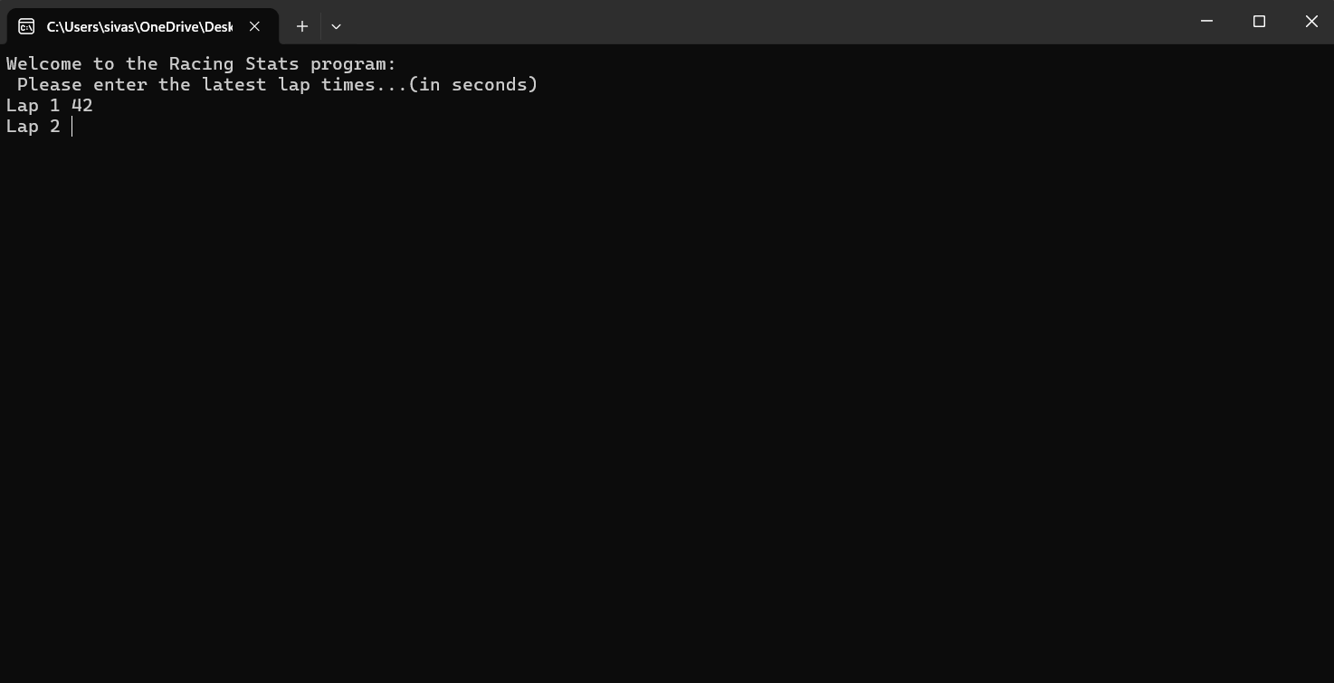
Result: Did the programme behave as expected ie syntactically and logically correct?
Yes, 42 was accepted as a positive value.

Test: ii) 2 seconds

Screenshot(s) of output:
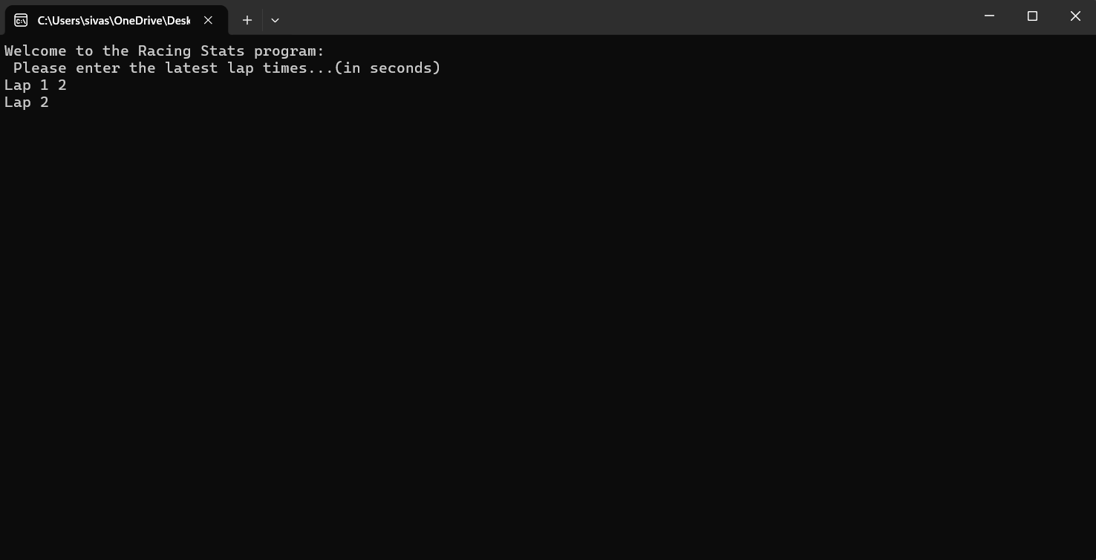
Result: Did the programme behave as expected ie syntactically and logically correct?
Yes, the answer “2” was accepted as a positive number.

Test: iii) -4 seconds

Screenshot(s) of output:
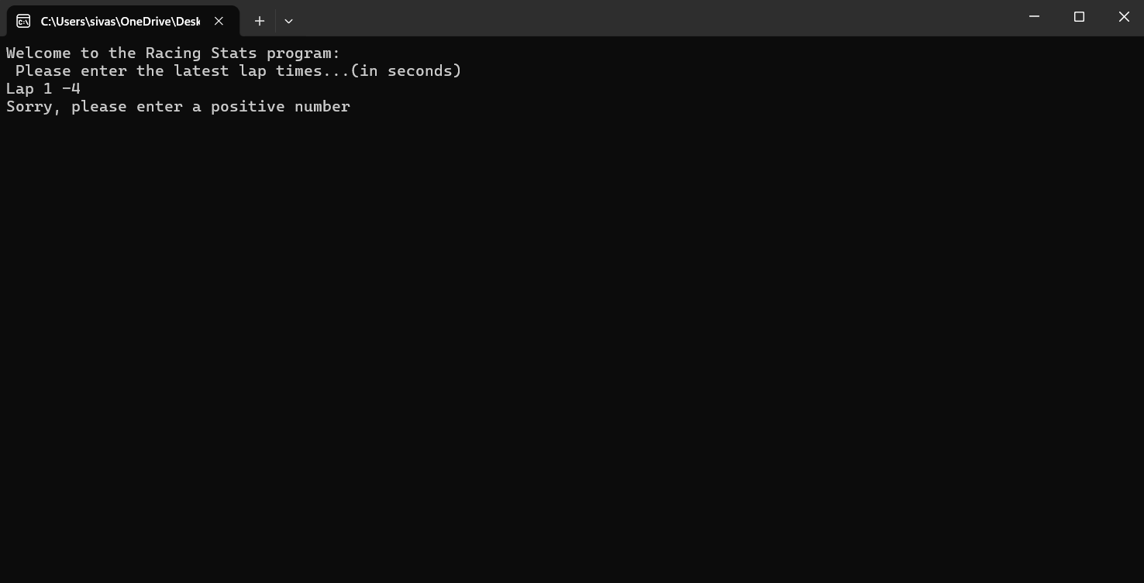
Result: Did the programme behave as expected ie syntactically and logically correct?
Yes, the negative value was rejected by the program and the user was asked to put entera positive input.

Test: iv) 53444 seconds

Screenshot(s) of output:
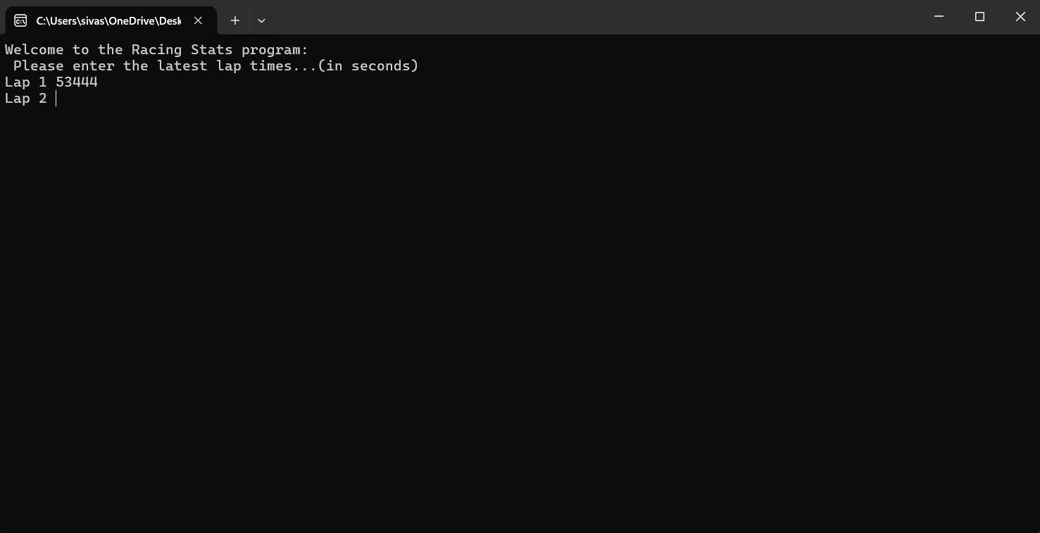

Result: Did the programme behave as expected ie syntactically and logically correct?
No, an unrealistic value i.e. 53444, which corresponds to a lap time of nearly 8 hours was accepted as a valid positive number by the program. This demonstrated to the user that the code was missing an upper limit check.

- Test: v) Test the target lap time – show that the values entered are reasonable

Screenshot(s) of output:
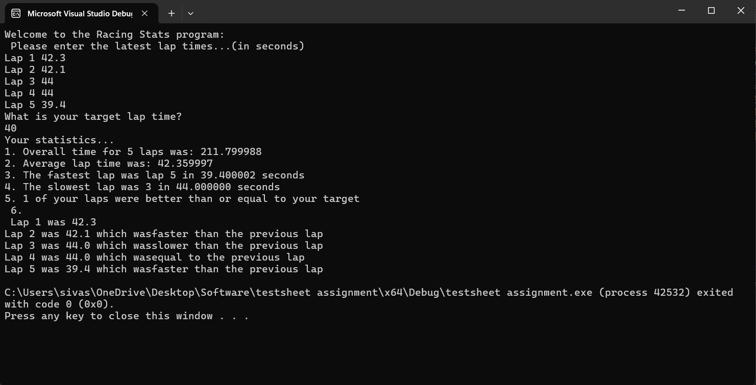
Result: Did the programme behave as expected ie syntactically and logically correct?
Yes, the program was able to tell the user that only one lap was equal to or better than the target lap time.

- Test: b) Using the same five lap times as the sample output ie

Screenshot(s) of output:
Result: Did the programme behave as expected ie syntactically and logically correct?
Yes, the program was able to identify the fastest and the slowest lap correctly and which lap was faster than previous one and also which lap was slower than previous one correctly as well.

- Test: c) Test two further sets of lap times of your own choice.

Screenshot(s) of output: 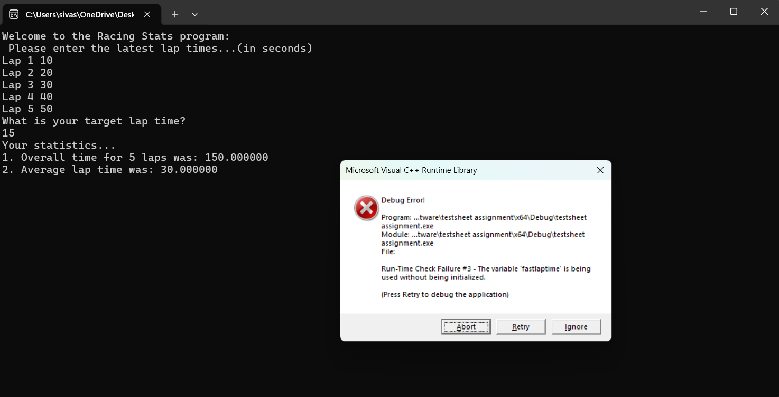

Result: Did the programme behave as expected ie syntactically and logically correct?
No, the program failed to identify lap 1 as the fastest lap and gave an error. The error was caused by a line in coding which was caused and error if the lap 1 was the fastest.

- Test: c) Test two further sets of lap times of your own choice.

Screenshot(s) of output: 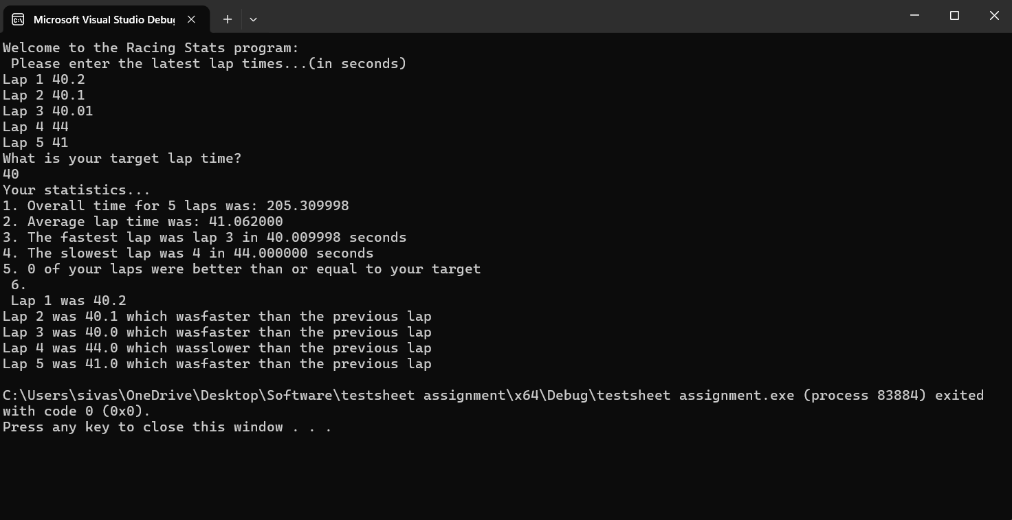

Result: Did the programme behave as expected ie syntactically and logically correct?
Yes, The program was able to detect all the laps correctly.

Test:

Screenshot(s) of output:

Result: Did the programme behave as expected ie syntactically and logically correct?
YES/NO (delete as appropriate)
If YES, comment on what happened.
If NO, what went wrong and why? Suggest how things could be improved

- Consider the results of the above tests and revisit your original code in order to address any tests that failed and/or improve code efficiency.

(Note: you may not be able to solve all of the problems that were encountered, but solve as many as you can.)

Paste your full revised code here :

#define _CRT_SECURE_NO_WARNINGS
#include <stdio.h>
#include <string.h>
#include <math.h>

void main()
{
float lap[5], overall, fast, slow, average, target;
int fastlaptime = 1, slowlaptime = 1, better;

printf("Welcome to the Racing Stats program:\n");
printf("Please enter the latest lap times...\n");

for (int i = 0; i < 5; i++)
{
printf("Lap %d: ", i + 1);
scanf("%f", &lap[i]);

while (lap[i] <= 0 || lap[i] > 10000)
{
printf("Error: Please enter a realistic positive number (1-10000): ");
scanf("%f", &lap[i]);
}
}

printf("\nWhat is your target lap time? ");
scanf("%f", &target);
while (target < 0)
{
printf("Sorry target time can not be negative please try again: ");
scanf("%f", &target);
}

printf("\nYour statistics...\n");
overall = lap[0] + lap[1] + lap[2] + lap[3] + lap[4];

printf("1. Overall time for 5 laps was: %.2f seconds\n", overall);

average = overall / 5;
printf("2. Average lap time was: %.2f seconds\n", average);

fast = lap[0];
for (int i = 0; i < 5; i++)
{
if (lap[i] < fast)
{
fast = lap[i];
fastlaptime = i + 1;
}
}
printf("3. The fastest lap was lap %d in %.2f seconds\n", fastlaptime, fast);

slow = lap[0];
for (int i = 0; i < 5; i++)
{
if (lap[i] > slow)
{
slow = lap[i];
slowlaptime = i + 1;
}
}
printf("4. The slowest lap was lap %d in %.2f seconds\n", slowlaptime, slow);

better = 0;
for (int i = 0; i < 5; i++)
{
if (lap[i] <= target)
{
better++;
}
}
printf("5. %d of your laps were better than or equal to your target\n", better);

printf("\n6. Lap Comparison:\n");
printf("Lap 1 was %.2f\n", lap[0]);

for (int i = 1; i < 5; i++)
{
printf("Lap %d was %.2f which was ", i + 1, lap[i]);
if (lap[i] < lap[i - 1])
{
printf("faster than the previous lap\n");
}
else if (lap[i] > lap[i - 1])
{
printf("slower than the previous lap\n");
}
else
{
printf("equal to the previous lap\n");
}
}
}

