Qualification: CIPD Diploma in Applied Human Resources

Module Name: Understanding Employment Law

Word Count: 4928

Student Name: Darren Bonnell
Student Number: 1810223
CIPD Membership Number: 53274287

By signing below, I confirm that the work/evidence presented is my own, unaided work. I understand the regulations pertaining to candidate malpractice and the action that may be taken as a result.

Signed: Darren Bonnell
Date: 11/03/2019

1.1) Explain the aims and objectives of Employment Law.
Daniels (2019) states that the purpose of employment law is to control the relationship between employers and employees as set out in the Employment Rights Act 1996. She states that it is one of the fastest evolving aspects of law in the UK and is used in order to bring in rules and designed ways of working into the workplace. Daniels (2019) goes on to say that although employment law comes predominately under the civil law function there is also aspects of criminal law that is applicable in certain cases. Taylor & Wilkinson (2016) state that due to the increase in employment law cases it is essential that HR managers are up to date with the latest regulations. They claim that factors such as costs and organisational reputation mean companies need to be aware of the rights of an employee in order to reduce the amount of cases that go to an employment tribunal. They go on to say that employment law has a massive impact on the policies that are implemented to ensure boundaries are set for both employee and employer. Daniels (2019) re-iterates this point and claims that there are external factors that will affect the laws that are made. Examples of this is Brexit which will result in new regulations and acts being written to keep up with the fast moving times. Simply put employment law is a set of rules designed to ensure harmony between a member of staff and the organisation they work for. It allows transparency and enables a clear understanding of what is expected in the working relationship.
1.2) Describe how employment law is enforced through tribunals and the court system.
As with any law if there is a breach in rules there are steps in place with employment law to ensure that the wronged person has a chance to get their case heard. In his factsheet for the CIPD Taylor (2016) states that the first process of getting employment laws in place come from three places which are Parliament, the courts and European Union institutions. Of these three Taylor & Wilkinson (2016) state the most common system of developing new employment laws come in the forms of statues passed in Parliament. They go on to say that, “these comprise Acts (such as Employee Relations Act 1996, the Employment Act 2002, the Equality Act 2010.” If an employer breaks one of these Acts then it could result in action being taken against them by the claimant. Taylor & Wilkinson (2016) state a claimant is someone who could be, “employees, ex employees or failed job applicants.” Taylor (2017) gives details of how a claim is first brought and states depending on the reason it will be heard in either;
- Employment Tribunal – formerly known as Industrial Tribunals they were brought in during the 1960s and have steadily grown in line with Employment Law. They are headed by employment judges and can hear over 80 different types of claims such as unfair dismissal and areas affecting payments. As a result of having to pay a fee to go to an Employment Tribunal between June 2013 and July 2017 the number of cases dropped dramatically. This was however challenged in the case of R(Unison) v Lord Chancellor [2017]) which resulted in the fees being scrapped.
- The County Court – The County Court will hear cases which relate to common law such as a breach of contract. These cases are heard by a judge.
- The High Court – As with the County Court the High Court hears most cases relating to common law but when the compensation being pursued is greater than £15,000.
Taylor & Wilkinson (2017) state that before a claim gets to an Employment Tribunal there must be first contact with the Advisory, Conciliation and Arbitration Service (ACAS). Representatives of ACAS will then look at a possibility of resolving the claim informally or with an out of court settlement. However, if this is not possible then the claim can be lodged and an Employment Tribunal arranged.
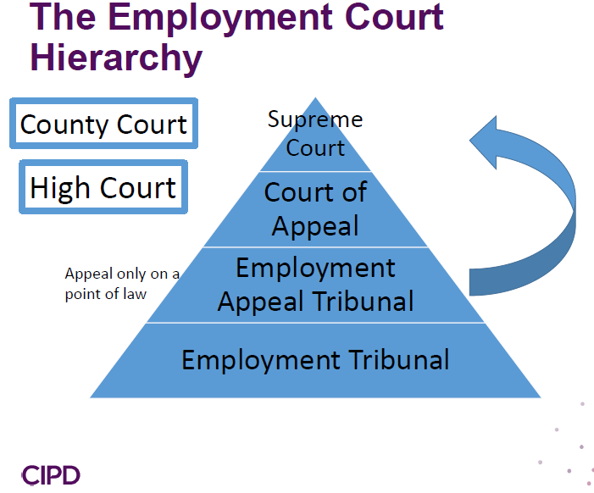
Taylor (2017) states that If following the Employment Tribunal the losing party is not satisfied with the result the next step would be to appeal to the Employment Appeal Tribunal (EAT). This would need to be done within 42 days of the decision and would have to set out the grounds in which they wanted to appeal. Following the decision from the EAT if the result was still not accepted there is another appeal court which is the Court of Appeal. Taylor & Wilkinson (2016) state cases are heard here quite rarely. They go on to say that the final court of appeal in regards to UK law is the Supreme Court which usually hears about four cases a year that are of public interest.
2.1) Identify the main principles of discrimination law in relation to recruitment and selection.
An employer will need to take into consideration discrimination law when they are looking to recruit a new employee. Wilkinson & Taylor (2016) state that an individual that has protected characteristics may seek a claim from a potential employer if they have been discriminated against during the recruitment and selection process. They go on to say that managers need to not only ensure they treat everyone equitably and fairly but that they are also seen to do so. The CIPD (2017) state that employers need to ensure they take into consideration the Equalities Act 2010 when recruiting. The Equalities Act 2010 came into force to replace other existing discrimination acts with a view of strengthening the Act by ensuring certain characteristics are protected which are;
- age
- disability
- gender reassignment
- race
- religion or belief
- sex
- sexual orientation
- marriage and civil partnership
- pregnancy and maternity
Wilkinson & Taylor (2016) state that there is different forms of discrimination at the recruitment stage. These include;
- Direct Discrimination – this is when a company knowingly rejects an application of one of the applicants as a result of a protected characteristic. For example, if an employer refused to appoint a person who had met all the essential criteria and was suitably qualified for the job because they were a male and the company wanted to employ a female it could result in a claim being put forward by the applicant. However, there are certain situations when a company could justify advertising for a female only and this would come under ‘occupational requirements’. An example of this would be if they were looking to recruit a female actress to play a role in a film.
- Indirect Discrimination – this is when an organisation has either ‘a rule, criterion or practice’ in place that would have an adverse effect on a large number of people who come under a protected characteristic. The CIPD (2017) give an example of this by saying if an organisation advertise for a ‘recent graduate’ it could result in age discrimination as it would generally be younger people would have recently graduated.
The Equalities Act 2010 has created a fair platform for applicants and ensures that everyone is given the same opportunity as others when applying for a job. It has made companies aware of the need to think of all aspects when going through the process and appointing a new employee. If they breach this it will result in being taken to an employment tribunal and potentially having to pay the applicant damages. In the case of McCoy vs McGregor & Sons Ltd (2007) the company was ordered to pay the claimant £70,000 for using the term ‘Youthful Enthusiasm’ when recruiting for a position as this was deemed to be age discrimination.
2.2) Explain how contracts of employment are established.
Daniels (2019) states that a contract of employment is the agreement of the working relationship between an organisation and the employee. She states that it can be agreed either in writing or orally but is a binding contract that needs to be abided by both parties. Daniels goes on to say that the terms of a contract can be categorised as;
- Express Terms – these are terms that have been agreed following a discussion between a company and the employee.
- Implied Terms – these are terms that have been established by the employer and include, “collective agreements; statue; custom and practice; the court; work rules;” (Daniels 2019, pp48)
Suff (2019) states that a contract of employment is governed by contract law and so in order to be established there would need to be;
- an offer of employment by the employer, which should be clear and unambiguous and may be conditional
- acceptance of that offer by the employee
- consideration between the parties, for example the work done by the employee in return for the wages paid by the employer
- an intention to create a legally binding arrangement.
In order to establish if a contract exists it is important for a company to recognise the different types of staff and see which category an individual falls into of employee, worker and self-employed. An employee would be a person who has entered into a contract of employment as covered in the Employment Rights Act (1996) where as a worker is someone who personally performs services for a company. Suff (2019) goes on to say that there are different methods to establish what category a member of staff falls into such as using;
- mutuality of obligation - does the employer have to provide work, and does the worker have to take the work that is offered?
- control - does the employer control how the worker does the work, and do the employer’s disciplinary procedures apply to the worker?
- integration - how far is the employee integrated into the employer’s organisation?
- multiple - looks at a number of factors including 'substitution' (that is, can the worker send another person to do work for the employer on their behalf?)
If a contract is established then a Written Statement of Particulars (Figure 1) will need to be sent out to the employee as per the Employment Act 2002. This should be done within two months if the commencement date currently but from April 2020 it will be required to be given on the first day of employment for both employees and workers.
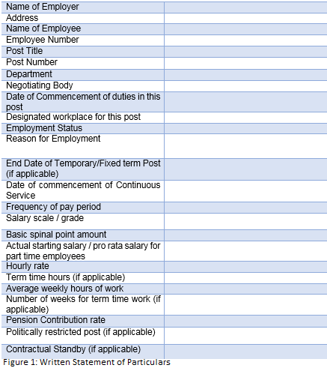
3.1) Describe when and how contracts can be changed lawfully.
Daniels (2019) states that as a contract of employment is a binding agreement between two parties the terms set out cannot just simply be changed by the employer. She goes on to say that in order for an organisation to be able to lawfully change the terms agreed in a contract they would need to follow set out regulations or risk having an employee either resigning from their role and take the company to court on constructive dismissal or changing terms reluctantly while still filing a claim for any detriment suffered. Suff (2019) explains that there are three main ways that an employer can change the terms of a contract which are;
- Consultation – if a company is able to meet up with staff in advance of the proposed change and explain the reasoning behind the change it could result in this being done amicably. With the staff having their opinions and queries taken into consideration it could result in a compromise being agreed which is suitable for both parties. As well as this an incentive could be given to the employee that resulted in them happily agreeing to the change in their contract.
- Make Changes Unilaterally – by doing this and changing the terms of a contract without the agreement of the staff member it is a huge risk when facing a potential claim from the employee. Regardless of the needs of the business and whether or not the employee reluctantly continues to work on the new terms it could still result in an employer being vulnerable in an employment tribunal as well as having a detrimental effect on the working relationship.
- Terminate Employee and Re-engage on new Terms & Conditions – this process again comes with risk as the employee could bring a claim of unfair dismissal but as new terms are being offered it would limit the compensation. This would be considered as a redundancy dismissal which would mean the due process of redundancy situations would need to be followed. The re-engagement would need to be continues so that any service acquired would remain.
3.2) Explain the main requirements of redundancy law.
Taylor & Wilkinson (2016) state that redundancies occur when a company reduces the number of staff for business reasons that include changes in the economic environment. Unfortunately all businesses will go through change that means certain roles are no longer required which results in the redundancy process being used. As per the Employment Rights Act 1996 redundancy if done correctly is a fair reason for dismissal. In order to ensure the process is fair and so that the business has acted reasonably Suff (2018) states they need to ensure they follow certain guidance which include;
- Planning – redundancies should always be the last resort so when a company identifies that staff are at risk they should look at other ways such as recruitment freezes, offering early retirement or changes in hours prior to going down the redundancy route.
- Identifying the pool for selection – the employer needs to identify the main selection pool of staff who are at risk of being made redundant. This could from a team doing the same work within a particular location.
- Seeking volunteers – this stage is asking for volunteers to step forward once the need for redundancies has been identified and offering them a redundancy package.
- Consulting employees – depending on the amount of people to be made redundant would mean that this would be a legal requirement as if 20 or more jobs would be going then it would need a collective consultation with either a recognised trade union or elected representatives. Staff would be given the reasons for the redundancies and given the opportunity to ask any questions for all other information at this stage.
- Selection for redundancy – a company would need to look at who was going to be made redundant by using different selection criteria. This could be last in first out or by using a points system where staff were assessed anonymously by looking at skills and experience before coming to a decision.
- Appeals and dismissals – once the employees have been selected they would need to be issued notice of the termination which would include information of the redundancy payment they would receive. Within this notice they would have the opportunity to appeal against the decision if they feel they had been unfairly selected.
- Suitable alternative employment – an organisation would try and get alternative employment for those staff that have been made redundant. If a staff member was to refuse the offer then it could result in their payment being withheld.

3.3) Explain the main law on business transfers.
Suff (2018) states that a Transfer of Undertakings Protection of Employment (TUPE) occurs when there is a transfer of business or service provision. She states that a business transfer is when a company takes over another which include assets such as staff and customers. A service provision when a company takes over the service from another such as bringing the service in house. It will result in the exact same service being given just by a different company. Taylor & Wilkinson (2016) states the TUPE regulations 2006 ensures that when an employee transfers from one organisation to another as part of the TUPE process that their terms and conditions are protected. This results in their contracts of employment, including all terms and conditions of employment such as pay, commission and bonus entitlements, holidays, job title and function, and sick pay provisions are transferred over with them. Suff (2018) reiterates this and goes on to say that TUPE Regulations 2006 ensures that the new employer cannot change the contract of an employee who has TUPE transferred across to a new company unless the employee is in agreement and it is a reason that is unconnected to the transfer itself or a reason connected with the transfer which is an economic, technical or organisational (ETO) reason entailing changes in the workforce. If the new employer did try and change the contract of an employee who had TUPE’d across it would almost certainly be classed as void by a tribunal. Another way in which the TUPE regulations protect staff is the fact that it would be classed as automatically unfair if the sole or principal reason for dismissing a member of staff who had TUPE’d across was the transfer itself. This ensures that the new employer has to honour the deal made when TUPE was agreed and gives staff insurances that when they go across to the new company they will continue to have the same rights and protection with their job that they have always had.
4.1) Identify the major statutory rights workers have in relation to pay, holidays and working time.
Pay
Daniels (2019) states that the employer has a duty to pay an employee for work that is undertaken. As well as this as stated in the Employment Rights Act 1996 an employee has the right to have a payslip either with or before they receive their wages. Daniels goes on to state that an employer must be paid in line with the National Minimum Wage Act 1998 which sets out the minimum hourly rate that an employee should receive depending on their age. As of April 2018 the rates were,
“£7.83 per hour for those ages 25+ years; £7.38 per hour for those aged 21 to 24 years; £5.90 per hour for those aged 18 to 20 years; £4.20 per hour for those aged 16 to 17 years;” (Daniels 2019, pp 96).
As well as the national minimum wage there is also the national living wage. This payment is not compulsory for employers but is adopted by some employers as it is thought the national minimum wage is too low. Taylor & Wilkinson (2016) state that an employee has to pay people equally regardless of gender. For example, if proven that two employees are doing the same job but one is being paid more because of gender it could result in an equal pay claim being put it.
Holidays and Working Time
An employer has the responsibility to ensure that an employee works in line with the Working Time Regulations 1998. Daniels (2019) states that the maximum an employee should work over a 17 week period should not amount to an average of more than 48 hours per week. However, an employee can opt out of this by having an agreement in writing. The working time regulations also give protection to night workers by ensuring they get regular assessments and ensuring they have an adequate break if the work is affecting their health. Daniels adds that all staff are entitled to at least 11 consecutive hours break time within a 24 hour period as well as a 20 minute break when working 6 consecutive hours. Staff are entitled to receive statutory holidays. This works out to 28 days for a full time employee which includes holidays and bank holidays.
4.2) Explain the main maternity, paternity and other family friendly employment rights.
Taylor & Wilkinson (2016) state that there are three types of maternity leave which are;
- Ordinary Maternity Leave (OML) – this leave equates to 26 weeks and can commence up to 11 weeks before the baby is born.
- Compulsory Maternity Leave (CML) – this leave has to be taken by the mother which would be the first two weeks after giving birth.
- Additional Maternity Leave (AML) – this would be for employees only and would be for a maximum of 26 weeks following the completion of OML.
During the duration of maternity leave an employee’s contract would remain the same. She would also have the same rights as anyone when it came to career advancement and must not be discriminated against because she is on maternity leave. Taylor & Wilkinson (2016) state that depending on the length of service a the father of a baby has the right to two weeks paternity leave which can be taken up to 56 days from the birth. This would be paid at whatever rate the statutory paternity pay (SPP) was at the time. New regulation introduced in 2014 now allow for shared parental leave which allows the mother to share the maternity leave with her partner after the two weeks compulsory maternity leave. Adoption leave falls in line with that of maternity leave. Daniels (2019) states there are other family friendly rights which include;
- Parental Leave – this came from the Maternity and Paternity Leave Regulations 1999 which allows parents to take up to 18 weeks off unpaid to care for a child up to the age of 18.
- Time off for dependants – as stipulated in the Employment Rights Act 1996 it gives a member of staff the right to take time off unpaid to take care of a dependant.
Taylor & Wilkinson (2016) also identify the ability of a member of staff to apply for flexible working. This allows staff to request a change in contract to suit an individual needs. Although it’s not compulsory to accept an organisation would need to give full consideration to the request and give valid reasons for rejecting.
5.1) Identify the major requirements of health and safety law.
An employer has the responsibility to ensure that their staff are safe when they are in the workplace. Taylor & Wilkinson (2016) state that although the function of Health and Safety is large there is one piece of legislation that needs to be abided by which is the Health and Safety at Work Act 1974. This act gives clear guidance on what is expected of an employer in the workplace which includes maintaining equipment as well as ensuring adequate facilities are in place which do not result in staff being injured. The act is governed by common law which could result in an employer facing penalties if they do not fully implement a safe working environment. In the most serious case employers could be charged with corporate manslaughter should an employee die in work as a result of the employer not following the correct procedure. As well as ensuring that employees have a safe working environment Taylor & Wilkinson (2016) also state that employers need to take into consideration the mental health of their employees. If an employee can prove that an employer had knowledge of their mental health and did not act in a reasonable way it could result in a personal injury claim being placed.

5.2) Summarise key legislation which support equality and diversity in the workplace.
As previously mentioned one of the main legislation that ensures equality within the workplace is the Equalities Act 2010. This legislation was introduced to combine several other legislations to ensure that staff with protected characteristics were not treated less favourably. Daniels (2019) states that discrimination comes in different forms. These include;
- Direct – this is when someone is discriminated against because of a protected characteristic. An example of this is the case of Moyhing and London NHS Trust (2006) when a male nurse was treated different because of his gender.
- Associative – this is when an employee is discriminated as a result of being associated to someone who has a protected characteristic. An example of this is Coleman v Attridge Law (2008) ECJ/303/06 which resulted in a mother being treated less favourably because her son was disabled.
- Perceptive – this is when someone is discriminated against because they are thought to have a protected characteristic. An example of this would be someone treating an employee less favourably because they have a perception of what their religious beliefs are due to their race.
- Indirect – this is discrimination that has affected a group of protected characteristics as a result of a policy or regulations that a company may have.
Daniels (2019) goes on to state that other forms of discrimination including victimisation and harassment would be protected under the Equalities Act 2010.
5.3) Explain the concept of implied duties in relation to the management of employees at work.
As previously stated when entering into a contract there are express terms and implied terms. Daniels (2019) states the implied terms come in the forms of;
- Collective Agreements – this is an agreement between a company and the trade union or workplace representatives that would result in a change to the terms of the whole staff that fall under the agreement. Areas such as pay and benefits are common areas of collective agreements. For example in local government before a new pay policy is implemented it would need to be collectively agreed with the trade unions.
- Statue – an employee must abide by any current acts such as the National Minimum Wage Act 1998. Therefore if this is increased an employee would need to ensure they pay what is required by law.
- Work Rules – this implied term is usually set out by management and gives employees instructions on how they want an employee to behave whilst in work. An example of this would be for managers of a restaurant requiring staff to wear their uniform in a certain way to ensure they meet the desired standards.
Other implied terms that are common include the requirement for an employee to turn up to work as well as the duty for an employer to provide work.
6.1) Explain the main requirements of unfair dismissal law, in respect of capability, misconduct and grievance issues.
When dismissing an employee, an employer must ensure they act in a reasonable way to ensure they are not taken to an employment tribunal with an unfair dismissal claim. Taylor & Wilkinson (2016) state the importance for managers to follow the procedure of the law correctly from the start in cases that could result in dismissal. They go on to state that an unfair dismissal claim can only been brought by an employee which would mean the majority of casual staff as well as agency workers and sub-contractors would not be able to make a claim. Taylor & Wilkinson (2016) go on to say that dismissals for misconduct and poor performance are deemed as fair providing they are dealt with lawfully. In a fact sheet ‘Discipline and Grievance at Work’ Suff (2018) states that in order to ensure there is a fair process for both parties it is recommended that employers follow the ACAS Code of Practice: Disciplinary and Grievance Procedures. She states that if an employment tribunal see that this code is not followed correctly an additional 25% may be awarded on top of the damages for failure to comply. She goes on to say that although when disputes in work arise it is always best to deal with them informally it is not always possible and certain cases will need to be dealt with formally resulting in an employee being dismissed. She states that the Employment Act 2008 is the main legislation that leads discipline and grievance.
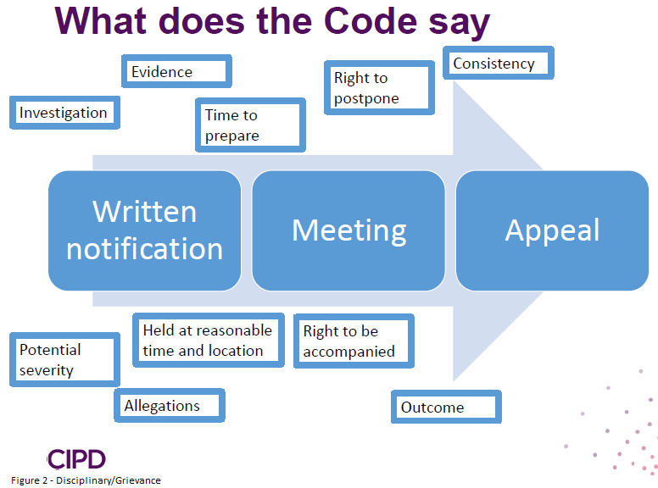
As per the ACAS code disciplinary procedures need to be followed in each case as per figure 2. This includes having an initial investigation to establish the facts before having the hearing and potentially an appeal. At each stage it is essential that the employee is kept up to date with the procedure and that no preconceived judgements are made. The employee should also be allowed the chance to be accompanied by a trade union representative or work colleague. Once the decision has been made it is good practice to first meet and give the outcome in person before subsequently following it up in writing. Before dismissing an employee the severity of the case would need to be outlined on whether it amounted to misconduct or gross misconduct. Taylor & Wilkinson (2016) outline the difference between these by stating ordinary misconduct would be classed as minor rule breaks and would not result in a dismissal for the first offence whereas gross misconduct is a serious breach which would result in an automatic dismissal without notice if proven. In the case of capability as a result of poor performance it should be handled in a similar way to misconduct. An employer should meet with the employee in a formal hearing and give them a time frame in which they should reach an acceptable level of performance. If they then fail to do so a decision to dismiss would be given at a later agreed date. Taylor & Wilkinson (2016) explain another reason to dismiss due to ill-health capability for staff that are not able to maintain an acceptable level of attendance due to a medical condition. This could be long term absence or multiple short term absences. In these cases disabilities should be taken into consideration to ensure that an employee is not being discriminated against due to their disability. Suff (2018) states the importance of a company in dealing with all grievances appropriately. They need to ensure it is held in a timely manner and staff are communicated with throughout. Whenever it is deemed an employee is going to be dismissed from an organisation the employer needs to ensure they have followed procedures correctly and documented thoroughly to ensure they protect themselves at employment tribunal. If done in a reasonable fair manner as laid out in the ACAS code of practice there is every chance that a staff member would not be able to make a claim citing unfair dismissal.

Bibliography
ACAS, 2017. Discipline and grievances at work, s.l.: ACAS.
CIPD, 2017. Recruitment and selection Q&As. [Online]
Available at: https://www.cipd.co.uk/knowledge/fundamentals/emp-law/recruitment/questions
[Accessed 3 March 2019].
Daniels, K., 2019. Introduction to Employment Law. 5th ed. London: CIPD.
Suff, R., 2018. Discipline and grievance at work. [Online]
Available at: https://www.cipd.co.uk/knowledge/fundamentals/emp-law/discipline/factsheet
[Accessed 10 March 2019].
Suff, R., 2018. Redundancy: an introduction. [Online]
Available at: https://www.cipd.co.uk/knowledge/fundamentals/emp-law/redundancy/factsheet
[Accessed 5 March 2019].
Suff, R., 2018. Transfer of undertakings (TUPE): an introduction. [Online]
Available at: https://www.cipd.co.uk/knowledge/fundamentals/emp-law/tupe/factsheet
[Accessed 7 March 2019].
Suff, R., 2019. Contracts of employment. [Online]
Available at: https://www.cipd.co.uk/knowledge/fundamentals/emp-law/terms-conditions/contracts-factsheet
[Accessed 4 March 2019].
Taylor, S., 2016. How UK employment law is made. [Online]
Available at: https://www.cipd.co.uk/knowledge/fundamentals/emp-law/about/uk-emp-law-made
[Accessed 3 March 2019].
Taylor, S., 2017. Employment law: the court system. [Online]
Available at: https://www.cipd.co.uk/knowledge/fundamentals/emp-law/about/court-system
[Accessed 1 March 2019].
Taylor, S. & Wilkinson, K., 2016. Employment Law. In: Human Resource Management: People and Organisations. London: CIPD, pp. 25-49.

