

Student name: Ana Baptista
Student ID: 2426392
Module name: Introduction to Physiology
Module code: BMHP5023
Lecturer name: Dr Soban Sadiq
Assessment: Written Assignment (Case Study Report)
Submission deadline: 9th April 2026 14:00 (2pm)

Introduction

Asthma is a chronic inflammatory disorder of the airways characterised by bronchial hyperresponsiveness, reversible airflow obstruction, and increased mucus production (Global initiative for Asthma, 2024). British Thoracic Society (2022) highlights that genetic predisposition and environmental factors, including allergens, tobacco smoke, air pollution, and viral infections, play a significant role in both initiating and worsening asthma. This inflammatory process narrows the airways, increases resistance to airflow, and impairs effective alveolar gas exchange, resulting in manifestations such as cough, chest tightness, wheeze and dyspnoea. The case study analysed in this report focuses on a Practice Nurse running a fortnightly asthma clinic for adolescents with asthma. The discussion explores the physical composition and the functional dynamics of respiration, the pathological impact of airway inflammation on ventilation, and the clinical significance of peak expiratory flow monitoring in supporting safe self-management. Lifestyle modification and health promotion strategies are also examined for the role in improving respiratory outcomes. This process is illustrated in Figure 1, which compares normal and asthmatic airways, showing inflammation and narrowing that directly impacts ventilation (The George Cooler Memorial Fund, 2025). The report concludes with a summary of key findings and a list of reliable references that informed this work.
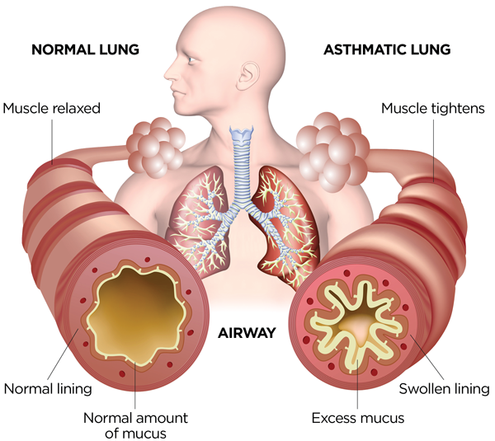
Figure 1: Normal and asthmatic airways showing inflammation and narrowing (The George Coller Memorial Fund, 2022).

Structure of the respiratory system

The respiratory system takes in oxygen, which is then delivered to tissues, while the circulatory system transports it and delivers carbon dioxide back to the lungs for exhalation, supported by the nervous, lymphatic, and immune systems. Furthermore, these parts form an integrated network that delivers oxygen and nutrients throughout the body and removes waste products efficiently (National Heart, Lung, and Blood Institute, 2022). In addition, Asthma + Lung UK (2024), explain that the lungs also protect the body by filtering harmful particles. Air begins by entering through the nose or mouth and then travels down the trachea, and reaches tiny alveoli, where oxygen moves into the blood. Moreover, based on Boyle’s Law (Canni & Ponicera, 2022) changes in pressure drive air into and out of the alveoli, through lymph interaction. The pleura, a thin membrane around the lungs, allows them to move smoothly, and the ribs, intercostal muscles, and diaphragm work together to control breathing. Consequently, mechanical respiration pertains to the structural process of breathing, where air moves in and out of the lungs during breathing, inhalation and exhalation. During inhalation, the diaphragm contracts and moves downward, while the intercostal muscles lift the rib cage. (National Heart, Lung, and Blood Institute, 2022a). This increases thoracic volume cavity and decreases pressure inside the lungs, allowing air to enter. In contrast, during exhalation, these muscles relax, reducing thoracic volume and forcing air out (as seen on Figure 2). Thus, the basic process is the same in adolescents, but smaller lung volumes and narrower airways mean conditions like asthma can more easily impair airflow. Therefore, mechanical respiration is essential for maintaining effective gas exchange and supporting cellular respiration in the body (Asthma and Lung UK, 2023).
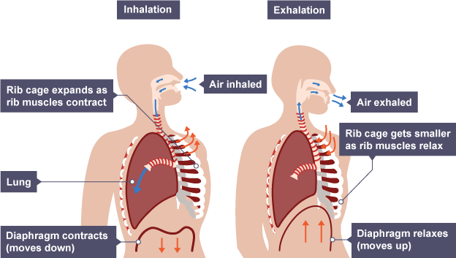
Figure 2: Mechanical respiration showing inhalation and exhalation (BBC Bitesize, 2019).

Gas exchange in lungs

Gas exchange in the lungs facilitates the uptake of oxygen to enter the blood and carbon dioxide to be removed, supporting cellular respiration. This process takes place in the alveoli, where thin walls and a large surface area enable efficient oxygen diffusion. Red blood cells transport oxygen to tissues, and carbon dioxide returns to the lungs to be exhaled, preventing harmful buildup. In adolescents with asthma, airway inflammation can narrow the bronchi, reduce airflow, and temporarily decrease gas exchange. The circulatory system then distributes this oxygenated blood throughout the body, where it is used by cells to produce energy. As cells do this, they generate carbon dioxide, which returns to the blood, is circulated back to the heart, and travels to the lungs via the pulmonary artery, where it moves from the capillaries back into the alveoli and is exhaled. As a result, when pulmonary function is impaired, breathing becomes laboured, and oxygen delivery to tissues is reduced (National Heart, Lung and Blood institute, 2022). Respiratory conditions such as asthma and severe COPD may worsen due to infection, damage, or inflammation of the airways. Findings from to the National Institutes of Health (2022), highlight that exposure to cigarette smoke and environmental pollutants can irritate the airway lining, increasing the severity of conditions such asthma. Similarly, evidence from the National Institute for Health and care Research (NIHR, 2023) indicates that airborne irritants, including dust, allergies, pollen, and pollution, can exacerbate respiratory conditions. When inhaled, these irritants trigger an inflammatory reaction, leading to swelling of the airway tissues and increased mucus production. This causes the bronchi and bronchioles to narrow, limiting the passage of air in both directions through the lungs. As a result, gas exchange becomes less efficient, reducing oxygen absorption by the bloodstream and limiting the removal of carbon dioxide. Consequently, adolescents are at higher risk of experiencing symptoms such as coughing, shortness of breath, wheezing, particularly those with asthma, whose airways are more sensitive. Overall, increased exposure to irritants impairs normal respiration by reducing airflow and causing inflammation of lung tissues (National Heart, Lung, and Blood Institute, 2022).

Recording and tracking respiratory functions

A person-centred approach is vital in asthma care for adolescents, as this period of rapid change brings heightened risks. In line with NICE guidance, Duncan (2022) also emphasizes that action plans must be personalized, holistic, and include emotional and social factors, not just clinical steps. Some ways to monitor asthma, according to NICE (2024) is to check time off work or school due to asthma, the amount of reliever inhaler used, including a check of the prescription record, the number of courses of oral corticosteroids and any admissions to hospital or attendance at an emergency department due to asthma. Monitoring and recording respiratory function are a fundamental component of effective asthma management in adolescents. Instruments including peak expiratory flow (PEF) measurements and symptom diaries enable both healthcare professionals and patients alike to track changes in lung function over time. Regular monitoring supports early identification of deterioration, allowing timely intervention and adjustment of treatment. Additionally, digital health tools and mobile applications can enhance self-management by promoting adherence and increasing awareness of symptoms patterns. Incorporating monitoring strategies into personalised asthma action plans empowers adolescents to actively engage in managing their condition and supports improved clinical outcomes. School nurses and healthcare professionals play a crucial role in guiding adolescents to take responsibility, ensuring they navigate the health system confidentiality and address both their physical and emotional needs. The following care plan illustrates how these steps are personalized, empowering adolescents to track their symptoms, recognize triggers, and take ownership of their asthma care. According to the British Thoracic Society (2026), it is vital for adolescents with asthma to develop self-management skills during their transition to independence. Using structured tools – such as the table of competences – they can name their condition, recall medications, and ask questions about their care. Effective transitions empower them to gradually take responsibility, supported by Clinicians and families. Although much of the evidence is qualitative, it underscores adolescents’ emotional challenges - such as embarrassment and guilt. When they discuss these feelings in educational sessions, they gain confidence and feel less isolated. Thus, schools and clinicians who implement these programs equip adolescents to track, understand, and take charge for their asthma. For example, adolescents can use spirometer or peak flow measurements, both before and after bronchodilator use, to monitor their lung function and see how well their treatment is working. If asthma symptoms are not tracked and triggers are not identified, adolescents may unknowingly continue exposure to harmful factors like smoke. Consequently, this can lead to uncontrolled inflammation, frequent exacerbations, and a greater risk of hospital visits (NICE, 2024).

Recommendations
Evidence- informed guidance emphasises that lifestyle modifications play a crucial role in improving asthma outcomes in adolescents. NICE (2025) defends that promoting positive lifestyle choices such as regular activity and balanced diet is essential in supporting long-term condition management. Engaging in appropriate physical activity is associated with improved lung function, increase aerobic capacity, and enhance overall quality of life. However, young people should be advised to exercise safely, including adequate warm-up routines and the use of reliever inhalers, when necessary, to prevent exercise-induced bronchoconstriction. In addition, nutritional patterns represent a significant modifiable factor. Nutrient-dense foods, including fruits and vegetables provide anti-inflammatory benefits, which may exacerbate symptoms. Weight management is also particularly important, as obesity has been associated with poor asthma control and increased symptoms severity. Supporting adolescents in maintaining a optimal weight can therefore contribute to better disease management outcomes. The House of Care model illustrates a comprehensive, whole-system approach to enhancing care for long-term conditions, with care planning as its core. Each component – patient engagement, professional collaboration, and system organization – supports a personalized care plan. Service users are encouraged to play an active role in shaping their own care, and addressing health inequalities is a central goal. The model recommends that NHS England and the Department of Health align to foster a unified approach across both national and local levels. (Dixon and Roberts, 2013). While the King’s Fund emphasizes holistic, person centred care and sharing decision making approach, GINA (Global Initiative for asthma, 2025) highlights that non-drug strategies are essential in asthma care alongside medications. Key lifestyle changes include quitting smoking and vaping, engaging in regular physical activity with appropriate medication, managing weight, and adopting a nutrient-dense eating plan. Avoiding triggers like smoke, allergens and stress – trough techniques like breathing exercises and yoga – also plays a vital role. GINA also recommends staying current with vaccinations, as preventing respiratory infections can reduce asthma attacks (Global Initiative for asthma, 2019). Furthermore, avoidance of environmental triggers remains a key recommendation. Exposure to allergens such as pollen, dust mites, and pet dander, as well as irritants like air pollution and tobacco smoke, can significantly worsen asthma symptoms. Education on identifying and minimising these triggers is essential in reducing exacerbations. Smoking cessation and avoidance of second-hand smoke are especially critical, as tobacco exposure is strongly linked to increased frequently, severity of asthma attacks. Psychological factors should also be considered, as stress and anxiety may exacerbate asthma symptoms. Encouraging stress management strategies, such as relaxation techniques and mindfulness, can support overall and improve symptom control. Importantly, these lifestyle recommendations should be delivered within a person-centred care framework, ensuring that adolescents are actively engaged in decision-making and feel empowered to manage their condition. By integrating lifestyle modifications with pharmacological treatment and personalised asthma action plans, healthcare professionals can significantly enhance adolescents in achieving better long-term health outcomes. Regular exercise has been shown to boost lung function and quality of life, while nutrient-rich diets and vegetables reduce airway inflammation. Moreover, addressing modifiable risk factors such as obesity, sedentary behaviour, and exposure to tobacco smoke is essential in preventing poor asthma outcomes (Stoodley et al., 2019). According to Dr. Edward Cetti (Top Doctors UK, 2025), these lifestyle adjustments paired with medication, significantly improve asthma management. Through recognising and minimising exposure to common triggers – such as smoke, dust and pollen – and ensuring a healthy weight, adolescents can reduce symptom severity. Safe physical activity, along with stress management and smoking cessation, further reduce flare-ups. Figure 3 illustrates a set of asthma management tips designed like a care plan to guide adolescents. These steps, such as regular checkups, a clean environment, and a healthy lifestyle, empower patients. Therefore, with a personalized action plan and these changes, asthma can be well-managed, reducing the risk of severe episodes.
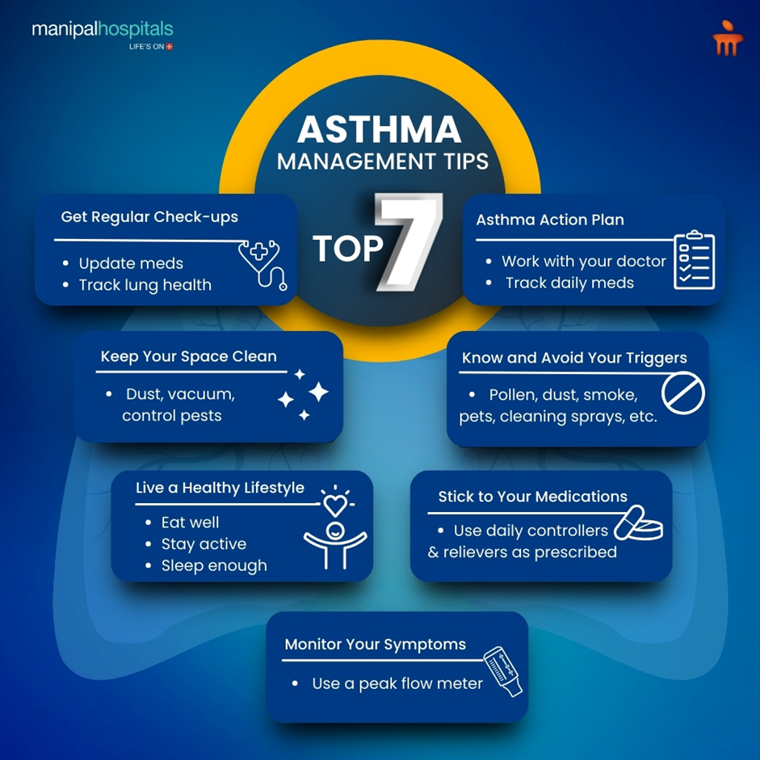
Figure 3: Seven essential asthma management tips (Dr. Elakya, 2025)

Conclusion
In conclusion, effective management of asthma in adolescents requires a holistic and person-centred approach that recognises the complex physical, psychological, and social transitions occurring during this change of life. Research-informed literature emphasises the health lifestyle interventions, including regular physical activity, balanced nutrition, and avoidance of triggers such as tobacco smoke, play a fundamental role in improving asthma control. However, successful management extends beyond clinical interventions, requiring the development of a trusting therapeutic relationship between the young person and healthcare professional. Supporting adolescents through shared decision-making, personalised action plans, and regular monitoring enables them to gradually assume responsibility for their condition. Therefore, integrating medical treatment with lifestyle adjustments and empathetic, individualised care can significantly enhance long-term outcomes, allowing adolescents to maintain optimal health and quality of life.

Reference list
Asthma + Lung UK (2024). How your lungs work | Asthma + Lung UK. [online] www.asthmaandlung.org.uk. Available at: https://www.asthmaandlung.org.uk/how-your-lungs-work [Assessed on 5 March 2026].
Asthma and Lung UK (2023). Asthma + Lung UK | Home. [online] Asthma & Lung UK. Available at: https://www.asthmaandlung.org.uk [Assessed on 5 March 2026].
BBC Bitesize (2019). Respiratory system - Edexcel - Revision 1 - GCSE Physical Education - BBC Bitesize. [online] BBC Bitesize. Available at: https://www.bbc.co.uk/bitesize/guides/ztkr82p/revision/1 [Assessed on 5 March 2026].
British Thoracic Society (2026a). BTS Asthma care bundles | British Thoracic Society | Better lung health for all. [online] Brit-thoracic.org.uk. Available at: https://www.brit-thoracic.org.uk/clinical-resources/asthma/bts-asthma-care-bundles [Accessed 28 Mar. 2026]. [Assessed on 27 March 2026].
British Thoracic Society (2026b). BTS/NICE/SIGN Joint Guideline on Chronic Asthma. [online] Brit-thoracic.org.uk. Available at: https://www.brit-thoracic.org.uk/clinical-resources/guidelines/asthma-chronic [Assessed on 27 March 2026].
Dixon, A. and Roberts, S. (2013). Delivering better services for people with long-term conditions. [online] The King’s Fund. Available at: https://www.kingsfund.org.uk/insight-and-analysis/reports/better-services-people-long-term-conditions [Assessed on 26 March 2026].
Dr. Elakya (2025). Take Control of Your Asthma: Top 7 Tips for Your Asthma Care Plan. [online] Manipal Hospitals. Available at: https://www.manipalhospitals.com/salem/blog/take-control-of-your-asthma-top-tips-for-your-asthma-care-plan [Accessed 6 Apr. 2026]. [Assessed on 3 April 2026].
Duncan, D. (2022). Asthma and self-management: Improving support for teenagers - Journal of Family and Child Health. [online] Journal of Family and Child Health. Available at: https://www.familyandchildhealth.com/content/clinical/asthma-and-self-management-improving-support-for-teenagers [Assessed on 27 March 2026].
Evans, H.J., Gibson, N.A., Bennett, J., Chan, S.Y., Gavlak, J., Harman, K., Ismail-Koch, H., Kingshott, R.N., Langley, R., Morley, A., Opstad, K.S., Russo, K., Samuels, M.P., Tan, H.L., Tweedie, D., Yanney, M. and Whitney, A. (2023). British Thoracic Society Guideline for diagnosing and monitoring paediatric sleep-disordered breathing. Thorax, [online] 78(10), pp.1043–1054. Doi: HTTPs://doi.org/10.1136/thorax-2022-219582 [Assessed on 14 March 2026].
GINA (Global Initiative for asthma) (2025). Global Strategy for Asthma Management and Prevention Global Strategy for Asthma Management and Prevention. [online] Available at: https://ginasthma.org/wp-content/uploads/2025/11/GINA-2025-Update-25_11_08-WMS.pdf [Assessed on 4 April 2026].
Global Initiative for asthma (2019). FAQs - Global Initiative for Asthma - GINA. [online] Global Initiative for Asthma - GINA. Available at: https://ginasthma.org/about-us/faqs [Assessed on 4 April 2026}.
Global Initiative for Asthma (GINA) (2023). A pocket guide for health professionals updated 2023 BASED ON THE GLOBAL STRATEGY FOR ASTHMA MANAGEMENT AND PREVENTION POCKET GUIDE FOR ASTHMA MANAGEMENT AND PREVENTION for adults, adolescents and children 6-11 years POCKET GUIDE FOR ASTHMA MANAGEMENT AND PREVENTION for adults, adolescents and children 6-11 years. [online] Available at: https://ginasthma.org/wp-content/uploads/2023/07/GINA-2023-Pocket-Guide-WMS.pdf [Assessed on 5 April 2026].
Global Initiative for Asthma (GINA) (2024). Global strategy for asthma management and prevention. [online] Available at: https://ginasthma.org/wp-content/uploads/2024/05/GINA-2024-Strategy-Report-24_05_22_WMS.pdf [Assessed on 27 February 2026].
gov.uk (2022). Air pollution: applying All Our Health. [online] GOV.UK. Available at: https://www.gov.uk/government/publications/air-pollution-applying-all-our-health/air-pollution-applying-all-our-health [Assessed on 5 March 2026].
Health, M. and Casper, L. (2025). What does health and social care mean? What are the impacts of 6C values on health and social care? [online] Institute of Mental Health. Available at: https://iomh.co.uk/what-does-health-and-social-care-mean-what-are-the-impacts-of-6c-values-on-health-and-social-care/ [Assessed on 1 March 2026].
Hirsch, L. (2022). Lungs and Respiratory System (for Parents) - KidsHealth. [online] Kidshealth.org. Available at: https://kidshealth.org/en/parents/lungs.html [Assessed on 12 March 2026].
Jadav, E. (2023). Children and young people’s asthma fact sheet - Transformation Partners in Health and Care. [online] Transformation Partners in Health and Care. Available at: https://www.transformationpartners.nhs.uk/children-and-young-peoples-asthma-fact-sheet [Accessed 28 Mar. 2026]. [Assessed on 6 March 2026].
Kenny, B.J. and Ponichtera, K. (2023). Physiology, Boyle’s Law. [online] PubMed. Available at: https://www.ncbi.nlm.nih.gov/books/NBK538183 [Assessed on 3 March 2026].
National Heart, Lung, and Blood Institute (2022a). How the Lungs Work - The Lungs | NHLBI, NIH. [online] www.nhlbi.nih.gov. Available at: https://www.nhlbi.nih.gov/health/lungs [Assessed on 3 March 2026].
National Heart, Lung, and Blood Institute (2022b). How the Lungs Work - The Respiratory System . [online] www.nhlbi.nih.gov. Available at: https://www.nhlbi.nih.gov/health/lungs/respiratory-system [Assessed on 2 March 2026].
National Heart, Lung and Blood institute (2022). How the Lungs Work - What Breathing Does for the Body | NHLBI, NIH. [online] Nih.gov. Available at: https://www.nhlbi.nih.gov/health/lungs/breathing-benefits [Assessed on 17 March 2026].
National Institute for Health and Care Excellence (2025). What are the risk factors and triggers for asthma? [online] NICE. Available at: https://cks.nice.org.uk/topics/asthma/background-information/risk-factors-triggers/ [Assessed on 5 March 2026].
NICE (2024a). Asthma: diagnosis, monitoring and chronic asthma management (BTS, NICE, SIGN) NICE guideline. [online] Available at: https://www.nice.org.uk/guidance/ng245/resources/asthma-diagnosis-monitoring-and-chronic-asthma-management-bts-nice-sign-pdf-66143958279109.
NICE (2024b). Asthma: diagnosis, monitoring and chronic asthma management (BTS, NICE, SIGN) NICE guideline. [online] Available at: https://www.nice.org.uk/guidance/ng245/resources/asthma-diagnosis-monitoring-and-chronic-asthma-management-bts-nice-sign-pdf-66143958279109 [Assessed on 21 March 2026].
NICE (2024c). Recommendations | Asthma: diagnosis, monitoring and chronic asthma management (BTS, NICE, SIGN) | Guidance | NICE. [online] Nice.org.uk. Available at: https://www.nice.org.uk/guidance/ng245/chapter/recommendations#asthma-control [Assessed on 27 March 2026].
NIHR (2023). Air pollution and respiratory health in the UK. [online] Nihr.ac.uk. Available at: https://bepartofresearch.nihr.ac.uk/news-and-features/air-pollution [Assessed on 5 March 2026].
Stoodley, I., Williams, L., Thompson, C., Scott, H. and Wood, L. (2019). Evidence for Lifestyle Interventions in Asthma. Breathe, [online] 15(2), pp.50–61. doi:https://doi.org/10.1183/20734735.0019-2019 [Assessed on 28 March 2026].
The George Coller Memorial Fund (2022). Asthma Facts - The George Coller Memorial Fund. [online] The George Coller Memorial Fund - Steps Towards A Brighter Future For Children With Asthma. Available at: https://georgecoller.co.uk/asthma-facts/ [Assessed on 27 February 2026].
Top Doctors UK (2025). Managing asthma. [online] @topdoctors_uk. Available at: https://www.topdoctors.co.uk/medical-articles/the-best-ways-to-manage-asthma [Accessed 28 Mar. 2026]. [Assessed on 28 March 2026].
UK (2025). Asthma and airborne allergens. [online] GOV.UK. Available at: https://www.gov.uk/guidance/asthma-and-airborne-allergens [Assessed on 5 Mach 2026].

