
Mr Brian

Tekime Kiobo
(2227504) 14/03/2023

Task 1

Essential skills for Studying & Employment

Essential skills for studying and employment include communication, critical thinking, time management, adaptability, collaboration, creativity, numeracy, information technology, emotional intelligence, and cultural competency.

These skills are necessary for success in both academic and professional settings, and involve abilities such as effective communication, problem-solving, leadership, and the ability to work effectively with others. Some of the most important ones include…

- Critical thinking: Being able to analyse and evaluate information and ideas is essential for problem-solving and decision-making.

- Collaboration: Working effectively with others is important in both academic and professional settings, and involves skills such as teamwork, conflict resolution, and leadership.

- Communication: The ability to communicate effectively, both verbally and in writing, is critical for success in both academic and professional settings.

- The ability to think creatively and generate innovative ideas is highly valued in many industries.

- Basic math skills are important for many jobs and are often necessary for success in academic subjects such as science and economics.

- Time management: The ability to manage your time effectively is important for meeting deadlines and balancing multiple tasks.

Time management
In the modern era we are living in time management is an essential skill to possess in your arsenal whether you’re a student or running a business. This skill is an essential skill as it helps you manage your time better making you more efficient and professional at whatever tasks/responsibilities you must take charge of. This skill will polish off other sectors of time management like Goal setting, Problem solving and delegation.
A good example of great time management would be writing a “to-do list” in the morning (on a piece of paper). It might sound old-fashioned but getting our priorities straight at the start of the day is an efficient way to begin every morning. Then crossing all the completed tasks off one by one once the tasks are completed. This example can help you become more efficient and organised as it will make you a very time efficient individual, intelligently organised and professional.
My personal time management isn’t the best but a great example of a way I could use time management to my advantage and implement time management into my daily routine would be me setting an alarm the night before (scheduling), so I don’t wake up late to my 9am lectures every Tuesday and Wednesday. That should improve my attendance which I prioritise, my time management priority will in turn help me digest a lot more information in class and boost my efficiency as a student. If I can consistently use time management, it should become a natural routine. This skill will benefit me and my destined carer choice, once I implement this skill effectively into my daily routine, I should become highly organised and a highly strategic thinker & exceptionally efficient & reliable. Below I’ve listed a few more tips on how to better manage your time to stay organised.

- Build a Personalized Schedule
- Strict time schedule
- Block out distractions.
- Establish a routine.
- Create a Calendar, set reminders/alarms.

Listening skills
In the modern era were living in, having good listening skills is quintessential day in day out. Acquiring good listening skills will boost your skill set. Having a modest listening ability is essential in a working/studying environment. To harness information or potentially resolve an issue. Listening is important because it keeps you engaged with your conversation partner in a positive way. It also makes the other person feel heard and valued. This skill is the foundation of a successful conversation in any setting whether at work, at home, or in social situations. This skill is beneficial for multiple purposes. I can utilise this skill more when I require help, listen carefully so I absorb the information first time to save time.

Teamwork
In the modern era we are living in, teamwork is an important skill to possess. Having good teamwork ability makes you compatible for group work required activities. Acquiring this specific helps you cooperate with others in different situations. Working well and developing effective relationships with diverse personalities. A great example of teamwork would be potentially working as a group and producing work, communicating, listening and contributing ideas. Many other skills will be tested and utilised when working as part of a group. I actively utilise teamwork in my day-to-day life whether I’m a work or studying. Having Good teamwork skills makes you highly competent & versatile in life, it can open many opportunities and different pathways of your choice if you require the Teamwork skill set.

Task 2
Link to my e portfolio….
https://sway.office.com/kAtY5KTpp5NnMybz?ref=Link

Task 3

Mendeley referencing tool
Mendeley is a reference management software that allows researchers to collect, organize, and share research papers and other documents. It also provides a platform for collaborative research and enables users to discover new research papers related to their field of study. With over 100 million cross-publisher articles available, Mendeley allows users to search for relevant research easily. The software also offers features like annotation, citation, and highlighting tools, making it easier for users to analyse and organize their research. Will document step by step how utilise the Mendeley referencing tool for my work.

So, in order to use the Mendeley referencing tool you first must download the Mendeley reference manager onto your laptop/device & the web importer also. Once you’ve downloaded everything and signed up, you’re then ready to begin to start using the Mendeley tool.

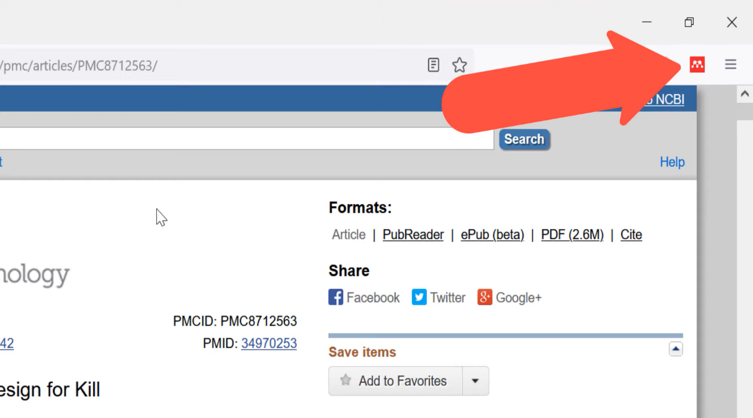

So, the simplest way to use the Mendeley referencing tool is by going on the actual site of the reference you want to add into your library and identify the Mendeley web importer icon.

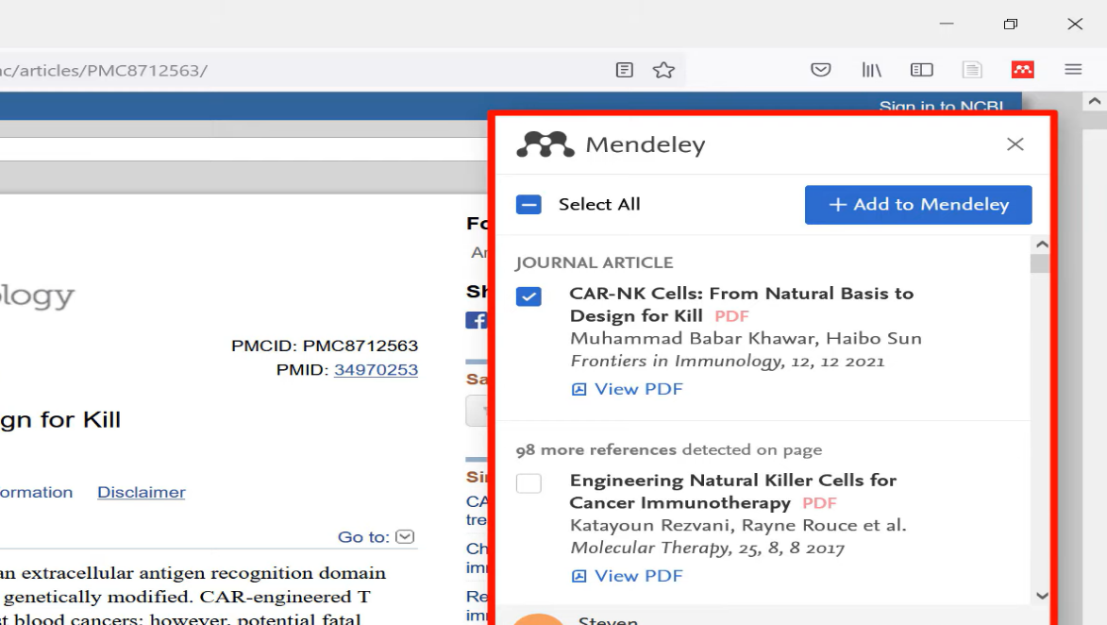
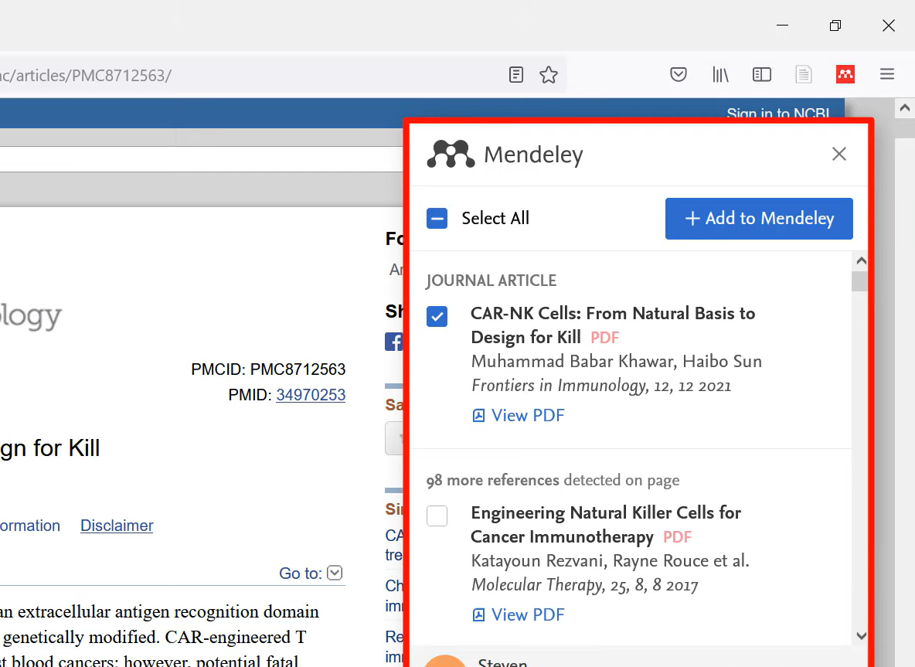

Once you’ve located the Mendeley icon, it should allow you to see all the available references that you can download from your chosen website into your Mendeley library.

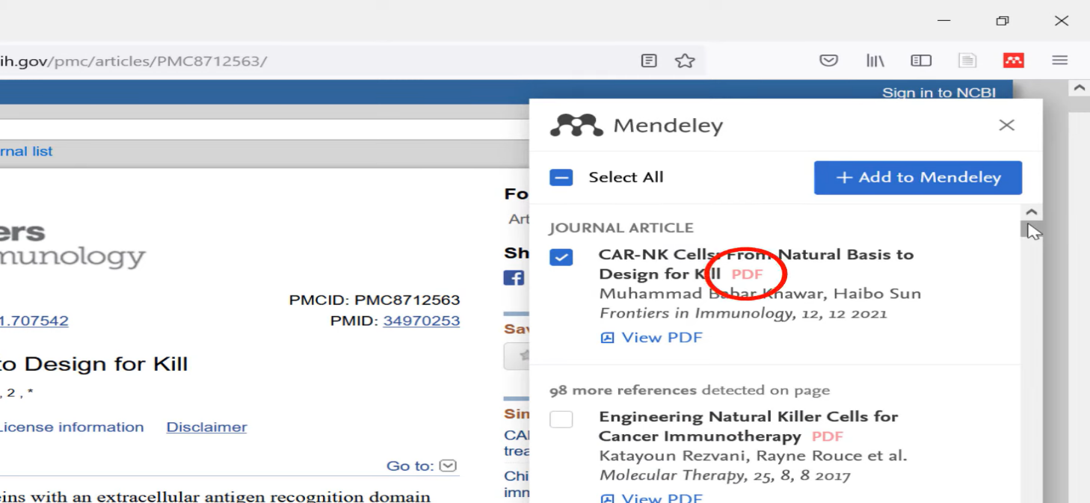
If the Text has a PDF available, the web importer will notify you with the highlighted text.
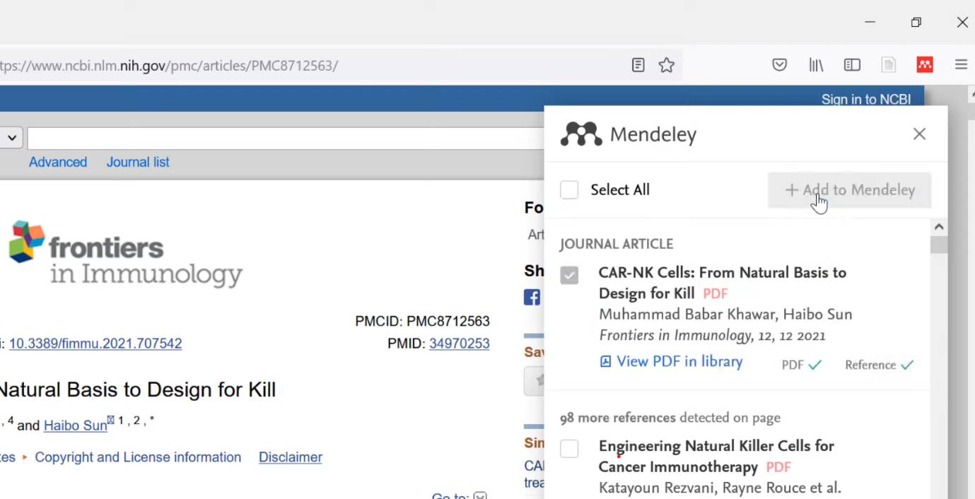

So, then you select your desired reference or references and press the add to Mendeley box and your desired references should be added into your file.

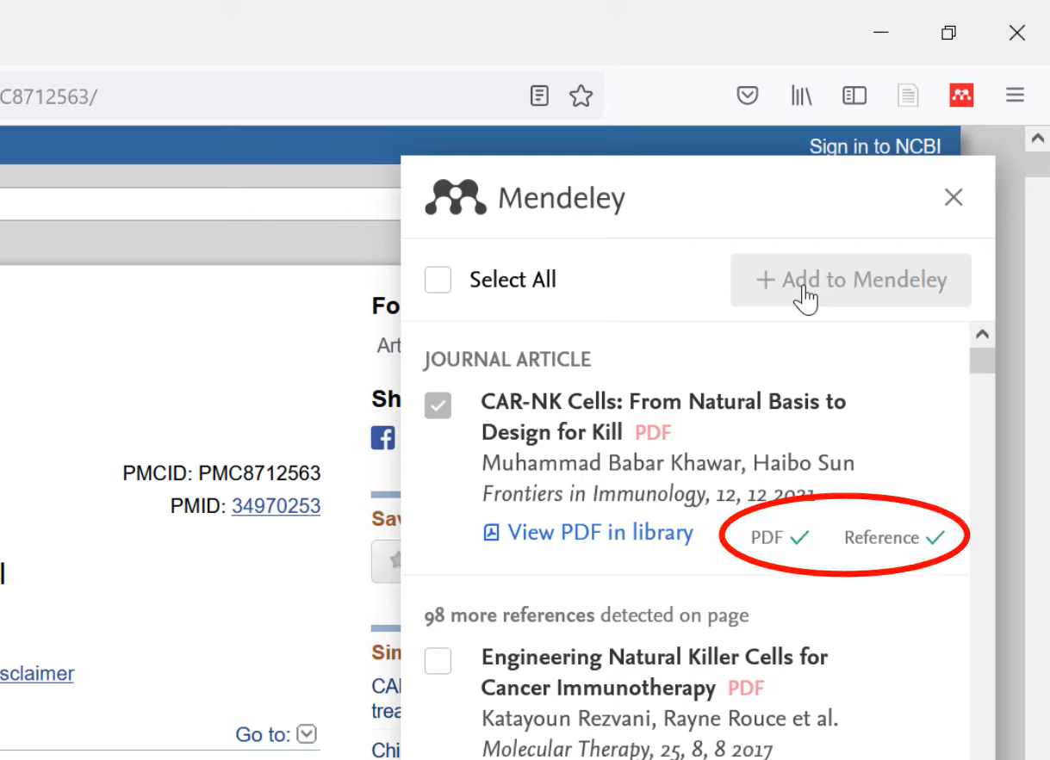
The highlighted sector indicates that the references has been saved to your library in pdf format.
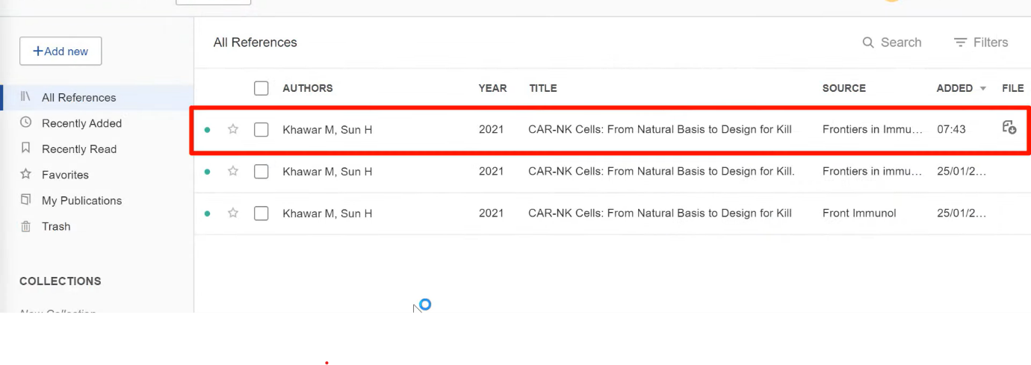

The saved reference should show up in your library with all your other saved references.

Overall, I agree that if you are in employment or studying that you should develop certain skills and attributes the help make you become better & more efficient at what you’re doing. It will make you more organised and professional and these skills make you a better person overall, so I deem the development or certain skills and attributes an essential for anyone in employment or studying.

References
Chaudhari, T., 2022. Time management Essentials and importance. Time management Essentials and importance , 8(5), pp. 6-8.
Mindtools, 2022. Mindtools. [Online]
Available at: https://www.mindtools.com/arb6j5a/what-is-time-management
[Accessed 14/03/2023 2023].
Page, M., 2023. Jobs and recruitment agency in USA, link to home page. [Online]
Available at: https://www.michaelpage.com/advice/career-advice/growing-your-career/5-tips-better-your-time-management
[Accessed 03 2023].
parsons, L., Oct 14, 2022. 8 time management tips for students. [Online]
Available at: https://summer.harvard.edu/blog/8-time-management-tips-for-students/
[Accessed 03 2023].
Tomaszewski, M., 2023. 30+ Time Management Skills & Examples for Your Resume. [Online]
Available at: https://zety.com/blog/time-management-skills
[Accessed march 2023].
Opie. (2001). Thinking Teams / Thinking Clients : Knowledge-Based Team Work. Columbia University Press,. https://doi.org/10.7312/opie11684

