3/24/2025
University of Wales Trinity Saint David
London campus
E-Portfolio Link:
Module Name: Learning In the Digital Era
Module Code: ACCA 4025

Student Name: Aybeniz Ozdemir
Student ID: 2614129
Group: 1

Lecturer’s Name: Koushik Modak

LDE Assignment 1
E-Portfolio
Table of Contents
Introduction 2
Main Body 2
Task 1: Essential Academic and Employment Skills for the future career Path 2
Task 1 (a): Report on Essential Academic and Employment Skills 2
Task 1 (b): Evaluation of Task 1 (a) based on Similarity report 2
Task 2: Collaborative Mind Map and Individual Poster 2
Mind Map (Collaborative) 2
Poster (Individual) 2
Task 3: Virtual Collaboration and RefWorks 2
Report on Virtual Collaboration 2
Step-by-step process of using RefWorks with visuals 2
Task 4: E-Portfolio Creation and Evaluation 2
Task 4 (a): E-Portfolio Creation 2
Task 4 (b): Illustrative Review of E-Portfolio tool Selection 2
Conclusion 2
References 2
Task 1 References: 2
Task 3 References: 2

Introduction
Technology is becoming more important in education. In future, I would like to work as an “AI Learning Experience Designer”. This job combines education, technology and creativity. A person in this role uses AI tools to create learning materials, lesson plans, online activities and quizzes for students. I am interested in this career because I believe technology can make learning easier and more interesting. AI can also help teachers understand students’ needs and prepare different activities for different learning levels. However, I believe AI should support teachers, not replace them. According to the World Economic Forum (2025), digital skills, analytical thinking and creative thinking are important for the future of work. Therefore, I would like to develop my communication, problem solving and digital skills to prepare for this career.

Main Body

Task 1: Essential Academic and Employment Skills for the future career Path

Task 1 (a): Report on Essential Academic and Employment Skills
Essential Academic and Employment Skills for an AI Learning Experience Designer; an AI Learning Experience Designer needs different academic and employment skills. These skills are important for creating useful learning materials and helping students learn more effectively.
- Communication and Academic Writing; communication is important because this job involves working with teachers, students and other professionals. Good writing skills are also needed to prepare lessons plans, reports and learning materials. Information should be clear and easy for students to understand.
- Digital and AI Skills; digital skills are necessary because this career involves using AI tools and online learning platforms. UNESCO (2024) explains that teachers need to understand AI, its educational uses and its ethical challenges. Therefore, I would need to learn how to use AI responsibly and check the information it provides. https://www.unesco.org/en/articles/ai-competency-framework-teachers?hub=365
- Analytical Thinking and Problem Solving; analytical thinking helps people understand information and find solutions to problems. For example, I could use student feedback or test results to identify which topics students find difficult. The World Economic Forum (2025) identifies analytical thinking as an important skill for the future workplace. https://www.weforum.org/stories/jobs-and-the-future-of-work/future-of-jobs-report-2025-jobs-of-the-future-and-the-skills-you-need-to-get-them/?trk=article-ssr-frontend-pulse_little-text-block
- Creativity and Adaptability; creativity is useful for designing interesting lessons, quizzes and interactive activities. Adaptability is also important because AI technology changes quickly. I would need to keep learning about new tools and ways of teaching. https://www.weforum.org/publications/the-future-of-jobs-report-2025/in-full/3-skills-outlook/?47a05339_page=2&47a05339_page=3&91a7963e_page=5
- The role would involve working with teachers, instructional designers, IT specialists and educational managers. Therefore, teamwork, leadership and interpersonal skills would be important. Continuous professional development would also be necessary because AI technology and educational practices are constantly evolving. LinkedIn Learning currently offers learning paths focused on AI literacy, prompting, AI productivity and evaluating AI-generated content. https://www.linkedin.com/learning/paths/building-ai-literacy
In conclusion, communication, digital skills, analytical thinking, creativity and teamwork are important for this career. Developing these skills would help me use AI effectively and support students in their learning.
Task 1 (b): AI Assistant Tools
AI assistants are becoming popular in educational and the workplace. They can help people with research, writing, planning, creativity and problem solving. I researched five AI tools and considered how they could be useful for my future career as an AI learning experience designer.
AI Assistant | Best Use | Application in Education
ChatGPT | Research, writing, brainstorming and data analysis. | Creating lesson plans, generating activities, analysing learning data and developing educational resources.
Microsoft Copilot | Productivity and Microsoft 365 tasks. | Supporting lesson planning, documents, presentations and workplace productivity.
Google Gemini | Learning, writing and idea generation. | Explaining concepts, brainstorming activities and creating learning resources.
Claude | Writing, reasoning and educational support. | Creating study materials, analysing text and developing discussion questions.
Perplexity | Research with cited sources. | Finding current information and supporting evidence based educational research.

- ChatGPT; can help with writing, research, lesson planning and generating ideas. For example, I could use it to create lesson plans, quizzes and activities for students. It can also help analyse data and explain difficult topics.
- Microsoft Copilot; Microsoft copilot can help users with everyday work and productivity tasks. It can be useful for preparing documents, presentations and educational materials, especially when working with Microsoft 365 applications.
- Google Gemini; google gemini can help with research, writing and brainstorming. I could use it to explain educational topics, develop lesson ideas and create activities for different student levels.
- Claude; claude is useful for working with long texts, writing and analysing information. It could help me prepare study materials, summarise educational documents and develop discussion questions.
- Perplexity; is useful for online research because it provides answers with links to sources. I could use it to find information about new educational technologies and check sources for my assignments.
I chose ChatGPT to demonstrate how AI can support my future career. First, I could ask it to create a 45-minute lesson plan for university students. This would help me organise learning objectives, activities and assessments. Second, I could ask ChatGPT to create three versions of an English writing activity for beginner, intermediate and advanced students. This could help me prepare activities for students with different abilities. Third, I could use ChatGPT to analyse anonymised student results and identify areas where students need more support. Finally, I could use ChatGPT to analyse anonymised student results and identify areas where students need more support. However, AI tools can sometimes provide incorrect information. Therefore, I would always check the answers and use reliable sources. I would also protect students’ personal information. In my future career, I believe AI should support huma teachers and help create better learning experiences.

SCREENSHOT 1 – Lesson Planning
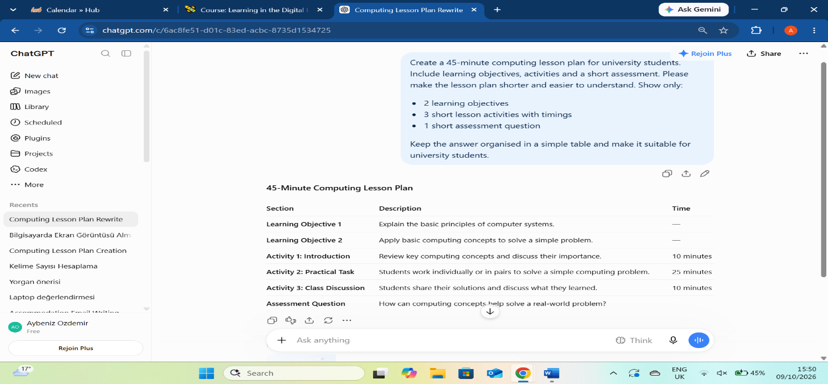
“Figure 1: using ChatGPT to create a lesson plan.” – ChatGPT helped me create a lesson plan with learning objectives, activities and a short assessment.
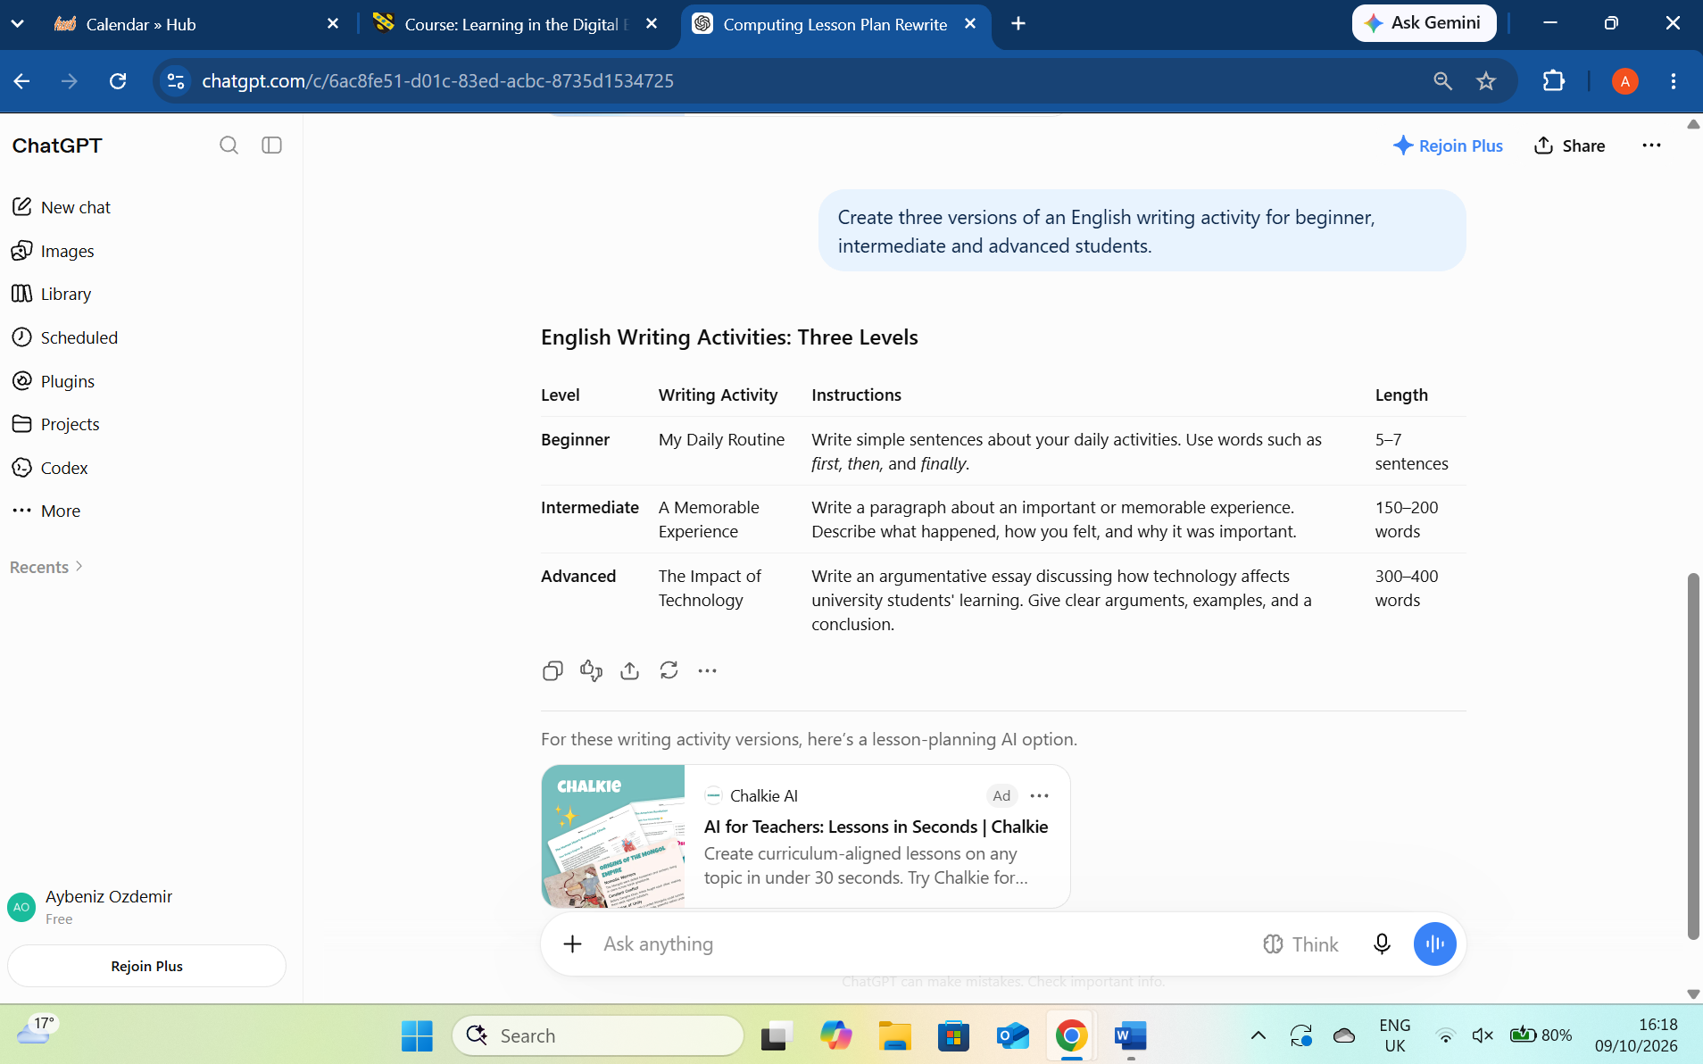
“Figure 2: Creating personalised learning activities.” – ChatGPT helped me create English writing activities for students with different levels of ability. This can make learning easier and more suitable for each student.

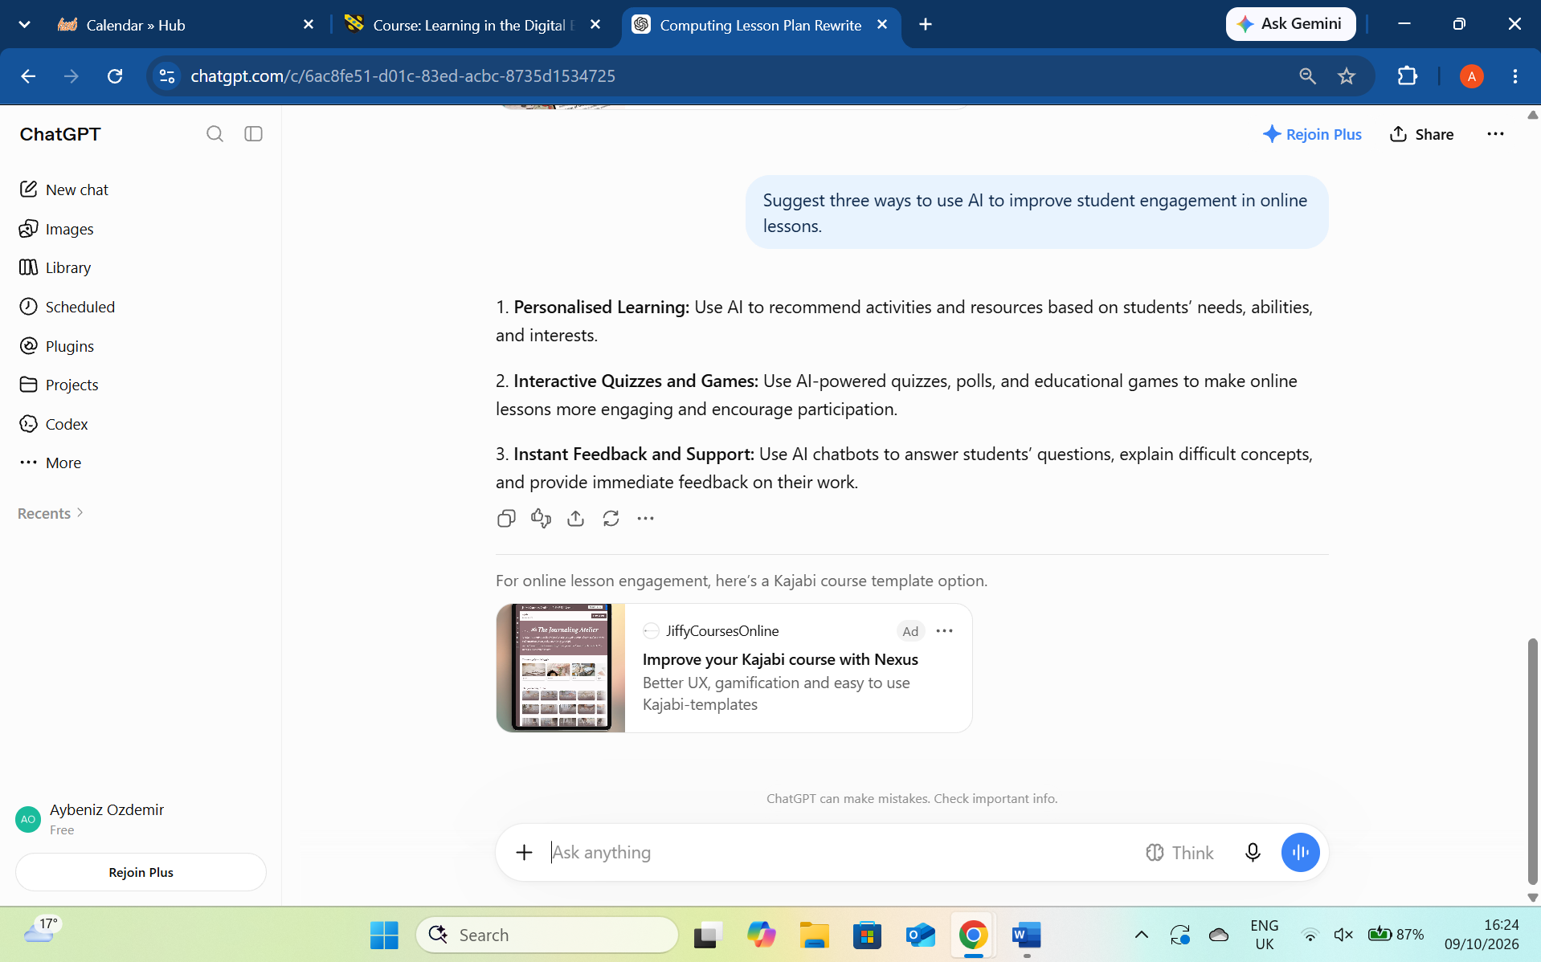
“Figure 3: Using AI for problem solving in education.” – ChatGPT helped me find ways to improve student engagement in online lessons. It suggested creative activities and strategies to make learning more interesting and interactive.

Task 1 (c): Evaluation of Task 1 (a) based on Similarity report
(approx. 100-150 words and 2 paragraphs where the first paragraph is about your similarity index and your areas of improvement. Then the second paragraph is about how much mark you deserve on your work with an appropriate justification-Remove this part after completing).

Task 2: Collaborative Mind Map and Individual Poster

Mind Map (Collaborative)
(approx. 450 words where 3 persons in one group and the contribution from each person should be 150 words approx..).

Poster (Individual)
No word limit

Task 3: Virtual Collaboration and RefWorks

Report on Virtual Collaboration
(approx. 350 words and 4-5 sources-Remove this part after completing).
Put your Chosen topic here and write a summary of that topic with IEEE referencing using RefWorks-Remove this part after completing.

Step-by-step process of using RefWorks with visuals
Put screenshots with appropriate discussion explaining what has been demonstrated in that screenshot-Remove this part after completing (100-150 words)

Task 4: E-Portfolio Creation and Evaluation

Task 4 (a): E-Portfolio Creation
Explain how you have created your e-portfolio with screenshots as evidence-Remove this part after completing.

Task 4 (b): Illustrative Review of E-Portfolio tool Selection
(approx. 100-150 words and 1-2 sources (if used)-Remove this part after completing).

Conclusion
(approx. 100 words -Remove this part after completing).

References

Task 1 References:

Task 3 References:

