ACMA 6002
William Holmes (2015755)
2015755@student.uwtsd.ac.uk
ACMA 6002
Applying Lean Techniques

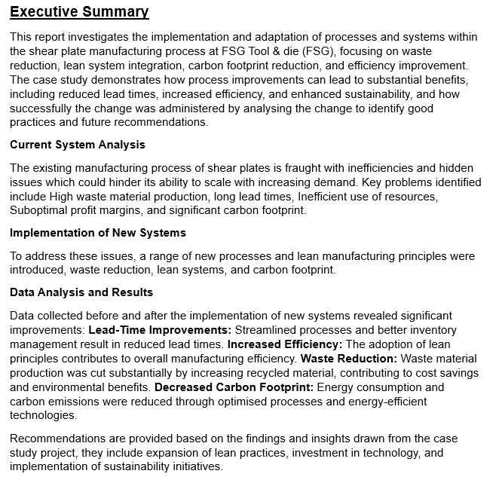

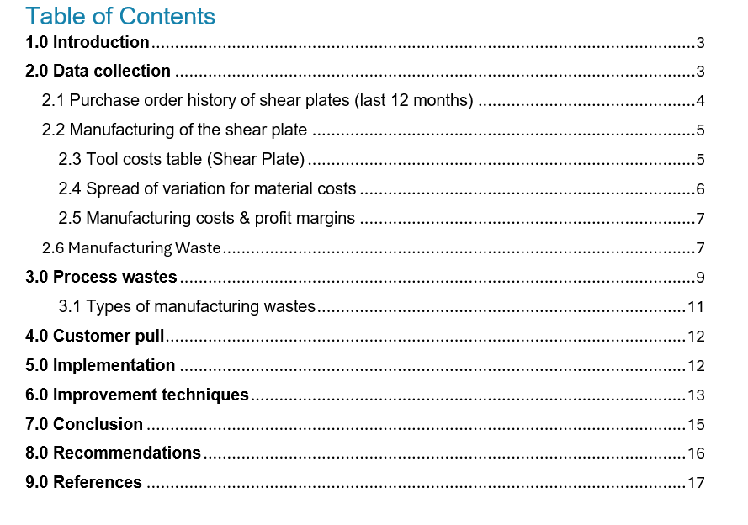

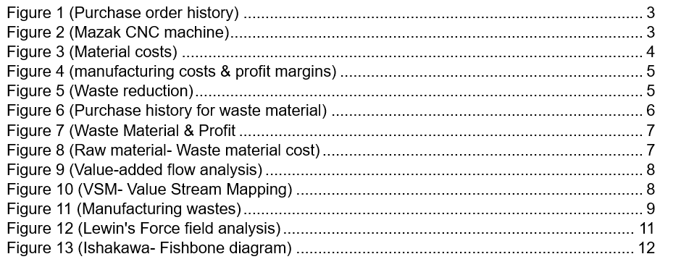

1.0 Introduction

“Perfection is achieved, not when there is nothing more to add, but when nothing is left to take away.” (exupery, 2024) This encompasses the directory of this paper, subtracting a process within the conveyor belt of manufacturing, analysing its cavities within the system, and offering solutions which prove value-adding for manufacturers and customers.
Within modern manufacturing, CNC (Computer Numerical Control) machining stands out as a cornerstone technology, enabling the precise and efficient production of complex components. However, this sophisticated process often has a significant drawback: waste generation.
As industries strive for sustainability and cost-effectiveness, reducing waste during CNC machining has become a paramount concern. This is summarised perfectly by Goldratt. E (1984) “Doing work and making money are not the same thing”. Not all work leads to making money. Much of it is wasted. This paper explores innovative strategies to minimise waste whilst enhancing the overall efficiency of CNC machining, thereby contributing to more sustainable manufacturing practices optimising material usage, upcycling waste, and identifying possible revenue streams. FSG has the potential to reduce their environmental footprint whilst achieving higher productivity and cost savings through the implementation of this approach by utilising its waste process material.

2.0 Data collection
The necessary quantitative and qualitative data was retrieved, using FSG’s databases, machinists’ logs, vendor information (Mitsubishi tooling), and sales information extracted from the sales department as FSG.
With thorough research the collated data from the above sources were analysed and quantified with a view to refine implementation of lean processes specifically relating to shear plates within FSG’s manufacturing process.
Shear plates are a part of the foil tooling process, which allows the material to be separated into manageable quantities during each stroke through the press.
The manufacturing process of shear plates involves large sections of material being trepanned to efficiently remove the vast portion of waste to achieve the correct form required for the tooling. The period of review spans between June 2023- June 2024.

2.1 Purchase order history of shear plates (last 12 months)
The order history of shear plates commences from June 23- June 24, the quantity, costs, profit, and waste can be calculated to give an in-depth understanding of the manufacturing costs across twelve months. Utilising this data accurate calculations can depict how lucrative the manufacturing process of shear plates was between June 23- June 24.

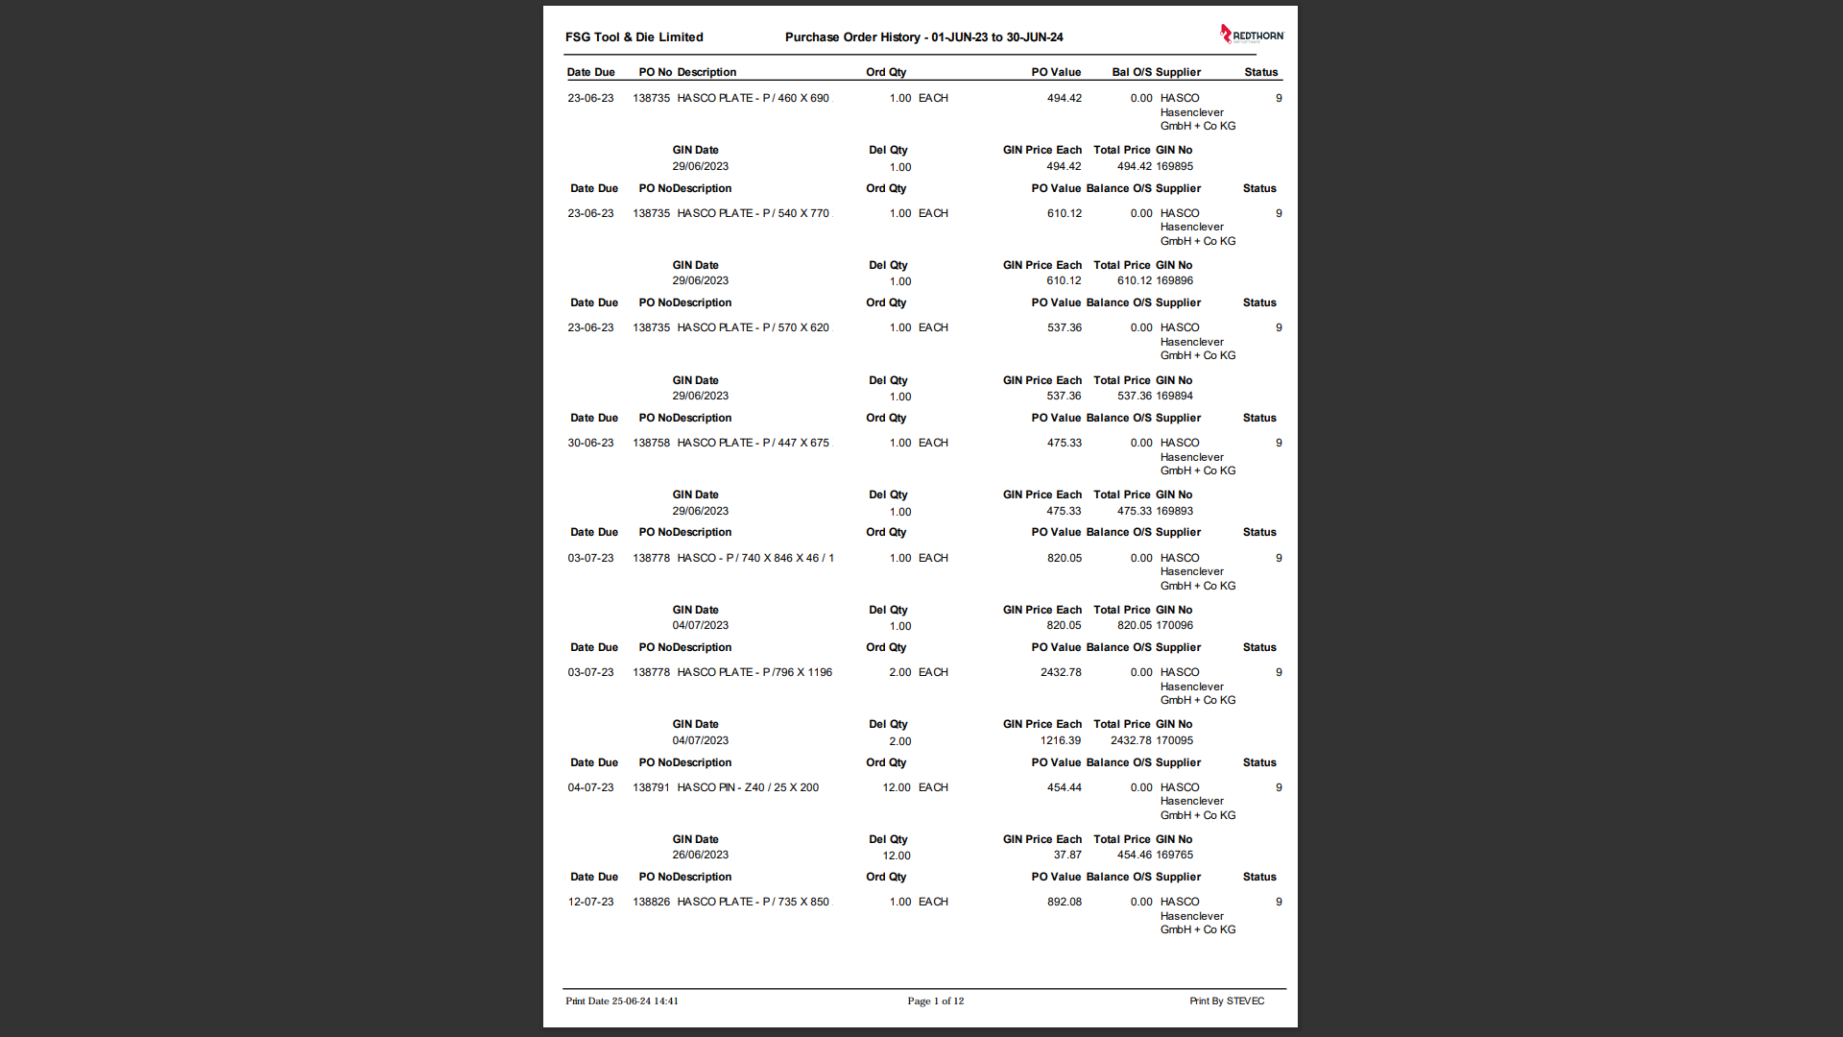
Figure 1 (Purchase order history)

2.2 Manufacturing of the shear plate
Determining the costs within the manufacturing process data was extracted from hourly machining costs at (£75) an hour, setup sheets, designed for operators to receive the information needed to complete the job at hand. The information included the total cutting time for the CNC program (3:14:13), and cutters needed with individual times for each toolpath. Using this information, we can estimate manufacturing costs with all previous sources listed.

Figure 2 (Mazak CNC machine)
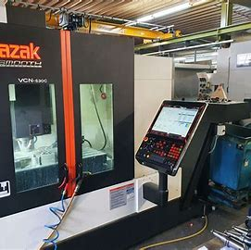

2.3 Tool costs table (Shear Plate)
Description | Quantity | Cost
12mm endmill (sharp) | X1 | £70
12 endmill x1 radius | X1 | £53
AJX face cutter tip | X5 | £6.19
APX face cutter tip | X5 | £9.33
8mm ball nose | X1 | £37.76
6mm x0.5 radius endmill | X1 | £32.50
3mm ball nose | X1 | £28.83
10.5mm chamfer tool | X1 | £57.09
Table 1 (Tooling costs)

With the information displayed above the overall manufacturing costs were calculated, with hourly machine rates at £75, cutting time at 3:25:37, and tooling costs calculated at £356.78. The overall manufacturing costs amount to £656.78.

2.4 Spread of variation for material costs
Figure 3 (Material costs)

Throughout the last twelve months from June 2023- June 2024, eighty-eight shear plates have been manufactured, this data has been quantified to display material cost and quantity. From the data extracted the average material cost was calculated to be £487.00.
With the addition of this information, a total manufacturing cost is estimated, using the average cost of tooling, machine hourly rates, and material cost a total manufacturing cost can be estimated at £1143.78. Using this data as a basis, further figures can be extracted.
The profit margins of shear plates are an estimated 15%-20% as company information states, the sales price would vary between (£1315.347-£1372.536) excluding wages, and company running costs being subtracted monthly.

2.5 Manufacturing costs & profit margins
Figure 4 (manufacturing costs & profit margins)

The above shows that the substantial work input doesn’t return significant output averaging £200.18 per shear plate or (£17,615.84) per annum. Against the manufacturing cost of £1143.78 or (£100,652.64), Although percentages are low due to high overheads and material costs, the project presents alternative revenue streams which prove to be value-adding to the environment, reducing carbon footprint, and manufacturer reducing overheads, material costs, and increased profits.

2.6 Manufacturing Waste
Figure 5 (Waste reduction)
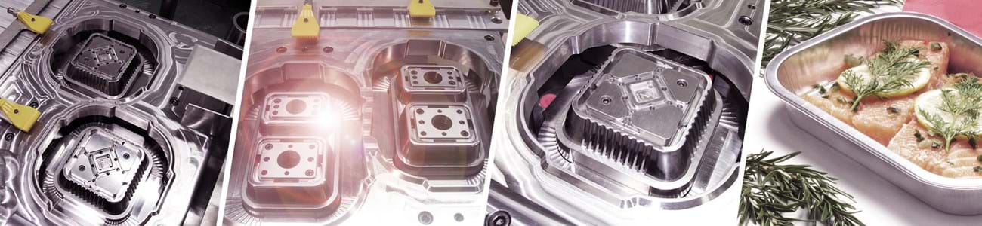

As shown above, the shear plates have large cutouts which are trepanned out during manufacturing to fit tooling specifications, this material can be recycled and re-used for alternative jobs, shop-tooling, or sold to increase the profitability of shear plates.

With the excess material trepanned from the initial plate, an average cost can be calculated by further developing the original data pulled from the shear plate manufacturing process. As per sales information, the average cost of the waste material trepanned from the shear plates is £167.93.
Figure 6 (Purchase history for waste material)
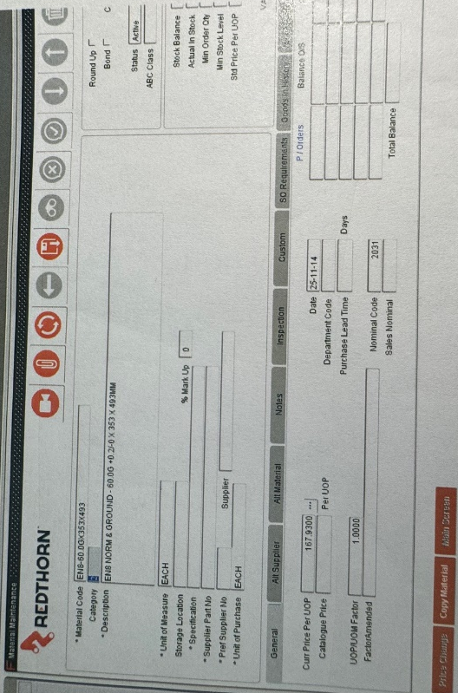
Knowing the average waste material cost and the average profit of a shear plate, comparisons can be made highlighting the importance of utilising the ‘free’ excess material made available during the manufacturing process.
As shown in the chart below the profit percentages and waste material costs are very much trending similarly across the manufacturing of all shear plates. It can be noted in some instances that the waste material costs exceed the profits made by that shear plate. Utilising the existing resources available through the manufacturing of shear plates, company manufacturing costs can be lowered by recycling the trepanned waste into new jobs or selling the waste material for additional profit.
Firstly, if the materials were re-used for additional jobs an average of 174 pieces of material would be available for other processes eliminating the need for material across a potential 174 jobs.
Secondly, with the purchase price of two pieces (one shear plate) at £167.93 as stated above, the total value of material would equate to £14,609.91 in saleable material. As it stands the average overall profit margin for June 23-24 stands at £17,615.84 (17.5%) per annum, with the addition of saleable material from trepanned processes profits could potentially increase to upward of (35%) with saleable material equivalating to 83% of profits.

Figure 7 (Waste material & Profit)

The chart below further quantifies the savings that can be made through adjusting the process of waste material. The chart states that the smaller pieces of previously scrapped material are bought for 50% of a full plate, saving thousands of pounds in stock and providing a profitable revenue stream without an implementation cost.
Figure 8 (Raw material- Waste material cost)

3.0 Process wastes
“Without a standard there is no logical basis for making a decision or taking action.”, (Juran, 1995), which was the premise in the late twentieth century, developing new lean manufacturing processes established the benchmark for process improvement and provided the foundation for the Lean Manufacturing movement. At this time many businesses underwent a transition that enabled them to greatly improve their competitiveness within their sectors by boosting value and reducing the work necessary to complete activities. In this modern day of manufacturing sister processes such as Six Sigma are regularly involved side by side with Lean aiding in the improvement of processes and systems. In this example, the use of the DMAIC system within Six Sigma has been implemented to improve the process of trepanning material from large shear plates and discarding it immediately into swarf bins “Lean is about moving ever closer to uninterrupted flow to the sequence of operations that deliver perfect quality”. (Howleg, 2016)
Figure 9 (Value-added flow analysis)
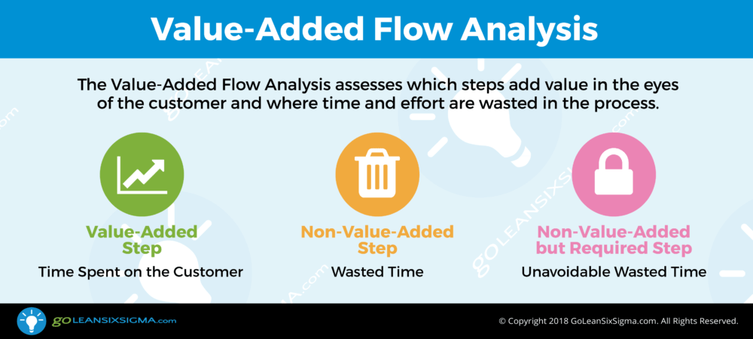
What constitutes waste in Lean Manufacturing?
Waste elimination is a fundamental principle of lean methods. In any firm, one of the most significant drains on profitability is waste. Lean waste might take the shape of time, material, or labour. However, it could also be related to the use of skill sets and ineffective planning.
In lean manufacturing, waste is defined as any expense or labour invested that does not transform raw materials into a product that the customer is willing to pay for. By optimising process stages and minimising waste, only value-adding activities are introduced at each stage of production which is often conveyed with the use of (VCS) value stream mapping.
Figure 10 (VSM- Value Stream Mapping)
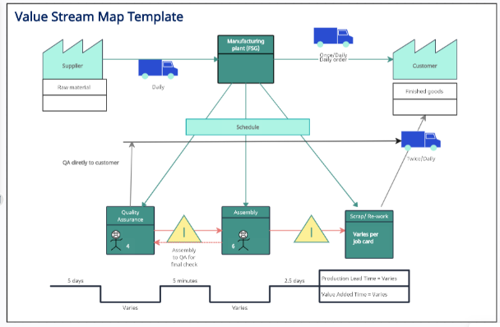

Today, the Lean Manufacturing model recognises eight categories of waste inside an operation, seven of which were originally envisioned when the Toyota Production System was first developed, and an eighth introduced when lean methodology was adopted in the Western world. Seven of the eight wastes are manufacturing process-related, while the eighth is directly tied to management's ability to use staff. Using improvement methods such as VCS mapping and, Kaizen creates a streamlined efficient process, when involving all factors and resources available, larger process improvements will seem like a smaller feat as they become standardised within the system.
3.1 Types of manufacturing wastes
Figure 11 (Manufacturing wastes)
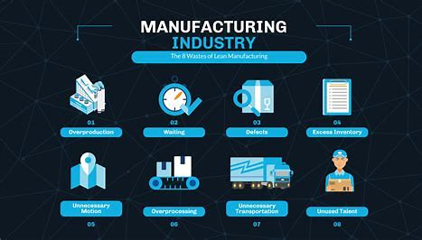

Throughout the manufacturing process of shear plates varying types of waste affect the efficiency and ergonomics of the process. Chronologically moving through the process, the first waste-causing effect is excess processing, this occurs during the (CAD) computer-aided design and (CAM) computer-aided manufacturing of the shear plates. As the software is passed through differing programmers and operators, management or administrative issues arise such as lack of communication, data duplication, overlapping authority, and human error, it could also be due to equipment design, poor job station tooling, or facility architecture.

Following, Inventory is deemed waste due to the associated keeping expenses. This is true for raw materials, work-in-process, and finished commodities. Overbuying or poor forecasting and planning can result in inventory waste. It could also indicate a faulty or poorly planned process relationship between manufacturing and procurement/scheduling. Lean Manufacturing needs process optimisation and communication across support functions in addition to a focus on the plant.
Purchasing, scheduling, and forecasting can use standardised work in the form of established minimums and maximums, as well as order points that are linked to process flow and takt time. This form of waste can be reduced by purchasing raw materials just when needed a manufacturing process known as just in time (JIT), decreasing work in progress, and removing or restricting the notion of "safety stock".
With the example used above the stock in question arguably has more value-adding wastes than negative. The positive factors include reduced material outgoing costs, a surplus that can be stored for varying jobs, increased profit margins, increased efficiency and reduced carbon footprint.
Negatively, inventory costs will increase, increased machine tooling costs to machine new material to re-usable standards (removing burrs, squaring up etc), reduced cashback on excess material (swarf) as there will be a decrease due to the upcycling of material and reduced availability on machinery due to machining stock material.

4.0 Customer pull
With the recycled use of trepanned material customer fulfilment could be increased. With the new surplus of usable material lead times will significantly reduce, from the time an order is placed to the time route cards hit the shop floor.
Additionally, the price average for machined goods could see a decrease as the material being used is recycled and with no initial costs. If built into the average manufacturing costs overall costs could significantly drop, as tooling is being used more effectively by completing operations and creating new stock simultaneously. Therefore, manufacturing costs could be reduced, throughput accelerated, and customer satisfaction is potentially increased through the value-added benefits of reduced lead times and manufacturing prices.

5.0 Implementation
The assessment and planning of the proposed process were analysed with data from multiple sources to verify. Secondly, ensuring adequate training and engagement has been emitted to employees on new methodologies and tools. “everyone must know what you are attempting to achieve and what area is the first priority” (Womack, 1996), this process is key for fostering a culture of continuous improvement through active employee involvement. Thirdly running pilot projects to ensure the processes' success before the full-scale implementation. Lastly monitoring and feedback, establishing robust monitoring systems to track progress and measure outcomes. This will allow further process improvements and steady data collection for future use on additional projects.
Implementing a new process can sometimes be costly and time-consuming, its merits are weighed against its negatives to determine the outcome of the process. The process similarly has merits and faults, the main concerns for the implementation of the discussed process would be storage costs due to the increased material, Machine time, tooling costs and running costs, as the material would need preparation before being stored or sold etc, and as machine time has been previously stated at (£75) an hour, and average time to trim the material at 30 minutes per part the cost of implementation equivalates to (£6600).
Positively the profits which are made far outweigh the implementation costs at (£14,609.91) in saleable material. Additionally, the plant wouldn’t see the effect of the process implementation dismissing any distress over lost plant losses. The proposed process will also make a leaner manufacturing process, reducing the number of moving parts by lowering the average removal of swarf bins, this also removes non-value-adding activities performed during the manufacturing process, essentially lowering manufacturing costs through deducting material prices from the recycled material now stored in house.

6.0 Improvement techniques
Throughout the implementation of lean manufacturing processes, various improvement methodologies were utilised these include; lean, six-sigma (DMAIC), Lewins force field analysis, Kaizen, value-stream mapping, (TPM) total productive maintenance, 5s, Ishikawa, (TQM) total quality management, and (JIT) just in-time management.
Lewin’s force field analysis report identified potential improvements which occurred within the company. Having a detailed analysis of the process in question solutions will begin to flow.
Figure 12 (Lewin's Force field analysis)
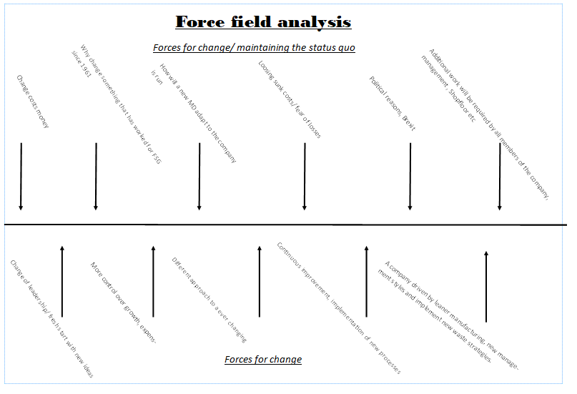

In an ever-ageing plant in an ever-evolving industry, it is key to maintain a strong grip on progress made and the skills the employees bring to the company. Therefore, going forward it is recommended by Velling (2019) that the 5s be integrated throughout the plan along with Total Productive Maintenance (TPM) to help maximise the performance from all sectors at the factory and push goals forward. Companies such as Harley-Davidson, Boeing, and Hewlett-Packard are using the 5s and TPM strategy as the framework for continuous improvement and innovation. With worldwide companies incorporating these techniques in day-to-day manufacturing, it paves a path for smaller companies to communicate it within their sectors to innovate day-to-day manufacturing.

The 5s include:
- Sort – sort through all inventory and remove unnecessary items
- Set in order – put all the items in the right place regarding functionality
- Shine – inspect all the machinery and maintain it regularly
- Standardise – standardised work helps to keep everything in order
- Sustain -In Sustain, the goal is to stick to the new rules. Workers keep the new standards in place and practice the first three steps every day until they become automatic
Total Productive Maintenance (TPM) includes:
- Achieve maximum equipment efficiency
- Develop maintenance skills for all employees
- Increase equipment reliability
- Improve the efficiency of maintenance management
- Avoid unplanned machine downtime
- Optimise quality costs related to machine failure

Figure 13 (Ishikawa- Fishbone diagram)
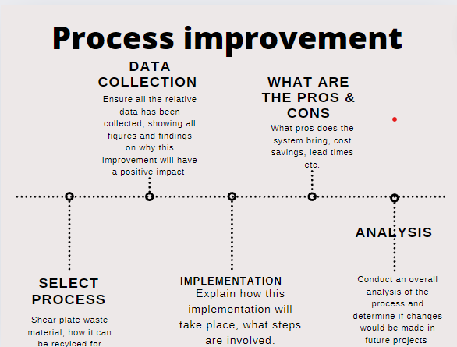
Fishbone Diagram (Ishikawa): Visualising potential causes of a problem to identify root causes. Using Ishikawa allows for a visualisation of what process will ensue upon completion.

7.0 Conclusion
Implementing process improvement techniques within our manufacturing operations is a strategic initiative that will drive substantial benefits in efficiency, waste reduction, cost reduction, product quality, lead times (customer pull), and customer prices. By adopting methodologies such as Lean Manufacturing, Six Sigma, Total Quality Management (TQM), Just-In-Time (JIT), Total Productive Maintenance (TPM), and advanced technologies associated with Industry 4.0, we are positioned to achieve transformative results.
Taking a holistic view of the entire spectrum of manufacturing processes for shear plates, reviewing the system improvement of waste reduction during the manufacturing of shear plates has the potential to be a valuable project, from workflow optimisation and waste reduction to enhanced equipment reliability and proactive maintenance. The integration of continuous improvement practices and the involvement of employees at all levels can foster a culture of innovation and accountability, ensuring sustainable progress and adaptation to evolving market demands.
The system was systematically refined through rigorous assessment, data collection and trialling, and our strategies and scale were successful. The expected outcomes of this initiative include increased operational efficiency, significant cost savings, superior product lead times and heightened customer satisfaction. By prioritising process improvement, we not only address current operational challenges but also lay a solid foundation for future success.
In conclusion, FSG’s commitment to process improvement is integral to its strategic vision. It enables FSG to meet and exceed customer expectations, respond effectively to market dynamics, and maintain a competitive edge in the industry. This initiative is not just about immediate gains but about establishing a culture of excellence and continuous improvement that will propel FSG forward in years to come.

8.0 Recommendations

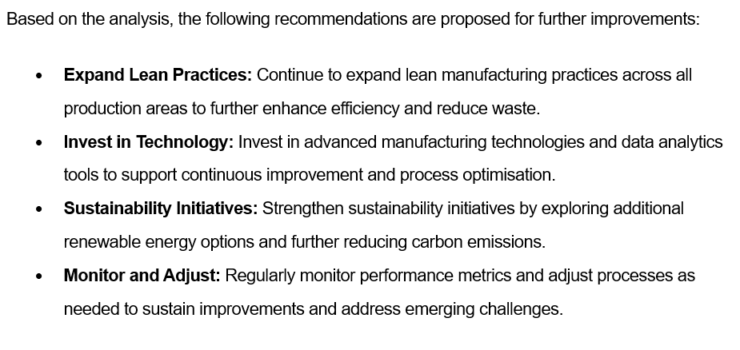

9.0 References



