Subtraction drawing with reactive dyes and drawing tools.
Take inspiration from the cut stamped pattern from Mondays session and the studio set up.

- Reactive dye - open screens colour removal using a weak bleach solution, brushes and tools of your choice.
- Reactive dye - open screens – layering of marks, textures and colours

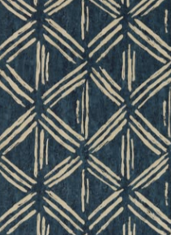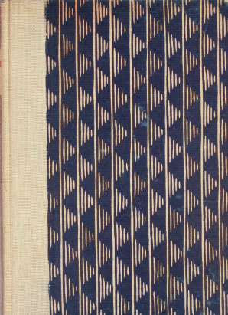
Clarke & Clarke. Moderne Dansk Boligkunst Danish Design:
1930-1945 furniture glass ceramics lamps (book cover)
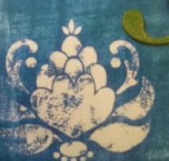
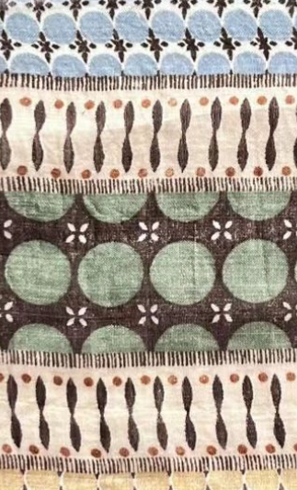
stamped motif using bleach
Unknown vintage textile
Take colour palettes from the ‘Organic Mediterranean’ trend.

Use mark making tools and brushes?

Consider solid wash of dye over an open screen (see images above) v’s stripes of dye that can be worked into pattern through subtraction method and colour reintroduction (image to the left).

Be playful.

