Your Exit Strategy: Personal Promotional Material

Hamza Qasim
University of Wales Trinity Saint David
Critical Review // ADFM6001
Richard W. Morgan

Contents Page
Contents Page 2
Personal Showreel 3
Professional Business Card 4
Bibliography 8

Personal Showreel
My showreel has been uploaded to YouTube. I want to focus my further education and career on Animation and VFX with a key focus in Environment Design. I have added what I think are necessary skills to the showreel and highlighted projects that show my keen interest in these specific areas. The link to my showreel can be found below, it is unlisted for the time being, meaning anyone with access to the link can view it. After this module and depending on the results, I might actually use it as my main showreel when applying for jobs.
https://youtu.be/k1RtPRcissg
Showreel / https://drive.google.com/drive/folders/1RnsEm35dLzW7qpjEa6k9MJwpkOjNl9p3?usp=sharing
In the event that the YouTube link somehow doesn’t work, I have linked a Google Drive folder containing everything.

Professional Business Card
Before this assignment, I had made several business cards that unfortunately or fortunately didn’t meet the requirements for a UK business card. I couldn’t settle on a design for what I, personally, wanted. I looked around for what seemed to be weeks, and still didn’t settle on anything. Only after working on another project and genuinely enjoying doing the tilesets for my pixel art game did I settle on something that I was proud to make and present.
The following images are the ones that DO adhere to the standard UK sizing for business cards. The images following are my submission for this assignment, there are two images, as it’s necessary to show the front and the back of the business card. I will also be providing a google drive link below which provides access to all my business cards and the PSD files for the main submission.
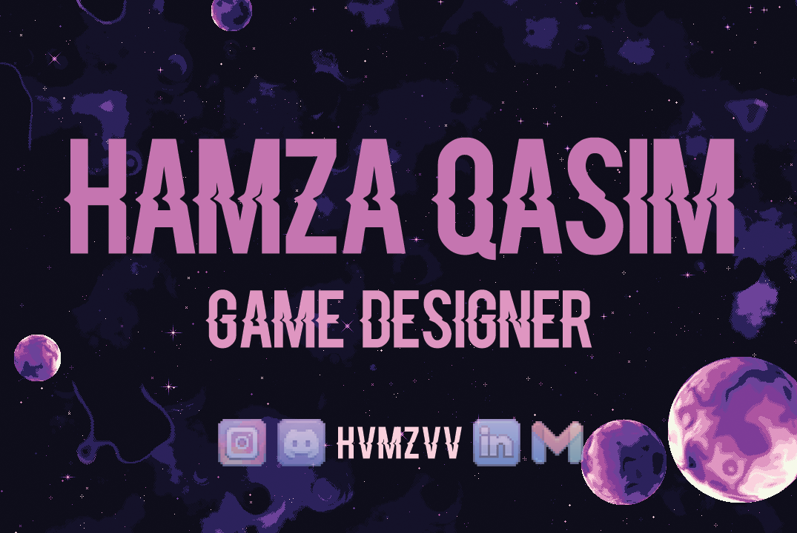
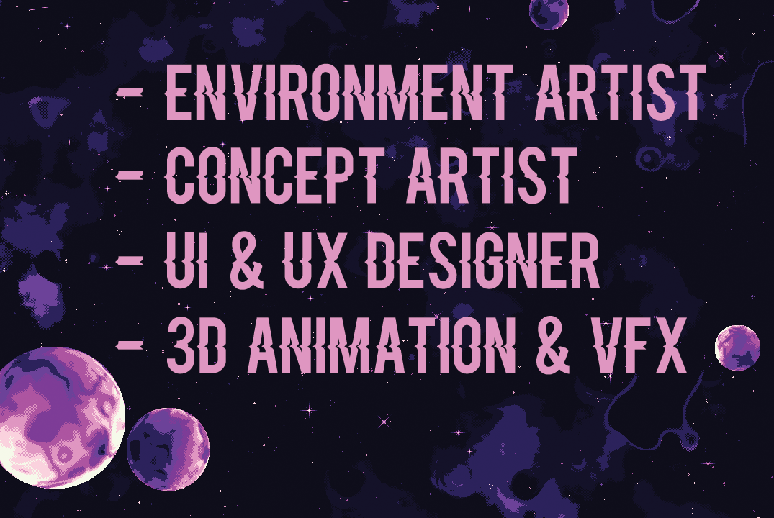
______________________________________________________________________________
The following images are NOT my submission for this assignment, however they DO adhere to the standard UK business card sizing. This is to show that I did make other designs before settling on one. Whilst this may look like a good design, it comes with a very very large risk of copyright infringement as well as a possibility to get sued by a large gaming corporation. Thus, it was only right to not be using this further in any way shape or form.
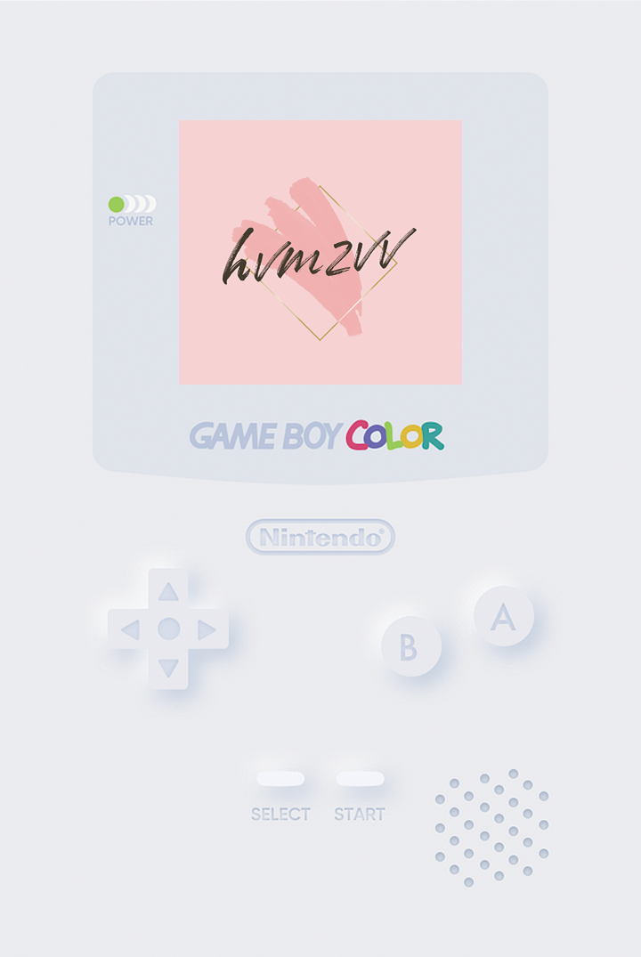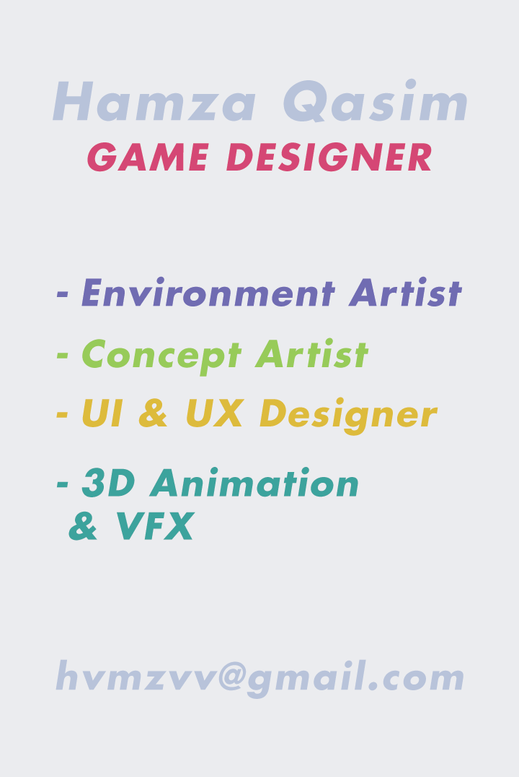
These can be found by clicking on the following link:
Business Cards / https://drive.google.com/drive/folders/1bseLAWQjUAv5DG10JfXVhS6JH9H5FNR8?usp=sharing
______________________________________________________________________________
The following images are my previous attempts at making a business card. These are NOT my submission for this assignment and DO NOT adhere to the standard UK business card sizing.

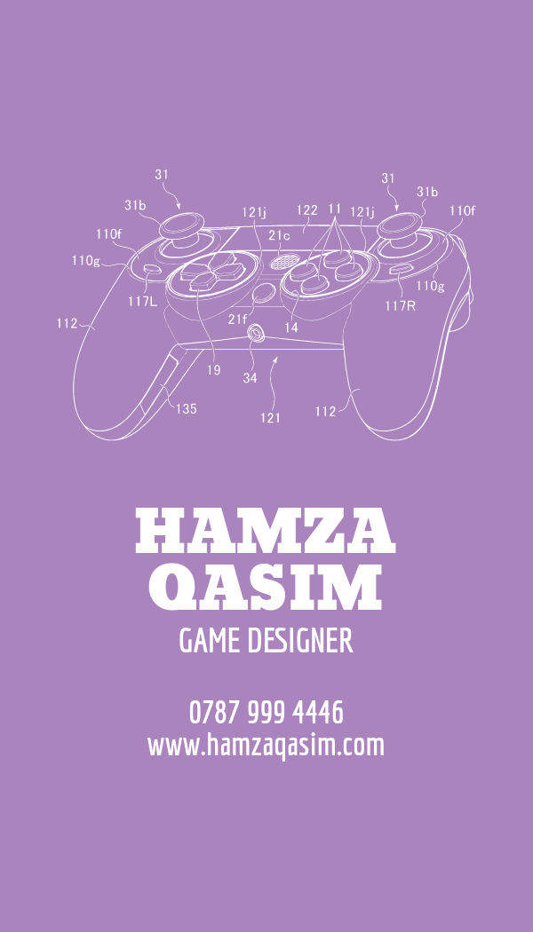

Bibliography
- M. Mehta, “3D environment artist ‘showreel 2022,’” YouTube, https://youtu.be/swfx7za4W8k (accessed May 8, 2024).
- “A guide to making a successful showreel,” Creative Lives in Progress, https://www.creativelivesinprogress.com/article/a-guide-to-making-a-successful-showreel (accessed May 8, 2024).
- P. Stringer , “Perry Stringer - hard surface showreel 2012,” YouTube, https://youtu.be/-v_cOV1ukuM (accessed May 8, 2024).
- M. Schellenberg, “3D environment artist - demo reel,” YouTube, https://youtu.be/bLFljde6qoM (accessed May 8, 2024).
- L. Torres, “One year in Unreal engine 5: Real-time environment art showreel [UE5],” YouTube, https://youtu.be/sd4qvI-tQoo (accessed May 8, 2024).
- M. Jaeger, “Building a Killer 3D portfolio and show Reel - FlippedNormals blog,” FlippedNormals Blog - News & Articles, https://blog.flippednormals.com/essentials-for-getting-a-job-reels-portfolios/ (accessed May 8, 2024).
- “Reel talk by escape studios,” WebDocs, https://webdocs.aub.ac.uk/Reel%20Talk%20by%20Escape%20Studios.pdf (accessed May 8, 2024).
- D. Johnson, “The art of creating compelling showreel scenes,” Daniel Johnson Films, https://www.danieljohnsonfilms.co.uk/the-art-of-creating-compelling-showreel-scenes/ (accessed May 8, 2024).
- ScreenSkills, “Environment artist in the VFX industry,” ScreenSkills, https://www.screenskills.com/job-profiles/browse/visual-effects-vfx/computer-generated/environment-artist-visual-effects-vfx/ (accessed May 8, 2024).
- U. Prom, “Unreal engine 5 environment showreel,” YouTube, https://www.youtube.com/watch?v=kNmbPLyQcSk (accessed May 8, 2024).
- “5 tips to create the perfect business card: How to design professional business cards,” YouTube, https://youtu.be/LiXsDUcDims (accessed May 8, 2024).
- J. Sagar, “The Pro’s Guide to creating memorable business cards,” Creative Bloq, https://www.creativebloq.com/features/the-pros-guide-to-creating-memorable-business-cards (accessed May 8, 2024).
- “How to design business cards that actually stand out,” WP Engine, https://wpengine.co.uk/resources/how-to-design-business-cards-that-actually-stand-out/ (accessed May 8, 2024).
- A. Gregory, “7 rules of Good Business Card Design,” The Balance, https://www.thebalancemoney.com/effective-business-card-2951735 (accessed May 8, 2024).
- “How to design a business card: The ultimate guide: Vistaprint US,” Vistaprint Ideas and Advice US, https://www.vistaprint.com/hub/how-to-design-business-card (accessed May 8, 2024).
- S. Lanier, “How to design a good business card,” HubSpot Blog, https://blog.hubspot.com/sales/how-to-design-business-card (accessed May 8, 2024).
- “Tips on Business Cards for Game DEVS (artists too!),” Transverse Audio - Sound libraries, EDM and game audio, tutorials and much more., https://transverseaudio.com/posts/tips-on-business-cards-for-game-devs-artists-too (accessed May 8, 2024).
- N. Johnson, “How I made my business card into a game: Flick fight,” Nomich Games, https://nomichgames.com/how-i-made-my-business-card-into-a-game-flick-fight (accessed May 8, 2024).
- M. Correia, “Contactics: A game on a business card,” Game Developer, https://www.gamedeveloper.com/business/contactics-a-game-on-a-business-card (accessed May 8, 2024).

