Surveying
Cristoffer Davies (1705493)

M4X01317

Cristoffer John Davies – 1705493

21-01-19

HNC Civil Engineering and Environmental management
Basic levelling of UWTSD site, SA1 Waterfront Development, Yr Athorfa

Dr Tobin



Table of contents

- Introduction to basic levelling
- Aim of report
- Equipment used during the exercise
- Procedures and methods followed
- Table of results and calculations
- Factors that could have an effect on results
- Conclusion

Introduction
According to Designing Buildings (2019 levelling is the method used to determine the relative height of different points above or below a surface. The principle of levelling is to obtain a horizontal line of sight with respect to which the vertical distances of the points above or below this line of sight are. The key objective is to establish the height of a given point with respect to the ordnance datum (od) or any given datum. It is one of the first tasks required before construction begins on a site so that the designers / architects of the project are aware of the ground or site conditions.

Aim of report
The aim of this report is to present my findings for a basic levelling survey on the proposed site to find out and calculate the reduced levels of various points using the ‘Rise and Fall method’ and also the ‘Fly levelling’ method. The client (University Wales Trinity Saint David) are proposing to create a vibrant student and staff gymnastics centre closer to the new library building in 2020.
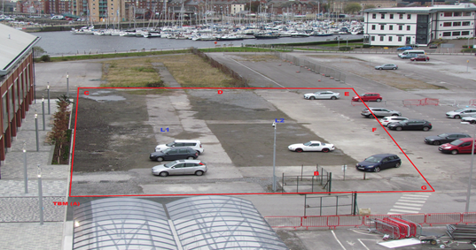
Figure 1 - Plan of proposed site / Dumpy levelling

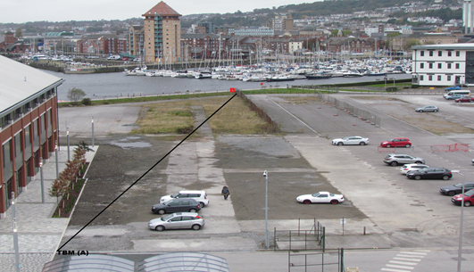
Figure 2 - Plan of proposed site / Fly levelling

Equipment used during survey
There were various pieces of equipment used during the levelling of the proposed site. Here, I will discuss the equipment used and their purposes.

Electronic level  According to Designing Buildings an electronic level is an optical instrument used to establish or verify points in the same horizontal plane in a process known as levelling, and is used in conjunction with a levelling staff to establish the relative heights levels of objects or marks. It is widely used in surveying and construction to measure height differences and to transfer, measure, and set heights of known objects or marks. | 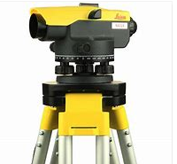  Figure 3 - Electronic level
Level Tripod  A level tripod was used during the survey. According to Brinker (2013) its purpose is to ensure that the electronic level remains still and stable for the duration of the survey. The tripod has extendable legs with sharp feet that find a good grounding on almost any surface without the fear of the ground interfering with the levels. The electronic level screws into the tripod securely and this ensures the level will not drop off and become damaged. | 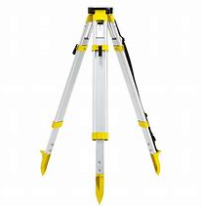  Figure 4 - Level Tripod
Plumb Bob  Deumlich (2010) notes that a plumb bob is a weight attached to a piece of string which is attached to the electronic level to give a vertical marker of the exact coordinate of the point of levelling. The weight usually has a pointed sharp end. | 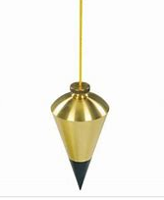  Figure 5 - Plumb Bob

Measuring Staff  A measuring staff is an extendable rod which is effectively a measuring tool used to give the height of an unknown point as noted by Deumlich (2010). A person will hold the staff at a point as vertically as possible while the other person will be at the electronic level reading the height of that given point relative to the level. | 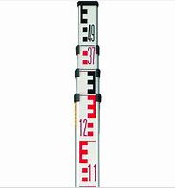  Figure 6 - Measuring staff
Measuring Wheel  Webster (1999) describes a measuring wheel as a device used during surveing work to calculate and read the distances from point to point. These are calibrated pieces of equipment which are very accurate. They are used, for example, in fly levelling, where you would measure from the point of the level via the plumb bob to the location of the staff. | 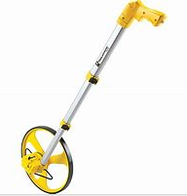  Figure 7 - Measuring Wheel
Personal Protective Equipment (PPE)  Any work carried out on a construction site requires any staff or sub-contractors, visitors etc. to wear the appropriate PPE required by law. During the work carried out on the site in question a high visibility jacket, hard hat and safety footwear was worn. | 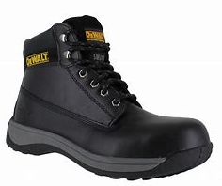  Figure 8 - PPE
Field Book and Stationery  Crawford (1995) notes the importance of accurate recording so that a field book and some stationery is essential for any surveying work carried out on site. The field book is used by the surveyor to record his/her findings accurately with sufficient notes that accurately describe where the recordings where taken, distances, a sketch of the site and also a sketch to show exactly where the change points were. The values of the back, fore and intermediate sights on the site are also recorded. |   Figure 9 - Field Book

Procedures and setting out – Dumpy Levelling
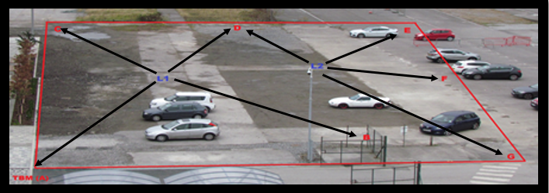
Here I will discuss the procedures and methods used during the survey.
Figure 10 - proposed site and actual locations of where readings were taken from
L1 | A=1.610 (BS) | B=1.670 (IS) | C=1.953 (IS) | D=1.690 (FS)
L2 | D=1.648 (BS) | E=1.835 (IS) | F=1.759 (IS) | G=1.753 (FS)

(BS) – Back sight reading
(IS) – Intermediate sight reading
(FS) – Fore sight reading
There are various terms used during a surveying report which I will describe:

Back sight
A back sight is the first reading taken from a known or given point. Since the survey progresses from a point of known position to points of unknown position a back sight is a reading looking back along the line of progress.

Fore sight
A foresight is the last reading taken from a known point. Since a survey progresses from a point of known position to points of unknown positions, a foresight is a reading looking forward along the line of progress.

Intermediate sight
An intermediate sight is a reading/s between the back sight (1st) and foresight (last) reading from a known point. There could be multiple intermediate sights from a known point.

Datum
A datum is a known and fixed level from which we can calculate the level of any given point relative to this datum.

Reduced level
A reduced level is an elevation calculated from the survey points with reference to a known datum. It can be positive or negative to the known point – depending on the readings taken and the topography of the site being levelled.

Fly levelling
Fly levelling is performed when the site in question is a lengthy distance away from the known datum or benchmark. This method will start with the surveyor taking a back sight at the known point and proceeds towards the worksite until a suitable place is found for a temporary benchmark. At the end of the survey the surveyor will come back to the original benchmark.

- The first task was to collect all the equipment needed for the survey. (See above for list of equipment used) and ensure that all equipment was free from any visible damage. I also ensured that the electronic level was within any given calibration dates.
- When I arrived site I ensured that I wore the correct PPE.
- I placed my equipment down safely next to my Temporary Bench Mark (TBM) and proceeded to the site of L1 and L2 which is shown in the above plan and spray pained them with a dot of blue spray so that I knew where they were on the site.
- I took the tripod to the point of L1 and removed the electronic level from its case, inspected it for damage and then attached it to the tripod via the screw from underneath the tripod.
- The next step was to set the level correctly. There is a spirit level attached to the side of the electronic level and must be levelled and centred before any surveying work is carried out. There are two adjuster knobs on the level and both must be adjusted to level it.
- Once the level was adjusted and levelled a plumb bob was attached to the bottom of the level where it is attached to the tripod. This was to ensure that the level was directly above the spots marked out as L1 and L2.
- My colleague proceeded to point A which was my TBM. My TBM was at a 109m. My colleague stood at point A with the measuring staff whilst I took a reading with the level. It read 1.610m. This was my first reading from L1 which was my back sight. All readings were recorded and double checked. My findings were written in my field book.
- My colleague proceeded to point B (as shown in the plan) and I measured a reading of 1.670m, this is a reading in-between my first and last, this is known as an intermediate sight.
- My colleague proceeded to point C which was also an intermediate sight recorded at 1.953m
- My colleague now proceeded to point D which will now be my last reading from L1, this is now the Fore sight which was recorded at 1.690m
- All readings at this point were complete from L1 and recorded correctly in my field book, along with a brief sketch of the site so that I knew where the readings came from.
- At this point there was a change in location. We moved the level and tripod safely over to point L2. As the level and tripod had now been disturbed the level had to be re levelled via the spirit bubble on the side.
- Once the level was re levelled my colleague proceeded to point D again – which was the same spot as my Fore sight from L1. This point D will now be my back sight from L2. The reading for D at L2 was 1.648m
- My colleague now proceeded to point E which was an intermediate sight measured at 1.835m
- Another intermediate sight was taken at point F which measured at 1.759m
- The last reading at L2 was the foresight which measured 1.753m

Results and Calculations
Here I will discuss the readings that were acquired during the survey and the calculations used to come up with the levelling results for the site in question. I will discuss also how I have calculated the results.
Booking |  |  |  |  |  | Reduction
 | Station | Points | BS | IS | FS | RISE | FALL | RL
 | L1 | A (TBM) | 1.610m |  |  |  |  | 109m
 | L1 | B |  | 1.670m |  |  | -0.06 | 108.94m
 | L1 | C |  | 1.953m |  |  | -0.283 | 108.657m
 | L1 | D |  |  | 1.690m | +0.263m |  | 108.92m
 | CHANGEOVER OF STATIONS
 | L2 | D | 1.648m |  |  |  |  | 108.92m
 | L2 | E |  | 1.835m |  |  | -0.187m | 108.733m
 | L2 | F |  | 1.759m |  | +0.076 |  | 108.809m
 | L2 | G |  |  | 1.753m | +0.006m |  | 108.815m

Method of calculating new reduced level
- My datum at point A for this site is 109m which is the RL given for point L1.

- BS @ L1 (1.610m) - IS @ L1 (1.670m) = Fall of 0.06m
Therefore RL at L1 will now be 109m – 0.06m = 108.94m
- IS @ L1 (1.670m) – IS @ L1 (1.953m) = Fall of 0.283m
Therefore RL at L1 will now be 108.94m – 0.283m = 108.657m
- IS @ L1 (1.953m) – FS @ L1 (1.690m) = Rise of 0.263m
Therefore RL at L1 will now be 108.657 + 0.263m = 108.92m
*********Changeover of Stations*********
- BS @ L2 (1.648m) – IS @ L2 (1.835m) = Fall of 0.187m
Therefore RL at L2 will now be 108.92m – 0.187m = 108.733m
- IS @ L2 (1.835m) – IS @ L2 1.759m) = Rise of 0.076m
Therefore RL at L2 will now be 108.733m + 0.076m = 108.809m
- IS @ L2 (1.759m) – FS @ L2 (1.753m) = Rise of 0.006m
Therefore RL @ L2 will now be 108.809 + 0.006m = 108.815m
To check and ensure that my new reduced levels were correct I added all my Back sight readings and deducted the total figure of Foresights to get the reduced level as seen. As a check the difference between the first reduced level and the last reduced level calculated should be the same as the difference between the fore sights and the back sights.

Total Back sights | 3.258 |  | First reduced level | 109
Total Fore sights | 3.443 |  | Last reduced level | 108.815
Difference | 0.185 |  | Difference | 0.185

As we can see, both values are equal and this provides us with an useful arithmetic check to ensure that we have a correct reduced level for the proposed site.

Procedures and setting out for fly levelling

Figure 11 - Photograph of site and location of Fly levelling
FS – 1.995M
BS – 1.58M
BS – 1.57M
FS – 1.7M

B
X
TBM (A) 109M

Above is a sketch which shows the results from the fly levelling of the proposed site. As you can see there is a slight increase in ground level, throughout the whole levelling process. The new level at B is
109M (TBM) + 1.995 = 110.995M

Factors which could have affected the results

There are many sources of error which could affect the results during a levelling project. Below is list of the various errors which could occur:
Equipment error
According to Kathir (2017)
- The electronic level must be checked before use for any signs of damage or faults. This device must also be calibrated so that results are accurate
- The measuring wheel must be calibrated to ensure correct distances are measured between the staff and the electronic level.
- The tripod must be secure and its legs must be locked in place before taking any readings.
Human Error
According to Kathir (2017)
- All readings must be gathered and recorded accurately – possibly the most important task that the surveyor must carry out.
- The staff must be held as still and as vertically as possible during the survey, any movement from the given point or any un-vertical movements will cause incorrect readings
- Surveyors must pre plan the survey before carrying out any work so that the team are aware of all points on the site.
Weather
According to T. Arneson (2011)
- Rain or drizzle will cause the electronic levels lens to become distorted. This may cause an incorrect recording.
- Heavy winds may cause the staff to be involuntary moved and may cause incorrect readings.
Obstacles / Site conditions
According to M. Banbury-Civil Engineeringx.com (2015)
- When carrying out a survey one must consider the site conditions and any obstacles that might become in the way of the surveyors line of site. If possible these obstacles may need to be moved out of line of site. Some obstacles may be unavoidable.

Bibliography / References

Brinker, R. (1995). The surveying handbook. New York; London: Chapman & Hall.
Crawford, W (1995). Construction surveying and layout: a step-by-step field engineering methods manual. University of Michigan: Creative Construction Pub
Designing Buildings (2019). Levelling in surveying - Designing Buildings Wiki. [online] Designingbuildings.co.uk. Available at: https://www.designingbuildings.co.uk/wiki/Levelling_in_surveying [Accessed 20 Jan. 2019].
Deumlich, F. (2010). Surveying Instruments. Berlin: Walter de Gruyter.
Webster, J. (1999). The Measurement, Instrumentation, and Sensors Handbook. Boca Raton: CRC Press
Banbury, M. (2019). Obstacles in Chaining | Civil Engineering. [online] Civilengineeringx.com. Available at: http://www.civilengineeringx.com/surveying/obstacles-in-chaining/ [Accessed 20 Jan. 2019].
Arneson, T. (2011). Errors in survey measurements. [online] Cdn.ymaws.com. Available at: https://cdn.ymaws.com/www.mnsurveyor.com/resource/resmgr/imported/C16_Arneson.pdf [Accessed 19 Jan. 2019].

