Name: Carolina Griza
Student number:2115255
Module Code: BMHP4014_BIRM Module Title: Changemakers: Creativity and Value Creation
Lecturer name: Robert Nartowski
Assignment Title: Written Assignment

Table of Contents
Introduction 3
GIBBS Model of Creativity and Value Creation in Health and Social Care Profession 3
Description 3
Feelings 4
Evaluation 5
Analysis 5
Conclusion 7
Action Plan - CPD Plan 8
Conclusion 9
Reference 10

Introduction
This module elaborates on the contribution that a creative mindset makes to the common good within the Healthcare and Social Care profession. Creativity and value creation can play a significant role in contributing to the common good. The health and social care professions require constant innovation to address the ever-changing needs of patients and communities. Healthcare professionals who are creative and can think outside the box can develop new and innovative solutions that improve patient outcomes. For instance, by designing more comfortable and functional environments, using creative approaches in patient care, or developing new technologies that improve communication, diagnosis, and treatment. Creativity can also be used to develop engaging and effective health education programs that help people understand how to improve their health and well-being. This can include using creative approaches to deliver health information, developing interactive programmes that encourage healthy behaviours. Creativity and value creation are essential components of the health and social care professions. They can be used to address the evolving needs of patients, improve the quality of care, enhance the patient experience, and ultimately contribute to the common good.

GIBBS Model of Creativity and Value Creation in Health and Social Care Profession

Description
As a student of health and social care, I recently worked on a project that required me to develop a health education programme for the community. The aim was to improve their health literacy and encourage healthy behaviours. Through the program, we wanted to provide value-based care and contribute to the common good. Creativity and value creation are vital to the health and social care professions, making an impact which is significant for patient outcomes, the patient experience, and healthcare costs. In the health and social care professions, creativity involves thinking outside the box to develop innovative solutions that address the evolving needs of patients and communities (Greenhalgh, Shaw and Janamian, 2016). Creativity allows healthcare professionals to develop solutions that are tailored to the specific needs of their patients, resulting in better health outcomes. Value creation is another essential component of the health and social care profession. It involves providing value-based care, which focuses on improving patient outcomes and reducing healthcare costs (Teisberg, Wallace and O’Hara, 2020). Value-based care aims to provide the right care at the right time, in the right setting, and at the right cost. This approach can help reduce healthcare costs by reducing unnecessary tests and procedures, reducing hospital readmissions, and reducing the length of hospital stays. Additionally, value-based care can improve patient outcomes by providing more personalised and efficient care. Together, creativity and value creation have a profound impact on the health and social care professions.

Feelings
Through my experiences, I have developed a critical understanding of the value of creativity and how it can positively impact the health and well-being of individuals and communities. This challenged me to think creatively and develop innovative solutions to address the health literacy gaps. This experience helped me to recognize the importance of creativity and innovation in developing effective solutions that make a positive impact on the health and well-being of individuals and communities. Value-based care is focused to improve patient outcomes and reduce healthcare costs by providing the right care at the right time and in the right setting. By working creatively and effectively, health and social care professionals can help to improve the health and wellbeing of their patients/clients, as well as transform the way they deliver their care. The creative concept is related to thinking differently and challenging the status quo, while value relates to outcomes and impacts for other people. Both creativity and value are associated with developing new ideas and ways of working, which are crucial for the Health and Social Care profession, which faces a number of challenges in the coming years, including: ageing populations; increasing pressures on services; and financial constraints (NHS Digital) (Johnson et al., 2020).. Creativity and value creation are two of the key themes of this year's Professional Standards Framework for Social Work and Social Care in Scotland (Flemig and Osborne, 2019). This framework sets out the standards of practise that every social worker and social carer in Scotland should follow, and it encourages them to be creative in their work and deliver high-quality services that will help to improve the lives of people.

Evaluation
Within the health and social care profession, creative thinking and innovation are vital to improving processes and services for clients. Researchers and practitioners within health and social services are constantly working to develop new and innovative ways to improve services and outcomes for their clients. Many health and social services organisations engage in activities that foster innovation and creativity among their employees (Weintraub and McKee, 2019). For example, some organisations may implement brainstorming sessions where employees are encouraged to identify new solutions to problems facing the organisation. I feel that my understanding of creativity and value creation has significantly improved. Through my coursework and practical experiences, I have gained a deeper understanding of how these concepts can positively impact patient care and healthcare outcomes. I have also learned that by providing value-based care, healthcare professionals can make a significant contribution to the common good by improving the health and well-being of the population and reducing healthcare costs. This journey has helped me identify the importance of innovation, creativity, and value-based care in the health and social care professions. By recognizing the value of creativity and its contribution to the common good, I have gained a greater understanding of the role that healthcare professionals play in improving the health and well-being of individuals and communities.

Analysis
Through this experience, I learned that creativity and value creation can play a significant role in contributing to the common good within the health and social care profession. Additionally, value-based care can improve the health of the population and reduce costs. There are a number of steps I learned via this module that help establish how creativity and value creation is important in the health care sector. Let’s discuss some of them below.
Mobilising Support: Through this module, I also learned about how mobilising support is a crucial aspect of the health professions, as a significant impact can be made on the provision of care and the outcomes of patients. One of the primary benefits of mobilising support is improved patient outcomes. When patients are actively involved in their care and have access to the resources they need, they are more likely to adhere to treatment plans and achieve positive health outcomes. Another important aspect of mobilising support is that it can help to address health disparities and inequities (McCartney, Escobar and Collins, 2021). By engaging with patients and communities, healthcare providers can identify and address barriers to care, such as lack of access to healthcare facilities, cultural or linguistic differences, or economic challenges.
Mind Maps: They are a tool which helps via visuals so that information can be organised and presented in a creative and engaging way. They are especially useful for brainstorming sessions, as they allow healthcare professionals to quickly generate and organise ideas (Buzan, 2018). By using mind maps, healthcare professionals can better identify areas for improvement, develop new treatment approaches, and communicate complex ideas to others. I have learned to use mind maps in order to better derive how the healthcare industry is affected by creativity and values.
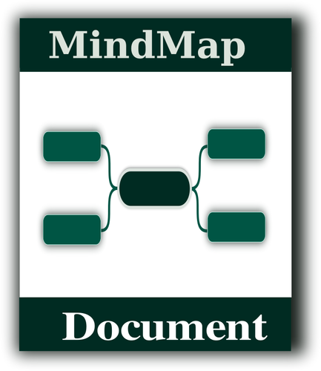
Figure 1: Example of how Mind Map works

Blogs: Blogs are another powerful tool for healthcare professionals. They allow healthcare providers to share their experiences, perspectives, and knowledge with a wider audience (Greenhalgh and Papoutsi, 2018). This can help to foster collaboration and spark new ideas, as well as provide patients and their families with valuable information and support. With the help of blogs, healthcare professionals will be able to expand my reach globally and affect the health care system on a larger scale.
Flyers: Flyers are a useful tool for healthcare professionals to communicate important information about health and social care services (Al Bardaweel and Dashash, 2018). By creating visually engaging flyers, healthcare providers can increase awareness of available services, promote health and wellness, and encourage patients to take a more active role in their care.
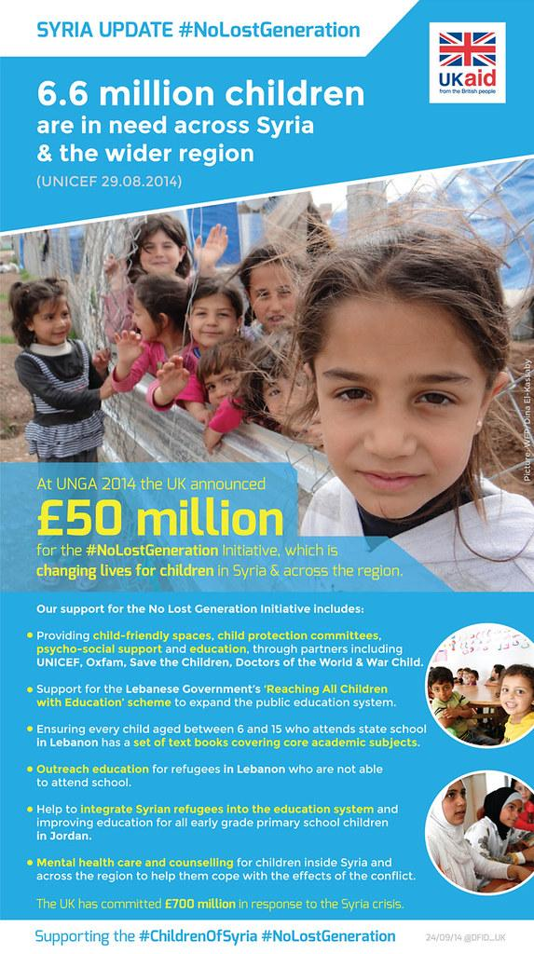
Figure 2: Flyer spreading awareness about Child Health victims in Syria

Conference Posters: Conference posters are an effective way for healthcare professionals to showcase their research and share their findings with others. By presenting research at conferences, healthcare providers can receive feedback, gain new insights, and build connections with other professionals in their field.
Overall, mind maps, blogs, flyers, and conference posters are all valuable tools that can help foster creativity and value creation in the health and social care profession. By leveraging these tools, healthcare professionals can better communicate their ideas, engage with others, and ultimately improve outcomes for patients.

Conclusion
Overall, my experience has helped me to appreciate the role that creativity and value creation play in the Health and Social care profession. Moving forward, I am committed to continuing my learning and applying these concepts in my work to improve patient care and healthcare outcomes. I have concluded that by recognising the importance of being open-minded, flexible, and willing to try new approaches in the Health and social care profession one can develop their skills and further push for advancements in the field. I have also recognized the significance of collaboration and teamwork in fostering creativity and innovation in healthcare. I have also come to appreciate the role that value-based care plays in the Health and Social care profession. I am committed to continuing my personal and professional development to enhance my knowledge and critical understanding of these important concepts, and to make a positive impact on the lives of those around me.

Action Plan - CPD Plan
What skill do I want/need to learn? | Why do I want to learn? | What will I do to learn/achieve? | What specific resources or support will I need to learn? | What will be my success criteria? | The target day for compilation
I must involve myself with the Healthcare workers completely. | Being close to them will help me better operate. | Interacting with them on a regular basis, whether online or offline, will help me get new ideas. | Developing conversation skills is a vital component here. | Observing myself every day while interacting with the workers will help me. | 2-3 months
Building an agile mindset in being creative | Create an impact on healthcare services on ab global scale | I must understand how being creative works and the positives of this aspect by researching. | By properly studying the dynamics of various healthcare institutions, I can achieve this. | By keeping an eye on how I apply these strategies, I can track my success. | 2-3 months
I must learn how to use value creation in order to successfully manage the streamlining and workflow process. | This skill will be beneficial, as I will be able to provide accurate information to the healthcare services and also provide my value. | I must cope with the new trends to make the services more reliable. Getting the essential guidance regarding technologies will help me upgrade my skills. | Many online Resources can help me get the proper guidance. | Checking my Overall improvement on a day to day basis will help me assess where I stand in my achievement. | 3 months

Conclusion
Together, creativity and value creation have a profound impact on the Health and Social care profession. They can also reduce healthcare costs, which can improve access to care and make healthcare more affordable for everyone. Overall, creativity and value creation are critical to the success of the Health and Social care profession and play a vital role in improving the health of individuals and communities. The Health and Social care profession requires constant innovation to address the ever-changing needs of patients and communities. Creativity can be used to design and implement value-based care programs that improve the health of the population, enhance patient outcomes, and reduce costs. This can include using creative approaches to deliver health information, developing interactive programs that encourage healthy behaviours, or designing innovative ways to deliver preventive care. In conclusion, creativity and value creation are essential components of the Health and Social care profession. They can be used to address the evolving needs of patients, improve the quality of care, enhance the patient experience, and ultimately contribute to the common good.

Reference
Al Bardaweel, S. and Dashash, M., 2018. E-learning or educational leaflet: does it make a difference in oral health promotion? A clustered randomized trial. BMC Oral Health, 18(1), pp.1-8.
Buzan, T., 2018. Mind map mastery: The complete guide to learning and using the most powerful thinking tool in the universe. Watkins Media Limited.
Flemig, S.S. and Osborne, S., 2019. The dynamics of co-production in the context of social care personalisation: Testing theory and practice in a Scottish context. Journal of Social Policy, 48(4), pp.671-697.
Greenhalgh, T. and Papoutsi, C., 2018. Studying complexity in health services research: desperately seeking an overdue paradigm shift. BMC medicine, 16, pp.1-6.
Greenhalgh, T., Jackson, C., Shaw, S. and Janamian, T., 2016. Achieving research impact through co‐creation in community‐based health services: literature review and case study. The Milbank Quarterly, 94(2), pp.392-429.
Johnson, J.K., Margolis, P.A., Seid, M., Höglund, P. and Batalden, P.B., 2020. Networked health care: rethinking value creation in learning health care systems (Vol. 4, No. 2, p. e10212).
McCartney, G., Escobar, O. and Collins, C., 2021. Health inequalities, fundamental causes and power: towards the practice of good theory. Sociology of health & illness, 43(1), pp.20-39.
Teisberg, E., Wallace, S. and O’Hara, S., 2020. Defining and implementing value-based health care: a strategic framework. Academic Medicine, 95(5), p.682.
Weintraub, P. and McKee, M., 2019. Leadership for innovation in healthcare: an exploration. International journal of health policy and management, 8(3), p.138.

