Introduction to modern workplace
Title: Evaluating the Structure and Culture of Syngenta
LCBB4003-Gregory Cowan
Radu Claudiu Pintea-1921951

Contents
Introduction 3
Structure 4
Functional structure 6
Geographic structure 7
Product structure 8
Human resource department of Syngenta 8
Culture 9
Organisational performance 11
Conclusion 13
Reference 13

Introduction
Syngenta is the agrochemical business organisation that innovate herbicide, insecticide and seeds to sustain the business and entering in new markets. The organisation innovate and research on the organisational culture and structure to distribute the powers and authority as well as information to increase the ability of the company to cope with the situation. Syngenta aims to collaborative and cooperative teams among the employees for building the trust and motivation to quality of production in the agro-chemical industry. The plan of the Syngenta is the good growth which ensures the suitability in the third world country as well as to provide the service to the first world for making the innovative technology (William, 2020). Knowing about the organisational culture helps the Syngenta to learn about thinking, beliefs and customs of the consumer as well as the internal organisational culture for making better product and service.

Structure
The organisational structure is the functional activities and distribution of the roles and responsibilities to the function of the company. The organisational structure provides the guideline to make understanding of the framework to distribute the work among the hierarchy of the systems. The good organisational structure, the organisation minimize the conflicts among the employees which helps to improve the motivation and innovation in the organisation. Syngenta is the multinational agro-food company based on Switzerland and its employees are about 24000 around 90 countries which has the complex structure that needs to minimize the complexities in the company and helps to improve the business condition by the organisational structure (Armstrong and Taylor,2017). The company apply the hierarchical organisational structure in which the organisational function like global supply chain, HR, sales and marketing, finance and information systems are divided the work follow of the company and improve the strength f innovation around the world. The consumers of the Syngenta is both government and farmer because of the innovative product and service which increase the production of crops and reduce the pesticide in the fields.
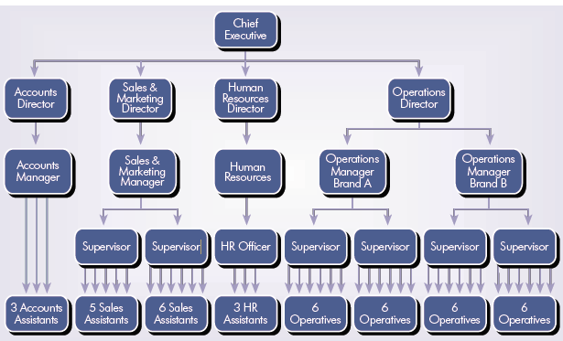
Figure; organisational structure of Syngenta (William, 2020)
Syngenta company follow the hierarchical organisational structure which helps the company to follow the information from the lower level to the upper level and decision distribute from a higher level to lower level of the hierarchy. For example, the sales and marketing direction of Syngenta set a mission of improving sales at 20 per cent at the year of 2021 where sales and marketing manager, supervisors and sales assistant combine work to achieve the departmental mission of the company. Research and development function of the organisation investment billions of dollars for inventing new crops and how to innovate the hybrid product and increase the productivity in the agro product. The global supply chain is the strong strength of Syngenta because it establishes a strong capability to make sure of reach to the consumers with innovative product and service especially the agro-based products. In the organisational function of Syngenta, the company focus on empowering of employees and enhance the motivation of the employee by increasing the incentive to continue business and ability to sustain in the markets (Huczynski, 2013). The competitors of Syngenta are Monsanto Company, Bayer CropScience and BASF which ensure the homogenous product and also focus on the innovation and cooperation among the employees. Structure of Syngenta ensures to make better communication and strong supply chain among the employees which helps to develop the product and service to the consumers.

Functional structure
Functional structure of Syngenta consists of function human resource, research and development, global supply chain and sales and marketing which helps the company to distribute the functional task among the organisation. The skills and competencies of the Syngenta based on the development of the organisational function and complexities and improve the strength to with competitors.

Figure: marketing function of Syngenta (Author)
The marketing and sales department of the organisation is the important function from collect the information of the consumers and market segmentation to sales the product and collect the money. The sales department is the only department which supports the organisation financially and other function can consume this money. The sub-function of the marketing and sales department is the order collection from the consumers either government or the dealers, marketing and selling operation which supply the ordered products. All of this sub-function, the marketing and selling relationship is important because it directly communicates with the consumers and knows about the requirement of their product and the sectors where the company need to develop (Jacobides, 2020).

Geographic structure
Syngenta is the multinational agro product company which ensure the product around the world and its country of operation is 90 countries. So the company has a strong geographic structure to communicate with various types of function and capabilities of the organisation. The geographic structure is types of organisational structure where the company connect various type of the employees and the function within the geographic areas to fulfil the mission and vision of the organisation (tutor2u, 2020).
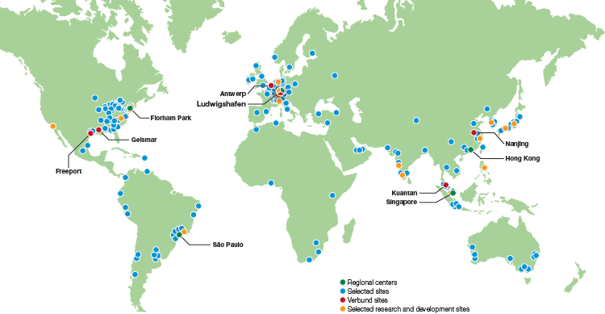
Figure; Regional structure of Syngenta (Grey, 2020)
The geographic structure helps the company to diversify the organisation based on the culture, region, belief and thinking of the consumers. Each region works as an independent organisation and helps to identify the strength and weakness in the regional activities to perform. The organisational development of a company largely based on the proper regional performance and its better communication with headquarters.

Product structure
Syngenta produces a range of product and supply this around the world and it improves the business activities and allows them to make better performance of the organisation. The range of product and service based on the development of the organisation and helps to improve the items of product and service.

Figure: Product variants of Syngenta (author)
The structure of the product especially on the three types that are herbicide which is the process of controlling unwanted plants in the fields. Before the invention of various types of herbicide by the Syngenta, the farmer is facing challenges of producing a large number of unwanted plants. Syngenta develops chemical to stop the unwanted plant from the filed easily. The insecticide is the chemical product that kills the insects from the fields and improves the growth of the plants and produces a large number of crops in the house. Another important product of Syngenta is the seed that increases the productivity in producing the crops of the farmers.

Human resource department of Syngenta
The employee of the organisation is an important resource that helps the company to compete with strong competitors and sustain in the pesticide and insecticide markets a long time and helps to improve the condition of the organisation. Syngenta is the leading agricultural innovation n and Technology Company with 4800 employees and working more than 100 countries and providing the service of agri-business. The company ensure the motivating employability skills for the employees and provide diversify employees to the company that helps to grow the company and improve the business. The annual sales of Syngenta are 23 billion dollars that come from the motivational employees and innovation of the company. The research and development wings of the company innovate pesticide and herbicide for capture the market and sustain in the leadership in the company and improve the ability of the company to make more amount of profits. The organisational structure helps to retain the employees and motivate the staff for building proper relationship among the employees and increase the quality of the product (Boddy, 2011).

Culture
Culture means long time thinking, belief, customs and religions of the country in which the organisation need to continue the business and maximize the profits as well as to fulfil the mission and vision within the organisation. Culture largely impact on the business and helps to continue the motivational program in that country. The culture helps to identify the strength and weakness in running the business to that cultural prospect and helps to improve the ability of the company. Culture differs from the condition of the business because it changes the behaviours of the consumers and employees to communicate with them. The cultural difference based on the development of the organisation and increase the motivation of the employees to meet the goals of the company. Hofstede’s cultural dimension has six dimensions which increase the ability of Syngenta to monitors and develop the cultural dimension of the organisation. The Hofstede dimension of culture affects the thinking and behaviours of the consumers who are working in the organisation and helps to develop the product and service.
Cultural dimension | The score obtained by Tesco | UK Country Comparison | Explanation
Power distance | 40/100 | 53/100 |  | The power distance of Syngenta is high as the company use a matrix organisational structure to distribute the authority and power among the employees.
Uncertainty avoidance | 45/100 | 48/100 |  | The company spends billions of dollar for research and development which is the high capabilities of taking a risk.
Individualism/collectivism | 30/1000 | 85/100 |  | The collective interest increases the performance and innovation of the company for building the quality of product and service. Syngenta follows the collective interest to gain the objective and mission of the company.
Masculinity/femininity | 18/100 | 56/100 |  | The femininity dimension of the organisation is the modesty, cooperation and collaboration and Syngenta follow the dimension femininity around the world.
Short term/Long term | 59/100 | 81/100 |  | The long term orientation of the company based on the development and increase the ability to continually upgrade.
Figure: Hofstede cultural dimension at Syngenta
The cultural difference of the organisation can be predicted by the Hofstede organisational dimension and its components of the organisation and increase the productivity of the company by coping with the cultural dimension of the company. The power distance dimension of the Hofstede based on the distribution of the powers. The Syngenta distribute unequal powers among the employees based on the hierarchy of the company. In the matrix organisational culture, the distribution of the powers can be unequal and employee face challenges in the cultural barriers. In the individual VS collectivism organisational dimension, the company based on the collective interest and collective development of the employees as Syngenta improve the business by developing innovation collectively. Masculinity VS femininity is a cultural dimension where the organisation based on the femininity where the company follow modesty, caring and cooperation on the development of Syngenta. Uncertainty avoidance the organisational thinking on the uncertainty and quality of product and service based on the certain ability and modify the organisation. The score of the Syngenta in the uncertainty where the company accepts uncertain risk and unpredictable situation.

Organisational performance
The performance of the organisation largely based on the organisational structure and culture that accelerate the development of the organisation and helps to improve the business. The performance of the organisation is the output of the organisation regarding the input and helps to identify the performance and productivity by the organisational structure and organisational culture. The effectiveness and efficiency is the precondition of the organisational performance which comes from the organisational structure and establishing beliefs, thinking and motivation of the employees. The matrix organisational structure is the two ways of communication from the regional managers and functional manager who cooperates tighter to fulfil the mission, vision and objectives of the organisation. Three ways of the organisational performance are the financial performance, market performance and shareholders values to the organisational development. The financial performance of Syngenta is very high as the company innovate various kinds of pesticide and herbicide for making the development of the organisation. Syngenta is the market leaders with their innovative products that help more production in the farmer.
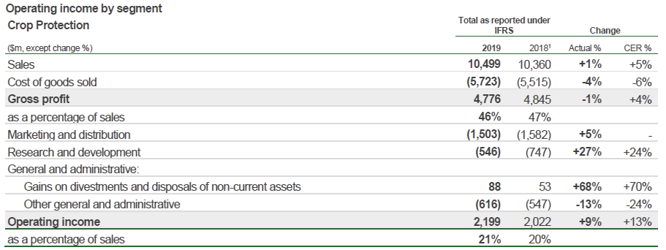
Figure: Operating income Crop protection Syngenta (William, 2020)
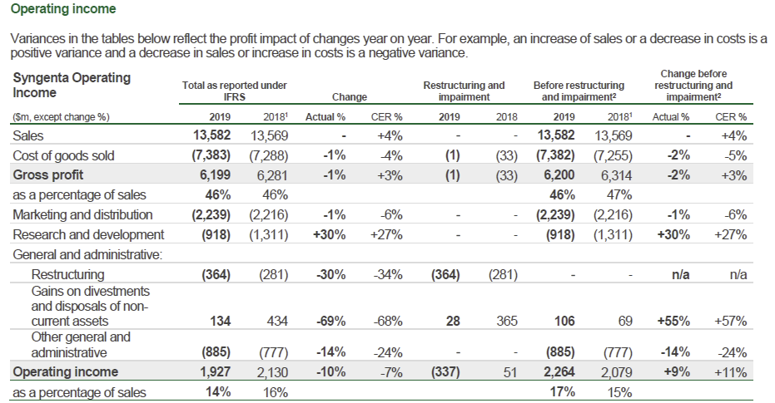
Figure: Comparison of operating income Syngenta (William, 2020)
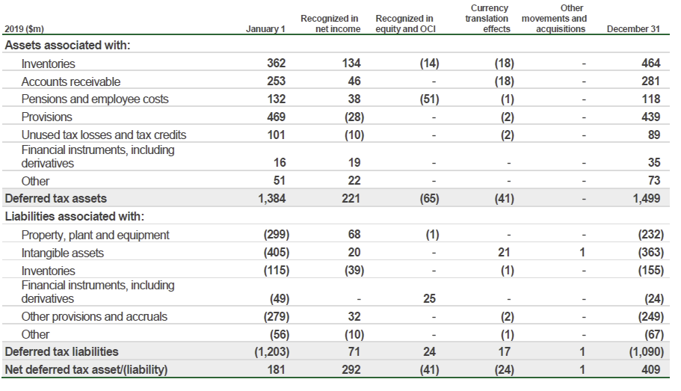
Figure: Net assets and tax of Syngenta (William, 2020)

Conclusion
After a discussion about organisational culture and structure of Syngenta, there is a large number of relationship with the performance of the organisation. If the organisation culture and structure are friendlier and innovate the organisation faces productivity and efficiency in the market leaderships. Syngenta uses a matrix organisational structure which creates a relationship between regional manager and functional manager for communication and flowing information upper to lower level. The performance of the company based on the cultural dimension and structural development of the company that improves the ability of the company to sustainability and continuation of the business.

Reference
Mullins, L, 2016 Management and Organisational Behaviour 11th Edition, Pearson.
Armstrong, M., Taylor, S., 2017 Armstrong's Handbook of Human Resource Management Practice, 14th Edition, Kogan Page.
Huczynski, A., Buchanan, D 2013Organisational Behaviour (8th edition) Harlow: Pearson

Jacobides, M. 2020. The Nature of Managerial Work - Thinkers 50. [online] Thinkers 50. Available at: https://thinkers50.com/blog/the-nature-of-managerial-work/ [Accessed 18 August, 2020].
tutor2u 2020. Organisational Culture (Overview). [online] YouTube. Available at: https://www.youtube.com/watch?v=MfL_0ko4T3o [Accessed 18 August, 2020].
Grey, C 2020A Very Short, Fairly Interesting and Reasonably Cheap Book about Studying Organisations (4th edition) London: Sage

Boddy, D., 2011Management: An Introduction (5th edition) Harlow: Pearson

Woods, M.2017. Linking risk management to strategic controls: a case study of Tesco plc. International Journal of Risk Assessment and Management, 7(8), p.1074.
Yuliarini, S. 2016. Remuneration and Management Behavior Evaluation: A Critical Review. Archives of Business Research, 4(6).
William, f, 2020. The financial data of Syngenta. Available at https://www.syngenta.com ( Accessed at 18 august, 2020).

