

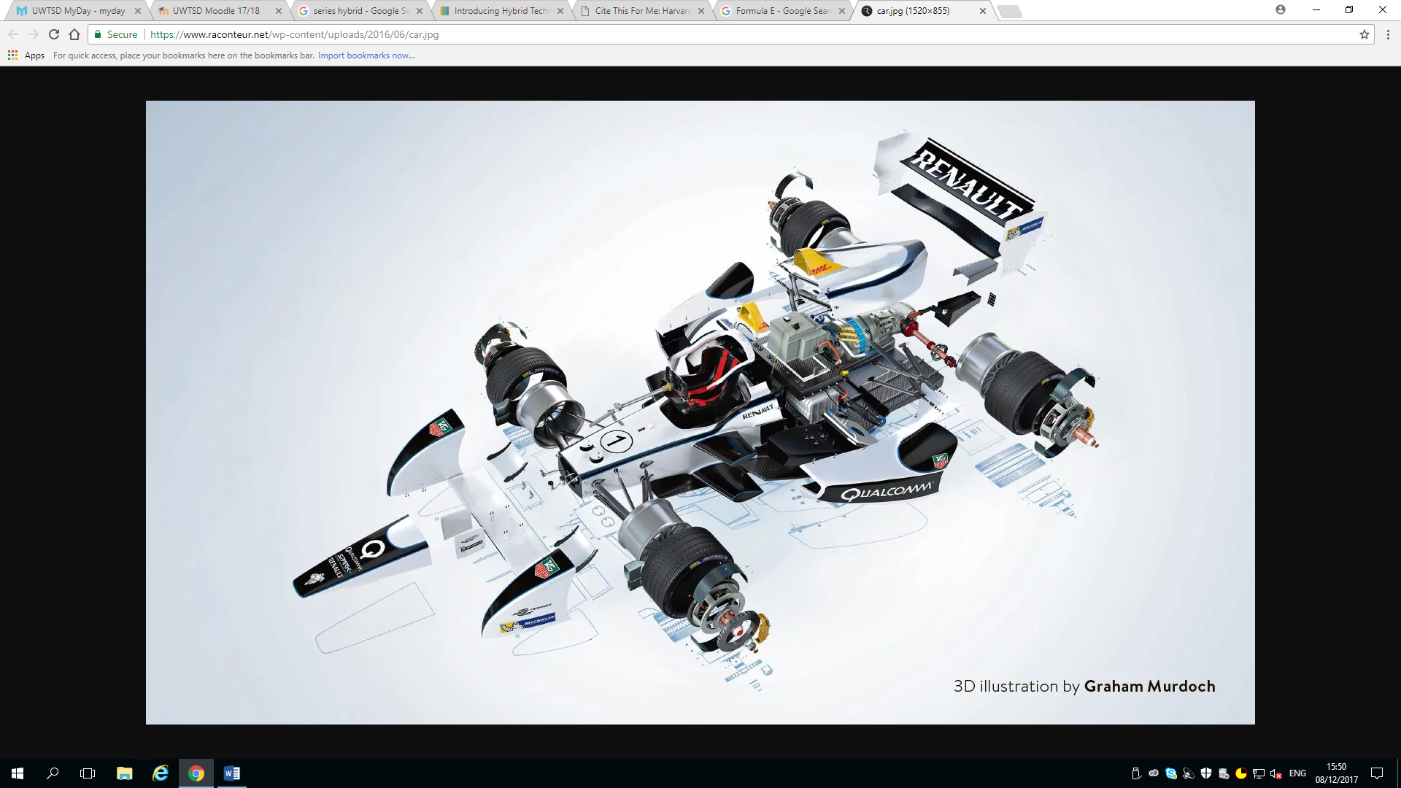
Figure 1; 3D illustration of the internal components of a Formula E car. (Murdoch, 2016)

Sustainability through Technology (M3X9483)
Feasibility study of Electric vehicles to reduce carbon impact.
BSc Motorsport Engineering
2017/2018
Luke Atkinson P146166

Abstract.

The motorsport industry has always been famed for being leaders of technology in the automotive industry. Most automotive technological advancements began their life in motorsport. The FIA commissioned a sport entitled Formula E in 2014 to try and tackle the global issue of rising CO2 levels. Formula E alongside other motorsport categories have been investigating the short, medium and long term implications of the implementation of renewable energy within motorsport. Is it cost effective and can it aid in the lowering of CO2 emissions.

The lowering of CO2 emissions will have a great effect on the planet. Lower CO2 emissions will bring more improved health in countries such as China where CO2 emissions are so high that some cities are covered in a thick layer of smog. The techniques used by the motorsport industry to reduce its carbon footprint can be transferred to the automotive industry which will affect the world.

Table of contents.
Abstract. 2
Table of contents. 3
List of Figures 4
1. Introduction. 5
2. Literature Review. 6
2.1. Electric Vehicles (EV). 6
2.2. Hybrid Vehicles. 7
3. Discussion. 8
3.1. Formula E. 8
3.2. E-Karting. 11
3.3. World Endurance Championship. 11
3.4. Cost. 12
4. Conclusion. 13
5. References. 14
6. Bibliography. 16

List of Figures

Figure 1; 3D illustration of the internal components of a Formula E car. (Murdoch, 2016) 1
Figure 2; Image illustrating the difference between parallel and series hybrid. (altenergymag.com, 2017) 7
Figure 3; Image of the updated Williams power unit. (Foumula E, 2017). 8
Figure 4; Image illustrating formula E power unit progress. (Mexperts, 2017) 9
Figure 5; Image of an E kart. (ElectricAutosport.com,2016) 11
Figure 6; graph illustrating price of hybrid vehicle battery packs. (Energy.gov, 2017) 12

Introduction.

Modern motor racing relies heavily on fossil fuels such a gasoline. Some categories allow for, and encourage, the use of diesel internal combustion engines but is this what the future holds for motor racing? Motor racing has moved forward with Formula 1 recently downsizing its engines in 2014 to 1.6L V6 Turbocharged engines. The loss of power has been replaced with two electric motor generator units. One entitled the MGU-H (Motor Generator Unit – Heat) converts the thermal energy from the exhaust into electrical energy and the other entitled the MGU-K (Motor Generator Unit – Kinetic) converts the kinetic energy usually lost from the flywheel and braking into electrical energy. (Formula 1, 2017)

This approach from the FIA is interesting because formula one has always been the pinnacle of motorsport which demonstrates that the FIA is interested in sustainability. The reduction in engine size brings a reduction in CO2 emissions but it is not enough for only formula one to implement these changes. The FIA has also introduced a fully electric series entitled Formula E, it is in essence electrically powered formula one cars. This backs up the statement of intent by the FIA to become more global friendly towards emissions.

Many motorsport categories have downsized their engines before, including formula one, but this is the first time it has been done solely to combat rising CO2 emissions. The rise of electrically enhanced vehicles has been outstanding. As is often the way in the automotive industry, technology filters down from motorsport.

This technical paper will analyse the short, medium and long term implications of the implementation of a large scale change the using renewable energy within the motorsport industry. The paper will look in the foundations of Formula E, Karting and the world endurance championship and comment on how these categories are implementing renewable energy and reducing CO2 emissions.

Literature Review.

Electric Vehicles (EV).

Electric vehicles are essentially vehicle shells containing an electrical energy source such, most typically a battery pack. The battery pack is usually connected to an electric motor through a controller. The motor is coupled to the driven wheels through transmission, sometimes a gear reduction system. (Brown and Hall, 1982)

Some advantages of electric vehicles are; Electric drive motors run quieter than internal-combustion engines. The noise emissions from electric vehicles is very low. At high speeds, the rolling noise from the tires is the loudest sound. Electric vehicles produce no harmful emissions or greenhouse gases while driving. If the high-voltage battery is charged from renewable energy sources, an electric vehicle can be run CO2-free. The electric drive motor is very robust and requires little maintenance. It is only subject to minor mechanical wear. Electric drive motors have a high degree of efficiency of up to 96% compared with internal-combustion engines that have an efficiency of 35–40% and the high-voltage battery can be charged at home, in a car park and by using any accessible sockets. The blue charging connector on the vehicle and on public charging stations has been standardized across Germany and is used by all manufacturers.

Electric vehicles do have disadvantages however. Electric vehicles have a limited range due to battery size and construction. Charging a high voltage battery can take a long time, depending on the battery charge and power source. The network of electric charging stations is sparse. If the destination is beyond the range of the electric vehicle, the driver will need to plan the journey. “Where can I charge my electric vehicle on the road?” (Volkswagen, 2013)

The most common and iconic electrical vehicle brand is Tesla. “Tesla was founded in 2003 by a group of engineers who wanted to prove that people didn’t need to compromise to drive electric – that electric vehicles can be better, quicker and more fun to drive than gasoline cars. Today, Tesla builds not only all-electric vehicles but also infinitely scalable clean energy generation and storage products. Tesla believes the faster the world stops relying on fossil fuels and moves towards a zero-emission future, the better.” (Tesla.com, 2017)

Hybrid Vehicles.

Hybrid vehicles are usually designed in three different driveline options. The first is the series hybrid, often referred to as a ‘plugin hybrid’. An electrical motor drives the wheels and the engine, usually and internal combustion engine (ICE) powers a generator which recharges the batteries and supplies energy to power the vehicle when the batteries are depleted past a specified level. Example; BMW i8.

The second option is the parallel hybrid. A parallel hybrid uses and electric motor and ICE to provide torque to the wheels either separately or together. The motor can be used to generate power to recharge the batteries, this feature is used when the ICE is producing enough power to propel the vehicle. Example; McLaren P1.

The third option is the split hybrid. The split hybrid uses electrical motors to drive the front wheels. The rear wheels are driven by the ICE. Example; Honda NSX. (Burke, 1992)

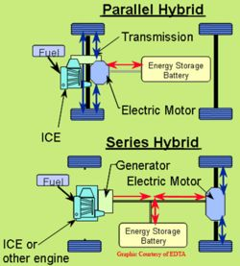
Figure 2; Image illustrating the difference between parallel and series hybrid. (altenergymag.com, 2017)

Discussion.

Formula E.

The governing body of motorsport the FIA has a keen interest in making motorsport more ‘green’. So much so that current Formula 1 engine regulations limit teams to a 1.6L V6 turbo hybrid unit, down from a 3.8L V8 naturally aspirated engine. The fuel flow is limited to 100 Kg/hour. (Formula 1, 2017) But is the reduction in engine size and implementation of electrical energy enough?

In 2014 the FIA began a new single seater series called Formula E. It is essentially Formula 1 but with electric powered vehicles, or is it? Formula E is the first electrical street racing series. Formula E is fighting climate change by offering electric vehicles as a solution to air pollution in city centres and breaking down the barriers to the electric vehicle market: Technology, Perception and Infrastructure. Formula E provides developers in and out of motorsport a test bed to address environmental issues.

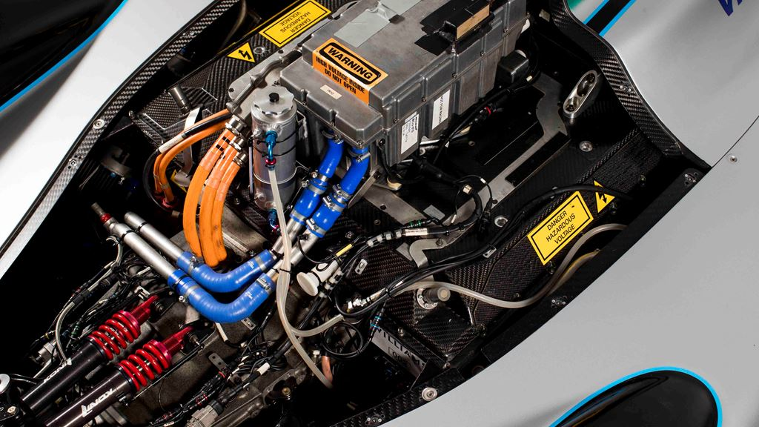
Figure 3; Image of the updated Williams power unit. (Foumula E, 2017).

The concept of sustainability for Formula E is to reduce the carbon footprint as much as possible and to have a positive impact on both people and the planet. Formula E does this under the following points;
Energy: Cars have virtually zero emission and 100% renewable fuel from revolutionary Formula E Glycerine Generators.
Tyres: Unique tyres are hybrids specially designed by Michelin, suitable for all weather conditions, last the entire race, and are all recycled at the end of the day!
Tracks: Formula E is the city street racing series, racing on temporary tracks in the hearts of some of the coolest cities in the world such as Mexico, Paris, Berlin, Montreal and NYC.
Spectators: Formula E brings the race to our fans in city centres to encourage the use of public transports.
Calendar: The race map has been designed to have a cluster approach region by region to optimise freight in order to use more boat or road freight and less place.
Clean: Formula E is supporting the transition to low carbon economies, societies and transportation through the advocacy of clean fuels. Formula E cars are charged by a 0% emission and 100% renewable glycerine fuel and are committed to RE100, powering the races with 100% renewable energy by season 5.

Life Cycle Assessment (LCA) is at the forefront of sustainable studies. It takes a holistic view of the production, running and the end of life of the event and assesses its impact.

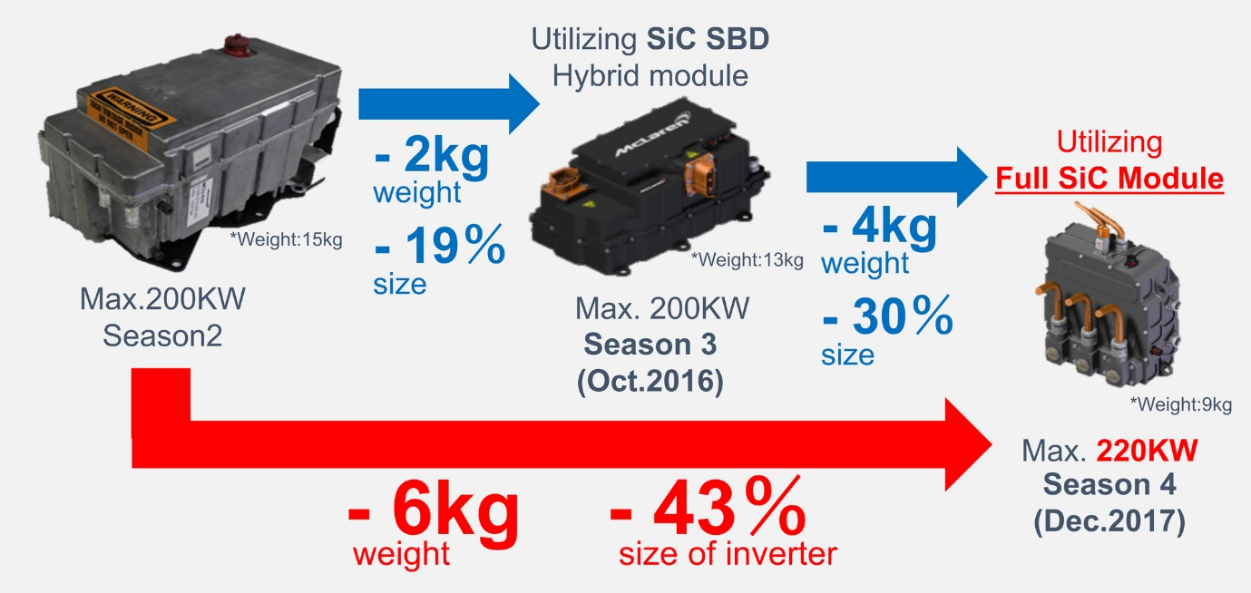
Figure 4; Image illustrating formula E power unit progress. (Mexperts, 2017)

In its first season Formula E’s footprint was estimated at 25,000t CO2-eq. To put that in perspective, this number equals:
- 110 flights from London to Chicago with 320 passengers aboard
- The electric consumption of 11,000 UK households per annum
- 3,400 trips around the Earth by Car

This was reduced dramatically, over 50%, for the second season of Formula E. In season 2, our footprint has been calculated at 12,000 tCO2-eq. This number is equivalent to:
- 60 transatlantic flights from Paris to New York with 320 passengers aboard
- The electricity consumption of 7,900 UK households
- 1,600 trips around the earth by car. This is a significant decrease in our footprint from season 1

Formula E can significantly contribute to remove electric vehicle market barriers and to create positive externalities and value for society over the next 25 years:
- 57-77M additional EVs sold around the world over the next 25 years
- 900M tonnes of CO2 avoided – the equivalent of Italy’s annual emissions over 2 years
- 25BN€ of savings on healthcare costs and productivity from pollution reduction.

Formula E is having an effect on the planet. The registration of electric vehicles (EV) rose by 70% between the years of 2014 and 2015 with over 1.26 million electric vehicles on the road at the end of 2015. (Formula E, 2017)

E-Karting.

In 2016 the FIA unveiled a new karting series, E-Karting. Electronic go karts are not new with a lot of go kart tracks across the UK using them instead of petrol powered karts. An electronic kart racing series is new. The FIA has teamed up with German motorsport association DMSB, Bosch Motorsport that provided the electric powertrain and Mach1 as chassis supplier.
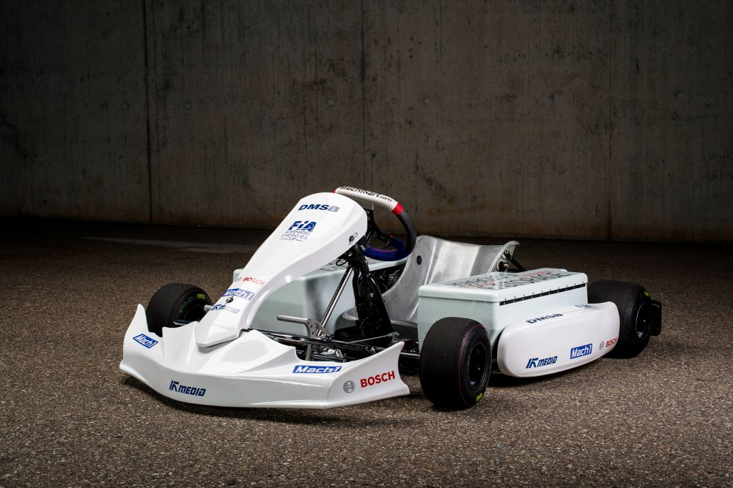
Figure 5; Image of an E kart. (ElectricAutosport.com,2016)
Two starter generators a used to deliver a 20kW of power. This is the basis of the powertrain which sends 300Nm of torque to the rear axle. The karts use a 48 volt lithium battery to store the energy. The starter generators can also recover energy like KERS system in F1. It uses a custom ECU to control energy flow throughout the kart. This electrical powertrain transforms the kart into a fully electric racer. (ElectricAutosport.com, 2016)

World Endurance Championship.

The world endurance championship has many categories. The LMP1 category allows for teams to use hybrid powered racers. Racers with no Energy Recovery Systems (ERS) are limited to 75 litres of fuel, racers with ERS are limited to 62.3 litres of petrol or 50.1 litres of diesel however. The world endurance championship does not race any fully electric racers however. (Fiawec.com, 2017)

Cost.

Can electric racing series really be cheaper to run than traditional racing series? In short yes, it can. Formula 1 has an estimated cost of $44 million for a small team such as the Sauber F1 team. Formula E on the other hand has a budget cap of $3.5 million. The reason for this massive gap in budget is because Formula E uses the same battery and chassis for every team. One disadvantage of having every team use the same battery is rate of development. If every team used their own battery, like F1 teams and engines, then the rate of development would increase due to teams attempting to gain an advantage. (CNN, 2016)

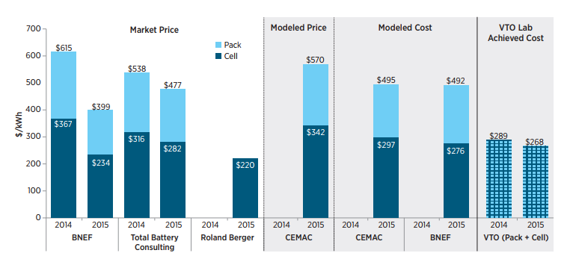
Figure 6; graph illustrating price of hybrid vehicle battery packs. (Energy.gov, 2017)

Conclusion.

To conclude, renewable energy such as electrical energy within motorsport is making its way to the forefront. Racing categories are becoming less strict on traditional power plants such as internal combustion engines and are allowing innovation for the future.

It is important for motorsport to pave the way for innovation. Innovative features in motorsport often tend to find their way into the automotive industry. A classic example being carbon fibre which first appeared on the 1981 McLaren MP4-1. Carbon fibre monocoques can now be found on various supercars such as the Porsche 918 Spyder and Carrera GT, Lamborghini Aventador, Ford GT and others. They are also found within the bodies of the BMW i3 and i8 electric vehicles. (Bonnici, 2017)

Formula E is the main focal point of electrical energy in motorsport and has many implications of its implementation. As mentioned Formula E reduced its own carbon footprint by over 50% in one year, this demonstrates that it is possible to reduce our own carbon footprint. Unfortunately at the present moment Formula E batteries can only last half race distance, which is around 50km, which is not good enough to compete with existing fuel alternatives. A new championship called the electric GT championship is quoting that their GT cars with 100 kWh Lithium-ion batteries can last 90km at racing speed. (Electric GT Championship, 2017)

Renewable energy racing series also have an ethical effect. Formula E has a target to reduce the number of incidents involving pollution. By the year 2042 it hopes to have saved €25bn in healthcare costs due to the reduction of emissions and pollution. E karting also helps towards this ethical goal of reducing emissions and pollution. Go karting is an extremely popular sport but indoor go karting can be harmful due to the emissions getting clogged in the building itself. By using electrical powered karts this can be avoided.

References.

- Murdoch, G. (2016). 3D illustration of the internal components of a Formula E car.. [image] Available at: https://www.raconteur.net/lifestyle/the-formula-e-car-broken-down

- Brown, P. and Hall, R. (1982). Safety Considerations for Electric and Hybrid Vehicles. SAE Technical Paper Series.

- Natef.org. (2013). Basics of Electric vehicles design and function. [online] Available at: http://www.natef.org/NATEF/media/NATEFMedia/VW%20Files/820233-Electric-Drives-7_9_2013_sm-(2).pdf

- Tesla.com. (2017). About Tesla | Tesla UK. [online] Available at: https://www.tesla.com/en_GB/about

- Burke, A. (1992). Hybrid/Electric Vehicle Design Options and Evaluations. SAE Technical Paper Series.

- altenergymag.com (2017). Image illustrating the difference between parallel and series hybrid. [image] Available at: https://www.altenergymag.com/articles/05.06.01/naftc/contents.html

- Formula 1® - The Official F1® Website. (2017). Power unit and ERS. [online] Available at: https://www.formula1.com/en/championship/inside-f1/rules-regs/Power_Unit_and_ERS.html

- Formula E (2017). Image of the updated Williams power unit. [image] Available at: http://www.fiaformulae.com/en/news/2017/april/insight-williams-updated-battery/

- Mexperts (2017). image illustrating formula E power unit progress. [image] Available at: http://www.presseagentur.com/rohm/detail.php?pr_id=4771&lang=en

- Formula E. (2017). Sustainability. [online] Available at: http://info.fiaformulae.com/sustainability

- ElectricAutosport.com. (2016). Is this the new electric kart for FIA eKarting Cup? - ElectricAutosport.com. [online] Available at: https://www.electricautosport.com/2016/05/new-electric-kart-fia-ekarting-cup/

- Fiawec.com. (2017). Classes - FIA World Endurance Championship. [online] Available at: http://www.fiawec.com/en/classes/32

- Sarah Holt, C. (2016). Do you know your Formula E from your Formula One? - CNN. [online] CNN. Available at: http://edition.cnn.com/2016/01/05/motorsport/formula-e-vs-formula-one-feature/index.html

- Energy.gov. (2017). Cite a Website - Cite This For Me. [online] Available at: https://energy.gov/sites/prod/files/2017/02/f34/67089%20EERE%20LIB%20cost%20vs%20price%20metrics%20r9.pdf

- Bonnici, D. (2017). Top 5 F1 innovations that made it to road cars. [online] WhichCar. Available at: https://www.whichcar.com.au/car-style/top-5-f1-innovations-that-made-it-to-road-cars

- Electric GT Championship. (2017). THE EGT CAR. [online] Available at: http://www.electricgt.co/egt-car/

Bibliography.

- Le Berr, F., Abdelli, A. and Benlamine, R. (2012). Sensitivity Study on the Design Methodology of an Electric Vehicle. SAE Technical Paper Series.

- Liddle, S. (1976). An Analytical Study of the Fuel Economy and Emissions of a Gas Turbine-Electric Hybrid Vehicle. SAE Technical Paper Series.

- Origuchi, M., Miyamoto, T., Horie, H. and Katayama, K. (1997). Development of a Lithium-ion Battery System for EVs. SAE Technical Paper Series.

- Boretti, A. (2011). Use of Bio-Ethanol and Bio-Diesel The Key Solution for a More Sustainable Road Transport. SAE Technical Paper Series.

- Veenstra, M. and Gearhart, C. (2012). A Pareto Frontier Analysis of Renewable-Energy Consumption, Range, and Cost for Hydrogen Fuel Cell vs. Battery Electric Vehicles. SAE International Journal of Alternative Powertrains.

- Hall, T. (2017). An Analysis of Braking Behavior in Formula-E® Racing. SAE Technical Paper Series.

- Joshi, A., Ezzat, H., Bucknor, N. and Verbrugge, M. (2011). Optimizing Battery Sizing and Vehicle Lightweighting for an Extended Range Electric Vehicle. SAE Technical Paper Series.

