Mathew Jones (2317425)
University of Wales Trinity Saint David
Network Operating Systems and Services - ACCA5023
Research, build, and deploy, a Virtualised network

Contents
Task 1 2
1.1 Research on Hypervisor 2
1.2 Research on IP Addressing 3
1.3. Research on Routing 4
1.4. Research on Network Services 5
Task 2 6
2.1 Choose your hypervisor: 6
2.2 Download and setup: 6
2.3 Configure IP addressing 8
2.4 Test and troubleshoot 10
Task 3 - Report reflection 13
References 14

Task 1

1.1 Research on Hypervisor
A hypervisor is a software which creates and runs virtual machines also known as VMs. It allows a host computer to support multiple guest VMs by sharing resources virtually. The resources that they share are memory and processing. There are many benefits to using this software such as greater cost and energy efficiency as you can run multiple virtual machines one device, speed is drastically improved as it makes providing resources simpler and finally you are able to use multiple operating systems on one server/host machine. The reason for this is due to the hypervisor running independent from the physical machine, this gives IT teams greater freedom to allocate networking, memory, storage and processing resources to different when needed.
There are two types of hypervisors, they are Type 1 and Type 2. Type 1 hypervisors also known as bare-metal or native hypervisor, do not require OS support and operates using the computer’s hardware. The type 2 hypervisor is known as the hosted hypervisor and operates on top of the user operating system. Additionally, it can use memory and CPU that is allocated by the user to function. [1] Two examples of Type 1 are VMware ESXi and XenServer. Type 2 examples are FreBSD’s, Oracle’s VirtualBox and VMware Workstation [2]. Below are examples of the architecture of a Type 1 and 2 hypervisor.

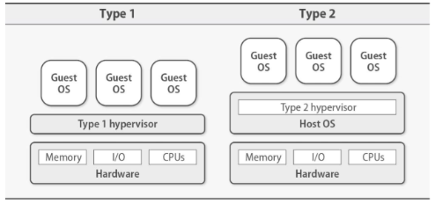

Type 1 and 2 hypervisors architecture [2]

Type 1 hypervisor:

Advantages | Disadvantages
Able to allocate resources to be quicker and more efficient. | Requires a higher level of knowledge.
Greater performance as no resource negotiation is required with the OS. | Updating and patching the VM OS is essential for security activity. This is not a major disadvantage but must be done.
Increase in security as there are no shared layers which gives it a higher degree of isolation,

Type 2 hypervisor:

Advantage | Disadvantages
Knowledge required is drastically lower. | Process is slower and less efficient.
Friendly for beginners using virtual machines. | Limited to resources the operating system can spare.
 | Less security.

Looking at the advantages and disadvantages of Type 1 and 2 hypervisors a user with a high degree of knowledge and a computer with the performance ability would be more inclined to use a Type 1 hypervisor. Using the same logic a user who is a novice with computing skills would have better luck using a Type 2 hypervisor.

1.2 Research on IP Addressing –

IP address also known as internet protocol address are the backbone of online communication and act as a home address for a device and just like a house address you require this to send mail or “data” to the desired location or even communicate. IP addresses either allow or block connection by using access control, security measures and firewall rules. There is also a unique address for every device known as Mac addresses, they identify where the device was manufactured and giving a specific number for the device. [3]
There are two types of IP addresses, they are IPv4 and IPv6. IPv4 or Internet protocol version 4 is the most used IP address and is represented like this “192.168.12.1” or another example is “172.16.26.57” it consists of 32 bits and has a number range of 0 to 255. IPv6 or Internet protocol version 6 is being used increasingly more and uses 128 bits and is displayed in a hexadecimal format. DCHP would automatically input this as someone would not remember all the numbers and letters as an example of one would be this “1536:0ab8:45n3:0000:0000:8f2a:0457:2743”. [4]
Data gets from one computer to another by a process called packet switching which transfers data over a network. The data is split into what is known as packets which is a bunch of 0s and 1s known as binary code and there is a maximum amount 1500 Bytes in a packet. This process is known as packetization of data. Within these packets is a header and footer. The header tells the user what kind of data is within the packet, where it’s originally from and where the target location is, this is known as the structure of the packet.
The packets travers a network by a process called dynamic path selection which is like how car would traverse a road rather than a train. A train would only have single track so if the track was blocked the train could not go to the desired location but just like a car when the path is blocked for the packets, the packets use a different path to ensure the data reaches it desired location. This increases the speed and robustness of data over the internet and different packets do not have to use the same path to get to the desired location. Additionally, when the packet data has reached its desired location, it will be reassembled back to its original form. [5]
Traffic though IP networks is clever as if a connection fails, data can travel a different route to its desired location. This works for individual network as well as the internet. Even if data is missing it can reference the other packets. Another message can be sent to try and send the data again which is called a redundancy. This process will take a few milliseconds. [6]

1.3. Research on Routing
There are two types of routing, and they are Static routing, which is manually configured in the routing table. Static routing has limited scope as staff will have to manually add new routes as they are fixed. In larger networks this can become complex and time consuming but can be a benefit if you have a smaller network as it is a lot simpler to implement. Additionally, static routing has the benefit of having higher security has no routing information is being shared on the network thus making it more secure. [7]

The final type is dynamic routing, this is automatically updated using protocols which updates the routing table based on what the network conditions are to find the most optimal path from one network device to another. This is called routing protocol and is extremely beneficial to larger companies as it increases scalability but does require larger amounts of resources and is less secure as routing information is being shared between routers. Additionally, it prevents human error as mistakes can be made when using static routing. [8]

There are three main types of routing protocols they are distance vector protocol, link state protocols and hybrid protocols. Distance vector routing protocol shares their routing tables with neighbour that are directly connected, and routes are chosen on a distance metric such as hop count. A few examples of DVRC are routing information protocol (RIP) and Interior gateway routing protocol (IGRP). The advantages of DVRC are that they are easier to configure, manage and has a lower CPU and memory usage. [9]

The second link state routing protocol or LSRP build a complete map of the network by transferring link state advertisements or LSAs with all routers in the area. To calculate the shortest path in the network, the routers run Dijkstra’s algorithm to do this. LSRP examples are open shortest path first or OSPF and intermediate system to intermediate system or IS-IS. The advantages of LSRP are it’s faster, more accurate as they use bandwidth and delay as metrics and are better in larger network. The disadvantages are increased complexity to set up, manage and requires more resources. [10]

The final is hybrid routing protocol, which is just a combination of the two, it uses DVP for route discovery and LSB for increase in efficiency of updates and scalability. Examples are Enhanced interior gateway routing protocol or EIGRP. The benefits are advantages are somewhere in between the other two. All of these are essential as a network communication failure will result in websites wait times to increase and websites could possibly crash if there are too many users. [11]

1.4. Research on Network Services

VPN

VPN also known as virtual private network protects your internet connection privacy online. They way it functions is by creating an encrypted tunnel for your data and hides your online identity by hiding your IP address. Additionally allowing your device to safely use public wi-fi where they are most at risk. [12]

DHCP

DHCP or Dynamic Host Configuration Protocol is a method of automatically assigning an IP address to any device on your network. It will automatically assign a new IP address even if the device moves to a new network. This makes work easier for network administrators as they will not have to manually input a new IP address every time. Additionally, it configures the DNS address, subnet mask and what gateway is required. [13]

Active Directory Domain Services

Active Directory Domain Services or ADDS stores and organises information about users, computers, printers and servers. It uses a hierarchical structure to make storing and managing data easier and is able to control and organise resources across a network. Additionally, it has built in security features such as sign in authentication and access controls. ADDS would be beneficial in a large or small network. [14]

Task 2

2.1 Choose your hypervisor:
I decided to choose Type 2 hypervisor as I have not used a virtual machine before and with my lack of experience it would make sense to attempt a type 2 first.

2.2 Download and setup:
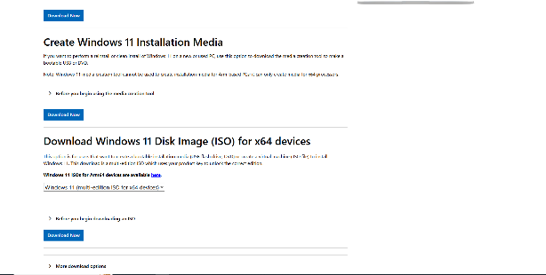
To begin work on a virtual machine you require an operating system, Windows and Debian were chosen and below are images showing this. For the Windows Server Windows 2022 was chosen and for the Client Windows 11 was chosen.

Download Windows 11 [15]
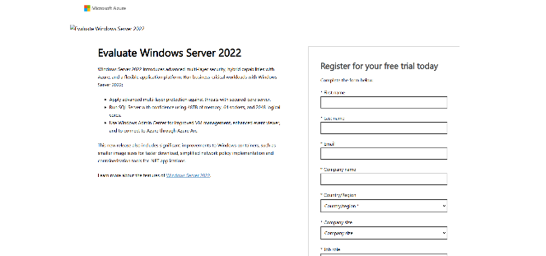

Download Windows 2022 [16]

Below are images showing the download process for the Windows and Linux operating system, during the configuration a few errors were made but they were easily rectified. The learning curve was felt quite high as there were many things I had never done before. Choosing to use a type 2 hypervsiror over a type 1 was a good I idea as I would have found it extremely difficult to get it functional.
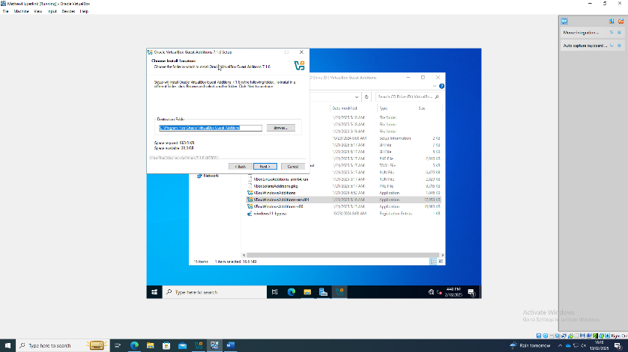

Image of setting up Virtual machine

Linux :-
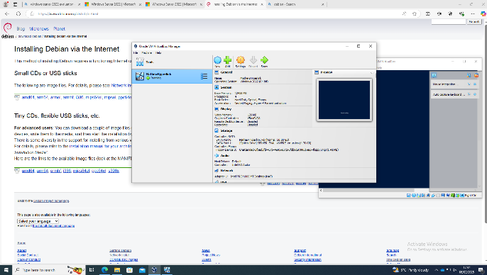

Downloading and setting up Debian [17]

Setting up Linux Server
This image shows the initialisation of the Linux Server. This includes using updating and installing commands in the command line. This took a bit of research of to work out what to do.
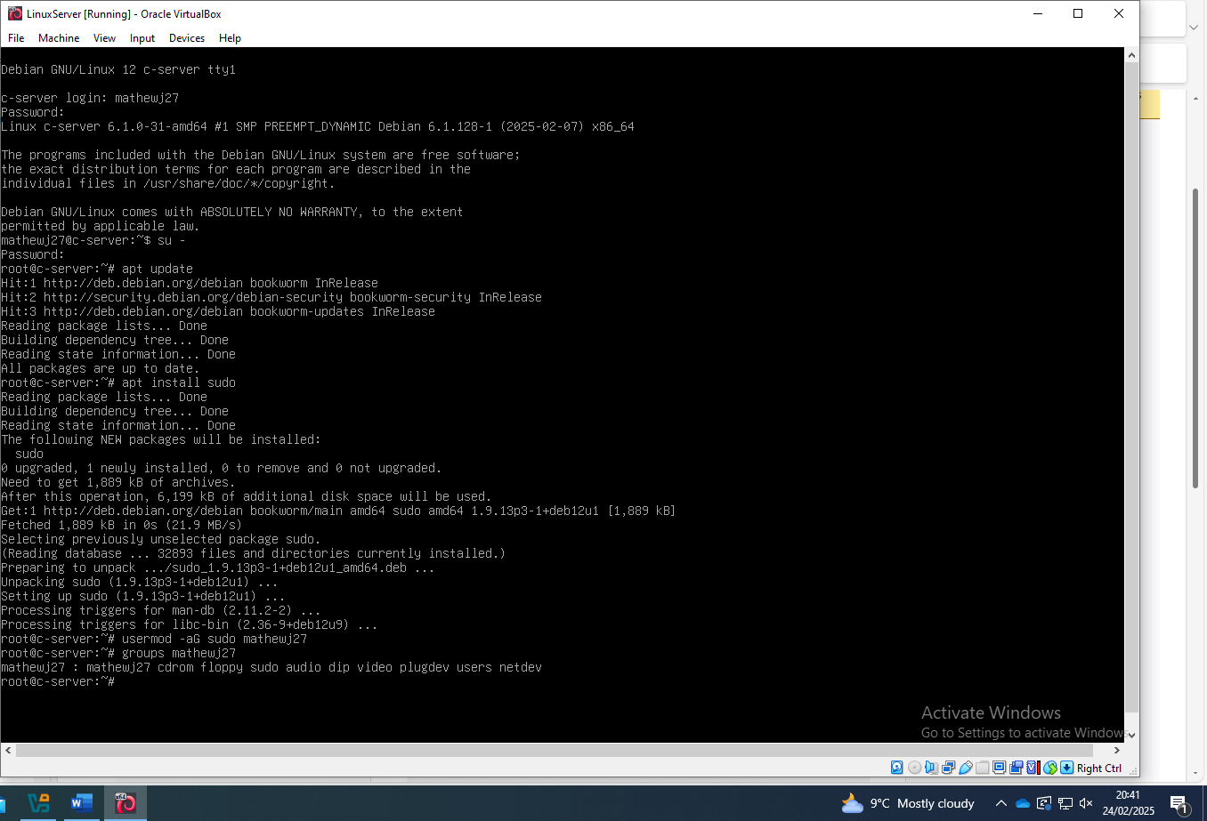

2.3 Configure IP addressing
In this section there will the be evidence of the configuration of the Windows Server, Client, Linux Server and Clients IP address and later on will be evidence of them succesfully pinging.

Windows Server IP address configuration
Below is evidence of the configuration of the Windows server static IP address. The IP address is 192.168.52.1 and the reason this has been used is due to uses in private and internal networks. This has the benefit for easier internal communication when it is in a network. Additionally at the end of the address 1 is used, the reason for this is it simplifies the network conifguaration and is common practice to use as a network gateway. [18]
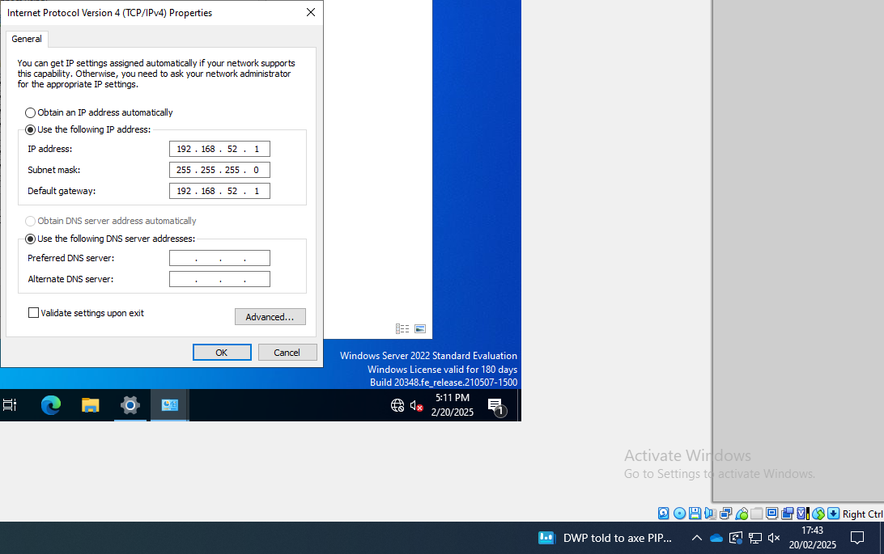

Windows Client IP address configuration
The configration of the Windows client IP address required the default gateway which is the Windows server IP address which is 192.168.52.1 and for simplicity the clients address 192.168.52.2.
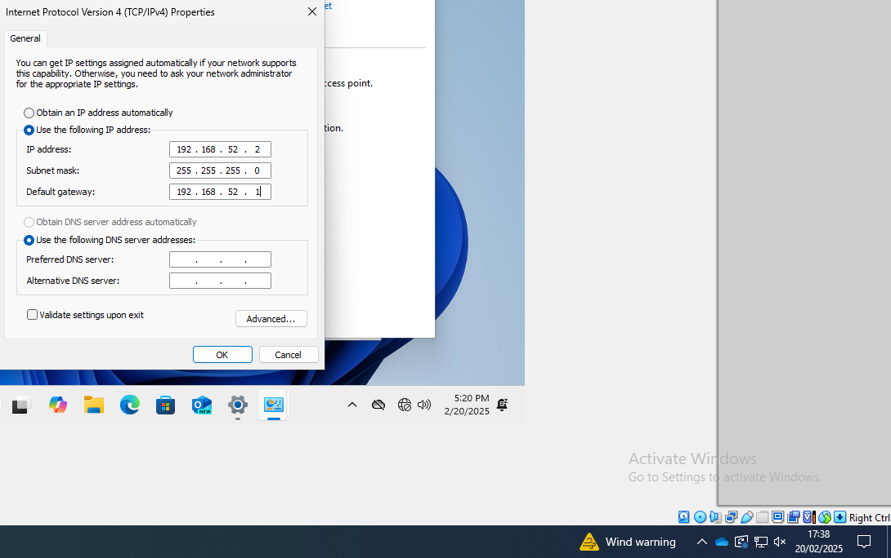

2.4 Test and troubleshoot
Showing Windows Server is unable to ping Windows Client
To confirm that that the Windows server and client are both connected there is a command called PING which sends a signal and if it receives a packet back then it is connected. Here the ping did not reach the desired location as on windows firewalls block them, so changes to the firewall rules was needed. There were a few options to do this such as turning off the firewall, but the decision was made to use commands:
- netsh advfirewall firewall add rule name=”Allow ICMPv4-In” protocol=icmpv4 dir=in action=allow
- netsh advfirewall firewall add rule name=”Allow ICMPv4-Out” protocol=icmpv4 dir=in action=allow
These two commands are used tom allow pings to enter and leave the firewall while it is still functioning.
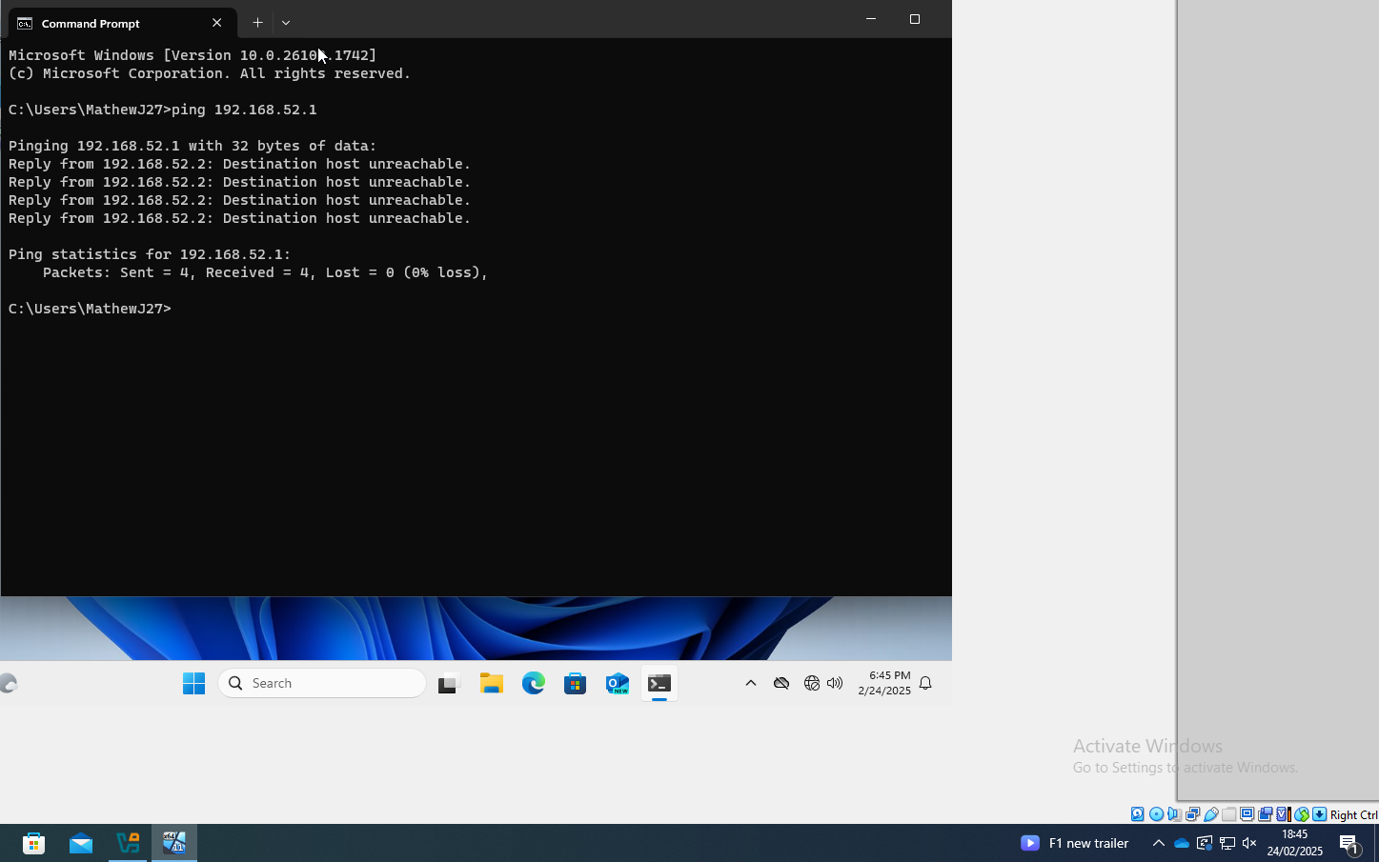

Evidence of command to allow pinging between Windows Server and Client
To enter these commands, you can use either PowerShell or command line, command line was used but you must have administrator rights to use this command. Below is evidence of the command being used.

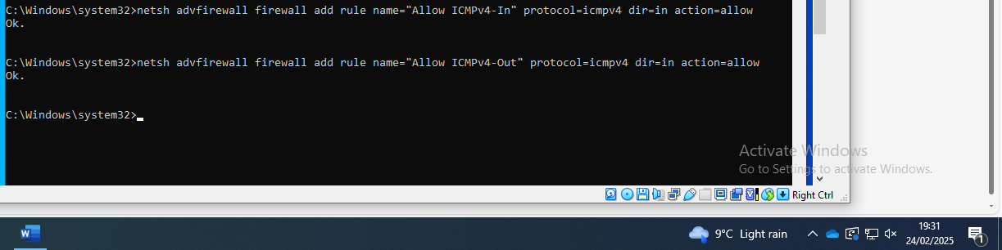

Windows Client successfully pinging Windows Server and vice versa
After allowing using the commands above the Windows server and client successfully pinged each other, below is evidence of this.
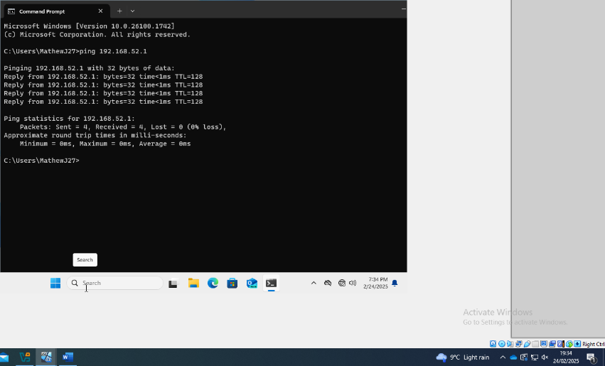

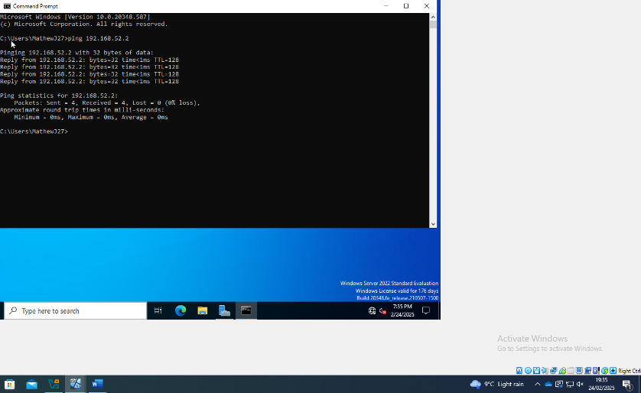

Linux Server pinging Windows Server
Below is evidence of the Linux server successfully pinging the Windows Server using the command PING 10.0.0.1.
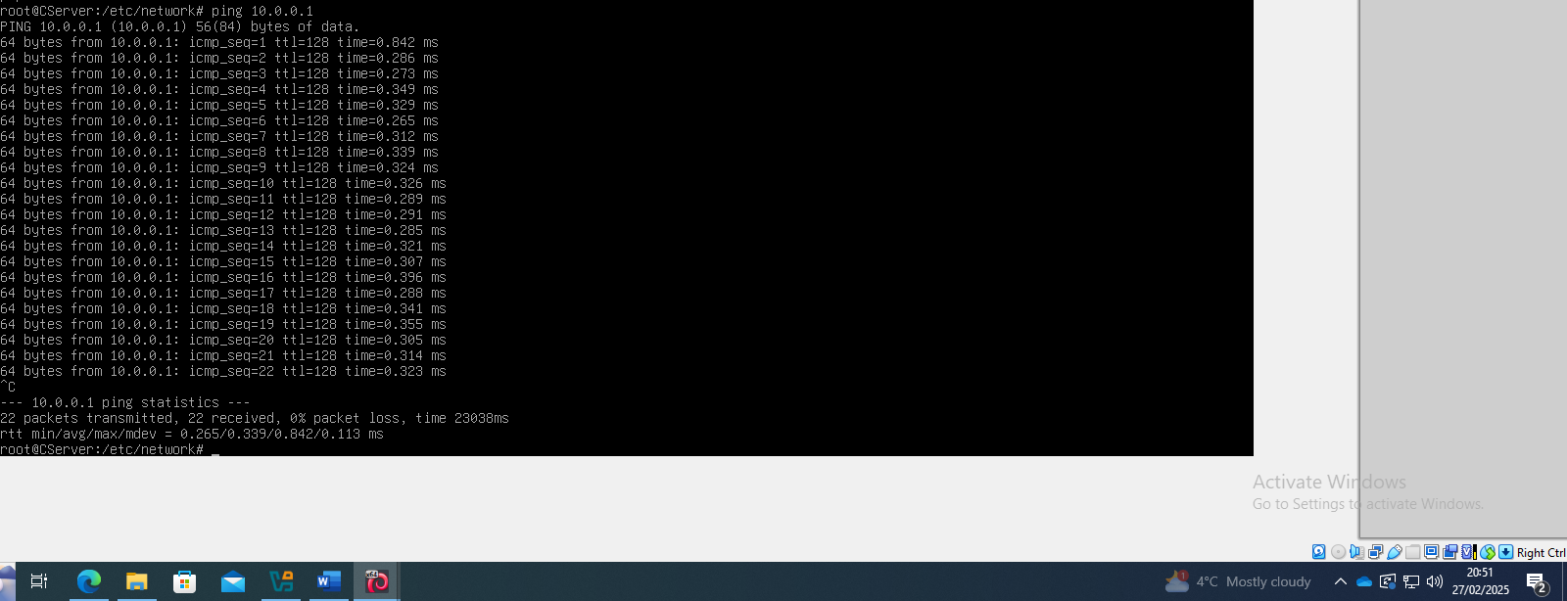
Linux Server pinging Linux User
Using the command ping 172.16.52.2 was successful in the Linux Server pinging the Linux client. There was no need changing the firewalls rules as it was not required on Debian.
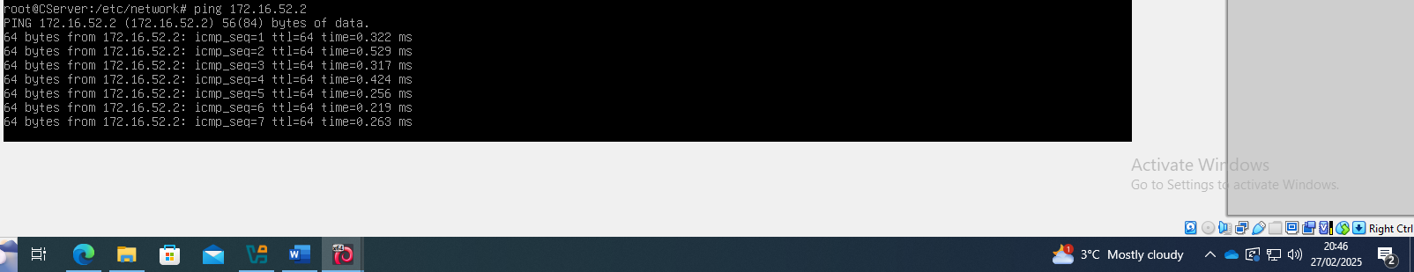

Linux Client pinging Linux Server
The image below is demonstrating the Linux client successfully pinging the Linux server. The command used was ping 176.16.52.1
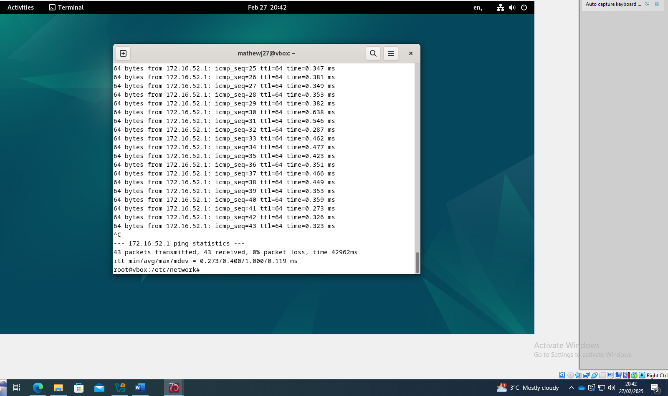

Task 3 - Report reflection

Within this report research has been done on the two types of hypervisors noting down their strengths and weaknesses. IP addresses were discussed and how critical they are to configuring a network as well as the two different types. Network services such as VPN and DHCP were discussed as well as the different types of routing and routing protocols. In the final part of the report there is evidence of the creation of four virtual machines. The operating systems were Windows 2022, Windows 11 and Linux Debian one operating as a server and the other as client. Additionally, there were screenshots of the virtual machines pinging each other to show they had been configured correctly, and it was done using a Type 2 Hypervisor.

References
[1] I. Smalley and Susnjara Stephanie, "What Are Hypervisors? | IBM." IBM. https://www.ibm.com/think/topics/hypervisors (accessed May 1).
[2] Wesley-Addison, UNIX and Linux system administration handbook, Fifth edition. Ed. Boston: Addison-Wesley, 2018. [Online]. Available: https://librarysearch.uwtsd.ac.uk/discovery/fulldisplay?docid=alma99100348560002421&context=L&vid=44WHELF_UWTSD:44WHELF_UWTSD_VU1&lang=en&search_scope=MyInst_and_CI&adaptor=Local%20Search%20Engine&isFrbr=true&tab=Everything&query=any,contains,UNIX%20and%20Linux%20System%20Administration%20Handbook&offset=0
[3] Portnox Team, "What is a MAC Address?", Portnox, https://www.portnox.com/cybersecurity-101/mac-address/ (accessed May 2, 2025).
[4] Cisco Team. "Understand the Ping and Traceroute Commands." Cisco. https://www.cisco.com/c/en/us/support/docs/ios-nx-os-software/ios-software-releases-121-mainline/12778-ping-traceroute.html (accessed May 3).
[5] Geeks for Geeks Team. "How data is tranferred over computer network?" Geeks for Geeks. https://www.geeksforgeeks.org/how-data-is-tranferred-over-computer-network/ (accessed May 4).
[6] Strickland Jonathan. "How IP Convergence Works." How stuff works. https://computer.howstuffworks.com/ip-convergence.htm (accessed May 5).
[7] Zomaya David. "What is Static Routing?" CBT Nuggets. https://www.cbtnuggets.com/blog/technology/networking/what-is-static-routing (accessed May 5).
[8] CatchPoint Team. "The Guide to Dynamic Routing Protocols." CatchPoint. https://www.catchpoint.com/dynamic-routing-protocols (accessed May 5).
[9] Geeks for Geeks Team. "Distance Vector Routing (DVR) Protocol." Geeks for Geeks. https://www.geeksforgeeks.org/distance-vector-routing-dvr-protocol/ (accessed May 6).
[10] Geeks for Geeks Team. "Unicast Routing - Link State Routing." https://www.geeksforgeeks.org/unicast-routing-link-state-routing/ (accessed May 6).
[11] NordVPN Team. "Hybrid routing protocol definition Glossary | NordVPN." NordVPN. https://nordvpn.com/cybersecurity/glossary/hybrid-routing-protocol/ (accessed May 7).
[12] NordVPN Team. "NordVPN’s 2-in-1 deal – don't miss out! | NordVPN." NordVPN. https://nordvpn.com/offer/what-is-a-vpn/?vpn=generic&nc=G-SR-GB-EN-VPN-SRC-Info--19/47-D-(WW)-GBP-&ns=google&nm=cpc&nt=vpn%20explained&na=156046096473&gad_source=1&gclid=Cj0KCQjwqcO_BhDaARIsACz62vMtMV9jmhb9vX0joF05bsFMjEpek62YeLiIp0jo7Nb8PeQW3-ZLCHEaAgFKEALw_wcB (accessed May 8).
[13] Akamai Team. "What Is DHCP?" Akamai. https://www.akamai.com/glossary/what-is-dhcp (accessed May 8).
[14] Microsoft Team. "Active Directory Domain Services overview." Microsoft. https://learn.microsoft.com/en-us/windows-server/identity/ad-ds/get-started/virtual-dc/active-directory-domain-services-overview (accessed May 9).
[15] Microsoft Team. "Download Windows 11." Microsoft. https://www.microsoft.com/en-us/software-download/windows11 (accessed Feb 24).
[16] Windows Team. "Evaluate Windows Server 2022." Windows. https://azure.microsoft.com (accessed Feb 24).
[17] Debian Team. "Installing Debian via the Internet." Debian. https://www.debian.org/distrib/netinst (accessed Feb 24).
[18] Arin Team. "IPv4 Private Address Space and Filtering." Arin. https://www.arin.net/reference/research/statistics/address_filters/ (accessed Feb 24).

