
Problem solving and decision making
(BMSW4004)

Report

STUDENT: CRISTINA DANIELA BESA
STUDENT ID: 2115351
LECTURER: DR.HUSAM

Table of Contents

INTRODUCTION…………………………………………………………………………………………………………………………………..3
Carry out an analysis of the data in order to assist with the process of decision making :…………………………………………………………………………………………..4
Apply a process for making decisions in order to evaluate a number of different options……………………………………………………………………………………………4
POTENTIAL SOLUTIONS………………………………………………………………………………...6
Use a decision making to evaluate solutions 7
Develop a plan for implemeting solutions: 7
Communicate the plan to stakeholders 10
Assess appropriate monitoring and review techniques to ensure success implementation 11
Conclusion: 11
References: 12
APPENDIX……………………………………………………………………………………………....14

Introduction:
Ineffective communication inside Tie Rack is the challenging workplace issue. Understanding communication patterns helps uncover issues and enhance organisational communication. At Tie Rack, communication is conversational, written, and digital. (Sherwood,2021)Verbal communication: Face-to-face dialogues include meetings, presentations, and one-on-one conversations. If the message is unclear or the listener is unengaged, these exchanges may fail. Telephone calls: Poor call quality or miscommunication can cause misunderstandings between employees, clients, or partners. Writing: Emails: Tie Rack frequently sends emails. Poorly written emails, unclear responses, and delayed responses can cause miscommunication. Reports, documents, Insufficient or confusing paperwork can cause misunderstandings, delays, and inefficiencies.(Tie Rack,nd) Memos and notices: If poorly written, employees may miss vital information, causing communication problems. Digital communication: Instant messaging: When communications are confusing, informal, or employees don't respond, instant messaging apps can cause problems. Video conferences: Technical challenges, poor audio or video quality, or unprepared attendees can ruin virtual meetings.
The lack of personal space afforded to workers at the real firm was the problematic aspect that was highlighted in the case study that was chosen to represent the real company. This led to issues for people who were employed by the Tie Rack. (Tie Rack,2021)Because it has the potential to provide workers with adequate privacy, personal space is an essential component for employees as well as the office. Because without it, the consequence is readily apparent in the fact that workers are dissatisfied with the level of stress they are experiencing, which leads to poor levels of productivity.(Sherwood,2021) Employees must have enough downtime to unwind from their work, as well as designated areas where they can store their personal items and take breaks. The personnel may have a more difficult and unpleasant job if these provisions aren't present. The efficiency with which individuals do their duties is significantly influenced by their working environment.(Vischer,2007)
The physical features of a workplace have a direct impact on an employee's performance, productivity, health, safety, comfort, focus, and general morale. Employees are protected from the possible detrimental impacts of their coworkers' behaviour by having private places. Minimizing potential distractions is directly related to one's capacity to concentrate on work-related duties.

Different studies emphasises the value of leveraging physical space to promote friendliness and openness. Space can be used in this situation to demonstrate enthusiasm to communicate with others and a sense of approachability.(Zalesny and Farace,1987)

Carry out an analysis of the data in order to assist with the process of decision making:
The issue at hand is not particularly complicated: workers at this company do not have adequate storage space for their personal things and have the impression that they do not have sufficient resources. The first stage in both the process of making a choice and the process of finding a solution to a problem is to identify the problem.(Sherwood,2021) The insufficient availability of essential resources and tools for workers is the primary focus of this case study's analysis of potential problems. In order to meet the demands of this predicament, one could make use of any number of strategies for problem-solving. It is of the utmost importance to keep in mind the age-old proverb that states "problems should be tackled head-on, and they become more manageable when not viewed in vast, global terms" .(Sundrom, et.al 1994)The company case study an excellent opportunity to practise a variety of strategies for resolving problems, including but not limited to trial and error, experimentation, affinity mapping, and even Fishbone analysis, before choosing the one that is most suited to the situation. Experimentation, mapping of affinity, and learning via trial and error are some examples of these types of tactics.(Aghaz , Hashemi and Asghari,2016)

Apply a process for making decisions in order to evaluate a number of different options for potential solutions:
The decision-making process is a difficult and involved one. It comes down to selecting one course of action from multiple possibilities.
It is essential for decisions to be taken not only at high levels (primarily), but also at lower (functional) or strategic levels. Neither one can exist without the other. The decisions that are made ought to be imaginative and directional. The process of making decisions can be approached from a number of various angles, including the following: The PESTLE and SWOT models are available, along with a few others. (Allen and Henn,2007)

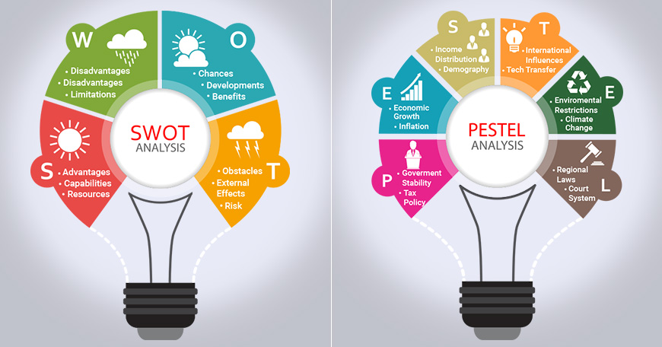
(ReserchOptimus,nd)

The PESTLE analysis is a powerful tool that can be used to advocate for certain ideals. When companies want to keep an eye on the environment in which they conduct their operations or when they are launching a brand-new programmed, product, or service, etc., they can put this concept to good use by monitoring it. (ReserchOptimus,nd)
PESTLE is an approach that can be helpful when it comes to making judgements.
PESTLE provides a broad view of things to consider while evaluating an idea or plan. Political, Economic, Social, Technological, Environmental, and Legal (PESTLE) aspects. Instead of offering solutions, this strategy identifies influential factors.
SWOT analysis aids decision-making in understanding a solution's strengths, weaknesses, opportunities, and threats. Individuals can also apply the "cause and effect" technique to identify a problem's core cause and find a solution.(Ki and Dear,2013)
Fishbone analysis can assist a person understand the cause-effect relationship and how to solve the problem. This analysis offers a solution.

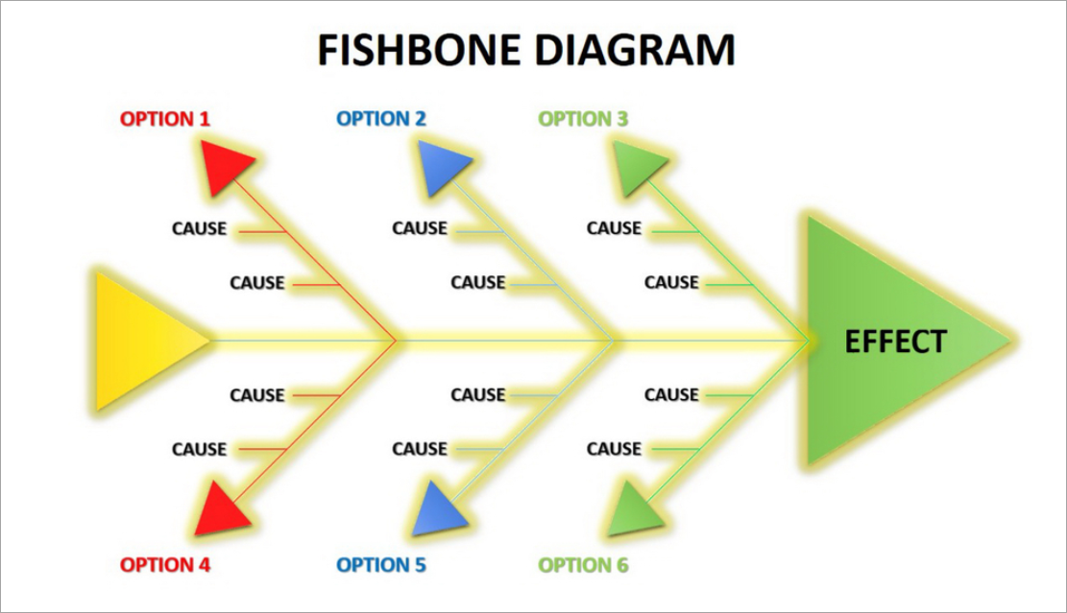

(ReserchOptimus,nd)

Here are some potential solutions:
-to split the workforce into two primary groups, during alternating weeks one group will work from home while the other stays at the office.
Renting a new workplace that is sufficiently spacious is yet another option that has been taken into consideration.(Allen and Henn,2007) Desk booking is another concept that has been considered, in which workers are given the ability to schedule their breaks in advance. A method of decision making was utilized for the purpose of doing an evaluation in order to select the optimal selections. The business has chosen to utilize the SWOT Analysis, and it has been applied to all of the potential solutions. After doing an analysis, it was determined that the most effective solution involves separating the employees into two groups and scheduling each week so that some of the employees from the first group work from home while the others are in the office, and vice versa. This will ensure that there is sufficient room for each employee.(Becker and Steele,1995)
After applying SWOT analysis to this decision, it was determined that this particular solution has the potential to be the most effective because it possesses the following strengths:

The implementation of this approach will result in a multitude of favorable outcomes, including increased levels of contentment and satisfaction among workers, as well as an increase in the amount of space available to them.Weaknesses include the fact that there will be some costs associated with having better apps for connecting with those people who are working from home.Opportunities: it is common knowledge that workers have always sought out flexible working arrangements; consequently, an improvement in worker satisfaction can be anticipated if these arrangements are made available.Threats: there may be some difficulties associated with putting this modification into effect.(De Been and Bejjer,2014)

Develop a plan for putting the following into action:
To begin, there is a problem with there not being enough space for the workers, and this is causing some confusion.
A management overview with the primary focus being on the consideration of several ways to successfully implement organisational change.
Ensuring that each manager is aware of the responsibilities that are assigned to them.
Important task: the Department of Human Resources should consider about having a talk with the Department of Finance in order to ensure that they have sufficient resources to offer to employees who are working from home.(SHRM,2021)
Review each stage of the implementation timeline as well as the specific deadlines that are linked with it.
1.Starting 1.05.2023.
2. Starting now and continuing until 5:09 o'clock, collect relevant information and materials.
3. Make advantage of the other resources available to you. 16.05
4.Through effective change management, encourage workers to adapt to the shifting demands of their jobs before the deadline of 30.05.
5. Put it into action and provide some guidance. 08.06.2023.
6. Once the project has been completely put into action, you should evaluate both its progress and the impacts it has had. 10.06.23
It is necessary to ensure that the tasks on the list pertaining to security and privacy are completed without endangering the employees in any way. As part of the documentation process, you will need to collect all of the relevant information pertaining to desk booking, such as the advantages and disadvantages of the practise, and have a discussion about how to most efficiently introduce change into the workplace.(Kim and Dear,2013) Continuously examining and tracking performance is crucial to ensure that the solution is being implemented effectively. By monitoring performance, individuals can determine if the solution is applied in the right context and make necessary adjustments if needed.
Acceptance The final stages that need to be finished before the solutions can be put into action are the formulation of the criteria, vocabulary, and references, in addition to the acceptance of the plan. All of these must be done before the solutions can be put into action. The firm will make use of PERT in addition to other helpful tools in order to guarantee that the plan will be carried out in an appropriate manner.(Kupritz,2003)

PERT:
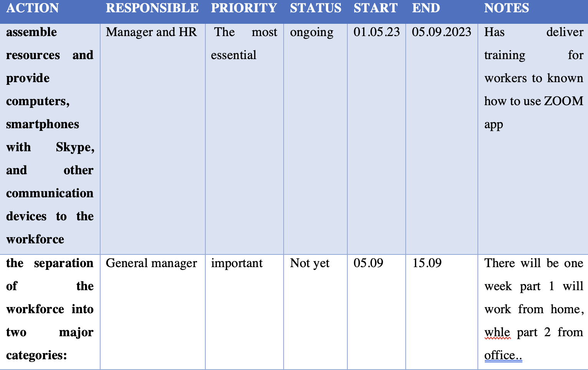

The workforce was divided into two primary categories, which were as follows: Notify the appropriate parties engaged in the plan of the following:
A group or an individual is regarded to be a stakeholder in the operations of a firm or organisation when they have an interest in those activities or when they can be affected by those operations. Stakeholders can come in the form of either groups or individuals. One-way communication, often known as the "public relations" strategy, is one method that may be utilized by a corporation in order to communicate its perspective to its stakeholders; however, in order for this method to be effective, the company must first ensure that its assumptions are accurate. It's possible that a greater understanding of the stakeholders' perspectives might be achieved through contact with them that goes in both directions. (Oldham and Brass,1979)Constructing an active communication plan that is in line with the strategy of the firm and that encourages stakeholders to support good opinions while directing them away from perspectives that could jeopardies the success of the company is the second step of managing stakeholders. This phase entails constructing an active communication plan. The primary objective has to be to bring about a shift in the balance of power and interests among the many parties. The importance of this focus on successful stakeholder management cannot be overstated.(De Croon et.al 2005)

STAKEHOLDERS COMMUNICATION PLAN:
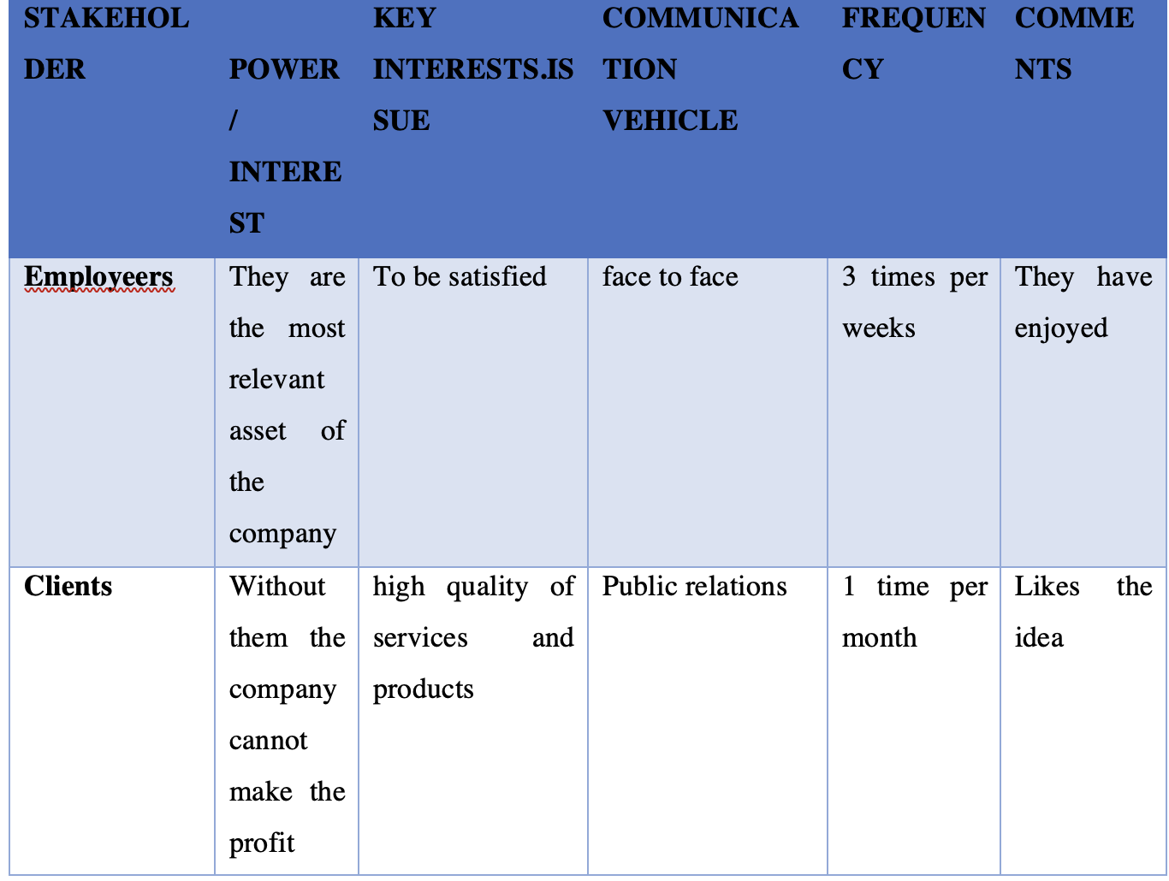

Asses appropiate monitoring and review techniques to enusre succes implementation
Evaluation of the effectiveness of the proposed solution
Benchmarking
The discipline of contrasting and comparing the achievement of a particular business on particular criteria with that of various companies that is considered as having attained high levels of achievement with the record of other firms operating within the same industry as the company being analyzed. (De Been and Bejer,2014
The management of the company will determine whether or not the amount of pleasure experienced by workers has increased by using a number of approaches, such as Control Systems, which have produced trustworthy information in the past. This verification and analysis will take place. In addition to this, Feedback Control will be adopted, and as part of this, surveys will be administered to both the employees and the customers in order to gain insight into how things are developing. (Gajendran and Harrison,2007)In addition, the efficiency of the staff will be assessed both before and after the solution is implemented in order to determine whether or not it was a success. Control Systems can be used by management to assess employee satisfaction. They will evaluate and analyze as needed. Feedback Control involves surveying staff and customers to assess progress. To determine success, they will evaluate employee performance before and after the remedy.(Ki and Dear,2013)
CONCLUSION
To conclude, ineffective communication is more than significant in terms of this,Tie Rack, and it is essential to break down and understand the various communication patterns to improve overall workplace experience and productivity. These communication patterns can be broadly categorized into three forms: verbal, written, and digital communication.
Therefore, implementing a flexibile work arrangement, in terms of dividing the workforce into different groups and made some flexible working,can alleviate the lack of personal space and provide employees with a better work environment. This solution was identified as the most effective after conducting SWOT analysis, considering its strengths, weaknesses, opportunities, and threats.

Reference list:
Aghast, A., Hashemi, M., & Asghar, M. (2016). The relationship between office workspace and employees' performance. Journal of Architecture and Urbanism, 40(2), 116-121.
Allen, T. J., & Henn, G. (2007). The organization and architecture of innovation: Managing the flow of technology. Amsterdam: Elsevier.
Appel-Ellenbrook, R. (2008). Managing “keep” factors of office tenants to raise satisfaction and loyalty. Property Management, 26(1), 43-55.
Becker, F., & Steele, F. (1995). Workplace by design: Mapping the high-performance workspace. San Francisco, CA: Jossey-Bass.
Brennan, A., Chough, J. S., & Kline, T. (2002). Traditional versus open office design: A longitudinal field study. Environment and Behavior, 34(3), 279-299.
De Been, I., & Beijer, M. (2014). The influence of office type on satisfaction and perceived productivity support. Journal of Facilities Management, 12(2), 142-157.
De Croon, E., Sluiter, J., Kuijer, P. P., & Frings-Dresen, M. (2005). The effect of office concepts on worker health and performance: A systematic review of the literature. Ergonomics, 48(2), 119-134.
Gajendran, R. S., & Harrison, D. A. (2007). The good, the bad, and the unknown about telecommuting: Meta-analysis of psychological mediators and individual consequences. Journal of Applied Psychology, 92(6), 1524-1541.
Kim, J., & de Dear, R. (2013). Workspace satisfaction: The privacy-communication trade-off in open-plan offices. Journal of Environmental Psychology, 36, 18-26.
Kupritz, V. W. (2003). Providing support for individual privacy and autonomy in the office: A case study. Environment and Behavior, 35(4), 469-496.
Oldham, G. R., & Brass, D. J. (1979). Employee reactions to an open-plan office: A naturally occurring quasi-experiment. Administrative Science Quarterly, 24(2), 267-284.
Sundstrom, E., Town, J. P., Rice, R. W., Osborn, D. P., & Brill, M. (1994). Office noise, satisfaction, and performance. Environment and Behavior, 26(2), 195-222.
Sherwood, H. (2013) 'Tie Rack gone to knots: Forgotten accessory or wardrobe staple?', The Guardian, 20 November. Available at: https://www.theguardian.com/fashion/shortcuts/2013/nov/20/tie-rack-gone-knots-forgotten (Accessed: 1 May 2023).
Veitch, J. A., Charles, K. E., Farley, K. M., & Newsham, G. R. (2007). A model of satisfaction with open-plan office conditions: COPE field findings. Journal of Environmental Psychology, 27(3), 177-189.
Vischer, J. C. (2007). The effects of the physical environment on job performance: Towards a theoretical model of workspace stress. Stress and Health, 23(3), 175-184.
Zalesny, M. D., & Farace, R. V. (1987). Traditional versus open offices: A comparison of sociotechnical, social relations, and symbolic meaning perspectives. Academy of Management Journal, 30(2), 240-259.

APPENDIX
TASK 1 ROLE PLAY

