BMIH4002: Food & Beverage Operations
Assignment 2

Student ID: 2233548
Student Name: Ayesha Siddiqua
Lecturer’s Name: Jaliya De Silva
Word Count: 390

Restaurant Concept

The foundation of the restaurant's brand is the concept itself. It's not hard to get funding for opening a new restaurant. The title "The Café Terrace" has been chosen for my new restaurant. The Cafe Terrace is an up-to-date interpretation of the classic restaurant theme that aims to make customers feel at ease. Connectivity to the Hotel Trinity Chain is planned (Shapkota, 2013). The restaurant is designed to appear and feel like a terrace commanding a beautiful environment. Inviting furnishings and warm lighting are included. Without a well-thought-out strategy, opening and running a restaurant may be an uphill battle. The Cafe Terrace has a welcoming and cosy vibe perfect for unwinding and taking it easy. And that's just right for a relaxed dinner or a social gathering (Walker, 2021). The restaurant's design is contemporary yet homely, with soft lighting and inviting seating.

The term target audience refers to the demographic profile of a company's ideal clientele. The Cafe Terrace caters to a clientele that is interested in upscale casual dining. And those who enjoy relaxing in a pleasant setting while eating delicious meals. The target audience, in this example, will be those looking for a place to eat. The patrons of The Cafe Terrace are those who like to dress casually but in an elegant manner while dining (Lepkowska-White, 2017). Adults in this age range tend to be health-conscious eaters who value fresh, local products and meticulous preparation. Travellers and tourists who are looking for a unique eating experience in a foreign land may also fall into the category of potential customers.

The Cafe Terrace's menu was designed with the diners' preferences in mind. The menu features both traditional and innovative takes on American cuisine. A contemporary restaurant draws from several eating traditions to provide a unique and enjoyable dining experience. In the same way, today's expressive and distinctive restaurant design. The dishes on the menu are meant to be friendly and familiar, but they also have a few surprises in store (Needles, 2013). Therefore, the items on the menu are prepared simply, allowing the ingredients' inherent flavours to shine through. The meals at The Cafe Terrace have been carefully selected to provide a wide range of familiarity and ease of ordering without sacrificing flavour or quality. The kitchen understands that diners prefer dishes prepared with seasonal, regionally produced components.

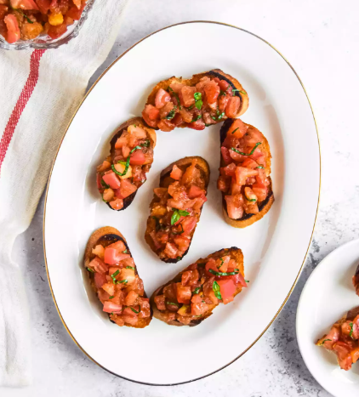
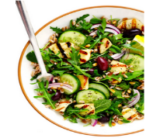
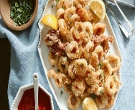
The Cafe Terrace
Appetizer
Bruschetta £8
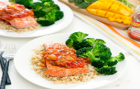
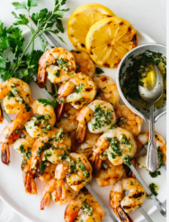
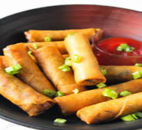
Pan-seared salmon fillet topped with fresh and zesty mango salsa, served with fragrant rice pilaf and steamed broccoli.
Seared Salmon £25
Garlic Butter Shrimp Skewers are made with plump and juicy shrimp marinated in a mouthwatering blend of garlic, butter, and herbs.
Garlic Butter Shrimp Skewers £11
Vegetable Spring Rolls £7
Grilled Halloumi Salad £11
A salad with halloumi cheese, assorted greens, and a tangy balsamic vinaigrette dressing.
Crispy and tender calamari rings served with a tangy lemon aioli dipping sauce.
Calamari £12
A classic Italian appetizer consisting of toasted bread topped with fresh tomatoes, basil, and drizzled with olive oil.

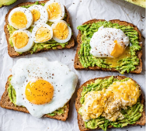
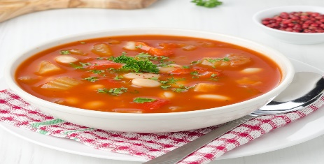
With toasted bread, mashed avocado, poached egg, and a side salad.
Roasted Chicken with Rosemary and Lemon, served with Roasted Vegetables and Mashed Potatoes.
Roasted Chicken £22
Avocado Toast £9
Delicious and crispy appetizer made by wrapping a mixture of vegetables and sometimes noodles or tofu in thin rice paper wrappers.
A soup made with fresh mushrooms, cream, and served with crusty bread.
Creamy Mushroom Soup £9

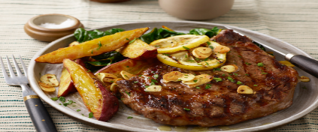
Main Items
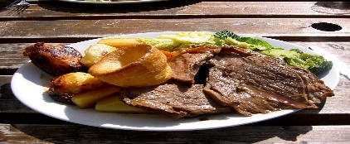
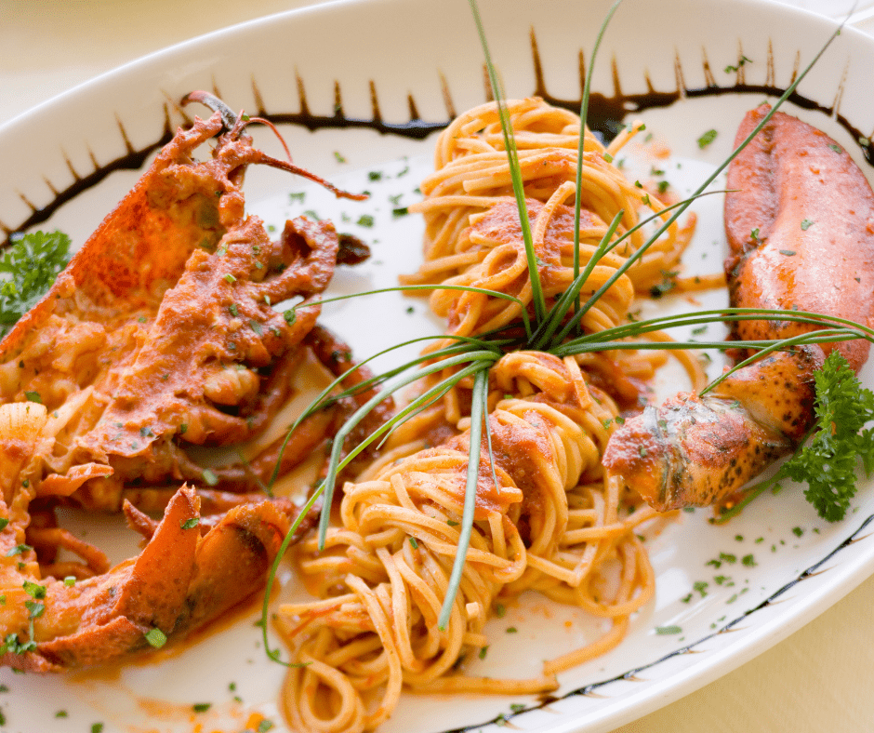
Roasted Vegetable Panini £10

Lobster, noodles, linguine pasta, butter, cream, oil
Roasted Vegetable PANINI £30
Grilled Ribeye Steak £28
It consists of a premium sirloin cut grilled to perfection and served with French fries and asparagus. The garlic butter imparts additional flavour to the dish.
The Roasted Vegetable Panini is a vegetarian option that features a variety of roasted vegetables, including zucchini, eggplant, and peppers, with melted cheese served on a Panini bread.
Beverages




Consists of equal parts espresso, steamed milk, and milk foam, creating a balanced and creamy drink.
Cappuccino £5
Brewed Coffee £4
Iced Green Tea £3
A strong and concentrated coffee
Chilled green tea infused with refreshing mint leaves and a hint of lemon.
Orange Juice £4
A refreshing and tangy drink made from freshly squeezed oranges.

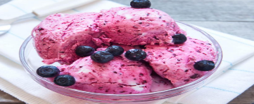
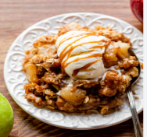

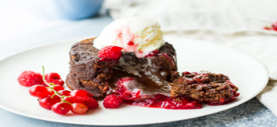
The Cafe Terrace
Beverages
Mixed Berry SORBET £6
Lemon Tart £7
Chocolate Lava CAKE £9
Warm Apple Crisp £ 8
A zesty and tangy lemon tart with a buttery crust, served with a dollop of whipped cream.
A refreshing and light dessert made with a variety of mixed berries, perfect for a cool and fruity finish to the meal.
A decadent chocolate cake with a molten chocolate center, complemented by a tart raspberry coulis.
Dessert of warm baked apples topped with a crispy crumbly topping, served with a scoop of creamy vanilla ice cream.

Special Dietary Requirements

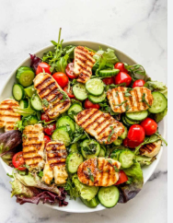
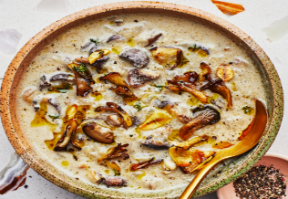
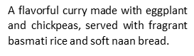
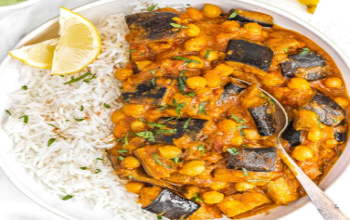
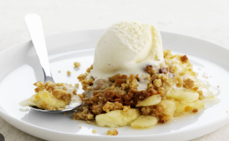
Grilled halloumi cheese, mixed greens, and a tangy balsamic vinaigrette dressing.
Grilled Halloumi Salad with Mixed Greens and Balsamic Vinaigrette (Diet) £11
Served with a scoop of creamy vanilla ice cream, catering to lactose-free preferences.
A vegetarian option, this creamy mushroom soup is rich and flavorful, perfect as a starter or a light meal on its own.
Creamy Mushroom Soup (vegetarian) £20

Warm Apple Crisp with Vanilla Ice Cream (lactose-free) £22
Vegan Eggplant and Chickpea Curry £18

References
Boussard, S., 2021. Food and Beverage Management in the Luxury Hotel Industry. Business Expert Press.
Cousins, J., Foskett, D., Graham, D. and Hollier, A., 2019. Food and beverage management: for the hospitality, tourism and event industries. Goodfellow Publishers Ltd.
Ezzat, H. and Ashry, A., 2017. Menu Sustainability in the Egyptian Upscale and Fine Dinning Restaurants: Descriptive Approach. International Journal of Heritage, Tourism and Hospitality, 11(1), pp.262
Filimonau, V. and Krivcova, M., 2017. Restaurant menu design and more responsible consumer food choice: An exploratory study of managerial perceptions. Journal of cleaner production, 143, pp.516-527.
Lepkowska-White, E., 2017. Exploring the challenges of incorporating social media marketing strategies in the restaurant business. Journal of Internet Commerce, 16(3), pp.323-342.
Magnini, V.P. and Kim, S., 2016. The influences of restaurant menu font style, background color, and physical weight on consumers’ perceptions. International Journal of Hospitality Management, 53, pp.42-48.
Needles, A. and Thompson, G.M., 2013. Social media use in the restaurant industry: A work in progress.
Ozdemir, B. and Caliskan, O., 2015. Menu design: A review of literature. Journal of Foodservice Business Research, 18(3), pp.189-206.
Qoura, A.G.F.O.E. and Gomaa, E.M.K., 2022. Restaurants' customers' attitudes toward menu sustainability and sustainable food. Journal of the Faculty of Tourism and Hotels-University of Sadat City, 6(2/2).
Shapkota, P., 2013. Developing a Business Plan For the Restaurant Ocean Dragon Oy.
Walker, J.R., 2021. The restaurant: from concept to operation. John Wiley & Sons.
Wood, R.C., 2013. Key concepts in hospitality management. Key Concepts in Hospitality Management, pp.1-20

