BUSINESS REPORT - COMPARISON OF TWO HOSPITALITY ORGANISATIONS SHANGRI-LA HOTELS AND
PREMIER INN HOTELS

Programme Name: BA International Hotel Management

Module Title: Financial Management for the Hotel Industry
Module Code: BMIH5007

Student Id:2238996
Student Name: Aiga Bordasa
Lecture: Tristan Hawkins
Executive Summary
In this report, the Shangri-La Hotels and Premier Inn are compared in terms of the market opportunities, threats, CSR activities and financial performance. Shangri-La uses elements of hedonic appeal through its luxury services, targeting market segments with high willingness to pay, different from Premier Inn which targets an economically conscious segment in the United Kingdom through utilitarian appeal offering accommodation services at reasonable prices. Each indeed faces growth barriers such as economic risks or competition challenges. Most of Shangri-La’s CSR programs focus on environmental concerns as well as community relations; some of their special projects are “Care for Nature” and “Friendship City.”
Whereas the company’s community and environmental responsibility is outlined online via the ‘Force for Good’ details are not readily available on the Premier Inn website. The recommendations for Shangri-La are to increase market penetration in the growth regions and to seek out other forms of revenue generation while for Premier Inn the focus should be on sustaining Customer Intimacy & Operational excellence. It is therefore important for both brands to continue practising effective financial management to ensure that the organizations sustain their growth and profit-making in the current competitive environment in the hospitality industry.

Table of Contents
1. Introduction 4
2. Overview of Shangri-La Hotels and Premier Inn Hotels 4
3. Total Revenue 4
3.1 Revenue Analysis 4
3.2 Sources of Revenue 5
3.2 Cost Structure 6
3.3 Revenue Trends and Drivers 7
4. Market Position 8
4.1 Market Share Analysis 8
4.2 Customer Demographics 9
4.3 Brand Perception 11
5. Growth Potential 12
5.1 Expansion Strategies 12
5.2 Market Opportunities 14
5.3 Barriers to Growth 15
6. Financial Commitment to CSR 15
6.1 Overview of CSR Initiatives 15
6.2 Financial Investment in CSR 17
6.3 Impact of CSR on Brand Image 17
7. Recommendations 17
7.1 Recommendation for Shangri-La Hotels 17
7.2 Recommendation for Premier Inn Hotels 18
8. Conclusion 18
Reference List 19

1. Introduction
Shangri-La Hotels and Premier Inn Hotels are well-known hotel companies in the world with operating strategies and financial planning in the worldwide market. In this context, the present report analyses their economic performance in certain areas, which are instrumental in shaping their sustainable development. Thus by analysing these aspects and comparing, all the stakeholders can receive the data about outcomes of their actions in the financial fields and about perspectives for improvements.

2. Overview of Shangri-La Hotels and Premier Inn Hotels
Shangri-La Hotels & Resorts is Asia’s and the Middle East’s reputed luxurious hotel franchise that delivers premium experiences and villa services (Shangri-La Group, 2020). On the contrary, Premier Inn caters the leisure and business travellers with moderately priced and comfortable accommodations. Though Shangri-La is established on the principles of glamorous and operating in the discerning niche, Premier Inn on the other hand is positioned on the principle of affordability with special consideration to customers and an efficient means to restructure the social impact of its presence.

3. Total Revenue

3.1 Revenue Analysis
Total revenues for Shangri-La Hotels in the financial year 2023 were USD 2,141.79 million against USD 1,462.15 million in 2022. On the other hand, Premier Inn Hotels realised total revenues of GBP 2,959.9 million (approximately USD 3,700 million) which specified their large market share for the budget hotel segment. Higher total revenue in Premier Inn was observed because of the higher number of hotels and better occupancy level, though the Revenue per available room (RevPAR) is below the Shangri-La (Premier Inn, 2024).
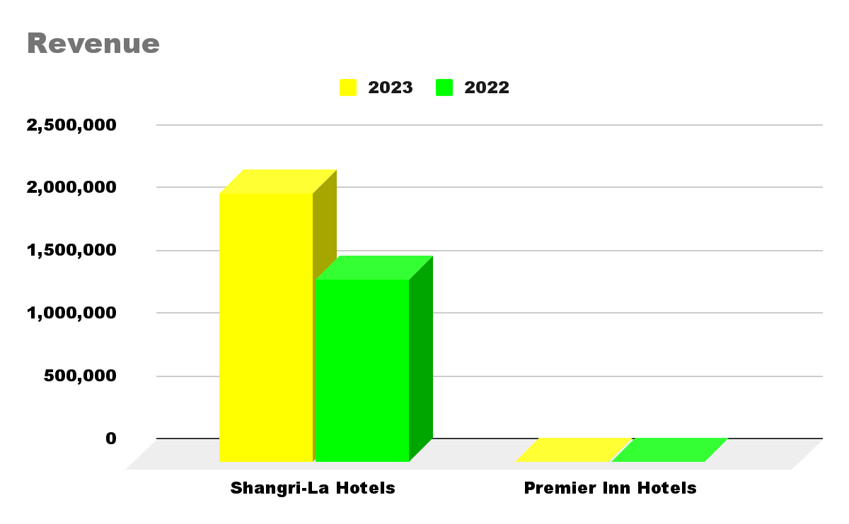
Figure 1: Comparison of Revenue
(Source: Self-Developed)

3.2 Sources of Revenue
Shangri-La Hotels and Resorts earns most of its income from accommodation sales and earnings from food and drink services and other interrelated products including spas, health and wellness, and facilities for meetings and events (Shangri-la.com 2024).
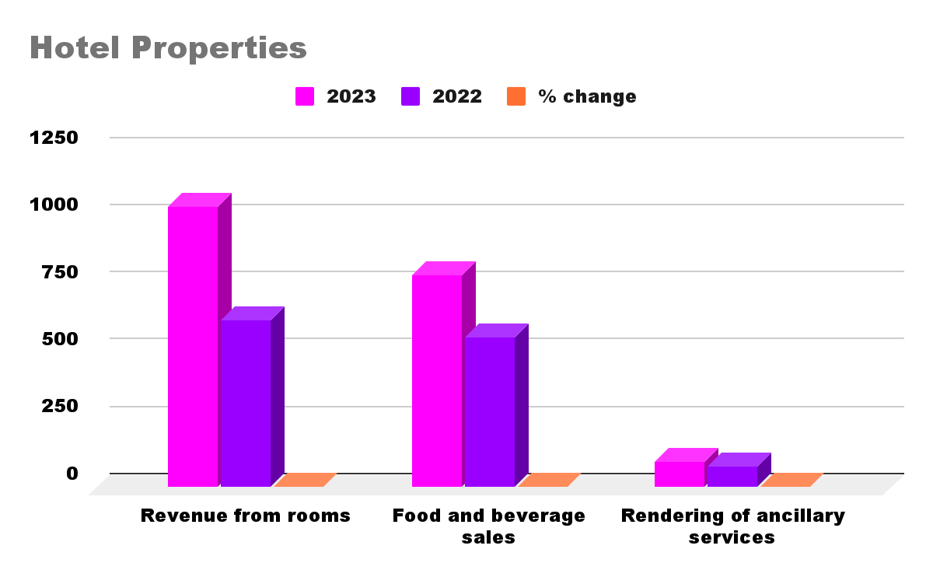
Figure 2: Sources of Revenue of Shangri-La
(Source: Self-Developed)
Being a low-cost brand, Premier Inn generates maximum earnings from room letting, providing inexpensive lodging. They correspondingly get their revenue from the sale of food and drinks, more particularly through their restaurant-borne facilities and affiliated restaurants succeeding to them.
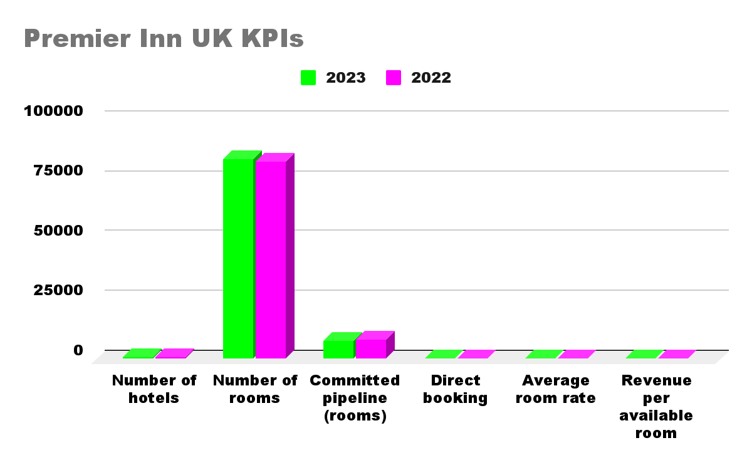
Figure 3: Sources of Revenue of Premier Inn
(Source: Self-Developed)

3.2 Cost Structure
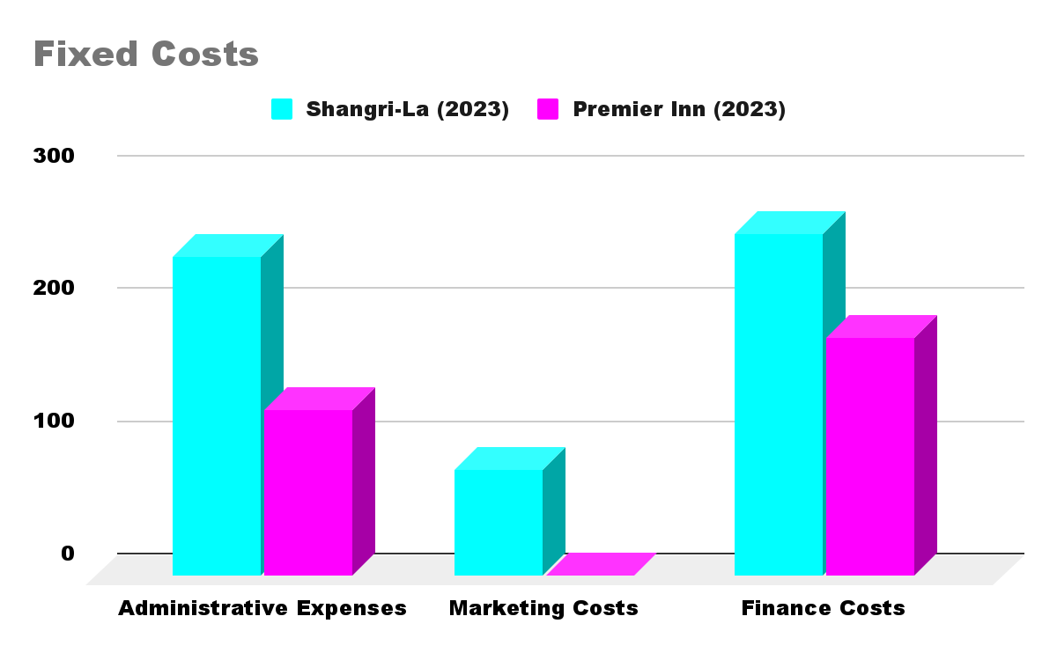
Figure 4: Fixed Costs of Shangri-La and Premier Inn
(Source: Self-Developed)
For the year ended 2023, the cost of sales in Shangri-La Hotels was USD 975.0 million which depicted that the company had substantial fixed costs of USD 241.1 million and marketing expenses of USD 80.2 million (Shangri-la.com 2024). Further, other operating expenses by the advantage of being variable were USD 639.8 million consisting of costs such as property operating expenses, utilities, supplies, laundry, repairs and maintenance among others.
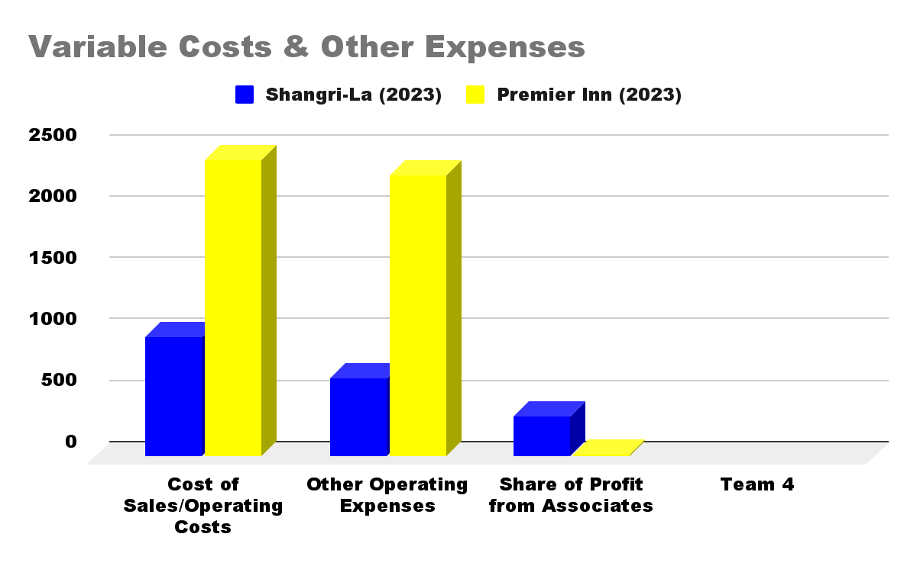
Figure 5: Variable Costs & Other Expenses of Shangri-La and Premier Inn
(Source: Self-Developed)
On the other hand, the operating cost was USD 3,025 million for the year ended February 31, 2021, by Premier Inn Hotels. Its cost model is the low fixed cost owing to the simple, limited amenities and effective management of properties (Whitbread, 2023a). As Premier Inn’s operations are optimally modest, it has less overhead and fixed costs and, thus, can scale up owing to high occupancy rates and maximum variable cost per room far lower than Shangri-La.

3.3 Revenue Trends and Drivers
It shows that the revenues have also been remarkably high in the financial year 2022-2023 where Shangri-La earned USD 1.46 billion in 2022 and USD 2.14 billion in 2023 which indicates a recovery of the hospitality business after the pandemic phase. Hence, this growth was occasioned by the growing travel needs, boost in inbound tourism and well-coordinated market expansion among other elite guests.
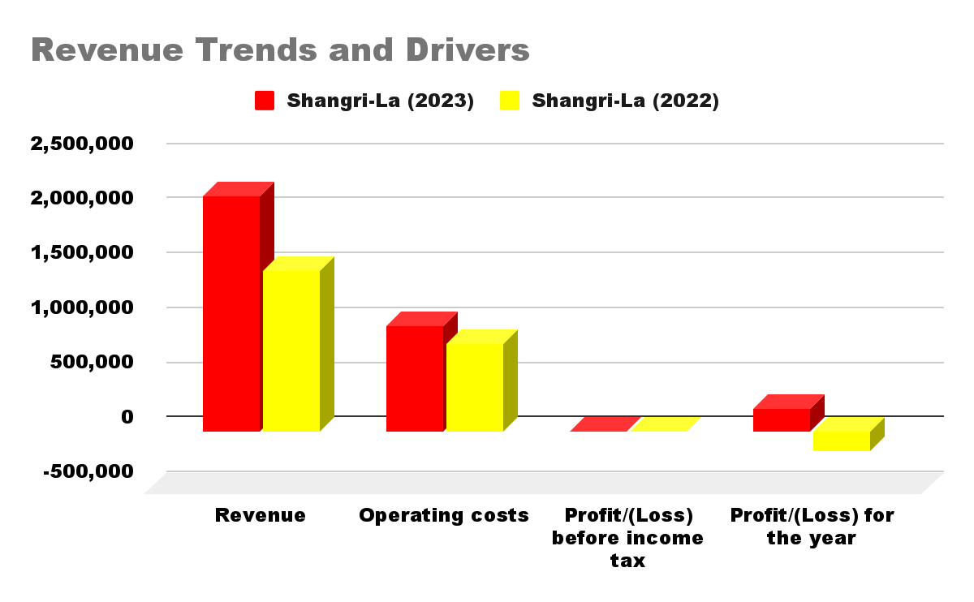
Figure 6: Revenue Trends and Drivers of Shangri-La and Premier Inn
(Source: Self-Developed)
Premier Inn correspondingly recorded increased revenues of £2.96 billion, from £2.63 billion for the 52 weeks ended February 2024. This enhancement has been owing to increased occupancy, fruitful expansion plans and the aptitude to offer particular of the best prices in the market (Whitbread, 2023a).

4. Market Position

4.1 Market Share Analysis
Shangri-La Hotels and Premier Inn operate on two different levels in the worldwide industry addressing different customers. As of 2024, it is affiliated with 97 hotels in different nations and regions for which Shangri-La targets luxury & up-market segment hotels primarily in Asia principally in China & South East Asia (FT, 2024). It has a market capitalization of about $2.57 billion which also shows its position in the luxury market.
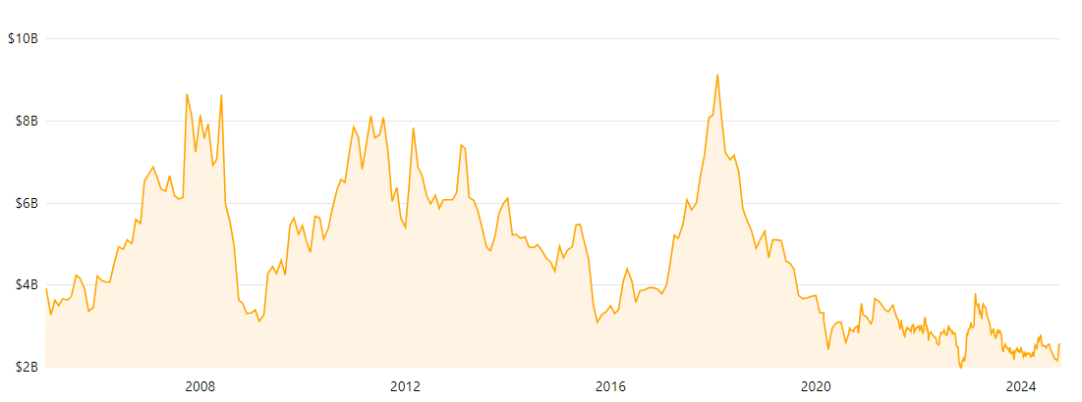
Figure 7: Market cap history of Shangri-La
(Source: FT, 2024)
While Marriott has a significantly smaller presence, Premier Inn operated by Whitbread has a network of 853 hotels largely located in the UK and Ireland and is targeted at economy tourists. Making close to £3 billion in sales for the financial year 2024, it is apparent that Premier Inn has a large market share within the budget and mid-range hotel market (Finance.Yahoo, 2024).
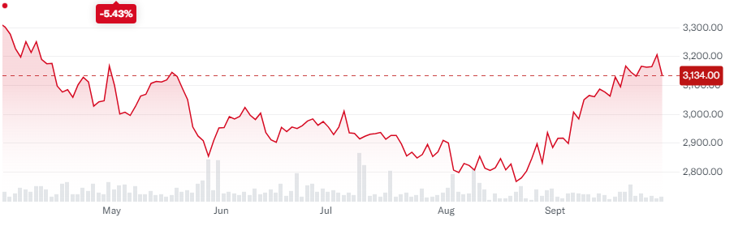
Figure 8: Market cap history of Premier Inn (Whitbread)
(Source: Finance.Yahoo, 2024)

4.2 Customer Demographics
Shangri-La Hotels and Services mainly focus on high-end leisure and business travellers in the market. Shangri-La focuses on wealthy customers who are in search of luxurious services, quality food, and wellness services on one hand, on the other hand, it targets business people attending conferences and tourists visiting Asia Pacific who want comfort and to receive a taste of the local culture (Siddharta, 2022). For instance, the Golden Sands Resort is targeting customers who expect luxury and excellent service delivery, which is associated with clients who possess high consumer ability.
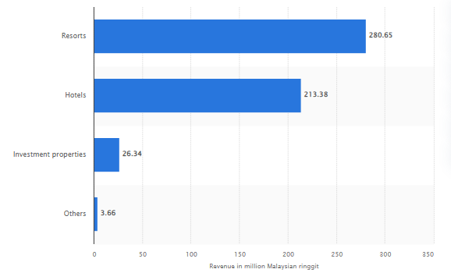
Figure 9: Revenue of Shangri-La Hotels by business segment
(Source: Siddharta, 2022)
Instead, Whitbread, who owns the Premier Inn brand, targets cost-sensitive leisure and business tourists in the UK and Germany mainly. The target market of the motel is families, mid-scale travellers, individuals on domestic trips, and business people who need low-cost but clean and comfortable accommodations. The brand is more preferred by the residents of the UK and the tourist who makes that country his or her destination prefers the brand because of the value for money it offers (Statista, 2024).
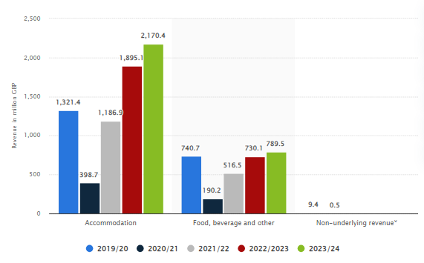
Figure 10: Revenue of Premier Inn (Whitbread) in Europe by segment
(Source: Statista, 2024)

4.3 Brand Perception
Service attributes that Shangri-La Hotels are well known for include exclusive service provision, easy and impressive building design and merchandising. From customers’ view, individual features of the hotels are stressed during the assessments, and many travellers described and valued the “Shangri-La Cares” as enhancing comprehensive health safety measures (Hirschmann, 2024).
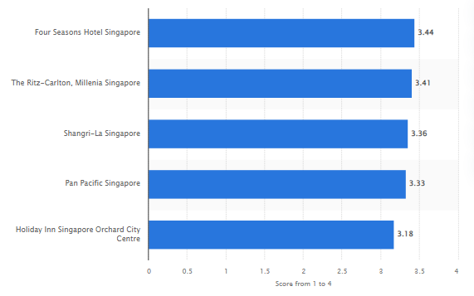
Figure 11: Leading hotels for business travellers based on customer evaluation by score
(Source: Hirschmann, 2024)
On the other hand, Premier Inn has an exceptional selling proposition through the value it brings through its clean and comfortable rooms for an affordable price. Though the crises earlier this year led to a lower value for money that affected the hotel's score, Premier Inn is the UK’s largest hotel brand, which is popular with business and leisure travellers. Consumers frequently select it amongst their favourite choices and it is considered an award-winning company owing to its services (Statista, 2022).
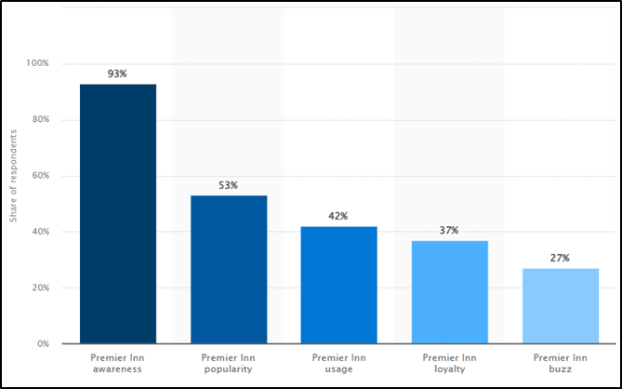
Figure 12: Premier Inn “brand awareness, usage, popularity, loyalty, and buzz” in the UK
(Source: Statista, 2022)

5. Growth Potential

5.1 Expansion Strategies
Shangri-La Hotels and Premier Inn have implemented diverse strategic development policies in the market, based on growth approaches such as expansion through innovative stores and acquisitions. Shangri-La believes in having a worldwide presence, and it does this by applying a strategic Asian touch to the company’s hospitality and then taking time to select the most strategic markets to expand to in terms of luxury properties (Whitbread, 2023).
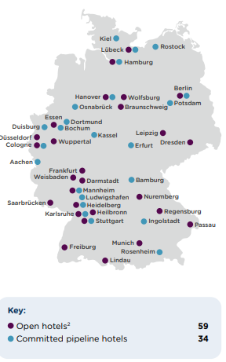
Figure 13: Shangri-La Hotels Strategic Development Strategies
(Source: Whitbread, 2023)
On the contrary, Premier Inn has a vertically integrated business model where it maintains the operational property to provide flexibility during expansion. Premier Inn, currently, has plans to expand in the UK adding 3,500 rooms and searching for deeper market penetration in Germany (Whitbread, 2021).
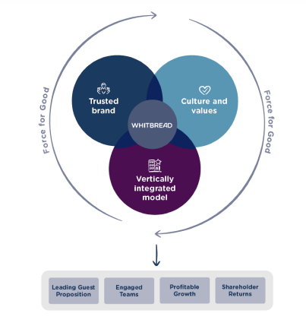
Figure 13: Premier Inn Vertically Integrated Business Model
(Source: Whitbread, 2021)

5.2 Market Opportunities
Southeast Asia and African markets hold prospective for Shangri-La by outfitting the high-end and luxury travel market. Premier Inn must take advantage of the increasing occurrences of millennial and business travellers seeking affordable hotels. The brand can then target the mid- and lower-tier cities to attain good quality products from well-established brands.
 | 2023 | 2022 | % Change
Revenue
Shangri-La Hotels | 2,141,790 | 1,462,145 | 31.73
Premier Inn Hotels | 3521.06 | 2284.69 | 35.11
Operating costs
Shangri-La Hotels | 961086 | 799714 | 16.79
Premier Inn Hotels | 2153.79 | 2861.84 | -32.87
Profit/(Loss) before income tax
Shangri-La Hotels | 503 | 78 | 84.48
Premier Inn Hotels | 280,146 | -174,443 | 162.27
Profit/(Loss) for the year
Shangri-La Hotels | 201,676 | -187,452 | 192.95
Premier Inn Hotels | 374 | 57 | 84.76
Table 1: Comparison of Market Opportunities
(Source: Self-Developed)
The scheme of transferring “112 underperforming restaurants” added “3,500 rooms” to the network of the parent group of Premier Inn “Whitbread” group. At present, the group has nearly “77,000 hotel rooms in the UK”. The group proposes to enhance that by nearly 25% by “mid-2029” (O’Neill, 2024).

5.3 Barriers to Growth
There are probably threats that are inherent in the micro environment that affect Shangri-La’s operations such as fluctuations in the macro environment that can affect discretionary expenditure between luxury travellers, affecting the occupancy levels. It also faces threats from other players within the industry such as the up-surging boutique hotels and other players in the accommodation industry like Airbnb. Some challenges which might exist for the Premier Inn are the intensity of rivalry in the current low-price segment that is mainly comprised of budget hotels. Turbulence in the economy lowers consumers’ willingness to travel for leisure as well as business and trade consequential in the low demand levels.

6. Financial Commitment to CSR

6.1 Overview of CSR Initiatives
CSR management is robust and substantial for both Shangri-La and Premier Inn with commitments to environmental responsibility, social contribution and social responsibility.
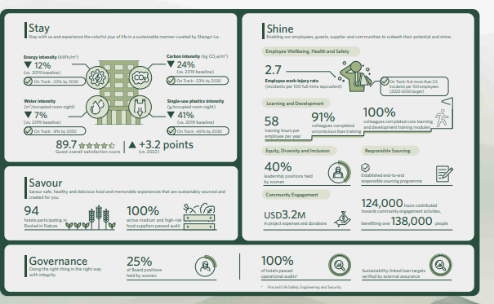
Figure 14: Shangri-La Hotels Sustainability Journey
(Source: Shangrila, 2024)
Environmental management at Shangri-La includes environmental practices, like the water bottling plant at Shangri-La Boracay and marine wildlife like the clownfish conservation at the Clownfish Discovery Centre. Their community engagement activities include the Care for Nature project and the affected people’s shelter in Turkey after the earthquake by the ‘Friendship City’ project.
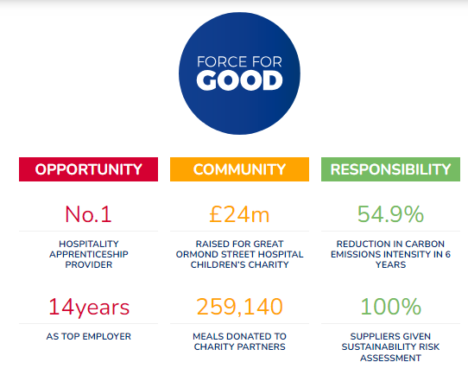
Figure 15: Whitbread’s Premier Inn Force for Good
(Source: Shangrila, 2024)
Whitbread’s Premier Inn policy rewards the local community in that it hires employees locally and allows them to volunteer. The “Force for Good” program makes it set productive emphases on economics, as extensive investigations prove that guests have a high propensity to spend within local areas (Whitbread, 2023b). Further, they pay consideration to sustainability objectives, such as strategies to accomplish net zero carbon emissions.

6.2 Financial Investment in CSR
Shangri-La supports long-term environmental and social solutions for large-scale management issues in the form of the formation of the Marine Sanctuary and Clown Fish Discovery Centre. They also supported the “Friendship City” project in Turkey for the construction of 300 houses for displaced people. The company helped 300 people by employing its employees’ donations. Following Whitbread’s “Force for Good” concept, Premier Inn pays special attention to such economic and societal concerns as carbon footprint and environmental impact investing in such values as public charitable projects, community volunteering, as well as various explorations in a social sphere (Premier Inn, 2023).

6.3 Impact of CSR on Brand Image
These CSR activities improve the brand perceptions and customers’ loyalty to both the Shangri-La and Premier Inn. Groups and CCRs such as Biodiversity Conservation, Promotion of Community Relations, and activities including the “Friendship City” take on disaster relief, therefore enhancing Shangri-La’s image of responsibility to the environment and society. This enhances customer bonds particularly the ones with vested interests in sustainability, hence improving customer loyalty.

7. Recommendations

7.1 Recommendation for Shangri-La Hotels
Precisely specified that the demand and popularity of ecotourism continue climbing, the places with a potential for growth that Shangri-La should invest in are the markets that emphasise environmental protection. Being an environmentally friendly company focusing on green technologies and luxury eco-resorts in developing areas such as Southeast Asia and Africa can serve as an environmentally friendly travel destination. Also, growing their loyalty programmes and providing exclusive appealing culturally themed experiences can enhance consumer loyalty and the business income streams.

7.2 Recommendation for Premier Inn Hotels
It is also recommended that more efforts should be made by the organisation to strengthen its digital transformation and deepen customer satisfaction, besides streamlining its operating model to achieve customer expectations. They can maintain and attract technologically inclined travellers through the integration of progressive booking systems as well as targeted marketing through the use of customer service technologies such as artificial intelligence.

8. Conclusion
The growth opportunities of Shangri-La and Premier Inn are broad-based but these chains are exposed to risks such as economic instability and competition. Supporting CSR activities strengthens brand reputation and customer-stakeholder relationships hence ensuring sustainable performance. The management of cash is still an important factor in managing the effects of market forces utilising resources and opportunities that come its way.

Reference List
Finance.Yahoo (2024) Whitbread PLC (WTB.L) stock price, news, quote and history - Yahoo Finance. Available at: https://uk.finance.yahoo.com/quote/WTB.L/?guccounter=1&guce_referrer=aHR0cHM6Ly93d3cuZ29vZ2xlLmNvbS8&guce_referrer_sig=AQAAAJH29sl-b43zZx44brc4qV-jfZhLxaz8-QxDPrvkMVun4DA2_F5r5xyV5r3CFZT4thDFVADX7mfcJKw-FBh7rc_MvEAmLHoH0vnSwL476wR9qmsM7RUAJ-z9lO5F55tTZCoBkjpsWGsMFmALjpTnH9TmsDmACjh6crnSn_q7paaC (Accessed: 1 October 2024).
FT (2024) Shangri-La Hotel PCL, SHANG:SET summary - FT.com. Available at: https://markets.ft.com/data/equities/tearsheet/summary?s=SHANG:SET.
Hirschmann, R. (2024) Singapore: leading hotels for business travelers 2022. Available at: https://www.statista.com/statistics/1381827/singapore-leading-hotels-for-business-travelers/.
O’Neill, S. (2024) Premier Inn to Grow Hotel Room Count by 25% Before 2030. Available at: https://skift.com/2024/04/30/premier-inn-to-grow-hotel-room-count-by-25-before-2030/.
Premier Inn (2023) Force For Good. Available at: https://www.premierinn.com/gb/en/why/force-for-good.html.
Premier Inn (2024) Why We’re Premier. Available at: https://www.premierinn.com/gb/en/why.html.
Shangrila (2024) Environmental, Social and Corporate Governance | Shangri-La Experiences. Available at: https://www.shangrilaexperiences.com/community-and-social-impact.
Shangri-La Group (2020) About Shangri-La. Available at: https://www.shangri-la.com/group/our-story/about-shangri-la.
Shangri-la.com (2024) Annual Report 2023, sitecore-cd.shangri-la.com. Available at: https://sitecore-cd.shangri-la.com/-/media/Project/Shangri-La-Group/Investor/Files/Public-Disclosures/Latest-Top-Publications/2023_Annual_Report_E.pdf
Siddharta, A. (2022) Shangri-La Malaysia: revenue by business segment. Available at: https://www.statista.com/statistics/1199674/shangri-la-malaysia-revenue-by-business-segment/.
Statista (2022) Premier Inn Brand Profile UK 2022. Available at: https://www.statista.com/forecasts/1335699/premier-inn-hotels-brand-profile-in-the-uk.
Statista (2024) Whitbread revenue by business segment 2021. Available at: https://www.statista.com/statistics/739891/revenue-whitbread-united-kingdom-uk-by-segment/.
Whitbread (2021) Our business model and strategy. Available at: https://www.whitbread.co.uk/about-us/our-business-model/.
Whitbread (2023) Building Building advantage on our. Available at: https://cdn.whitbread.co.uk/media/2024/05/Whitbread-PLC-Annual-Report-and-Accounts-2023_Single_pages-1.pdf.
Whitbread (2023b) Sustainability. Available at: https://www.whitbread.co.uk/sustainability/.

