

Changemakers: Creativity and Value Creation
Professions (BMHP5014)

Component 1: Online portfolio of set exercises

Student name: Carla Silva
Student number: 2333077
Lecturer’s name: Laila Surani

Table of contents
Introduction…………………………………………………………………………pag3
Innovation, Creativity, Value Creation and Change…………………………….pag4,5
Mind Map……………………………………………………………………………pag6
Self-Reflection of Group Activity…………………………………………………..pag7,8
The High Intensity Use (HIU) Service………………………………………….…pag9,10
Isolation Among Older Adults…………………………………………………….pag11,12
Digital Innovation in the Health and Social Care…………………………………pag13
Understanding the NHS Leadership Framework…………………………………pag15
Self-Reflection……………………………………………………………………..…pag16
References…………………………………………………………………………pag17,18

Introduction
Heath and social care services are functioning in a context increasing complexity. Increased demand, and quickly emerging technologies. In recognition of this innovation and creativity are now crucial factors in raising the standard, effectiveness, and accessibility of healthcare. While creativity allows professionals to think differently, question presumptions, and create solutions that better serve the needs of people and communities, innovation promotes the creation of new concepts, procedures, and technology. When employed properly, these strategies promote value creation by improving patient outcomes, enhancing the service-user experience, and guaranteeing the prudent use of resources. All these innovation, creativity, and value creation constitute the foundation for meaningful and lasting change in health and social care, helping services adapt to modern challenges and deliver compassionate, person-centred care.

Innovation, Creativity, Value Creation and Change

The operationalization of creative potential with a business and social goal using novel, adaptable solutions that add value, utilize new inventions or technologies, provide businesses a competitive edge, and boost economic growth is known as innovation. Creative potential, motivation, action, psychological and ecological processes, originality, and results includes value creation and economic growth are some of the broad issues it encompasses. Among these, freshness is a concept that exists consistently in all definitions of innovation (Singh, S. and Aggarwal, Y.).
The source of the creative potential that supports innovation is implied to be creativity, which includes the psychological processes and motivations that result in the production of novel concepts or solutions. It is the fundamental component that makes innovation possible by converting original concepts into beneficial and helpful results (Singh, S. and Aggarwal, Y.).
One of the main results of innovation is value creation, which is defined as the process by which business models or innovation ecosystems produce economic or shared value. This process includes internal processes such strategies and methods, external processes include actors, structure, governance, and relationships, and outputs such value created.
Particularly in outcome-based business models, value creation is also associated with the alignment of value creation and value capture activities throughout phases for value proposition conception, value provision design, and value-in-use provision (Sjodin, D. et al 2020).
In addition, as demonstrated by frameworks such as the value creation wheel, value creation is essential to cooperative agreements and decision-making procedures that require into account the opinions of various stakeholders (Lages, F.L et al 2020).
Innovation and value creation are linked to charge as a dynamic process that causes transformation, including the transformation of cities through innovative entrepreneurship.
Change involves ongoing adaptation and development, which is frequently made possible by innovation and value-creation processes that have an impact on society and the economy in variety of settings, including large cities that are changing (Wise, N. et al 2020).
In health and social care, innovation, creativity, value creation, and change are crucial because they address pressing issues such changing demographics, financial limitations, and the demand for more integrated, people-centered, and technologically advanced care systems. For example, service design goes beyond conventional explanatory research to actively reform healthcare systems by utilizing human-centered and transformative methodologies to create creative solutions that improve healthcare delivery and welfare.
Improving the efficiency, sustainability, and adaptability of health and social care systems to address complex issues for the benefit of both providers and services users (Patricio, L.et al 2020).

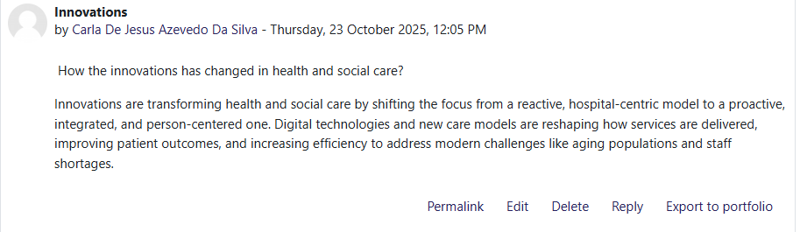

Mind Map
Suggestions and execution
Creating a timeline
Creating a team
Solve problems in HSC
Information collection
Update
Analysing
These are the steps to solving health and social care problems: firstly, building together a team, put together a multidisciplinary group to investigate and identify the problem. Information collection, gather all pertinent information, such as witness interviews, reports and video recordings. Creating a timeline to make a throught chronology of the occurrences that preceded the awafuel event. Analysis is important to ask why the incident happened in a methodical manner and use resources such as the ‘5 Whys’ to determine all the contribuiting variables. Suggestions and execution to stop recurrence, create and suggest corrective measures based on the analysis. Update, track the success of the adjustments that have been made over time (Balleau, R. 2023).
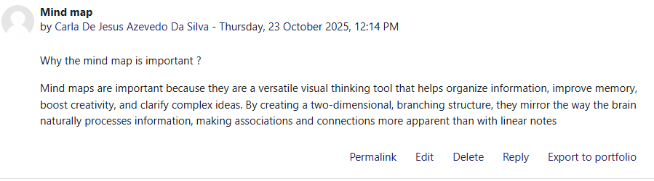
Self-Reflection of Group Activity
The two separate cognitive processes involved in creativity and problem-solving are convergent and divergent thinking. Divergent thinking is typified by the production of several, diverse concepts, or solutions, which frequently result in unique and unusual consequences. It enables the development of a variety of cognitive pathways through extensive, exploratory searching and flexible relevance assessments. Convergent thinking, on the order hand, emphasizes focused review and early concept filtering to reduce the number of choices and arrive at a single correct or conventional solution (Choi, Y. et al 2025).
Through its four-stage cycle concrete experience, reflective observation, abstract conceptualization, and active experimentation, Kolb’s experiential learning model which is widely cited in the context of education and professional development can be used to explain convergent and divergent learning processes. Divergent learning is in line with the phases of reflective observation and concrete experience, when students gather a variety of viewpoints and consider their experiences, encouraging creativity and comprehension and active experimentation, in which students synthesize knowledge and use it to test theories or solve problems, emphasizing decision-making and practical application (Rodriguez, M. et al 2024).
During the group activity, by utilizing both strategies, a thought solution to a challenging problem can be developed by first broadening the scope of options and then concentrating and honing them to create a workable solution.
For example, using divergent thinking, the objective is to produce as many concepts, options, and fixes as you can without passing judgment or offering critique right away. The strategy is an unstructured, imaginative, and informal procedure that entails thinking freely and investigating viewpoints. The number of ideas produced is the focus. How we used: divergent might be applied during the first discovery of ideation stage in a situation like Stanleys, where he must deal with staffing shortages and vaccine scarcity while for equal distribution.

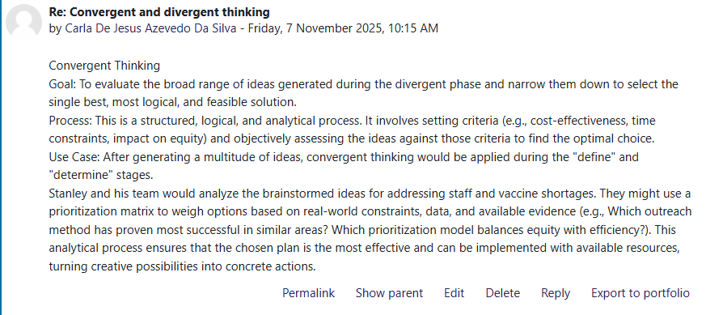

The High Intensity Use (HIU) Service

The High Intensity Use (HIU) service, which uses artificial intelligence (AI) to proactively identify and help frequent users of emergency services, is an example of an innovative NHS inniative. The goals of this project are to lessen the burden on A&E departments, treat the underlying reasons of recurrent hospital visits, and deliver more individualized and appropriate care (NHS,2024).
Furthermore, to its innovative use of technology, the HIU service is innovative in its human-centered approach to care. Changing from reactive to proactive care, the service employs AI and data analytics to proactively identify at-risk individuals is one of the main innovative applications. Coaching that is holistic and person-centered the innovation addresses the underlying social, emotional, and financial reasons that contribute to frequent use of A&E in addition to medical treatment. Collaborative community and social enterprise (VCSE) organizations and independence to innovate this grants HIU leads the ‘freedom to act and freedom to innovate’ allowing creative problem-solving tailored to each individuals unique situation (NHS,2022).
The HIU service was developed to solve the serious issue of high-intensity users, or frequent ED visitors.
Issue, unplanned among a tiny segment of the population. Limited resources, the large number of non-medical or complex-needs visits puts a tremendous strain on the hospital’s capacity and staff time in the emergency department. Inadequate personal care, episodic and reactive emergency care is frequently unsuitable and ineffectual for the underlying problems of high-intensity users. It results in a cycle of reliance on emergency services, poor health outcomes and isolation (NHS,2025).
The whole healthcare system benefits greatly from the HIU service. Value for clients and patients are enhanced well-being patients report more wellbeing, reduced loneliness, and increased confidence in managing their health. More suitable treatment for patients whose demands are not primarily medical, the service offers a more appropriate method and decreased stigma the service lessens the possibility of stigma that regular attendees may experience while engaging with emergency personnel by educating staff and offering regular personal support plans. The values for employees are enhanced self-assurance, workload was decreased, and procedures were streamlined (Health Innovation Network, 2025).
Numerous reports and studies have demonstrated notable benefits, such as decreased hospital admissions: in the West of England, hospital admissions for enrolled high-impact users were reduced by 67% because of the supporting high impact users in emergency departments (SHarED) study (Health Innovation West of England, 2025).
By radically rethinking the care model for regular emergency service consumers, the High Intensity Use (HIU) service exhibits a unique approach. It takes a proactive, comprehensive, and person-centered approach in place of a reactive, crisis-driven cycle (NHS, 2025).
There is strong evidence from numerous assessments and expert sources that the HIU service is effective.
The Red Cross of Britain, a 2023 study called ‘Seen and Heard’ describes the effects of British Red Cross-sponsored HIU services. For instance, decreased attendance, decreased transportation and admissions (British Red Cross, 2023).

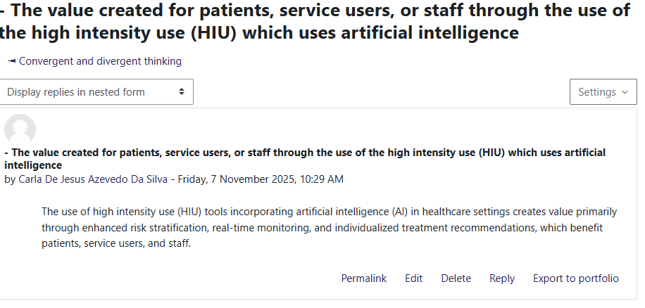

Isolation Among Older Adults

A current issue in health in social care is the isolation among older adults. There are more obstacles to healthcare equity, particularly considering the COVID-19 epidemic. To enhance older people’s health and quality of life, interventions must consider both their subjective experiences and systemic injustices. It is stressed that equity-based and person-centred strategies are required to reduce the detrimental health effects of social isolation in this vulnerable group (Dassieu, L.and Sourial, N.2021).
‘Health is much more strongly associated with chronic loneliness than living alone. One in ten adults who live alone report chronic loneliness, while nearly three in ten adults in bad health are chronically lonely’ (Orso, L. et al 2021).
‘Several interconnected variables contribute to elderly persons feeling isolated. Social isolation is largely caused by structural constraints, especially for low-income older persons residing in social housing, such as unstable income and restricted access to social activities.
Participation in the community and social support networks may be impeded by these obstacles
Anxiety and depression are two psychological conditions that are closely linked to elevated feelings of loneliness because they might lower motivation or the capacity to sustain social relationships’ (Agarwal, G. et al 2021)
We can comprehend some of the causes of this issue in health and social care by using these two academic sources.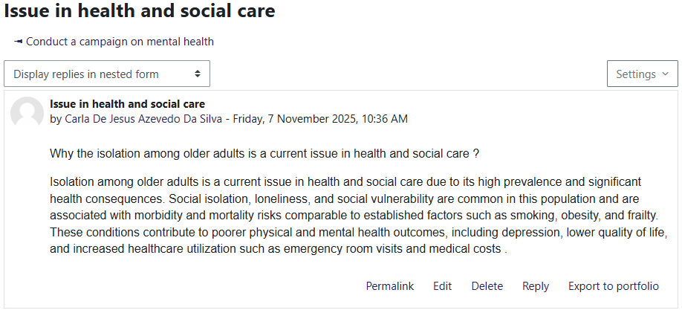

Digital Innovation in Health and Social Care

Digital Innovation is being used in the health and social care sectors to improve patient participation, data management, communication, and tailored care. Although Health initiatives that improve access to health information and services have been made possible by advancements in information and communication technologies (ICTs), such as mobile phones and the internet, there are still issues in settings with limited resources because of fragmented data systems and unequal access to electronic health records. For example, digital health advances, such as AI-driven tracking apps, big data analytics for forecasting health outcomes, and telemedicine services that preserved access to health during lockdowns, were propelled by the COVID-19 pandemic (Hadiiat, Y. 2023)
The ability of wearable health technologies to offer ongoing, customized monitoring that facilities early detection, patient involvement, and customized interventions is one benefit in the management of chronic diseases, potentially enhancing health outcomes and quality of life those with chronic conditions
To maximize the collaborative affordances of EHRs and overcome obstacles as information overload and administrative complexity, coordinated organizational, technical, and behavioural adjustments are necessary (Vos, J.F.J et al 2020).
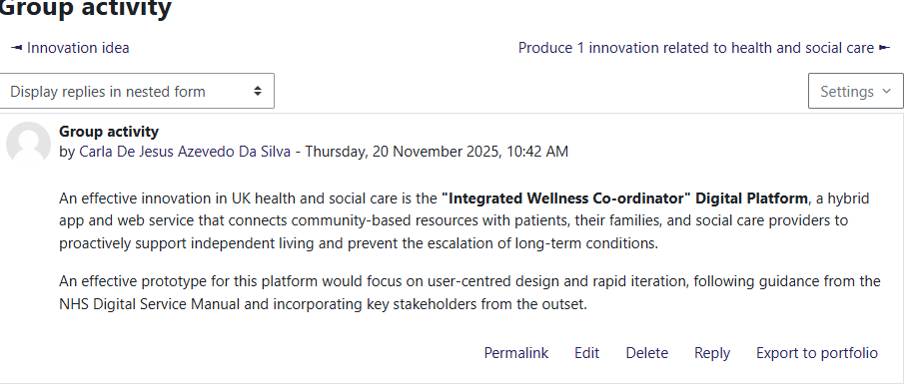

Understanding the NHS Leadership Framework

Effective leadership at all levels of the National Health Service is guided and encouraged by the NHS Leadership Framework. Its goal is to assist people in comprehending the abilities, attitudes, and traits required to provide high-quality care, enhance services, and promote an inclusive and positive workplace culture.
The framework outlines essential leadership skills that are applicable to all NHS employees, regardless of their clinical or non-clinical jobs. These involve assessing data, building capacity, providing compassionate leadership, communicating the vision, motivating the team influencing for results and trying our service collectively. It matters because organizational performance, employee well-being, and patient outcomes are all directly impacted by positive, values-based leadership. The NHS Leadership Framework helps develop leaders who can motivate others, effectively handle change, and guarantee that patient care stays at the centre of every decision-making by encouraging self-awareness and continual growth (NHS England, 2024).
Developing Capability is one type of leadership behaviour, and foster creativity, this behaviour focuses on assisting individuals and teams in their learning and growth. By establishing a secure space for employees to exchange innovative ideas and learn from errors, a leader can leverage building capability to promote creativity and innovation. For instance, a hospital ward manager may have frequent ‘innovation discussions’ where nurses and healthcare professionals can propose minor adjustments to enhance patient care, for instance better ways to schedule handovers or lower prescriptions errors. This strategy is consistent with transformational leadership, in which leaders encourage employees to realize their full potential and support organizational objectives (Bass & Riggio, 2006).
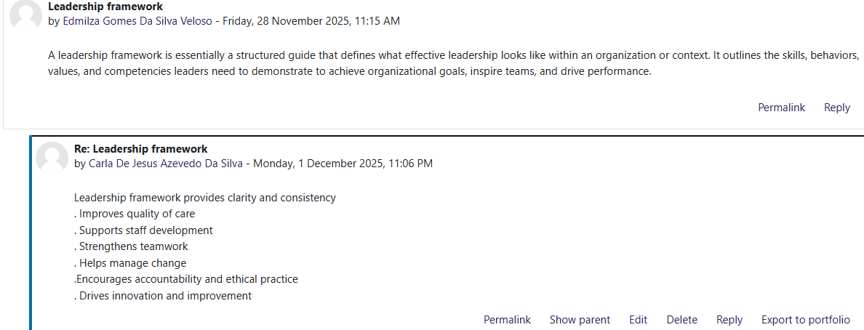

Self-Reflection

When considering innovation, creativity, and value creation in health and social care, several interrelated insights become apparent. In the healthcare industry, creativity frequently arises from front-line workers responding to crises or system breakdowns. Their knowledge allows them to come up with original and practical ideas that not only solve immediate issues but also have an impact on organizational outcomes and their own well-being.
The research methods group activity from week three was the assignment that altered my viewpoint. I discovered that there are various research methodologies, techniques, and processes in the fields of health and social care, each with a unique goal.
I will be able to utilize qualitative and quantitative research in a complementary way mixed-methods approach to inform practice, assess initiative, and develop policy in my future career.

References
- British Red Cross (2023) Seen and heard: Understanding frequent attendance at A&E. Available at: Exploring high-intensity use of Accident and Emergency. (Accessed 20 October 2025).
- Choi, Y. et al. (2025) ‘Think Creatively Outside the Search Box: Divergent and Convergent Thinking Using Creativity Support Search Tools’, Proceedings of the Association for Information Science and Technology, 62(1), pp. 138–149. Available at: https://doi.org/10.1002/pra2.1243.

- Dassieu, L. and Sourial, N. (2021) ‘Tailoring interventions for social isolation among older persons during the COVID-19 pandemic: challenges and pathways to healthcare equity’, International journal for equity in health, 20(1). Available at: https://doi.org/10.1186/s12939-020-01360-8. (Accessed 24October 2025).

- Health Innovation West of England (2025). SHarED: Supporting high impact users in Emergency Departments. Available at: SHarED: supporting high impact users in Emergency Departments. (Accessed 14 October 2025).

- Hadjiat, Y. (2023) ‘Healthcare inequity and digital health–A bridge for the divide, or further erosion of the chasm?’, PLOS digital health, 2(6), p. e0000268. Available at: https://doi.org/10.1371/journal.pdig.0000268.(Accessed 7 November 2025).

- Health Innovation Network (2024). Supporting high impact users to reduce demand for emergency care. Available at: Supporting high impact users to reduce demand for emergency care - The Health Innovation Network. (Accessed 20 October 2025).
- I2Comply (2023) Rachel Bailleau. What is the Root Cause Analysis. Available at: What is Root Cause Analysis? | i2Comply. (Accessed 15 October2025).
- Lages, L.F. et al. (2020) ‘Frameworks for innovation, collaboration, and change: Value creation wheel, design thinking, creative problem‐solving, and lean’, IDEAS Working Paper Series from RePEc, 29(2), pp. 195–213. Available at: https://doi.org/10.1002/jsc.2321. (Accessed 13 October 2025).
- Nesta (2021) Loneliness, obesity and health in England in nine charts. Available at: Loneliness, obesity and health in England in nine charts | Nesta. (Accessed 24 October 2025).

- NHS England (2025) Black Country Health Care. World Mental Health Day Spotlight: From existing to living, a look at the High Intensity Use Service. Available at: World Mental Health Day Spotlight: From existing to living, a look at the High Intensity Use Service :: Black Country Healthcare NHS Foundation Trust. (Accessed 20 October 2025).
- NHS England (2022) Setting up a high intensity use service. Available at: NHS England » Setting up a high intensity use service. (Accessed 19 October 2025).
- NHS England (2025) High Intensity Use Programme. Available at: NHS England » High Intensity Use programme (Accessed 14 October2025).
- NHS England (2022) NHS artificial intelligence (AI) giving patients better care and support. Available at: NHS England » NHS artificial intelligence (AI) giving patients better care and support. (Accessed 21 October 2025).
- NHS England (2019) Clinical Leadership- a framework for cation. Available at: NHS England » Clinical leadership – a framework for action. (Accessed on 13 November 2025).
- NHS England (2024) Nhs leadership competency framework for board members. Available at: NHS England » NHS leadership competency framework for board members. (Accessed 13 November 2025).
- Patrício, L. et al. (2020) ‘Leveraging service design for healthcare transformation: toward people-cantered, integrated, and technology-enabled healthcare systems’, International journal of service industry management, 31(5), pp. 889–909. Available at: https://doi.org/10.1108/JOSM-11-2019-0332. (Accessed 20 October 2025).
- Rodriguez, M., Dooley, K.E. and Roberts, T.G. (2024) ‘A Phenomenological Study of Intensive Experiential Learning for University Faculty Professional Development’, The Journal of experiential education, 47(4), pp. 685–703. Available at: https://doi.org/10.1177/10538259241235915 (Accessed 7 November 2025).
- Sjödin, D. et al. (2020) ‘Value Creation and Value Capture Alignment in Business Model Innovation: A Process View on Outcome‐Based Business Models’, The Journal of product innovation management, 37(2), pp. 158–183. Available at: https://doi.org/10.1111/jpim.12516. (Accessed 21 October2025).
- Singh, S. and Aggarwal, Y. (2022) ‘In search of a consensus definition of innovation: a qualitative synthesis of 208 definitions using grounded theory approach’, Innovation (Abingdon, England), 35(2), pp. 177–195. Available at: https://doi.org/10.1080/13511610.2021.1925526. (Accessed 21 October 2025).
- Vos, J.F.J. et al. (2020) ‘The influence of electronic health record use on collaboration among medical specialties’, BMC health services research, 20(1). Available at: https://doi.org/10.1186/s12913-020-05542-6. (Accessed 7 November 2025).

- Wise, N., Gökbulut Özdemir, Ö. and Fillis, I. (2023) ‘Creative entrepreneurship, urban transformation and the (Baltic) triangle model’, Journal of research in marketing and entrepreneurship, 24(2), pp. 385–404. Available at: https://doi.org/10.1108/JRME-02-2021-0017. (Accessed 16 October 2025).

