Sophie Pitcock
P150414

Contextual practice
Louise Burton and Sarah Tombs

“How do we remember? Using at least three examples, discuss the social, political and historical aspects of commemoration.”

Word count: 2201 words

Within this assignment the art of commemoration will be discussed, having a comprehensive look at the social, political and historical aspects behind it in hope to answer the question ‘How do we remember?’
The third edition Oxford English dictionary definition of commemoration describes it as “the act of honouring the memory of or serving as a memorial to someone or something.” (Stevenson, 2010) This could imply that generally the act of commemoration is a way of paying tribute to those who have had a part to play in the significant historical events in our cultures history.
Joseph Campbell once stated “A hero is someone who has given his or her life to something bigger than oneself.” (Campbell, 1988) This could suggest that commemoration is a way of honouring those who have made our lives easier to live through sacrificing their own via a selfless act. The word ‘hero’ implies that we should look up to aspire to these individuals, and starts to give us an idea of why commemorative events are so important in our modern culture.
Each county has its own unique events that it celebrates and different ways of going about this. This differs depending on the history of that country, religious and political convictions and the cultural background of the people living there. This difference can be highlighted when looking at religious commemorative events celebrated around the world. For example, Diwali in India, Dia de los Muertos in Mexico and Semana Santa in Guatemala. Even though these celebrations stand to signify something different for each culture and religion, the underlying themes surrounding the celebrations remains the same. Each of these occasions revolve around inclusive human emotion such as love, loss, joy, despair, achievement and sacrifice.
Author Seline Shenoy who writes specifically about this subject expressed that:
“It seems that as a species we are instinctually driven to honour the significant moments in our lives. There are deep underlying needs that drive us to engage in celebrations. As a result, we have found so many wonderful ways to meet these needs and create more meaning in our lives.” (Shenoy, 2016)
By saying this she is suggesting that our need to commemorate the things that happen to us collectively is innate as it drives us to live a more fulfilled and connected life with the people around us.
The reasons behind why we do this are vast and varied. By commemorating times of significance as a collective, whether it be to celebrate or to mourn, brings us closer together and provides us with a sense of unity. We celebrate the paramount milestones in our lives and the lives of others to give a sense of meaning and significance to our time spent in this world.
Historian and professor J. Winter when writing for The Brill Dictionary of Religion stated that:
“Public commemoration is a matrix of activity, through which social groups express a collective shared knowledge of the past, on which a groups sense of unity is based.” (Winter, 2007)
Winter suggests that commemoration in a social sense is a community of people gathering to remember the same thing on the same day, and with this we develop a bond through our shared past experiences. An example of this would be Christmas, an event originally started by the Christian faith to celebrate the birth of Jesus. As time has moved on, the original meaning behind celebrating this event has somewhat lost what it stood for and transformed into something slightly different. Less people are celebrating Christmas in a religious sense and are instead using it as a time to create long-lasting fond memories with their loved ones. This can be seen when looking at a few statistics from recent Christmases. It is approximated that last year the U.K. consumed approximately 10 million turkeys but in 2014 only 2.4 million people attended a festive Church of England service. These statistics suggest that there are more people partaking in the social aspect of celebrating the festive period than the religious aspect, which were the primary origins for this commemorative event.
Winter also wrote for the International Encyclopaedia of the Social and Behavioural Sciences stating that:
“All forms of public commemoration have a half-life; the initial charge that they bear diminishes when those who create it move away, grow old, or turn to other interests. Then newcomers take over and transform an event within one context into another.” (Winter, 2001)
This could support the idea that the original meaning behind commemorative events has the ability to change and adapt through different generations as time goes on. Another example of this occurring could be the Pagan holiday of May Day, where dancing around a maypole and Morris dancing were a way of celebrating love and romance on the first day of May. Because of the celebrations strong roots in the Pagan religion, when Paganism became less popular, fewer and fewer people began to celebrate May day in the same way that it was originally celebrated. Over time commemorative events have changed due to change in culture and religion.
When you look at the act of commemoration in a political sense rather than a social sense the general themes shift from those of celebration to memorial. For example, on Remembrance day we wear poppies to symbolise the memory of sacrifices made by soldiers in past wars. By wearing the poppy it serves as a reminder of the awful things that happened politically within our country and to not let them happen again.
When writing about commemoration researcher and author Andrew Whitmarsh declared that:
“The twentieth century saw the development of commemorative traditions: customs and narratives by which individuals, groups and nations remember, commemorate and attempt to resolve memories of the traumatic experience that is war.” (Whitmarsh, 2001)
Whitmarsh suggests that by commemorating the distressing things that have happened to our country, it can provide the people involved with a bit of closure. By everyone standing together to remember the people who sacrificed their lives for ours, it shows a collective appreciation for those people. By remembering that these horrible situations happened, it makes the original events a little bit more bearable to emotionally deal with.
This could also imply that there are certain social pressures that go hand in hand with political commemoration. For example, if you were not to wear a poppy on Remembrance day this may be viewed as a political statement against the troops and everything they did. To avoid confrontation people may join in with this commemoration and that’s what carries it on.
Dr Dominic Bryan specified in the Knowledge Exchange Seminar Series, which promoted evidence led policy and law making within Northern Ireland, that:
“Commemoration of historical events has important current political relevance… where contested events from the past have the potential to both upset and enhance community relations” (D. Bryan 2016)
This stating this Dr Bryan could be suggesting that political commemoration could also cause protest. An example of this could be that in Christchurch on Anzac day in 1967 a protest wreath was placed as a way of protesting the people’s views opposing the Vietnam war. Ten years later more protest arose when another wreath was laid by a women’s group in memory of the women that were raped and killed during the war. It was felt that the protestors were dishonouring the memorial by turning the day into a platform to voice their political opinions. As a result, Anzac day is a day of both commemoration and a celebration of nationhood. They now claim that they debate defence against war related issues to avoid the need to build war memorials in the future.
Sir Seretse Khama President of Botswana once famously proclaimed during a speech to the people of Africa that:
“A nation without a past is a lost nation and a people without a past is a people without a soul.” (Khama. S 1970)
Sir Seretse Khama could be suggesting that because we have a past it completes us in some way, and to remember this past pays respect to our ancestors who made history for our culture. Celebrating and commemorating our past is a way of building a collective memory and develops a social unity, it brings us together as a nation.
Public holidays and national events are a way of commemorating historical significance. An example of this would be Guy Falkes night. Every year we join together and set off fireworks to remember one specific night in our nation’s history where one man’s plans to overthrow the government and monarchy failed.
An English folk verse was created proceeding the event (c.1870):
“Remember remember the fifth of November
Gunpowder, treason and plot
I see no reason why gunpowder treason
Should ever be forgot.”
Teaching these nursery rhymes to our children could be considered an act of commemoration in itself, that along with actually celebrating the event every year helps us to teach the generations below us the defining moments in our nation’s history whilst still coming together and having a good time.
Art is a medium that can be used to express people’s commemorative views. For example, to mark a century since the start of World War one, in July 2014 street theatre company Royal de Luxe created giant marionettes and walked them through the city of Liverpool. The art piece was titled ‘Memories of 1914.’
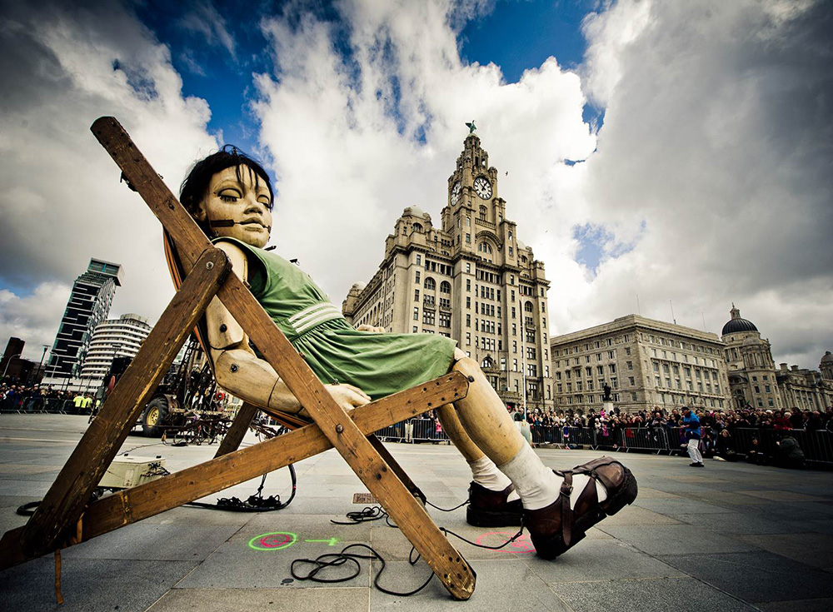
Royal de Luxe (2014). Sea Odyssey Giant Spectacular.
Commemorating crucial moments in time through the medium of art engages with us in a far more significant way than any other form of commemoration would be able to. This is due to the fact that it is so visual, we can see it and its tangible and this makes the reasoning behind the experience far easier to emotionally process.
Another act of commemoration that has been shown through the use of art is that of the Holocaust survivors. By creating a self-portrait in relation to a specific moment in time the artist is encapsulating their emotions indefinitely, we then as the viewer can look back on and remember what caused them to look this way.
Self-portraits are an extremely intimate form of art as they can express a plethora of information, including how the artist was feeling, the state that their mind was in and what was going on in their life at the time.
Professor and Author Sheryl Silver Ochayon who teaches for the International School for Holocaust Studies commented on these self-portraits saying:
“At times, rather than expressing identity in a recognizable form, they express a jarring loss of identity, the result of the trauma experienced by the artist.” (Ochayon. S, 2018)
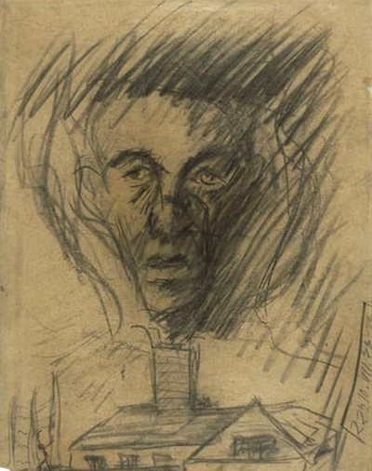
“Yehuda Bacon (b.1929), In Memory of the Czech Transport to the Gas Chambers. 1945. Charcoal on paper”
The portrait shows a face that comes across as gaunt and exhausted rising from a chimney, presumably a gas chamber. By creating this art, it makes the memory of the event live on, commemorating the thousands of deaths that happened in this way. It ensures that the lives of many mistreated people won’t be forgotten.
We see a human face in front of us, making the image instantly recognisable and relatable. Powerful imagery is used causing the piece to be hard to dismiss and easily memorable. The paramountcy of importance of this art work is highlighted when taking into account that the artist was only sixteen when he created this dark and comfortless piece. It reminds us of the awful things that happened to the innocent, and how we cannot let them happen again.
To conclude, we remember in a number of ways for a variety of different reasons. It appears that we commemorate not only to remember and honour our predecessors, but also to serve ourselves in modern day society, with commemorative events giving us a stronger and more defined cultural identity.

Bibliography
Books
Stevenson, A (2010) The Oxford Dictionary of English. OUP Oxford
Campbell, J., Moyers, B. (1991) The Power of Myth. USA: Anchor books
Winter, J (2007) The Brill dictionary of Religion. Brill books
Winter, J (2001) The International Encylopedia of the Social and Behavioural Sciences. Pergamon

Journals
Whitmarsh, A., (2001). "We Will Remember Them" Memory and Commemoration in War Museums. Journal of Conservation and Museum Studies. (Accessed: 09 March 2018).

Bryan, D., (2016). “Ireland’s Decade of Commemorations: A Roundtable” New Hibernia Review. pp.63-86 (Accessed: 09 March 2018).
Yadvashem.org. (2018). Commemoration in the Art of Holocaust Survivors - Education & E-Learning. [online] Available at: http://www.yadvashem.org/yv/en/education/newsletter/26/main_article.asp [Accessed 19 Mar. 2018].

Websites
Nzhistory.govt.nz. (2018). Modern Anzac Day - Anzac Day | NZHistory, New Zealand history online. [online] Available at: https://nzhistory.govt.nz/war/modern-anzac-day [Accessed 19 Mar. 2018].
Thuto.org. (2018). A Nation Without A Past - Sir Seretse Khama. [online] Available at: http://www.thuto.org/ubh/bw/skquote1.htm [Accessed 19 Mar. 2018].
Royal-de-luxe.com. (2018). Giants spectacular - Royal de Luxe. [online] Available at: https://www.royal-de-luxe.com/en/creative-work/giant-spectacular/ [Accessed 19 Mar. 2018].

Pictures
Royal de Luxe (2014). Sea Odyssey Giant Spectacular. [image].
Yehuda Bacon (b.1929), In Memory of the Czech Transport to the Gas Chambers. 1945. Charcoal on paper. [image].

