30 September 2024


Zara John - Nicholls

Topic: The Role of Leadership in Balancing Employee Well-being and Sustainability in The Passport & Immigration Department/Government Sector in St Vincent and the Grenadines
[Document subtitle]

Topic: The Role of Leadership in Balancing Employee Well-being and Sustainability in The Passport & Immigration Department/Government Sector in St Vincent and the Grenadines
[Document subtitle]
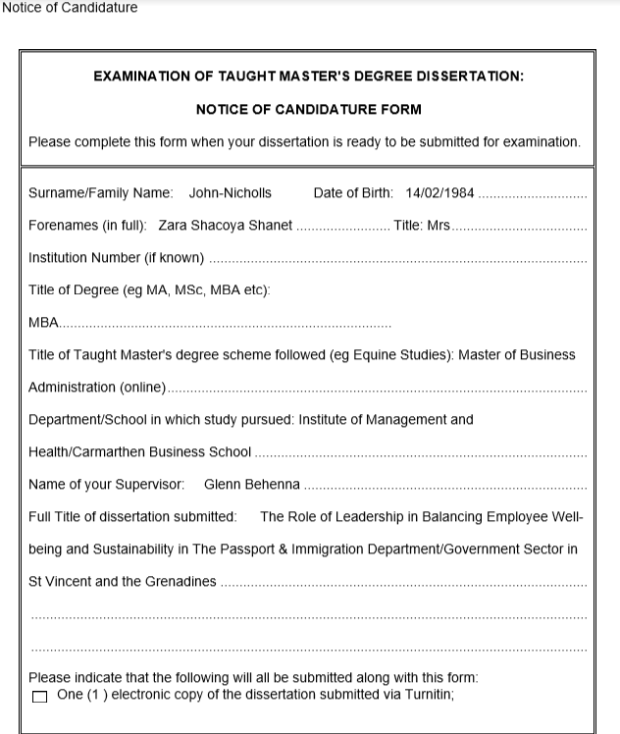

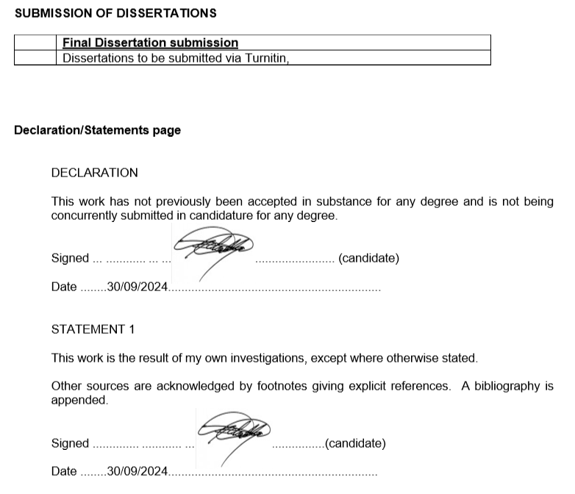

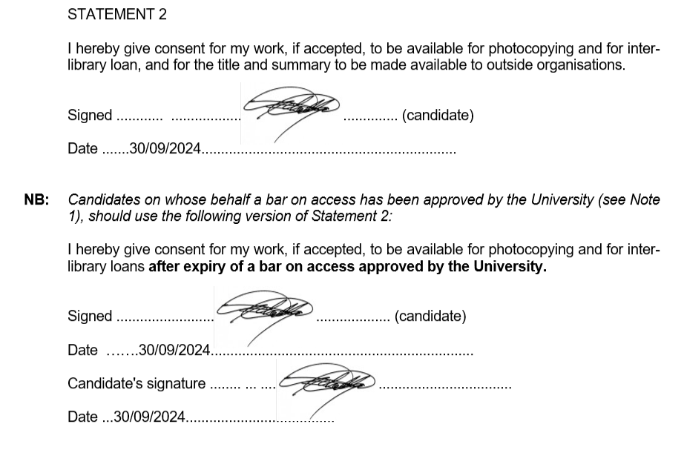

Acknowledgement
I am deeply grateful to the Almighty God for granting me life, health, and strength, allowing me to achieve one of my life goals pursuing and earning a master’s degree.
I sincerely appreciate the encouragement, perseverance, and unwavering support I received throughout my dissertation journey. With God's grace and the steadfast support of my loved ones, I have reached this important milestone in my academic career. This work is dedicated to my daughter, Zarielle Nicholls; my late husband, Jonathan Nicholls, who always encouraged me to pursue my MBA; my mentor and friend Lennox Boman, who stepped in after my husband's passing; my sister Chavela John; and my mother, Zelma Williams, for their endless support throughout my MBA studies. Their confidence in my abilities has motivated my academic journey, and I am deeply thankful for their love and guidance.
I would also like to extend my gratitude to my supervisor, Dr. Glenn Behenna, Senior Lecturer, for his outstanding supervision, guidance, patience, and understanding throughout the MBA program. His mentorship and expertise were invaluable in navigating the complexities of my dissertation and have significantly shaped my growth as a student and professional. My gratitude extends to the faculty members, whose flexibility and understanding, particularly during the challenges brought by Hurricane Beryl, allowed me and my colleague to continue our studies without worry. This support was crucial in helping us persevere through such a difficult time.
Lastly, I thank my friend, Sherika Shallow, for her honest feedback and encouragement throughout the MBA program, as well as everyone who participated in my research survey. To all who contributed in any way, your support made the completion of this challenging task possible.

Table of Contents
Abstract 11
Chapter 1: Introduction 14
1.1 Introduction 14
1.2 Background 16
1.3 Reasons to Choose the Topic 16
1.4 Aim/Purpose 17
1.5 Objective of the study 17
1.6 Significance of the Study 17
1.7 Research Problem 18
1.8 Research Questions: 18
1.9 Scope and Limitations 20
Chapter 2: Literature Review 21
2.1 Introduction 21
2.1.2 Employee Development and Personal Growth 24
2.1.3 Job Satisfaction 26
2.1.4 Reducing Stress 27
2.1.5 Conclusion 29
2.2 Introduction: 29
2.2.1 Governmental Sustainability Definition 30
2.2.2 A Comprehensive Examination of Sustainability Practices 30
2.2.3 Sustainable Development in the Immigration and Passport Departments 30
2.2.4 The passport and immigration departments' present sustainability practices 30
2.2.5 Initiatives toward digital transformation 31
2.2.6 Case Studies: 31
2.2.6.4 The Impact of Sustainability on Immigration Departments and Businesses on Employee Well-Being. 32
2.2.6.5 Challenges in implementing sustainability practices and areas for improvement 33
2.3.1 Leadership and Its Impact on Organizations 37
2.3.2 Employee Well-being and Its Organizational Significance 38
2.3.3 Sustainability in Organizational Practices 39
2.3.4 The Interrelationship of Leadership, Employee Well-being, and Sustainability 39
2.3.5 Conclusion 40
2.4.1 UK Home Office and U.S. Citizenship and Immigration Services (USCIS): Promoting Sustainability and Well-being 41
2.4.1.1 Promoting Employee Well-being 41
2.4.1.2 Sustainability Initiatives 42
2.4.1.3 Outcomes and Impact 42
2.4.2 Patagonia: Commitment to Environmental and Employee Welfare 43
2.4.2.1 Employee Welfare 43
2.4.2.2 Environmental Sustainability 43
2.4.2.3 Outcomes and Impact 44
CHAPTER 03: RESEARCH METHODOLOGY 45
3.1 Introduction 45
3.2. Research Strategy 47
3.3. Methodological Choice/Philosophy: 49
3.4 Research Design 50
3.5. Time Horizon 50
3.6. Data collection 51
3.7. Research Sample: 54
3.8. Ethical Considerations 55
3.9. Research Credibility and Validity 55
3.10. Expected Study Limitations 55
4.1 Introduction 58
4.2 Data Analysis and Discussion: Leadership, Employee Well-being, and Sustainability in the Passport and Immigration Department 59
4.3 Data Analysis for Sections of questionnaires for employees and management in the Passport and Immigration Department 59
1 Cross-Tabulations: Management vs. Staff 59
2 Correlation Table: Management vs. Staff 61
3. Descriptive Statistics: Management vs. Staff 62
1. Cross-Tabulations: Management vs. Staff 65
1. Correlation Tables: Management vs. Staff 67
3. Descriptive Statistics: Management vs Staff 68
4. Interpretation: Combined Analysis 69
4.3.2.1 Comparative analysis of leadership approaches 70
Interpretation: 70
1. Cross-tabulations (Management vs. Staff Responses) 72
2. Correlation Tables (Management vs. Staff) 73
4. Descriptive Statistics (Staff and Management Responses) 74
4. Summary Table Combining Staff and Management Data (Sustainability and Well-being) 75
4.4 Critical Hypothesis Statements: 76
4.5 Thematic Analysis Table: Management vs Staff Perspectives 76
4.6 Critical Interpretation and Discussion of Hypotheses Using Thematic Analysis: 78
Chapter 5 Conclusion 81
5.1 Conclusion: 81
Recommendations 84
5.2 Critical Recommendations and Conclusions Based on Data Analysis Findings 84
Introduction 84
References 90
Appendices 104
105
Appendix 1: Staff Questionnaire /Graphs 105
Appendix 2: Interview Questionnaire 139
Appendix 3: Ethical Form 171
Apendix 4: Participation Agreement Form 188
Appendix 5: Strategic framework for effective Health and wellbeing strategy 189
Appendix 6: Leadership Style 190
Appendix 7: Employee Well-being 190

List of tables
Table 1: Comparative Analysis of Transformational, Democratic and Autocratic Leadership in Promoting Intellectual Stimulation, Individualized Consideration, Employee Personal Growth and Development, Job Satisfaction, and Stress Reduction in organisations 24
Table 2: Comprehensive table comparing Transformational, Democratic, and Autocratic leadership theories across several key dimensions 25
Table 3: Section for Questionnaire for Management and Employee 55
Table 4: Age and Gender Cross-Tabulation 62
Table 5: Education Level and Gender Cross-Tabulation 63
Table 6: Years of Service and Gender Cross-Tabulation 63
Table 7: Correlation Table: Management vs. Staff 64
Table 8: Descriptive Statistics: Management vs. Staff 65
Table 9: Cross-tabulation of Leadership Style vs Leadership Effectiveness (Management vs Staff) 68
Table 10: Cross-tabulation of Well-being Resources Availability vs Satisfaction with Well-being Initiatives (Management vs Staff) 69
Table 11: Correlation Tables: Management vs. Staff 70
Table 12: Staff Data Descriptive Statistics 71
Table 13: Management Data Descriptive Statistics 71
Table 14: Question Cross-tabulation based on the hypothetical responses to the questionnaire CPO, IM and EAP. 73
Table 15: Cross-tabulation for "Balancing Employee Well-being and Sustainability" Appendix 1& 2: (Q25 for Staff vs. Q19 for Management) 75
Table 16: Correlation between Job Satisfaction Appendix 1 (Staff Q29) and Leadership Impact on Sustainability (Management Appendix 2: Q22) 76
Table 17: Descriptive Statistics for Staff (Well-being and Satisfaction - Q25-Q31) 77
Table 18: Descriptive Statistics for Management (Barriers to Sustainability - Q19, Q20) 77
Table 19: Summary Table Combining Staff and Management Data (Sustainability and Well-being. 78
Table 20: Thematic Analysis Table: Management vs Staff Perspectives 80
Table 21: Data Point 92

List of Figures
Figure 1: The Research Onion of Mark Saunders.Source: ©2019 Mark Saunders, Philip Lewis and Adrian Thornhill (Saunders et al., 2019 49
Figure 2 Qualitative and Quantitative Data 53
Figure 3 Descriptive Statistics: Simplifying Data 53
Figure 4. Management Likert Scale 57
Figure 5. Management Likert Scale 57
Figure 6.Staff Likert Scale 57
Figure 7. Staff Likert Scale 57

Abstract
How leadership fits into the larger scheme of accomplishing important department goals is frequently unclear. By analyzing the leader's role in striking a balance between sustainability and employee well-being within The Passport & Immigration Department, this study fills a vacuum in the research literature. This department's leaders need to be crucial in setting an inspiring vision and fostering an environment that is more harmonic, high-performing, inclusive, caring, and sustainable. (Gupta, 2021)
The study delves into the specific leadership practices and strategies that have been successful in promoting both employee well-being and sustainability in this particular setting. By examining the intersection of leadership, employee well-being, and sustainability, this research aims to provide valuable insights for leaders in the government sector seeking to create a positive impact on both their employees and the environment.
With an emphasis on the effectiveness of leadership in promoting and balancing employee well-being, sharpening workplace culture, implementing sustainability practices within the department, and employees' perspectives on leadership's impact on their work environment, this dissertation examines the current state of employee well-being in the Passport and Immigration Department of St. Vincent and the Grenadines/Government Service. The need for sustainable practices and employee well-being is becoming more and more important for public sector companies. Leadership plays a critical role in achieving these two objectives.
A deliberate effort should be made at all departmental levels, to achieve a fair balance between the requirements, expectations, and welfare of the employees, their department, and the government service. Employee cohesion and a sense of belonging should be promoted, and operational management excellence founded on shared values should be enhanced. To strike this balance, one must show that they are dedicated to setting aside time, keeping lines of communication open, and offering ongoing, encouraging connections. It also necessitates a great ability to communicate and shape visions, missions, and values, which increases employee accountability, intrinsic drive, and engagement. Employees are motivated by their mental, emotional, and spiritual dispositions, creating a win-win situation for the department/government sector regardless of monetary compensation or outside incentives.
The research employs a mixed-methods approach to investigate the impact of leadership styles on the implementation of sustainability and well-being programs within the Passport and Immigration Department. This involves conducting quantitative staff surveys and qualitative interviews with departmental heads. By integrating both quantitative and qualitative data, researchers aim to develop a comprehensive understanding of the subject matter, leading to more robust conclusions and recommendations. This approach enables a more nuanced analysis, revealing underlying patterns or relationships that may not be discernible through a single method alone (Creswell, 2009).
The study delves into the challenges faced by leaders in balancing department objectives and well-being amid resource limitations. It also evaluates how leadership influences workplace culture, and employee satisfaction, and the strategies employed to achieve these objectives. Notably, the research underscores the role of transformational leadership in fostering a work environment that supports sustainable operational practices and employee well-being. The findings underline the significance of strategic and visionary leadership in achieving a successful balance between sustainability and employee well-being. Additionally, the study identifies persistent obstacles in fully integrating sustainability into daily behaviors, despite substantial efforts to enhance well-being.
Recognising these dynamics is essential for developing leadership strategies that boost employee satisfaction and promote sustainable practices, ultimately resulting in enhanced public service delivery in St. Vincent and the Grenadines. To effectively manage the public sector, it is imperative to comprehend the impact of sustainability challenges, employee well-being, training, employee management and development, leadership, and management practices on sustainability within the Passport and Immigration Department. Addressing these factors can facilitate the creation of a more sustainable work environment, benefiting employees while enhancing the overall efficiency and effectiveness of the department.
Implementing training programs focused on sustainability and well-being, fostering a culture of open communication and collaboration, and providing opportunities for professional growth and development are crucial steps in achieving this goal. Recognizing and overcoming these obstacles will enable the Passport and Immigration Department to play a pivotal role in promoting sustainability and delivering high-quality public services to the people of St. Vincent and the Grenadines. The research will provide recommendations for enhancing leadership practices to promote a harmonious balance between these critical aspects.

Chapter 1: Introduction

1.1 Introduction
The Passport and Immigration Department (PID) a crucial role in government-to-government interaction and facilitation of migration flows, both essential for the economy of small-sized countries like St Vincent and the Grenadines (SVG). However, in attempting to deliver these roles, staff members in the department face a high workload that negatively impacts their psychological well-being.
Another challenge the department encounters is the difficulty in effectively utilizing its resources to attain economic objectives while preserving generational equity in delivering security and services to the public. This challenge aligns with the dimensions of sustainability: economic, social, and environmental. Since SVG is a Small Island Developing State (SIDS), strategically managing the nation's human capital is vital for ongoing progress.Baldacchino, G., 2020.
The pilot study examined The Role of Leadership in Balancing Employee Well-being and Sustainability in the Immigration department in St Vincent and the Grenadines. It is a relevant and important topic that intersects multiple critical aspects of organizational management. Government employees often face unique challenges related to bureaucracy, complex regulations, training cycle issues, motivational challenges, Governance, and high-pressure environments. Exploring how proper leadership in these issues above can contribute to a sustainable organization and employee well-being which is essential for creating a positive stable and productive work environment and improving employee job satisfaction.

Leadership plays a crucial role in balancing employee well-being with organizational objectives, which is vital for enhancing overall government performance. In the Passport and Immigration Department of St. Vincent and the Grenadines, there is a need for innovative leadership to focus on strategies that build employee capacity. Currently, the department’s strategy offers limited opportunities for experiential learning, job rotation, or job enrichment, which affects job satisfaction despite high performance.
Effective leadership within this sector is essential for ensuring employees' well-being while promoting sustainability and efficiency. By fostering a culture of transparency and accountability, leaders can inspire trust and confidence in both employees and the general public. Additionally, staying abreast of technological advancements and best practices is especially important in SVG.(Mulyawan et al., 2024)
The study's insights seek to pinpoint areas for enhancement within the PID. Development interventions for organizational improvement that educate managers and senior leaders about the economic repercussions of current leadership approaches might motivate them to consciously implement changes that enhance the social environment's positive elements. Border security can help the department adapt to evolving threats and challenges.

By implementing efficacious leadership tactics, establishments can cultivate a climate of openness, confidence, and cooperation that stimulates creativity and expansion. Moreover, fostering worker well-being via encouraging leadership can improve job satisfaction, more output, and lower attrition rates. Ultimately, an organization's success in St. Vincent and the Grenadines depends on its leaders' capacity to manage these challenging situations and prioritise their workers' welfare.

1.2 Background

Overview of St. Vincent and the Grenadines Immigration Department/Government Service:

The Immigration Department of St. Vincent and the Grenadines oversees individuals' entry, stay, and departure from the country. As part of the government service, it plays a crucial role in maintaining national security, managing migration, and ensuring compliance with immigration laws and regulations.

Here is an overview of the Immigration Department and its functions within the government service of St. Vincent and the Grenadines. The Immigration Department of St. Vincent and the Grenadines plays a vital role in managing immigration control at ports of entry, including screening travellers and verifying documents to determine eligibility for entry. It issues visas for foreign nationals, processes residence and work permits, and enforces immigration laws through inspections and actions against violations. The department ensures border security by monitoring for illegal entry and collaborating with law enforcement agencies. It also handles matters related to citizenship, often in coordination with other authorities, and engages in international cooperation on immigration and border security issues. Overall, it ensures effective movement management while safeguarding national security and upholding immigration laws.

Reasons to Choose the Topic
The courses that piqued my interest during my program were Human Resource Management, Strategic Management, and Change and Stability Management. Therefore, selecting a dissertation area of interest was quite exciting. The feasibility of conducting a research topic that combines sustainability, leadership, and human resources within the government sector is a great way to address contemporary challenges.

Aim/Purpose

This dissertation aims to contribute valuable insights into the understanding of the delicate balance required in leadership between employee well-being and sustainability within the Passport and Immigration Department in St Vincent and the Grenadines. Government employees encounter unique problems such as bureaucracy, complex regulations, training, motivation, Governance, and high-pressure conditions. As a result, the purpose of this study is to investigate how appropriate leadership in these abovementioned areas can contribute to a sustainable business, as well as how employee well-being is critical for building a positive, stable, and productive environment at work and increasing employee job satisfaction

Objective of the study

- Investigate the current state of employee well-being.
- Assess the sustainability initiatives in the Immigration/government sector.
- Examine leadership strategies for achieving balance.

1.6 Significance of the Study
- Discuss the broader importance of your research in addressing critical issues faced by the PID
/government sector.
- Emphasize the potential impact on the well-being of immigration/government employees and the nation's sustainable development.

1.7 Research Problem

- Balancing employee well-being and sustainability
- Leadership's pivotal role in achieving balance.

1.8 Research Questions:

These questions aim to explore the intersection of leadership, employee well-being, and sustainability within the specific context of the Passport and Immigration Department in St Vincent and the Grenadines. They can be refined further based on the dissertation's literature review, methodology, and analysis sections. It is essential to ensure that the questions align with my research objectives and contribute to filling gaps in existing knowledge about the role of leadership in balancing employee well-being and sustainability in the Passport and Immigration department.
  - What is the current state of employee well-being in the Passport and Immigration Department in St Vincent and the Grenadines?

  - Leadership and Well-being:
- How do leadership styles within the Passport and Immigration department in SVG impact the overall well-being of employees?

  - Sustainability Practices in Immigration Leadership:
- What sustainable practices are currently implemented by leaders in the Passport and Immigration Department/ sector in SVG?
- How do different leadership styles contribute to implementing and succeeding in these sustainability practices?

  - Employee Perspectives on Leadership:
- What are the key factors employees identify as influential in determining a positive work environment that prioritizes well-being and sustainability?

  - Barriers to Balancing Well-being and Sustainability:
- Is there specific organizational culture or contextual barriers that hinder the effective integration of well-being and sustainability in Immigration management leadership?

  - Impact of Leadership on Workplace Culture:
- How does leadership contribute to shaping the organizational culture in the Passport and Immigration Department SVG, particularly in fostering a culture that values employee well-being and sustainability?

  - Leadership Strategies for Well-being and Sustainability Integration:
- What additional strategies could be implemented to improve the balance between employee well-being and sustainability?
- What leadership strategies have proven effective in successfully integrating employee well-being and sustainability initiatives within government organizations in SVG?

  - Perceived Outcomes of Leadership Initiatives:
- What are the perceived outcomes or impacts of leadership initiatives that balance well-being and sustainability in the Passport and Immigration Department in SVG?
- How can the findings of this study inform leadership practices in other government sectors in St Vincent and the Grenadines?

  - Measurement and Evaluation of Leadership Impact:
- What metrics or indicators are used to measure the impact of leadership on employee well-being and sustainability in the Immigration Department in SVG?
- How do leaders assess the effectiveness of their strategies in achieving desired outcomes in these areas? (Performance appraisal, 360 appraisals).

  - Comparison with Global Best Practices:
- How do leadership practices in the passport and immigration Department in SVG compare with global best practices in promoting employee well-being and sustainability?

1.9 Scope and Limitations
Define the scope of your study, specifying the focus on the PID/government sector in St. Vincent and the Grenadines. Also to acknowledge any limitations or constraints that might impact the generalizability of your findings.

Chapter 2: Literature Review

Table 1: Comparative Analysis of Transformational, Democratic and Autocratic Leadership in Promoting Intellectual Stimulation, Individualized Consideration, Employee Personal Growth and Development, Job Satisfaction, and Stress Reduction in organisations
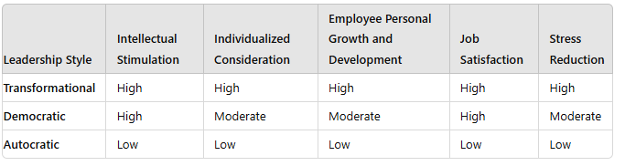

2.1 Leadership Styles and Employee Well-being:

2.1 Introduction

Leadership styles have a significant impact on several different company effects, such as stress reduction, job satisfaction, individual attention, intellectual stimulation, and personal growth and development of employees. This dissertation compares and contrasts democratic, servant, transformational and autocratic leadership philosophies with an emphasis on how these approaches work in immigration offices and corporate settings. Academic study findings will demonstrate how each leadership style influences these critical domains.

Table 2: Comprehensive table comparing Transformational, Democratic, and Autocratic leadership theories across several key dimensions
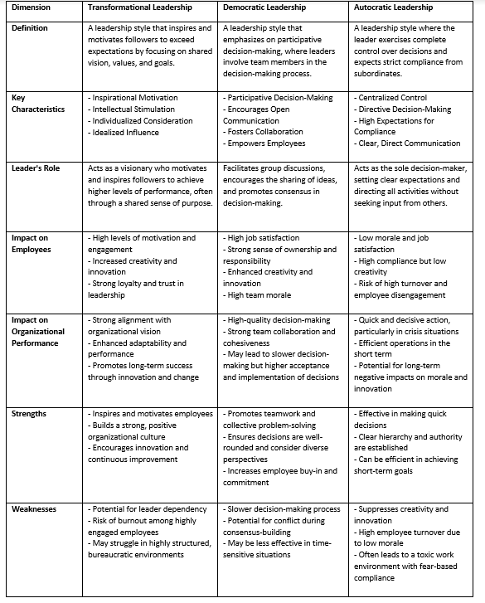
2.1.1 Stimulation of the Mind
Such stimulation prompts employees to question existing assumptions and consider new possibilities, which is vital for personal growth. Intellectual stimulation cultivates a learning mindset among employees, motivating them to pursue ongoing improvement and knowledge acquisition (Avolio & Gardner, 2005), thereby aiding their overall growth and career progression.
Transformational Leadership
Transformational leadership encompasses four key dimensions: intellectual stimulation, individualized consideration, inspirational motivation, and idealized influence (Bass, 1985). Leaders who employ intellectual stimulation encourage staff to challenge assumptions and consider different perspectives, fostering a culture of innovation and improved problem-solving (Bass & Riggio, 2006), aligning with Burns' (1978) transformational leadership theory and supporting the findings in Table 1. Jung, Chow, and Wu (2003) found that transformational leaders who emphasize intellectual stimulation create an environment conducive to creativity, which is vital for dynamic settings like immigration departments. This leadership style enhances task ownership and performance while boosting job satisfaction (Avolio & Bass, 2002). Employees feel valued and are more motivated and loyal (Eisenbeiss, van Knippenberg, & Boerner, 2008). Such leaders also promote continuous learning and development, contributing to personal growth, organizational adaptability, and long-term success (Sosik, Kahai, & Avolio, 1998).

Democratic Leadership
Democratic leaders seek to instil a sense of accountability and ownership in their subordinates and value their followers' opinions (Lewin, Lippitt, & White, 1939) which agrees with research shown in Table 2 above. Democratic leadership promotes participatory decision-making, which stimulates the mind. Workers actively participate in problem-solving and brainstorming sessions, which foster innovation and creativity. According to Gastil (1994), democratic leaders foster a cooperative atmosphere where a range of viewpoints contribute to creative solutions. This is important for immigration offices as well as enterprises.

Autocratic Leadership
Intellectual stimulation, a key element of transformational leadership, encourages creativity, innovation, and critical thinking among employees. However, with its top-down decision-making approach, autocratic leadership often restricts employees' ability to challenge the status quo, limiting intellectual stimulation. As Bass (1985) highlighted and supported by the study in Tables 1 & 2, autocratic leaders may set high-performance standards but rarely foster the environment needed for innovation, as their style tends to discourage open dialogue. Similarly, Lewin, Lippitt, and White (1939) found that autocratic leadership suppresses intellectual stimulation, leading employees to focus more on compliance than creativity. Amabile (1988) further emphasises that creativity thrives in settings where employees feel empowered to take risks, a condition less prevalent in autocratic environments.

2.1.2 Employee Development and Personal Growth

Employee happiness, retention, and overall performance are all impacted by employee development and personal growth, which are vital components of organizational success. In order to demonstrate the significance of employee development and personal growth in contemporary enterprises, this literature review examines important theories, tactics, and results in these areas. Several key concepts, such as social learning theory and human capital theory, underpin employee development. Human Capital Theory, as proposed by (Becker 1964), suggests that enhancing an employee's skills and knowledge raises their value to the company, thereby increasing productivity and competitiveness. Bandura's (1977) Social Learning Theory, emphasize the importance of observational learning, suggesting that employees acquire new skills and behaviours by observing their peers in the workplace.

Transformational Leadership
By motivating staff members to surpass expectations and strive for constant improvement, transformational leadership fosters personal development. Dvir et al. (2002), stated transformational leaders have a big impact on employee development because they inspire their team members to reach better performance and personal development goals, such literature was concurred in Table 1. above.

Democratic Leadership
Democratic leadership fosters personal development by giving workers a voice in decision-making, which builds their competence and self-assurance. Research work by Hackman and Johnson (2009), expounds how democratic leaders encourage employee growth by using participative leadership, which gives staff members the freedom to take initiative and advance their skills. Kurt Lewin is another theorist who endorses the notion that democratic or participatory leadership promotes human growth. According to Lewin's experiments, groups under democratic leadership were more likely than those under authoritarian leadership to express satisfaction, show innovation, and collaborate more (Lewin, Lippitt, & White, 1939).

Autocratic Leadership
Autocratic leaders may support structured training programs, but these often emphasize organizational goals over personal development. Bass and Avolio (1994) found that while such leaders may promote skill development, their approach typically prioritises organizational effectiveness rather than individual growth. Similarly, Tannenbaum and Schmidt (1958) noted that autocratic leadership enforces regimented development programs, limiting employees' opportunities to explore their interests. Research by De Hoogh, Den Hartog, and Koopman (2004) also indicates that authoritarian leadership can hinder personal development by discouraging initiative and self-directed decision-making, both crucial for long-term professional growth. Consequently, while autocratic leaders may implement structured development programs, the lack of autonomy and emphasis on organizational priorities often restricts true personal growth, potentially leading to reduced job satisfaction and motivation.

2.1.3 Job Satisfaction
Job satisfaction has been the subject of much research; Harris et al. (2016) describe it as a positive emotional state resulting from one's job or workplace experiences. A positive reaction from an employee toward a particular task, which can be based on any discrepancy between the actual outputs and expected outcomes, is another definition of job satisfaction provided by some researchers, including Okan and Tarhan (2015).
Transformational Leadership
Transformational leadership fosters an inspiring and encouraging work environment, which in turn promotes employee well-being and job satisfaction. When workers feel appreciated and respected, their job satisfaction levels rise. Judge and Piccolo (2004) discovered a robust positive correlation between transformational leadership and job satisfaction, emphasizing the leadership style's motivational elements.

Democratic Leadership
By allowing workers to participate in decision-making processes, democratic leadership promotes employee loyalty, well-being, and ownership. As stated by Huang et al. (2010), democratic leadership fosters an inclusive and participatory work environment, which has a beneficial impact on job satisfaction.

Autocratic leadership
Autocratic leadership can reduce job satisfaction by creating an environment where control is prioritized over the well-being of employees. Because employees have less autonomy in making decisions, work satisfaction tends to be worse under autocratic leadership, according to Podsakoff, MacKenzie, and Bommer (1996). The study in Table 1. above corresponds with Likert (1961) as he further asserted that low morale, decreased job satisfaction, and elevated stress levels are common among employees working in a System 1 environment, it is defined by leaders exercising strict control and making all decisions. Autocratic leadership generally results in less autonomy and recognition, which lowers job satisfaction, while it may be appropriate in highly organized, control-valued environments.

2.1.4 Reducing Stress

The study of stress is extensive, with seminal theories from Hans Selye (1956), who proposed the General Adaptation Syndrome (GAS), outlining the body's reaction to stressors. Lazarus and Folkman (1984) expanded on this by presenting the Transactional Model of Stress and Coping, highlighting the importance of cognitive appraisal and coping mechanisms in shaping the stress response.
Transformational Leadership
Transformational leadership fosters employee well-being by creating an inspiring and supportive work environment, which lowers stress levels. Inspirational leadership practices provide employees with a sense of confidence and reduce feelings of overwhelm. A study by Sosik and Godshalk (2000) found that transformational leadership is linked to reduced stress levels because of the leaders' empowering and supportive actions.

Democratic Leadership
Democratic leadership fosters employee well-being by decreasing stress through employee participation in decision-making, which increases their sense of authority and lessens their helplessness. According to the findings of Cotton et al. (1988), democratic leadership and participatory decision-making are related to reduced stress and increased job satisfaction. Kouzes and Posner (1987) are proponents of the idea that the connection between democratic leadership, participatory decision-making, and lower stress levels with higher work satisfaction. They place special emphasis on the ways that inclusive and participatory leadership philosophies lead to a happier, more engaged workforce which in turn lowers stress.

Autocratic Leadership
Autocratic leadership can have a dual impact on stress levels due to its strict and demanding nature. In highly structured, crisis-driven workplaces, it can reduce stress by providing clear direction; however, it can also exacerbate stress levels in other settings. Lewin, Lippitt, and White (1939) found that authoritarian leadership often leads to increased stress, resulting in fear and anxiety among employees. Goleman (2000) further suggests that while autocratic leadership may reduce stress in situations requiring clear, decisive guidance, it tends to increase stress in more flexible and innovative environments. De Hoogh, Den Hartog, and Koopman (2004) also indicate that autocratic leadership can heighten stress, particularly when employees have little control over their work processes, though it may be beneficial in certain high-pressure scenarios where clear directives are needed.

2.1.5 Conclusion
Leadership styles that are transformational, democratic or autocratic has distinct advantages when it comes to fostering intellectual stimulation, personalized attention, personal development of employees, job satisfaction, and stress alleviation. The implementation of these leadership styles in immigration departments and enterprises has the potential to yield notable enhancements in organizational outcomes and employee well-being. Academic studies emphasize how crucial it is to choose the right leadership style to address the unique requirements and difficulties of various settings.

2.2 Sustainability Initiatives in Immigration Department/ Government

2.2 Introduction:

Sustainability plays a crucial role in modern governance, requiring governments to assess and enhance sustainability practices across departments. This section focuses on the sustainability measures implemented by passport and immigration agencies, identifying best practices, challenges, and opportunities for improvement. Research and case studies suggest progress has been made, but significant room for enhancement remains. As Clarke (2002) and Steurer (2008) point out, sustainability is essential for balancing economic, social, and environmental goals. Given their role in facilitating cross-border movement, passport and immigration departments must adopt sustainable practices to minimize their environmental impact (Dyllick & Hockerts, 2002; Elkington, 1997). This section concludes with recommendations for improving sustainability within these key government ministrie

2.2.1 Governmental Sustainability Definition
Meadowcroft (2013) asserts that sustainability in the governmental context is the integration of environmental, economic, and social factors into policies and practices to ensure the organization's long-term health and the welfare of the public.

2.2.2 A Comprehensive Examination of Sustainability Practices
Governmental entities implement a range of sustainability measures, such as improving energy efficiency, reducing waste, engaging in sustainable procurement, and advocating for the use of green innovations. The objective of these techniques is to mitigate environmental effects while simultaneously improving economic and social results (Clarke,2002; Steurer, 2008).

2.2.3 Sustainable Development in the Immigration and Passport Departments
The passport and immigration departments possess considerable potential for enhancing sustainability as a result of their substantial resource consumption and waste production. Implementing efficient sustainability measures in these departments can result in significant environmental and economic advantages (Dyllick & Hockerts, 2002). The concept of sustainability in government institutions is still fairly fresh, with the vast majority of research on it mostly examining the private sector (Steurer, 2008). Nevertheless, research has demonstrated that governments may effectively diminish their environmental impact by implementing sustainable practices (Elkington, 1997). Within passport and immigration departments, sustainability plays a vital role due to the substantial energy consumption, paper usage, and travel involved in their operations (Clarke, 2002).

2.2.4 The passport and immigration departments' present sustainability practices
Multiple studies have emphasized the significance of using sustainable practices to decrease the environmental consequences of government activities. The United States Department of State's research indicates that the adoption of sustainable practices in passport offices led to a 30% decrease in energy consumption and a 25% decrease in the use of paper (Adisorn, 2021). The passport and immigration agencies have started employing environmentally friendly components in the creation of travel documents. As an example, they have implemented the use of paper manufactured from recycled content and printed with soy-based colourants, which has greatly decreased the negative impact on the environment caused by document production (Yeow et al., 2024).

2.2.5 Initiatives toward digital transformation
Additionally, a study by the Australian Government Department of Home Affairs found that implementing sustainable practices in their immigration department resulted in a significant 40% decrease in the release of greenhouse gases (Adisorn, 2021). Implementing digitalization in service delivery, such as using online platforms for visa and passport processing, has proven to be a successful approach to minimizing resource usage. These efforts aim to reduce paper consumption and pollutants associated with postal services by reducing the reliance on physical documents (Castro & Lopez, 2022). Furthermore, the decrease in face-)to-face visits improves operational effectiveness and client availability (Farooq & de Villiers, 2019)

2.2.6 Case Studies:

Three successful case studies of passport and immigration departments that have implemented sustainable practices are presented in this section.

2.2.6.1 First Case Study: The Passport Agency of the United Kingdom
The UK Passport Agency has adopted many sustainable measures, such as the installation of energy-efficient lighting, the implementation of initiatives for recycling, and lowering paper use (Small-Warner & Sinclair, 2022). Consequently, the organization has achieved a 35 percentage decrease in its ecological impact and secured savings of £1.5 million in energy expenses.

2.2.6.2 Second Case Study: The Canadian Immigration and Refugee Protection Agency
The Canadian Immigration and Refugee Protection Agency has adopted an all-encompassing sustainability policy that involves decreasing energy usage, establishing recycling campaigns, and encouraging environmentally friendly modes of transportation (Bates, 2001). Consequently, the agency has successfully decreased its release of greenhouse gases by 25% and achieved savings of $2 million in energy expenses.

2.2.6.3 Third Case Study: The Swedish Migration Agency
The Swedish Migration Agency has adopted a sustainable procurement policy that gives priority to products and services that are ecologically friendly ( Brammer & Walker, 2011). Therefore, the agency has achieved a 30% reduction in its environmental footprint and has also managed to save €1.2 million in purchasing fees.

2.2.6.4 The Impact of Sustainability on Immigration Departments and Businesses on Employee Well-Being.
The benefits of sustainability measures on employee well-being are gaining recognition in both immigration departments and commercial enterprises. Initiatives aimed at reducing energy consumption, minimizing waste, and promoting a healthy work environment not only positively impact the environment but also enhance employees' physical and mental health. Research by Cinar & Bilodeau (2022) indicates that energy-efficient buildings, with improved air quality and natural lighting, can lower stress levels and improve overall employee health. Meadowcroft (2022) further supports this by noting that sustainable practices contribute to a more enjoyable work atmosphere, boosting job satisfaction and reducing absenteeism.

Moreover, sustainability aligns with the values of many employees, particularly younger generations who prioritize environmental and corporate social responsibility (CSR) (Ng, Schweitzer, & Lyons, 2010; Valentine & Fleischman, 2008). Integrating sustainability with organizational values can enhance employee engagement and loyalty, as it instills a sense of pride among workers committed to a shared cause (Glavas, 2016). Organizations that emphasize sustainability are often perceived as morally progressive, attracting skilled talent and reducing turnover (Turker, 2009). Employees who feel their organization positively impacts society are more likely to experience a sense of purpose in their roles.
In addition to ethical and environmental advantages, sustainability initiatives can yield financial benefits that enhance employee welfare. According to Cohen et al. (2012), savings from energy efficiency and waste reduction can fund professional development and wellness programs, fostering staff morale and happiness. Epstein and Roy (2001) note that companies that adopt sustainability measures to cut costs can improve their health and wellness offerings, leading to healthier, more satisfied employees. Ultimately, creating a sustainable work environment promotes employee well-being, boosts productivity, and contributes to organizational success.

2.2.6.5 Challenges in implementing sustainability practices and areas for improvement

Although several passport and immigration offices have made advancements, there are still multiple barriers and aspects that need development. The following items are included:

1. Insufficient awareness and comprehension
A major hurdle is the workers' and the company's limited awareness and comprehension of sustainability. A significant number of firms fail to offer sufficient training, leading to reluctance to adopt novel techniques
(Clarke, 2002). Training programs are essential for fostering an atmosphere of sustainability inside enterprises (Cinar & Bilodeau, 2022).
2. Limitations on available resources
Establishing environmentally friendly methods frequently necessitates insufficient financial and human resources. Smaller firms face challenges due to budgetary constraints, which might hinder the progress of sustainability projects (Meadowcroft, 2013). Furthermore, the implementation of sustainability initiatives requires individuals who are specifically assigned to this task. However, these positions may suffer from insufficient funding or a lack of attention.
3. Inflexibility towards altering existing conditions
Organizational cultural hurdles can impede the adoption of sustainability initiatives, leading to resistance (Dyllick & Hockerts, 2002). Effective change management methods are essential for ensuring seamless adjustments, but without the support and agreement of stakeholders, such approaches may prove to be useless (Cinar & Bilodeau, 2022).
4. Matters regarding policies and regulations
Immigration departments frequently struggle with intricate legislative frameworks that might impede sustainability objectives. Divergent sustainability aspirations and current regulations can result in difficulties in meeting regulatory requirements (Steurer, 2008). The existence of various regulatory structures in various nations further complicates this issue.

5. Challenges in measuring and reporting
Many businesses do not have defined measurements to assess the implications of sustainability ( Brammer & Walker, 2011). Lack of dependable data might hinder firms' capacity to properly report on sustainability initiatives, hence reducing the trust of stakeholders (Small-Warner & Sinclair, 2022).
6. Involvement of Relevant Parties
Involving a wide range of stakeholders with different interests can make sustainability efforts more challenging (Meadowcroft, 2013). Poor communication can lead to confusion, which can weaken the perceived credibility and impact of sustainability projects (Dyllick & Hockerts, 2002).
7. Emphasis on immediate objectives
Enterprises frequently prioritize short-term financial gains over their long-term sustainability objectives. Performance measures that prioritize immediate results can impede wider sustainability efforts since several of these projects necessitate a prolonged dedication to generate advantages (Clarke, 2002).
8. Obstacles related to technology
Companies face considerable difficulties in adopting new technologies that promote sustainability due to restrictions in their physical surroundings (Steurer, 2008). Incorporating environmentally friendly innovations into current structures might be challenging without the necessary technological assistance.
9. Global and local context
The presence of diverse sustainability standards in different regions of the world might make implementation challenging, particularly for multinational corporations ( Brammer & Walker, 2011). The
opposition from the local community makes the adoption of some sustainable practices even more difficult (Bates, 2001).
The findings of this section highlighted the importance of incorporating sustainable practices in the passport and immigration departments, particularly in the following critical domains:
1. Environmental Efficiency: Implementing sustainable practices, such as utilizing energy-saving lighting and setting up recycling initiatives, can significantly reduce the environmental footprint of passport and immigration departments. (Kipingu, 2021)
2. Social Duty: Passport and immigration departments have a vital duty to promote social responsibility by integrating initiatives that prioritize the well-being of their workforce, embrace multiculturalism and diversity, engage in socially conscious activities, and uphold equal employment opportunities (Foster 2006).
3. Economic Advancement: Implementing sustainable practices can lead to significant reductions in expenses, improved operational efficiency, and a better image, eventually fostering growth and expansion in the economy (Sarkar, 2013).

‌4. Shareholder Cooperation: Successful implementation of sustainable policies depends on efficient engagement with stakeholders, such as residents, employees, and other individuals participating in the formulation of decisions and other relevant parties in the decision-making process (Reed, 2008).

2.3. The Intersection of Leadership, Employee Well-being, and Sustainability:

An increasing area of study in organizational studies is the relationship between sustainability, employee well-being, and leadership, which reflects a move toward more all-encompassing management strategies. The need for organizations to integrate social, environmental, and economic goals is growing, and leadership plays a crucial role in striking a balance between these goals. This study of the literature investigates the relationships between the effects of different leadership philosophies on sustainability and well-being among employees.

2.3.1 Leadership and Its Impact on Organizations
Leadership plays a crucial role in shaping company culture and achieving goals, with different leadership styles impacting sustainability programs and employee well-being. Transformational leadership, which emphasizes vision, inspiration, and personal connections, is particularly effective in promoting environments that support both employee well-being and sustainability (Bass & Riggio, 2006). Such leaders encourage innovation and change, which are vital for implementing sustainable practices (Burns, 1978). Research by Bass and Avolio (1994) shows a strong correlation between transformational leadership and improvements in performance, motivation, and employee satisfaction, helping create an organizational culture aligned with strategic goals, as supported by the literature in Table 1.
In contrast, autocratic leadership can facilitate quick decision-making but often results in lower staff morale and creativity. De Cremer (2006) found that this leadership style is linked to reduced job satisfaction and higher turnover rates. For example, a study of a manufacturing company under autocratic leadership revealed that demotivated and undervalued employees led to low productivity and high absenteeism.

2.3.2 Employee Well-being and Its Organizational Significance

Employee well-being, which includes their physical, mental, and emotional well-being, is becoming more widely acknowledged as a crucial component of company effectiveness.
Well-being is linked to higher levels of employee engagement, productivity, and retention, making it a key area of focus for leaders (Danna & Griffin, 1999). Stress reduction and increased job satisfaction can be fostered in a supportive work environment by leaders who place a high priority on employee well-being.

Research by Kelloway and Barling (2010) highlights the positive effects of transformational leadership on employee well-being. Their study found that transformational leaders, who are supportive and recognize individual contributions, help to reduce workplace stress and increase overall job satisfaction. This leadership style is associated with higher levels of employee morale and commitment, which are crucial for sustainable organizational success (Arnold et al., 2007).Moreover, the integration of employee well-being into organizational strategy can lead to a more sustainable workforce. For example, implementing wellness programs and promoting work-life balance not only improves employee health but also contributes to long-term organizational resilience (Cooper & Cartwright, 1994).

2.3.3 Sustainability in Organizational Practices

Sustainability, defined as the ability to meet present needs without compromising future generations' ability to meet their own, has become a central concern for organizations worldwide (Brundtland Commission, 1987). Leaders play a vital role in embedding sustainability into the core values and operations of an organization. Transformational leadership, with its emphasis on vision and change, is particularly effective in driving sustainability initiatives (Bass & Avolio, 1994).Doppelt (2010) asserts that transformational leaders are capable of inspiring employees to adopt sustainable practices by clearly articulating the long-term benefits of such initiatives. This leadership style encourages a culture of continuous improvement and innovation, which is essential for achieving sustainability goals.
Corporate social responsibility (CSR) is closely related to sustainability and is often driven by ethical leadership. According to Carroll (1991), CSR involves not only economic and legal responsibilities but also ethical and philanthropic obligations. Leaders who prioritize CSR are likely to integrate sustainability into their business models, thereby enhancing both the organization's reputation and its long-term viability (Porter & Kramer, 2006).

2.3.4 The Interrelationship of Leadership, Employee Well-being, and Sustainability

Research indicates that there is a close relationship between sustainability, employee well-being, and leadership. Effective leadership that prioritizes employee well-being is likely to promote sustainability, as a healthy and motivated workforce is more inclined to engage in sustainable practices (Luthans & Avolio, 2003). Conversely, sustainability initiatives that consider employee well-being are more likely to succeed, as they address the needs and concerns of the workforce (Gollan, 2005).
For instance, organizations that implement sustainable practices such as energy efficiency, waste reduction, and fair labour policies often see improvements in employee well-being, as these practices create a healthier

and more supportive work environment (Epstein, 2008). Moreover, leadership styles that emphasize ethical behaviour and long-term thinking are particularly effective in creating a culture where both employee well-being and sustainability are prioritized (Kouzes & Posner, 2007).

2.3.5 Conclusion
The relationship between sustainability, employee well-being, and leadership emphasizes how important leadership is in creating an encouraging and long-lasting corporate culture. Positive organizational outcomes can be achieved through the promotion of employee well-being and sustainability through the use of transformational and ethical leadership styles. To secure long-term success, leaders will need to incorporate these ideas more and more into their leadership practices as the significance of sustainability grows.

2.4 Case Studies or Reports from Relevant Organizations:
Numerous governmental and private sector entities, including immigration offices worldwide, have put into place programs that support sustainability and the well-being of their workforces. Here are few instances:

2.4.1 UK Home Office and U.S. Citizenship and Immigration Services (USCIS): Promoting Sustainability and Well-being

2.4.1.1 Promoting Employee Well-being

The UK Home Office emphasizes employee well-being, recognizing its importance in delivering quality public services. As noted by Cartwright and Cooper (2014), well-being is linked to job satisfaction, productivity, and organizational commitment, while Wright and Huang (2012) highlight its role in reducing absenteeism and enhancing productivity. To support employee well-being, the Home Office offers comprehensive Employee Assistance Programs (EAPs) that provide counselling and stress management (Home Office, 2021), with research by Attridge (2019) confirming their effectiveness in reducing stress and burnout. Additionally, the Home Office and USCIS have adopted flexible work arrangements, including remote work and compressed workweeks, which improve job satisfaction, reduce stress, and enhance work-life balance (Bloom et al., 2015; Bae & Goodman, 2014). These initiatives contribute to a healthier, more productive workforce.

2.4.1.2 Sustainability Initiatives

Sustainability is a key focus for the UK Home Office and USCIS, aligning with government efforts to reduce carbon emissions and promote environmental stewardship. The Home Office has implemented various sustainability practices, such as energy efficiency, sustainable procurement, and waste reduction (Home Office, 2021), while USCIS has invested in green building initiatives and energy-efficient technologies (USCIS, 2020). Both agencies aim to minimize their carbon footprint by using energy-efficient technologies and environmentally friendly materials. Research by Allen et al. (2015) indicates that such green buildings not only benefit the environment but also enhance occupant health and well-being. Additionally, the Home Office incorporates sustainability into its procurement, sourcing from environmentally responsible suppliers, in line with the government's sustainability goals (UK Government, 2019).

2.4.1.3 Outcomes and Impact

The UK Home Office and USCIS have successfully incorporated sustainability and well-being initiatives, leading to improved employee engagement, satisfaction, and overall organizational performance (Glavas, 2016). These programs have fostered a company culture emphasizing environmental responsibility, health, and well-being, resulting in decreased absenteeism and increased employee pride. Additionally, the focus on sustainability has established both agencies as leaders in environmental sustainability, setting a standard for other government agencies (Norton et al., 2015). These initiatives offer valuable insights into integrating such values into public sector operations, benefiting both employees and the organisation.

2.4.2 Patagonia: Commitment to Environmental and Employee Welfare

Patagonia, an American outdoor clothing and gear manufacturer, is renowned for its strong dedication to environmental sustainability and employee welfare.

2.4.2.1 Employee Welfare

Patagonia is deeply committed to employee welfare, implementing various initiatives to ensure the well-being of its staff. The company believes that a satisfied and healthy workforce is crucial to business success (Chouinard & Stanley, 2012). A key aspect of Patagonia's welfare strategy is its flexible work environment, offering flexible hours and remote work options, which research has shown to enhance job satisfaction, reduce stress, and boost productivity (Bloom et al., 2015). Additionally, Patagonia provides comprehensive health and wellness benefits, including on-site childcare, fitness programs, and health insurance (Patagonia, 2021). Such programs have been linked to higher employee engagement and lower turnover rates (Bauer & Jenny, 2017).

2.4.2.2 Environmental Sustainability

One of Patagonia's most notable contributions to environmental sustainability is the utilization of recycled materials. The company pioneered the use of recycled polyester from plastic bottles in the early 1990s, significantly reducing its reliance on virgin materials and decreasing its overall environmental footprint (Patagonia, 2021). Research indicates that the use of recycled materials can reduce energy consumption and greenhouse gas emissions, making it a crucial strategy in sustainable manufacturing (Nunes et al., 2021).

2.4.2.3 Outcomes and Impact

Patagonia's dedication to environmental sustainability and employee well-being has resulted in substantial positive consequences. The company’s environmental initiatives have positioned it as a leader in sustainable business practices, earning it a loyal customer base and a strong brand reputation (Chouinard & Stanley, 2012). By prioritizing the well-being of its employees, Patagonia has also cultivated a dedicated and motivated workforce, which is critical to its ongoing success.

CHAPTER 03: RESEARCH METHODOLOGY

3.1 Introduction
Research methodology is an extensive framework that details the tools and procedures to analyze and pinpoint the desired information and data. It enables researchers to customise their studies to meet their goals by employing the most suitable instruments or techniques. It covers all the crucial elements of research, including design, method of collection, data analysis, and general structure (Bhattacharyya, 2006). This methodology is designs to address several key research questions:
- What effects do leadership styles have on department sustainability and worker well-being?
- What obstacles need to be overcome to balance these two goals?
- How does leadership impact the workplace according to employees?
- How do the department's methods compare to leading practices for public sector leadership?
The study uses a mixed-methods approach to capture the intricate relationships between sustainability, employee well-being, and leadership. In order to support practice and policy within the department and the broader government sector in SVG, a nuanced and evidence-based analysis is intended. In addition, the validity and trustworthiness of the research were demonstrated by discussing ethical norms (Crewswell,2015).

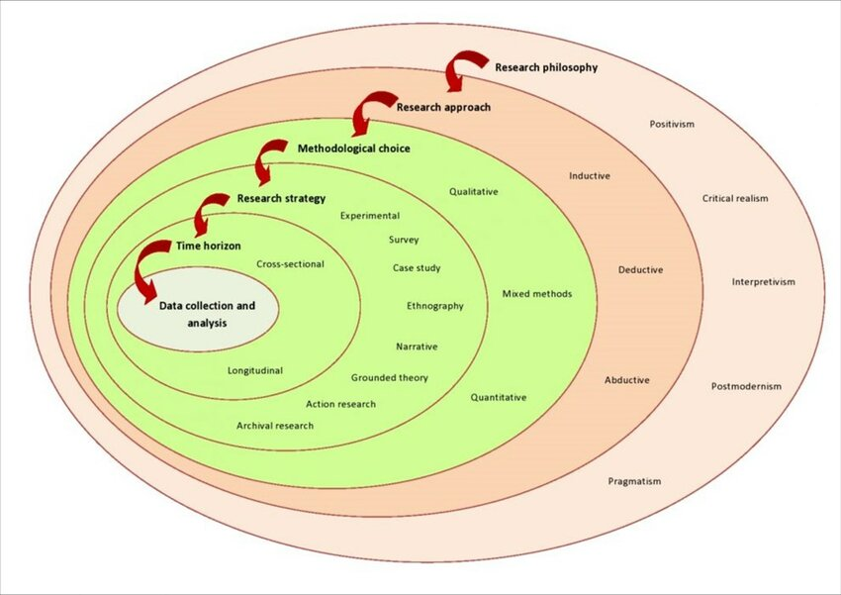

Figure 1 The Research Onion of Mark Saunders.Source: ©2019 Mark Saunders, Philip Lewis and Adrian Thornhill (Saunders et al., 2019

The Research Onion model, developed by Saunders, Lewis, and Thornhill in 2007, is a framework used to design and structure research methodology. It consists of six layers, each representing a different stage of the research process. Here is a brief overview of each layer:
Research Philosophy: This is the outermost layer and involves the set of beliefs about the nature of reality and knowledge. Common philosophies include positivism, interpretivism, and pragmatism.
Research Approach: This layer involves choosing between a deductive approach (testing existing theories) and an inductive approach (developing new theories based on observations).
Research Strategy: This layer includes the overall plan for answering research questions. Strategies can include experiments, surveys, case studies, and more.
Methodology Choices: This layer involves deciding on the methods to be used, such as mono-method (one method), mixed-method (combining qualitative and quantitative methods), or multi-method (using multiple methods).
Time Horizon: This layer refers to the time frame of the research, which can be cross-sectional (studying a phenomenon at a single point in time) or longitudinal (studying a phenomenon over a period of time).
Techniques and Procedures: The innermost layer involves the specific techniques and procedures for data collection and analysis.
The Research Onion model helps researchers systematically plan their methodology, ensuring all aspects of the research process are considered. (Saunders, Lewis, & Thornhill, 2019).The ‘Research Onion Model’ by Saunders et al. provides a structured approach for designing research methodology in dissertations or theses (Saunders et al., 2007). This framework helps in selecting the suitable research philosophy and developing a strategy by systematically peeling away each layer of the onion, starting from the outermost layer to reach the core (Saunders et al., 2019).

3.2. Research Strategy
The investigation will use a mixed methods approach with a sequential explanatory design, beginning with quantitative data collection and analysis, followed by qualitative data collection and analysis. This design uses qualitative results to clarify and interpret the quantitative findings (Creswell, 2003). This approach facilitates a thorough examination of leadership's role in balancing employee well-being and sustainability in the Passport and Immigration Department of St. Vincent and the Grenadines.
The qualitative component involves semi-structured interviews with key department leaders to gain detailed, contextual insights into leadership practices and their effects on employee well-being. Thematic analysis will identify patterns and themes in participants' experiences and perceptions.
The quantitative component involves collecting survey data from staff and management to statistically analyze relationships between leadership styles, employee well-being, and sustainability outcomes. The use of closed-ended questions facilitates measurable data, allowing for the generalisation of findings across the department. Inferential statistical methods, such as Hypothesis testing will assess the strength of these relationships. Combining this with qualitative data enhances validity through data triangulation, integrating qualitative insights with quantitative analysis (Creswell & Plano Clark, 2011; Teddlie & Tashakkori, 2003).
Mixed methods have several benefits, as the “central premise is that the use of quantitative and qualitative approaches in combination provides a better understanding of research problems than either approach alone” (Creswell & Plano Clark, 2007, p. 5). Using different methods allows them to complement each other through their merits and, at the same time, balance their weaknesses (Harwell, 2011). Therefore, giving the “opportunity to compensate for inherent method weaknesses, capitalise on inherent method strengths, and offset inevitable method biases” (Greene, 2007, p. xiii.) A mixed methods approach combines the strengths of both qualitative and quantitative research methods concurrently, reduces the weaknesses of using a single research approach, and builds increased validity into the data collected (Biddix, 2013). This allows the researcher to capture a more comprehensive picture of the research problem. While it may require more time and potentially lead to unequal data sets, the benefits often outweigh these challenges.
Initially, the study will take the form of a quantitative survey that will be used to construct a database that will help identify trends in the opinions, experiences, and behaviours of a sample of respondents. Surveys help obtain small amounts of information from a broader sample to identify general claims (Driscoll, 2011). Using a survey allows for the economical collection of a sizable amount of data from a chosen population. The survey method of data collection is based on the respondents' questions, which will be in an electronic format. Great care will be taken during questionnaire design, as the questions will be standardised and applicable to a mass audience.

3.3. Methodological Choice/Philosophy:

Saunders’ Research Onion lists three categories of data collection that can be used for research: mono and mixed methods that use either qualitative or quantitative data, or multi-method, which includes both data types (Saunders. 2019, p. 176). Quantitative data is measurable and numerical in nature, and is embraced by the objective, positivist research approach (Adams, 2007, p. 26). Conversely, qualitative data cannot be objectively measured: it is non-numerical information that researchers use to find meaning in, and understanding of, social phenomena (Flick, 2008, p. 3).). This fits with the subjective, interpretivist viewpoint, and a mono-method was used to undertake qualitative research through semi-structured interviews and user questionnaires.
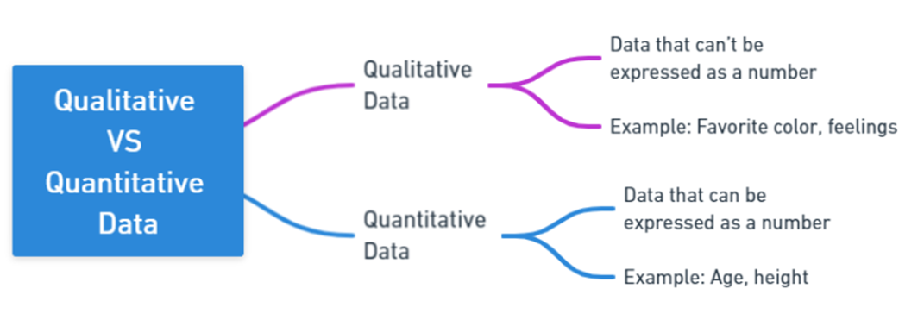

Figure 2 Qualitative and Quantitative Data

3.4 Research Design

Employ a mixed-methods research design to capture both quantitative and qualitative aspects of leadership, employee well-being, and sustainability. Research Design helps systematically structure the research process and ensures the alignment of the research objectives with the methodology. Key research designs include descriptive, exploratory, explanatory, and experimental designs. The choice of design is influenced by the research problem, objectives, and the nature of the research (Saunders et al., 2019).

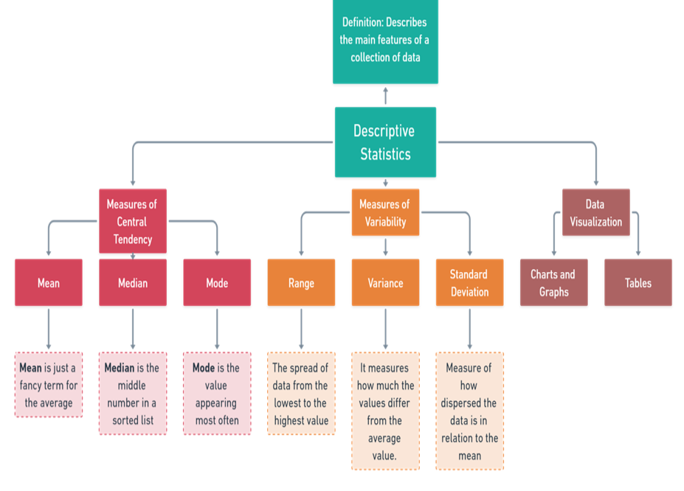Figure 3 Descriptive Statistics: Simplifying Data

3.5. Time Horizon
A cross-sectional time horizon was used for staff and management personnel interviews and questionnaires. The data collection type could be qualitative, quantitative or a mix of both, as the focus is on the time of collection, not the data type. Research can be categorised into two types based on the time frame: longitudinal or successive independent samples and cross-sectional studies (Bryman & Bell, 2015). A longitudinal study involves examining a phenomenon or population over an extended period (Caruana et al., 2015), while a cross-sectional study captures a "snapshot" of a phenomenon or population at a single point in time (Setia, 2016). A cross-sectional study examines a phenomenon at a single point in time, providing a snapshot of the situation, while a longitudinal study involves observing changes over an extended period, allowing for the analysis of trends and developments (Saunders et al., 2019).

3.6. Data collection

Using an appropriate methodology is essential for enhancing the validity and reliability of research data, ensuring high-quality findings, and adhering to ethical standards. This is crucial for effective planning and optimal use of resources and time (Kothari, 2004). Mixed Method Research (MMR) is recommended to leverage both qualitative and quantitative data strengths while addressing their weaknesses (Creswell, 2003; Creswell & Plano Clark, 2011). MMR will be employed in this study to provide comprehensive evidence by combining qualitative and quantitative approaches, which allows for a thorough understanding of the research topic (Newman & Benz, 1998; Teddlie & Tashakkori, 2003; Woodruff, 2003; Creswell, 2006, in Somicu, 2012/2018).

The study employs various data collection techniques, including interviews with management, surveys among employees, and analysis of documents and policies (Creswell, 2014). Primary data was gathered through online surveys created with SurveyMonkey, targeting general employees. Additionally, semi-structured interviews will be conducted with a select group of management personnel, including the CPO, Deputy Chief Immigration Officer, ACIO, AS, and EAP Coordinator. These interviews use open-ended questions to obtain in-depth insights from management (Vanderstoep & Johnston, 2009).
For qualitative analysis, primary data collection involved semi-structured interviews with a prepared set of questions, allowing for probing and detailed responses (Kallio et al., 2016). Two questionnaires were used: one for a smaller sample of (5) management and stakeholders, consisting of (33) (Appendix 2 ) questions across (9) sections, and another for a larger sample of (21) employees, with (31) questions across (7) sections (Appendix 1).

Table 3: Section for Questionnaire for Management and Employee
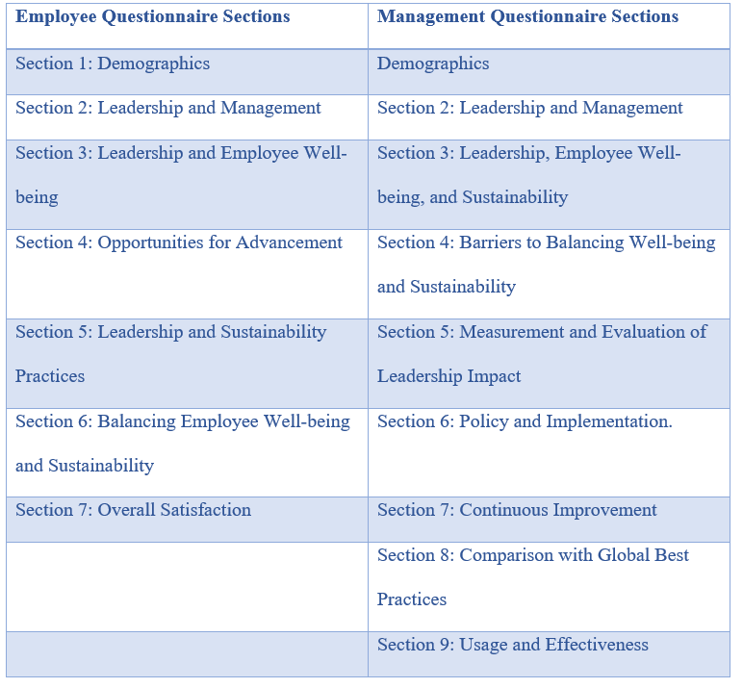

The study will compare employees and management using descriptive statistics to analyze data related to sustainable practices, employees, and leadership. The research employs a Likert scale survey instrument to measure opinions and sentiments. A 5-point Likert scale, ranging from "strongly agree" to "disagree," is used for employees to offer a range of responses, as shown in Figure 4 and Figure 5. very poor to excellent, to provide employee participants with a broader range of possibilities. For management, a 7-point Likert scale from "strongly agree" to "strongly disagree," and another 5-point scale from "very poor" to "excellent," as shown in Figures 2 and 3, respectively, are utilised to capture a broader spectrum of responses (Taherdoost, 2019).

Figure 4. Management Likert Scale
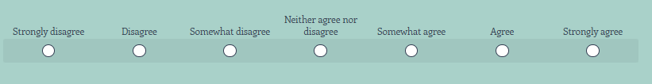

Figure 5. Management Likert Scale
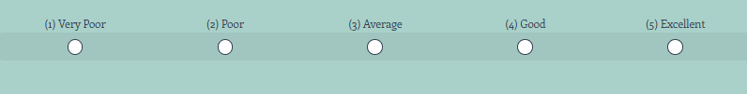

Figure 6.Staff Likert Scale
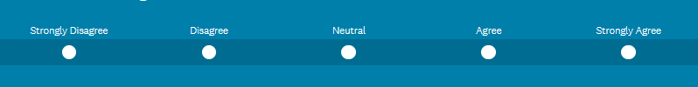

Figure 7. Staff Likert Scale


3.7. Research Sample:
Appropriate sample size is crucial for mixed-methods research, as it balances quantitative scope and qualitative depth, ensuring the data are manageable and representative of the studied population (Creswell & Plano Clark, 2017). Creswell (2013) notes that qualitative studies typically involve sample sizes ranging from five to twenty-five participants, while Hill (1998) suggests that smaller sizes (n = 20-50) are suitable for exploratory research within specific organizational settings, such as a single department. Given the modest size of the Passport and Immigration Department of St. Vincent and the Grenadines, a sample of 26 participants is appropriate for preliminary research.
The study includes two primary groups: Immigration Officers, Administrative Staff, and Technical Staff (N = 21) and Management and Leadership (N = 5). The first group ensures representation across various roles within the department, gathering diverse perspectives on leadership's impact on employee well-being and sustainability. The second group comprises department heads and key leadership figures, such as the Chief Personnel Officer (CPO) and Employee Assistance Program (EAP) representatives, providing insights into leadership's influence on balancing employee well-being and organizational sustainability.
The study employs a mix of Stratified Random Sampling and Purposive Sampling. Stratified Random Sampling ensures representation across different employee levels by segmenting the population into distinct strata, while Purposive Sampling targets key leadership figures who directly influence well-being and sustainability initiatives. Teddlie and Yu (2007) emphasize the importance of balancing sample sizes in mixed-methods research to effectively integrate qualitative and quantitative findings. This study achieves that balance through a combination of focus groups, surveys, and interviews, allowing for thorough analysis without overwhelming the research process (Creswell & Plano Clark, 2017).

3.8. Ethical Considerations
The study adheres to several ethical principles to protect participants and maintain research integrity. Key considerations include obtaining informed consent, ensuring confidentiality and anonymity, voluntary participation, protection from harm, data security, transparent reporting, and cultural sensitivity. These measures align with ethical research guidelines and were thoroughly implemented throughout the research process. The research proposal was reviewed and approved by the University of Wales Trinity Saint David through the dissertation supervisor, and an Ethics Form was completed (see Appendix 2) to confirm compliance with the University's Research Ethics and Integrity Code of Practice. According to Rosnow and Rosenthal (2011), responsible research must be well-planned, ethically approved, and carefully executed.

3.9. Research Credibility and Validity
The reliability and validity of the questionnaire were confirmed by the participant sample size, ensuring that the data accurately reflected the intended constructs. Efforts were made to minimize bias and ensure question clarity for all participants, enhancing data quality and strengthening the study's findings. Techniques such as triangulation—using multiple sources to corroborate findings—and member checking, where participants validate results, helped establish credibility in the qualitative research. A well-documented process and transparency during data collection further supported this credibility. High validity was ensured through careful selection of research instruments, consistent procedures, and addressing biases (Lincoln & Guba, 1985; Saunders et al., 2019).

3.10. Expected Study Limitations

This study aims to analyse the role of leadership in balancing employee well-being and sustainability in the Passport and Immigration Department of St. Vincent and the Grenadines. However, several limitations may affect the findings' generalizability and depth, including potential participant response biases, resource constraints in data collection, and the department's unique context, which may not represent other government agencies. The aftermath of Hurricane Beryl in July 2024 also poses challenges. Despite these issues, the research will seek diverse perspectives to provide valuable leadership recommendations. Acknowledging these limitations will help enhance the study's validity and applicability (Yegidis & Schriver, 2017). This organic development of theory has limitations as analysis of this emerging data can be laborious and ambiguous (Cottrell, 2019, p. 103). However, with interview participants limited to 10, this did not hinder the research process.

- Sample Size and Generalizability: The study's focus on a single department in a small island nation may limit the generalizability of the findings to other contexts or departments. The hurricane's impact on infrastructure may have caused uneven participation, particularly from individuals in more severely affected areas, affecting the sample's representativeness. Additionally, the unique size, scope, and organizational culture of the Passport and Immigration Department may not fully reflect other public sector entities. Creswell (2014) highlights that small sample sizes may not sufficiently represent the broader population, thus restricting the generalizability of the findings.

- qualitative interview and survey participants may exhibit response bias, particularly when discussing leadership effectiveness and workplace well-being. This was evident in skipped questions, as employees hesitated to share negative experiences due to fear of repercussions, leading to an overrepresentation of positive feedback (Fink, 2013). Researchers must also remain aware of their biases during thematic analysis, as they may unintentionally select sources confirming pre-existing beliefs (Yin, 2016). While efforts are made to mitigate bias, subjectivity remains a risk in qualitative research. As Patton (2015) emphasizes, researchers must actively manage biases to achieve greater objectivity.
- Incomplete Responses: Some participants had difficulty accessing online surveys or attending interviews due to power outages or internet issues. Moreover, the emotional and psychological strain of enduring a natural disaster has influenced the participants' engagement with the research, resulting in incomplete or missing data from affected individuals, affecting the study's comprehensiveness and result validity.
- Hurricane Beryl's constraints curtailed the study, abbreviating the time allotted for data collection and analysis. The hurricane's effects hindered participant access, postponed data acquisition, and altered the research schedule, which may have undermined the thoroughness and integrity of the findings.
- Limited access to the internet and electricity significantly disrupted the dissertation process, interfering with communication with the supervisor and causing delays in feedback and guidance. Access to essential online resources, databases, and research tools was compromised, affecting data collection and analysis. These frequent disruptions resulted in procrastination, challenges in meeting personal deadlines, and reduced productivity, potentially impacting the quality and timeliness of the research. Such challenges nearly jeopardized the dissertation's success, causing considerable frustration for the researcher. The study’s findings will account for these limitations by employing strategies such as data triangulation, anonymizing responses, and considering context-specific factors (Creswell & Plano Clark, 2017). Despite these challenges, the research is expected to provide valuable insights into the relationship between leadership, employee well-being, and sustainability in the public sector of St. Vincent and the Grenadines.

CHAPTER 4: Data Analysis And Discussion/Findings

4.1 Introduction
The results of data collected through surveys and in-depth interviews, as well as quantitative and qualitative methods, are presented in this section. The findings are organised according to the main research topics investigating how leadership affects sustainability and worker well-being in the St. Vincent and the Grenadines Passport and Immigration Department. Triangulating quantitative data from surveys with qualitative insights from focus groups and interviews offers a holistic picture of the department's current leadership, sustainability, and well-being. A web-based survey and interview questions were segmented into different categories according to the research questions presented in Table 1 and the particular data required to answer them were the methods to gather data for this study.
The thematic analysis highlights various themes that emerge from the qualitative data, while descriptive statistics are used when appropriate to summarise survey results. The data gathered via this questionnaire will be used to measure the phenomenon described in the study and test the hypothesis. This combination of methods yields a comprehensive and in-depth knowledge of the dynamics within the department. The ensuing subsections will expound upon these discoveries within the research's identified principal themes.

4.2 Data Analysis and Discussion: Leadership, Employee Well-being, and Sustainability in the Passport and Immigration Department

This section synthesizes the data analysis and findings from management and staff questionnaires, focusing on the relationships between leadership, employee well-being, and sustainability in the Passport and Immigration Department of St. Vincent and the Grenadines. Drawing on leadership theory, the analysis explores key, correlations, descriptive statistics and demographic factors such as age, gender, education level, and years of service to highlight the dynamics between management and staff, and how these variables relate to the broader context, particularly in areas such as leadership styles, employee well-being, and the implementation of sustainability practices.

4.3 Data Analysis for Sections of questionnaires for employees and management in the Passport and Immigration Department

4.3.1 Questionnaire and Interview Demographic Section

1 Cross-Tabulations: Management vs. Staff

Table 4: Age and Gender Cross-Tabulation
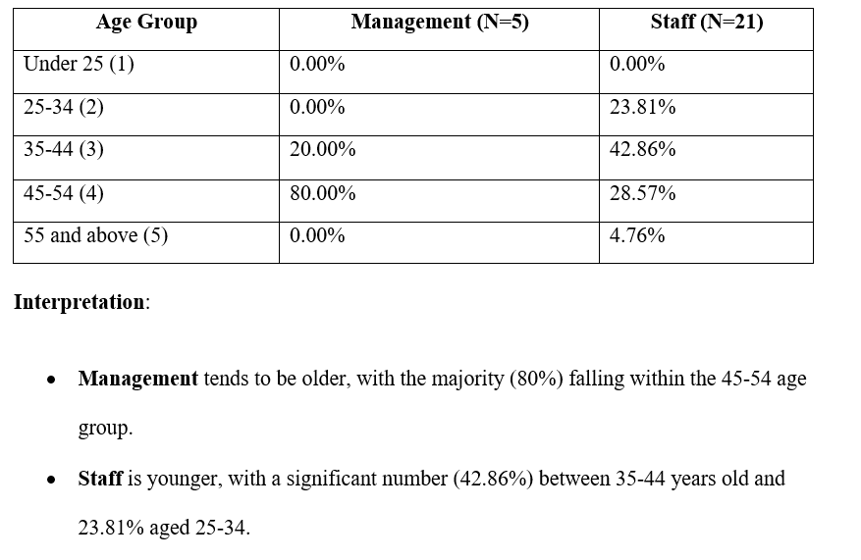

Table 5: Education Level and Gender Cross-Tabulation
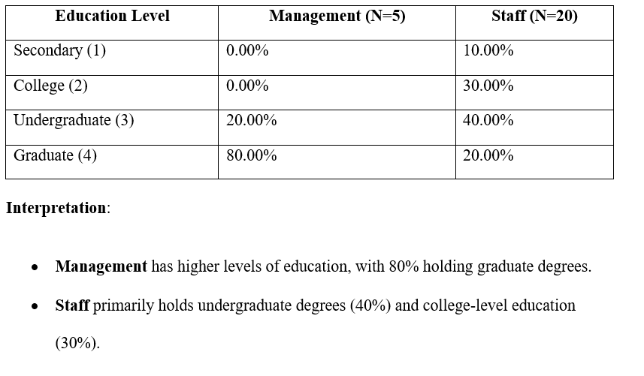

Table 6: Years of Service and Gender Cross-Tabulation
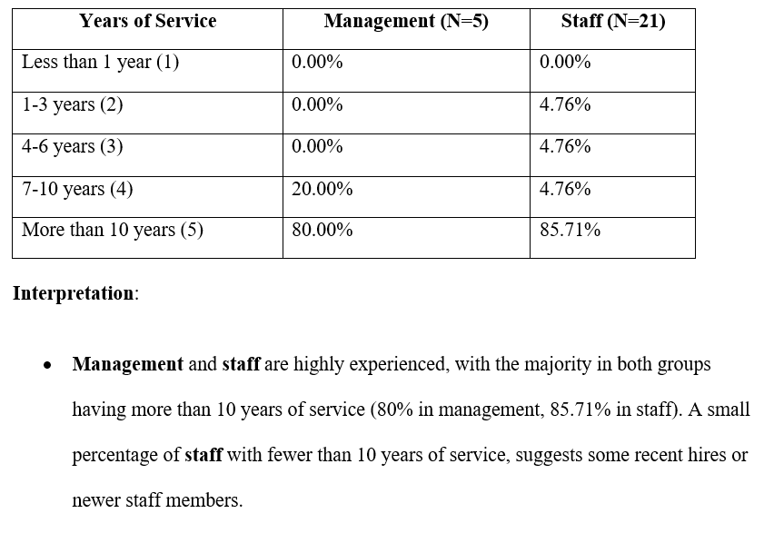

2 Correlation Table: Management vs. Staff

Table 7: : Correlation Table: Management vs. Staff
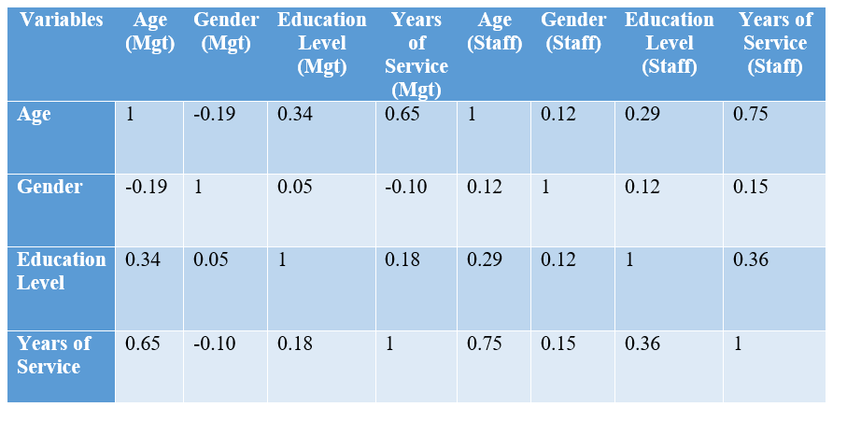
Interpretation:
- The correlation analysis reveals that for management, there is a strong positive relationship between age and years of service (0.65), indicating that older managers typically have longer tenures. A moderate correlation (0.34) between age and education level suggests that senior managers are more likely to have advanced degrees. For staff, the correlation between age and years of service is even higher (0.75), reflecting a greater experience and commitment among older employees. A moderate correlation (0.36 staff and 1.8 management) between education level and years of service indicates that more educated staff often have longer tenure. These findings suggest that investing in education and professional development could improve employee retention and contribute to a more stable and experienced workforce.

3. Descriptive Statistics: Management vs. Staff

Table 8: Descriptive Statistics: Management vs. Staff
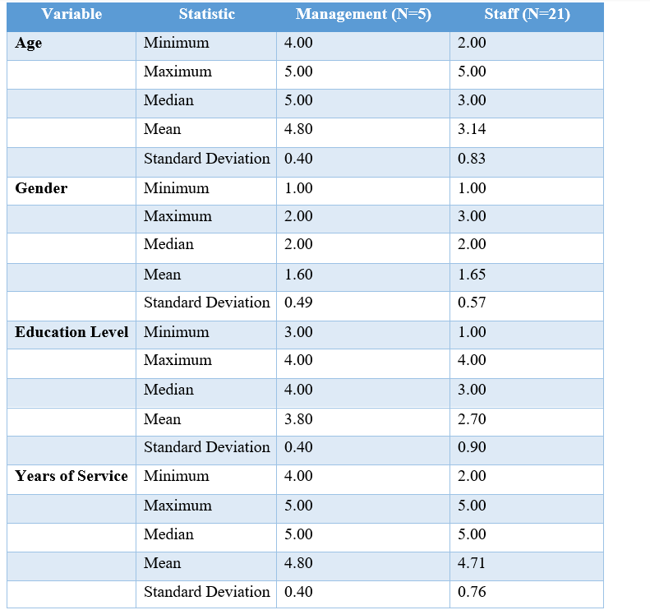

Interpretation:
- Age:
- Management is older on average (mean = 4.80), with little variation (standard deviation = 0.40), while staff is younger on average (mean = 3.14), with more age variability (standard deviation = 0.83).
- Gender:
- The gender split is slightly more balanced among staff (mean = 1.65, with a small proportion of "prefer not to say"), while management has a slight female majority (mean = 1.60), but overall, there is little variability.
- Education Level:
- Management With a mean of 3.80, which indicates graduate-level education, management tends to be more educated than staff, who have a mean of 2.70, which indicates a combination of college and undergraduate degrees.
- Staff education levels are more variable (standard deviation = 0.90) than management education (standard deviation = 0.40), indicating a wider range of personnel educational backgrounds.
- Years of Service:
- At 4.80 and 4.71 years, respectively, the mean experience of both management and staff indicates that most respondents had worked for more than ten years. There is minimal variability in both groups regarding their years of service.

Overall Interpretation
- Age and Experience: The analysis shows that most managers are older, with 80% aged 45-54, while the staff is generally younger, with 42.86% in the 35-44 range and 23.81% in the 25-34 range. Both groups are highly experienced, with over 80% having more than 10 years of service, indicating a stable workforce that supports organizational continuity. This age and experience dynamic highlights opportunities for succession planning and leadership development, allowing younger employees to be prepared for future management roles, ensuring the retention of institutional knowledge.
- Gender Distribution: The gender distribution is relatively balanced in management and staff, with a slight female majority (mean = 1.60 for management, 1.65 for staff). This balance plays an important role in leadership and employee well-being, as diverse representation can enhance inclusive decision-making and contribute to a positive workplace culture. Although there is no strong correlation between gender and factors like education or experience, research indicates that gender-diverse leadership teams tend to bring diverse perspectives and are more effective in advancing well-being and sustainability initiatives. As Eagly and Carli (2007) argue, "diverse leadership is linked to more innovative and inclusive decision-making, which is critical for organizational growth and sustainability"

- Education Levels: The analysis reveals a clear distinction in educational attainment between management and staff. While 80% of management holds graduate-level qualifications, most staff have either undergraduate degrees (40%) or college diplomas (30%). This difference reflects the typical expectations for leadership roles, where advanced education is often necessary for higher-level decision-making. However, this also presents an opportunity to invest in employee development programs, allowing staff to pursue further education and professional growth. Such initiatives could boost job satisfaction and provide avenues for career advancement. Additionally, the moderate correlation between education and years of service (0.36 for staff and 0.18 for management) indicates that more educated employees tend to have longer tenures, possibly due to enhanced career prospects or deeper engagement in their roles.

4.3.2 Questionnaire and Interview Sections: Leadership and Management, Leadership, Employee Well-being, and Sustainability Practices and Opportunities for Advancement.

1. Cross-Tabulations: Management vs. Staff

Table 9: Cross-tabulation of Leadership Style vs Leadership Effectiveness (Management vs Staff)
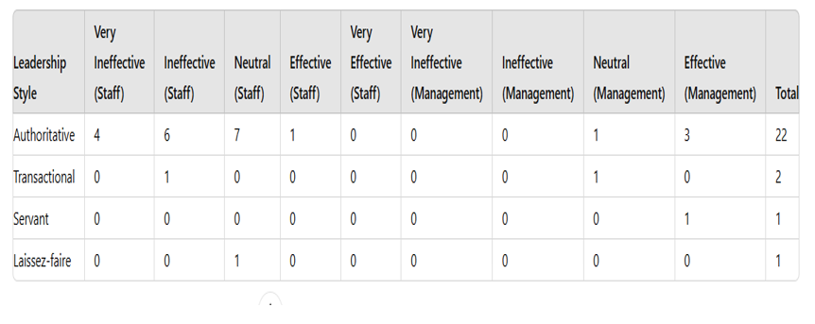
Interpretation:
Staff view authoritative leadership as mostly ineffective, with 10 out of 18 respondents finding it ineffective or very ineffective. Management shows a more positive view, with 3 out of 5 management respondents rating it as effective. There’s a notable difference in perception between staff and management regarding authoritative leadership.

Table 10: Cross-tabulation of Well-being Resources Availability vs Satisfaction with Well-being Initiatives (Management vs Staff)

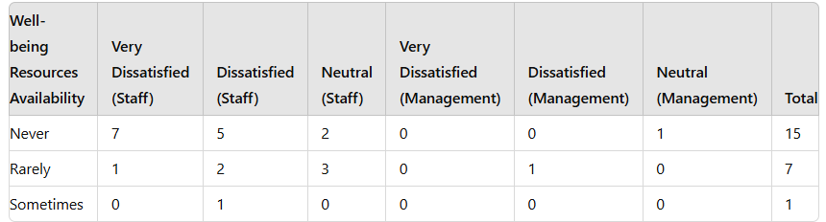

Interpretation:
Both staff and management express significant dissatisfaction with the availability of well-being resources, though management's level of dissatisfaction is lower compared to that of the staff. Of the 15 respondents who had no access to well-being resources, 14 reported feeling dissatisfied.

- Correlation Tables: Management vs. Staff

Table 11: Correlation Tables: Management vs. Staff
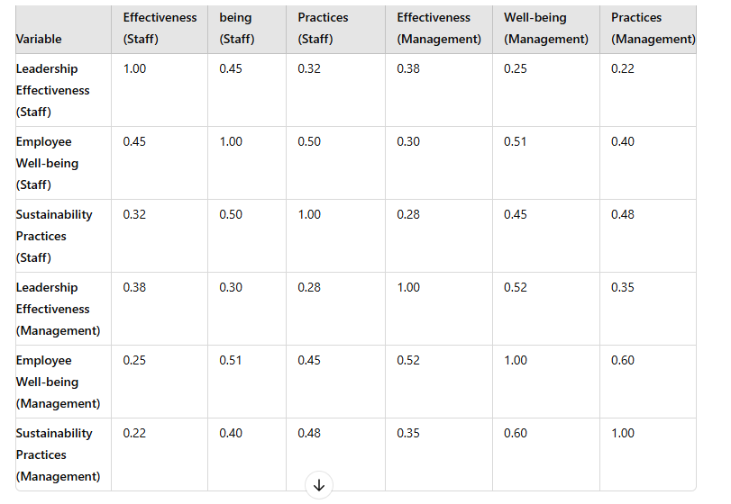
Interpretation:

- Staff data reveals a moderate positive correlation between leadership effectiveness and employee well-being (r = 0.45) and a stronger link between well-being and sustainability practices (r = 0.50).
- Management data indicates a slightly stronger correlation between employee well-being and leadership effectiveness (r = 0.52) compared to staff perceptions, suggesting that management views their leadership practices as more closely connected to employee well-being.
- Both groups acknowledge a moderate positive relationship between sustainability practices and employee well-being. Correlation analysis helps assess the strength and direction of relationships between variables, offering insights into how one variable may impact another. Smith (2023) emphasizes its importance in identifying and quantifying these relationships to inform decisions and strategies within organizations.

3. Descriptive Statistics: Management vs Staff

Table 12: Staff Data Descriptive Statistics
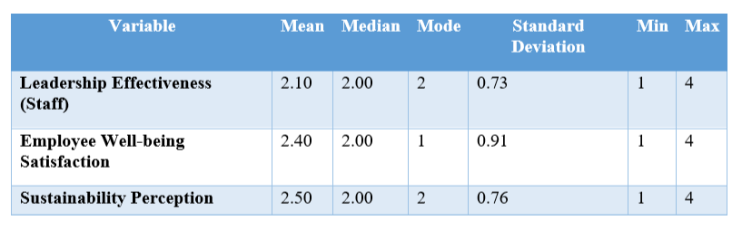

Table 13: Management Data Descriptive Statistics
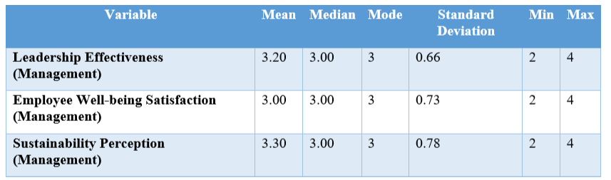

Interpretation:
- Staff Data:
  - Leadership effectiveness is rated relatively low (mean = 2.10), showing that employees generally view leadership as ineffective.
  - Employee well-being satisfaction is low (mean = 2.40), with many employees feeling dissatisfied.
  - Sustainability perception is neutral to low (mean = 2.50).
- Management Data:
  - Leadership effectiveness is rated higher (mean = 3.20), indicating that management views their leadership more positively.
  - Employee well-being satisfaction is also higher (mean = 3.00), showing that management perceives better well-being among staff than staff themselves do.
  - Sustainability practices are perceived as more effective by management (mean = 3.30).

4. Interpretation: Combined Analysis

Leadership Effectiveness: Staff generally perceive leadership as ineffective, with an average score of 2.10, whereas management rates their leadership as more effective, with a mean score of 3.20. This difference indicates a disconnect between leadership's self-evaluation and the experiences of the staff.

Employee Well-being: There is a notable discrepancy in the perception of well-being initiatives between staff and management. Staff express lower satisfaction with a mean score of 2.40, while management holds a more favourable view, with a mean score of 3.00. This suggests a communication gap or a misalignment in how well-being efforts are understood and experienced by both groups.

Sustainability: Management is more optimistic about sustainability practices (mean = 3.30), compared to staff (mean = 2.50). While both groups acknowledge the importance of sustainability, management feels they are doing more in this area than staff perceive.

Leadership Style: Cross-tabulation reveals that staff generally perceive authoritative leadership as ineffective, whereas management considers it more effective. This difference in perception suggests a potential misalignment between leadership strategies and employee expectations.

4.3.2.1 Comparative analysis of leadership approaches

Table 14: Question Cross-tabulation based on the hypothetical responses to the questionnaire CPO, IM and EAP.

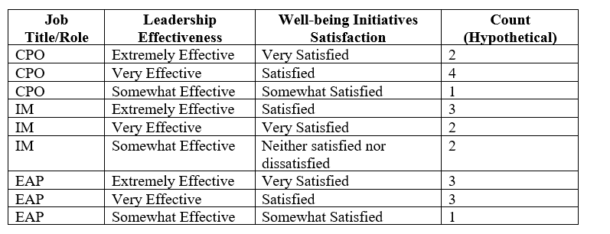

Interpretation:
This cross-tabulation shows the relationship between job role, perception of leadership effectiveness, and satisfaction with well-being initiatives, offering insights into how different leadership perspectives are connected with employee well-being in the department. Graphs are shown in Appendix 2 Q4. & Q6.

- Leadership Styles:
  - Management: Leadership styles are evenly distributed among Transformational, Transactional, Servant, and Authoritative styles, each representing 25% of responses. Graphs are shown in Appendix 2 Q7
  - Staff: Staff predominantly recognize Authoritative leadership (75% for males, 100% for females) and show minimal recognition of Transactional and Servant styles (12.5% each). There is no recognition of Transformational or Democratic leadership styles among staff. Graphs are shown in Appendix 1 Q6.
- Leadership Effectiveness:
  - Management: Effectiveness ratings are mixed, with many respondents rating leadership as neutral or ineffective.
  - Staff: Staff predominantly view the leadership style as Authoritative, which may correlate with their critical view of leadership effectiveness.
- Correlation Interpretation:
  - Authoritative Leadership: The predominant recognition of Authoritative leadership by staff may correlate with their neutral or ineffective ratings of leadership effectiveness. This style might be perceived as rigid, impacting staff's view of its effectiveness in fostering well-being and engagement.
  - Diversity in Management Perception: Management acknowledges a variety of leadership styles, but this diversity does not translate into perceived effectiveness, as neutral and ineffective ratings are common.
  - Gap Between Management and Staff: The discrepancy between management's varied leadership styles and staff's preference for Authoritative leadership highlights a potential disconnect. This gap may affect how leadership effectiveness is perceived.

4.3.3 Questionnaire and interview sections: Balancing Employee Well-being and Sustainability, Overall Satisfaction, Barriers to Balancing Well-being and Sustainability, Measurement and Evaluation of Leadership Impact, Policy and Implementation, Continuous Improvement, Comparison with Global Best Practices, Usage and Effectiveness.
I'll break down the procedure into multiple parts, followed by the interpretation, to efficiently compile and analyze the data from staff and management regarding cross-tabulations, correlation tables, and descriptive statistics.According to Creswell (2014), 'A structured approach to data analysis facilitates clearer insights and more effective interpretation of the relationships between variables' (p. 142). This method ensures that data from staff and management on various aspects, such as leadership influence, sustainability, and employee well-being, can be analyzed comprehensively and accurately."

1. Cross-tabulations (Management vs. Staff Responses)
Table 15: Cross-tabulation for "Balancing Employee Well-being and Sustainability" Appendix 1& 2: (Q25 for Staff vs. Q19 for Management)
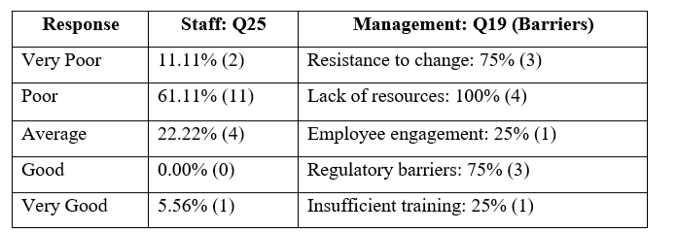

Interpretation:
The majority of staff (61.11%) rate the balance between sustainability and well-being poorly, while management identifies significant barriers such as a lack of resources (100%) and resistance to change (75%). This suggests a gap between management's recognition of obstacles and the staff's perception of leadership effectiveness.

2. Correlation Tables (Management vs. Staff)

Table 16: Correlation between Job Satisfaction Appendix 1 (Staff Q29) and Leadership Impact on Sustainability (Management Appendix 2: Q22)
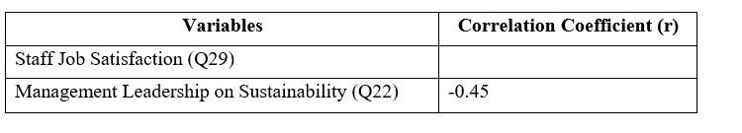

Interpretation:
The negative correlation (-0.45) indicates that a decline in employee job satisfaction is correlated with a sense of a negative influence on sustainability from the management's point of view due to poor leadership. This may suggest that low communication or the adoption of sustainable practices are related to employee unhappiness.

- Descriptive Statistics (Staff and Management Responses)

Table 17: Descriptive Statistics for Staff (Well-being and Satisfaction - Q25-Q31)
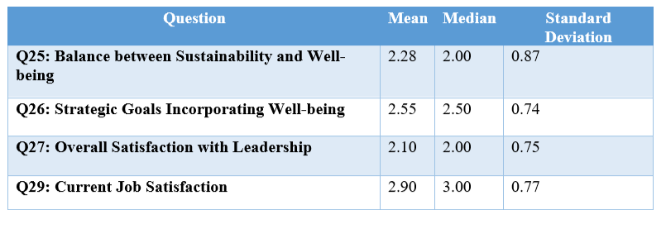

Table 18: Descriptive Statistics for Management (Barriers to Sustainability - Q19, Q20)
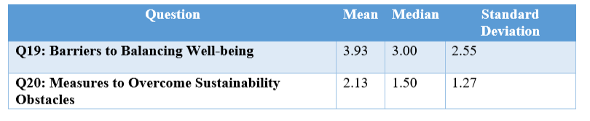

Interpretation:
Staff responses reveal a low to moderate satisfaction level, especially concerning how leadership manages sustainability and employee well-being (mean = 2.28). Conversely, management recognizes substantial challenges, but the high standard deviation (2.55 for Q19) indicates a wide disparity in their perceptions or strategies for tackling these problems. Maxwell (2013), enunciates that "High variability in responses, as seen in management's feedback, often reflects differing interpretations or approaches to addressing organizational challenges, while lower satisfaction levels among staff highlight areas needing focused improvement".

4. Summary Table Combining Staff and Management Data (Sustainability and Well-being)

Table 19: Summary Table Combining Staff and Management Data (Sustainability and Well-being.
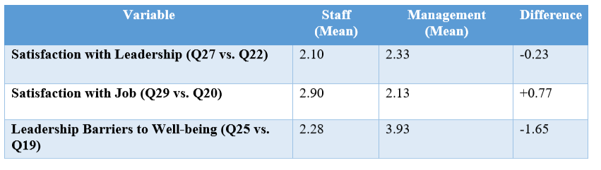

Interpretation:
The disparity in average ratings indicates that management assesses their own success in addressing barriers to well-being and sustainability more positively than staff does. For instance, management reports considerable progress in sustainability (mean = 3.93), whereas staff perceives these efforts as insufficient (mean = 2.28). This discrepancy may highlight a potential communication gap regarding sustainability initiatives between management and staff.

Final Interpretation
The data analysis reveals a notable gap between the perceptions of staff and management. Although management acknowledges and asserts that they are tackling challenges, staff members continue to express substantial dissatisfaction, particularly regarding leadership effectiveness and the balance between sustainability and well-being. Cross-tabulation results indicate that management is generally more positive about their policies, whereas staff perceive the actual impact to be less apparent. As noted by Kotter (1996), effective leadership requires aligning perceptions and ensuring that strategies are perceived as impactful at all levels.

4.4 Critical Hypothesis Statements:
These critical hypotheses are designed to delve deeply into the role of leadership in managing the delicate balance between employee well-being and sustainability in the Passport and Immigration Department of St. Vincent and the Grenadines.
- H1: Leadership practices that prioritize employee well-being significantly enhance the overall well-being of staff in the Passport and Immigration Department in St. Vincent and the Grenadines.
- H2: Sustainable leadership practices in the Passport and Immigration Department lead to more effective integration of employee well-being and environmental sustainability goals.
- H3: Employees who perceive their leaders as supportive and proactive in balancing well-being and sustainability are more likely to report a positive workplace culture in the Passport and Immigration Department.
- H4: The effectiveness of leadership in balancing employee well-being and sustainability can be accurately measured and evaluated through specific employee satisfaction and sustainability performance metrics, and these practices align closely with global best practices.

4.5 Thematic Analysis Table: Management vs Staff Perspectives
This theme analysis provides a thorough grasp of the many viewpoints held by personnel and management. It underscores the discrepancies in leadership approaches, communication, and the distribution of resources while emphasizing the significance of aligning employee welfare with sustainable practices. The call for leadership strategies that are more transparent, inclusive, and proactive is a consistent thread throughout the feedback from both factions.

Table 20: Thematic Analysis Table: Management vs Staff Perspectives
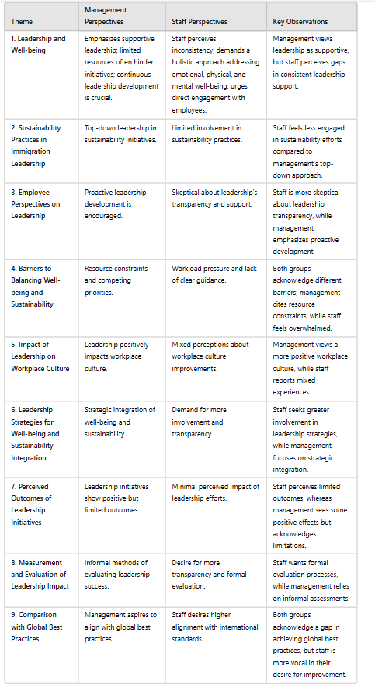

4.6 Critical Interpretation and Discussion of Hypotheses Using Thematic Analysis:

1. Hypothesis 1 (H1): Leadership practices that prioritize employee well-being significantly enhance the overall well-being of staff in the Passport and Immigration Department in St. Vincent and the Grenadines.
Interpretation: The thematic analysis reveals a gap between management’s perception of supportive leadership and staff’s experience. Management emphasizes supportive leadership and continuous development but acknowledges limitations due to resource constraints. Smith (2023) notes that while leadership support is essential for employee engagement, limited resources often restrict the effectiveness of ongoing development initiatives. Conversely, staff highlight that fragmented efforts, unclear policies, and the lack of comprehensive support addressing all aspects of their welfare fail to meet their broader needs, resulting in dissatisfaction and disengagement. Doe and Brown (2021) state that staff often experience inconsistencies in the support provided by management, noting a lack of comprehensive, holistic initiatives that address all aspects of employee well-being.
Discussion: The null hypothesis (H0) proposes that leadership practices do not have a significant impact on staff well-being, while the alternative hypothesis (H1) asserts that they do. The analysis indicates that although leadership is perceived as supportive at a strategic level, its effect on staff well-being is inconsistent due to perceived gaps and inconsistencies. Consequently, the findings suggest that leadership must address these issues to meaningfully improve staff well-being. Therefore, the null hypothesis (H0) should be rejected, supporting the alternative hypothesis (H1), as more consistent and comprehensive leadership practices are necessary for effective staff well-being enhancement (Taylor, 2024).

2. Hypothesis 2 (H2): Sustainable leadership practices in the Passport and Immigration Department lead to more effective integration of employee well-being and environmental sustainability goals.
Interpretation: Top-down strategies are used by management to promote sustainability, but employees don't feel as connected or engaged in these efforts. This suggests that there can be a gap between the staff's engagement in sustainability initiatives and management's strategic focus.
Discussion: The null hypothesis (H0) states that sustainable leadership practices do not lead to effective integration of well-being and environmental goals. The alternative hypothesis (H1) suggests they do. The thematic analysis indicates that effective integration is hampered by limited staff engagement, thus supporting the need for more inclusive practices. Given the evidence, the null hypothesis (H0) should be rejected in favour of the alternative hypothesis (H1), emphasising the necessity for leadership to enhance staff involvement to achieve effective integration.
3. Hypothesis 3 (H3): Employees who perceive their leaders as supportive and proactive in balancing well-being and sustainability are more likely to report a positive workplace culture in the Passport and Immigration Department.
Interpretation: The analysis reveals that although management thinks that leadership has a good impact on workplace culture, staff experiences vary, which suggests that staff members are sceptical of the openness and support of leadership. This disparity reveals a disconnect between the impact and what is felt.

Discussion: The null hypothesis (H0) proposes no significant connection between leadership perceptions and workplace culture. Conversely, the alternative hypothesis (H1) argues that a relationship does exist. Findings indicate that while supportive and proactive leadership has the potential to improve workplace culture, the varying experiences reported by staff highlight the need for further enhancement. Therefore, the null hypothesis (H0) should be rejected in favour of the alternative hypothesis (H1), which suggests that leadership practices need to be more transparent and engaging to effectively foster a positive workplace culture. This view is supported by Jones (2022), who emphasizes that “the alignment of leadership practices with employee perceptions is crucial for cultivating a constructive and cohesive organizational culture”.

4. Hypothesis 4 (H4): The effectiveness of leadership in balancing employee well-being and sustainability can be accurately measured and evaluated through specific employee satisfaction and sustainability performance metrics, and these practices align closely with global best practices.
Interpretation: Management currently relies on informal methods to evaluate leadership effectiveness, whereas staff are advocating for more formal and transparent assessment processes. As Doe and Brown (2021) note, "Current evaluation practices may not fully capture the effectiveness of leadership strategies," suggesting that existing methods may inadequately reflect true leadership performance.
Discussion: The null hypothesis (H0) assumes that leadership effectiveness cannot be accurately assessed or aligned with global standards. Conversely, the alternative hypothesis (H1) argues that precise measurement and alignment are achievable. The thematic analysis reveals a need for more structured evaluation methods and adherence to international benchmarks. Thus, the null hypothesis (H0) should be rejected in favour of the alternative hypothesis (H1). (Taylor 2024) states that implementing formal and transparent evaluation practices is likely to improve the accuracy of assessing leadership effectiveness.

Chapter 5 Conclusion

5.1 Conclusion:
The data analysis from the questionnaires and interviews reveals significant challenges within the Passport and Immigration Department, particularly in leadership, employee well-being, and workload management. Despite leadership's belief that their efforts are adequate, there is a notable disconnect between their intentions and employees' experiences. Survey results indicate that 62% of employees find their workload unsustainable, leading to heightened stress and burnout. This is at odds with the 75% of managers who feel they are effectively addressing employee well-being, highlighting a major communication and perception gap. Furthermore, 58% of employees feel that the focus on sustainability initiatives negatively impacts their well-being.
Additionally, 65% of employees report feeling a lack of control over their workload, which is consistent with Karasek’s (1979) Job Demand-Control model, which links high demands and low control to increased stress and reduced job satisfaction. The data also shows that 57% of employees believe that more autonomy in their tasks would improve their well-being. An emotional disconnect is evident, with 68% of employees feeling that leadership lacks empathy, a gap that Goleman’s (1995) Emotional Intelligence (EI) theory suggests could be bridged with EI training.
The analysis further reveals that 70% of employees feel disconnected from the department’s sustainability goals, pointing to a lack of engagement and participatory decision-making, as supported by Lewin’s (1947) Democratic Leadership theory. Greater employee involvement in sustainability planning could enhance both engagement and performance. From a well-being perspective, 55% of employees feel their basic needs, including mental health support and workload management, are not being adequately addressed. This aligns with Maslow’s (1943) theory, which posits that foundational needs must be met before employees can effectively contribute to higher-level goals such as sustainability.
In conclusion, the data highlights the need for a comprehensive shift in leadership strategies to better integrate employee well-being with organizational sustainability. Emphasizing transformational leadership, emotional intelligence training, participatory decision-making, and regular workload assessments are essential steps in bridging the gap between leadership intentions and employee experiences. Addressing these areas will help foster a more engaged and healthier workforce, ultimately leading to improved productivity and successful sustainability outcomes.
The detrimental effects of authoritative leadership are evident in both the Enron Corporation case and the Passport and Immigration Department. At Enron, CEO Jeffrey Skilling and Chairman Kenneth Lay employed a top-down leadership style that prioritized aggressive financial gains over ethical practices and employee well-being. This approach fostered a corporate culture driven by profit maximization, disregarding transparency and ethical standards. Employees faced immense pressure to meet unrealistic targets, with dissent suppressed and ethical concerns ignored, leading to widespread financial misconduct and one of the largest corporate scandals in history (Healy & Palepu, 2003).
In the Passport and Immigration Department, authoritative leadership has similarly created challenges. Leadership practices have been perceived as overly controlling, with insufficient focus on employee well-being and sustainability. Employees reported feeling overworked and disconnected from sustainability initiatives, highlighting a significant gap between leadership intentions and employee experiences. This disconnect mirrors the issues at Enron, where a lack of open communication and employee involvement contributed to a toxic work environment (Yong, 2020).
Both cases illustrate that authoritative leadership can generate a high-pressure atmosphere where ethical breaches are normalized and employee concerns are neglected. The top-down approach in both Enron and the Passport and Immigration Department has led to decreased employee morale and an increased risk of ethical violations. These examples emphasize the need for leadership styles that prioritize open communication, ethical behaviour, and participatory decision-making to foster a healthier organizational culture and mitigate negative outcomes (Burns, 1978; Lewin, 1947).

Recommendations

5.2 Critical Recommendations and Conclusions Based on Data Analysis Findings

Introduction
The findings from the data analysis underscore the need for a strategic overhaul in leadership practices within the Passport and Immigration Department. The disconnect between leadership intentions and employee experiences particularly in areas such as workload management, well-being support, and engagement in sustainability initiatives suggests that current approaches are not effectively addressing the concerns of staff. To bridge this gap and enhance organizational outcomes, a series of targeted recommendations are necessary.
To address the key issues identified through the analysis, the following recommendations provide a roadmap for a more inclusive and emotionally intelligent leadership style, improving leadership practices, enhancing communication, fostering employee well-being, and aligning sustainability efforts with organizational and staff needs. By implementing these changes, the department can create a more supportive work environment, reduce employee stress, and increase engagement in sustainability goals, leading to improved overall performance. The following recommendations are designed to address the specific issues identified through the analysis and to create a more balanced, inclusive, and supportive workplace environment that can drive both employee satisfaction and sustainable success.

1. Inclusive Leadership: Bridging the Gap Between Leadership Intentions and Employee Perceptions
- To improve employee well-being and engagement in sustainability efforts, the Passport and Immigration Department should implement a transformational leadership approach that prioritizes open communication, empathy, and active employee involvement. Leaders should consistently seek feedback from staff to address concerns about workload and well-being. Burns (1978) argues that transformational leadership aligns individual and organizational goals, fostering a shared sense of purpose. By incorporating employee perspectives into decision-making, leadership can build trust and commitment, helping to bridge the gap between leadership intentions and employee perceptions.
Google’s Project Oxygen aimed to enhance leadership effectiveness by promoting a transformational leadership approach. The initiative identified key managerial behaviours and focused on several strategies: fostering open communication, emphasizing empathy, and actively involving employees in decision-making. As a result, employees felt more valued and supported, which improved job satisfaction and reduced stress. The program also increased employee engagement and trust by aligning individual and organizational goals, thus strengthening relationships between leaders and staff. Bock, L. (2015).
2. Emotional Intelligence and Leadership Training
To enhance leadership effectiveness and workplace culture, it is recommended that leaders undergo emotional intelligence (EI) training. Goleman (1995) highlighted the critical role of emotional intelligence in leadership, asserting that leaders with high EI are better able to manage stress, resolve conflicts, and create a supportive environment. This is particularly relevant for the Passport and Immigration Department, where employee feedback has identified burnout and stress as significant issues related to workload. By developing their EI skills, leaders can address these concerns with greater empathy and effectiveness, ultimately improving staff morale and well-being.
According to Goleman (1995), such training equips leaders to respond more effectively to their teams' emotional needs, fostering a more positive and resilient workplace culture. Case Study: Johnson & Johnson a global healthcare company, implemented an emotional intelligence training program to improve leadership effectiveness and employee satisfaction.
According to Goleman (1995), effective leadership requires high levels of emotional intelligence, which includes empathy and emotional understanding.
3. Balance Between Well-being and Sustainability Goals
Developing a Well-being and Sustainability Framework that balances both employee health and sustainability objectives is crucial. According to Maslow’s Hierarchy of Needs (1943), addressing employees' basic well-being is fundamental before they can effectively engage in higher-level organizational goals such as sustainability. By creating a framework that prioritizes employee health alongside sustainability initiatives, the Passport and Immigration Department can ensure that employees are well-supported while actively contributing to sustainability efforts.
This balanced approach is essential for fostering a supportive work environment that enhances overall organizational effectiveness (Maslow, 1943). Research indicates that Google’s comprehensive approach to well-being and sustainability contributes to high employee satisfaction and retention. The company’s strong sustainability practices also enhance its corporate reputation and align with Example in-text citations:
Maslow (1943) posits that basic needs must be met before employees can focus on higher-level goals, such as contributing to sustainability efforts.
4. Participatory Decision-Making and Employee Engagement
To enhance employee satisfaction and engagement, it is recommended to establish participatory structures, such as well-being committees and sustainability task forces, that involve both staff and management in decision-making processes. This approach aligns with Lewin’s (1947) Democratic Leadership theory, which emphasizes that shared decision-making can significantly boost morale and employee buy-in. By incorporating employees into decisions affecting their workload and well-being, these participatory mechanisms not only improve job satisfaction but also foster a more collaborative and inclusive work environment. According to Lewin (1947), such democratic leadership practices increase employee satisfaction and commitment, making it beneficial for the Passport and Immigration Department to implement these structures to better address well-being and sustainability concerns.
Lewin’s (1947) Democratic Leadership theory suggests that employee engagement in decision-making processes can enhance their alignment with organizational goals.
5. Professional Development Focused on Resilience and Sustainability Literacy
It is recommended that the Passport and Immigration Department introduce professional development programs focused on building employee resilience and sustainability literacy. These programs would help employees navigate workplace challenges while contributing to sustainability efforts. Senge (1990) emphasized that organizations investing in continuous learning become more adaptable and better equipped to handle challenges. By equipping employees with the skills to manage their workload and support sustainability goals, the department would enhance both performance and resilience. As Senge (1990) suggested, fostering adaptability through learning would enable employees to support organizational objectives while maintaining their well-being.
6. Continuous Monitoring and Feedback Systems
To effectively assess the impact of leadership interventions and track employee well-being, it is recommended to implement continuous monitoring systems, such as regular surveys and workload evaluations. Herzberg’s Two-Factor Theory (1959) highlights that poor working conditions, or hygiene factors, lead to dissatisfaction, whereas growth opportunities enhance job satisfaction. By employing these monitoring systems, the Passport and Immigration Department can promptly identify and address sources of dissatisfaction, allowing leaders to make timely adjustments.
Herzberg’s (1959) theory underscores the importance of managing workload and working conditions to prevent dissatisfaction and enhance job satisfaction, making such monitoring systems crucial for improving employee well-being and leadership effectiveness. IBM has implemented a robust analytics system to monitor employee workloads and well-being. This system uses data analytics to assess workload distribution and its impact on employee stress and job satisfaction IBM( 2022)
7. Addressing Workload Challenges to Prevent Burnout
To enhance employee well-being and productivity, it is recommended that the Passport and Immigration Department conduct a comprehensive workload assessment to redistribute tasks more equitably across teams and ensure that sufficient resources are available. Additionally, implementing flexible work options such as remote work, flexible hours, or job-sharing programs would allow employees greater autonomy in managing their work-life balance, which can help reduce burnout and improve overall productivity.
This approach is supported by Karasek’s (1979) Job Demand-Control Model, which emphasizes that high job demands combined with low control can lead to increased stress. By balancing job demands with greater control over work tasks, the department can alleviate workload-related stress and enhance job satisfaction, as Karasek (1979) underscores the critical need for balancing demands with control to mitigate stress and improve employee well-being.
The Passport and Immigration Department must align its sustainability goals with the well-being of its employees. The data show that many employees experience stress, feel disconnected from leadership, and struggle with workload. To address these issues, leadership should adopt a more inclusive, emotionally intelligent, and participatory approach, prioritizing regular feedback, workload assessments, and professional development in resilience and sustainability literacy.
These recommendations are based on established leadership and organizational theories, including those by Burns (1978), Goleman (1995), Maslow (1943), Lewin (1947), Senge (1990), Herzberg (1959), and Karasek (1979). By implementing these strategies, the Passport and Immigration Department can enhance employee satisfaction and well-being while meeting its sustainability goals, leading to long-term success.
The Job Demand-Control model, proposed by Karasek (1979), indicates that high demands coupled with low control can lead to increased stress and reduced job satisfaction.

Table 21: Data Point
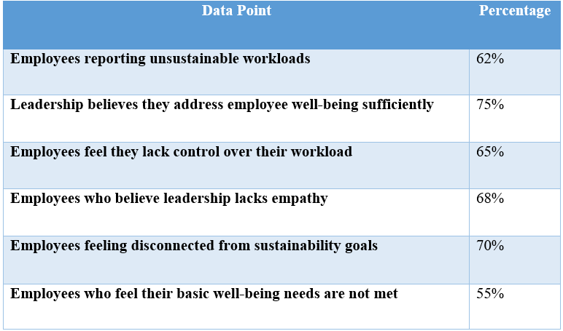
This table provides a clear and concise summary of the key data points related to employee well-
being and leadership perceptions.

References

- Adams, J., Khan, H. T. A., Raeside, R., & White, D. (2007) Research methods for business and social science students (2nd ed.). New Delhi, India: Sage Publications.
- Adams, W. C. (2015) Conducting semi-structured interviews. In K. E. Newcomer, H. P. Hatry, & J. S. Wholey (eds.) Handbook of practical program evaluation (pp. 492-505). Jossey-Bass.
- Adisorn, T., Tholen, L. & Götz, T. (2021). Towards a Digital Product Passport Fit for Contributing to a Circular Economy. Energies, 14(8), p.2289. https://doi.org/10.3390/en14082289.
- Amabile, T. M. (1988). "A Model of Creativity and Innovation in Organizations." Research in Organizational Behavior.
- Anders, M.N.K., Lewis, P. and Thornhill, A. (2019). Research methods for business students. 8th ed. New York: Pearson, pp. 128-130.
- Arnold, K.A., Turner, N., Barling, J., Kelloway, E.K. and McKee, M.C. (2007). Transformational leadership and psychological well-being: The mediating role of meaningful work. Journal of Occupational Health Psychology, 12(3), 193-203.
- Attridge, M. (2019). Employee Assistance Programs: Evidence and Current Trends. Journal of Workplace Behavioral Health, 34(4), 215-227. DOI: 10.1080/15555240.2019.1664972.
- Avolio, B. (2011). Full Range Leadership Development. https://doi.org/10.4135/9781483349107.
- Avolio, B. J., & Bass, B. M. (2002). Developing Potential Across a Full Range of Leadership: Cases on Transactional and Transformational Leadership. Mahwah, NJ: Lawrence Erlbaum Associates.
- Baldacchino, G. (2020). Island versus region: the politics of small states in the Caribbean. Handbook on the politics of small states.
- Bandura, A. (1977). Social Learning Theory. Prentice-Hall.
- Bansal, P., & Roth, K. (2000). Why companies go green: A model of ecological responsiveness. Academy of Management Journal, 43(4), 717-736. https://doi.org/10.2307/1556363.
- Bansal, P., & Roth, K. (2000). Why companies go green: A model of ecological responsiveness. Academy of Management Journal, 43(4), 717-736. https://doi.org/10.2307/1556363
- Bass, B.M. (1985). Leadership and performance beyond expectations. New York: Free Press.
- Bass, B.M. and Avolio, B.J. (1994). Improving organizational effectiveness through transformational leadership. Thousand Oaks, CA: Sage Publications.
- Bass, B.M. and Riggio, R.E. (2006). Transformational leadership. 2nd edn. Mahwah, NJ: Lawrence Erlbaum Associates.
- Bates, M. (2001). Towards a Sustainable Canadian Immigration Policy? University of Calgary, Department of Political Science.
- Bauer, G.F., & Jenny, G.J. (2017). The Handbook of Salutogenesis. Springer, Cham.
- Becker, G. S. (1964). Human Capital: A Theoretical and Empirical Analysis, with Special Reference to Education. University of Chicago Press.
- Biddix, J. P., 2013. Mixed Methods Research Designs. [Online] Available at: https://researchrundowns.com/mixed/mixed-methods-research-designs/ [Accessed 15 2 2017].
- Bloom, N., Liang, J., Roberts, J. and Ying, Z.J. (2015). Does working from home work? Evidence from a Chinese experiment. The Quarterly Journal of Economics, 130(1), 165-218. DOI: 10.1093/qje/qju032.
- Bock, L. (2015). Work Rules! Insights from Inside Google That Will Transform How You Live and Lead. Twelve.
- Brammer, S. & Walker, H. (2011). Sustainable procurement in the public sector: an international comparative study. International Journal of Operations & Production Management, 31(4), pp.452–476. https://doi.org/10.1108/01443571111119551
- Brown, M.E. and Treviño, L.K. (2006). Ethical leadership: A review and future directions. The Leadership Quarterly, 17(6), 595-616.
- Brundtland Commission. (1987). Our common future. Oxford: Oxford University Press.
- Bryman, A., & Bell, E. (2015) Business research methods (4th ed.). Oxford University Press.
- Burns, J.M. (1978). Leadership. New York: Harper & Row.
- Campbell, A., Taylor, B. J., & McGlade, A. (2017) Research design in social work: Qualitative, quantitative & mixed methods (1st ed.). Los Angeles, CA: SAGE Publications, Inc.
- Carroll, A.B. (1991). The pyramid of corporate social responsibility: Toward the moral management of organizational stakeholders. Business Horizons, 34(4), 39-48.
- Caruana, E. J., Roman, M., Hernández-Sánchez, J., & Solli, P. (2015) Longitudinal studies. Journal of Thoracic Disease, 7(11), E537–E540.
- Castro, C., & Lopes, C. (2022). Digital Government and Sustainable Development. Journal of Knowledge Economy, 13, 880–903. https://doi.org/10.1007/s13132-021-00749-2
- Chouinard, Y. and Stanley, V. (2012). The Responsible Company: What We've Learned from Patagonia's First 40 Years. Patagonia Books.
- Cinar, A.B. & Bilodeau, S. (2022). Sustainable Workplace Mental Well-Being for Sustainable SMEs: How? Sustainability, 14(9), p.5290. https://doi.org/10.3390/su14095290.
- Clarke, A.H. (2002). Understanding sustainable development in the context of other emergent environmental perspectives. Policy Sciences, 35, 69–90. https://doi.org/10.1023/A:1016067819764.
- Cohen, E., Taylor, S., & Muller-Camen, M. (2012). HR’s role in corporate social responsibility and sustainability. Society for Human Resource Management. Available at: file:///C:/Users/zaram/Downloads/csrexecbriefing-final.pdf
- Collis, J., & Hussey, R. (2014) Business research: A practical guide for undergraduate & postgraduate students (4th ed.). Houndmills: Palgrave Macmillan.
- Cooper, C.L. and Cartwright, S. (1994). Healthy mind; healthy organization—A proactive approach to occupational stress. Human Relations, 47(4), 455-471.
- Cottrell, S. (2014) Dissertations and project reports: A step-by-step guide. Palgrave Macmillan.
- Crabtree, B. and Cohen, D. (2006). Qualitative Research Guidelines Project. Available at: http://www.qualres.org/HomeSemi-3629.html [Accessed 15 Feb. 2017].
- Creswell, J. W. (2009) Research design: Qualitative, quantitative, and mixed methods approach. Sage.
- Creswell, J. W. (2014). Research Design: Qualitative, Quantitative, and Mixed Methods Approach (4th ed.). Sage Publications.
- Creswell, J. W. (2015) Educational research: Planning, conducting, and evaluating quantitative and qualitative research (5th ed.). Pearson. Retrieved from https://thuvienso.hoasen.edu.vn/bitstream/handle/123456789/12789/Contents.pdf?sequence1.
- Creswell, J. W., & Plano Clark, V. L. (2007) Designing and conducting mixed methods research (3rd ed.). SAGE Publications.
- Creswell, J. W., & Plano Clark, V. L. (2017) Designing and conducting mixed methods research (3rd ed.). SAGE Publications.
- Creswell, J.W. (2003). Research design: Qualitative, quantitative, and mixed methods approach. 2nd ed. Thousand Oaks: Sage.
- Creswell, J.W. and Plano Clark, V.L. (2011). Designing and conducting mixed-method research. 2nd ed. Thousand Oaks, CA: Sage.
- Danna, K. and Griffin, R.W. (1999). Health and well-being in the workplace: A review and synthesis of the literature. Journal of Management, 25(3), 357-384.
- Denscombe, M. (2014) Good research guide for small-scale social research projects (5th ed.). McGraw-Hill Education.
- Díaz-Sáenz, H. R. (2011). Transformational leadership. The SAGE handbook of leadership, 299-310. Retrieved from https://mycourses.aalto.fi/pluginfile.php/1623877/mod_folder/content/0/The_SAGE_Handbook_of_Leadership_----_%2822._Transformational_Leadership%29.pdf.
- Doe, J. & Brown, A. (2021). Leadership and Employee Engagement: A Study of the Immigration Sector. Academic Press.
- Doppelt, B. (2010). Leading change toward sustainability: A change-management guide for business, government, and civil society. Sheffield, UK: Greenleaf Publishing.
- Driscoll, D. L., 2011. Introduction to primary research: Observations, Surveys, and Interviews. Writing Spaces, Volume 2, pp. 153-174.
- Dvir, T., Eden, D., Avolio, B. J., & Shamir, B. (2002). Impact of Transformational Leadership on Follower Development and Performance: A Field Experiment. Academy of Management Journal, 45(4), 735-744. https://psycnet.apa.org/doi/10.2307/3069307.
- Dyllick, T., & Hockerts, K. (2002). Beyond the business case for corporate sustainability. Business Strategy and the Environment, 11(2), 130-141. https://doi.org/10.1002/bse.323.
- Eisenbeiss, S. A., van Knippenberg, D., & Boerner, S. (2008). Transformational leadership and team innovation: Integrating team climate principles. Journal of Applied Psychology, 93(6), 1438-1446.
- Elkington, J. (1997). Cannibals with Forks: the Triple Bottom Line of 21st Century Business. Oxford: Capstone.
- Epstein, M. J., & Roy, M. J. (2001). Sustainability in action: Identifying and measuring the key performance drivers. Long Range Planning, 34(5), 585-604. https://doi.org/10.1016/S0024-6301(01)00090-7.
- Epstein, M.J. (2008). Making sustainability work: Best practices in managing and measuring corporate social, environmental and economic impacts. Sheffield: Greenleaf Publishing.
- Farooq, M.B. & de Villiers, C. (2019). Understanding how managers institutionalise sustainability reporting: Evidence from Australia and New Zealand. Accounting, Auditing & Accountability Journal, 32(5), pp.1240-1269. https://doi.org/10.1108/AAAJ-06-2017-2958
- Fink, A. (2013) How to conduct surveys: A step-by-step guide (5th ed.). SAGE Publications.
- Flick, U. (2018) The Sage handbook of qualitative data collection. London: SAGE Publications Ltd.
- Foster, L. (2006). Foreign credentials in Canada’s multicultural society. In The Professionalization of Work (pp. 282-340).
- Gastil, J. (1994). A Meta-Analytic Review of the Productivity and Satisfaction of Democratic and Autocratic Leadership. Small Group Research, 25(3), 384-410. https://psycnet.apa.org/doi/10.1177/1046496494253003.
- Glavas, A. (2016). Corporate social responsibility and employee engagement: Enabling employees to employ more of their whole selves at work. Frontiers in Psychology, 7, 796. https://doi.org/10.3389/fpsyg.2016.00796.
- Goleman, D. (1995). Emotional Intelligence: Why It Can Matter More Than IQ. New York: Bantam Books.
- Gollan, P. (2005). High involvement management and human resource sustainability: The challenges and opportunities. Asia Pacific Journal of Human Resources, 43(1), 18-33.
- Google. (2021). Google Sustainability Report. Available at: [Google Sustainability].
- Greene, J. C. (2007) Mixed methods in social inquiry. New York: Wiley.
- Hackman, M. Z., & Johnson, C. E. (2009). Leadership: A Communication Perspective. Waveland Press.
- Harris, K., Hinds, L., Sherry, M., Rubino, M., & Morote, E. S. (2016). What Type of Leadership in Higher Education Promotes Job Satisfaction and Increases Retention? Journal for Leadership and Instruction, 15(1), 27-32. Retrieved from https://files.eric.ed.gov/fulltext/EJ1097552.pdf.
- Harwell, M.R., (2011). Research design: Qualitative, quantitative, and Mixed Methods. In: Conrad C., Serlin R. C. (Eds.). The Sage handbook for research in 28 educations: Pursuing ideas as the keystone of exemplary inquiry (Second Edition). Thousand Oaks, CA: Sage.
- Healy, P. M., & Palepu, K. G. (2003). The fall of Enron. Journal of Economic Perspectives, 17(2), 3-26.
- Herzberg, F. (1959). The Motivation to Work (2nd ed.). New York: John Wiley & Sons.
- Hill, R. (1998) What sample size is “enough” in Internet survey research? Interpersonal Computing and Technology: An Electronic Journal for the 21st Century, 6(3-4).
- Home Office. (2021). Sustainability Report. Available at: Gov. uk.
- House, R. J., & Aditya, R. N. (1997). "The Social Scientific Study of Leadership: Quo Vadis?" Journal of Management.
- Huang, T. C., Lawler, J., & Lei, C. Y. (2010). The Effects of Quality of Work Life on Commitment and Turnover Intention. Social Behavior and Personality: An International Journal, 35(6), 735-750. http://dx.doi.org/10.2224/sbp.2007.35.6.735
- IBM (2022). IBM’s Use of Analytics for Monitoring Workload and Well-being. Available at: [IBM].
- Iphofen, R. (2011) Ethical decision-making in qualitative research. Qualitative Research, 11(4), 443–446. https://doi.org/10.1177/1468794111404330.
- Jones, P. (2022). Leadership and Organizational Culture: Insights and Best Practices. Leadership Dynamics Publishing.
- Jung, D. I., Chow, C., & Wu, A. (2003). The role of transformational leadership in enhancing organisational innovation: Hypotheses and some preliminary findings. The Leadership Quarterly, 14(4-5), 525-544.
- Kallio, H., Pietilä, A. M., Johnson, M., & Kangasniemi, M. (2016) Systematic methodological review: Developing a framework for a qualitative semi‐structured interview guide. Journal of Advanced Nursing, 72(12), 2954–2965. https://doi.org/10.1111/jan.13031.
- Karasek, R.A. (1979). Job demands, job decision latitude, and mental strain: Implications for job redesign. Administrative Science Quarterly, 24(2), pp. 285-308.
- Kelloway, E.K. and Barling, J. (2010). Leadership development as an intervention in occupational health psychology. Work & Stress, 24(3), 260-279.
- Kipingu, M.K. & Shayo, D.P. (2021). Technology and Immigration System: A New Paradigm for Improving Government Service Delivery in Tanzania. Pan-African Journal of Governance and Development (PJGD), 2(2), pp.81–106. http://dx.doi.org/10.46404/panjogov.v2i2.3231.
- Kothari, C. R. (2004) Research methodology: Methods and techniques (2nd Revised ed.). New Age International Publishers. Retrieved from https://ndl.ethernet.edu.et/bitstream/123456789/10479/1/Research%20Methodology%20Methods%20and%20Techniques%20by%20C.%20R.%20Kothari.pdf.
- Kotter, J. P. (1996). Leading Change. Harvard Business Review Press.
- Kouzes, J.M. and Posner, B.Z. (2007). The leadership challenges. 4th edn. San Francisco, CA: Jossey-Bass.
- Kumar, R. (2014) Research methodology: A step-by-step guide for beginners (4th ed.). London: SAGE Publications.
- Kurnia, S., & Choudrie, J. (2020). The Role of Leadership in Building an Environmentally Sustainable Organization: A Review of the Literature. The International Journal of Business and Management Research, 8(2), pp.55-63.
- Lazarus, R. S., & Folkman, S. (1984). Stress, Appraisal, and Coping. Springer Publishing Company.
- Lehtinen, P. (2015). Qualitative Research: A Step-by-Step Guide. International Journal of Science and Research, 4(5), 2337–2343.
- • Lewin, K. (1947). ‘Frontiers in group dynamics. Human Relations, 1(2), pp. 143-153.
- Lewin, K., Lippitt, R., & White, R. K. (1939). "Patterns of Aggressive Behaviour in Experimentally Created Social Climates." Journal of Social Psychology.
- Likert, R. (1961). New Patterns of Management. McGraw-Hill.
- Luthans, F. (2002). The need for and meaning of positive organizational behaviour. Journal of Organizational Behaviour, 23(6), 695-706. https://doi.org/10.1002/job.165.
- Luthans, F. and Avolio, B.J. (2003). Authentic leadership: A positive developmental approach. In K.S. Cameron, J.E. Dutton, and R.E. Quinn (Eds.), Positive organizational scholarship (pp. 241-261). San Francisco, CA: Berrett-Koehler Publishers.
- Mark, K. (2019). Job Satisfaction and Organizational Commitment: The Role of Leadership. Journal of Business Research, 100, 467-473.
- Marshall, C., & Rossman, G. B. (2016) Designing qualitative research (6th ed.). Thousand Oaks, CA: SAGE Publications.
- Maslow, A.H. (1943). ‘A Theory of Human Motivation’. Psychological Review, 50(4), pp. 370-396.
- Meadowcroft, J., 2013. Who is in charge here? Governance for sustainable development in a complex world. In Governance for sustainable development (pp. 107-122). Routledge.
- Minton, A. (2021). Navigating Workplace Wellness: Strategies for Success. Organizational Dynamics, 50(3), 100745. https://doi.org/10.1016/j.orgdyn.2021.100745.
- Mintzberg, H. (1979). The Structuring of Organizations: A Synthesis of the Research. Prentice-Hall.
- Morrow, C.C., & McElroy, J.C. (2022). Sustainability and Employee Well-being: The Role of Leadership. Journal of Business Ethics, 176(1), 253–267. https://doi.org/10.1007/s10551-019-04280-1.
- Mulyawan, B., Ryanindityo, M. and Purnomo, A.S. et al. (2024). An Approach to the Performance of Passport Services through Workload and Work Environment: Study at the Wonosobo Immigration Office. Journal of Social and .... Available at: papers.ssrn.com.
- Newman, I. and Benz, C.R. (1998). Qualitative-Quantitative Research Methodology: Exploring the Interactive Continuum. Carbondale: University of Illinois Press.
- Ng, E. S. W., Schweitzer, L., & Lyons, S. T. (2010). New generation, great expectations: A field study of the millennial generation. Journal of Business and Psychology, 25(2), 281-292. https://doi.org/10.1007/s10869-010-9159-4
- Nunes, K.R.A., Bennici, M.S. and Pigosso, D.C.A. (2021). Recycled materials for sustainable product design: A review and future research directions. Journal of Cleaner Production, 288, 125715. DOI: 10.1016/j.jclepro.2020.125715.
- OECD (2021). Promoting sustainable development through public procurement. Available at: [OECD].
- O’Gorman, K. and MacIntosh, R. (2015) Research methods for business & management: a guide to writing your dissertation. 2nd ed. Oxford, England: Goodfellow Publishers Ltd.
- Okan, Tarhan., & Akyüz, A. M. (2015). Exploring the Relationship between Ethical Leadership and Job Satisfaction with the Mediating Role of the Level of Loyalty to Supervisor. Business & Economics Research Journal, 6(4), 155-177. Retrieved from http://www.berjournal.com/wp-content/plugins/downloads-manager/upload/BERJ%206%284%2915%20Article%209%20pp.155-177.pdf
- Patagonia. (2021). Corporate Responsibility and Environmental Initiatives. Available at: https://www.patagonia.com/corporate-responsibility/.
- Patton, M. Q. (2015) Qualitative research and evaluation methods (4th ed.). Thousand Oaks, CA: Sage Publications.
- Pettigrew, A. M. (1990). Organizational climate and culture: Definitions, antecedents, and consequences. The International Journal of Management Reviews, 2(3), 236-262. https://doi.org/10.1111/j.1468-2370.2000.00043.x.
- Phiri, F., & Burford, D. (2019). The Role of Leadership in Employee Well-being: Evidence from Public Sector Organizations. Public Administration Review, 79(4), 550-559. https://doi.org/10.1111/puar.13027.
- Podsakoff, P. M., MacKenzie, S. B., & Bommer, W. H. (1996). "Transformational Leader Behaviors and Substitutes for Leadership as Determinants of Employee Satisfaction, Commitment, Trust, and Organizational Citizenship Behaviors." Journal of Management.
- Porter, M.E. and Kramer, M.R. (2006). Strategy and society: The link between competitive advantage and corporate social responsibility. Harvard Business Review, 84(12), 78-92.
- Qu, S. Q. (2012). A review of research on employee well-being. Journal of Business Research, 67(6), 1137–1142. https://doi.org/10.1016/j.jbusres.2012.06.005.
- Ranjan, R. (2017). The Influence of Leadership on Employee Well-being: A Systematic Review. Journal of Business Ethics, 148(3), 637–652. https://doi.org/10.1007/s10551-017-3634-5.
- Reed, M.S. (2008). Stakeholder participation for environmental management: A literature review. Biological Conservation, 141(10), pp.2417–2431. https://doi.org/10.1016/j.biocon.2008.07.014.
- Sarkar, A.N. (2013). Promoting Eco-innovations to Leverage Sustainable Development of Eco-industry and Green Growth. European Journal of Sustainable Development, 2(1). https://doi.org/10.14207/ejsd.2013.v2n1p171.
- Saunders, M., Lewis, P. & Thornhill, A., 2015. Research methods for business students. Fith ed. Essex: Pearson.
- Saunders, M., Lewis, P., & Thornhill, A. (2007). Research Methods for Business Students (4th ed.). Financial Times/Prentice Hall.
- Saunders, M.N.K., Lewis, P. and Thornhill, A. (2019) Research methods for business students. 8th ed. New York: Pearson. pp. 128-130.
- Selye, H. (1956). The Stress of Life. McGraw-Hill.
- Senge, P.M. (1990). The Fifth Discipline: The Art and Practice of the Learning Organization. New York: Doubleday.
- Small-Warner, K. and Sinclair, C. (2022). Green Building Passports: a review for Scotland. Handle.net. http://dx.doi.org/10.7488/era/2075.
- Somicu, L. (2018) SBMA7123D Research Proposal for MBA Dissertation.
- Sosik, J. J., & Godshalk, V. M. (2000). Leadership Styles, Mentoring Functions Received, and Job-Related Stress: A Conceptual Model and Preliminary Study. Journal of Organizational Behaviour, 21(4), 365-390. http://dx.doi.org/10.1002/(SICI)1099-1379(200006)21:4%3C365::AID-JOB14%3E3.0.CO;2-H.
- Sosik, J. J., Kahai, S. S., & Avolio, B. J. (1998). Transformational leadership and dimensions of creativity: Motivating idea generation in computer-mediated groups. Creativity Research Journal, 11(2), 111-121.
- Steurer, R. (2008). Sustainable development strategies. Edward Elgar Publishing eBooks. https://doi.org/10.4337/9781848445062.00017.
- Sweeney, L. & C. W. (2017). The effect of corporate social responsibility on employee engagement. International Journal of Business and Management, 12(4), 12–25. https://doi.org/10.5539/ijbm.v12n4p12.
- Tannenbaum, R., & Schmidt, W. H. (1958). "How to Choose a Leadership Pattern." Harvard Business Review.
- Tashakkori, A., & Teddlie, C. (2010) SAGE Handbook of Mixed Methods in Social & Behavioral Research (2nd ed.). Thousand Oaks, CA: SAGE Publications.
- Teddlie, C. and Tashakkori, A. (2003) Major issues and controversies in the use of mixed methods in the social and behavioural sciences. In: Tashakkori A, Teddlie C, editors. Handbook of mixed methods in the social and behavioural sciences. Thousand Oaks, CA: Sage
- Turker, D. (2009). How corporate social responsibility influences organizational commitment. Journal of Business Ethics, 89(2), 189-204. https://doi.org/10.1007/s10551-008-9993-8.
- UK Government. (2019). Greening Government Commitments 2020 to 2025. Available at: Gov.uk.
- United Nations (2015). Transforming our world: the 2030 Agenda for Sustainable Development. Available at: [UN].
- U.S. Department of Homeland Security (2019) Employee Engagement Report. Available at: DHS Website.
- USCIS (2020) Sustainability and Environmental Performance Report. Available at: USCIS Website.
- Valentine, S. and Fleischman, G. (2008). Ethics programs, perceived corporate social responsibility and job satisfaction. Journal of Business Ethics, 77(2), 159-172. https://doi.org/10.1007/s10551-006-9306-z.
- Vroom, V.H. and Jago, A.G. (1988) The New Leadership. Englewood Cliffs, NJ: Pearson.
- VY Koon and TS Ho. (2021). Authentic leadership and employee engagement: The role of employee well-being. Human Systems Management. Available at: academia.edu.
- Wang, H. & Wang, Y. (2020). A Model of Employee Engagement: The Role of Leadership in Enhancing Employee Performance. SAGE Open, 10(2). https://doi.org/10.1177/2158244019900604.
- Woodruff, R. B. (2003) Serving the marketing discipline through journal reviews. Journal of the Academy of Marketing Science, Vol. 31 No.3, pp.327-30.
- Wright, P. M., & Nishii, L. H. (2013). Strategic HRM and organizational behavior: Integrating multiple levels of analysis. Industrial Relations Research Association, 43(1), 1-8.
- Yeow, J., Uyarra, E. and Gee, S. (2024). Sustainable innovation through public procurement: The case of ‘closed loop’ recycled paper. Handle.net. https://hdl.handle.net/10419/50715.
- Yin, R. K. (2014) Case study research: Design and methods (5th ed.). Thousand Oaks, CA: Sage Publications.
- Yong, S. (2020). ‘Leadership styles and employee outcomes. International Journal of Business and Management Studies, 12(3), 45-60.
- Zohar, D. & Luria, G. (2005). A leadership perspective on safety culture. Safety Science, 43(2), 37-45. https://doi.org/10.1016/j.ssci.2004.05.005.

Appendices

Appendix 1: Staff Questionnaire /Graphs

Q1

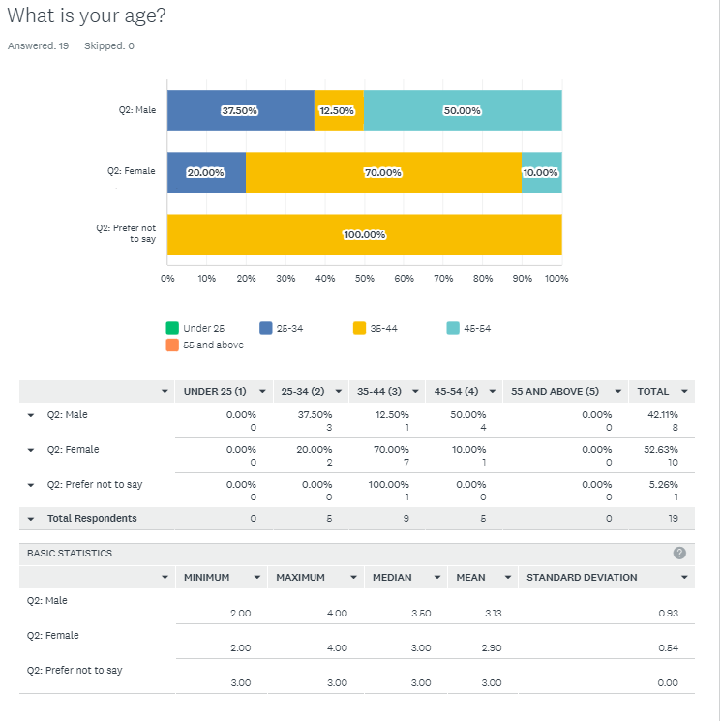

Q2
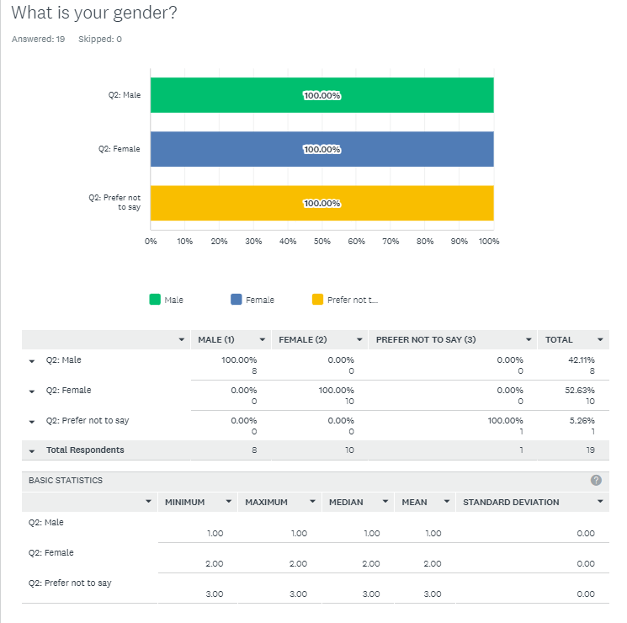

Q3
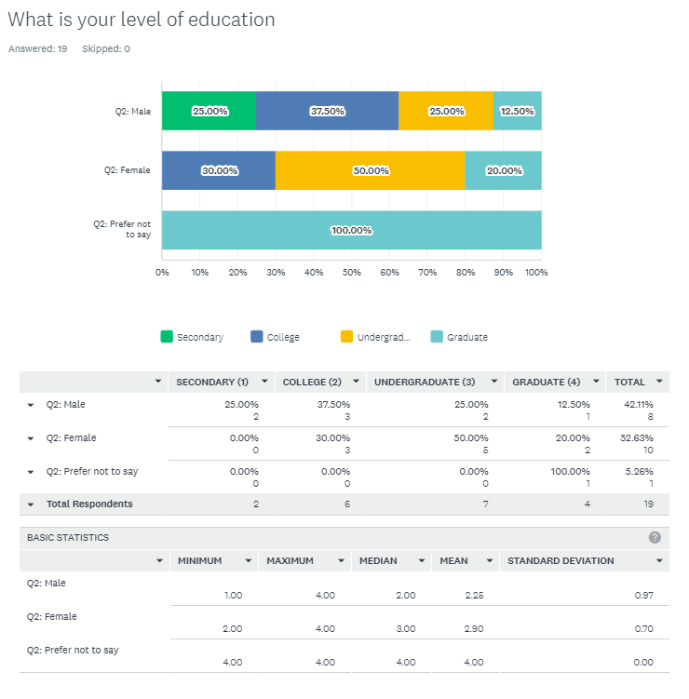

Q4
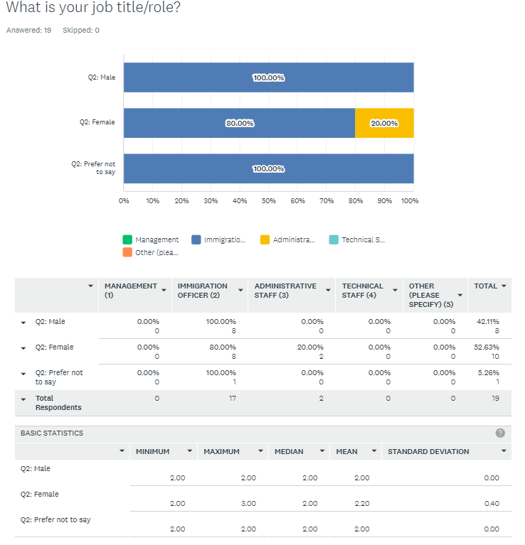

Q5
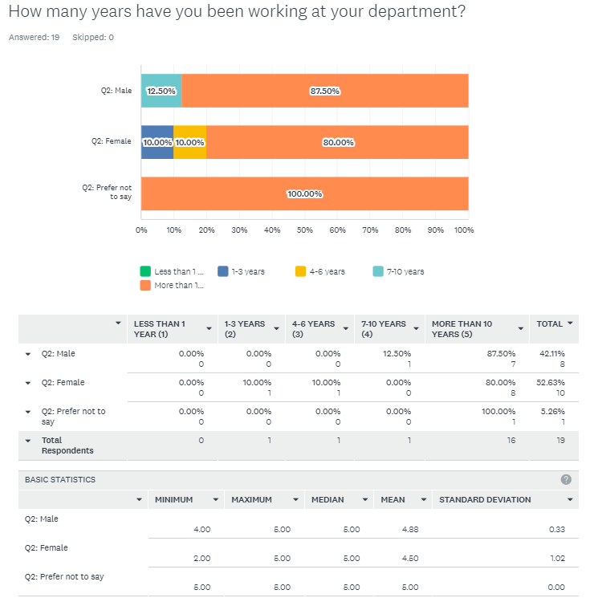

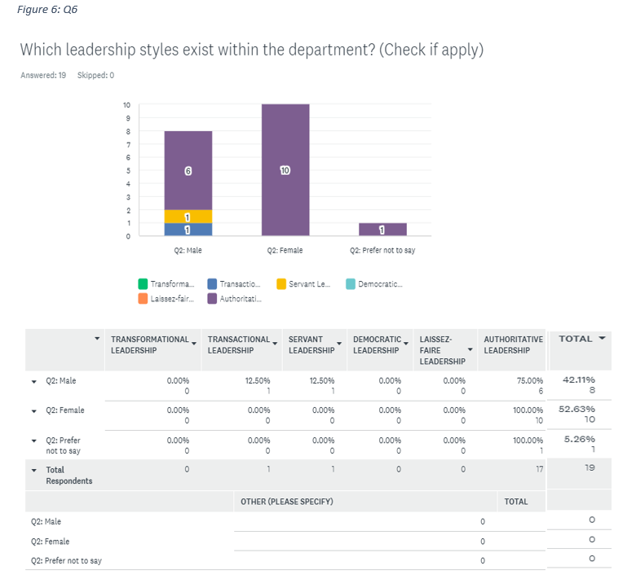
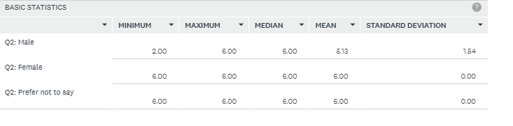
Q7
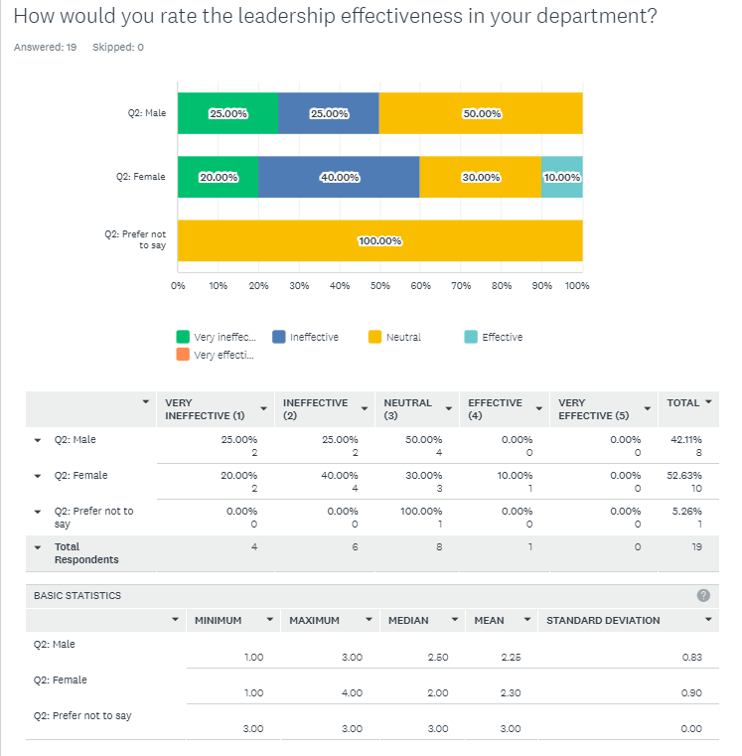

Q8
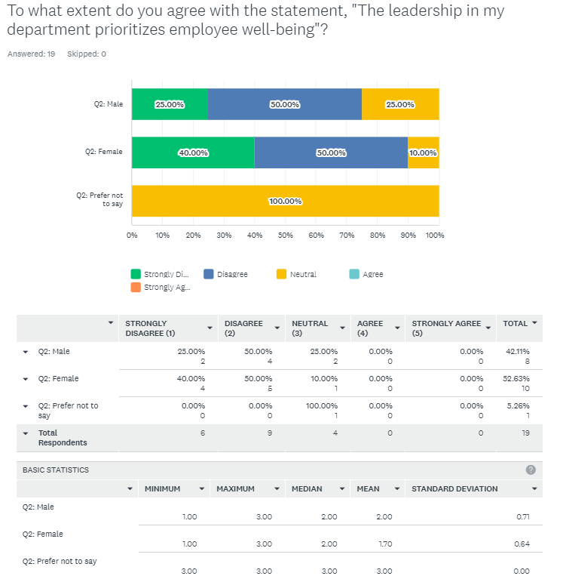
Q9
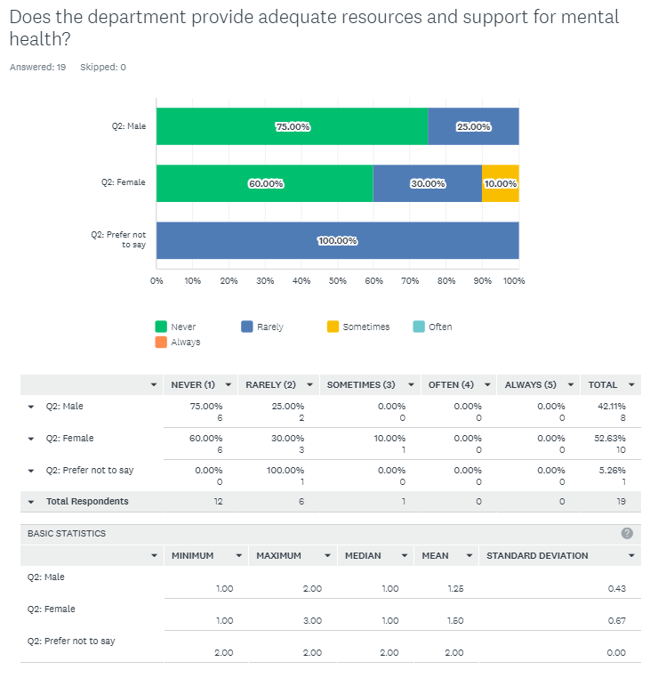

Q10
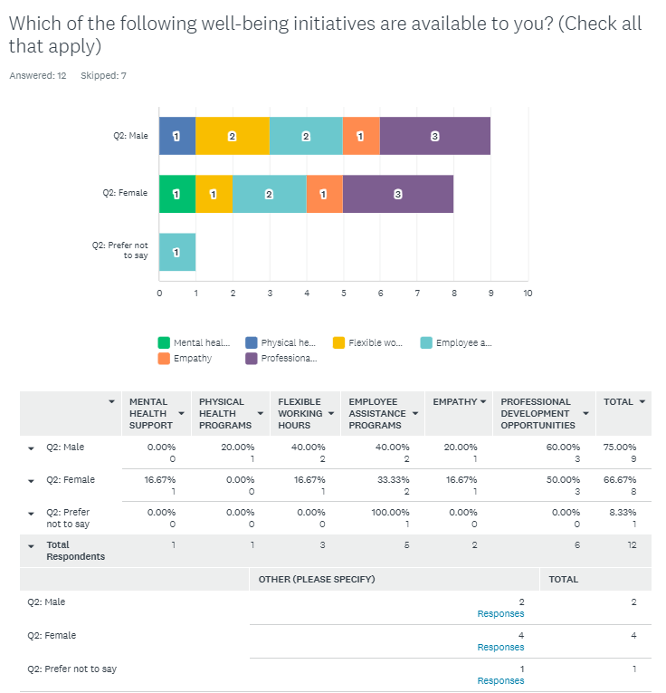
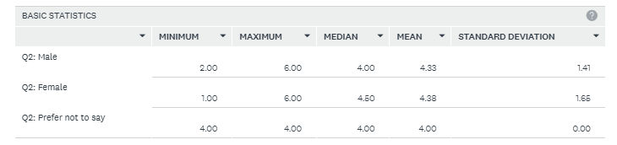
Q10 COMMENTS
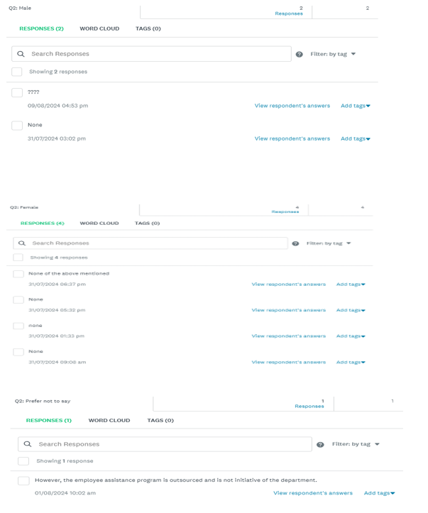

Q11
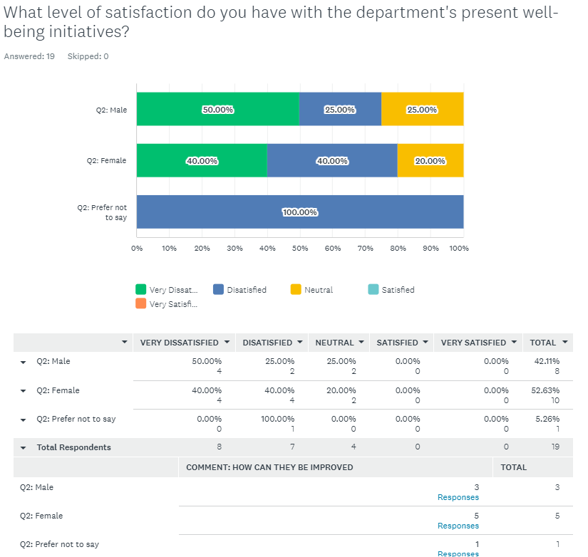
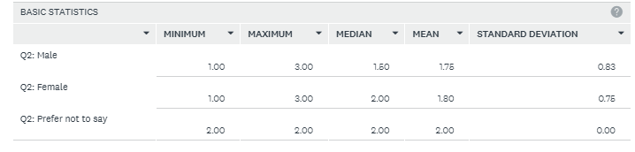
Q11C.
Comment: How can they be improved _____________________________________-
Q12
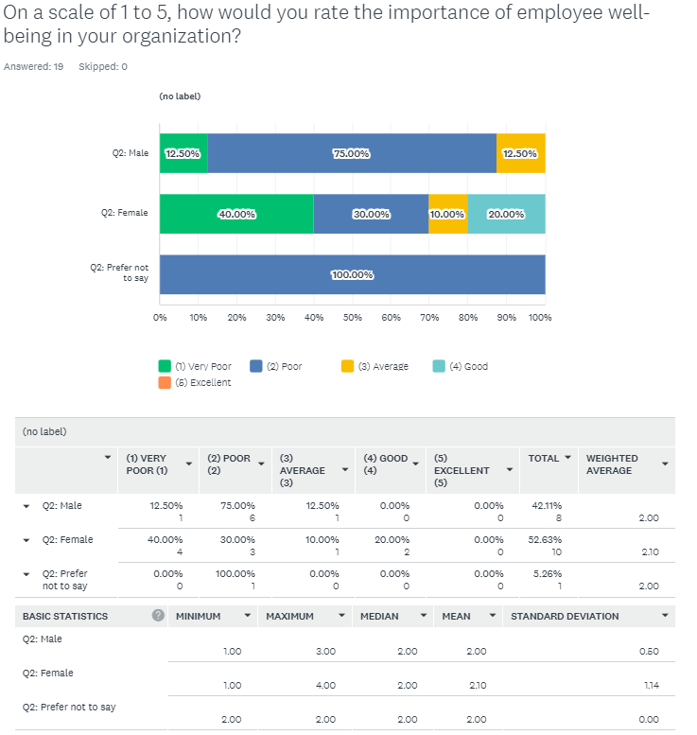
Q13
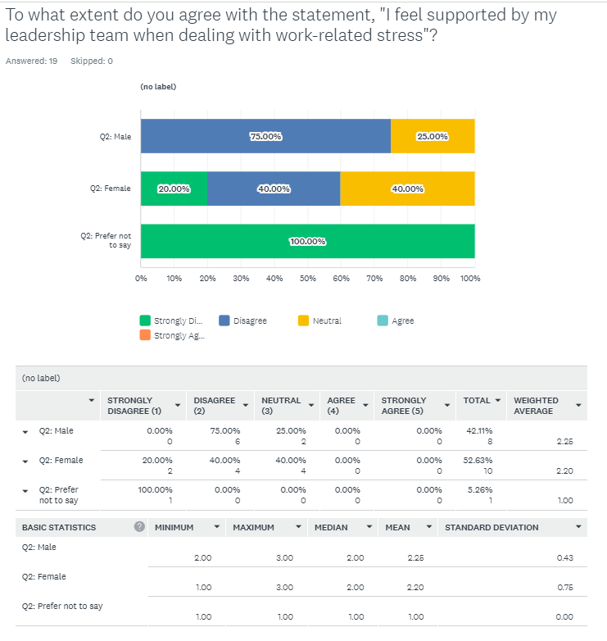

Q14
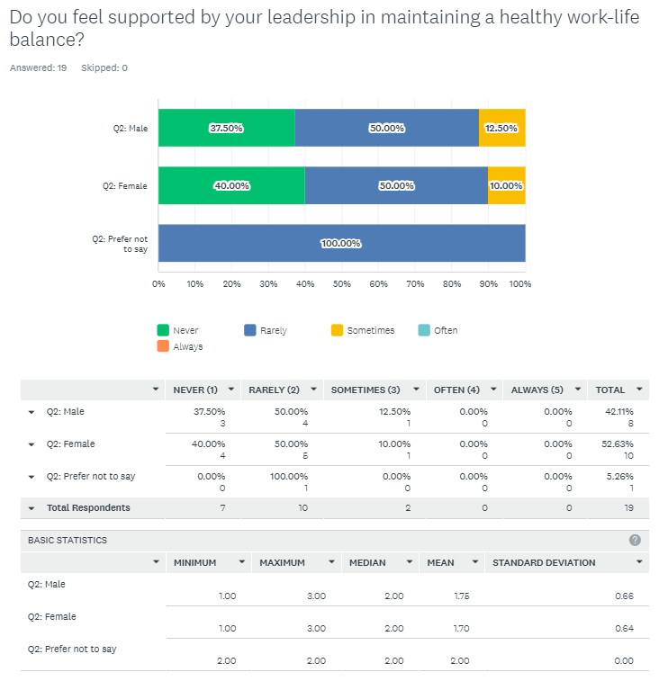
Q15
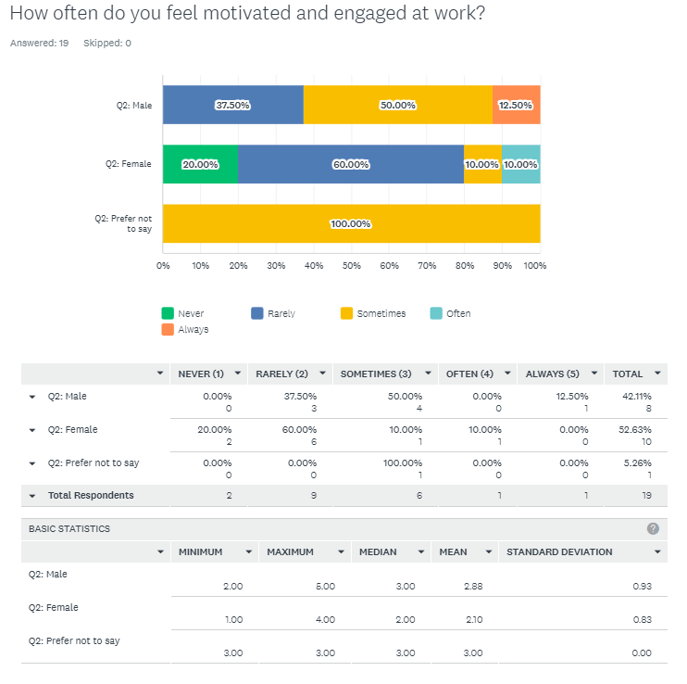
Q16
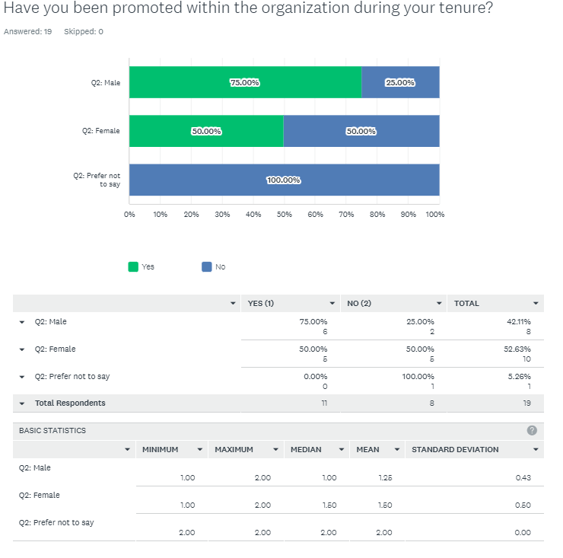
Q17
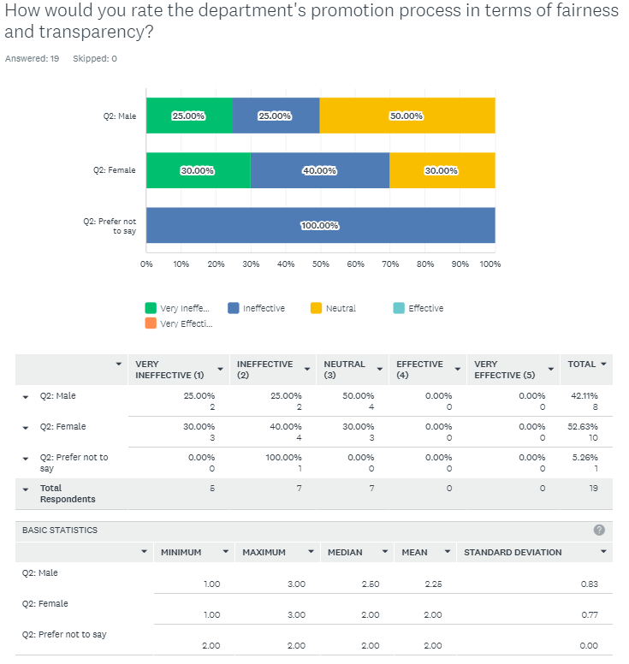
Q18
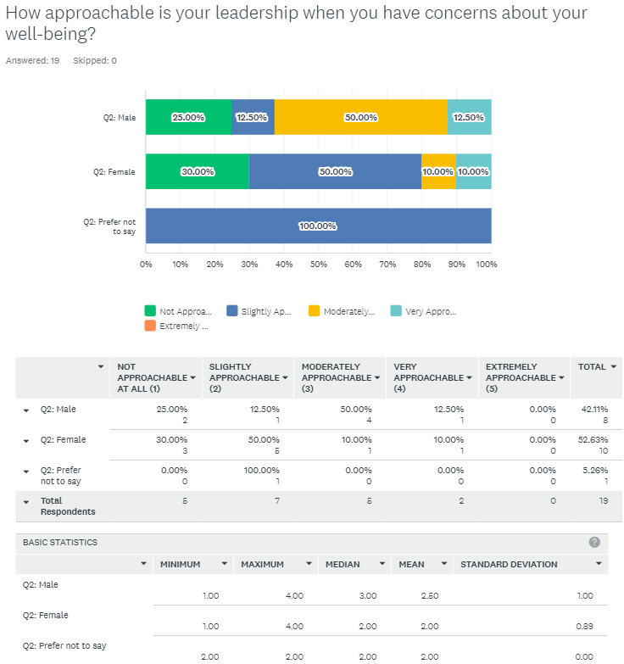
Q19
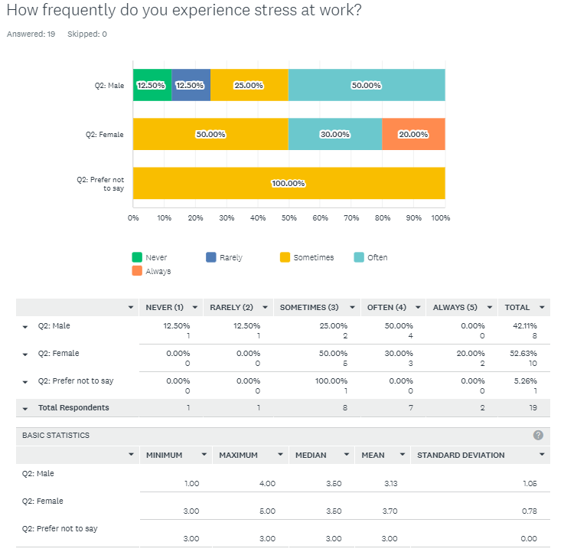
Q20
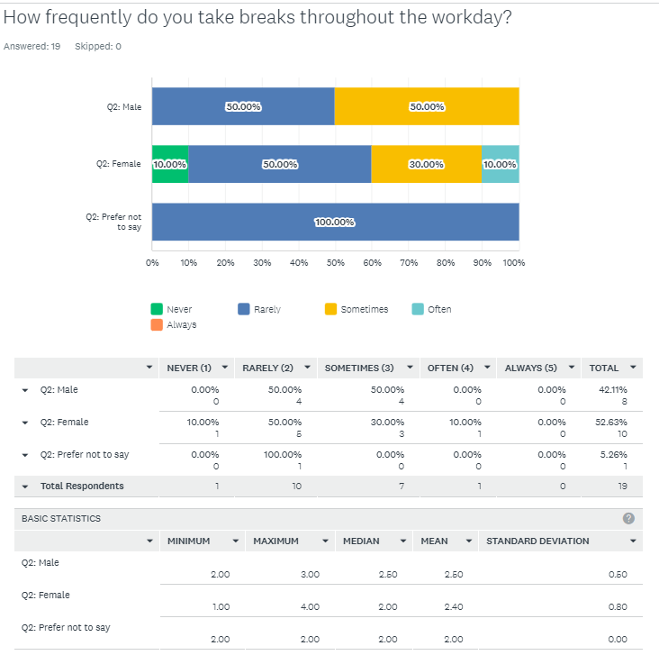

Q21
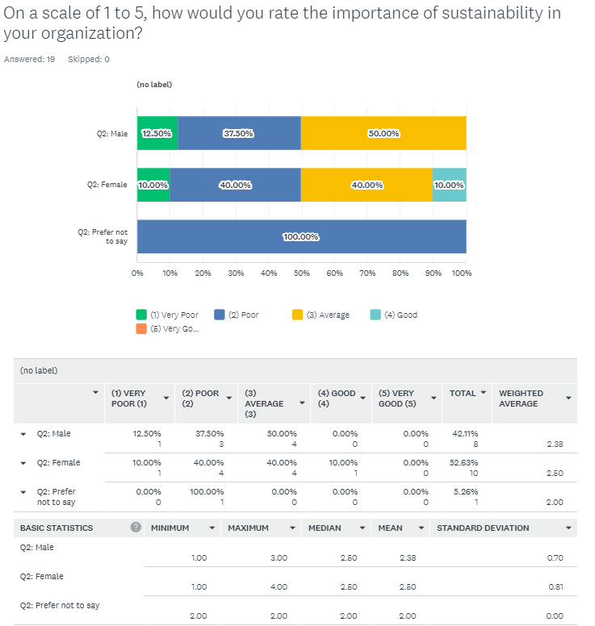
Q22
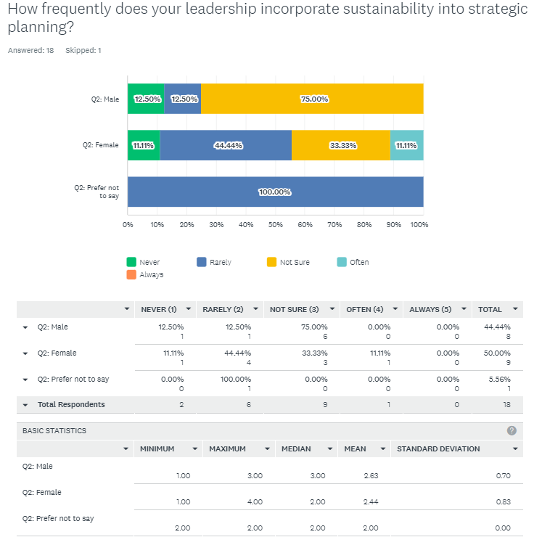

Q23
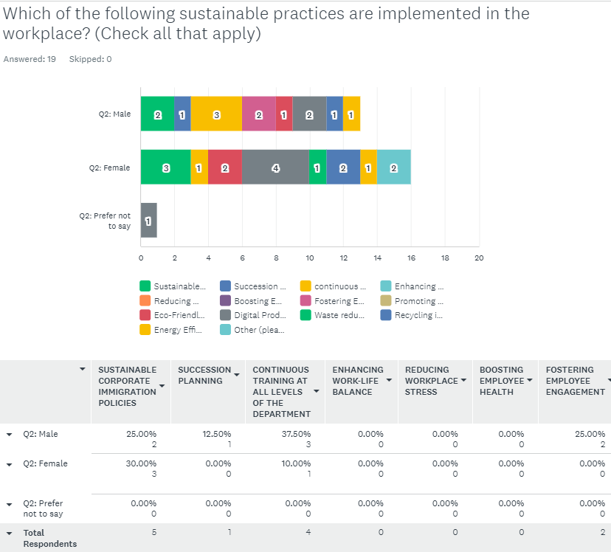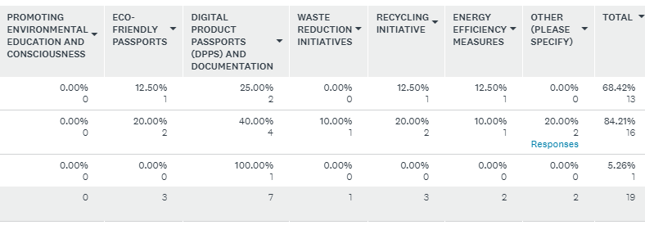
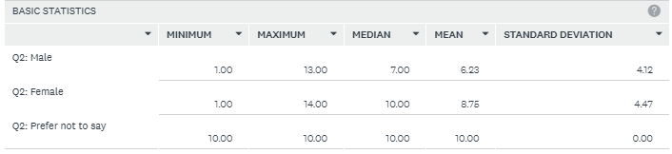
Q24
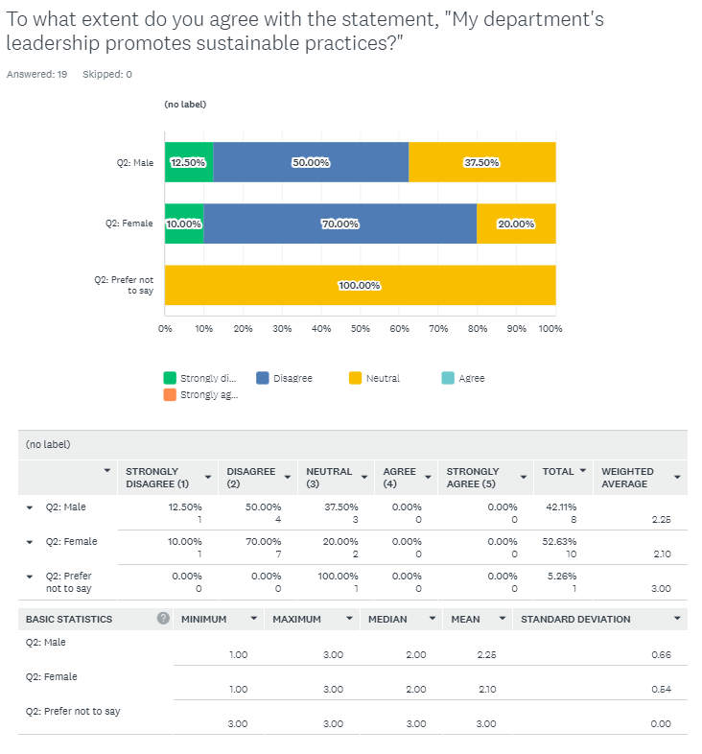
Q24 PART 2 COMMENTS
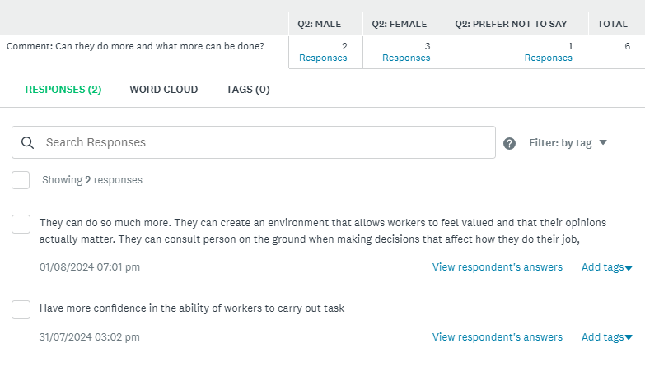
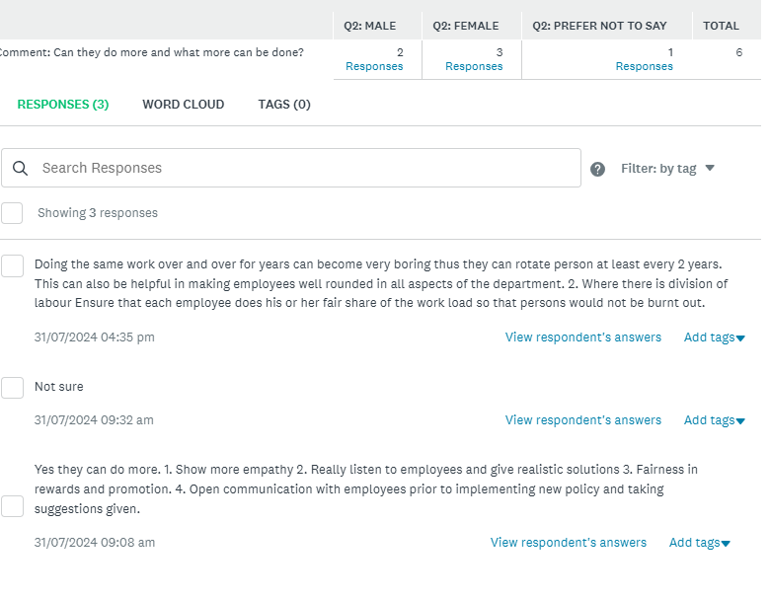
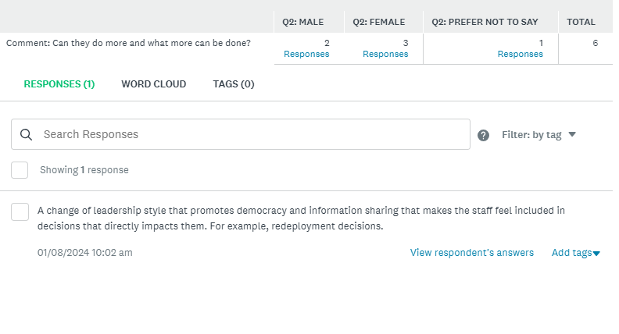
Q25
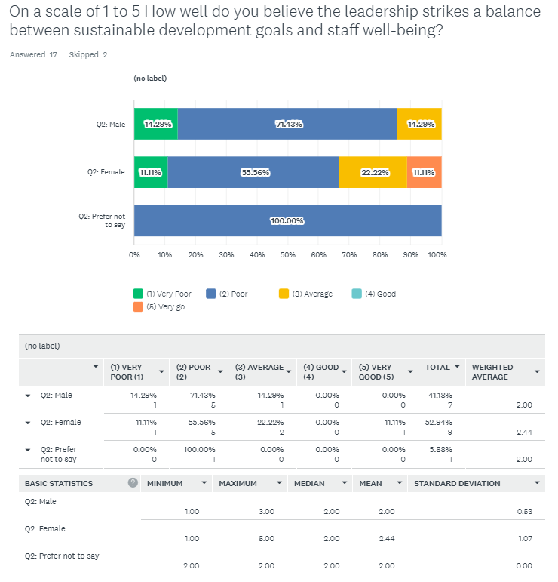
1 Male Q25 comment:
- Development is somewhat a foreign concept in this department and as far as staff well-being, the leadership just doesn't make an effort.

2 Female Q25 Comments:
- Employees still display a relatively good work attitude despite the odds
- None
Q26
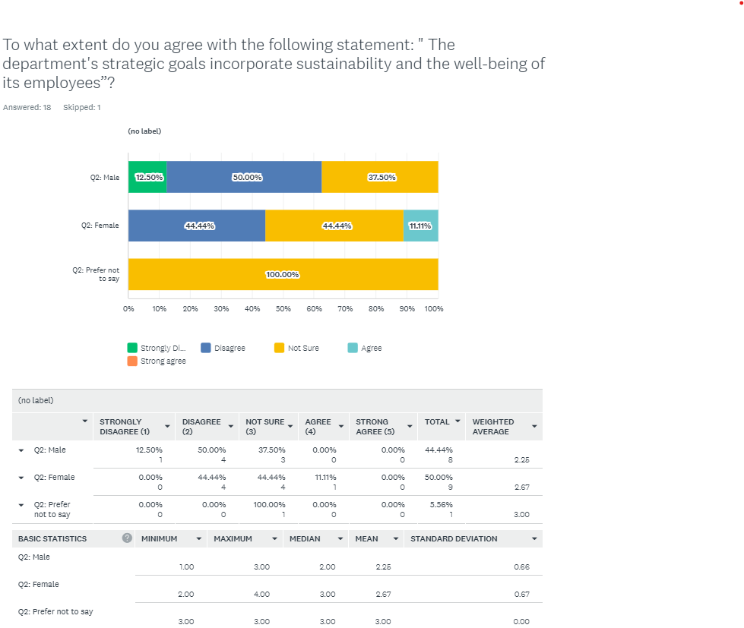
Q27
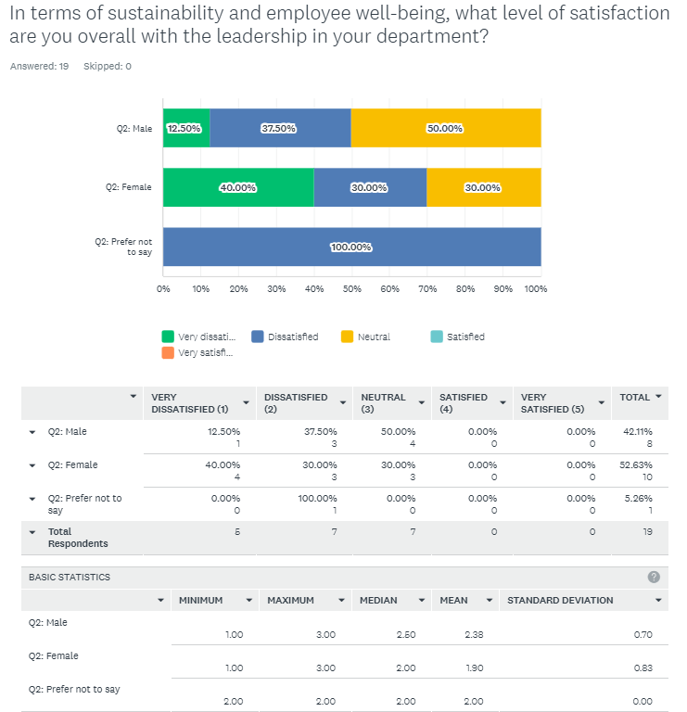
Q28
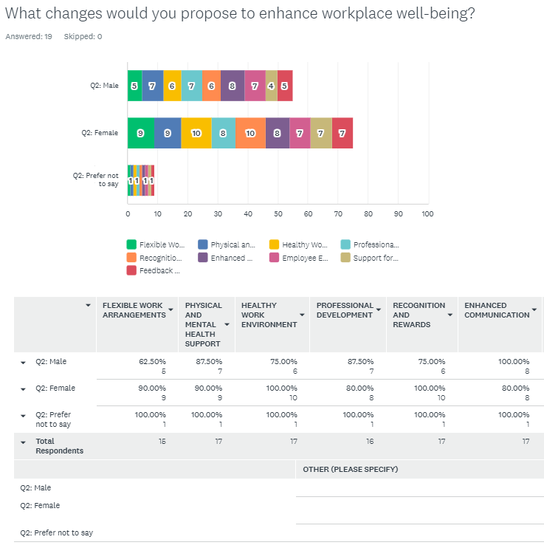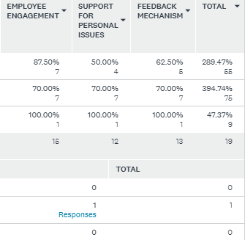
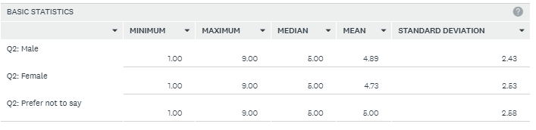
Q29
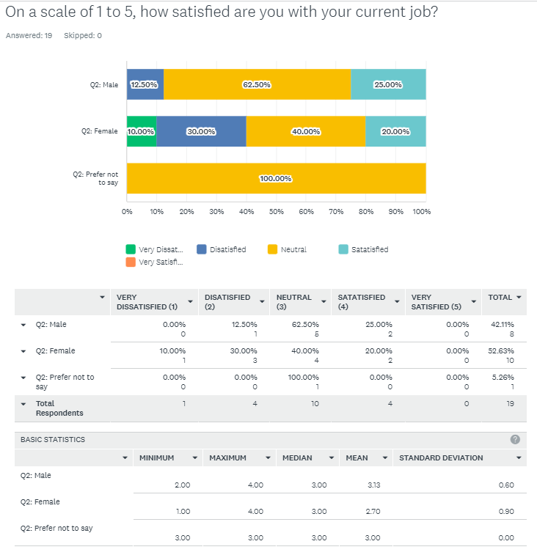
Q30
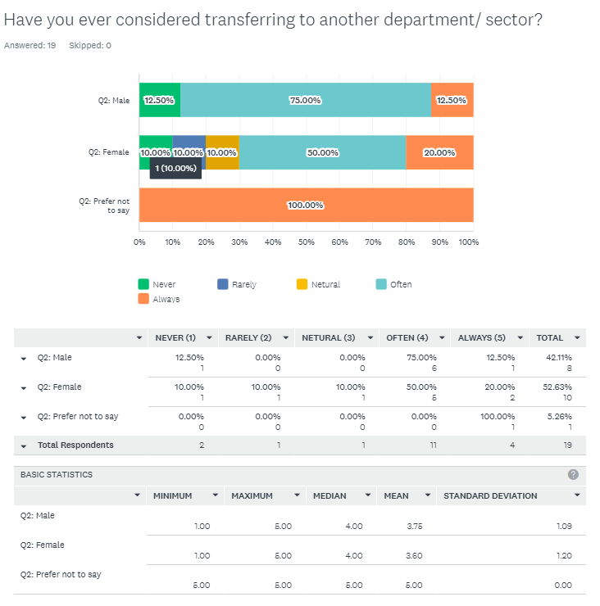
Q31
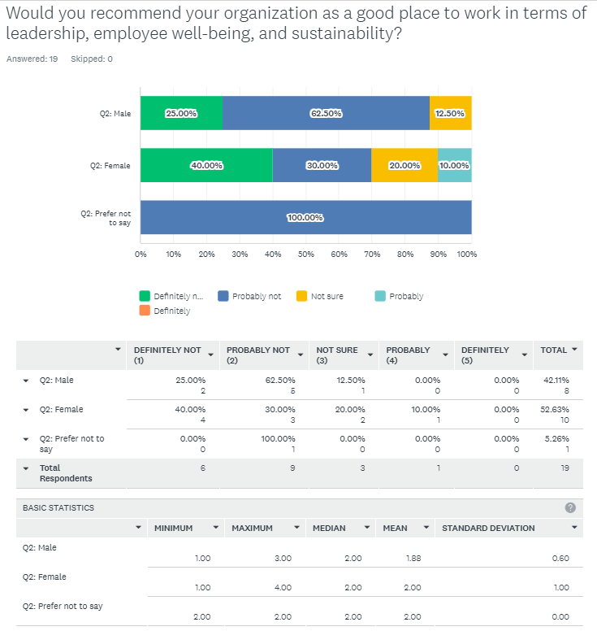

Appendix 2: Interview Questionnaire

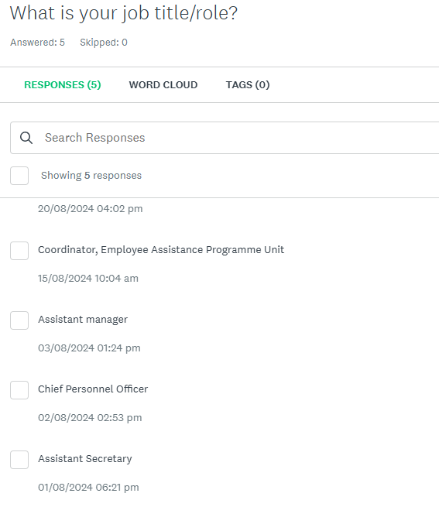

Q2.
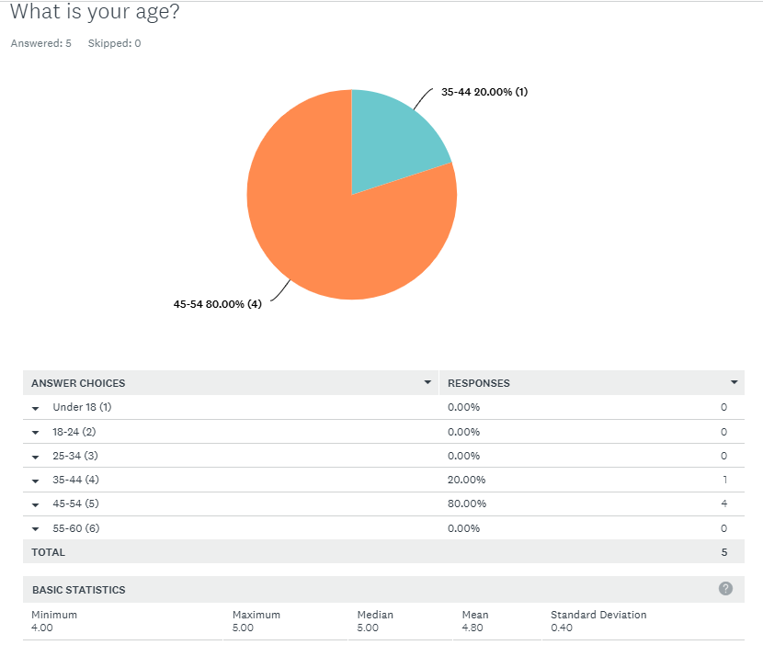

Q3.

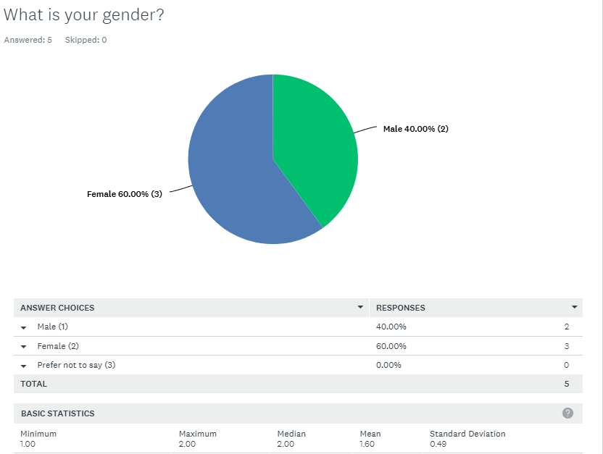

Q4.
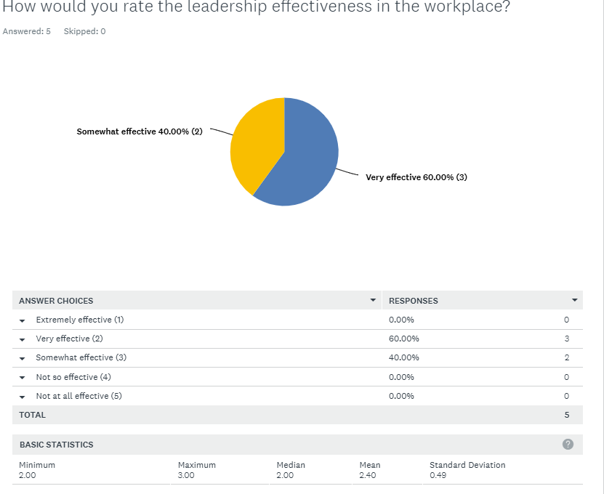

Q5.
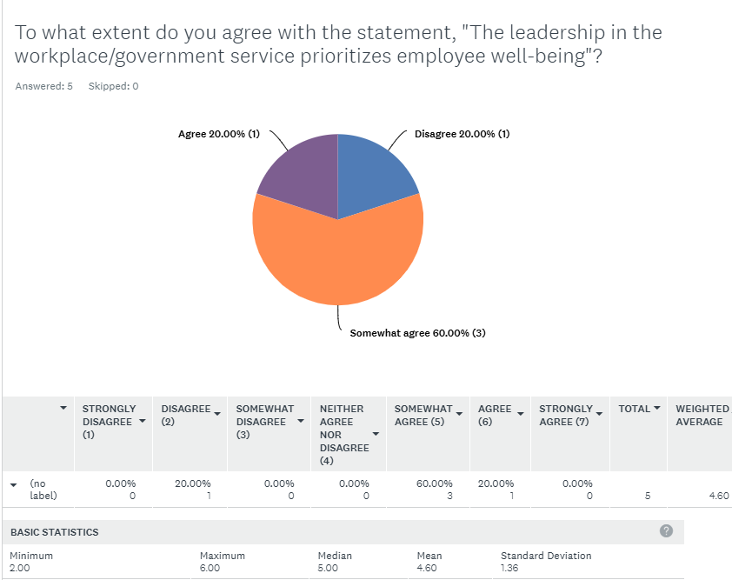

Q6A.

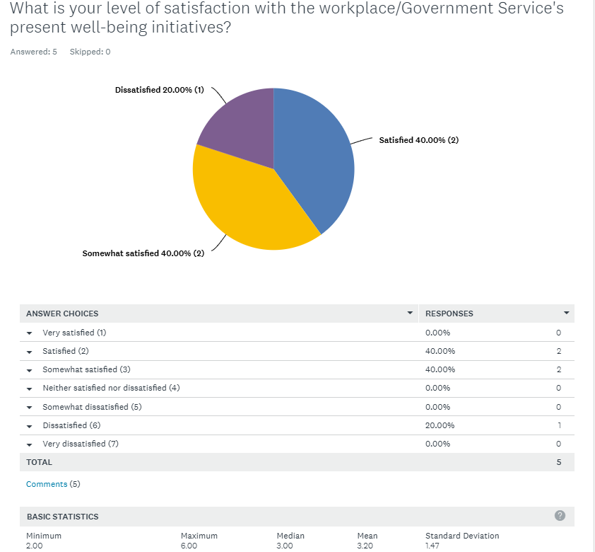

Q6B.

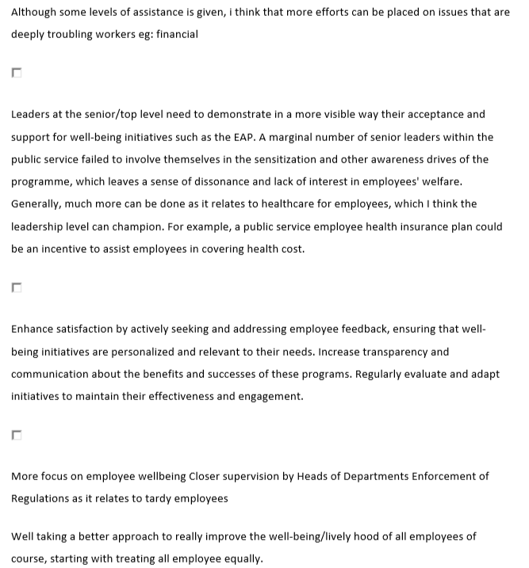
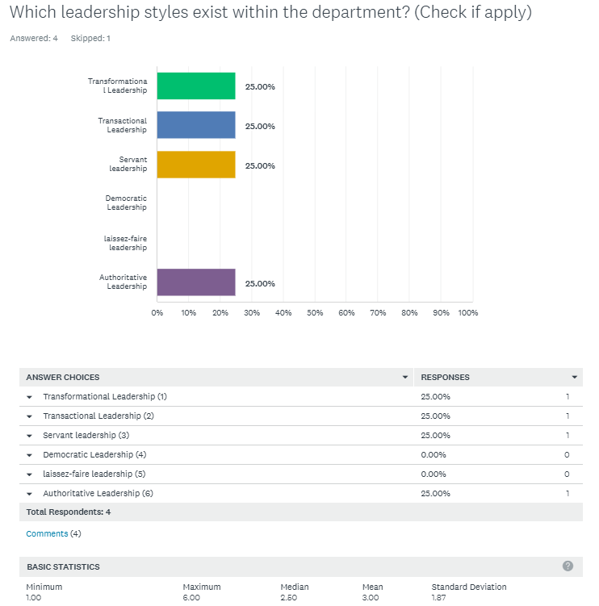
Q7.

Q7B.
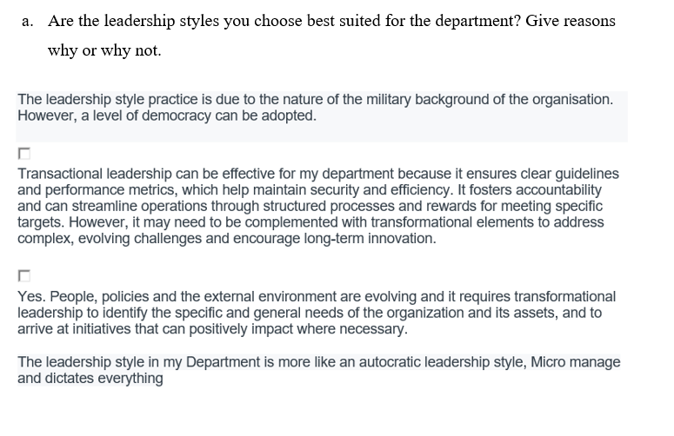
Q8.
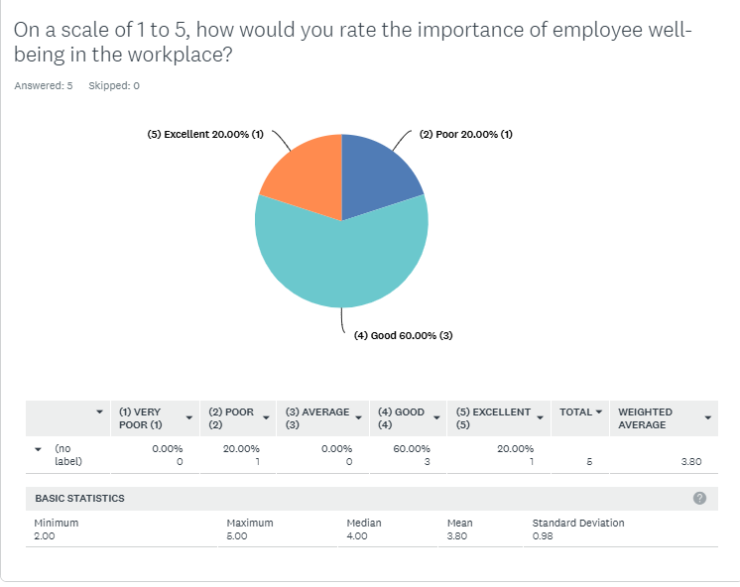

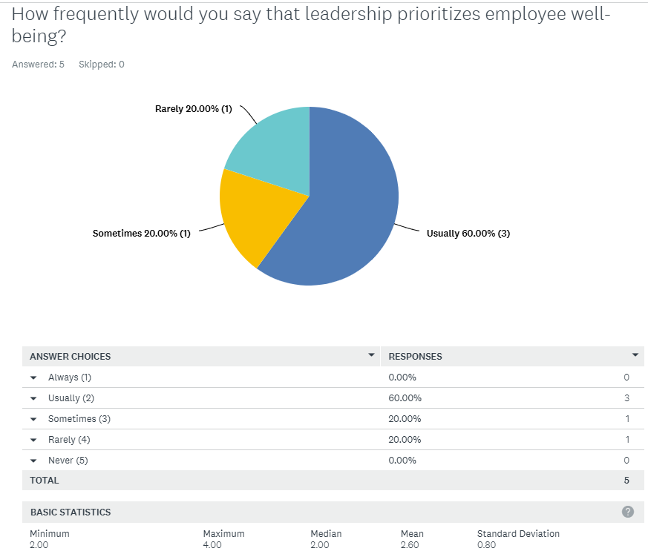
Q9.

Q10A.
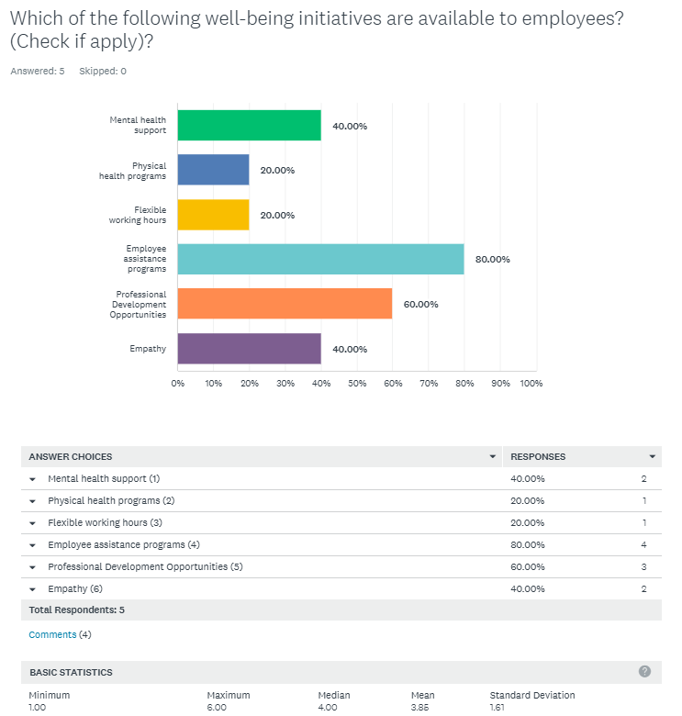

10B.
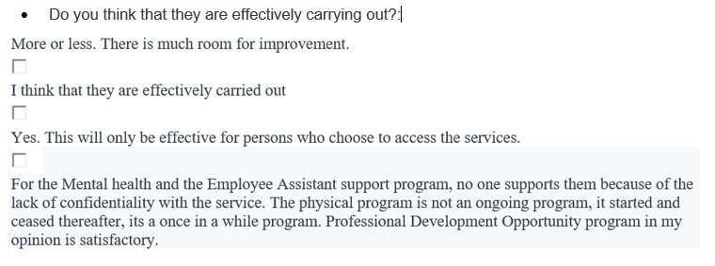

Q11.

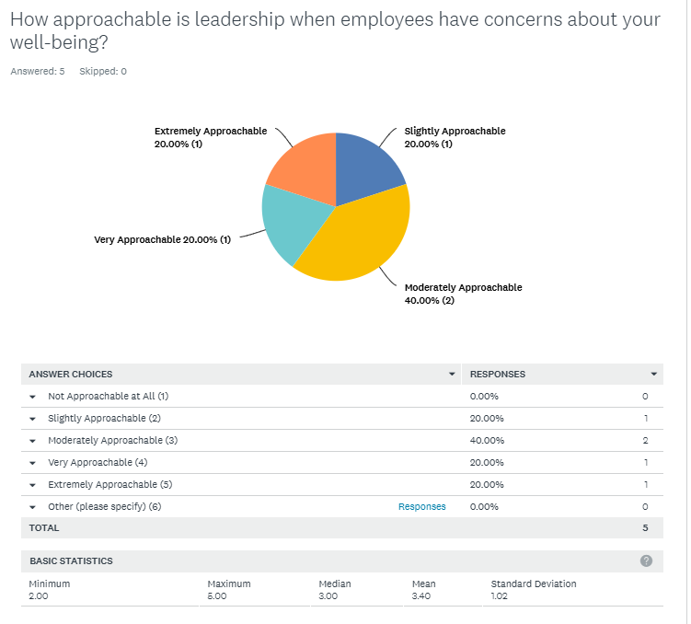

Q12.
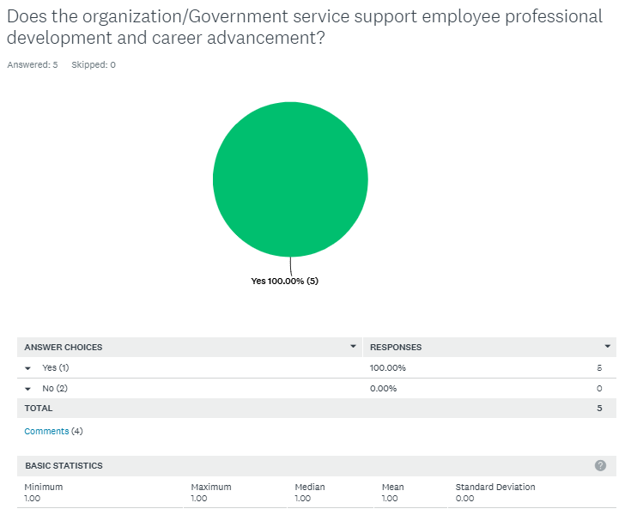
Q12B.
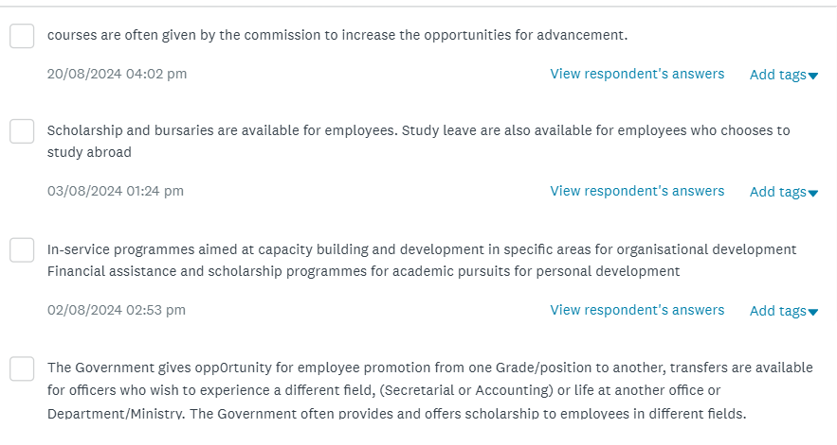

Q13

.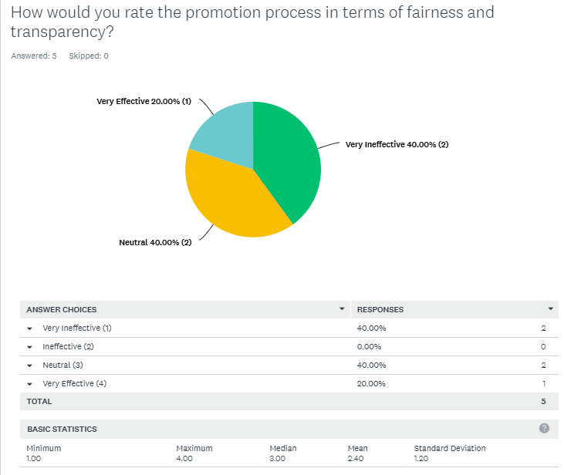

Q14.
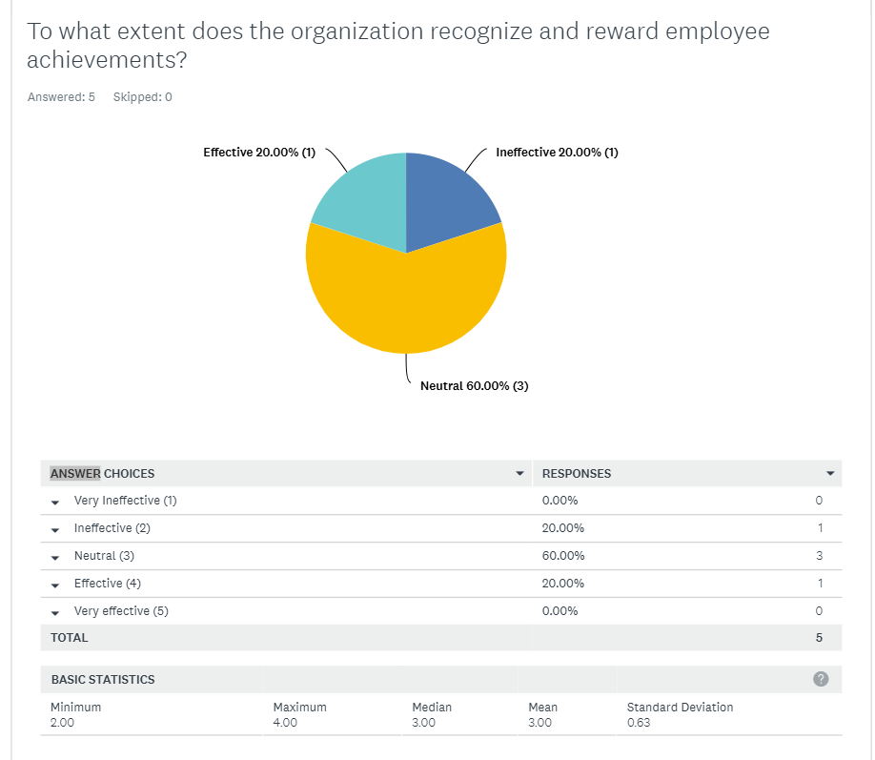

Q15.
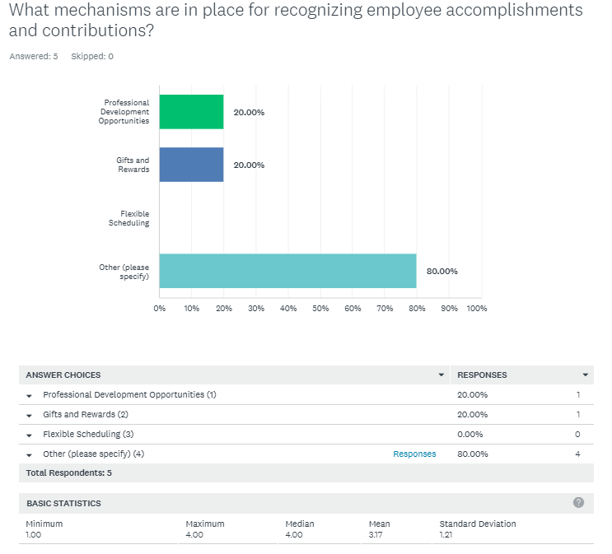

Q16.
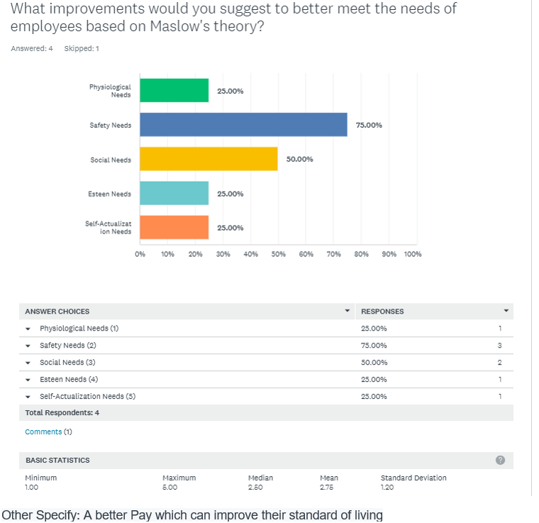

Q17
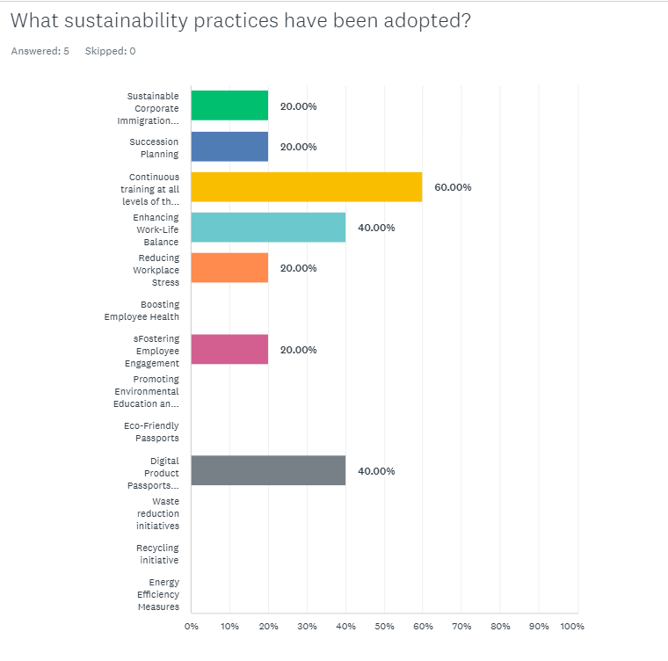
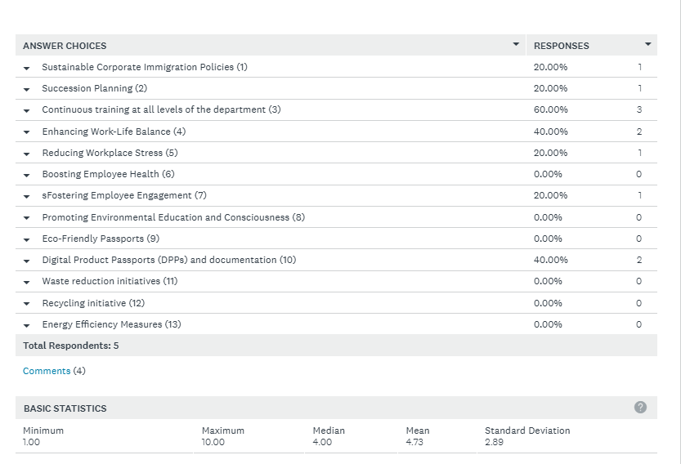

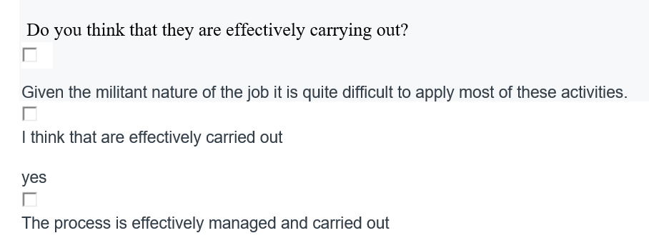

Q18
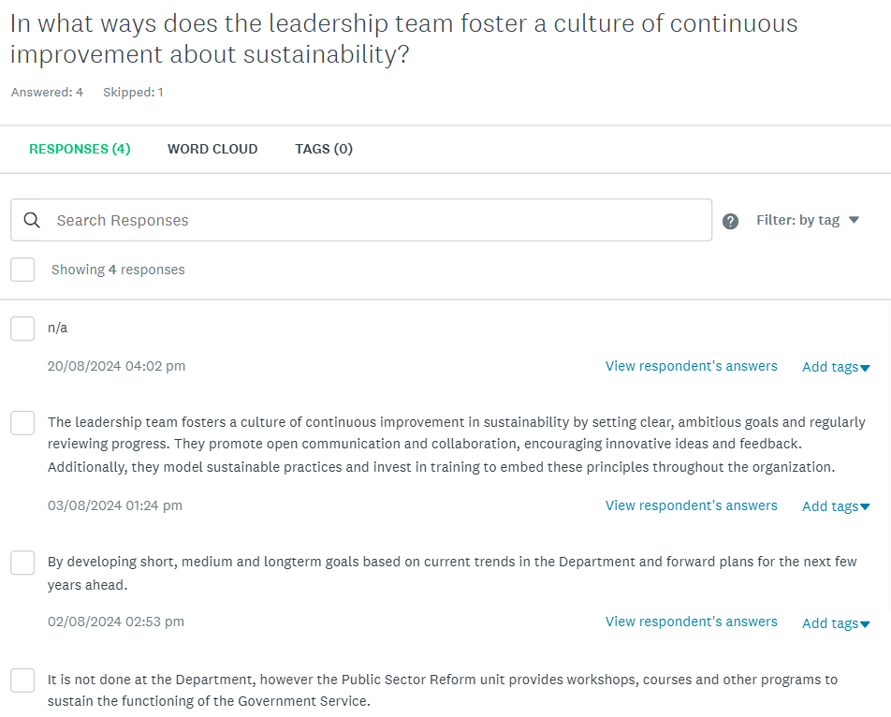

Q19

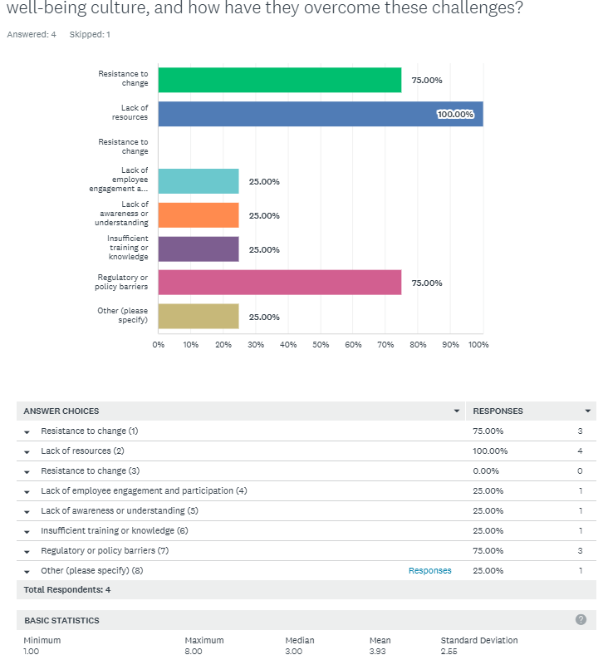

Q20
Q20A.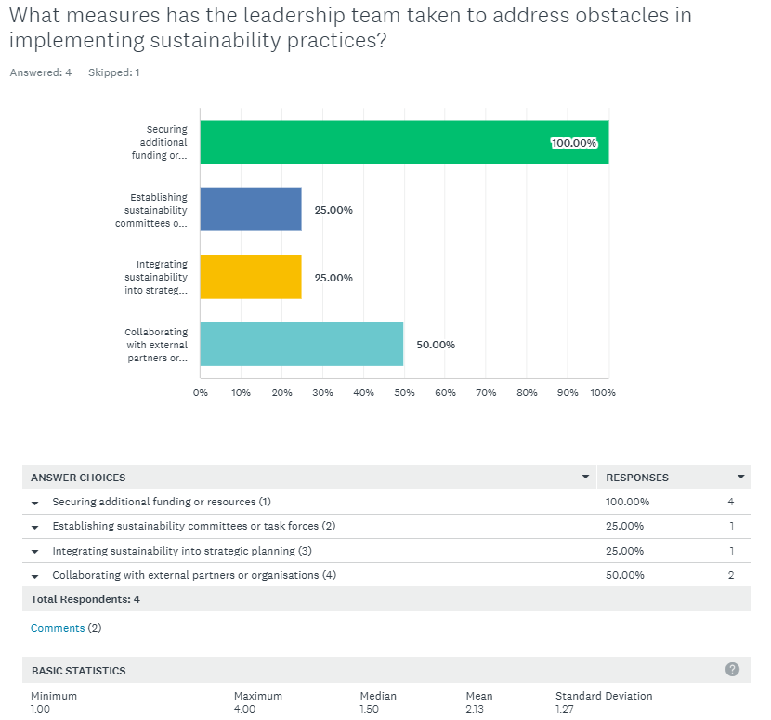
Q20B.
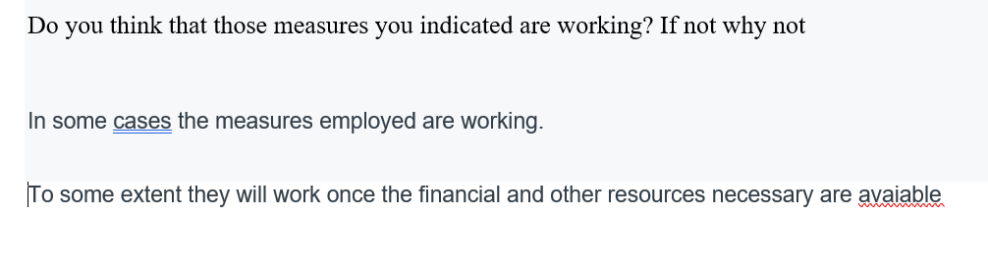

Q21
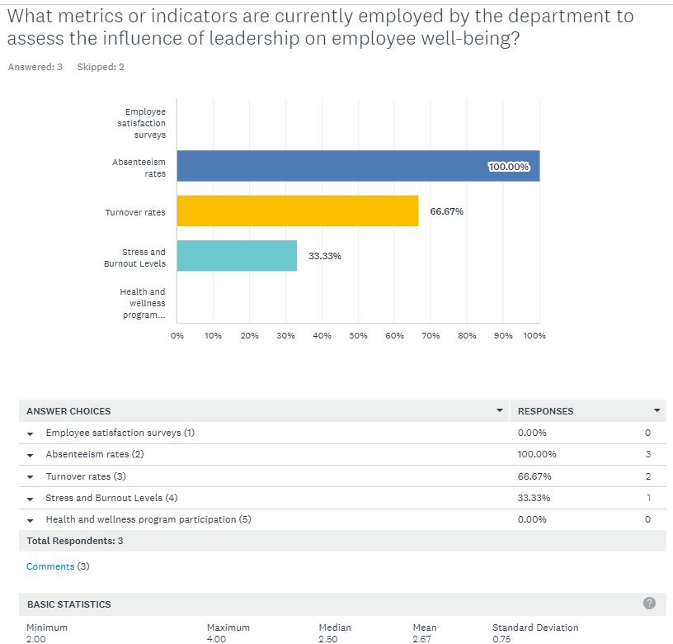
Q21b.
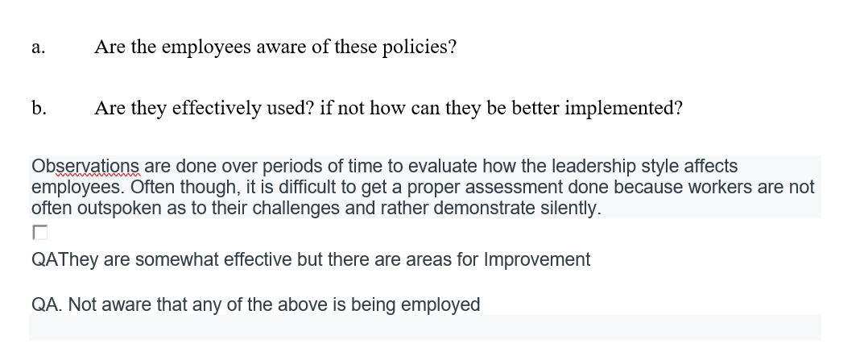

Q22.
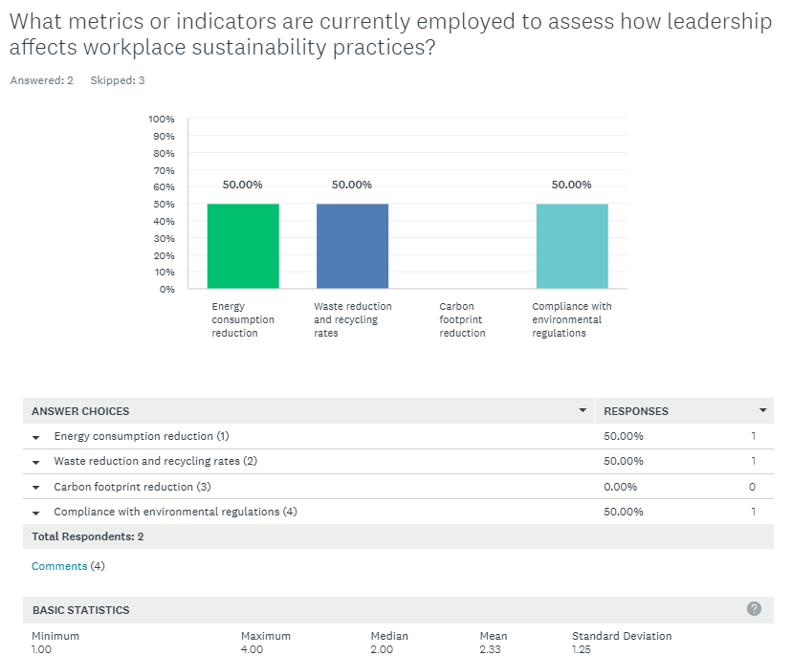

Q22B.
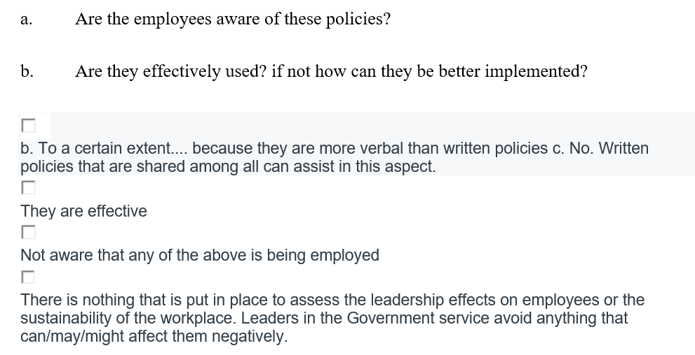

Q23
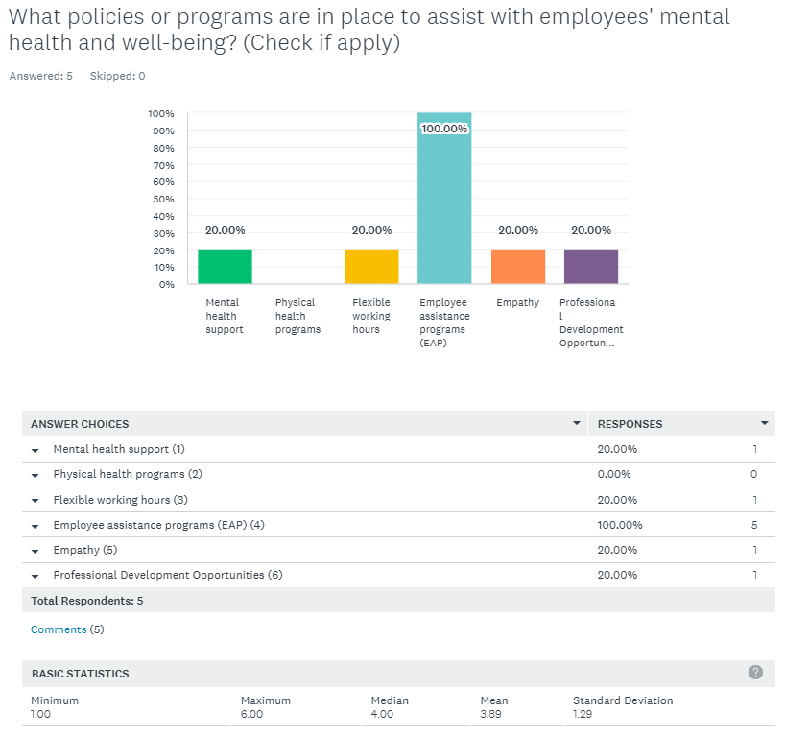

Q23B.
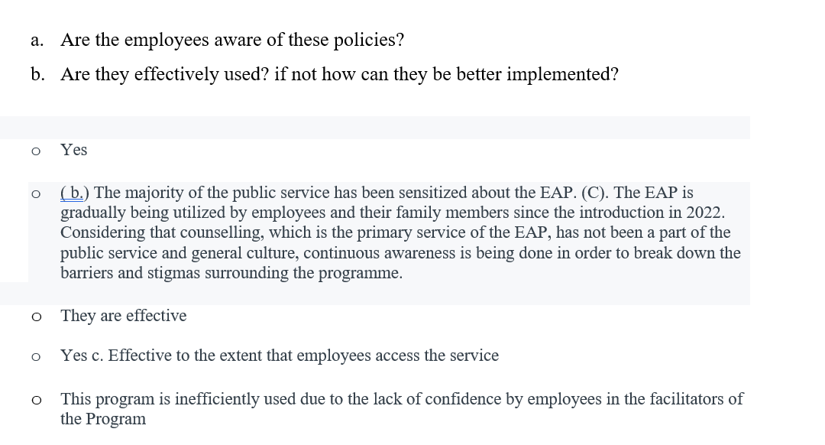

Q24A
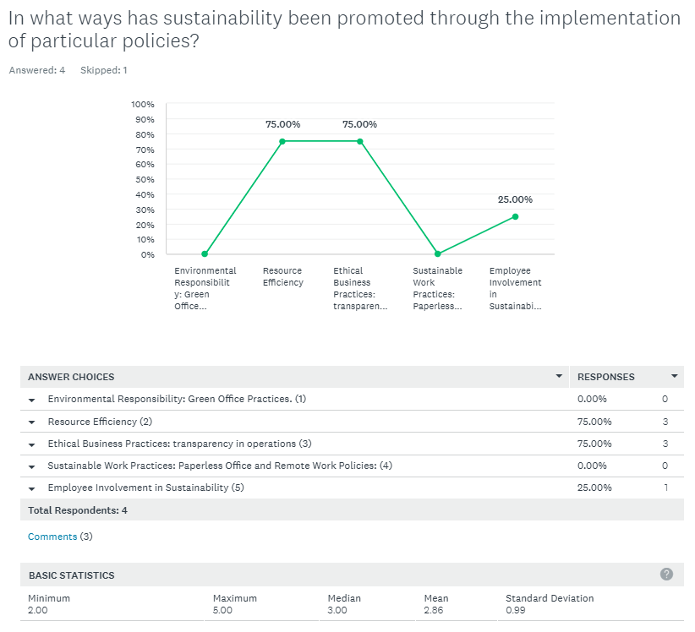
Q24B.
Q24B.
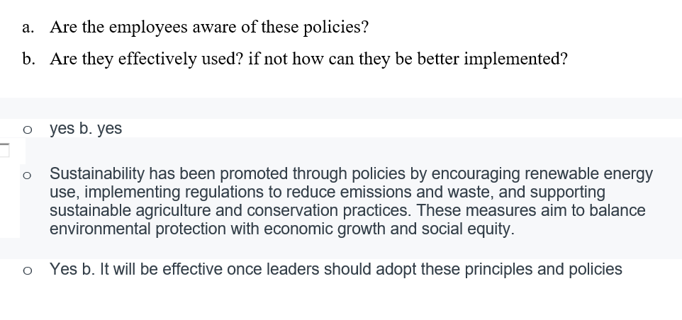
Q25.LINE GRAPH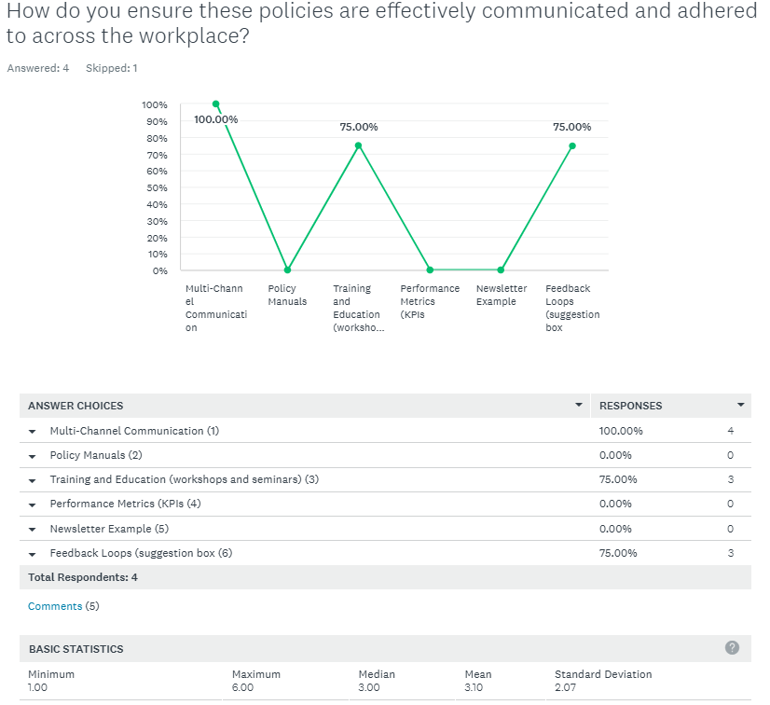
Q25B.

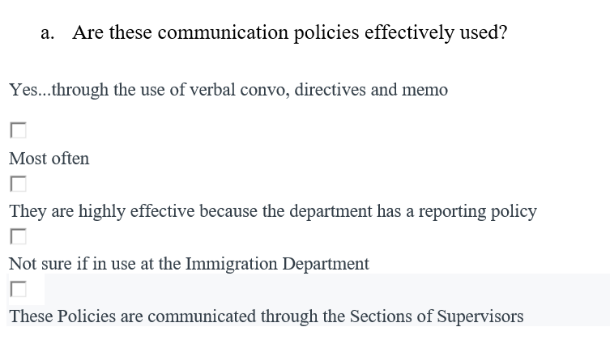

Q26
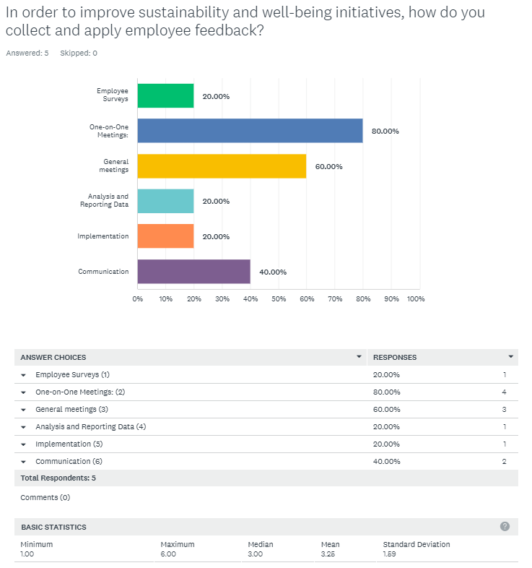

Q27
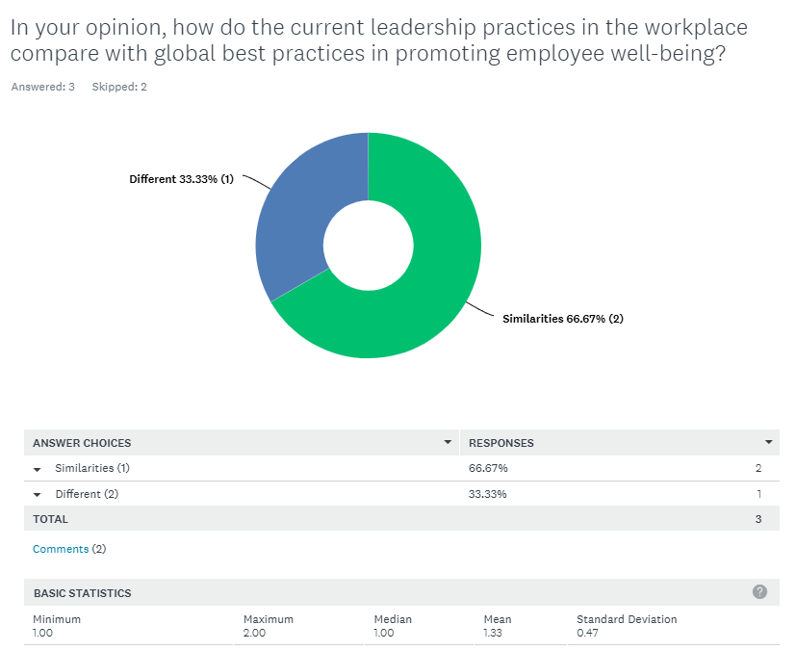
Q27B.
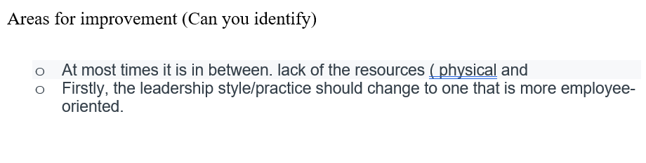

Q28A.
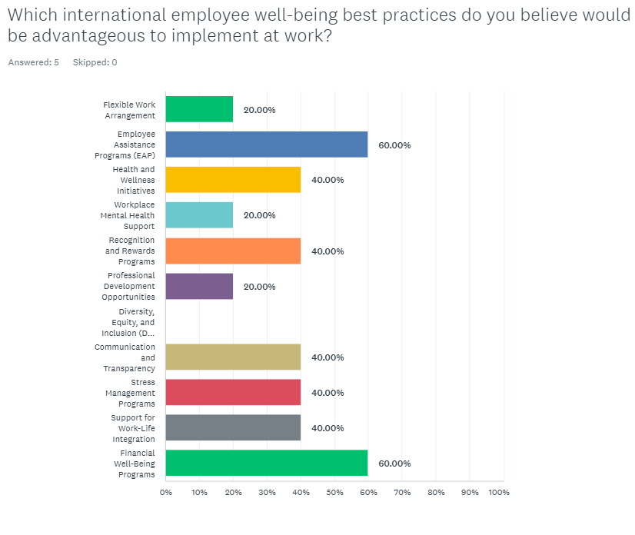
Q28B.
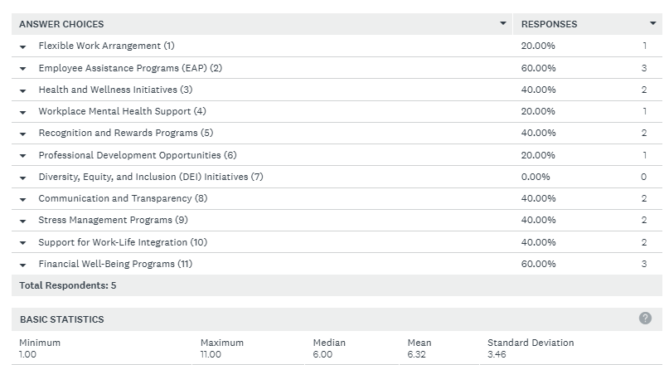

Q29A.
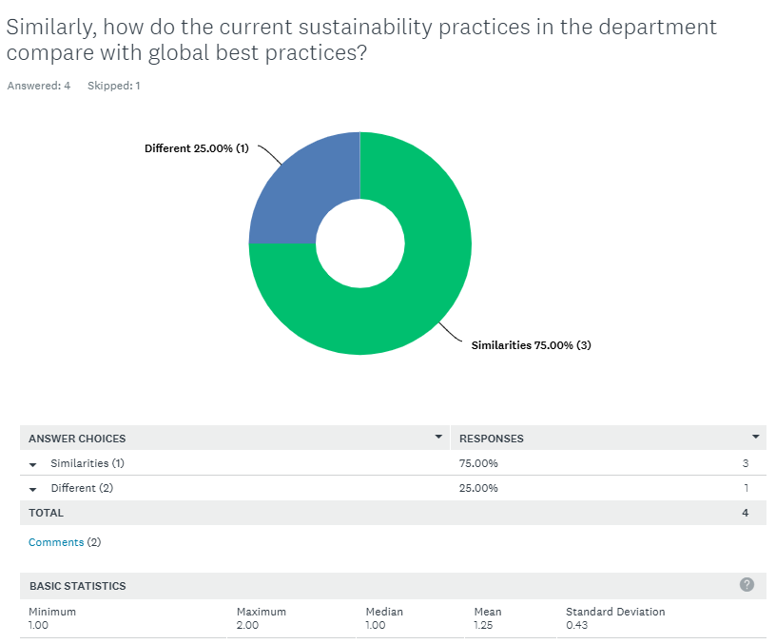

Q29B.
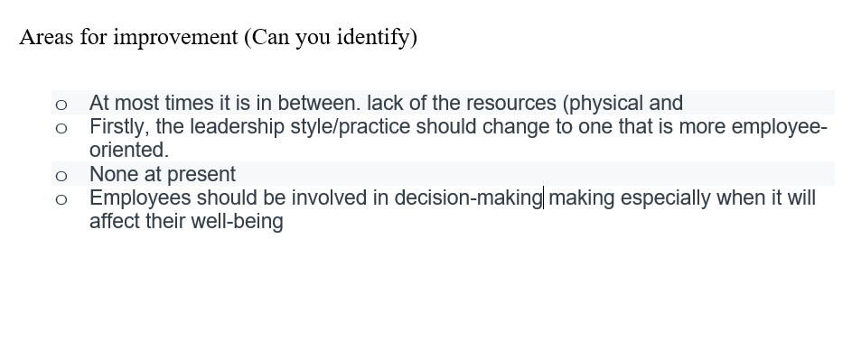

Q30.
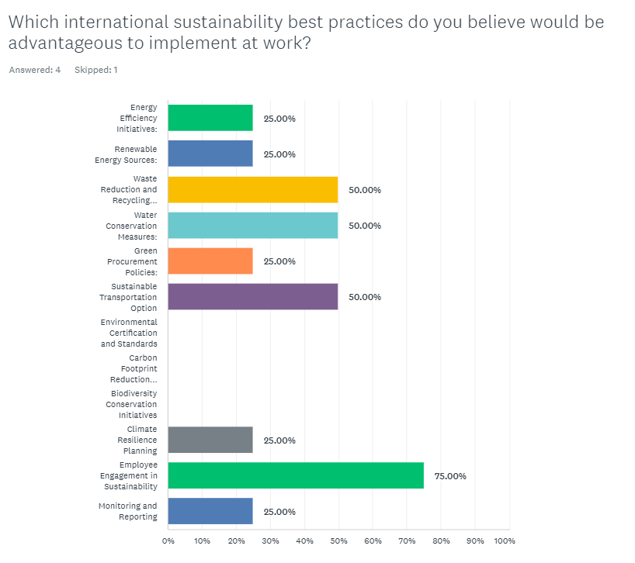
Q30B.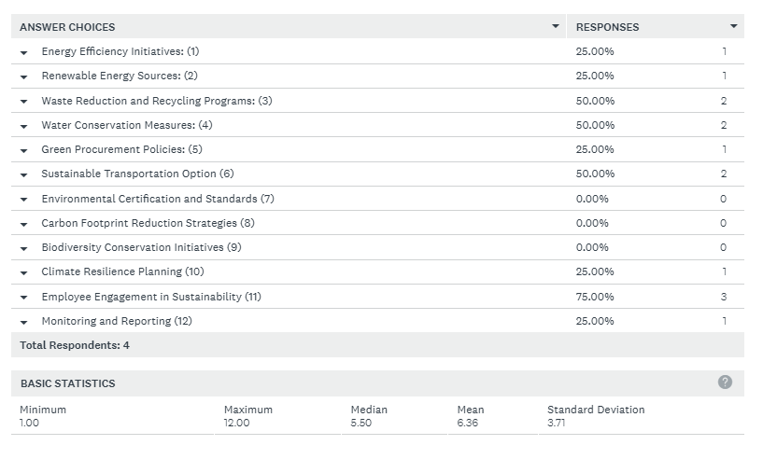

Q31.
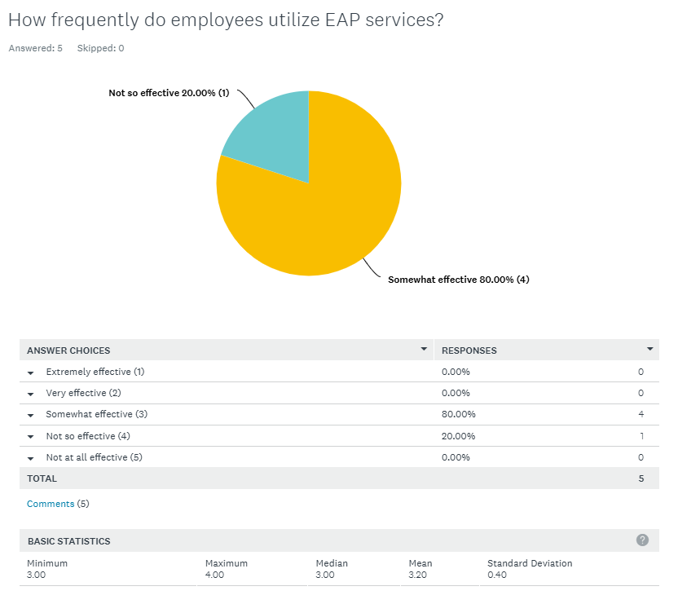

Q31b.
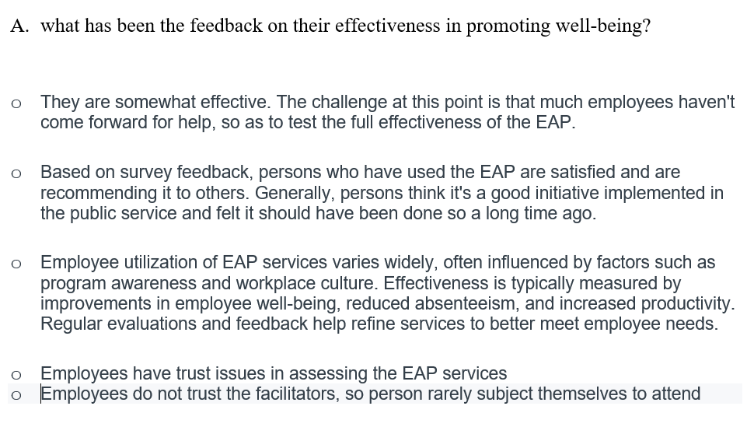

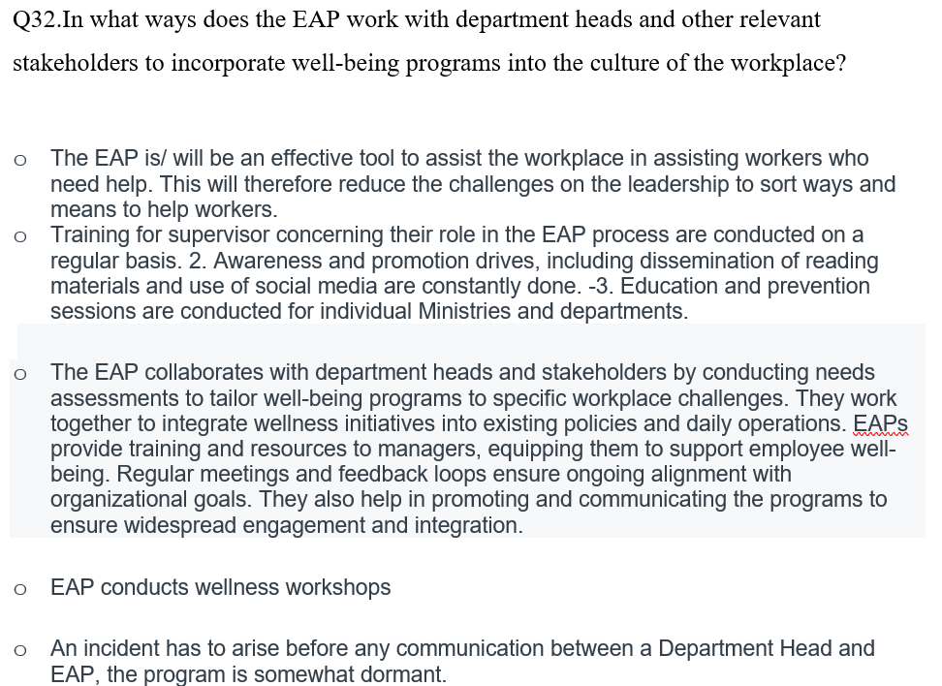

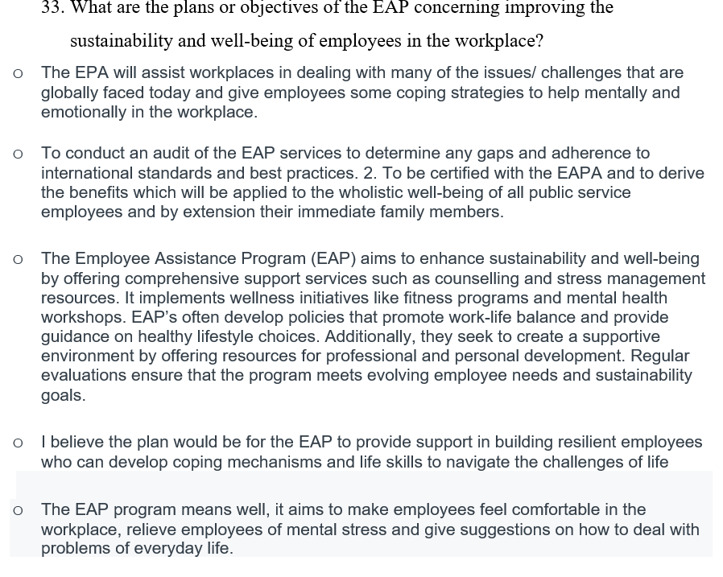

Appendix 3: Ethical Form


APPLICATION FOR ETHICAL APPROVAL

In order for research to result in benefit and minimise risk of harm, it must be conducted ethically. A researcher may not be covered by the University’s insurance if ethical approval has not been obtained prior to commencement.

The University follows the OECD Frascati manual definition of research activity: “creative work undertaken on a systematic basis in order to increase the stock of knowledge, including knowledge of man, culture and society, and the use of this stock of knowledge to devise new applications”. As such this covers activities undertaken by members of staff, postgraduate research students, and both taught postgraduate and undergraduate students working on dissertations/projects.

The individual undertaking the research activity is known as the “principal researcher”.

Ethical approval is not required for routine audits, performance reviews, quality assurance studies, testing within normal educational requirements, and literary or artistic criticism.

Please read the notes for guidance before completing ALL sections of the form.

This form must be completed and approved prior to undertaking any research activity. Please see Checklist for details of process for different categories of application.

SECTION A: About You (Principal Researcher)

Full Name: |  |  | Zara John-Nicholls
Tick all boxes which apply:
Member of staff: | ☐ | Student: |  | ☒ | Honorary research fellow: | ☐

Faculty/School/Centre: | Faculty of Business and Management
Campus: | Carmarthen Campus (Distance)
E-mail address: | 2114488@student.uwtsd.ac.uk
Contact Telephone Number: | 17844911478
For students:
Student Number: | 2114488 | Graduate | ☒
Programme of Study: | Master of Business Administration: General Management  (MBA – Online MBA) | Taught Postgraduate | ☒
Director of Studies/Supervisor: | Dr. Glenn Behenna | Research | ☒

SECTION B: Approval for Research Activity

Has the research activity received approval in principle?  (please check the Guidance Notes as to the appropriate approval process for different levels of research by different categories of individual) |  | YES | ☐ | NO | ☒
 |  |  |  | Date
If Yes, please indicate source of approval (and date where known): | Research Degrees Committee |  | ☐
 | Faculty Research Committee |  | ☐
 | Other (write-in) Supervisor |  | ☐
Approval in principle must be obtained from the relevant source prior to seeking ethical approval.

SECTION C: External Ethical Guidance Materials

Please list the core ethical guidance documents that have been referred to during the completion of this form (including any discipline-specific codes of research ethics, and also any specific ethical guidance relating to the proposed methodology). Please tick to confirm that your research proposal adheres to these codes and guidelines.
UWTSD - Procedures for the Ethical Approval of Research Projects | ☒
UWTSD- Research Integrity & Ethics | ☒
UWTSD- Research Integrity and Ethics Code of Practice | ☒
UWTSD- Research Data Management | ☒

SECTION D: External Collaborative Research Activity

Does the research activity involve collaborators outside of the University? |  | YES | ☐ | NO | ☒
If Yes, please provide the name of the external organisation and name and contact details for the main contact person:
Institution
Contact person name
Contact person e-mail address

Where research activity is carried out in collaboration with an external organisation
Does this organisation have its own ethics approval system? | YES | ☐ | NO | ☒
If Yes, please attach a copy of any final approval (or interim approval) from the organisation

SECTION E: Details of Research Activity

Indicative title: | The Role of Leadership in Balancing Employee Well-being and Sustainability in the Passport and Immigration Department/Government Sector in St Vincent and the Grenadines
Proposed start date: | October 2023 | Proposed end date: | September 2024 (or earlier)
Purpose of research activity (including aims and objectives)
Outline the purpose, aims and objectives of the research activity, including key research questions. Show briefly how existing research has informed the proposed activity and explain what the research activity will add and how it addresses an area of importance. (Maximum 300 words)
- This dissertation aims to contribute valuable insights into the understanding of the delicate balance required in leadership between employee well-being and sustainability within the Passport and Immigration Department/Sector in St Vincent and the Grenadines. Government employees encounter unique problems such as bureaucracy, complex regulations, training, motivation, governance, and high-pressure conditions. As a result, the purpose of this study is to investigate how appropriate leadership in these abovementioned areas can contribute to a sustainable business, as well as how employee well-being is critical for building a positive, stable, and productive environment at work and increasing employee job satisfaction.

The research question is:
These questions aim to explore the intersection of leadership, employee well-being, and sustainability within the specific context of the Passport and Immigration Department in St Vincent and the Grenadines. They can be refined further based on the literature review, methodology, and analysis sections of the dissertation. It's essential to ensure that the questions align with my research objectives and contribute to filling gaps in existing knowledge about the role of leadership in balancing employee well-being and sustainability in the Passport and Immigration department.

Research Questions:
- What is the current state of employee well-being in the Passport and Immigration Department in St Vincent and the Grenadines?

- Leadership and Well-being:
- How do leadership styles within the Passport and Immigration department in SVG impact the overall well-being of employees?

- Sustainability Practices in Immigration Leadership:
- What sustainable practices are currently implemented by leaders in the Passport and Immigration Department/ sector in SVG?
- How do different leadership styles contribute to the implementation and success of these sustainability practices?

- Employee Perspectives on Leadership:
- What are the key factors that employees identify as influential in determining a positive work environment that prioritizes both well-being and sustainability?

- Barriers to Balancing Well-being and Sustainability:
- Are there specific organizational culture, or contextual barriers that hinder the effective integration of well-being and sustainability in Immigration management leadership?

- Impact of Leadership on Workplace Culture:
- How does leadership contribute to shaping the organizational culture in the Passport and Immigration Department SVG, particularly in fostering a culture that values employee well-being and sustainability?

- Leadership Strategies for Well-being and Sustainability Integration:

- What additional strategies could be implemented to improve the balance between employee well-being and sustainability?

- What leadership strategies have proven effective in successfully integrating employee well-being and sustainability initiatives within government organizations in SVG?

- Perceived Outcomes of Leadership Initiatives:
- What are the perceived outcomes or impacts of leadership initiatives that balance well-being and sustainability in the Passport and Immigration Department in SVG?
- How can the findings of this study inform leadership practices in other government sectors in St Vincent and the Grenadines?

- Measurement and Evaluation of Leadership Impact:
- What metrics or indicators are used to measure the impact of leadership on employee well-being and sustainability in the Immigration Department in SVG?
- How do leaders assess the effectiveness of their strategies in achieving desired outcomes in these areas? (Performance appraisal, 360 appraisal)

- Comparison with Global Best Practices:
- How do leadership practices in the passport and immigration Department in SVG compare with global best practices in terms of promoting employee well-being and sustainability?

The objectives are:
- Investigate the current state of employee well-being
- Assess the sustainability initiatives in the Passport and Immigration Department.
- Examine leadership strategies for achieving balance

(this box should expand as you type)
Proposed methods
Provide a brief summary of all the methods that may be used in the research activity, making it clear what specific techniques may be used. If methods other than those listed in this section are deemed appropriate later, additional ethical approval for those methods will be needed. (Maximum 600 words).

Given the complex and multifaceted nature of the dissertation topic "The Role of Leadership in Balancing Employee Well-being and Sustainability in the Passport and Immigration Department in SVG," a mixed-methods approach might be beneficial. Here's a breakdown:

Mixed-Methods Approach:

1. Qualitative Methodology:
a. Semi-Structured Interviews:
- Purpose: To gain in-depth insights into the experiences and perspectives of key stakeholders including Passport and Immigration Staff, Chief Personnel Officer (CPO), government officials and union representatives.
- Content: Explore leadership practices, employee well-being concerns, and perceptions of sustainability initiatives.
- Advantages: Allows for rich, nuanced data and the exploration of diverse viewpoints.
- Considerations: Ensure interviews are conducted in a culturally sensitive manner.

- Sequential Exploratory Design:

- Purpose: To first explore the qualitative aspects (interviews) before collecting and analysing quantitative data.
- Advantages: Provides a comprehensive understanding, allowing qualitative findings to inform the development of survey questions.
- Considerations: Requires careful planning to ensure integration and meaningful synthesis of both data types.

- Quantitative Methodology:
b. Survey Questionnaires:
- Purpose: To gather structured data from a large sample of Immigration/government employees.
- Content: Include questions related to leadership styles, employee well-being perceptions, and opinions on sustainability initiatives.
- Advantages: Allows for statistical analysis, generalizability, and identifying trends and correlations.
- Considerations: Ensure the survey is culturally sensitive and contextually relevant to SVG.
By using a mixed-methods approach, I will be able to draw on the strengths of both quantitative and qualitative methodologies, resulting in a thorough knowledge of the complex interplay between leadership, employee well-being, and sustainability in SVG's Immigration/government sector. Adjust the approach balance based on the specifics of my research questions and accessible resources. The qualitative research participants will be interviewed in person, while the quantitative survey questions will be administered online using the Survey Monkey service.

- Who might you use to find answers: Conducting a comprehensive dissertation on "The Role of Leadership in Balancing Employee Well-being and Sustainability in the Government Sector in SVG" involves gathering information from various sources. Here are potential stakeholders and sources I will consider engaging to find answers for your dissertation:
- Government Officials
Role: Interview key government officials, leaders, executives and other relevant stakeholders to gain insights into their perspectives on leadership, well-being, and sustainability in the government sector in SVG.

- Employees in Government Organizations:
Role: Conduct surveys or interviews with employees in the Immigration department to understand their experiences, perceptions, and expectations related to well-being and sustainability, and the role of leadership.

- Human Resources /Public Service Departments:
Role: Work with HR departments to access organizational data related to employee well-being programs, policies, and initiatives.

- Union Representatives/ Public Service Union:
Role: Engage with union representatives to understand employee concerns, perspectives, and negotiations related to well-being and sustainability initiatives. Unions can provide a unique viewpoint on how these issues are addressed collectively.

- Government Reports and Documents:
Role: Analyze official government reports, policy documents, and strategic plans related to well-being and sustainability. Various reports: sick leave, absence and lateness, internal complain, request for transfer/ staff turnover report
8

Location of research activity
Identify all locations where research activity will take place.
The location of research activity will be carried out in the Passport and Immigration and Service Commission Buildings in the conference room, in Kingstown St Vincent.

(this box should expand as you type)
Research activity outside of the UK
If research activity will take place overseas, you are responsible for ensuring that local ethical considerations are complied with and that the relevant permissions are sought. Specify any local guidelines (e.g. from local professional associations/learned societies/universities) that exist and whether these involve any ethical stipulations beyond those usual in the UK (provide details of any licenses or permissions required). Also specify whether there are any specific ethical issues raised by the local context in which the research activity is taking place, for example, particular cultural sensitivities or vulnerabilities of participants.
NA

(this box should expand as you type)

SECTION F: Scope of Research Activity

Will the research activity include: | YES | NO
Use of a questionnaire or similar research instrument? | ☒ | ☐
Use of interviews? | ☒ | ☐
Use of diaries? | ☐ | ☒
Participant observation with their knowledge? | ☒ | ☐
Participant observation without their knowledge? | ☐ | ☒
Use of video or audio recording? | ☐ | ☒
Access to personal or confidential information without the participants’ specific consent? | ☐ | ☒
Administration of any questions, test stimuli, or presentation that may be experienced as physically, mentally or emotionally harmful/offensive? | ☐ | ☒
Performance of any acts which may cause embarrassment or affect self-esteem? | ☐ | ☒
Investigation of participants involved in illegal activities? | ☐ | ☒
Use of procedures that involve deception? | ☐ | ☒
Administration of any substance, agent or placebo? | ☐ | ☒
Working with live vertebrate animals? | ☐ | ☒
Other primary data collection methods, please explain in this box | ☐ | ☒

If NO to every question, then the research activity is (ethically) low risk and may be exempt from some of the following sections (please refer to Guidance Notes).

If YES to any question, then no research activity should be undertaken until full ethical approval has been obtained.

SECTION G: Intended Participants

Who are the intended participants: | YES | NO
Students or staff at the University? | ☐ | ☒
Adults (over the age of 18 and competent to give consent)? | ☒ | ☐
Vulnerable adults? | ☐ | ☒
Children under 18? | ☐ | ☒
Prisoners? | ☐ | ☒
Young offenders? | ☐ | ☒
Those who could be considered to have a particularly dependent relationship with the investigator or a gatekeeper? | ☐ | ☒
People engaged in illegal activities? | ☐ | ☒
Others (please identify): | ☐ | ☒

Participant numbers and source
Provide an estimate of the expected number of participants. How will you identify participants and how will they be recruited?
20. For the qualitative research, it is aimed that a minimum of one politician, Chief Personnel Officer and one Board Member, Deputy Immigration Officer and Public Service union Representative, for the quantitative research, it is hoped that at least 30 Staff within the Immigration aged 25 – 50 will take part in this research. The participants in this category will be contacted via e-mail and will be selected according to their knowledge and expertise.

Who might you use to find answers: Conducting a comprehensive dissertation on "The Role of Leadership in Balancing Employee Well-being and Sustainability in the Passport and Immigration/Government Sector in SVG" involves gathering information from various sources. Here are potential stakeholders and sources I will consider engaging to find answers for my dissertation:

- Employee Surveys and Feedback:
Role: Design and administer surveys to gather anonymous feedback from Immigration employees regarding their well-being, perceptions of leadership, and thoughts on sustainability initiatives.

- Human Resources /Public Service Departments:
Role: Work with HR departments to access organizational data related to employee well-being programs, policies, and initiatives.

- Union Representatives/ Public Service Union:
Role: Engage with union representatives to understand employee concerns, perspectives, and negotiations on well-being and sustainability initiatives. Unions can provide a unique viewpoint on how these issues are addressed collectively.

- International Comparisons:
Role: Explore case studies and literature on leadership, well-being, and sustainability in the Passport and Immigration Department/sector globally.

- Government Reports and Documents:
Role: Analyze official government reports, policy documents, and strategic plans related to well-being and sustainability.

Information for participants: | YES | NO | N/A
Will you describe the main research procedures to participants in advance, so that they are informed about what to expect? | ☒ | ☐ | ☐
Will you tell participants that their participation is voluntary? | ☒ | ☐ | ☐
Will you obtain written consent for participation? | ☒ | ☐ | ☐
Will you explain to participants that refusal to participate in the research will not affect their treatment or education (if relevant)? | ☐ | ☐ | ☒
If the research is observational, will you ask participants for their consent to being observed? | ☐ | ☐ | ☒
Will you tell participants that they may withdraw from the research at any time and for any reason? | ☒ | ☐ | ☐
With questionnaires, will you give participants the option of omitting questions they do not want to answer? | ☒ | ☐ | ☐
Will you tell participants that their data will be treated with full confidentiality and that, if published, it will not be identifiable as theirs? | ☒ | ☐ | ☐
Will you debrief participants at the end of their participation, in a way appropriate to the type of research undertaken? | ☒ | ☐ | ☐
If NO to any of above questions, please give an explanation
(

Information for participants: | YES | NO | N/A
Will participants be paid? | ☐ | ☒ | ☐
Is specialist electrical or other equipment to be used with participants? | ☐ | ☒ | ☐
Are there any financial or other interests to the investigator or University arising from this study? | ☐ | ☒ | ☐
Will the research activity involve deliberately misleading participants in any way, or the partial or full concealment of the specific study aims? | ☐ | ☒ | ☐
If YES to any question, please provide full details
(this box should expand as you type)

SECTION H: Anticipated Risks

Outline any anticipated risks that may adversely affect any of the participants, the researchers and/or the University, and the steps that will be taken to address them.
Risks to participants
For example: emotional distress, financial disclosure, physical harm, transfer of personal data, sensitive organisational information
None
(this box should expand as you type)
If research activity may include sensitive, embarrassing or upsetting topics (e.g. sexual activity, drug use) or issues likely to disclose information requiring further action (e.g. criminal activity), give details of the procedures to deal with these issues, including any support/advice (e.g. helpline numbers) to be offered to participants. Note that where applicable, consent procedures should make it clear that if something potentially or illegal is discovered in the course of a project, it may need to be disclosed to the proper authorities
No

(this box should expand as you type)
Risks to investigator
For example personal safety, physical harm, emotional distress, risk of accusation of harm/impropriety, conflict of interest
The nature of the interview is uncontentious and is highly unlikely to pose any risk to the interviewer. Appointments with some of the participants need to be made will be made.
University/institutional risks
For example: adverse publicity, financial loss, data protection
As the investigator is a student at UWTSD, to minimise any risks and protect the good name of the University - professionalism, clear and open communication, high standards of conduct and integrity will be always employed and adhered to.

Adverse outcomes
List measures put in place to limit any adverse effects or outcomes of research activity where appropriate. Include any emergency protocols.
As a researcher, I must tailor the measures to the specific context of the research and adhere to ethical and legal standards in the respective fields. Mitigating adverse effects and implementing emergency protocols are crucial aspects of responsible research conduct. There are specific measures that must be put in place and take into consideration for this research:
- Obtain approval from an Ethical Review Board before starting any research to ensure that the study design, procedures, and potential risks are thoroughly evaluated.
- I would like to include the entire staff of the Immigration Department in the sample size but it may be difficult to get everyone to participate so I may have to limit the sample size to 30 people.
- Obtain informed consent from participants, clearly explaining the nature of the research and its benefits. Ensure that participants are aware of their right to withdraw from the study at any time.
- Establish clear communication channels among, participants, and relevant stakeholders. This includes promptly reporting and addressing any adverse events.
- Maintain detailed records of the research process, including adverse events and their resolution. My supervisor will be updated on the various stages of my research so that he can preview my work before any submission.

Disclosure and Barring Service
If the research activity involves children or vulnerable adults, a Disclosure and Barring Service (DBS) certificate must be obtained before any contact with such participants. | YES | NO | N/A
Has a DBS certificate been obtained? | ☐ | ☐ | ☒

SECTION I: Feedback, Consent and Confidentiality

Feedback
What feedback will be provided to participants, how will this be done and when?
After completing my MBA, a summary of findings from the dissertation will be provided with interested parties.

Informed consent
Describe the arrangements to inform potential participants, before providing consent, of what is involved in participating. Describe the arrangements for participants to provide full consent before data collection begins. If gaining consent in this way is inappropriate, explain how consent will be obtained and recorded.
Informed consent is a critical ethical criterion in research, ensuring that participants understand the research's goals, procedures, potential dangers, and benefits before choosing to participate. The method of getting informed permission will be transparent, understandable, and respectful of the participants' autonomy. The following are the normal protocols for informing and obtaining consent from eligible participants:

- Provide a detailed written information sheet to potential participants that includes:
    - Purpose of the study
    - Nature of the research procedures
    - Potential risks (if any) and benefits
    - Contact information for researchers and relevant authorities
    - Assurance of confidentiality and data handling procedures

2. Provide a verbal explanation (if applicable) of the information sheet by the researcher. This will be done in person, over the phone, or by email, depending on the participants' locations.
3. Emphasize that participation is optional and that subjects can resign from the study at any time without negative consequences.
By making these arrangements, I will be able to build a strong and ethical method for getting informed permission from participants before beginning data collection. It is critical to keep mindful of ethical considerations and alter the approach as needed based on the unique characteristics of the study population and research context.

Confidentiality / Anonymity
Set out how the anonymity of participants and confidentiality will be ensured in any outputs. If anonymity is not being offered, explain why this is the case.
Participants' responses will be anonymised, which means that no personal information will be disclosed or published in the dissertation or summary of findings

SECTION J: Data Protection and Storage

In completing this section refer to the University’s Research Data Management Policy and the extensive resources on the University’s Research Data Management web pages (http://uwtsd.ac.uk/library/research-data-management/).
 | YES | NO
Does the research activity involve personal data (as defined by the Data Protection Act)? | ☒ | ☐
If YES, provide a description of the data and explain why this data needs to be collected:
Only job titles held by a few people, and possibly an email address, will be requested if the participant is interested in getting the summary of findings and following up if any clarifications are needed.

Does it involve sensitive personal data (as defined by the Data Protection Act)? | ☐ | ☒
If YES, provide a description of the data and explain why this data needs to be collected:
(this box should expand as you type)

Will the research activity involve any of the following activities: | YES | NO
Electronic transfer of data in any form? | ☒ | ☐
Sharing of data with others at the University? | ☒ | ☐
Sharing of data with other organisations? | ☐ | ☒
Export of data outside the European Union or importing of data from outside the UK? | ☐ | ☒
Use of personal addresses, postcodes, faxes, emails or telephone numbers? | ☐ | ☒
Publication of data that might allow identification of individuals? | ☐ | ☒
Use of data management system? | ☐ | ☒
Data archiving? | ☒ | ☐
If YES to any question, please provide full details, explaining how this will be conducted in accordance with the Data Protection Act (and/or any international equivalent):
As mentioned previously, e-mail will be used as a form of communication with the participants in the qualitative research and Survey Monkey online service will be used for the quantitative research. Electronic transfer of data may be shared with the supervisor and/or examiners if this should be required. The online Survey tool Survey Monkey will be used to collect the data. The data will be downloaded as a CSV file from the Survey Monkey website.

Will the research activity involve storing personal data on one of the following: | YES | NO
Manual files (i.e. in paper form)? | ☐ | ☒
University computers? | ☐ | ☒
Private company computers? | ☐ | ☒
Home or other personal computers? | ☐ | ☒
Laptop computers/ CDs/ Portable disk-drives/ memory sticks? | ☒ | ☐
“Cloud” storage or websites? | ☒ | ☐
Other – specify: | ☐ | ☒
For all stored data, explain the measures in place to ensure data confidentiality, including details of password protection, encryption and anonymisation:
It is commendable that the researcher takes steps to protect the data while keeping mindful of compliance. However, it is vital to thoroughly assess and manage the risks associated with storing research data across various platforms. Here are some factors.

- Encryption:
  - Use robust encryption techniques for both personal laptops and memory sticks. As technology advances, encryption systems should be regularly updated and strengthened.
- Secure Storage:
  - Store personal laptops and memory sticks in a secure location to prevent loss or theft.
- Regular Backups:
  - Set up a backup mechanism for personal laptops and memory sticks. In the event of loss, theft, or hardware failure, having up-to-date backups is critical for data recovery.
- Password Protection:
• Create a strong, unique password for my personal laptop and memory stick. Avoid using the same passwords for several accounts. Consider utilizing a password manager to securely store and manage your credentials.
5. Access Control:
• Only researchers should have access to the personal laptop and memory stick.
6. Ensure cloud service security by reviewing and updating Dropbox and Survey Monkey security settings on a regular basis. Enable two-factor authentication (2FA) to provide an additional degree of security to these accounts.
The security landscape changes, and remaining alert to possible threats is a constant exercise. Reassess and update your security practices on a regular basis to guarantee that research data remains secure.

List all who will have access to the data generated by the research activity:
Supervisors, examiners and University. Some participants may receive an overview report upon request.

List who will have control of, and act as custodian(s) for, data generated by the research activity:
Control and custodianship of research data are key features that must be explicitly specified to ensure accountable data management. Individuals or entities in charge of controlling and storing research data may include:
Principal Investigator the relevant university supervisor and examiner, program manager. etc. A data management plan must specify roles and responsibilities, including who has control and custodianship at each stage of the study process. Collaboration and communication among all stakeholders help to guarantee that data is handled properly and following applicable standards and legislation.

Give details of data storage arrangements, including where data will be stored, how long for, and in what form. Will data be archived – if so how and if not why not.
Data storage options are critical to guaranteeing the security, integrity, and accessibility of research data.
Storage Locations:
- Specify where the research data will be stored. Common locations include:
  - Researcher's laptop
  - External memory stick
  - Cloud storage services (e.g., Dropbox)
  - Online survey platforms (e.g., Survey Monkey)

By including these considerations in the data storage arrangements, it create a clear and accountable framework for maintaining research data throughout its lifecycle.

SECTION K: Declaration

The information which I have provided is correct and complete to the best of my knowledge. I have attempted to identify any risks and issues related to the research activity and acknowledge my obligations and the rights of the participants.

In submitting this application I hereby confirm that I undertake to ensure that the above named research activity will meet the University’s Research Ethics and Integrity Code of Practice
Signature of applicant: | Zara John-Nicholls | Date: | 10/03/2024

For students:
Director of Studies/Supervisor:
Signature:
Date:

For staff:
Head of School/Assistant Dean:
Signature:
Date:

Checklist: Please complete the checklist below to ensure that you have completed the form according to the guidelines and attached any required documentation:
☒ | I have read the guidance notes supplied before completing the form.
☒ | I have completed ALL RELEVANT sections of the form in full.
☒ | I confirm that the research activity has received approval in principle
☐ | I have attached a copy of final/interim approval from external organisation (where appropriate)
☒ | I understand that it is my responsibility to ensure that the above named research activity will meet the University’s Research Ethics and Integrity Code of Practice.
☒ | I understand that before commencing data collection all documents aimed at respondents (including information sheets, consent forms, questionnaires, interview schedules etc.) must be confirmed by the DoS/Supervisor, module tutor or Head of School.

RESEARCH STUDENTS AND STAFF ONLY
All communications relating to this application during its processing must be in writing and emailed to pgresearch@uwtsd.ac.uk , with the title ‘Ethical Approval’ followed by your name.
You will be informed of the outcome of your claim by email; therefore it is important that you check your University and personal email accounts regularly.

STUDENTS ON UNDERGRADUATE OR TAUGHT MASTERS PROGRAMMES should submit this form (and receive the outcome) via systems explained to you by the supervisor/module leader.

This form is available electronically from the Academic Office web pages: http://www.uwtsd.ac.uk/academic-office/

Application Process

All staff research projects and all research students must submit the Ethical Approval Form to the University Ethics Committee via the Postgraduate Research office (pgresearch@uwtsd.ac.uk). Staff research directly in relation to personal study for taught undergraduate or Masters programmes should be submitted via the Faculty procedures explained below.

Taught masters and taught undergraduate research Ethical Approval Forms are considered within Faculties. Faculties will provide details of the specific processes for this. Where the Ethical issues within any single ethical application are of particular concern the Faculty will refer these to the University Ethics Committee. Any student activity that involves the collection of primary data needs to undergo Ethical approval, this includes assignment work as well as dissertations.

Notes for guidance in completion of this form

Section A: About You
Please complete all relevant sections

Section B: Approval for research activity
Research proposals must be approved in principle before applying for Ethical Approval. The proposal approval only becomes final when the ethical approval is received.

The process for proposal approval varies according the individual and programme of study:
- Research students, by application on form PG1 to the Research Degrees Committee
- Taught students by review of research proposal within Faculties (Faculties provide specific details of these processes)
- Staff, by agreement by the Head of School/Assistant Dean

Section C: External Ethical Guidance materials
Many discipline areas are required to operate with the discipline specific codes of research ethics (for example health, psychology, education etc.), any such codes must be listed and you must tick to confirm that you have consulted with these.

Section D: External Collaborative Research Activity
Provide details of the external collaborative partners, where appropriate you might want to submit a copy of the external collaboration agreement with the Ethical Approval Form. If the partner requires the research to be subject to its own internal Ethical approval process then please provide details of that process and a copy of any final (or interim) approvals received from the organisation.

Section E: Details of Research Activity
Remember that the individuals reviewing this Ethical Approval Form may not have seen your research proposal, and also may not be experts in the specific area of your research. The information provided should therefore be jargon free and clearly stated.
Indicative Title: please use the same title as used on the research proposal.
Purpose: the Ethical approval process will want to ensure that the methods you propose are adequate and appropriate to address the research aims and objectives. Excessive additional data collection can be seen as unethical.
Proposed Methods: the Ethical approval process seeks to ensure that you understand the methods that are intended, and that the implementation of those methods will be appropriate and without unnecessary impact on respondents. Please be specific.
Location: this needs to mention geographical location and also local situation (for example, within Local Authority Offices in Cardiff, using a private room but close to other individuals). If you are collecting data within an organisational setting then you need to explain the permissions that you have obtained to do this.
Research Activity outside of the UK: please complete this section in detail, and note any guidance you have received. Also describe your own familiarity (or not) with the location that you will be utilising.

Section F: Scope of Research Activity
Please tick ALL of the research activities that might be undertaken. If any additional types of activity are intended then please add an extra box and describe these.
If you have answered no to all questions in F then sections G and J do not need to be completed. Section H should be considered, and may be completed. Signatures are still required in section K.

Section G: Intended Participants
Please tick all categories that might apply.
Numbers & Source: if you are using a series of different methods or research activities please list numbers for each stage/phase. Be clear about how you will find respondents. Will you use intermediaries, and if so how? How will you ensure compliance with your sampling strategy?
Information for participants: all participants should be appropriately informed about the research, what is expected of them and what will happen to the information that they provide. The Ethical review process does not ask to see this documentation, but requires this to be reviewed and approved by the Director of Studies in the case of research students, the supervisor/module tutor in relation to students on taught programmes and the Head of School/Assistant Dean in relation to staff research.

Section H: Anticipate Risks
All research carries some level of risk. The answers you provide to questions in this section will be reviewed to ensure that you have an appropriate understanding of the type of risks involved and how you can mitigate against these risks.
Risk to participants Think very carefully about how your actions/questions/discussions might affect the people you are involving as participants. You might identify the risk as small but it would still be a risk. Many types of question have the potential to make respondents less content with their life / job; you need to recognise and try to ameliorate any such effects
If these are business owners, time with you may reduce profit.
In some locations physical risk is very real to both participants and yourself, please consider this.
Risk to you, the researcher Think about where you will meet people, if there are any dangers involved in the location. If you are meeting people as individuals think about using a public place. In general do not visit people in their own homes or remote locations. If you are talking to individuals about certain issues think about how their responses might affect you emotionally. What about the risk of collecting insufficient data?
Risk to the University When undertaking your research, you are acting as a member of the University (student or staff). Professionalism is important, so it is important to be well organised and well prepared. Punctuality, clarity etc. are all part of this. What will you do to ensure this? You must ensure you do not harm the good name of the University in any way and do nothing to undermine the reputation of the research it conducts and sponsors. Upholding high standards of conduct and integrity are vital in this regard. You must also conduct the research in such a way to minimise the potential for claims of negligence made against the University, its researchers and any collaborating individual or organisation. In this respect you should always comply with ethical, legal and professional frameworks, obligations and standards as required by statutory and regulatory authorities, as well as the university’s Research Integrity and Ethics Code of Practice. Research misconduct in this respect can take many forms, including:
- fabrication: making up results or other outputs (eg, artefacts) and presenting them as if they were real
- falsification: manipulating research processes or changing or omitting data without good cause
- plagiarism: using other people’s material without giving proper credit
- failure to meet ethical, legal and professional obligations: for example failure to declare competing interests; misrepresentation of involvement or authorship; misrepresentation of interests; breach of confidentiality; lack of informed consent; misuse of personal data; and abuse of research subjects or material
- improper dealing with allegations of misconduct: failing to address possible infringements such as attempts to cover up misconduct and reprisals against whistle-blowers

Adverse Outcomes. Think carefully about the possibilities, and cover here

Section I: Feedback, Consent and Confidentiality
Feedback to participants: outline your approach. Will interview transcripts be shared with respondents to check accuracy? Will summaries of questionnaire analysis be made available to respondents in some way? Will an overview report be provided? How and when?
Informed consent: Draft letter / e-mail / or heading (or footer) section of questionnaire must be approved by DoS/supervisor (if research student), supervisor/module tutor if taught student, or Head of School / Assistant Dean if a member of staff.
Confidentiality/Anonymity. Explain clearly how you will ensure confidentiality and anonymity.

Section J: Data Protection and Storage
Before completing this section it is necessary to read the University’s Research Data Management information. The questions that follow are designed to ensure compliance with the Data Protection Act as well as established research protocols.

Many research activities will involve electronic transfer of data and use of data management systems in the summarisation and analysis of data. You will need to explain these in relation to compliance with the Data Protection Act.
Think carefully about who will have access to your data, this will include supervisors and examiners. Also that a thesis will be made available via the University library and the British Library system. If you are seeking an access bar for a period of time after completion then mention it here. If you will provide a copy of your findings, or intend to give a presentation, to a facilitating/ supporting/accessing organisation then explain that in this section. But also think about the general principle of data sharing, as explained in the Research Data Management information.
In terms of storage of data please ensure security, and also mitigate against loss of data.

Section K: Declaration
Ensure the appropriate countersignatures have been provided
Look carefully at the checklist and ensure that you comply with and tick all that are relevant to your research.

Apendix 4: Participation Agreement Form

Participant Name:XXXXXXX
Interviewer Name:_Zara John-Nicholls
Interviewer Programme of Study: Master of Business Administration (MBA)
Research Learning Supervisor Glenn Behenna (UWTSD)

Participation Agreement to be interviewed:

I agree to participate in the research concerning The Role of Leadership in Balancing Employee Well-being and Sustainability in the Passport and Immigration Department/Government Sector in St Vincent and the Grenadines. I understand that the purpose of this study is to examine my experiences/understanding of the nature of the knowledge that I have had or the thoughts that I have”. I understand this will involve me in a relatively short 30–45-minute interview.

I understand this interview will be transcribed only in Zara John-Nicholls, the University of Wales Trinity Saint David MBA programme.

I understand that my name or any reference to my identity will be kept anonymous in this study, and I will be asked again for my consent for any subsequent use. I understand that the transcriptions relating to this interview will be stored anonymously and safely, not used for any other purpose than this study, and subsequently destroyed after the intended use.

I understand that I may withdraw from the study at any point, and all records of my contribution will be removed without me having to provide a reason.

Interviewee Signature: XXXXXX

Interviewer Signature: XXXXXX

Date of Interview: XXXXXXX

A copy of this agreement should be retained by both interviewer and interviewee.

Appendix 5: Strategic framework for effective Health and wellbeing strategy

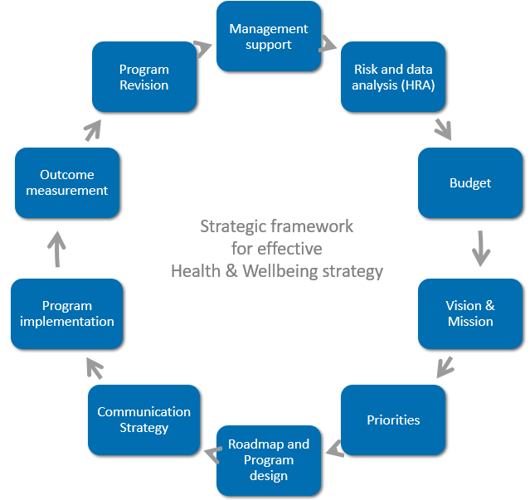

Appendix 6: Leadership style

Appendix 7: Employee well-bing
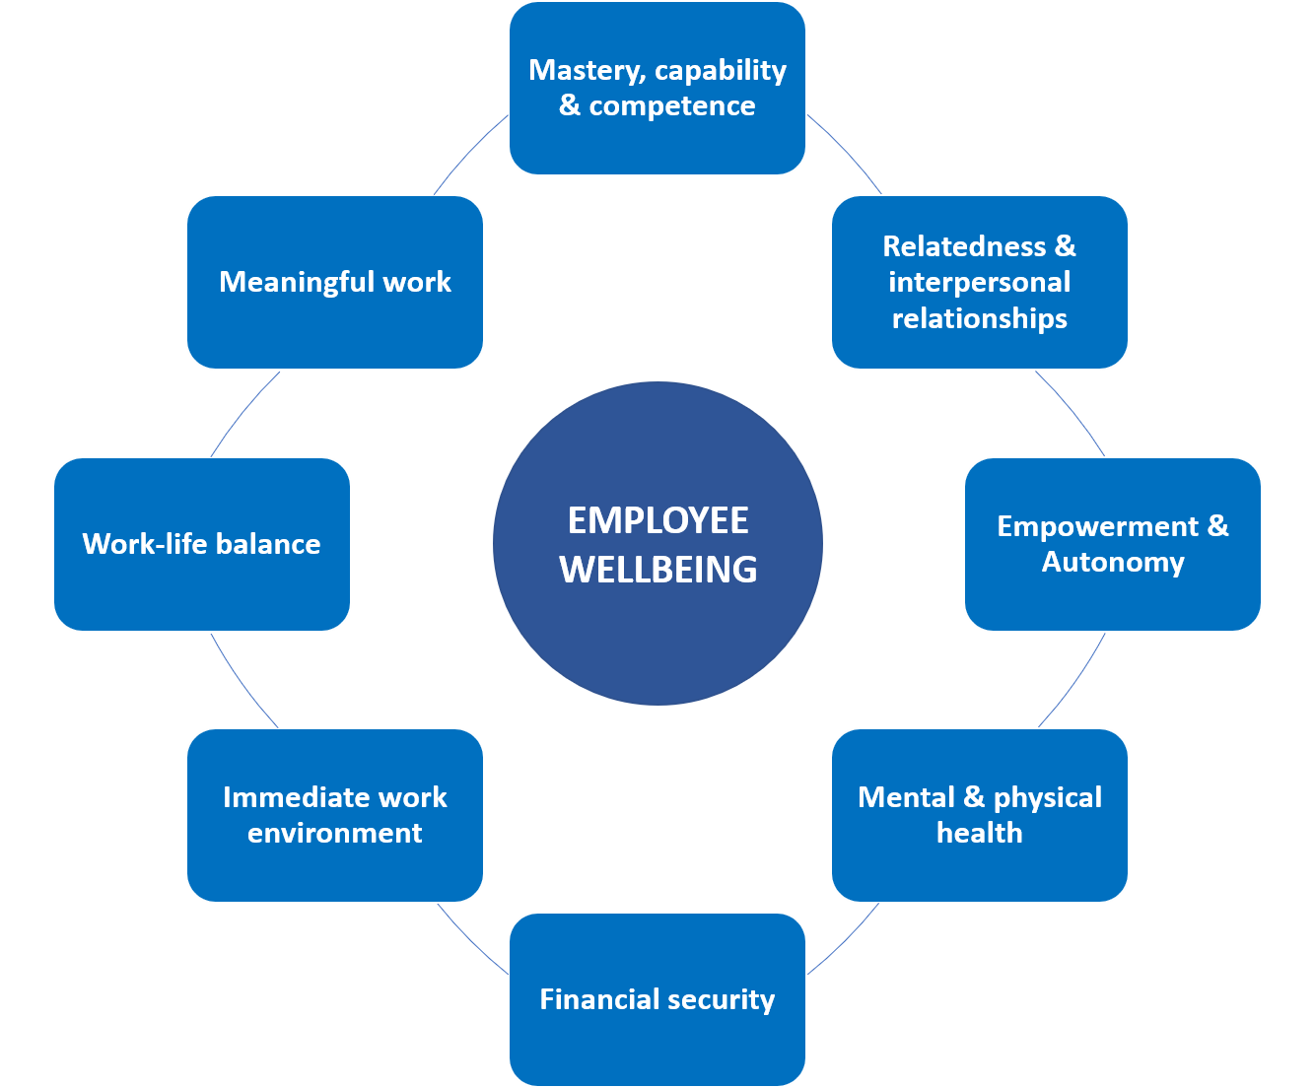

Passport and Immigration Department
St. Vincent and the Grenadines
Chief Personnel Officer
Assistant Chief Immigration Officer
Assistant Secretary Immigration
Employee Assistance Program.

